Air University Multan Campus
Full Stack Web Dev Final Lab Exam
233574
BSCS (B)
Question 01
Fitness Tracker Application
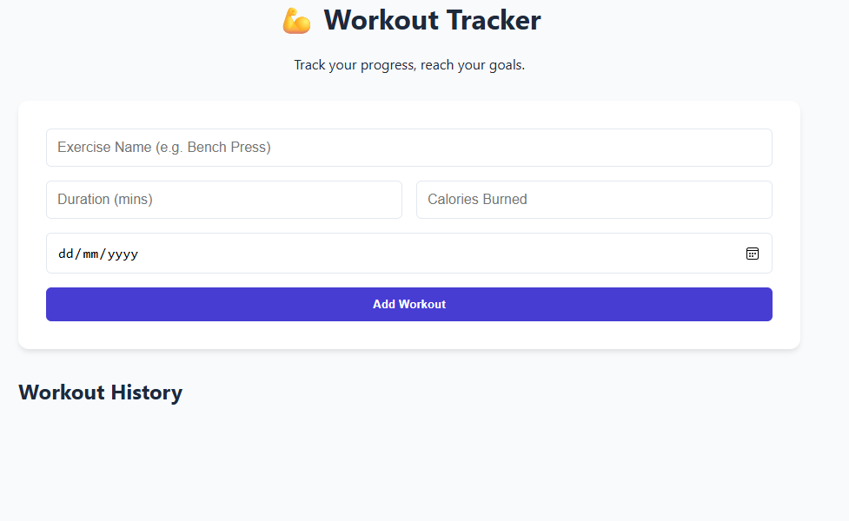

The application where user can login their daily workout activities. The application should allow the users to record new workout sessions, view their complete workout history, and update their progress. The system uses mern stack and must be deployed on github.
Task1:UI/UX Design react frontend
Create a user friendly single page application using react
React SPA architecture(routes/Components)
1.create a functional component for the workout entry from the input fields:
- Erercise name
- Duration in minuites
- Calories burned
- Date
2.Create a functional component to display the workout history in a list or card formate
3.implement proper component structure with clear sepration of concerns
Responsive UI Design(css styling)
1.must adapt different screen sizes
2.style form with appropriate colors
3.add an update progress or delete progress button for each workout entry with proper styling
State handeling(fetching & Displaying Data)
1.use useState hook to manage from inputs and workout list satate
2.use useEffect hook to fetch workout data from backend when component loads
3.Handle form submission and dynamically update the workout list in realtime

Task 02 Backend API – Node.js + Express
Create RESTful Api using node.js and express to handle workout tracking operations.
Node/Express server setup & Middle ware
1.setup and express server running on port 5000
2.configure express.json() middleware for parsing json request
3.setup cors to allow frontend-backend communication
REST Api implementation(Get,post,PUT/DELETE)
1.post route /api/workouts to log a new workout session
2.get route /api/workouts to retrive all workout sessions
3.a put route /api/workouts/ :id to update workout details or a delete route /api/workouts/ :id to remove a workout record
MongoDB connection & schems design
Establish connection using moongse local mongodb
In last I want to upload it to github and update .gitignore file to ignore unnecessary file and this react project is vite and with javascript and mongodb local….but I want u to give me html css and js files only for preview of realtime as server file will act as backend

