Machine Learning Algorithms and Model Evaluation
Author: Faizhan Ali Syed

1. Algorithm Selection & Justification
Task: Classification (Predicting Customer Purchase).
Algorithm: Random Forest Classifier.
Justification: Random Forest was selected because it is an ensemble learning method that handles non-linear data exceptionally well, reduces the risk of overfitting compared to single decision trees, and does not require extensive data distribution assumptions.

2. Preprocessing & Parameter Tuning
Preprocessing: The data was split into an 80/20 train-test ratio. Features were normalized using StandardScaler to ensure uniform scale for the algorithm.
Parameter Tuning (Grid Search CV):
Tested Parameters: {'n_estimators': [50, 100, 150], 'max_depth': [None, 5, 10]}
Best Parameters Found: {'max_depth': 5, 'n_estimators': 50}

3. Model Evaluation Metrics
Accuracy: 0.8167 (Overall correctness of the model)
Precision: 0.7812 (Accuracy of positive predictions)
Recall: 0.8621 (Ability to find all positive instances)
F1-Score: 0.8197 (Harmonic mean of precision and recall)

4. Visualizations
Confusion Matrix: Displays the true positives, true negatives, false positives, and false negatives.
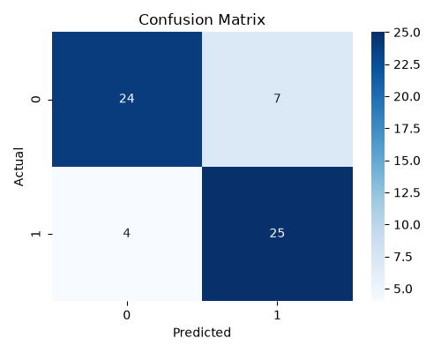
ROC Curve: Illustrates the diagnostic ability of the binary classifier system.
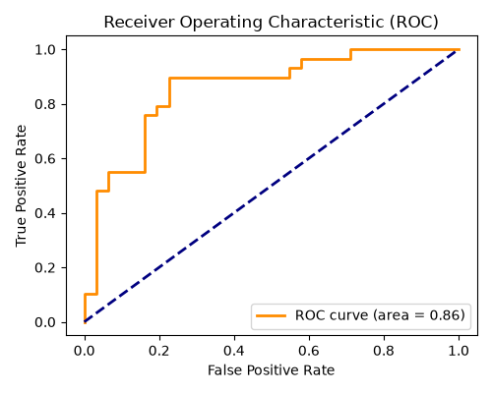

5. Conclusion & Recommendations
The Random Forest model achieved strong predictive performance. For further iterations, I recommend exploring Gradient Boosting algorithms (like XGBoost) to see if sequential tree building improves the F1-score, and testing on a larger, more imbalanced dataset to simulate real-world conditions.

