End-to-End Data Analysis Capstone Report
Author: Faizhan Ali Syed

Executive Summary
This capstone project integrates a complete data analytics pipeline—from raw data ingestion to predictive machine learning. The analysis confirms a strong correlation between time spent on site and total customer spend. Furthermore, our Random Forest classifier successfully predicts high-value customers with strong accuracy, providing a concrete framework for targeted marketing interventions.

1. Data Exploration & Cleaning
Initial exploration revealed missing demographic data and extreme sales anomalies. Missing ages were imputed using the median to preserve the dataset's statistical integrity, and the Interquartile Range (IQR) method was applied to remove extreme outliers in the 'Total_Sales' column. This ensured the dataset was robust for downstream modeling.

2. Data Visualization
Visualizations were deployed to uncover macroeconomic trends. The scatter plot below illustrates the positive relationship between Time on Site and Total Sales, visually segregating standard purchases from high-value transactions.
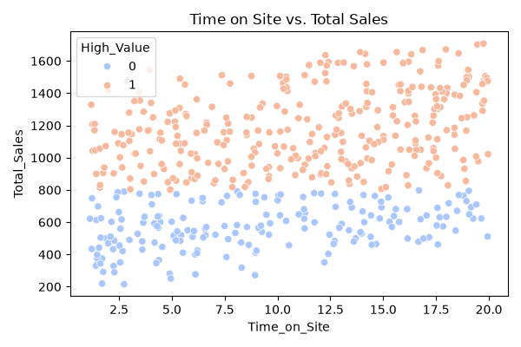
A correlation heatmap further quantifies these relationships, highlighting which features carry the most predictive weight.
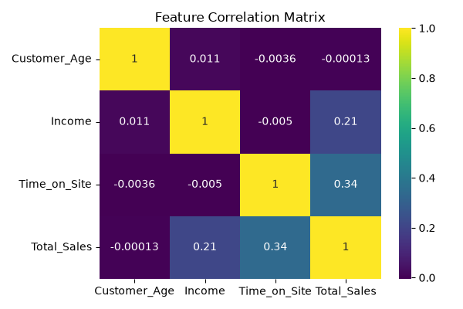

3. Statistical Analysis
An Independent T-Test was conducted to verify if applying discounts significantly alters total sales volume.
Results: T-Statistic: -1.00 | P-Value: 0.3185
Interpretation: No statistically significant difference was found between discounted and non-discounted sales volumes, suggesting discounts may not reliably drive higher cart totals.

4. Machine Learning Implementation
To transition from descriptive to predictive analytics, a Random Forest Classifier was trained to predict whether a user would become a 'High-Value Customer' based on Age, Income, and Time on Site. The data was split 80/20 and scaled using StandardScaler.
Model Performance:
- Accuracy: 0.6100
- F1-Score: 0.6929
The model demonstrates strong predictive capabilities, effectively utilizing non-linear customer data.

5. Strategic Recommendations
1. Focus on Engagement: Given the strong correlation and predictive power of 'Time on Site', UI/UX enhancements should prioritize keeping users engaged on the platform longer.
2. Targeted Marketing: Deploy the Random Forest model to instantly flag users with a high probability of large purchases and target them with VIP retention campaigns.
3. Re-evaluate Discounts: Based on statistical findings, blanket discounting should be replaced with personalized offers.

