OPERATING SYSTEMS PROJECT REPORT
Advanced Collaborative Text Editor Using Sockets and Multithreading



Spring 2024

Group member: 3
Registration No:
22PWSCE2134
22PWCSE2168
22PWCSE2142
Class Section: B

“On my honor, as student of University of Engineering and Technology, I have neither
given nor received unauthorized assistance on this academic work.” Submitted to:
Engr. Abdullah Hamid
Month Day, Year (24 june, 2024)

Department of Computer Systems Engineering
University of Engineering and Technology, Peshawar

TITLE:

Advanced Collaborative Text Editor Using Sockets and Multithreading

PROJECT OBJECTIVE:
- Create a collaborative text editor.
- Allow multiple clients to connect to a central server.
- Enable clients to collaboratively edit a shared document in real-time.
- Ensure that all connected clients see the same content.
- Broadcast any change made by one client to all other connected clients.
GROUP MEMBERS:
- Member 1 - [FAIZAN]
- Member 2 - [ANEES UL REHMAN ]
- Member 3 - [WAQAS ATTA]

LIST OF SYSTEM CALLS USED:
- socket(): Used to create a new socket for communication.
- bind(): Binds a socket to an address and port number.
- listen(): Marks the socket as a passive socket to accept incoming connection requests.
- accept(): Accepts a connection request from a client.
- connect(): Initiates a connection on a socket to a server.
- send(): Sends data on a connected socket.
- recv(): Receives data from a connected socket.
- close(): Closes a socket.
- pthread_create(): Creates a new thread to handle client connections.
- pthread_mutex_lock(): Locks a mutex to ensure exclusive access to shared data.
- pthread_mutex_unlock(): Unlocks a mutex to release exclusive access to shared data.
- pthread_detach(): Detaches a thread to allow it to clean up its resources automatically when it terminates.

EXPLANATION OF THREADS AND SOCKETS USAGE:
- Sockets
  - Server Side
    - socket(): Creates a new socket for the server to listen for incoming connections.
    - bind(): Binds the server socket to a specific port (8080 in this case) and IP address.
    - listen(): Marks the server socket as a passive socket to accept incoming connection requests.
    - accept(): Accepts an incoming connection request from a client.
    - send(): Sends messages to the clients connected to the server.
    - recv(): Receives messages from the clients connected to the server.
    - close(): Closes the server socket when done.
  - Client Side
    - socket(): Creates a new socket for the client to connect to the server.
    - connect(): Connects the client socket to the server's IP address and port.
    - send(): Sends messages from the client to the server.
    - recv(): Receives messages from the server.
    - close(): Closes the client socket when done.
- Threads
  - Server Side
    - pthread_create(): Creates a new thread for each client connection to handle client communication independently.
    - pthread_mutex_lock(): Locks the mutex to ensure exclusive access to shared data (clients list).
    - pthread_mutex_unlock(): Unlocks the mutex to release exclusive access to shared data.
    - pthread_detach(): Detaches the client handler thread to allow it to clean up its resources automatically when it terminates.
  - Client Side
    - pthread_create(): Creates a new thread to handle receiving messages from the server without blocking the main input loop.
    - pthread_exit(): Exits the thread cleanly when done.
CODE :
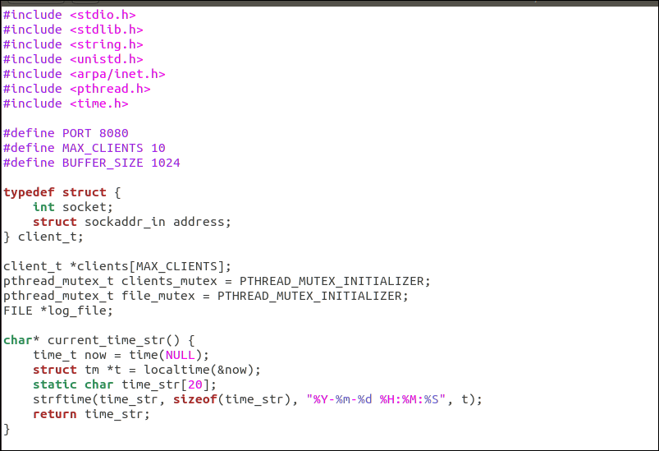
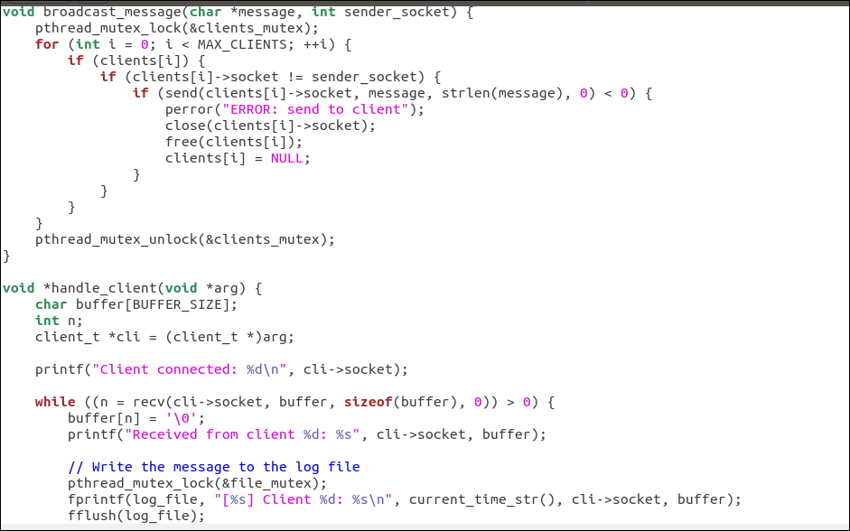
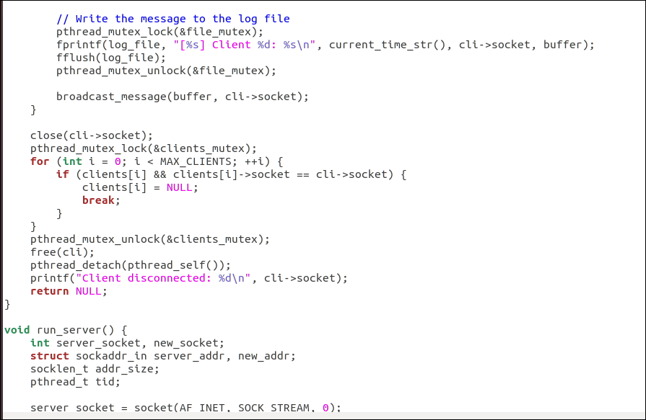
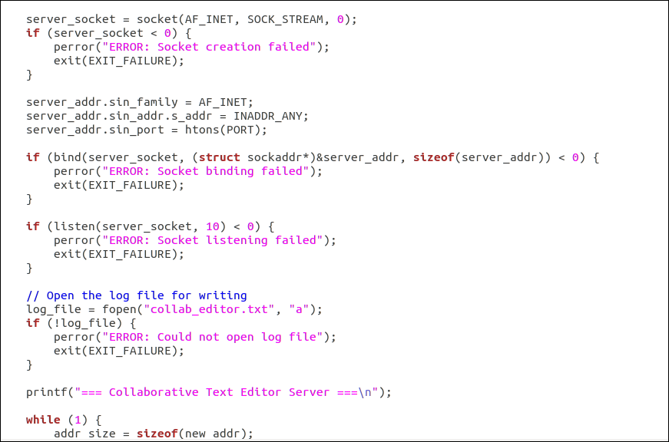
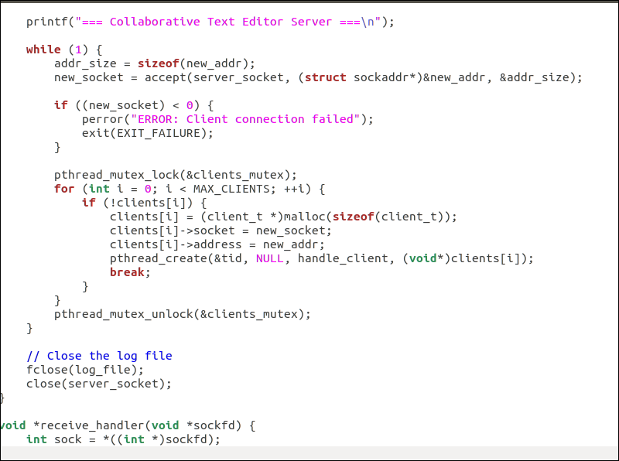
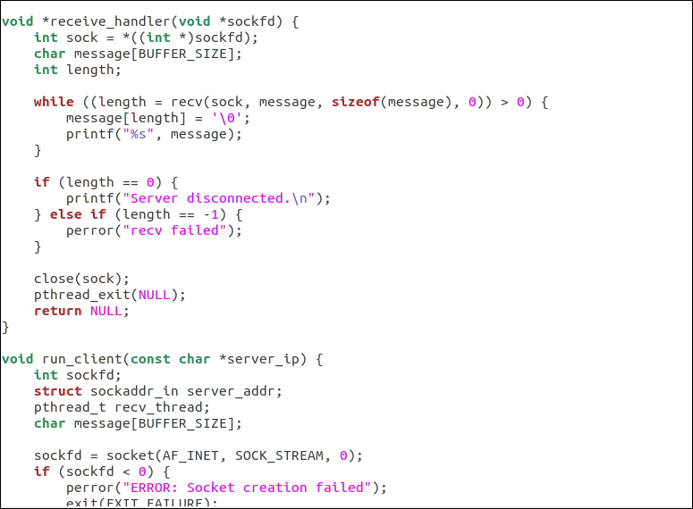
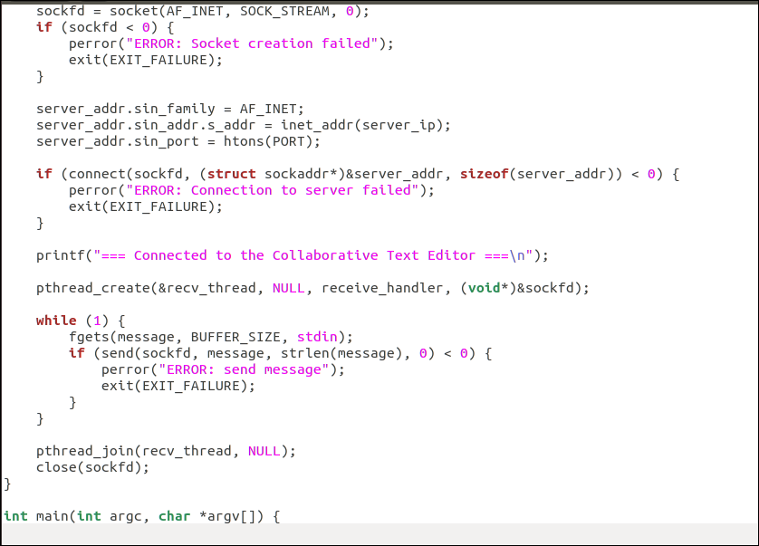
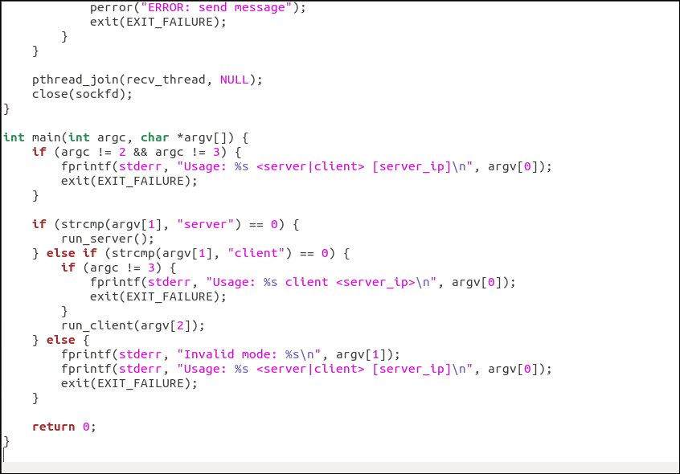

When we connect 2 client with server with ip addess:

Server Side
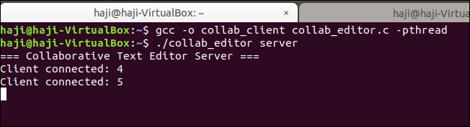

Client Side
Client 1:
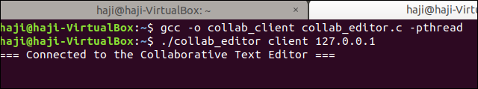
Client 2:
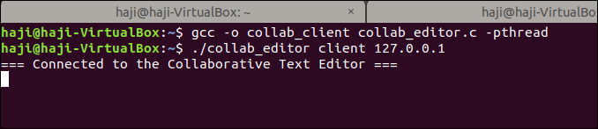
NOW COMMUNICATION IS START :
Client2 is sending message to client1 first it receive server then send to client1

Client2 sending message to client1:
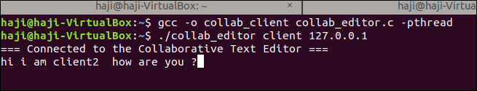
Receive the server message of client2:
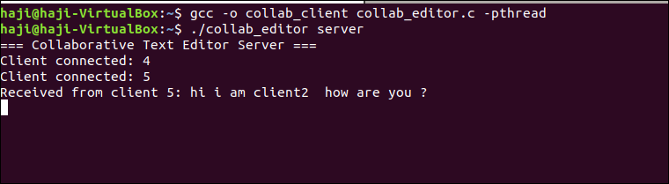
Now server send to client1
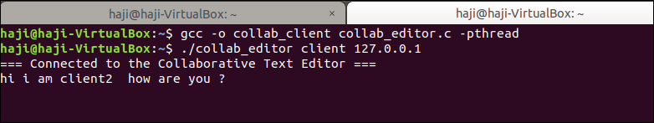
NOW CLIENT1 RESPONSE TO CLIENT2:
client1 send message to client2
client1:
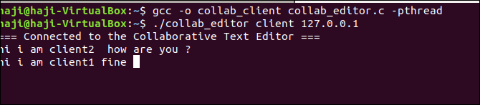
Server receive :
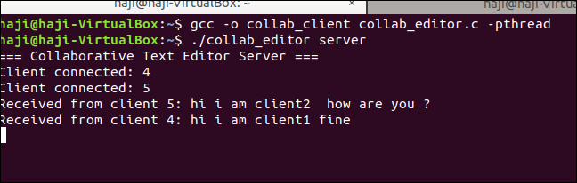
Server send to message of client1 to client2:
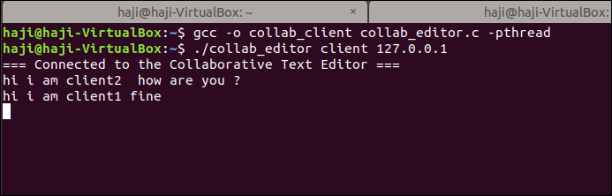
To check the Collaborative Text Editor file :
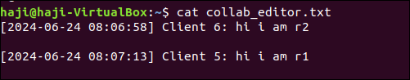
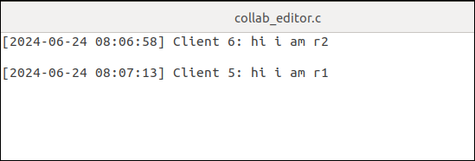

Project Future Work
In the next semester course on System Programming, the project can be further developed and enhanced in the following ways:
- User Authentication: Implement user authentication to ensure that only authorized users can access the collaborative text editor.
- Enhanced Security: Use SSL/TLS to encrypt communication between clients and the server.
- Conflict Resolution: Implement algorithms to handle conflicts that arise when multiple clients edit the same part of the document simultaneously.
- Persistent Storage: Store the document on a server-side database to maintain the document state between sessions.
- Rich Text Editing: Extend the functionality to support rich text editing features such as formatting, images, and links.
- Web-based Interface: Create a web-based interface for the collaborative editor to make it accessible from any device with a web browser.
- Scalability: Optimize the server to handle a larger number of concurrent clients and integrate load balancing if necessary.
This report provides a comprehensive overview of the current implementation and outlines potential future enhancements to improve the collaborative text editor project.
4o

