PROJECT REPORT



Fall 2024

CSE208L Object Oriented Programming Lab
Presentator Names:
Faizan (22PWCSE2134)
Naveed Ahmad (22PWCSE2165)
Sharjeel Qurashi (22PWCSE2199)

“On my honor, as student of University of Engineering and Technology, I have neither given nor received unauthorized assistance on this academic work.”

Submitted to:

Engr. Sumayyea Salahuddin

January 30, 2024

Department of Computer Systems Engineering
University of Engineering and Technology, Peshawar.

MOBILE CHATBOT.

Introduction:-
. A mobile chatbot is a computer program designed to simulate conversation with users, specifically focusing on providing information or assistance related to mobile phones.

Working:
A simple interactive chat-bot loop where the user can input a mobile phone brand. If the input matches a predefined brand like ‘ iphone' or ‘ sam-sung,‘ etc .the chat-bot responds with pre-stored information about that brand..
If the input match amoung specific condition then related data is display The loop continues until the user enters exit

Learning Outcome:
The program allows us to understand the basic principle under through which way data is access from source to destination or taking collection of data by user tensorflow library.

IDE’s Used:
Spyder and jupyter notebook IDE

OOP Used in Project:
- Infinite while loop is used in this python code.
- Functions

CODE SCREENSHOTS:
Support.py file:-
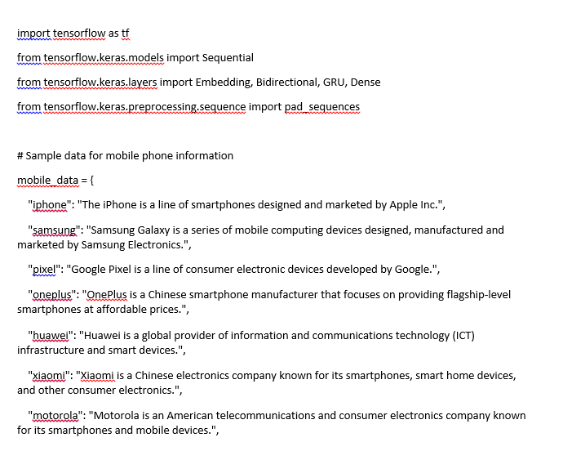

Figure 2
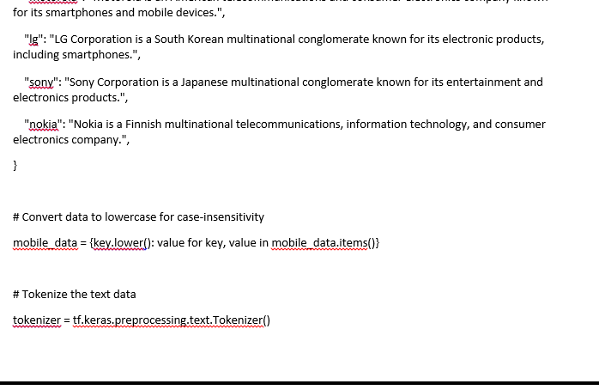

Figure 3
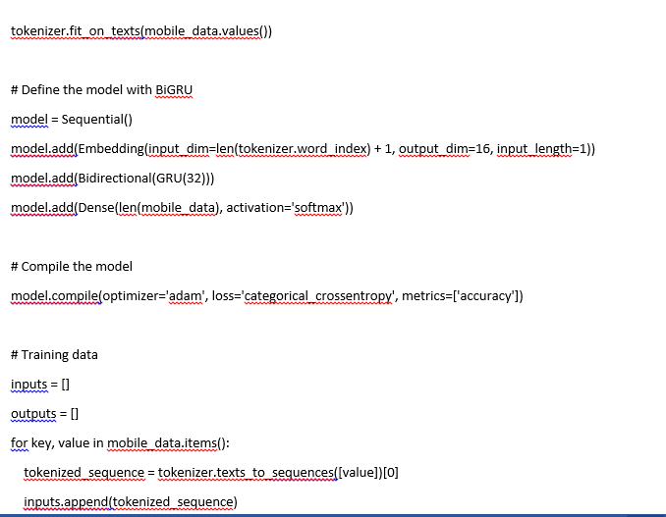

Figure 4
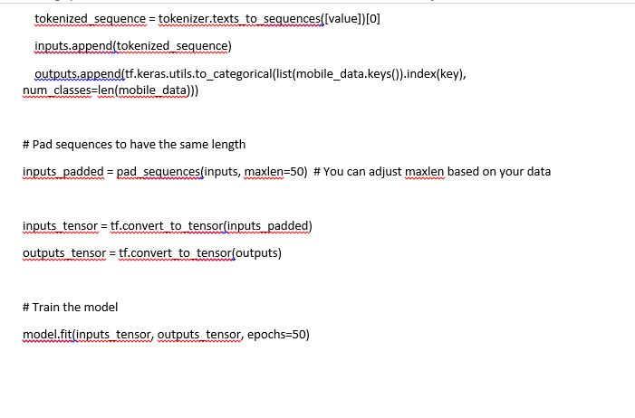

Figure 5

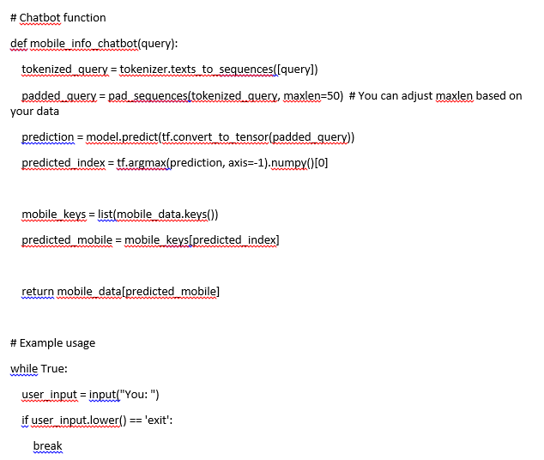

Integration_test.py:-

Figure 6
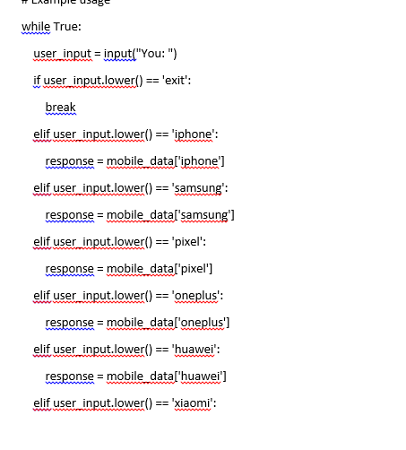

Figure 7
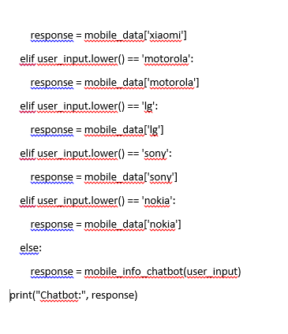
OUTPUT OF THE CODE
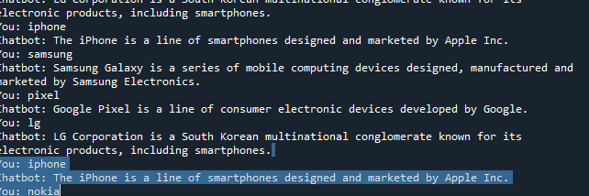
Flow chart
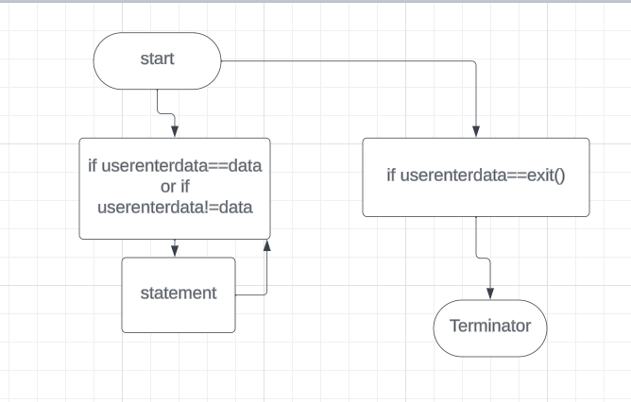
Here if user enter data that related to mobile phone that I stored in this program so the the related data is display if user data that is not equal to data then the compiler again show cosle to input data of user if user enter exit then loop will be terminate.

Conclusion:
So we can easily get data from chatbot of our own choice this project exactly define how chatgpt work.

