SELF STUDY SEMINAR

On

# “Image Compression using Discrete Cosine Transform”

Under the guidance of

Dr. Malti Bansal,

Assistant Professor,

Department of Electronics and Communication Engineering, Delhi Technological University

Submitted by

Bhavyai Gupta 2K12/EC/051

Anadi Anant Jain 2K12/EC/024

Ankush Bhushan 2K12/EC/029

Faizan Ayubi 2K12/EC/065

BTech (Electronics and Communication Engineering), DTU



Department of Electronics and Communication Engineering, Delhi Technological University

Shahbad Daulatpur,

Main Bawana Road,

Delhi-110042

Certificate

This is to certify that the report entitled “Image Compression using Discrete Cosine Transform” is a bonafide record of Self Study Seminar submitted by Bhavyai Gupta (Roll no. 2K12/EC/051) as the record of the work carried out by him under my guidance. It is being accepted in fulfilments of the Self Study Seminar, in the department of Electronics and Communication, Delhi Technological University, Delhi.

Project Guide

Dr. Malti Bansal

Assistant Professor

Department of Electronics

and Communication

Engineering

Delhi Technological University

Acknowledgement

I express my deepest gratitude to my project guide **Dr. Malti Bansal**, Department of Electronics and Communication Engineering, Delhi Technological University whose encouragement, guidance, and support from the initial to the final level enabled me to develop an understanding of the subject. Her suggestion and ways of summarizing the things made me to go for independent studying and trying my best to get the maximum in the topic, this made my circle of knowledge very vast. I am highly thankful to her for guiding me in this project.

Finally, I take this opportunity to extend my deep appreciation to my family and my self-study group members **Anadi Anant Jain**, **Ankush Bhushan** and **Faizan Ayubi**, for all that they meant to me during the crucial times of the completion of my project.

Date Bhavyai Gupta

Roll no. 2K12/EC/051

BTech (ECE)

Index

|  |  |  |
| --- | --- | --- |
| **S No** | **Title** | **Page No.** |
| 01 | Abstract | 5 |
| 02 | Introduction | 6 |
| 03 | How Images are formed | 7 |
| 04 | What is a format | 8 |
| 05 | Image Resolution | 9 |
| 06 | Compression | 10 |
| 07 | Image Compression | 12 |
| 08 | Working of Code | 14 |
| 09 | MATLAB Code | 15 |
| 10 | Output | 16 |
| 11 | Conclusion | 17 |
| 12 | References | 18 |

Abstract

Image compression is the application of data compression on digital images. Image compression can be lossy or lossless. In this project it is being attempted to implement basic JPEG compression using only MATLAB functions. In this paper the lossy compression techniques have been used, where data loss cannot affect the image clarity in this area. Image compression addresses the problem of reducing the amount of data required to represent a digital image. It is also used for reducing the redundancy that is nothing but avoiding the duplicate data. It also reduces the storage area to load an image. For this purpose we are using JPEG. JPEG is a still frame compression standard, which is based on, the Discrete Cosine Transform and it is also adequate for most compression applications.

The Discrete Cosine Transform (DCT) is a technique for converting a signal into elementary frequency components. It transforms digital image data from the spatial domain to the frequency domain. It is widely used in image compression.

Introduction

With the wide use of computers and consequently need for large scale storage and transmission of data, efficient ways of storing of data have become necessary. With the growth of technology and entrance into the Digital Age, the world has found itself amid a vast amount of information.

Dealing with such enormous information can often present difficulties. The purpose of data compression is to make a file smaller by minimizing the amount of data present. When a file is compressed, it can be reduced to as little as 25% of its' original. It is done to reduce the amount of space it takes to save the data wherever the data is stored and also makes it better to send through the internet if the files are large. Many files can be combined into one compressed document making sending easier.

Image compression is minimizing the size in bytes of a graphics file without degrading the quality of the image to an unacceptable level. The reduction in file size allows more images to be stored in a given amount of disk or memory space. It also reduces the time required for images to be sent over the Internet or downloaded from Web pages. JPEG is an important techniques used for image compression.

JPEG image compression standard uses Discrete Cosine Transform (DCT). It is a fast transform. It is a widely used and robust method for image compression. It has excellent compaction for highly correlated data. DCT has fixed basis images. It gives good compromise between information packing ability and computational complexity.

Compressing an image is significantly different than compressing raw binary data. Of course, general purpose compression programs can be used to compress images, but the result is less than optimal. DCT has been widely used in signal processing of image. The one-dimensional DCT is useful in processing one-dimensional signals such as speech waveforms. For analysis of two- dimensional (2D) signals such as images, we need a 2D version of the DCT data, especially in coding for compression, for its near-optimal performance. JPEG is a commonly used standard method of compression for photographic images. The name JPEG stands for Joint Photographic Experts Group, the name of the committee who created the standard. JPEG provides for lossy compression of images.

How Images are Formed

Digital Photography

Digital photography uses an array of electronic photo-detectors to capture the image focused by the lens, as opposed to an exposure on photographic film. The captured image is then digitized and stored as a computer file ready for digital processing, viewing, digital publishing or printing.

Raw Image Format

A camera raw image file contains minimally processed data from the image sensor of a digital camera, image scanner, or motion picture film scanner. Raw files are named so because they are not yet processed and therefore are not ready to be printed or edited with a bitmap graphics editor. Normally, the image is processed by a raw converter in a wide-gamut internal colorspace where precise adjustments can be made before conversion to a "positive" file format such as TIFF or JPEG for storage, printing, or further manipulation, which often encodes the image in a device-dependent colorspace. There are dozens if not hundreds of raw formats in use by different models of digital equipment (like cameras or film scanners).

Raw image files are sometimes called digital negatives, as they fulfil the same role as negatives in film photography: that is, the negative is not directly usable as an image, but has all of the information needed to create an image

The purpose of raw image formats is to save, with minimum loss of information, data obtained from the sensor, and the conditions surrounding the capturing of the image.

What is a Format

File Format

A file format is a standard way that information is encoded for storage in a computer file. It specifies how bits are used to encode information in a digital storage medium. File formats may be either proprietary or free and may be either unpublished or open.

Image File Format

There are numerous types of image formats such as .gif, .jpg, .png, .tif, .bmp, etc. each one with their own advantages and disadvantages.

* **GIF** The Graphics Interchange Format is a bitmap image format that was introduced by CompuServe in 1987 and has since come into widespread usage on the World Wide Web due to its wide support and portability.
* **PNG** Portable Network Graphics is a raster graphics file format that supports lossless data compression. PNG was created as an improved, non-patented replacement for Graphics Interchange Format (GIF), and is the most used lossless image compression format on the Internet.
* **JPEG** named after its creator the Joint Photographic Expert Group, is a format for encoding high-resolution graphic images as computer files for storage and transmission.

Image Resolution

Image resolution is the detail an image holds. In terms of sensor, it is the capability of sensor to observe or measure the smallest object clearly with distinct boundaries. The term applies to raster digital images, film images, and other types of images. Higher resolution means more image detail. There are four types of image resolution-

* Pixel resolution

Pixel is a unit of digital image. Resolution depends upon the size of pixel. Smaller the size of pixel, higher will be the resolution and more clear the object will be in image. Image having smaller pixel size occupy more size on disk.

* Spatial resolution

The measure of how closely lines can be resolved in an image is called spatial resolution, and it depends on properties of the system creating the image, not just the pixel resolution in pixels per inch (ppi). For practical purposes the clarity of the image is decided by its spatial resolution, not the number of pixels in an image. In effect, spatial resolution refers to the number of independent pixel values per unit length.

* Spectral resolution

Color images distinguish light of different spectra. Multispectral images resolve even finer differences of spectrum or wavelength than is needed to reproduce colour. That is, multispectral images have higher spectral resolution than normal color images.

* Temporal resolution

Movie cameras and high-speed cameras can resolve events at different points in time. The time resolution used for movies is usually 24 to 48 frames per second (frames/s), while high-speed cameras may resolve 50 to 300 frames per second, or even more.

Compression

Compression or bit-rate (no. of bits conveyed per unit of time) reduction involves encoding information using fewer bits than the original representation. Compression can be either lossy or lossless. Lossless compression reduces bits by identifying and eliminating statistical redundancy. No information is lost in lossless compression. Lossy compression reduces bits by identifying unnecessary information and removing it. The process of reducing the size of a data file is popularly referred to as data compression, although it’s formal name is source coding (coding done at the source of the data before it is stored or transmitted).

Compression is useful because it helps reduce resources usage, such as data storage space or transmission capacity. Because compressed data must be decompressed to use, this extra processing imposes computational or other costs through decompression. Data compression is subject to a space-time complexity trade-off.

The design of data compression schemes involves trade-offs among various factors, including the degree of compression, the amount of distortion introduced (e.g., when using lossy data compression), and the computational resources required to compress and uncompress the data.

* Lossless Compression

Lossless data compression is a class of data compression algorithms that allows the original data to be perfectly reconstructed from the compressed data. Lossless compression is preferred for archival purposes and often for medical imaging, technical drawings, clip art, or comics.

* Lossy Compression

Lossy compression is a data encoding method that compresses data by discarding some of it. The procedure aims to minimize the amount of data that needs to be held, handled, and/or transmitted by a computer.

It permits reconstruction only of an approximation of the original data, though this usually allows for improved compression rates (and therefore smaller sized files).

Lossy methods are especially suitable for natural images such as photographs in applications where minor (sometimes imperceptible) loss of fidelity is acceptable to achieve a substantial reduction in bit rate. The lossy compression that produces imperceptible differences may be called visually lossless.

* Advantages of Lossy Compression

The advantage of lossy methods over lossless methods is that in some cases a lossy method can produce a much smaller compressed file than any lossless method, while still meeting the requirements of the application.

In many cases, files or data streams contain more information than is needed for a particular purpose. For example, a picture may have more detail than the eye can distinguish when reproduced at the largest size intended; likewise, an audio file does not need a lot of fine detail during a very loud passage. Developing lossy compression techniques as closely matched to human perception is beneficial in such cases.

Lossy methods are most often used for compressing sound, images or videos. This is because these types of data are intended for human interpretation where the mind can easily see past very minor errors or inconsistencies.

Image Compression

Need For Image Compression

The need for image compression becomes apparent when number of bits per image is computed resulting from typical sampling rates and quantization methods. For example, the amount of storage required for given images is

(i) a low resolution, TV quality, color video image which has 512 x 512 pixels/color,8 bits/pixel, and 3 colors approximately consists of 6 x106 bits;

(ii) a 24 x 36 mm negative photograph scanned at 12 x 10−6mm: 3000 x 2000 pixels/color, 8 bits/pixel, and 3 colors nearly contains 144 x 106 bits;

(iii) a 14 x 17 inch radiograph scanned at 70 x 10−6mm: 5000 x 6000 pixels, 12 bits/pixel nearly contains 360 x 106 bits. Thus storage of even a few images could cause a problem. As another example of the need for image compression, consider the transmission of low resolution 512 x 512 x 8 bits/pixel x 3- color video image over telephone lines. Using a 96000 bauds (bits/sec) modem, the transmission would take approximately 11 minutes for just a single image, which is unacceptable for most applications.

Principles behind Compression

Number of bits required to represent the information in an image can be minimized by removing the redundancy present in it. There are three types of redundancies -

(i) Spatial redundancy, which is due to the correlation or dependence between neighbouring pixel values;

(ii) Spectral redundancy, which is due to the correlation between different color planes or spectral bands;

(iii) Temporal redundancy, which is present because of correlation between different frames in images. Image compression research aims to reduce the number of bits required to represent an image by removing the spatial and spectral redundancies as much as possible.

Data redundancy is of central issue in digital image compression. If n1 and n2 denote the number of information carrying units in original and compressed image respectively ,then the compression ratio CR can be defined as CR=n1/n2;

And relative data redundancy RD of the original image can be defined as

RD=1-1/CR;

Three possibilities arise here

(1) If n1=n2, then CR=1 and hence RD=0 which implies that original image do not contain any redundancy between the pixels.

(2) If n1>>n1, then CR→∞ and hence RD>1 which implies considerable amount of redundancy in the original image.

(3) If n1<<n2, then CR>0 and hence RD→-∞ which indicates that the compressed image contains more data than original image.

Working of Code

Main Functions Explained

* **imread()**

A = IMREAD(FILENAME,FMT) reads a grayscale or color image from the file specified by the string FILENAME. The return value A is an array containing the image data.

If the file contains a grayscale image, A is an M-by-N array. If the file contains a true color image, A is an M-by-N-by-3 array.

* **rgb2gray()**

I = RGB2GRAY(RGB) converts the truecolor image RGB to the grayscale intensity image I.

* **dct2()**

B = DCT2(A) returns the discrete cosine transform of A. The matrix B is the same size as A and contains the discrete cosine transform coefficients.

* **flipud()**

It flips matrix in up/down direction. FLIPUD(X) returns X with columns preserved and rows flipped in the up/down direction.

* **idct()**

B = IDCT2(A) returns the two-dimensional inverse discrete cosine transform of A.

MATLAB Code

%%%%%%%%% START %%%%%%%  
clc  
close all  
im=imread('a.bmp');  
im = double(im)/255;  
im = rgb2gray(im);  
subplot(211)  
  
imshow(im)  
title('Original image');  
img_dct=dct2(im);  
img_pow=(img_dct).^2;  
img_pow=img_pow(:);  
[B,index]=sort(img_pow);%no zig-zag  
B=flipud(B);  
index=flipud(index);  
compressed_dct=zeros(size(im));  
coeff = 20000;

% maybe change the value  
for k=1:coeff  
compressed_dct(index(k))=img_dct(index(k));  
end  
im_dct=idct2(compressed_dct);  
subplot(212)  
imshow(im_dct)  
title('DCT Compress Image');  
  
% for saving this image use "imwrite" command   
imwrite(im_dct, 'compress.bmp')  
  
%%%%%%%% END %%%%%%%

Output

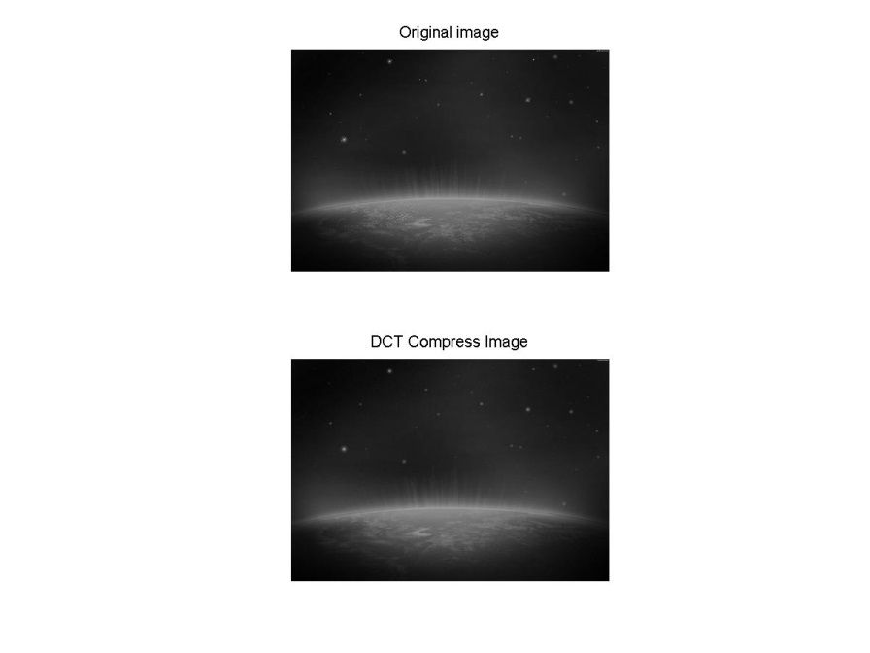

Conclusion

This project successfully implemented the DCT for image compression. The system is designed by using MATLAB software. This project has been tested for all possible situations on MATLAB environment on Windows 7 and finally produced an 8x8 Compressed DCT image. One of the main problems and the criticism of the DCT is the blocking effect. In DCT, images are broken into blocks of 8x8 or 16x16 or bigger. The problem with these blocks is that when the image is reduced to higher compression ratios, these blocks become visible. This has been termed as the blocking effect. This image is compressed using 8x8 blocks and only 4 coefficients are retained.

References

1. http://www.cs.cf.ac.uk/Dave/Internet/node155.html
2. http://www.uni-kiel.de/Kardiologie/dicom/1999/compression1.html
3. http://en.wikipedia.org/wiki/Jpeg
4. http://en.wikipedia.org/wiki/Lossless_data_compression
5. http://en.wikipedia.org/wiki/Lossy_data_compression
6. http://en.wikipedia.org/wiki/Discrete_cosine_transform
7. http://en.wikipedia.org/wiki/Digital_photography
8. http://en.wikipedia.org/wiki/Image_compression
9. http://www.scribd.com/doc/26156035/Image-Compression-Using-DCT-Implementing-Matlab
10. http://www.debugmode.com/imagecmp/
11. http://www.noupe.com/design/everything-you-need-to-know-about-image-compression.html
12. http://downloadpdfz.com/pdf/image-compression-using-discrete-cosine-transform-amp-discrete-7961665.html
13. http://www.mathworks.com/matlabcentral/fileexchange/4772-image-compression