AI Lab Tasks
The Superior University
October 24, 2026
Faizan E Muhammad
SU92-BSSEM-S25-035
Artificial Intelligence (Lab)
Lab 03
Contents
Graph: 3
Task no. 1 3
Breadth-first Search (BFS) 3
Traversal Order 4
Depth-First Search (DFS) 4
Traversal Order 4
Task no. 2 4
Depth Limited Search (DLS) 4

Graph:
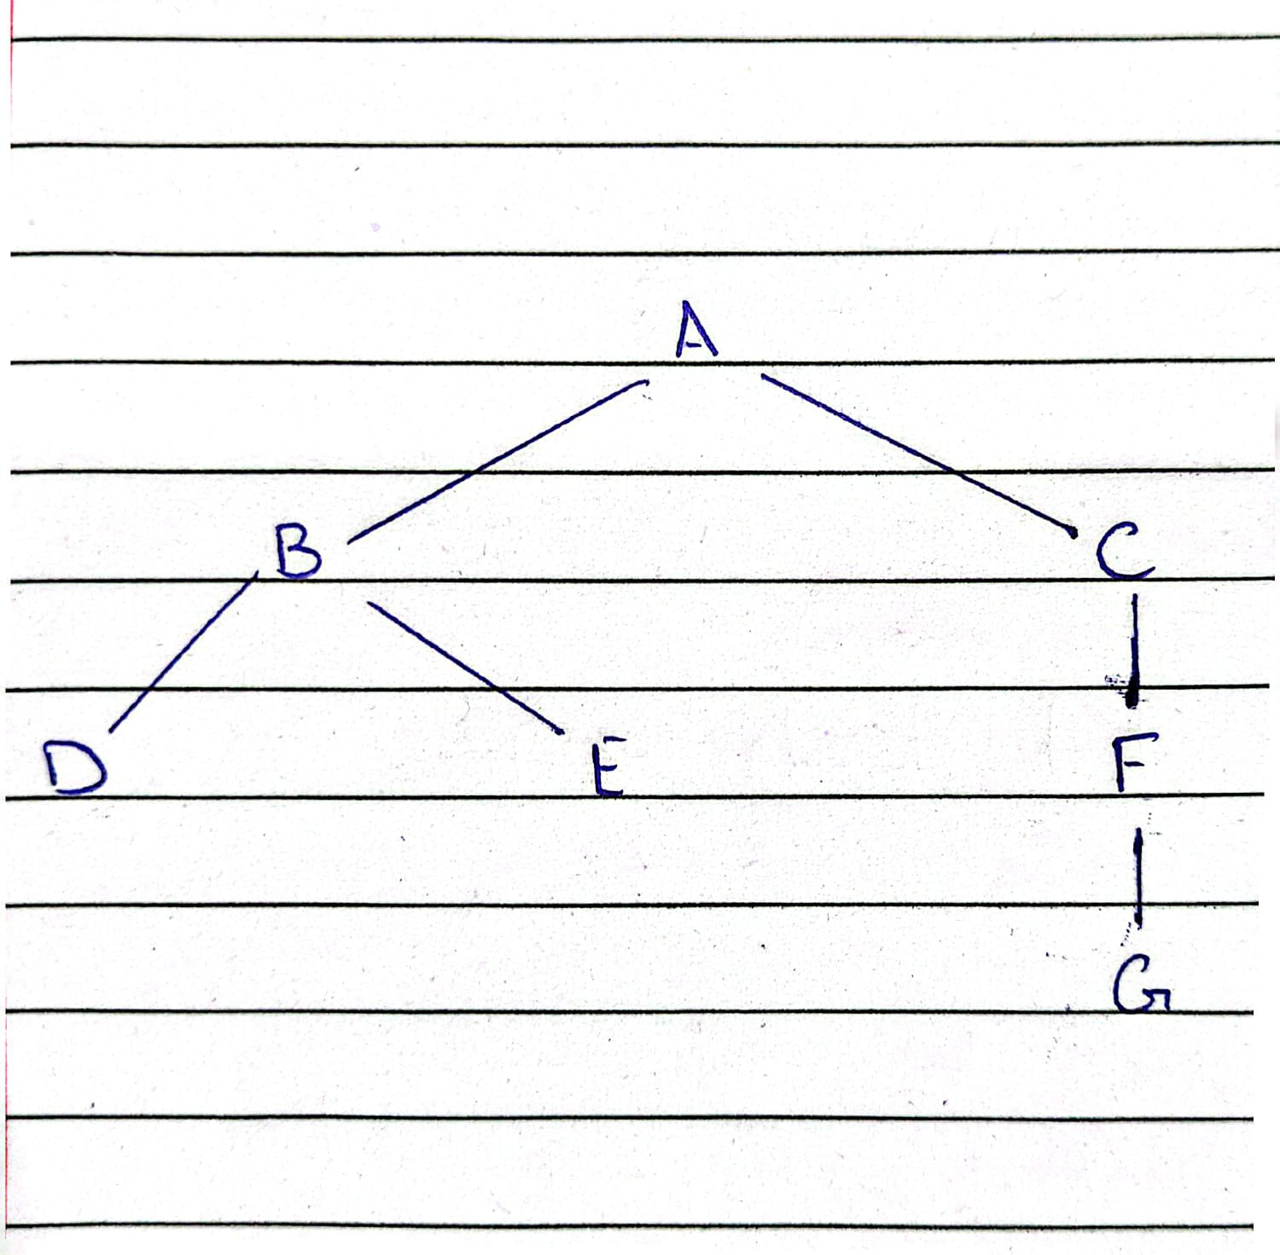

Task no. 1

Breadth-first Search (BFS)
BFS explores graph level by level. It visits the starting node first, then it’s immediate children, followed by the nodes at next level. In this implementation, a Python list named queue is used to store the nodes waiting to be explored. The append() method adds nodes to the end of the queue, while pop(0) removes the first node, following the First-In, First-Out (FIFO) principle.
The visited list stores the nodes that have been processed. During each iteration, the program prints the current queue and visited list to show how the algorithm processes.

Traversal Order
A → B → C → D → E → F → G

Depth-First Search (DFS)
DFS explores a branch of the graph as deeply as possible before backtracking to explore other branches.
In this implementation, a Python list named stack is used to store nodes waiting to be explored. The append() method adds nodes to the stack, while pop() removes the last node, following the Last-In, First-Out (LIFO) principle.

Traversal Order
A → C → F → G → B → E → D

Task no. 2

Depth Limited Search (DLS)
DLS is a variation of DFS that restricts how deeply the algorithm can explore a graph. A maximum depth limit is specified to prevent the search from continuing beyond a certain level. In my code, node A is the starting node and node G is the goal node. The root node A is counted at depth 0 and each edge increases the depth by one.
Meaning of three statuses
- FOUND: The goal node has been found within the specified depth limit. The function returns the path from the starting node to the goal.
- CUTOFF: The search reached the depth limit while at least one relevant branch had children that couldn’t be explored within that limit.
- FAILURE: The search exhausted the available paths without finding the goal and without encountering a depth cutoff.

