**1)**

var mysql = require('mysql');

var con = mysql.createConnection({

host: "localhost",

user: "test",

password: "test"

});

con.connect(function(err) {

if (err) throw err;

console.log("Connected!");

});

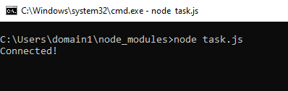

**2)** var mysql = require('mysql');

var con = mysql.createConnection({

host: "localhost",

user: "test",

password: "test"

});

con.connect(function(err) {

if (err) throw err;

console.log("Connected!");

con.query(sql, function (err, result) {

if (err) throw err;

console.log("Result: " + result);

});

});

**3)**

var mysql = require('mysql');

var con = mysql.createConnection({

host: "localhost",

user: "test",

password: "test"

});

con.connect(function(err) {

if (err) throw err;

console.log("Connected!");

con.query("CREATE DATABASE mydb", function(err, result){

if (err) throw err;

console.log("Database (mydb) Created!");

})

});

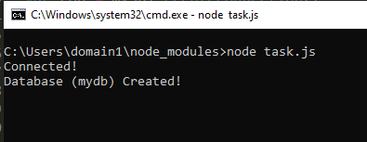

**4)**

var mysql = require('mysql');

var con = mysql.createConnection({

host: "localhost",

user: "test",

password: "test",

database: "mydb"

});

con.connect(function(err) {

if (err) throw err;

console.log("Connected!");

con.query("CREATE TABLE customers (name VARCHAR(255), address VARCHAR(255))", function(err, result){

if (err) throw err;

console.log("Table customers added to mydb!");

})

});

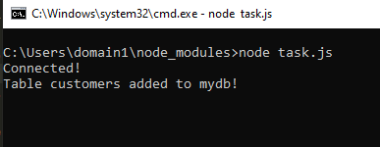

**5)**

var mysql = require('mysql');

var con = mysql.createConnection({

host: "localhost",

user: "test",

password: "test",

database: "mydb"

});

con.connect(function(err) {

if (err) throw err;

console.log("Connected!");

con.query("ALTER TABLE customers ADD CONSTRAINT cm_pk PRIMARY KEY (name)", function(err, result){

if (err) throw err;

console.log("Primary key (name) added table!");

})

});

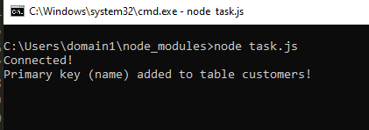

**6)**

var mysql = require('mysql');

var con = mysql.createConnection({

host: "localhost",

user: "test",

password: "test",

database: "mydb"

});

con.connect(function(err) {

if (err) throw err;

console.log("Connected!");

con.query("INSERT INTO customers (name, address) VALUES ('faizan', 'nust')", function(err, result){

if (err) throw err;

console.log("1 row inserted!");

})

});

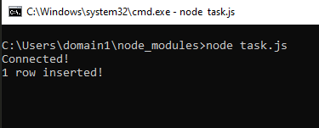

**7)**

var mysql = require('mysql');

var con = mysql.createConnection({

host: "localhost",

user: "test",

password: "test",

database: "mydb"

});

con.connect(function(err) {

if (err) throw err;

console.log("Connected!");

con.query("INSERT INTO customers (name, address) VALUES ('fareed', 'nust'),('ali', 'fast');", function(err, result){

if (err) throw err;

console.log("2 rows inserted!");

})

});

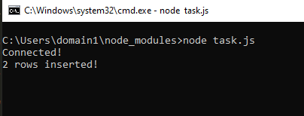

**8)**

var mysql = require('mysql');

var con = mysql.createConnection({

host: "localhost",

user: "test",

password: "test",

database: "mydb"

});

con.connect(function(err) {

if (err) throw err;

con.query("SELECT * FROM customers", function (err, result, fields) {

if (err) throw err;

console.log(result);

});

});

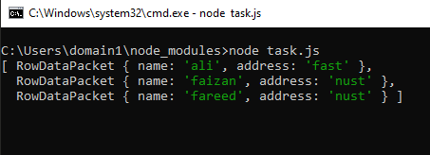

**9)**

var mysql = require('mysql');

var con = mysql.createConnection({

host: "localhost",

user: "test",

password: "test",

database: "mydb"

});

con.connect(function(err) {

if (err) throw err;

con.query("SELECT name, address FROM customers", function (err, result, fields) {

if (err) throw err;

console.log(result);

});

});



**10)**

var mysql = require('mysql');

var con = mysql.createConnection({

host: "localhost",

user: "test",

password: "test",

database: "mydb"

});

con.connect(function(err) {

if (err) throw err;

con.query("SELECT name, address FROM customers", function (err, result, fields) {

if (err) throw err;

console.log(fields)

});

});

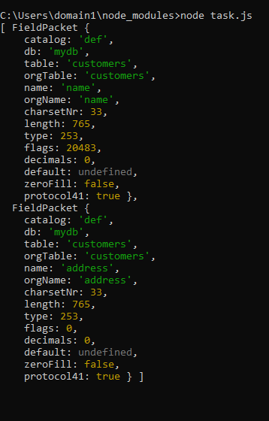

**11)**

var mysql = require('mysql');

var con = mysql.createConnection({

host: "localhost",

user: "test",

password: "test",

database: "mydb"

});

con.connect(function(err) {

if (err) throw err;

con.query("SELECT * FROM customers WHERE address = 'nust'", function (err, result, fields) {

if (err) throw err;

console.log(result);

});

});

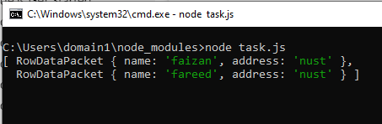

**12)**

var mysql = require('mysql');

var con = mysql.createConnection({

host: "localhost",

user: "test",

password: "test",

database: "mydb"

});

con.connect(function(err) {

if (err) throw err;

con.query("SELECT * FROM customers WHERE address = 'S%'", function (err, result, fields) {

if (err) throw err;

console.log(result);

});

});

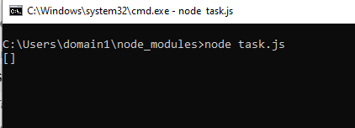

**13)**

var mysql = require('mysql');

var con = mysql.createConnection({

host: "localhost",

user: "test",

password: "test",

database: "mydb"

});

con.connect(function(err) {

if (err) throw err;

con.query("SELECT * FROM customers ORDER BY name", function (err, result, fields) {

if (err) throw err;

console.log(result);

});

});

**14)**

var mysql = require('mysql');

var con = mysql.createConnection({

host: "localhost",

user: "test",

password: "test",

database: "mydb"

});

con.connect(function(err) {

if (err) throw err;

con.query("DELETE FROM customers WHERE address = 'Mountain 21'", function (err, result, fields) {

if (err) throw err;

console.log("Number of Rows affected: " + result.affectedRows);

});

});

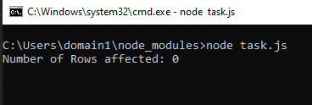

**15)** var mysql = require('mysql');

var con = mysql.createConnection({

host: "localhost",

user: "test",

password: "test",

database: "mydb"

});

con.connect(function(err) {

if (err) throw err;

con.query("DROP TABLE customers", function (err, result, fields) {

if (err) throw err;

console.log("Table Deleted!”);

});

});

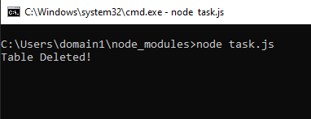

**16)**

var mysql = require('mysql');

var con = mysql.createConnection({

host: "localhost",

user: "test",

password: "test",

database: "mydb"

});

con.connect(function(err) {

if (err) throw err;

con.query("UPDATE customers SET address = 'Canyon 123' WHERE address = 'Valley 345'", function(err, result, fields){

if (err) throw err;

console.log("Affted rows: " + result.affectedRows);

});

});

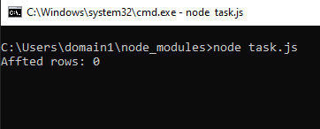

**17)**

var mysql = require('mysql');

var con = mysql.createConnection({

host: "localhost",

user: "yourusername",

password: "yourpassword",

database: "mydb"

});

con.connect(function(err) {

if (err) throw err;

var sql = "SELECT * FROM customers LIMIT 5";

con.query(sql, function (err, result) {

if (err) throw err;

console.log(result);

});

});

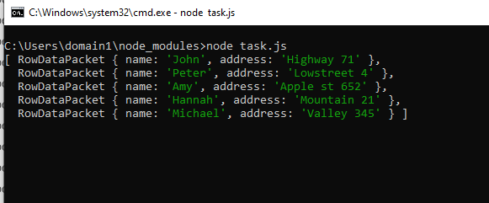

var mysql = require('mysql');

var con = mysql.createConnection({

host: "localhost",

user: "yourusername",

password: "yourpassword",

database: "mydb"

});

con.connect(function(err) {

if (err) throw err;

var sql = "SELECT * FROM customers LIMIT 5 OFFSET 3";

con.query(sql, function (err, result) {

if (err) throw err;

console.log(result);

});

});

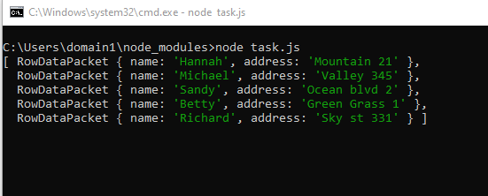

**18)**

var mysql = require('mysql');

var con = mysql.createConnection({

host: "localhost",

user: "yourusername",

password: "yourpassword",

database: "mydb"

});

con.connect(function(err) {

if (err) throw err;

var sql = "SELECT users.name AS user, products.name AS favorite FROM users JOIN products ON users.favorite_product = products.id";

con.query(sql, function (err, result) {

if (err) throw err;

console.log(result);

});

});

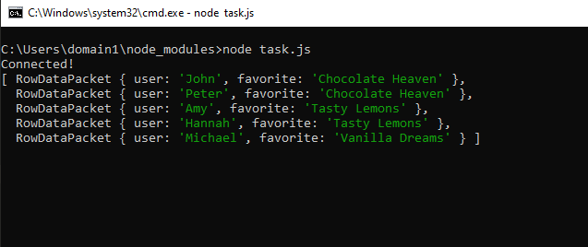

var mysql = require('mysql');

var con = mysql.createConnection({

host: "localhost",

user: "test",

password: "test",

database: "mydb"

});

con.connect(function(err) {

if (err) throw err;

console.log("Connected!");

var sql = "SELECT users.name AS user, products.name AS favorite FROM users LEFT JOIN products ON users.favorite_product = products.id";

con.query(sql, function (err, result) {

if (err) throw err;

console.log(result);

});

});

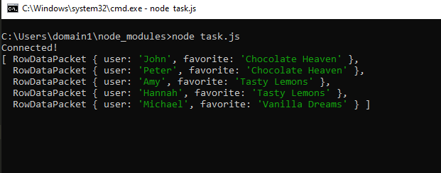

var mysql = require('mysql');

var con = mysql.createConnection({

host: "localhost",

user: "test",

password: "test",

database: "mydb"

});

con.connect(function(err) {

if (err) throw err;

console.log("Connected!");

var sql = "SELECT users.name AS user, products.name AS favorite FROM users RIGHT JOIN products ON users.favorite_product = products.id";

con.query(sql, function (err, result) {

if (err) throw err;

console.log(result);

});

});

