**TASK 1**

**SERVER.js:**

var express = require('express');

var bodyParser = require('body-parser')

var app = express();

app.use(bodyParser.urlencoded({extended : true}))

app.get('/index.html', function(req, res){

res.sendFile(__dirname + '/' + 'index.html');

});

app.post('/submit-form', function(req, res){

const fname = req.body.firstname;

const lname = req.body.lastname;

res.send('String Recieved: ' + JSON.stringify(req.body));

res.end();

});

var server = app.listen(8081, function () {

var host = server.address().address

var port = server.address().port

console.log("Example app listening at http://%s:%s", host, port)

})

**INDEX.html:**

<form action="submit-form" method="POST">

First name:<br>

<input type="text" name="firstname">

<br>

Last name:<br>

<input type="text" name="lastname">

<br><br>

<input type="submit" value="Submit">

</form>

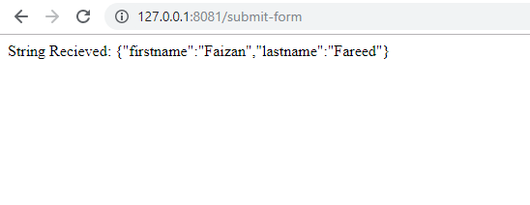

**TASK 2**

**SERVER.js:**

var express = require('express');

var bodyParser = require('body-parser')

const multer = require('multer');

var app = express();

var storage = multer.diskStorage({

destination: function (req, file, cb) {

cb(null, 'uploads')

},

filename: function (req, file, cb) {

cb(null, file.fieldname + '.png')

}});

var upload = multer({ storage: storage });

app.get('/index.html', function(req, res){

res.sendFile(__dirname + '/' + 'index.html');

});

app.post('/upload', upload.single('myFile'), function (req, res, next) {

const file = req.file;

if (!file) {

const error = new Error('Please upload a file');

error.httpStatusCode = 400;

return next(error);

}

res.send(file);

});

var server = app.listen(8081, function () {

var host = server.address().address

var port = server.address().port

console.log("Example app listening at http://%s:%s", host, port)

});

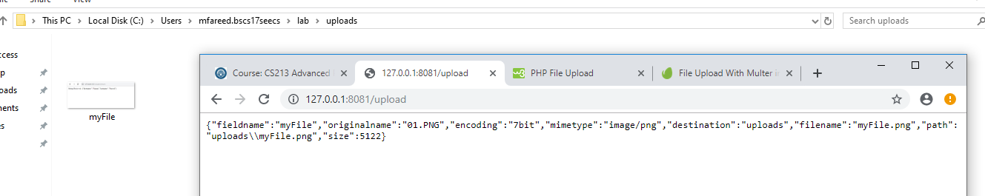

**TASK 3**

**SERVER.js:**

var express = require('express');

var bodyParser = require('body-parser');

var app = express();

app.use(bodyParser.urlencoded({extended : true}))

app.set('view engine', 'pug');

app.set('views','./views');

app.get('/', function (req, res) {

res.render('first_view');

})

app.post('/register', function (req, res) {

res.send('String Recieved: ' + JSON.stringify(req.body));

res.end();

})

var server = app.listen(8081, function () {

var host = server.address().address

var port = server.address().port

console.log("Example app listening at http://%s:%s", host, port)

});

**FIRST_VIEW.pug:**

doctype html

html

head

title Hello Pug

body

h1= "Registration Form"

form(action="register" method="POST")

p First Name:

input(type="text" name="fname" placeholder="Enter You First Name")

p Last Name:

input(type="text" name="lname" placeholder="Enter You Last Name")

p DOB:

input(type="text" name="dob" placeholder="Date of Birth")

p Password:

input(type="password" name="pass")

br

input(type="submit")

