**Task 1:**

**welcome.js**

import React, {Component} from 'react';

class Welcome extends Component{

constructor(){

super();

this.state = {message : "Welcome Visitor"};

}

render(){

return (<h1>{this.state.message}</h1>)

}

}

export default Welcome;

**app.js**

import React from 'react';

import logo from './logo.svg';

import './App.css';

import Welcome from './welcome';

function App() {

return (

<Welcome></Welcome>

);

}

export default App;

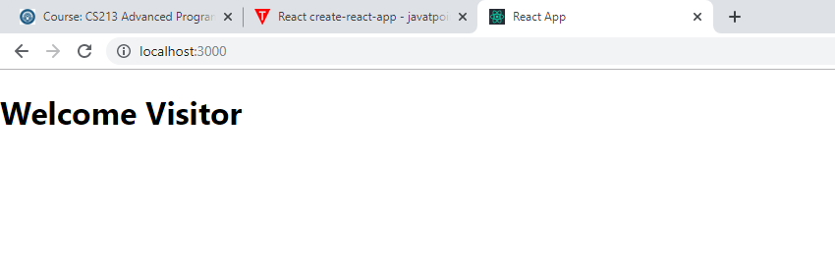

**welcome.js**

import React, {Component} from 'react';

class Welcome extends Component{

constructor(){

super();

this.state = {

message1 : "Welcome Visitor"

}

this.changeState = this.changeState.bind(this);

}

changeState(){

this.setState({message1 : "Thankyou for Subscribing"});

}

render(){

return(

<div>

<h1>{this.state.message1}</h1>

<button onClick={this.changeState}> Subscribe ! </button>

</div>

);

}

}

export default Welcome;

**app.js**

import React from 'react';

import logo from './logo.svg';

import './App.css';

import Welcome from './welcome';

function App() {

return (

<div className="App">

<Welcome></Welcome>

</div>

);

}

export default App;

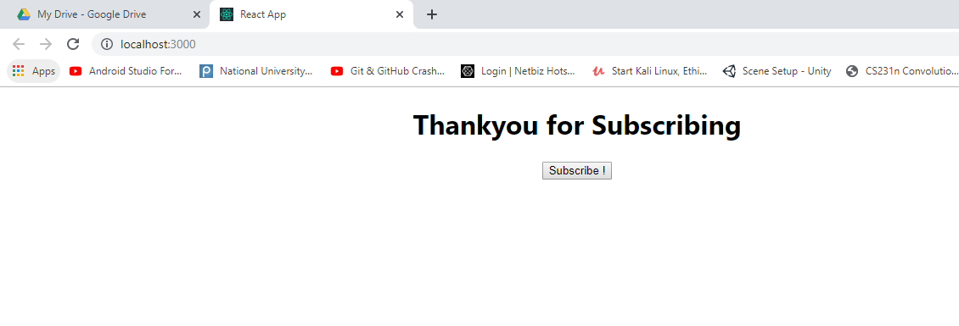

Counter Application

**counter.js**

import React from 'react';

class Counter extends React.Component{

constructor(){

super();

this.state={count : 0};

this.Increment = this.Increment.bind(this);

}

Increment(){

this.setState({count : this.state.count + 1});

}

render(){

return(

<div>

<h1>Counter - {this.state.count}</h1>

<button onClick={this.Increment}>Increment</button>

</div>

);

}

}

export default Counter;

**app.js**

import React from 'react';

import logo from './logo.svg';

import './App.css';

import Welcome from './welcome';

import Counter from './counter';

function App() {

return (

<div className="App">

<Counter />

</div>

);

}

export default App;

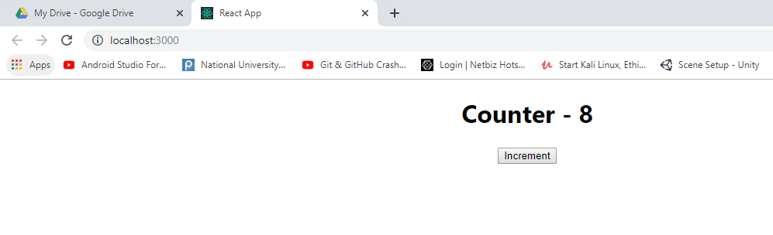

**Task 2:**

**form.js**

import React from 'react';

class TimerForm extends React.Component{

constructor(){

super();

this.state = {

value : 0,

timer : false,

seconds : 59

};

this.handleChange = this.handleChange.bind(this);

this.handleClick = this.handleClick.bind(this);

}

handleChange(event){

this.setState({value : event.target.value});

}

handleClick(event){

this.setState({

value:this.state.value - 1,

timer:true,

seconds:59

});

this.timer = setInterval(() => {

if(this.state.seconds == 0){

if(this.state.value==0){

this.setState({timer:false});

this.stopTime();

}

else{

this.setState({value:this.state.value-1, seconds:59});

}

}

this.setState({seconds:this.state.seconds-1});

}, 1000);

}

stopTime(){

clearInterval(this.timer);

}

render(){

let minutes = (!this.state.timer) ? <h1>{this.state.value}</h1> : null;

let time = (this.state.timer) ? <h1>{this.state.value}:{this.state.seconds}</h1> : null;

let input = (!this.state.timer) ?

<input type="number" value={this.state.value} onChange={this.handleChange} /> : null;

let button = (!this.state.timer) ? <button onClick={this.handleClick}>Start !</button> : null;

return (

<div>

{input}

{minutes}

{button}

{time}

</div>

);

}

}

**app.js**

import React from 'react';

import logo from './logo.svg';

import './App.css';

import TimeForm from './inputform';

function App() {

return (

<div className="App">

<TimeForm />

</div>

);

}

export default App;

