Due to Limited Memory, I was unable to emulate android device. I started the app on my connected device.

Here are folder structures and terminal commands.

React Native Folder:

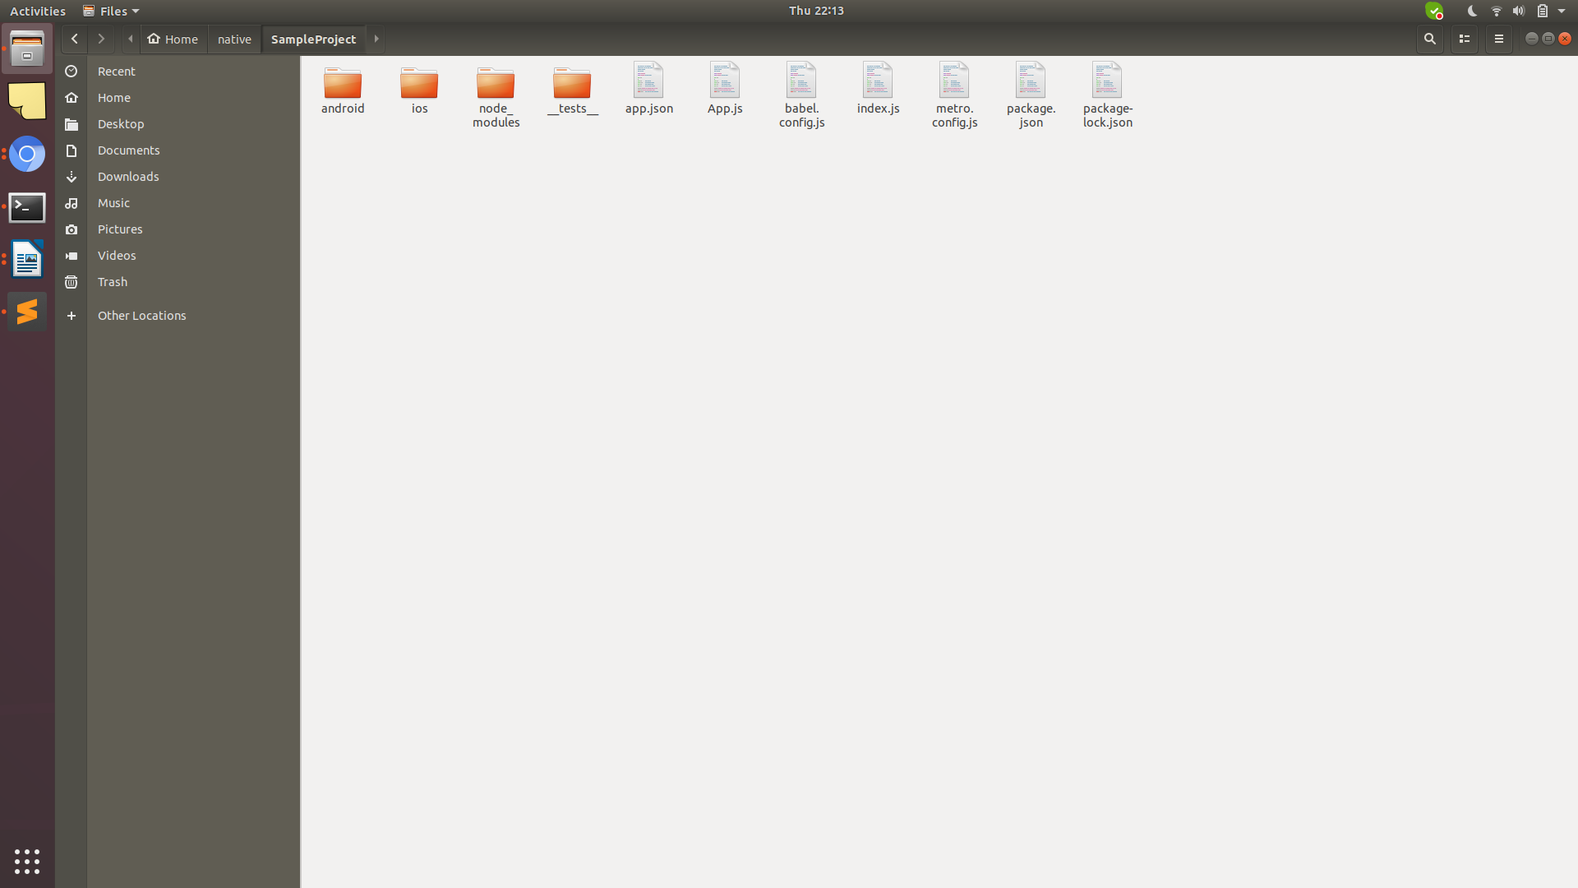

Android SDK folder:

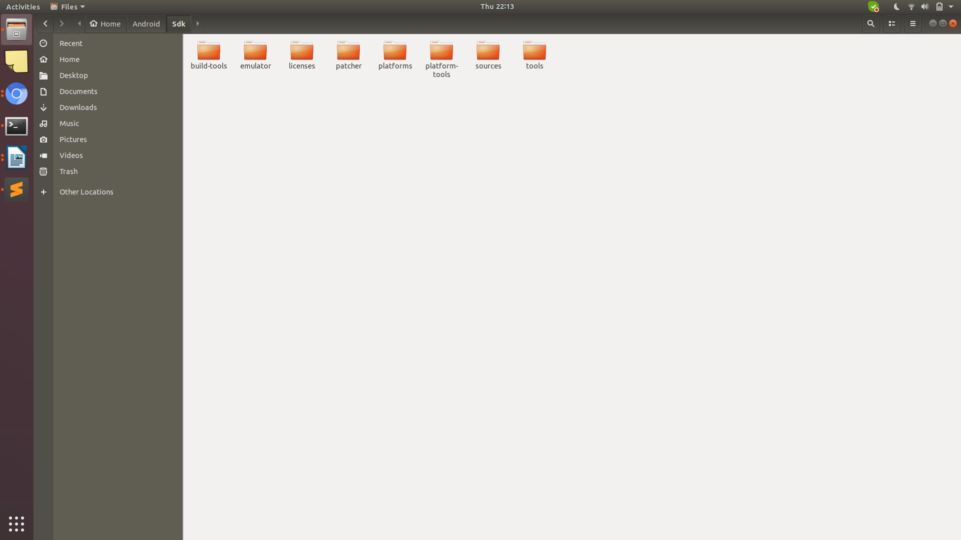

Terminal:

