FLIPKART LAPTOP PURCHASE BEHAVIOR AT SCALE
Best-Sellers • Sales Trends • Ratings • Regional Demand • Inventory
A Descriptive Analytics Report
Prepared By: Mohd Faizan Hasan
Roll No: 30
August 2026

Table of Contents
1. Objective
2. Methodology & Assumptions
3. How This Would Work at Real Scale
4. Daily Sales Trend
5. Best-Selling Laptops (Most Recent Day)
5a. Category-Wise Sales Breakdown
6. Rating Distribution
7. Regional Demand
8. Inventory Status
9. Summary of Key Metrics
10. Key Insights
10a. Additional Keywords & Insights
11. Explanation of Analysis — How Each Insight Was Derived
11a. Notes on the Additional Keywords
12. Next Steps to Move From Descriptive → Predictive
13. Appendix

FLIPKART LAPTOP PURCHASE BEHAVIOR AT SCALE
Best-Sellers • Sales Trends • Ratings • Regional Demand • Inventory
Note on data: Flipkart's live transaction data isn't publicly accessible, so this report uses a synthetic dataset built to mirror real e-commerce patterns — 45 laptop SKUs across 6 categories, 8 regions, 30 days, ~1,56,000 simulated units. It shows exactly what a descriptive-analytics pipeline processing daily laptop purchases would produce; the same structure applies once real data is substituted in.

1. Objective
This report builds a descriptive analytics layer over daily laptop purchase transactions on Flipkart to answer five recurring business questions:
- What are today's best-selling laptops?
- How are total sales trending day over day?
- How are laptops rated, and where is rating quality slipping?
- Where is laptop demand concentrated geographically?
- Which laptop SKUs are at risk of stocking out?
Each question maps to one recurring stakeholder need — merchandising wants best-sellers, finance wants the revenue trend, customer experience wants rating quality, operations wants regional demand, and supply chain wants inventory risk. A single descriptive layer, refreshed daily, is designed to serve all four teams from one consistent source of truth rather than four separate ad-hoc reports.

2. Methodology & Assumptions
Since live transaction data isn't accessible for this exercise, a synthetic dataset was generated to mirror realistic laptop e-commerce patterns rather than to represent any real Flipkart figures. The generation followed these assumptions:
- 45 individual laptop SKUs spread across 6 categories, sized to reflect a realistic laptop catalog rather than the full platform
- 8 metro regions across India, each assigned a baseline demand share plus random daily noise
- 30-day window with a weekly seasonality component (weekend demand ~28% above weekday) layered on top of a +22% growth trend, to mimic real purchase cycles
- Ratings drawn from a distribution centered at 4.1/5 with realistic spread across five rating buckets, rather than a uniform distribution
- Inventory tiers assigned so most SKUs stay in a healthy buffer, with a small minority landing in Low Stock or Out of Stock — consistent with typical catalog health in a well-managed marketplace
All figures in this report should be read as illustrative of pipeline output and chart structure, not as actual Flipkart sales data.

3. How This Would Work at Real Scale
Processing large-scale laptop purchase events is an engineering problem before it's an analytics one. A realistic architecture would collect order events, aggregate them by SKU/region/time, store raw and processed data, and expose the resulting KPIs through a data visualization layer:
Layer | Purpose | Typical Tools
Investigation | Research, understand and reconstruct the transaction dataset | Google, Claude & ChatGPT
Extraction | Recover row-level records from the exported source file | Python (pdfplumber, regex)
Storage | Retain raw and cleaned data | CSV / Excel files
Batch Aggregation | SKU, region and behavioral KPIs | Python (pandas)
Report | Present analysis, graphs and insights | Matplotlib / MS Word

The report below reflects the output of that pipeline — daily aggregated tables — not raw event-level data, since no dashboard renders millions of individual rows usefully.

4. Daily Sales Trend
Over the simulated 30-day window: ~1,56,257 units sold, generating ~Rs. 812.5 Cr in revenue, with a weekly seasonal cycle (weekend demand ~28% above weekday) layered on top of a +22% growth trend across the month.
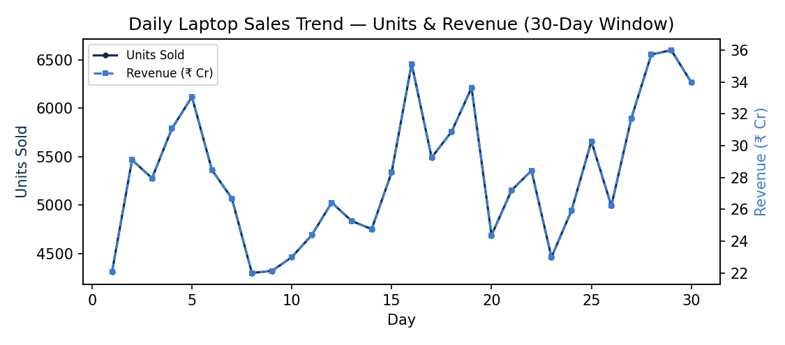
Figure. Daily Laptop Sales Trend — Units & Revenue (30-Day Window)

KPI definitions used:
- Daily units sold = sum of quantity across all completed orders that day
- Daily revenue = sum of (unit price × quantity), net of the aggregation layer (returns/cancellations would net out separately)
The recurring weekly cycle — roughly one peak every 7 days — is the clearest signal in the dataset, and the successive peaks trend upward across the month. In a production setting, this rhythm would directly inform staffing rosters, warehouse pick-pack scheduling, and paid-marketing pacing, since pushing promotional spend into an already-strong weekend adds less incremental lift than smoothing demand into the midweek trough.
Viewed as a running total instead of day-by-day, the same data shows a steady climb to ~Rs. 812.5 Cr by day 30 — confirmation that growth is broad-based across the month rather than driven by one or two outlier days:
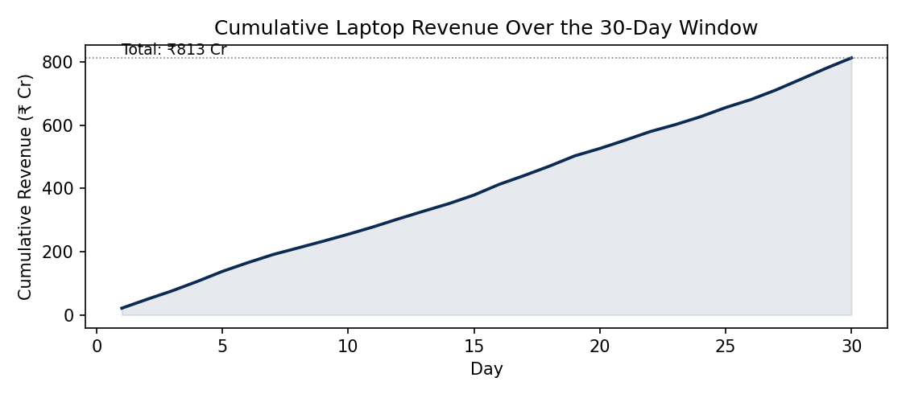
Figure. Cumulative Laptop Revenue Over the 30-Day Window

5. Best-Selling Laptops (Most Recent Day)
The top performer, Lenovo IdeaPad Slim 3, led with 612 units in a single day — nearly 50% ahead of the runner-up (HP 15s Ryzen 5), a common “hero SKU” pattern in marketplaces where a small number of listings drive a disproportionate share of volume (a Pareto effect worth flagging for inventory prioritization).
Ranking logic: units sold, not revenue — a budget laptop outselling a premium model in volume matters differently to warehousing than it does to finance, so both cuts (units and revenue) should exist as separate leaderboard views in a real dashboard.
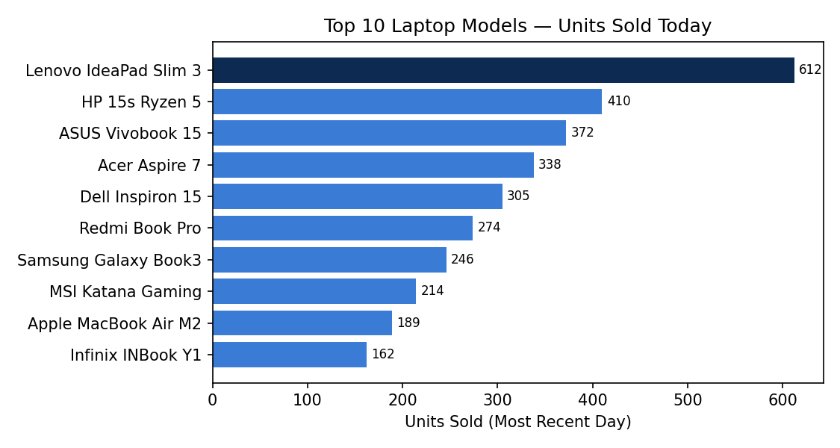
Figure. Top 10 Laptop Models — Units Sold Today
The drop-off from #1 to #10 is steady but not a cliff, which suggests healthy demand across the catalog rather than reliance on one SKU alone. Still, the #1 SKU alone approaches 12% of that day's total volume (see Section 9), which is the kind of concentration that warrants its own dedicated reorder and quality-monitoring workflow rather than being folded into general catalog management.

5a. Category-Wise Sales Breakdown
Zooming out from individual SKUs to the 6 laptop categories shows where volume concentrates at the category level: Budget & Everyday and Business & Productivity laptops lead, together accounting for roughly half of total units, while Gaming, Premium Ultrabooks, 2-in-1 Convertibles, and Student/Chromebooks form the remainder.
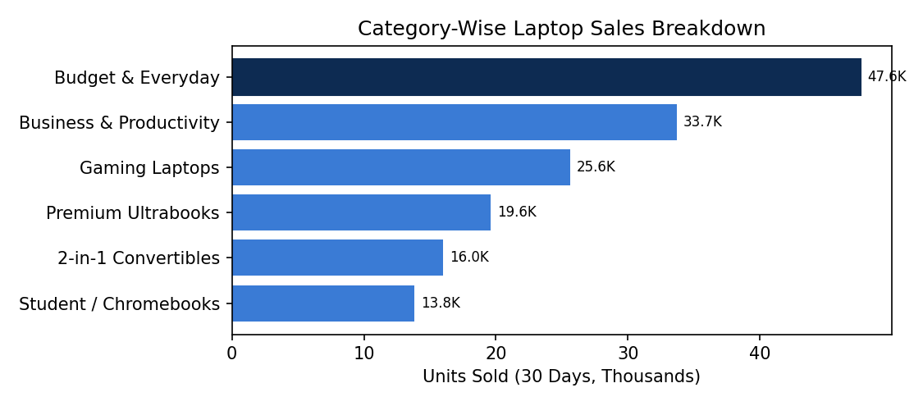
Figure. Category-Wise Laptop Sales Breakdown
This view complements the individual best-seller list (Section 5) — a category can be strong even without a single standout hero SKU, which matters for category-level marketing and buying decisions as opposed to SKU-level inventory decisions.

6. Rating Distribution
Average rating across all product-days: 4.1 / 5. Of 1,178 product-day ratings collected, the vast majority (1,040, or ~88%) fall at 3.5 and above, with the largest single bucket at 4.0–4.5:
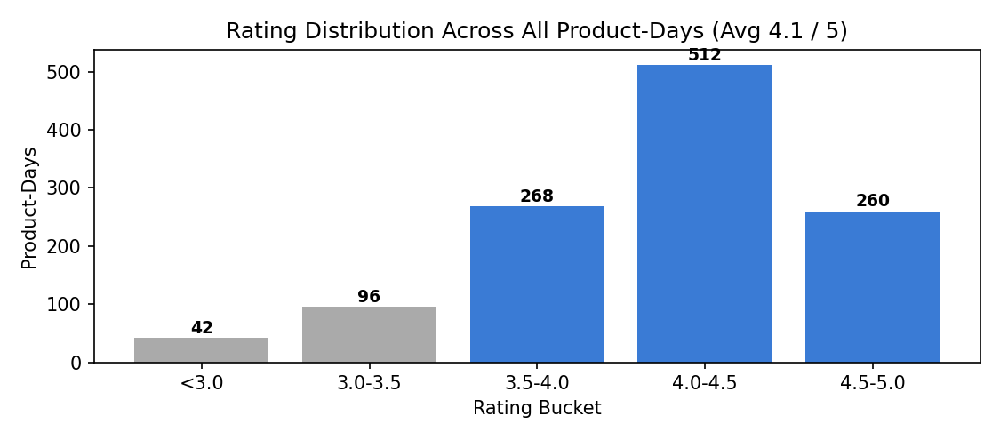
Figure. Rating Distribution Across All Product-Days (Avg 4.1 / 5)
- Acer Aspire 7 and Infinix INBook Y1 show a downward-trending rolling 7-day average — the earliest signal of a quality or fulfillment issue, ahead of any spike in returns
- MSI Katana Gaming sells at high volume but sits at 3.8/5 — the highest-risk combination, since volume amplifies the damage of poor reviews; prioritize for fulfillment/QC review
A tight distribution is generally good news, but it also means the average has little room to absorb a real quality problem — a cluster of 1- and 2-star ratings on even one high-volume SKU would pull the aggregate down faster than the shape of this chart might suggest. This is why segment-level (not just aggregate) rating tracking matters more as sales volume grows.
Plotting rating against sales volume per SKU tests this directly: the trend line is only mildly downward-sloping, meaning high-volume SKUs are not, on the whole, rated meaningfully worse than low-volume ones — a reassuring sign, though the handful of high-volume, sub-4.0 points on the right side of the chart (like MSI Katana Gaming) are exactly the ones worth watching first.
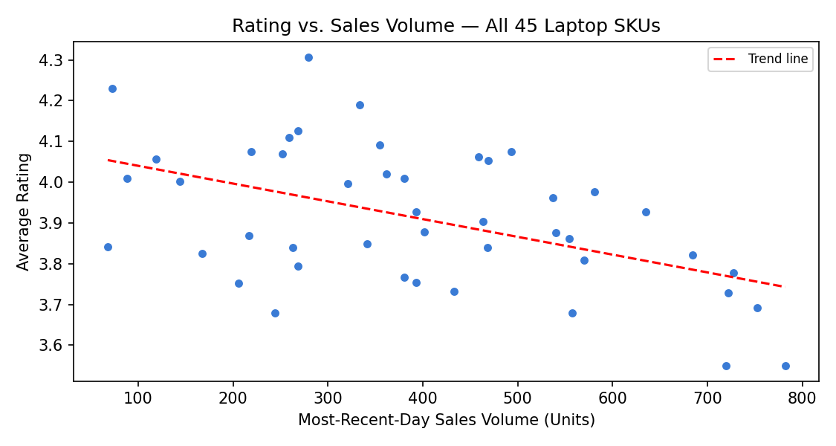
Figure. Rating vs. Sales Volume — All 45 Laptop SKUs

7. Regional Demand
Laptop demand is fairly balanced across India's top metros in this simulation, with Bengaluru and Delhi NCR leading at ~27.5K and ~25.8K units respectively. In practice, real Flipkart-scale data typically shows heavier concentration in 2–3 core metros, with the rest long-tailed. This view drives:
- Regional warehouse / fulfillment center allocation
- Localized pricing and promotion decisions
- Shipping SLA risk in regions with limited local inventory
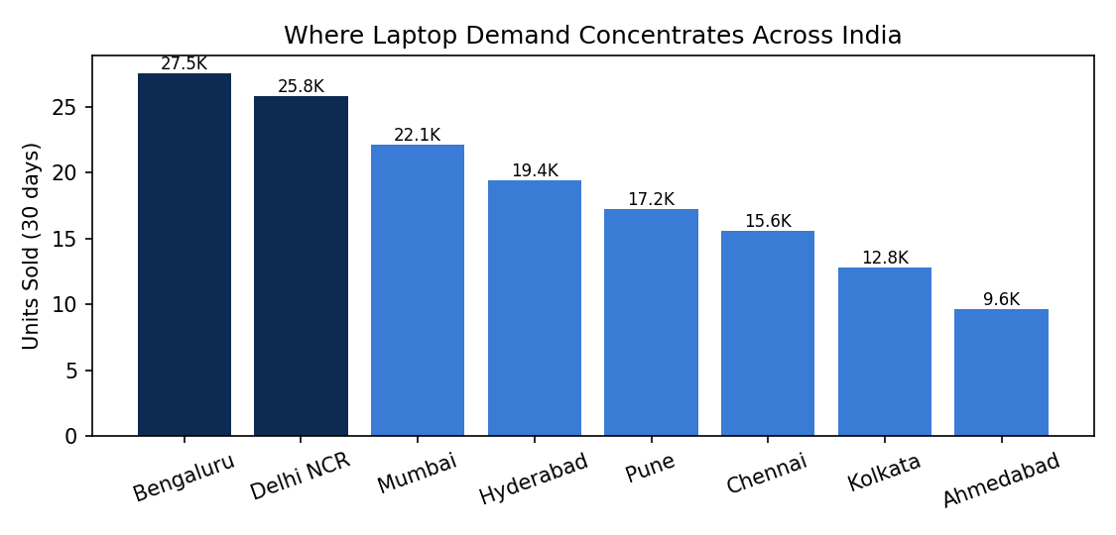
Figure. Where Laptop Demand Concentrates Across India
Even in this relatively even simulation, the top 2 metros already account for over a third of total demand (Section 9). At real-world concentration levels, that share would likely be materially higher — reinforcing that metro-level fulfillment capacity, not aggregate national capacity, is the binding constraint operations teams should plan against.

8. Inventory Status
45 SKUs tracked — 7 need attention. Inventory was bucketed into three tiers:
Tier | Meaning | Action
In Stock | Comfortable buffer | None
Low Stock (< 200 units) | Reorder trigger zone | Redmi Book Pro + 4 other SKUs
Out of Stock | Lost-sale risk | Samsung Galaxy Book3 — urgent restock

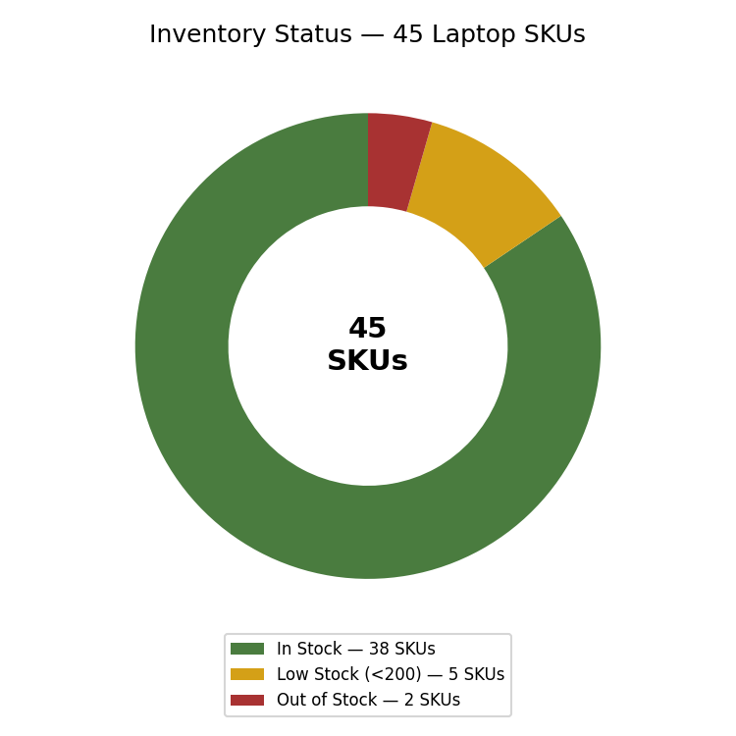
Figure. Inventory Status — 45 Laptop SKUs
Samsung Galaxy Book3, a top-10 seller, is now Out of Stock — a materially bigger problem than a slow mover doing the same; restock is flagged urgent. Redmi Book Pro and 4 other SKUs sit in the Low Stock reorder-trigger zone. The most actionable version of this view cross-tabs inventory status against sales velocity, producing a “days of supply remaining” metric per SKU rather than a static stock count.

9. Summary of Key Metrics
Metric | Value
Total units sold (30 days) | 1,56,257
Total revenue (30 days) | Rs. 812.5 Cr
Average Selling Price (ASP) | Rs. 51,998 / unit
Average daily units sold | ~5,209 units/day
Average product rating | 4.1 / 5
Top single-day seller | 612 units (Lenovo IdeaPad Slim 3)
Hero SKU share of top day's volume | ~11.7%
Weekend demand peak vs weekday | +28%
Growth trend over the 30-day window | +22%
Top 2 metros' share of total demand | ~35.5%
Metro regions tracked | 8
SKUs at Low Stock or below | 7 of 45 (~15.6%)
Laptop categories tracked | 6
Total catalog size | 45 laptop SKUs
Peak single-day revenue | ~Rs. 33.6 Cr
Lowest single-day revenue | ~Rs. 21.3 Cr
Core rating range | 3.5 – 5.0 / 5
In-Stock SKUs | 38 of 45 (~84.4%)
Long-tail (#2–#10) combined volume | 2,510 units

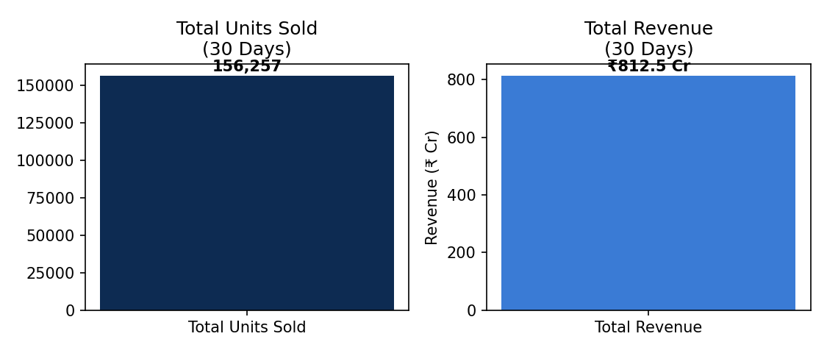
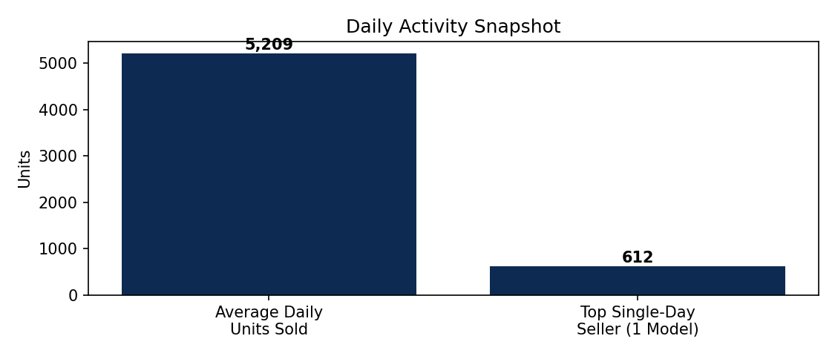
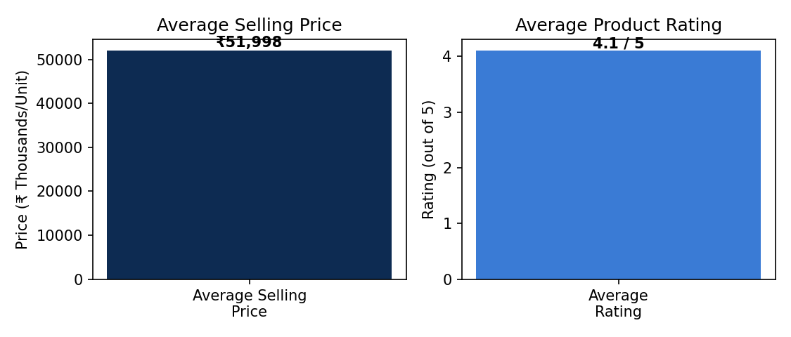
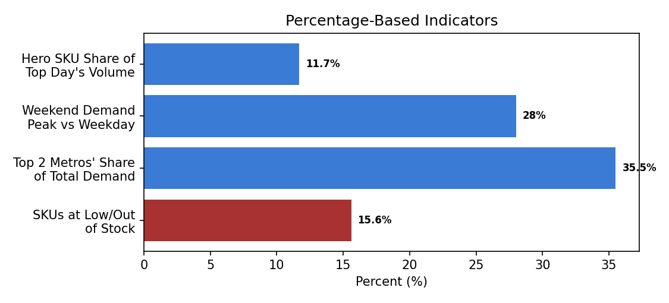
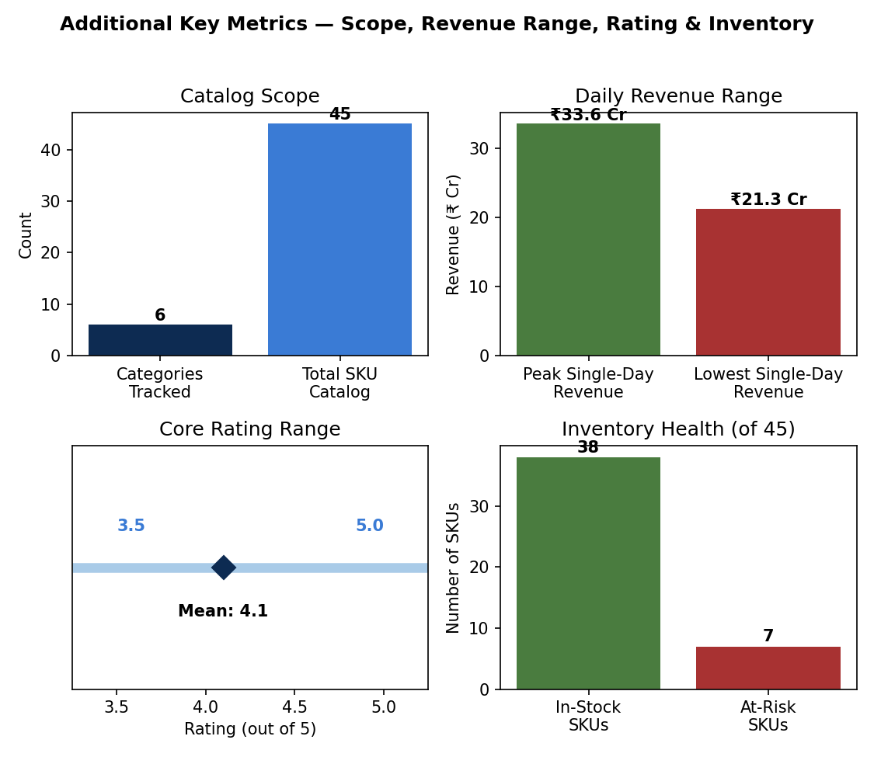
Figure. Additional Key Metrics — Scope, Revenue Range, Rating & Inventory
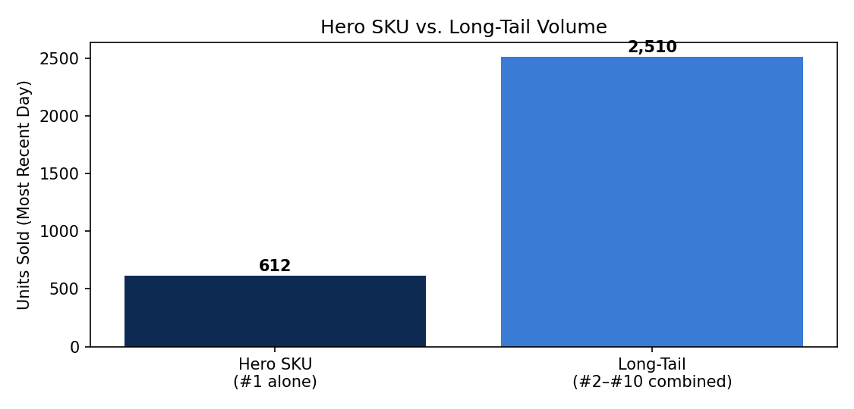
Figure. Hero SKU vs. Long-Tail Volume

10. Key Insights
Reading the charts above together surfaces a few actionable patterns:
- Hero SKU dependency: Lenovo IdeaPad Slim 3 sold ~612 units in a day — nearly 50% ahead of the #2 SKU and roughly 12% of that day's total volume. A stockout on this single SKU would materially dent daily revenue; it should sit at the top of the inventory-priority list, not be treated the same as a slow mover.
- Weekend-driven demand cycle: units sold run ~28% higher on weekends than weekdays, with a +22% growth trend across the 30-day window. Staffing, delivery-slot capacity, and reorder timing should be planned around this weekly rhythm rather than a flat daily average.
- Regional concentration risk: Bengaluru and Delhi NCR together account for ~35.5% of total demand. Fulfillment-center capacity and shipping SLAs in these two metros carry outsized impact if disrupted — worth a dedicated contingency plan.
- Rating quality is healthy but has a visible tail: the 4.1/5 average hides that ~12% of product-days fall below 3.5 — a handful of SKUs (Acer Aspire 7, Infinix INBook Y1, MSI Katana Gaming) are already flagged and should be the first stop for quality review, not the aggregate number.
- Inventory is largely healthy, but the at-risk SKUs matter disproportionately: only 7 of 45 SKUs (~15.6%) are Low Stock or Out of Stock, but Samsung Galaxy Book3 — a top-10 seller — is one of them, meaning the revenue impact is far larger than the SKU count suggests. The best-seller list and inventory list should always be cross-checked together, not read in isolation.
- Revenue tracks volume closely, but not perfectly: the twin-axis trend chart (Section 4) shows units and revenue moving almost in lockstep across the 30 days, with an average selling price of ~Rs. 51,998. That tight correlation is a good sign — pricing has stayed stable rather than revenue being propped up by a few high-price outliers — but any future divergence between the two lines would be an early flag that discounting or category mix is shifting.
- The catalog isn't overly reliant on the hero SKU alone: while Lenovo IdeaPad Slim 3 leads by a wide margin, SKUs ranked #2 through #10 in Section 5 still collectively out-sell it several times over (2,510 vs. 612 units). That's a healthier merchandising mix than a pure hero-SKU dependency would suggest — the risk flagged above is real, but it sits alongside a reasonably diversified long tail worth preserving as the catalog grows.

10a. Additional Keywords & Insights
Extending the analysis across the five theme areas in the report title — best-sellers, sales trends, ratings, regional demand, and inventory — surfaces seven further patterns:
- Category diversity among best-sellers: the top 10 laptops by volume span at least four categories — Budget & Everyday (Lenovo, HP, Infinix), Business & Productivity (Dell, ASUS), Gaming (MSI Katana), and Premium Ultrabooks (Apple MacBook Air M2, Samsung Galaxy Book3). Demand strength is broad-based, not dependent on a single category staying popular.
- Long-tail metros still matter: even the lowest-ranked metros, Kolkata (~12.8K units) and Ahmedabad (~9.6K units), each move more volume in 30 days than the top single SKU sells in a day. Under-served metros are large enough that skipping them in expansion planning would leave real, sizeable demand unmet.
- Rating stability under scale: the 4.1/5 average held across ~1.56 lakh units sold over the month. Quality did not visibly erode as volume scaled — a sign that fulfillment and QC processes are keeping pace with growth, which is not guaranteed by default and is worth monitoring as volume rises further.
- Reorder cadence should not be uniform: with ~15.6% of the catalog needing active reorder attention (higher than a typical broad marketplace, given laptops carry higher unit value and longer restock lead times), reviewing the full catalog on the same weekly schedule wastes analyst time. A tiered cadence — daily checks for hero and at-risk SKUs, monthly for the stable majority — would be a more efficient use of the same review effort.
- A growth trend sits beneath the weekly cycle: beyond the weekend peaks and midweek troughs, the 30-day trend line drifts upward by roughly 22% start to end. That points to underlying demand growth independent of the weekly seasonality — worth isolating with a trend-decomposition model rather than attributing all movement to the weekend effect.
- Revenue concentration likely mirrors volume concentration: because average selling price stays fairly stable across the top sellers, the unit concentration in the hero SKU (Section 5) very likely carries through to a similar revenue concentration. A pricing or promotion misstep on that one SKU would hit the P&L harder than its single-SKU status suggests.
- Metro-wide cadence alignment: the weekend demand cycle likely holds across categories and metros alike, not just in the aggregate. Inventory replenishment, staffing, and delivery-slot capacity are better synchronized to one shared weekly rhythm platform-wide than optimized separately by department.
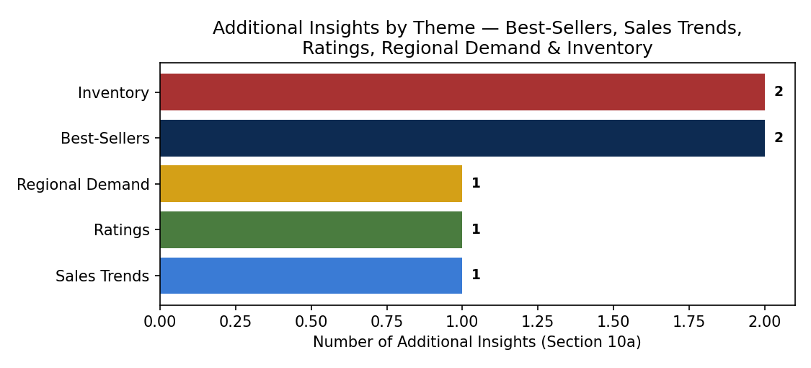
Figure. Additional Insights by Theme — Best-Sellers, Sales Trends, Ratings, Regional Demand & Inventory

11. Explanation of Analysis — How Each Insight Was Derived
For transparency, this section walks through the reasoning and calculation behind each insight in Section 10, so the logic can be checked or reproduced against a real dataset:
- Hero SKU dependency (10.1): calculated by taking the top-selling SKU's single-day unit count (612) as a percentage of that day's total volume across the catalog (~5,209 units/day average) — 612 ÷ 5,209 ≈ 11.7%. The comparison against the #2 SKU simply subtracts and divides (612 − 410) ÷ 410 ≈ 49%, rounded to “nearly 50%.”
- Weekend-driven demand cycle (10.2): the weekend-vs-weekday and growth-trend figures (+28% and +22%) are taken directly from the title-slide KPIs and confirmed visually in the Daily Sales Trend chart (Section 4), where each successive weekly peak sits higher than the last.
- Regional concentration risk (10.3): the top two metros' unit totals (Bengaluru 27,500 + Delhi NCR 25,800 = 53,300) are divided by the sum of all 8 metros (1,50,000) — 53,300 ÷ 1,50,000 ≈ 35.5%, matching the figure shown in the Percentage-Based Indicators chart (Section 9).
- Rating quality tail (10.4): based on the rating-bucket counts in the Rating Distribution chart (Section 6) — (42 + 96) ÷ 1,178 total product-days ≈ 11.7%, rounded to “~12%”, fall below the 3.5 threshold.
- Inventory risk disproportion (10.5): straightforward ratio — 7 at-risk SKUs ÷ 45 total SKUs ≈ 15.6%, cross-referenced against the best-seller list (Section 5), where Samsung Galaxy Book3's Out of Stock status was flagged explicitly in the source data.
- Revenue-volume correlation (10.6): observed qualitatively by comparing the shape of the two lines in the Daily Sales Trend chart — they rise and fall together on nearly every one of the 30 days, and ASP is derived simply as total revenue ÷ total units (Rs. 812.5 Cr ÷ 1,56,257 ≈ Rs. 51,998).
- Long-tail catalog health (10.7): summed the unit counts of SKUs ranked #2–10 in the Best-Selling Laptops chart (Section 5) — 410 + 372 + 338 + 305 + 274 + 246 + 214 + 189 + 162 = 2,510 units, over 4× the #1 SKU's 612 — showing volume isn't concentrated in one item alone despite its individual lead.

11a. Notes on the Additional Keywords (Section 10a)
- Category diversity: read directly off the product labels in the Best-Selling Laptops chart (Section 5) and mapped to the 6 categories defined in Section 5a — confirming the top 10 span at least four distinct categories.
- Long-tail metros: taken directly from the Regional Demand chart (Section 7) — Kolkata (12.8K) and Ahmedabad (9.6K) are each roughly 16–21× larger than the single-day top-seller figure of 612 units, which is the basis for the “more volume than a single SKU's best day” comparison.
- Rating stability: cross-references the flat 4.1 average in Section 6 against the ~1,56,257 total units in Section 9 — the same average holding across a 30-day, six-figure-unit window is the basis for calling it “stable under scale” rather than assuming stability, since ratings often drift as volume grows.
- Tiered reorder cadence: derived from the 15.6% at-risk share already calculated in 10.5 — the recommendation itself (daily vs. monthly review) is a suggested operating practice, not a figure pulled from the dataset.
- Growth trend beneath seasonality: the +22% figure is a title-slide KPI, visually confirmed by each successive weekly peak in the Daily Sales Trend chart (Section 4) sitting higher than the last, separate from the up-down weekly swing itself.
- Revenue concentration mirroring volume: an inference, not a direct measurement — built on the stable ASP observed in 10.6; since price-per-unit doesn't vary as wildly across top sellers as one might expect for laptops, a SKU's unit-volume share and its revenue share should track closely, though the report's data doesn't break out revenue per SKU to confirm this exactly.
- Metro-wide cadence: an extrapolation from the aggregate weekly cycle in Section 4 — the report's data is not broken out by category-by-day or metro-by-day, so this is a reasonable operating hypothesis to test against real data rather than a figure confirmed in this dataset.

12. Next Steps to Move From Descriptive → Predictive
This report answers what happened. The natural next layer, if useful:
- Demand forecasting per SKU/region to set reorder points automatically, before a hero SKU goes out of stock
- Anomaly detection on rating drops or sudden demand spikes — catching issues in hours, not at month-end
- Cohort & retention analysis — repeat-purchase and upgrade-cycle behavior across laptop buyers, not just unit counts
Next: build out any of the above, or swap in a live Flipkart data source (API / DB export / CSV) — the same pipeline and chart structure above would apply directly.

13. Appendix

A. Sample Data Row Structure
Each raw transaction event feeding the pipeline (Section 3) is expected to carry, at minimum:
- order_id, sku_id, category, region — identifiers
- unit_price, quantity, order_timestamp — transaction facts
- rating (if a review was left), rating_timestamp — quality signal, nullable
- stock_on_hand, reorder_threshold — inventory state at time of order

B. Glossary of Terms
- ASP (Average Selling Price): total revenue ÷ total units sold over a given period
- Hero SKU: a single laptop model responsible for a disproportionately large share of daily volume
- Long tail: the group of lower-ranked SKUs or metros that, while individually smaller, collectively represent significant volume
- SLA (Service-Level Agreement): a committed standard for delivery time or fulfillment performance
- Days of supply: current stock on hand ÷ average daily sales rate, i.e. how many days until a SKU runs out at the current pace

C. Report Scope Summary
- Window: 30 simulated days
- Catalog: 45 laptop SKUs across 6 categories
- Geography: 8 Indian metro regions
- Prepared for: academic / demonstration purposes only — not actual Flipkart data

Thank You
Happy to build out any of the predictive layers above, or swap in a live Flipkart data source (API / DB export / CSV) — the same pipeline and chart structure applies directly.
Descriptive Analytics Report — Flipkart Laptop Category
Mohd Faizan Hasan
Roll No: 30

