**Name: Faizan Nazir**

**Arid No: 19-ARID-5157**

**Program: BSCS7A**

**Course: Modern Programming Language**

**Assignment No: 01**

**Teacher Name: Mr. Saeed Nawaz**

Q1:

**Next () Method** used to get 1 word when we write long sentence with spaces it will store only first word in string variable and discard all other words.

**Next Line () Method** unlikenext method it does not store only first word by this method we can store whole sentence in a string variable.

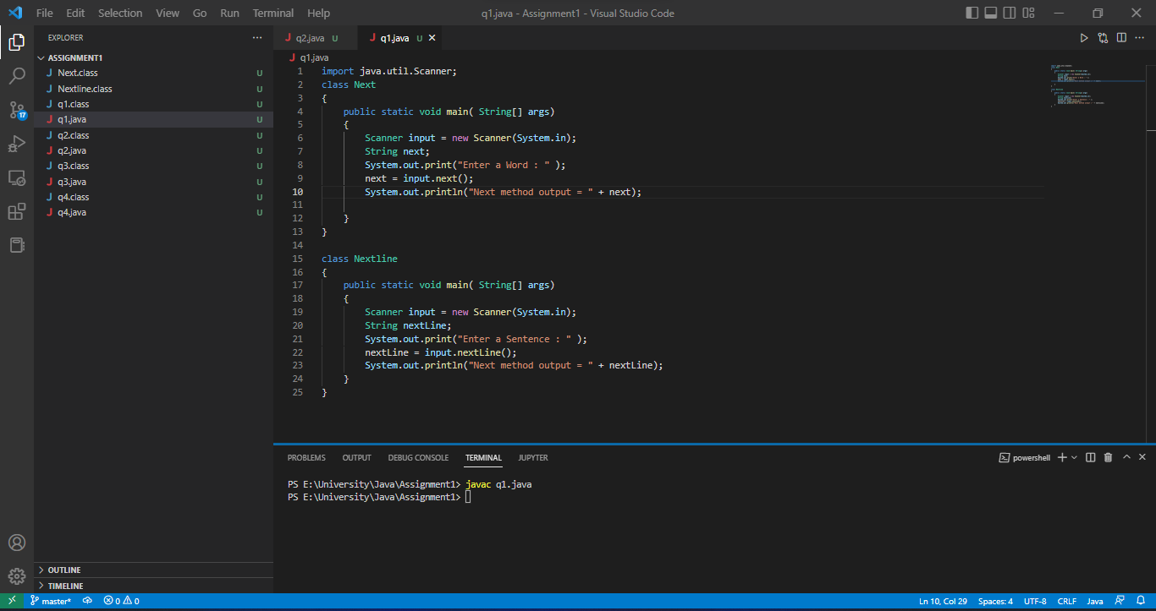

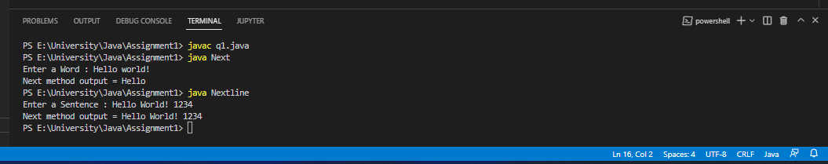

Q2:

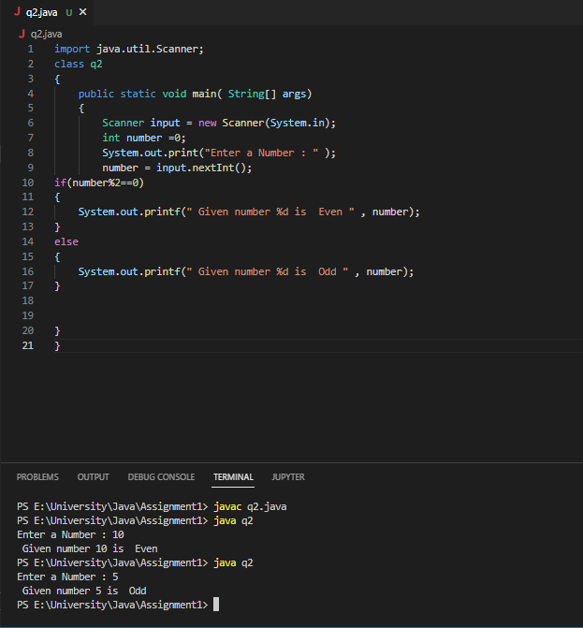

Q3:

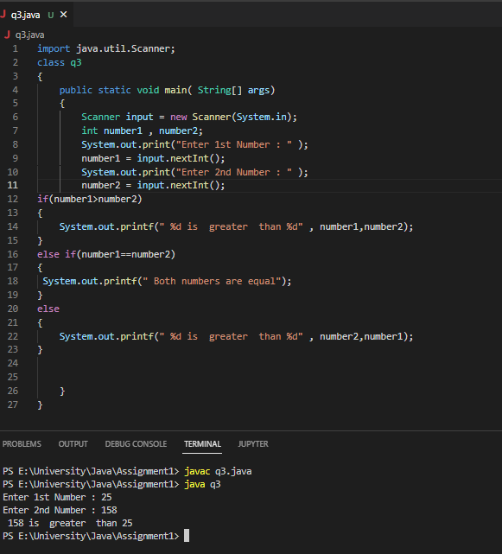

Q4:

