**Name: Faizan Nazir**

**Arid No: 19-ARID-5157**

**Program: BSCS7A**

**Course: Web Technologies**

**Assignment No: 01**

**Teacher Name: Ms. Aiman Hafeez**

**Q1: Write down the HTML code to add Comments and Quotations on the Web Page.**

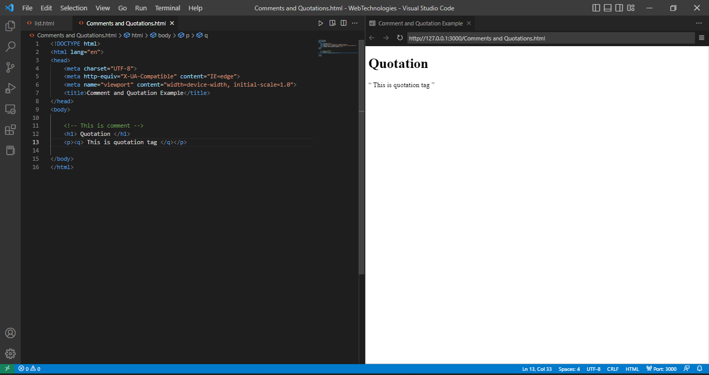

**Q No. 2 Write down the HTML code to add an image to the web page. Upon clicking on the specific area of an image, the following relevant web page opens.**

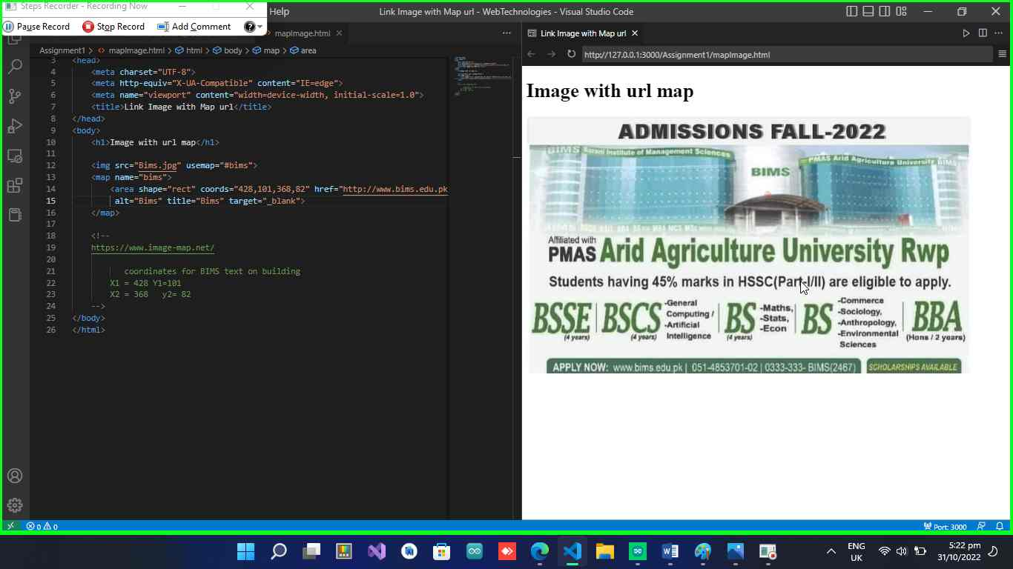

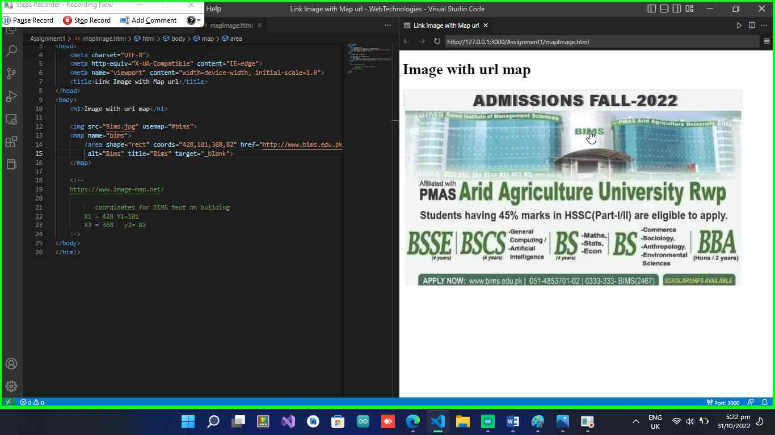

**Q3:**

