**IOT Based Attendance and Surveillance System through Face Recognition**



**Bilal Raza**

**19-arid-5149**

**Sharyar Khan**

**19-ARID-5253**

**Faizan Nazir**

**19-ARID-5157**

**Ameer Hamza**

**19-ARID-5136**

**DEPARTMENT OF COMPUTER SCIENCES & INFORMATION TECHNOLOGY**

**BARANI INSTITUTE OF MANAGEMENT SCIENCES RAWALPINDI**

**PAKISTAN**

**2019-2023**

**IOT Based Attendance and Surveillance System through Face**

**Recognition**

by

**Bilal Raza**

**19-arid-5149**

**Sharyar Khan**

**19-ARID-5253**

**Faizan Nazir**

**19-ARID-5157**

**Ameer Hamza**

**19-ARID-5136**

Final Year Project Submitted in partial fulfillment of

the requirement for degree of

**BS**

in

**Computer Science**

**Department of Computer Sciences & Information Technology**

**Barani Institute of Management Sciences Rawalpindi**

**Pakistan**

**2019-2023**

**CERTIFICATION**

I hereby undertake that this research is an original one and no part of this thesis falls under plagiarism, if found otherwise at any stage, I will be responsible for the consequences.

Name: **Bilal** **Raza** Signature: ______________

Registration Number: **19-ARID-5149** Date: ______________

Name: **Sharyar Khan** Signature: ______________

Registration Number: **19-arid-5253** Date: ______________

Name: **Faizan Nazir**  Signature: ______________

Registration Number: **19-Arid-5157** Date: ______________

Name: **Ameer Hamza** Signature: ______________

Registration Number: **19-arid-5136** Date: ______________

Certified that the contents and form of thesis entitled

**“IOT Based Attendance and Surveillance System through Face**

**Recognition”**

submitted by **“Sharyar Khan, Bilal Raza, Faizan Nazir, Ameer Hamza”** has been found satisfactory for requirements of the degree.

Supervisor: **Mr. Nouman AL Hassan**

Signature: ___________

Date: ___________

**DEDICATION**

We would like to dedicate our work to our respected parents who have been there to appreciate, support and push us up in our hard times throughout our academic life. We also like to dedicate a part of our work to our respected and kind teachers that making usable to think wide and sharp in all prospective life.

**CONTENTS**

Page

List of Tables …………………………………………………………………. v

List of Figures ………………………………………………………………... vi

Acknowledgements ………………………………………………………….. vii

Chapter 1 Introduction ……………………………………………………….. 1

1.1 PROJECT OBJECTIVES ……………………………………………………. 1

1.2 PROJECT SCOPE …………………………………………………………. 2

1.3 TOOLS FOR DEVELOPMENT …………………………………………… 2

1.3.1 Back-end Tools and Technologies …………………………………………. 2

*1.3.2* Front-End Tools and Technologies ……………………………………… 3

1.4 HARDWARE REQUIREMENT …………………………………………….. 3

1.5 DEPLOYMENT …………………………………………………………….. 3

Chapter 2 STUDY OF EXISTING SYSTEM ………………………………. 4

2.1 DISADVANTAGES OF EXISTING SYSTEM …………………………... 4

2.2 PROPOSED SYSTEM …………………………………………………….. 5

2.2.1 Benefits of Proposed System …………………………………………….. 5

Chapter 3 ………………………………………………………………………. 7

3.1 Functional Requirements ………………………………………………….. 7

3.2 Non-Functional Requirements …………………………………………….. 8

3.3 USE CASE DIAGRAMS ………………………………………………….. 8

3.3.1 ADMIN USE CASE DIAGRAM: ………………………………………. 8

3.3.2 USER USECASE DIAGRAM …………………………………………. 10

3.4 USE CASE DESCRIPTION TABLES …………………………………… 12

**List of Tables**

Table 3.1: Admin use case description table 12

Table 3.2: User use case description table 12

**List of Figures**

.

Figure 3.3.1: Admin use case diagram 9

Figure 3.3.2: User use case diagram 10

Figure 3.3**.**3: 11

Acknowledgements

I take this moment to thank Allah Almighty and Holy Prophet (Peace Be Upon Him), for blessing us with his grace and taking our endeavor to a successful culmination. We extend our sincere and heartfelt thanks to our esteemed guide **Mr. Nouman Al Hassan**, for providing the right guidance and advice at the crucial junctures and for showing the right way. I would like to thank the other faculty members also, at this occasion. Last but not the least, we would like to thank our friends and family for the support and encouragement they have given us during the course of our work.

**Sharyar Khan**

**Bilal Raza**

**Faizan Nazir**

**Ameer Hamza**

# Introduction

Most educational institutions and international test centers, they use traditional methods for entrance and exit, by presenting an identity document or a passport. The entry procedures take a long time and constitute an obstacle in identifying the identity when the number of students are increased. Moreover, the difficulties you face in identifying impersonators. Also, most companies take a long time to record the attendance of employees in traditional ways using the most common fingerprint. Several institutions use different systems to manage attendance, such as fingerprint and magnetic cards, which depend on the method of use, cost, reliability and security.

The central ideology of this project is identifying faces in real-time video and mark their attendance and for supervision of prospect and maintain surveillance and generating record in database.

The images from real-time video frames will be extracted and compared with already available datasets and attendance will be marked automatically without user’s interaction and after those reports will be generated automatically.

The main building of the project that is:

* Image which is going to acquiring image of the person
* Face Detection which is going to detect the face of the person.
* Feature extension which is extract the features of the image.
* Face Recognition which is extracted features are assign sort to characters of certain image.
* Verification & Identification which is combine all the data.

## PROJECT OBJECTIVES

The objective of this project is to develop face recognition based automated student employee attendance and surveillance system. Expected achievements in order to fulfill the objectives are:

* To detect the face segment from the video frame.
* To extract the useful features from the face detected.
* To classify the features in order to recognize the face detected.
* To record the attendance of the identified student/employee.
* To save Time.
* To maintain accurate record with images.
* Efficient Surveillance of student or employee.
* Easy to use.
* For security purpose to keep un-recognized person put of boundaries.

## PROJECT SCOPE

This system can be implemented to any organization in the locality or to multinational companies having the required resources which would allow them to be able to keep the attendance and surveillance 24/7 and update the information whenever something new comes up.

The admin portal provides a comfortable and user-friendly environment for the admin to be able to stay up to date without much hustle and allows them to keep track of every record/information.

The system is however to ensure security, access control, reliability, efficiency and better performance of attendance and surveillance system.

## TOOLS FOR DEVELOPMENT

Our website is based on the following tools and computer languages:

### Back-end Tools and Technologies

* MySQL
* Python (Django)
* VS Code

### Front-End Tools and Technologies

* VS Code
* HTML/CSS (Bootstrap)
* JavaScript

## HARDWARE REQUIREMENT

* Computers equipped with a minimum Core i3 processor or higher, the computer must have approximately 64GB of free hard drive space and 4GB of RAM or more. And must have a GPU.
* Cameras.

## DEPLOYMENT

* Any Web Browser. Preferred (Google chrome)
* WSGI OR ASGI Python Standard Web Server, MYSQL DBMS Based on Linus OS

# STUDY OF EXISTING SYSTEM

Managing student attendance during lecture periods has become a difficult challenge. The manual system of taking attendance is done on paper by the use of pen, students write their names, index numbers and sign on a sheet of paper, this makes the system unreliable because students can write names for friends who are not in class. Also, the ability to compute the attendance percentage becomes a major task as manual computation produces errors, and also wastes a lot of time. For the stated reasons, an efficient attendance management system using bio-metrics is designed. This system takes attendance electronically with the help of a finger print device or facial recognition and the records of the attendance are stored in a database. Attendance is marked after student identification.

## DISADVANTAGES OF EXISTING SYSTEM

Existing methods of student’s attendance identification are mostly manual (i.e., use of paper sheets where students write and/or sign against their name) and using e-commerce website application like **BIMS portal** (i.e., This system captures user logs into the organizational website alongside other activities such as mouse clicks and keyboard taps). In manual system uses a log book. Users arrive at a terminal where the log book is placed. They write their names, the time of arrival and then sign against their names. Some organizations provide clock for arrivals to use at the terminal. This system is limited by lack of user authentication. Users may write wrong time and the log book may even be stolen or destroyed. Sometime forget to mark the attendance of present students.

If we talk about the biometric system for the professors or employees at the institutions or organization this system serves one at a time, this system is reliable but it is time consuming process so why not ship to the automatic attendance system which works on the face recognition technique.

## PROPOSED SYSTEM

The automatic attendance system using facial recognition will automatically mark the attendance of the given particular person by extracting the feature of the image in a classroom or at entry gates the system will automatically mark the attendance of the students, professors or employees, if the image of the face of any given person matches with the any of the face in the given database the system has ability to find out that person extract the feature of that given image and mark the attendance of the particular person. This system is widely used in the various areas such as security control, police control, forensic medicine and management of the attendance system.

This system determines various unique features of a face that can distinguish it from the face of the any other people. These features could be size of eyes, nose, length of the face, size of lips, color of skin, when all these features of image is compared from the face of the people in the database which is already known the system automatically mark the attendance of a given particular person as a human being our brain is capable to do all of these automatically and instantaneously but to design a system , we have to use some component so for capturing image we take a camera as an input and a python programming language to extract the features of the image and to mark the attendance.

### Benefits of Proposed System

In our work we tried to overcome some of the disadvantage:

This system can in our work we tried to overcome some of the disadvantage:

This system can easily detect multiple faces at a time. So, time and resource saving. One can easily manage attendance with this system. Starting with the most efficient and significant benefit, saving time. As an automated attendance-management system, facial recognition provides precise time records, reducing costly mistakes. As a result, accurate data assists managers in providing specific productivity and payroll details.

The facial recognition system helps monitor the time and attendance of field employees. As a result, no extra technology is necessary to deploy a facial recognition attendance system, and hence no maintenance costs are incurred. This solution is both cost-effective and efficient when contrasted to other biometric solutions. Easily detect multiple faces at a time. So, time and resource saving.

One can easily manage attendance with this system. Starting with the most efficient and significant benefit, saving time. As an automated attendance-management system, facial recognition provides precise time records, reducing costly mistakes. As a result, accurate data assists managers in providing specific productivity and payroll details.

The facial recognition system helps monitor the time and attendance of field employees. As a result, no extra technology is necessary to deploy a facial recognition attendance system, and hence no maintenance costs are incurred. This solution is both cost-effective and efficient when contrasted to other biometric solutions.

# 

**REQUIREMENT ANALYSIS**

Our project follows the steps of SDLC under which the SRS model developed for the system is listed below:

The SRS model contains

* Functional requirements
* Non-function requirements

## Functional Requirements

The Function requirements are part of the system that describe the functional behavior that should be possessed by the system. Each requirement maps to a high-level function that transforms the given set of input data into output data.

1. **Admin:**

* The web portal should allow the admin to login to account
* The admin can Forget password
* The web portal should allow the admin to create, delete, and update user accounts for employees.
* The web portal should allow the admin to view and track employee attendance data.

1. **User:**

* The web portal should allow user to create an account.
* The web portal should allow user to login.
* The web portal should allow view their own attendance data.

## Non-Functional Requirements

Non-functional are properties and qualities the software system must possess providing its intended functional requirements.

* The web portal should have a secure login system to protect employee data and prevent unauthorized access.
* The web portal should have a responsive and user-friendly interface that works well on different devices and browsers.
* The web portal should have a fast and reliable connection to ensure that the user experience is smooth and seamless.
* The web portal should have a scalable infrastructure to handle large amounts of data and traffic.
* The web portal should have a reliable backup and recovery system to ensure the availability and integrity of the data.
* The surveillance camera should have a high level of accuracy in detecting and recording the presence of a person.
* The web portal should have secure access controls to prevent unauthorized access to the recorded data.
* The camera should have a reliable and stable connection to the database to ensure that the recorded data is properly stored and retrieved.
* The camera should have a user-friendly interface for the admin and employees to easily access and view the recorded data.

## USE CASE DIAGRAMS

The Use Case model of the UML is used here to specify the functionality of the system from the users‟ point of view and show the way the system and the users interact to achieve its stated functions and perform its goal.

### ADMIN USE CASE DIAGRAM:

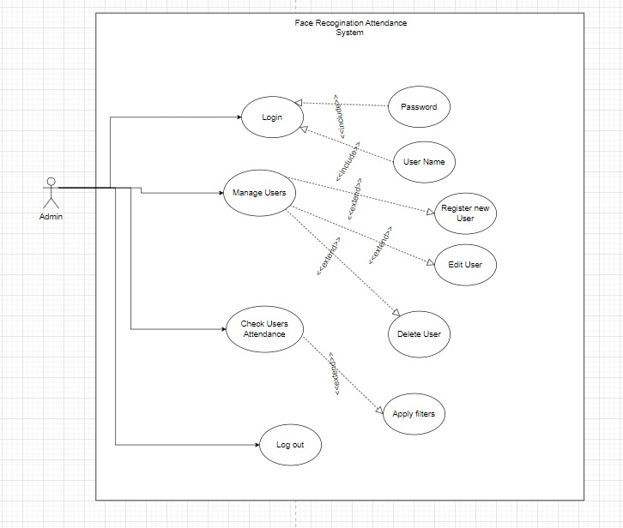

Figure 3.3.1: Admin use case diagram

### USER USECASE DIAGRAM

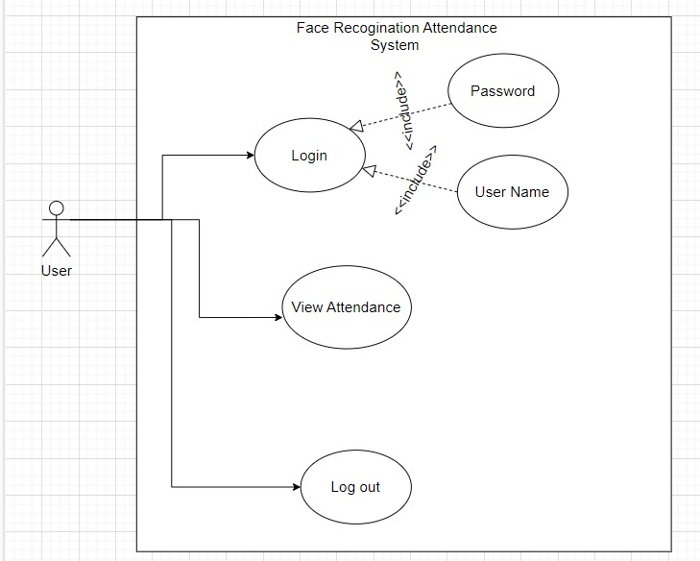

Figure 3.3.2: User use case diagram

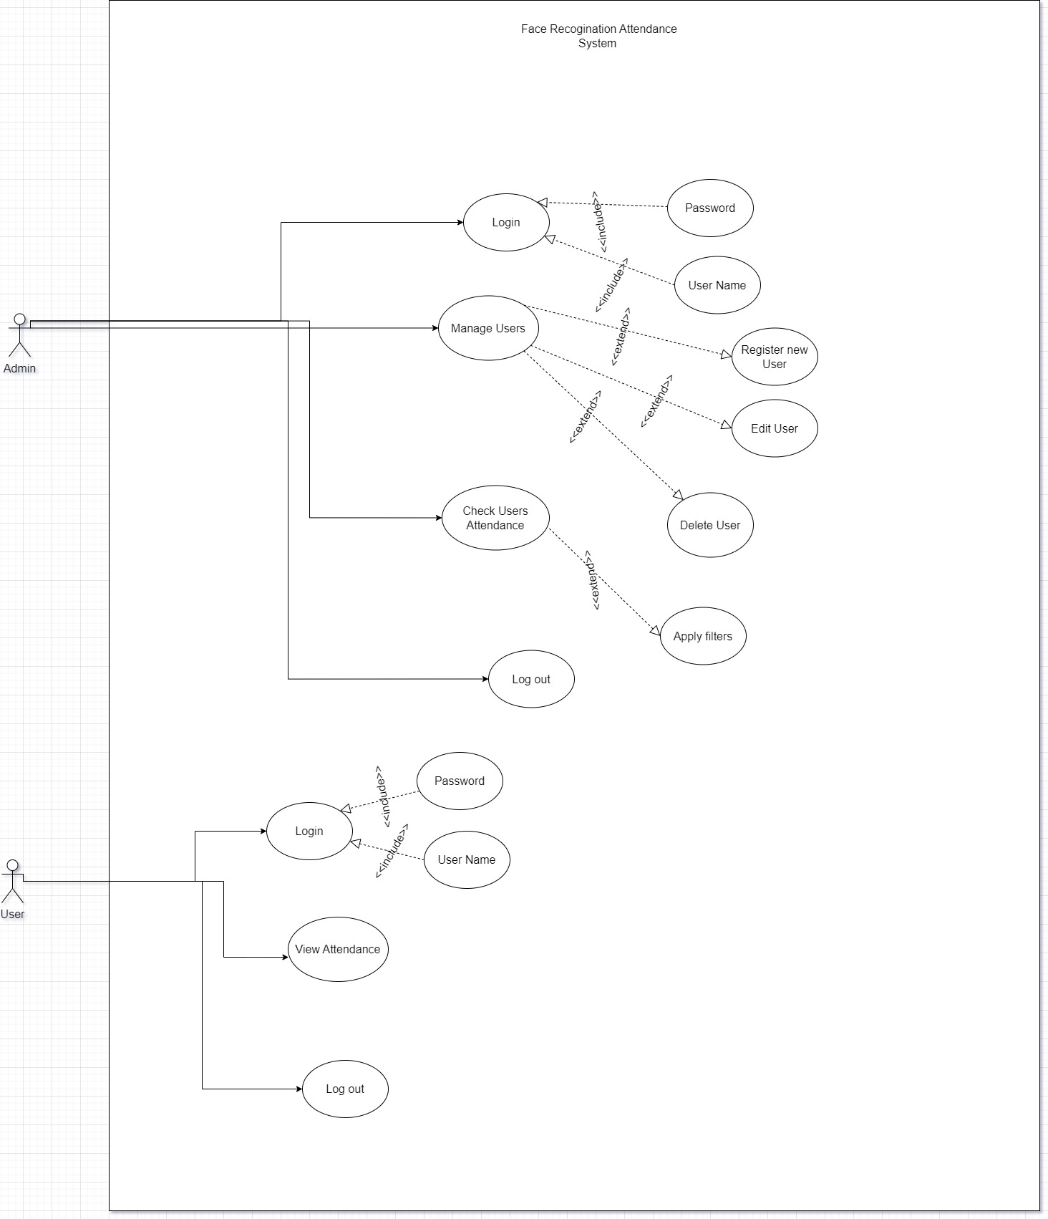

Figure 3.3**.**3:

## USE CASE DESCRIPTION TABLES

| **Use Case** | **Description** |
| --- | --- |
| Admin Login | The admin logs into their account. |
| Admin Reset Password | The admin resets their forgotten password. |
| Admin Manage User Accounts | The admin creates, deletes, and updates employee user accounts. |
| Admin View and Track Attendance Data | The admin views and tracks attendance data for all employees. |

Table 3.1: Admin use case description table

| **Use Case** | **Description** |
| --- | --- |
| User Login | The user logs into their account. |
| User View Attendance Data | The user views their own attendance data. |

Table 3.2: User use case description table