IOT Based Attendance and Surveillance System through Face Recognition


Sharyar Khan
19-ARID-5253
Faizan Nazir
19-ARID-5157
Bilal Raza
19-arid-5149
Ameer Hamza
19-ARID-5136

DEPARTMENT OF COMPUTER SCIENCES & INFORMATION TECHNOLOGY
BARANI INSTITUTE OF MANAGEMENT SCIENCES RAWALPINDI
PAKISTAN
2019-2023

IOT Based Attendance and Surveillance System through Face Recognition
by
Sharyar Khan
19-ARID-5253
Faizan Nazir
19-ARID-5157
Bilal Raza
19-arid-5149
Ameer Hamza
19-ARID-5136

Final Year Project Submitted in partial fulfillment of
the requirement for degree of

BS
in
Computer Science
Department of Computer Sciences & Information Technology
Barani Institute of Management Sciences Rawalpindi
Pakistan
2019-2023
CERTIFICATION
I hereby undertake that this research is an original one and no part of this thesis falls under plagiarism, if found otherwise at any stage, I will be responsible for the consequences.
Name: Sharyar Khan Signature: ______________
Registration Number: 19-arid-5253 Date: ______________
Name: Faizan Nazir Signature: ______________
Registration Number: 19-Arid-5157 Date: ______________
Name: Bilal Raza Signature: ______________
Registration Number: 19-ARID-5149 Date: ______________
Name: Ameer Hamza Signature: ______________
Registration Number: 19-arid-5136 Date: ______________

Certified that the contents and form of thesis entitled
“IOT Based Attendance and Surveillance System through Face
Recognition”
submitted by “Sharyar Khan, Faizan Nazir, Bilal Raza, Ameer Hamza” has been found satisfactory for requirements of the degree.

Supervisor: Mr. Nouman AL Hassan
Signature: ___________
Date: ___________

DEDICATION
We would like to dedicate our work to our respected parents who have been there to appreciate, support and push us up in our hard times throughout our academic life. We also like to dedicate a part of our work to our respected and kind teachers that making usable to think wide and sharp in all prospective life.

CONTENTS
Page
List of Tables v
List of Figures vi
Acknowledgements vii
Chapter 1 Introduction 1
1.1 PROJECT OBJECTIVES 1
1.2 PROJECT SCOPE 2
1.3 TOOLS FOR DEVELOPMENT 2
1.3.1 BACK-END TOOLS AND TECHNOLOGIES 3
1.3.2 FRONT-END TOOLS AND TECHNOLOGIES 3
1.4 HARDWARE REQUIREMENT 3
1.5 DEPLOYMENT 3
Chapter 2 STUDY OF EXISTING SYSTEM 4
2.1 DISADVANTAGES OF EXISTING SYSTEM 4
2.2 PROPOSED SYSTEM 5
2.2.1 BENEFITS OF PROPOSED SYSTEM 5
Chapter 3 Requirement Analysis 7
3.1 Functional Requirements 7
3.2 Non-Functional Requirements 7
3.2.1 USER USECASE DIAGRAM 9
3.2.2 ADMIN USE CASE DIAGRAM: 10
3.2.3 USER USECASE DIAGRAM 11
3.3 USE CASE DESCRIPTION TABLES 12
3.3.1 ADMIN USECASE TABLES 12
3.3.2 USER USECASE TABLES 19
Chapter 4 System DEsign 23
4.1 Class Diagram 23

List of Tables
Table 3.1: Admin Login 12
Table 3.2: Create User Account 13
Table 3.3: Create User Account 14
Table 3.4: Delete User Account 15
Table 3.5: View Attendance 16
Table 3.6: Admin Reset Password 17
Table 3.7: Admin Logout 18
Table 3.8: User Login 19
Table 3.9: View Attendance 20
Table 3.10: User Reset Password 21
Table 3.11: User Logout 22

List of Figures

.
Figure 3.1 User and Admin Use Case Diagram 9
Figure 3.2: Admin use case diagram 10
Figure 3.3: User use case diagram 11
Figure 4.1 Class Diagram 24

Acknowledgements

I take this moment to thank Allah Almighty and Holy Prophet (Peace Be Upon Him), for blessing us with his grace and taking our endeavor to a successful culmination. We extend our sincere and heartfelt thanks to our esteemed guide Mr. Nouman Al Hassan, for providing the right guidance and advice at the crucial junctures and for showing the right way. I would like to thank the other faculty members also, at this occasion. Last but not the least, we would like to thank our friends and family for the support and encouragement they have given us during the course of our work.

Sharyar Khan
Faizan Nazir
Bilal Raza
Ameer Hamza

Introduction

Most educational institutions and international test centers, they use traditional methods for entrance and exit, by presenting an identity document or a passport. The entry procedures take a long time and constitute an obstacle in identifying the identity when the number of students is increased. Moreover, the difficulties you face in identifying impersonators. Also, most companies take a long time to record the attendance of employees in traditional ways using the most common fingerprint. Several institutions use different systems to manage attendance, such as fingerprint and magnetic cards, which depend on the method of use, cost, reliability and security.
The central ideology of this project is identifying faces in real-time video and mark their attendance and for supervision of prospect and maintain surveillance and generating record in database.
The images from real-time video frames will be extracted and compared with already available datasets and attendance will be marked automatically without user’s interaction and after those reports will be generated automatically.
The main building of the project that is:
- Our system will extract images from real time video.
- Face Detection is going to detect the faces of the person from the images.
- The feature extractor extracts the features of the image.
- Extracted features are going to be compared with stored data of images already provided.
- Mark the attendance of matched faces.

PROJECT OBJECTIVES
The objective of this project is to develop face recognition based automated user attendance and surveillance system. Expected achievements in order to fulfill the objectives are:

- To detect the face segment from the video frame.
- To extract the useful features from the face detected.
- To classify the features in order to recognize the face detected.
- To record the attendance of the identified student/employee.
- To save Time.
- To maintain accurate record with images.
- Efficient Surveillance of student or employee.
- Easy to use.
- For security purpose to keep un-recognized person put of boundaries.

PROJECT SCOPE
This system can be implemented to any organization in the locality or to multinational companies having the required resources which would allow them to be able to keep the attendance and surveillance 24/7 and update the information whenever something new comes up.
The admin portal provides a comfortable and user-friendly environment for the admin to be able to stay up to date without much hustle and allows them to keep track of every record/information.
The system is however to ensure security, access control, reliability, efficiency and better performance of attendance and surveillance system.

TOOLS FOR DEVELOPMENT
Our website is based on the following tools and computer languages:

BACK-END TOOLS AND TECHNOLOGIES
- Python (Django)
- OpenCV
- MySQL
- VS Code

FRONT-END TOOLS AND TECHNOLOGIES
- HTML/CSS (Bootstrap)
- JavaScript
- VS Code

HARDWARE REQUIREMENT
- Computers equipped with a minimum Core i3 processor or higher, the computer must have approximately 64GB of free hard drive space and 4GB of RAM or more. And must have a GPU.
- Cameras.

DEPLOYMENT
- Any Web Browser. Preferred (Google chrome)
- WSGI OR ASGI Python Standard Web Server, MYSQL DBMS Based on Linus OS

STUDY OF EXISTING SYSTEM

Managing student attendance during lecture periods has become a difficult challenge. The manual system of taking attendance is done on paper by the use of pen, students write their names, index numbers and sign on a sheet of paper, this makes the system unreliable because students can write names for friends who are not in class. Also, the ability to compute the attendance percentage becomes a major task as manual computation produces errors, and also wastes a lot of time. For the stated reasons, an efficient attendance management system using bio-metrics is designed. This system takes attendance electronically with the help of a finger print device or facial recognition and the records of the attendance are stored in a database. Attendance is marked after student identification.

DISADVANTAGES OF EXISTING SYSTEM
Existing methods of student’s attendance identification are mostly manual (i.e., use of paper sheets where students write and/or sign against their name) and using e-commerce website application like BIMS portal (i.e., This system captures user logs into the organizational website alongside other activities such as mouse clicks and keyboard taps). In manual system uses a log book. Users arrive at a terminal where the log book is placed. They write their names, the time of arrival and then sign against their names. Some organizations provide clock for arrivals to use at the terminal. This system is limited by lack of user authentication. Users may write wrong time and the log book may even be stolen or destroyed. Sometime forget to mark the attendance of present students.
If we talk about the biometric system for the professors or employees at the institutions or organization this system serves one at a time, this system is reliable but it is time consuming process so why not ship to the automatic attendance system which works on the face recognition technique.

PROPOSED SYSTEM
The automatic attendance system using facial recognition will automatically mark the attendance of the given particular person by extracting the feature of the image in a classroom or at entry gates the system will automatically mark the attendance of the students, professors or employees, if the image of the face of any given person matches with the any of the face in the given database the system has ability to find out that person extract the feature of that given image and mark the attendance of the particular person. This system is widely used in the various areas such as security control, police control, forensic medicine and management of the attendance system.
This system determines various unique features of a face that can distinguish it from the face of the any other people. These features could be size of eyes, nose, length of the face, size of lips, color of skin, when all these features of image is compared from the face of the people in the database which is already known the system automatically mark the attendance of a given particular person as a human being our brain is capable to do all of these automatically and instantaneously but to design a system , we have to use some component so for capturing image we take a camera as an input and a python programming language to extract the features of the image and to mark the attendance.

BENEFITS OF PROPOSED SYSTEM
In our work we tried to overcome some of the disadvantage.
This system can easily detect multiple faces at a time. So, time and resource saving. One can easily manage attendance with this system. Starting with the most efficient and significant benefit, saving time. As an automated attendance-management system, facial recognition provides precise time records, reducing costly mistakes. As a result, accurate data assists managers in providing specific productivity and payroll details.
The facial recognition system helps monitor the time and attendance of field employees. As a result, no extra technology is necessary to deploy a facial recognition attendance system, and hence no maintenance costs are incurred. This solution is both cost-effective and efficient when contrasted to other biometric solutions. Easily detect multiple faces at a time. So, time and resource saving.
There are several potential benefits to using a facial recognition attendance system for a project or in a workplace setting:
- Improved accuracy: A facial recognition attendance system can accurately track attendance by identifying an individual's unique facial features. This can be more reliable than traditional methods like signing in with a pen and paper or using a punch card, which can be prone to errors or fraud.
- Increased efficiency: A facial recognition attendance system can automate the attendance tracking process, which can save time and reduce the workload for HR or administrative staff.
- Enhanced security: A facial recognition attendance system can provide an additional layer of security by ensuring that only authorized individuals are able to access a particular location or event.
- Greater convenience: A facial recognition attendance system can be more convenient for employees, as they don't have to remember to sign in or out or carry around a physical card.
- Detailed tracking and reporting: A facial recognition attendance system can provide detailed tracking and reporting on employee attendance, which can be useful for analyzing employee productivity or identifying patterns of absence.
Overall, a facial recognition attendance system can offer a range of benefits in terms of accuracy, efficiency, security, convenience, and tracking and reporting.

Requirement Analysis
Our project follows the steps of SDLC under which the SRS model developed for the system is listed below:
The SRS model contains
- Functional requirements
- Non-function requirements

Functional Requirements
The Function requirements are part of the system that describe the functional behavior that should be possessed by the system. Each requirement maps to a high-level function that transforms the given set of input data into output data.
- Admin:
- The web portal should allow the admin to login to account
- The web portal should allow the admin to create, delete, and update user accounts for employees.
- The web portal should allow the admin to view and track employee attendance data.
- The web portal should allow the admin to logout from portal.
- User:
- The web portal should allow user to login.
- The web portal should allow user to view their own attendance data.
- The web portal should allow user to logout from portal.

Non-Functional Requirements
Non-functional are properties and qualities the software system must possess providing its intended functional requirements.

- Security:
- The system should protect against unauthorized access and data breaches, and ensure the confidentiality of personal information.
- Usability:
- The web portal should have a responsive and user-friendly interface that works well on different devices and browsers.
- The camera should have a user-friendly interface for the admin and employees to easily access and view the recorded data.
- Performance:
- The web portal should have a fast and reliable connection to ensure that the user experience is smooth and seamless.
- The web portal should have a scalable infrastructure to handle large amounts of data and traffic.
- The surveillance camera should have a high level of accuracy in detecting and recording the presence of a person.
- Reliability:
- The web portal should have a reliable backup and recovery system to ensure the availability and integrity of the data.
- The camera should have a reliable and stable connection to the database to ensure that the recorded data is properly stored and retrieved.
- Access Control:
- The web portal should have secure access controls to prevent unauthorized access to the recorded data.

USER USECASE DIAGRAM

The Use Case model of the UML is used here to specify the functionality of the system from the user’s point of view and show the way the system and the users interact to achieve its stated functions and perform its goal.
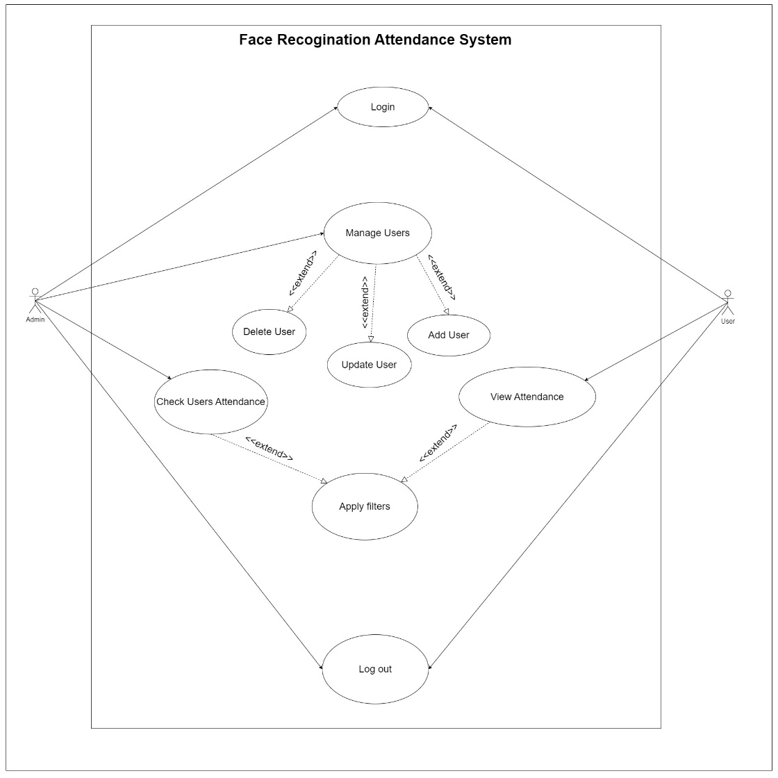
Figure 3.1 User and Admin Use Case Diagram

ADMIN USE CASE DIAGRAM:
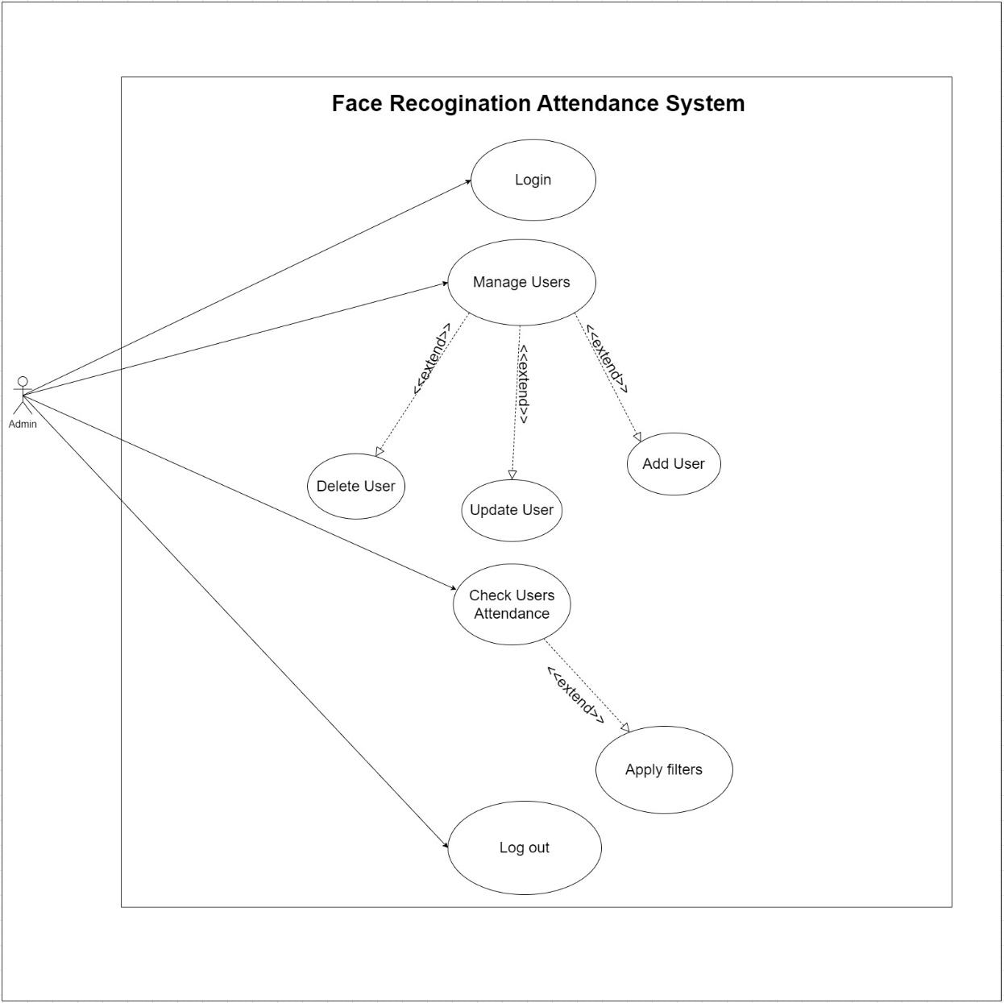
Figure 3.2: Admin use case diagram

USER USECASE DIAGRAM
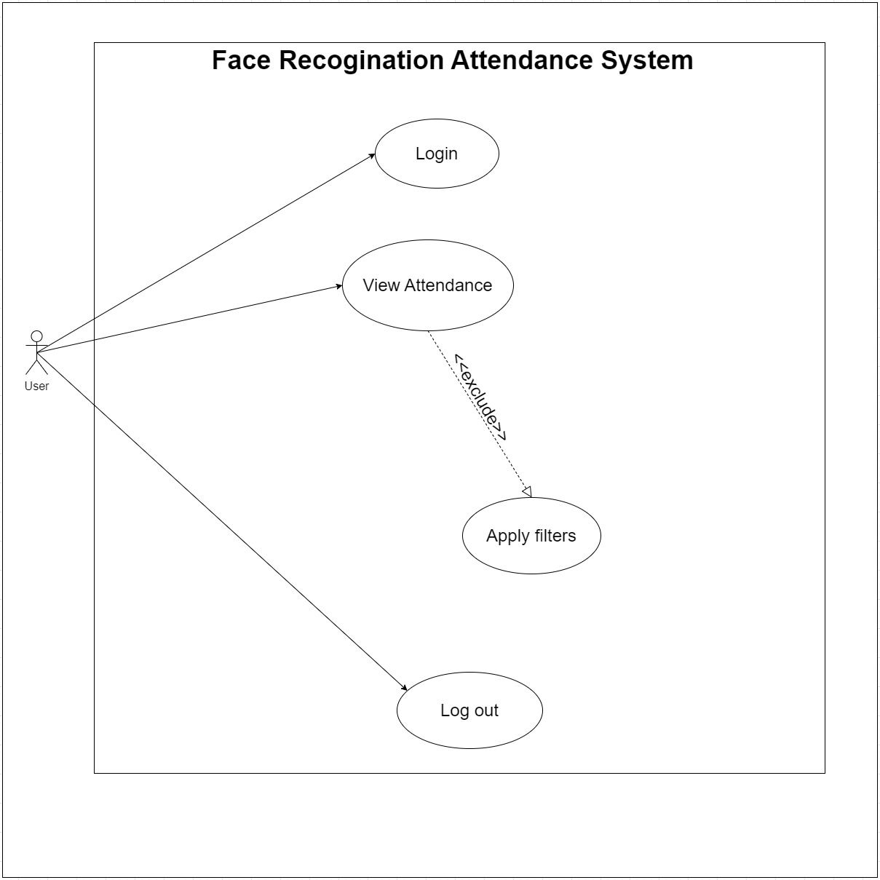
Figure 3.3: User use case diagram

USE CASE DESCRIPTION TABLES

ADMIN USECASE TABLES
Table 3.1: Admin Login
Use Case Name | Login
Use Case ID | UC1
Triggering Event | Admin needs to access the web portal.
Brief Description | The admin logs in to their account by entering their email and password
Actors | Admin
Related use cases | N/A
Stakeholders | Admin, Web portal
Preconditions | Admin account must exist
Postconditions | Admin successfully logs in
Flow of Activities | Actor: Admin | System: Web Portal
Flow of Activities | - Admin enters email  - Admin enters password  - Admin requests login | 1.4 Login successfully
Exception Conditions | 1.5 System rejects login due to incorrect credentials

Table 3.2: Create User Account
Use case name | Create User Account
Use Case Id | UC2
Triggering Event | Admin needs to create a new user account
Brief Description | The admin creates a new user account by entering the necessary information
Actors | Admin
Related use cases | Update User Account, Delete User Account
Stakeholders | Admin, Employee
Preconditions | Admin must be logged in
Post conditions | New user account is created
Flow of activities | Actor: Admin | System: Web Portal
Flow of activities | - Admin selects "Create User Account" option  - Admin enters employee information (name, email, password, etc.)  - Admin submits information | 1.4 System creates new user account
Exception conditions | 1.5 Account already exist

Table 3.3: Create User Account
Use Case Name | Update User Account
Use Case Id | UC3
Triggering Event | Admin needs to update an existing user account
Brief Description | The admin updates an existing user account by editing the necessary information
Actors | Admin
Related Use Cases | Create User Account, Delete User Account
Stakeholders | Admin, Employee
Preconditions | Admin must be logged in user account must already exist
Post conditions | User account is updated
Flow of Activities | Actor: Admin | System: Web Portal
Flow of Activities | - Admin selects "Update User Account" option  - Admin selects user account to update  - Admin edits employee information  - Admin submits changes | 1.5 System updates user account
Exception Conditions | N/A

Table 3.4: Delete User Account
Use Case Name | Delete User Account
Use Case Id | UC4
Triggering Event | Admin needs to Delete an existing user account
Brief Description | The admin deletes an existing user account.
Actors | Admin
Related Use Cases | Create User Account, Update User Account
Stakeholders | Admin, Employee
Preconditions | Admin must be logged in and user account must already exist
Post conditions | User account is deleted
Flow of Activities | Actor: Admin | System: Web Portal
Flow of Activities | - Admin selects "Delete User Account" option  - Admin selects user account to delete  - Admin confirms deletion  - Admin submits changes | 1.5 System deletes user account
Exception Conditions | N/A

Table 3.5: View Attendance
Use Case Name | View Attendance
Use Case Id | UC5
Triggering Event | Admin needs to view employee attendance data
Brief Description | The admin views employee attendance data
Actors | Admin
Related Use Cases | N/A
Stakeholders | Admin, Employee
Preconditions | Admin must be logged in
Post conditions | Attendance data is viewed
Flow of Activities | Actor: Admin | System: Web Portal
Flow of Activities | - Admin selects "View Attendance" option  - Admin selects employee to view attendance data | 1.3 System displays employee's attendance data
Exception Conditions | N/A

Table 3.6: Admin Reset Password
Use case name | Reset Password
Use case id | Uc6
Triggering event | Admin has to Reset Password
Brief description | The admin reset their password by entering the confirmation code send to their email associated with their account
Actors | Admin
Related use cases | N/A
Stakeholders | Admin, Credential, Reset-Password
Preconditions | Must be admin type
Post conditions | Successfully reset the password
Flow of activities | Actor | System
Flow of activities | 1.1 Request for Password reset  1.2 Entail email and check your email and click at password reset link and enter your new password  1.3 Request password reset | 1.4 Password Reset successfully
Exception conditions | 1.5 Password Reset unsuccessful

Table 3.7: Admin Logout
Use Case Name | Logout
Use Case Id | UC7
Triggering Event | Admin needs to logout from the web portal
Brief Description | The admin logs out from their account
Actors | Admin
Related Use Cases | N/A
Stakeholders | Admin, Web portal
Preconditions | Admin must be logged in
Post conditions | Admin successfully logs out
Flow of Activities | Actor: Admin | System: Web Portal
Flow of Activities | - Admin selects "Logout" option | 1.2 System logs out admin
Exception Conditions | N/A

USER USECASE TABLES

Table 3.8: User Login
Use Case Name | Login
Use Case ID | UC8
Triggering Event | User needs to access the web portal.
Brief Description | The user logs in to their account by entering their email and password
Actors | User
Related use cases | N/A
Stakeholders | User, Web portal
Preconditions | User account must exist
Postconditions | User successfully logs in
Flow of Activities | Actor: User | System: Web Portal
Flow of Activities | - User enters email  - User enters password  - User requests login | 1.4 System verifies credentials and logs in
Exception Conditions | 1.5 System rejects login due to incorrect credentials

Table 3.9: View Attendance
Use Case Name | View Attendance
Use Case Id | UC9
Triggering Event | User needs to view their own attendance data
Brief Description | The user views their own attendance data
Actors | User
Related Use Cases | N/A
Stakeholders | User
Preconditions | User must be logged in
Post conditions | User views their own attendance data
Flow of Activities | Actor: User | System: Web Portal
Flow of Activities | - User selects "View Attendance" option | 1.2 System displays user's attendance data
Exception Conditions | N/A

Table 3.10: User Reset Password
Use case name | Reset Password
Use case id | Uc10
Triggering event | User has to Reset Password
Brief description | The user reset their password by entering the confirmation code send to their email associated with their account
Actors | User
Related use cases | Reset Password
Stakeholders | User, Credential, Reset, Password
Preconditions | Must be user type
Post conditions | Successfully reset the password
Flow of activities | Actor: User | System: Web Portal
Flow of activities | 1.1 Request for Password reset  1.2 Entail email and check your email and click at password reset link and enter your new password  1.3 Request password reset | 1.4 Password Reset successfully
Exception conditions | 1.5 Password Reset unsuccessful

Table 3.11: User Logout
Use Case Name | Logout
Use Case Id | UC11
Triggering Event | User needs to logout from the web portal
Brief Description | The User logs out from their account
Actors | User
Related Use Cases | N/A
Stakeholders | User, Web portal
Preconditions | User must be logged in
Post conditions | User successfully logs out
Flow of Activities | Actor: User | System: Web Portal
Flow of Activities | - User selects "Logout" option | 1.2 System logs out user
Exception Conditions | N/A

System DEsign

Class Diagram
A class diagram is a type of diagram and part of a unified modeling language (UML) that defines and provides the overview and structure of a system in terms of classes, attributes and methods, and the relationships between different classes. It is used to illustrate and create a functional diagram of the system classes and serves as a system development resource within the software development life cycle.
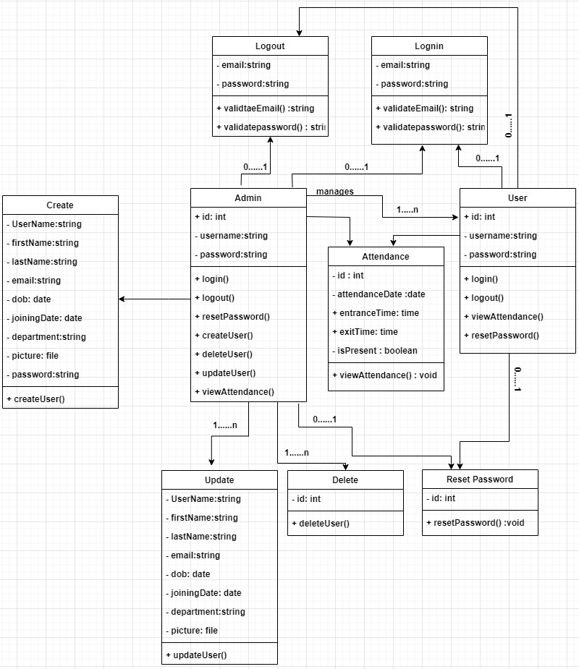
Figure 4.1 Class Diagram

