PAGE 1 – NEWS

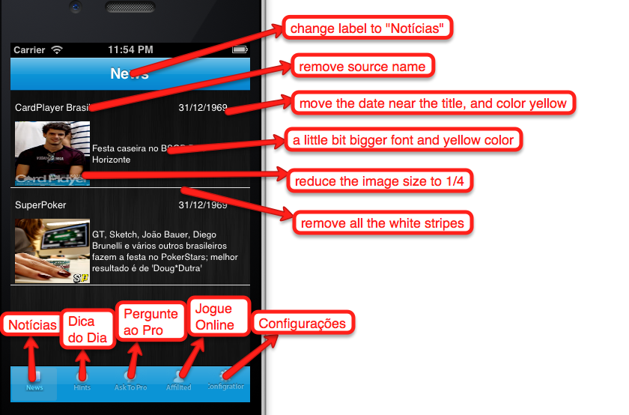

PAGE 2 – HINTS

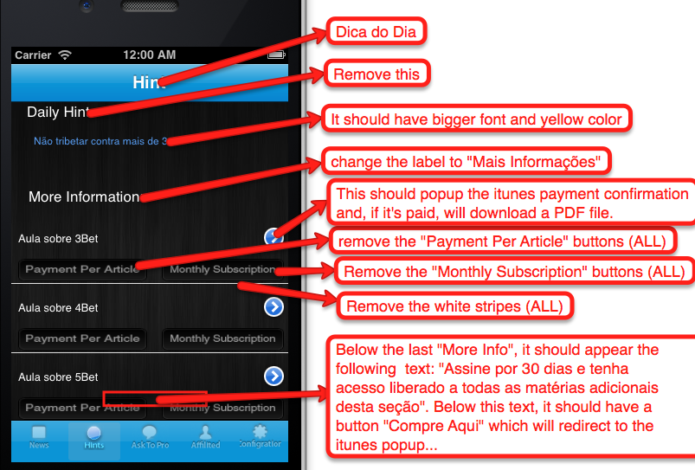

PAGE 3 – ASK TO PRO

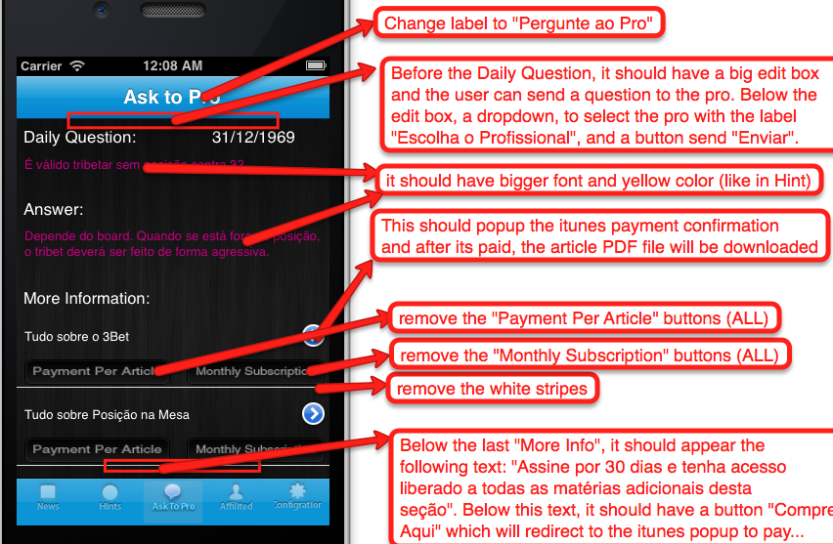

PAGE 4 – AFFILIATES

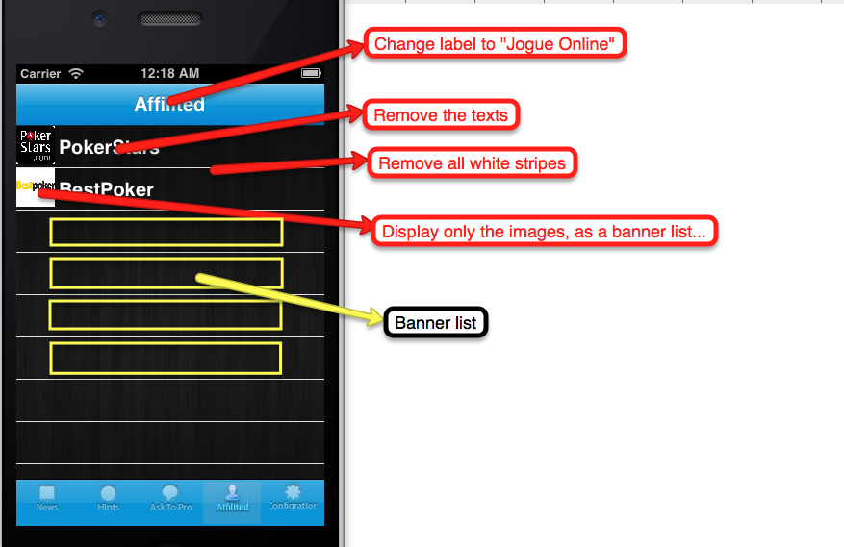

PAGE 5 – CONFIGURATION

