**OOP PROJECT REPORT:**

**(HOSPITAL MANAGEMENT SYSTEM)**

**(DESIGNED UNDER THE SUPERVISION AND COLLABORATION OF MS ASMA KHAN.)**

**PRESENTED BY:**

* MUHAMMAD RAYYAN SIDDIQUI(SE-051)
* MUHAMMAD FAIZAN SIDDIQUI(SE-053)

**MAIN OBJECTIVE:**

A significant part of the operation of any hospital involves the acquisition, management and timely retrieval of great volumes of information. This information typically involves: patient Personal information and medical history, staff information, room and ward scheduling, staff Scheduling, operating theater scheduling and various facilities waiting lists. All of this Information must be managed in an efficient and cost wise fashion so that an institution’s Resources may be effectively utilized HMS will automate the management of the hospital making it more efficient and error free. It aims at standardizing data, consolidating data ensuring data integrity and reducing inconsistencies.

**PROJECT MODULES:**

* Form 1
  + Signup
  + Login as Admin
    - Admin login view
      * View Patient details
      * New patient
  + Login as Patient
    - Patient details
    - Doctor schedules

**MODULE DESCRIPTIONS:**

**Name of module 1: Form1**

**Description:** Form1 contains 3 buttons (Login as patient, login as admin, signup). It is the main interface of the program.

**Interface:**

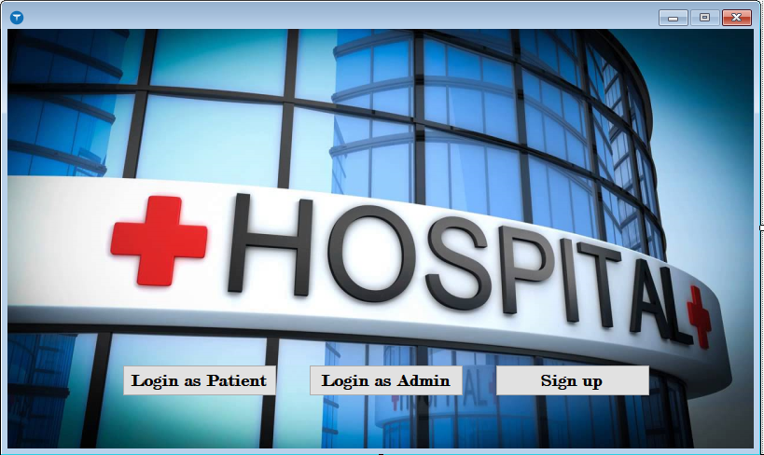

**Code:**

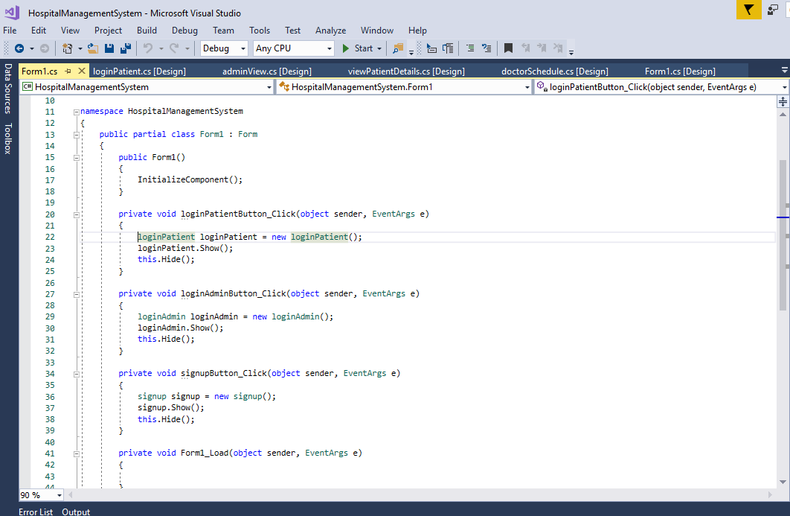

**Name of module 2: Signup**

**Description:** after clicking on the “Signup” button on form1, we jump to the “signup” form. This form contains data regarding to new employees who need to signup first to enter their personal information into the database as an admin. It contains 8 fields like full name, age, contact no., etc. after entering the data into the database there is a back button to go directly to the main interface i.e. Form1.

**Interface:**

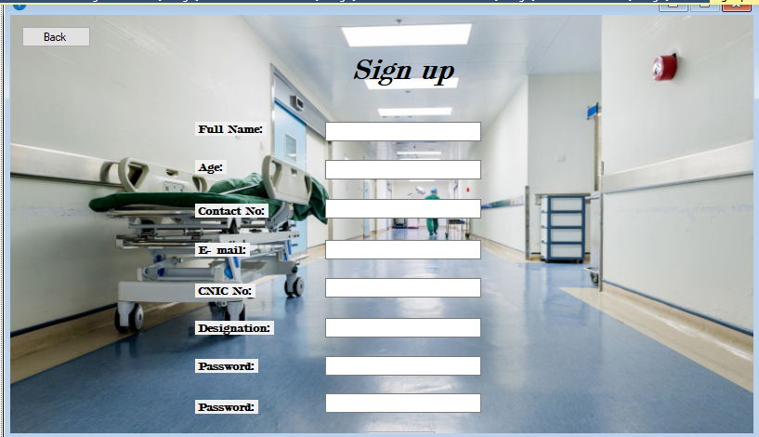

**Coding:**

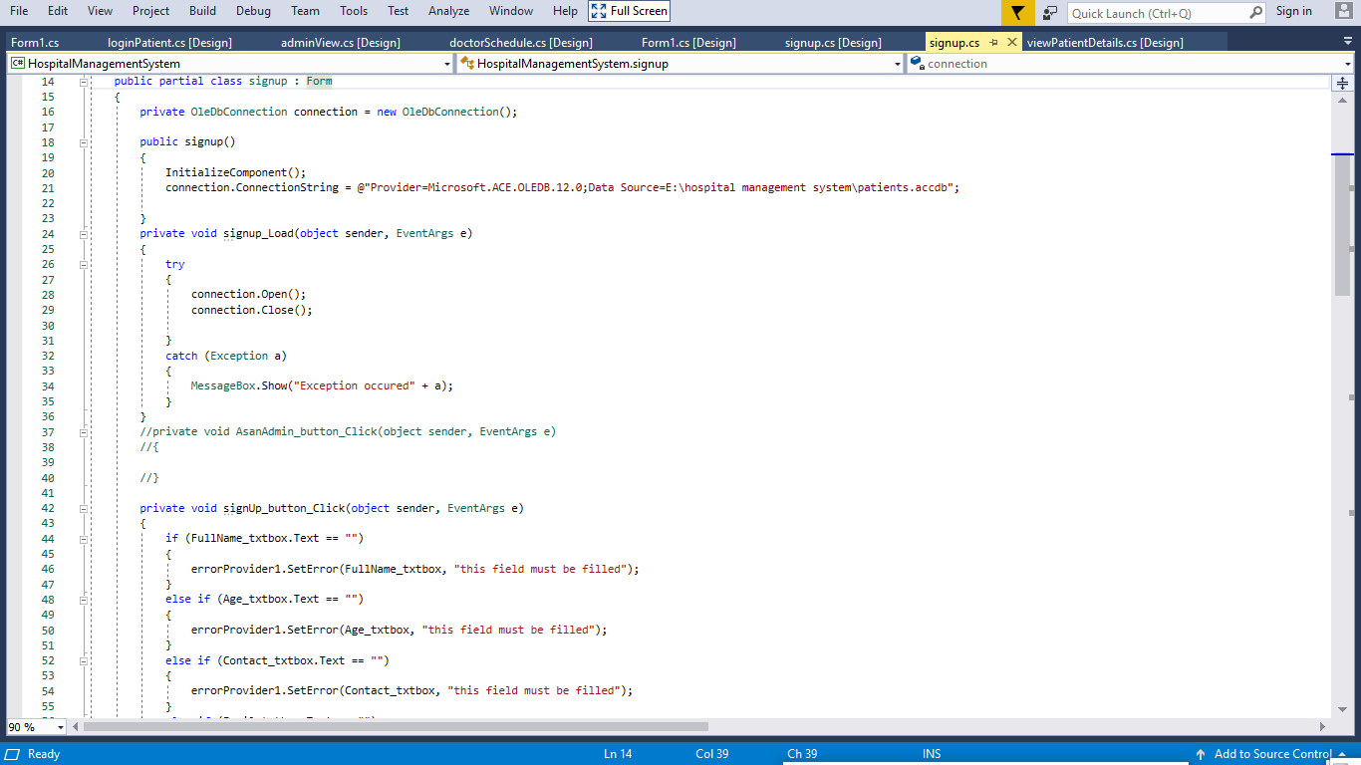

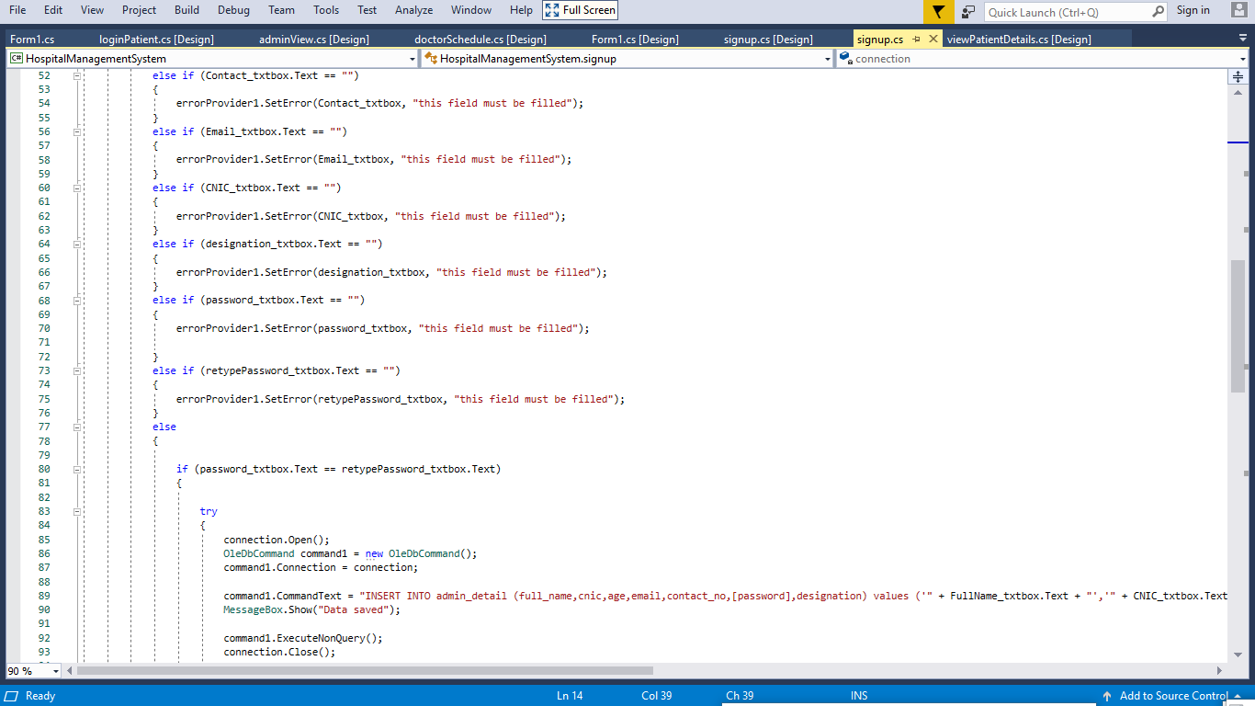

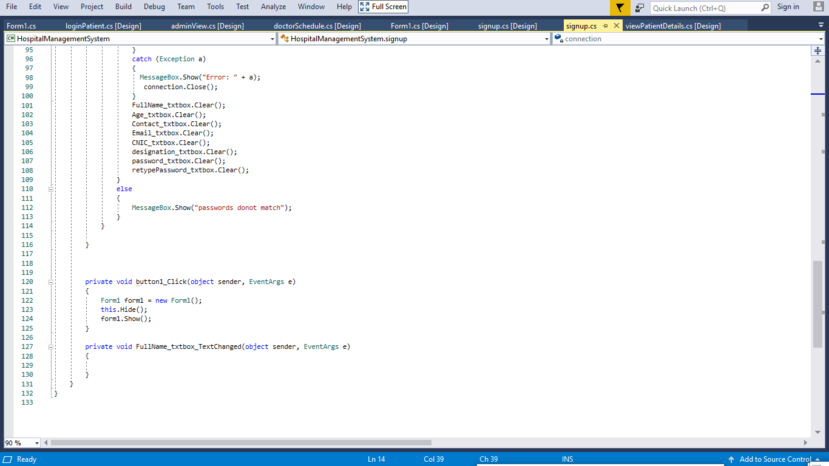

**Name of module 3: login as Admin**

**Description:** after clicking “login as admin” button on form1 you jump to the “login as admin” form. Here you are given two fields to fill.

* Username
* Password

Username and the password are the same fields that the employee filled while signing up for the first time on the “signup” form. After entering above fields there is a “login” button to login to the server. A “back” button is also present to go back to the main form.

**Interface:**

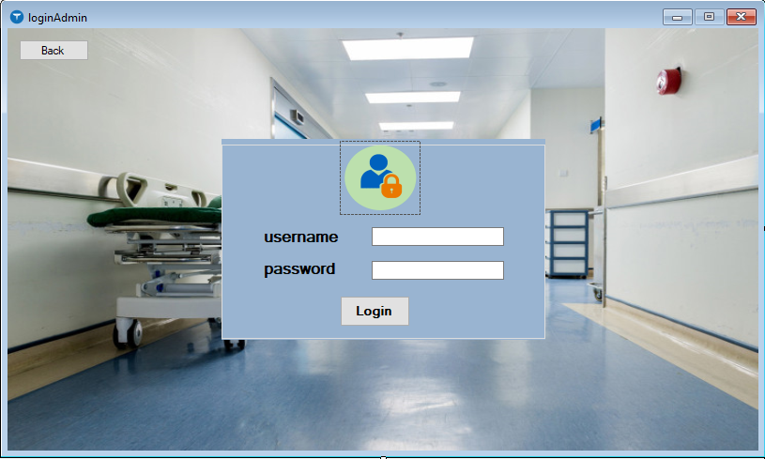

**Coding:**

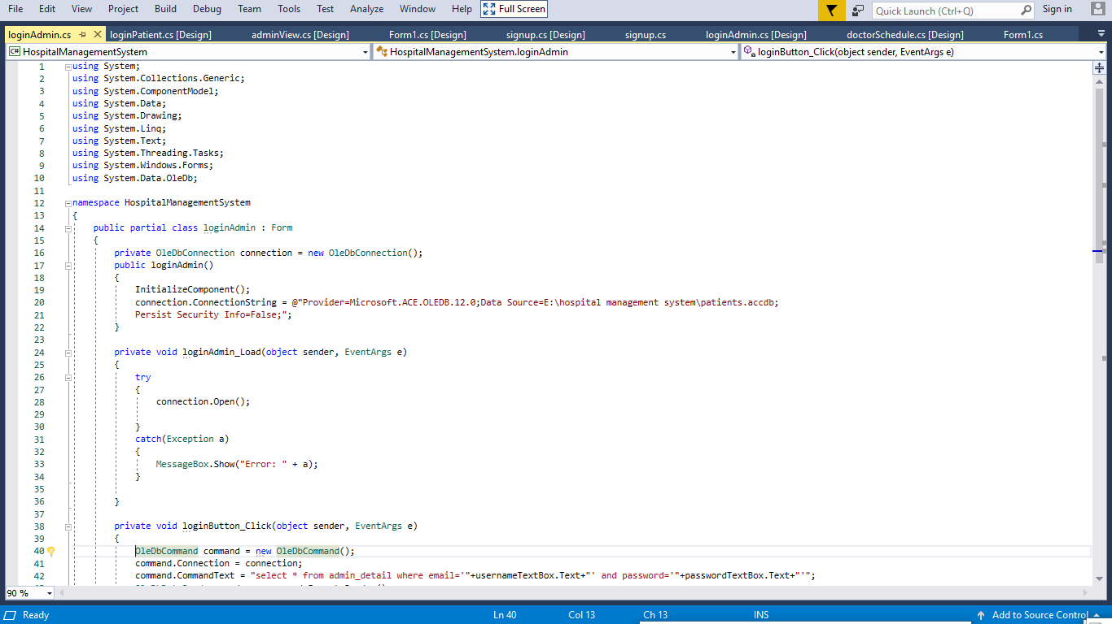

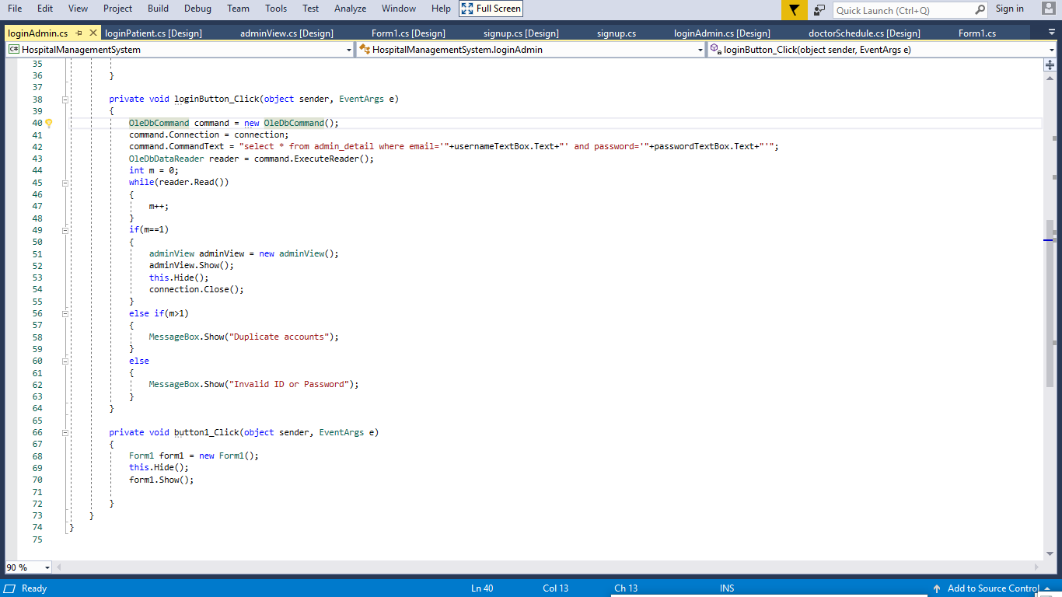

**Name of module 4: Admin login view**

**Description:** After logging into the server, an “admin login view” form is opened. It contains two main buttons

* **View patient details** – in this form admin has the authority to change/update some field information to a some extent.
* **New patient** – in this form the doctor fills in the required data of the patient.

It also contains a “back” and a “logout” button.

**Interface:**

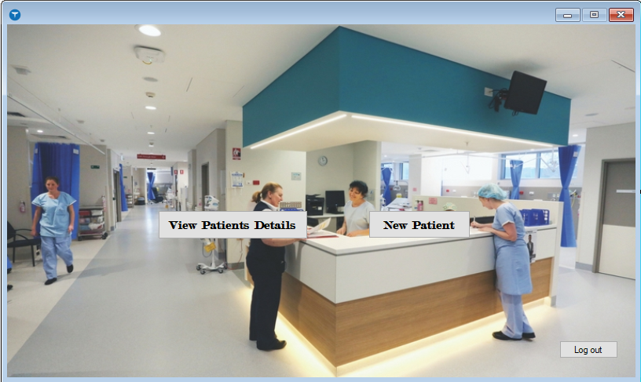

**Coding:**

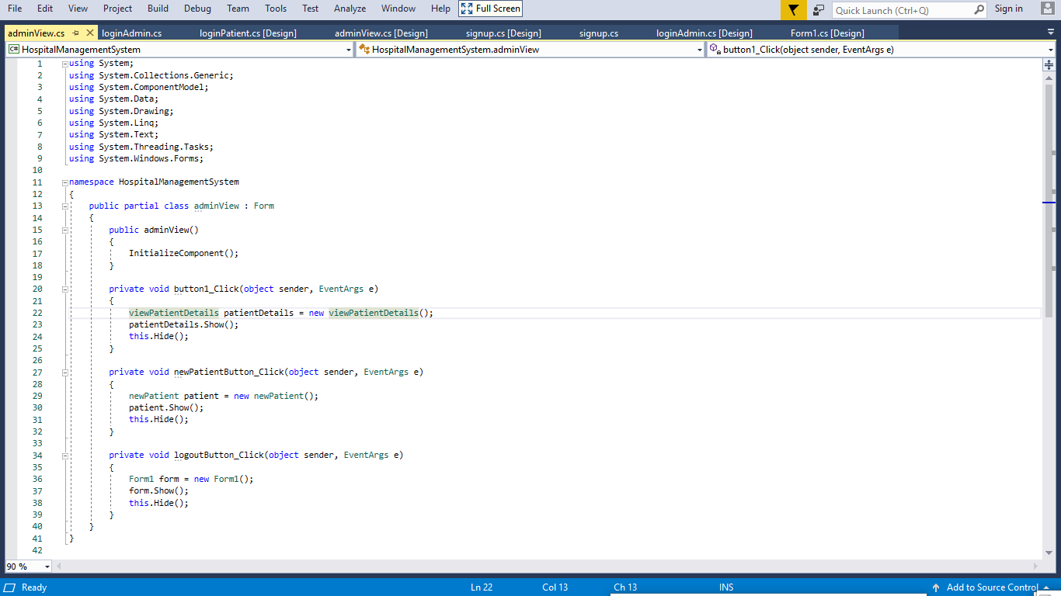

**Name of module 5: view Patient details**

**Description:** After clicking the “view patient details” button, a “view patient details” form is opened. This form contains all of the patient’s medical past and present history. Only authorized personnel can access the patient’s detail. It contain 3 main buttons:

* **Edit data** – to edit any information regarding the patient except his personal information like name, sex, address etc.
* **Update** – to update the database with any changes made with the information.
* **Clear data** – to clear the patient’s information from the database once and for all permanently.

It also contains a “search” button to search the desired patient’s details. A “back” button is also given.

**Interface:**

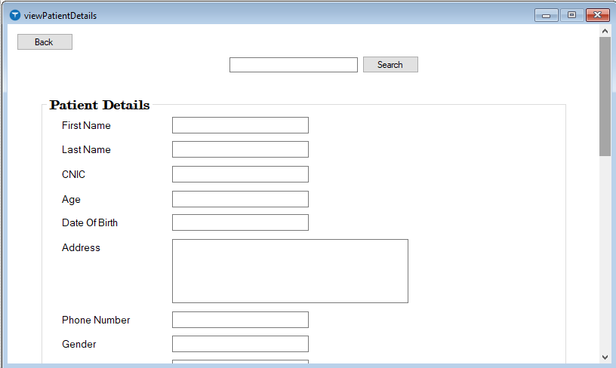

**coding:**

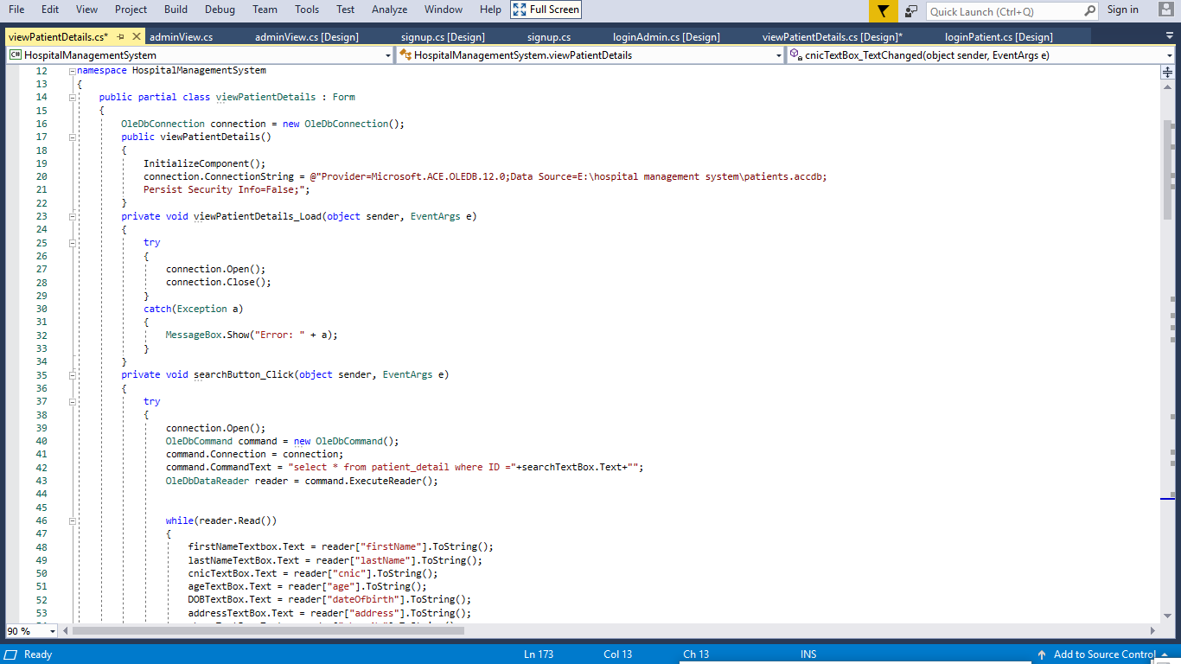

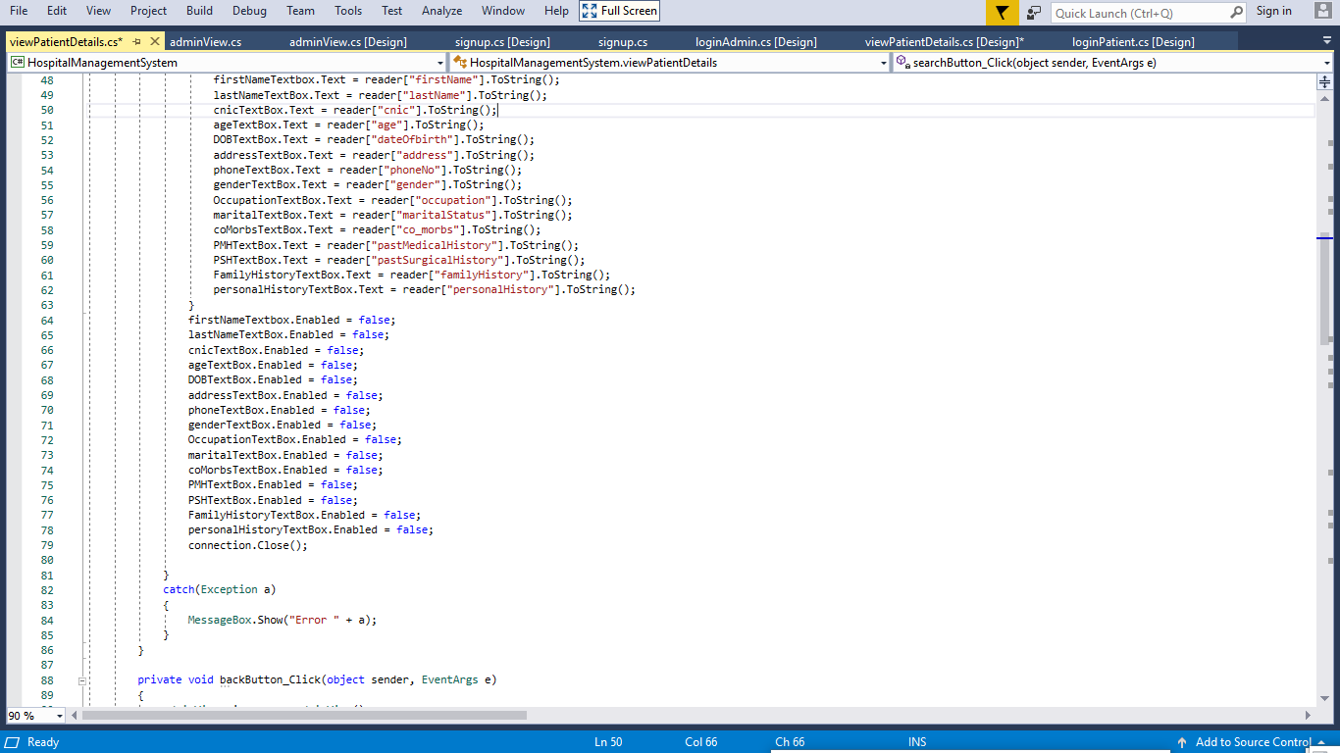

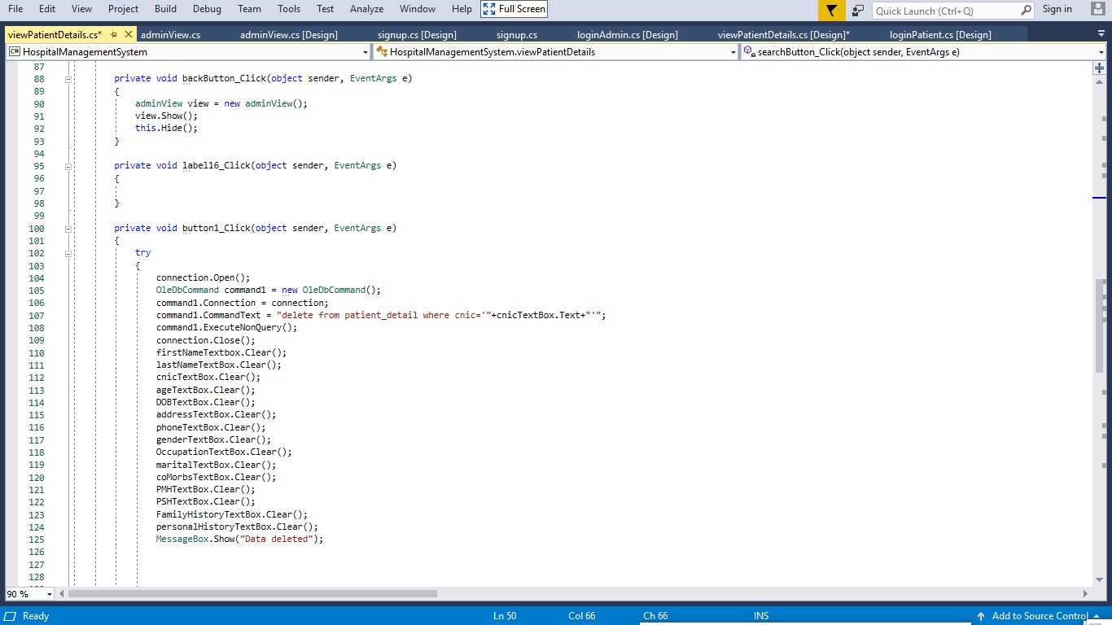

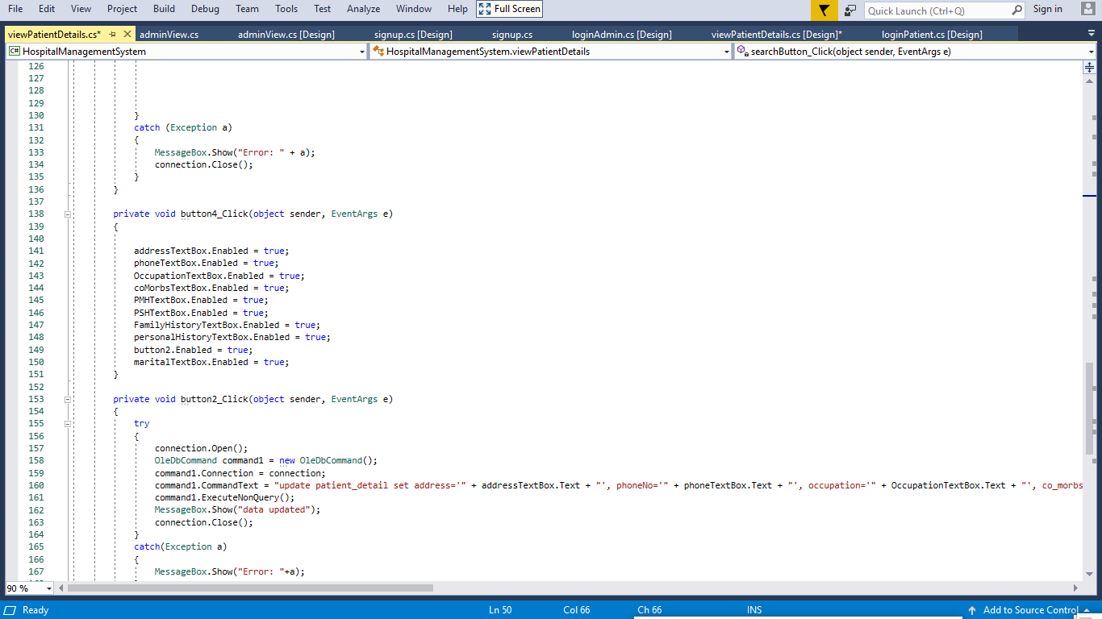

**Name of module 6: New patient**

**Description:** This form contains a “save data” button to save the patient’s detail…

**Interface:**



**Coding:**

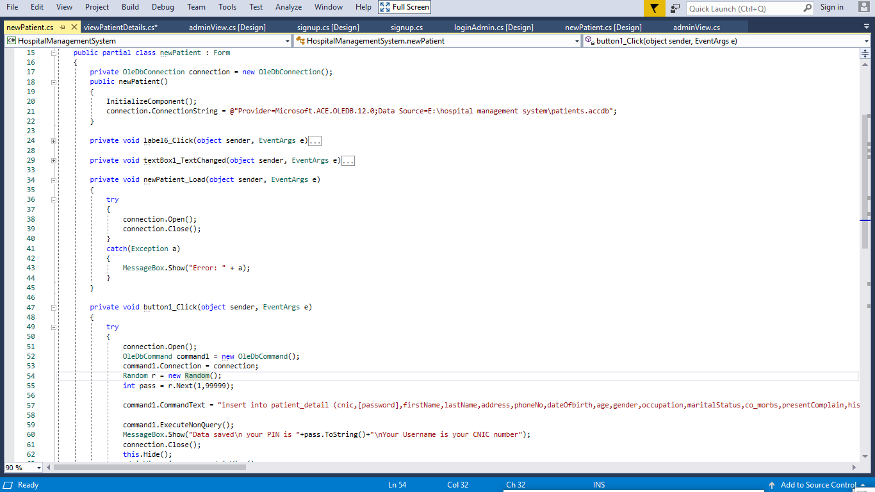

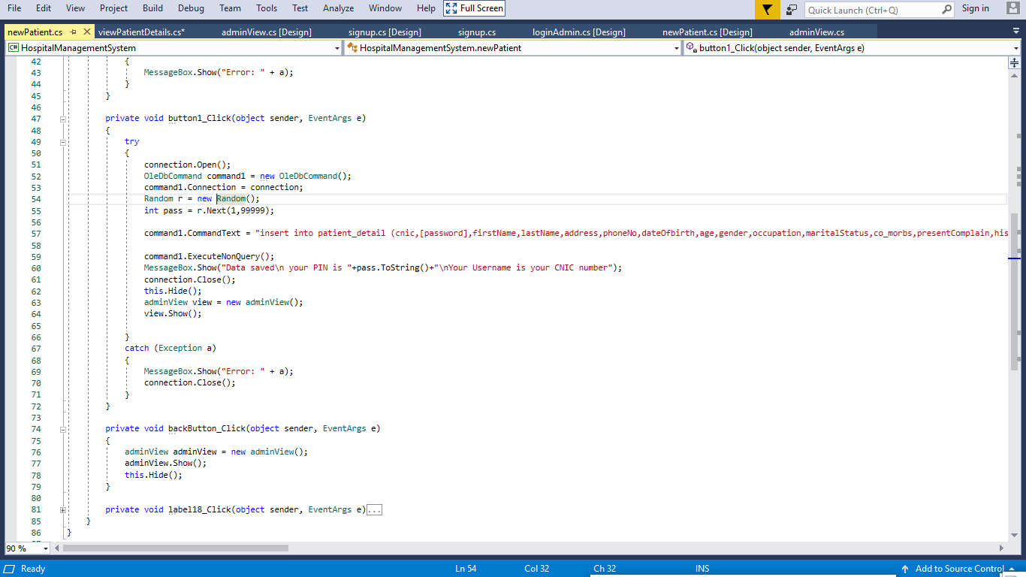

**Name of module 7: login as Patient**

**Description:** after clicking “login as patient” button on form1 you jump to the “login as patient” form. Here you are given two fields to fill.

* Username
* Password

After entering above fields there is a “login” button to login to the server. A “back” button is also present to go back to the main form

**Interface:**



**Coding:**

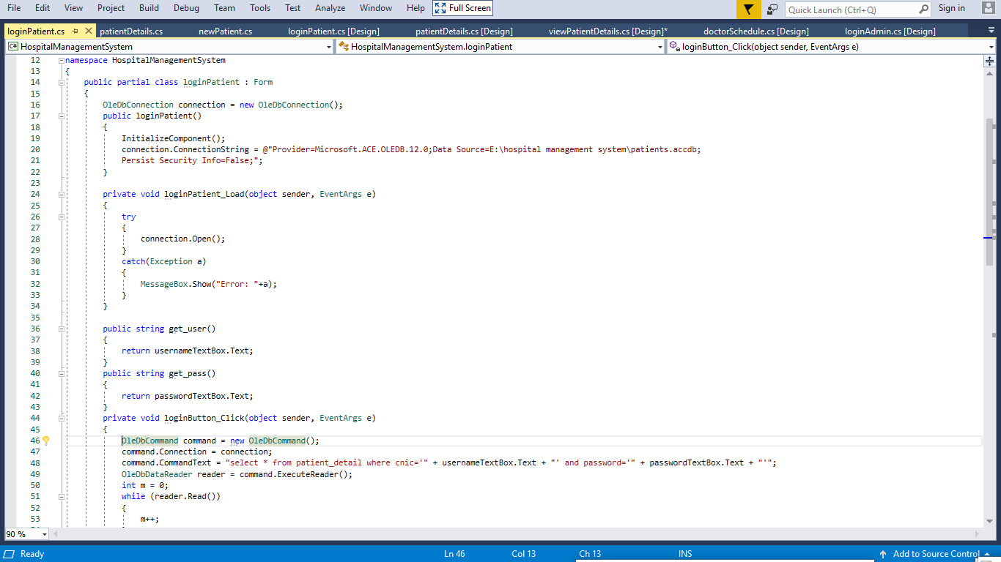

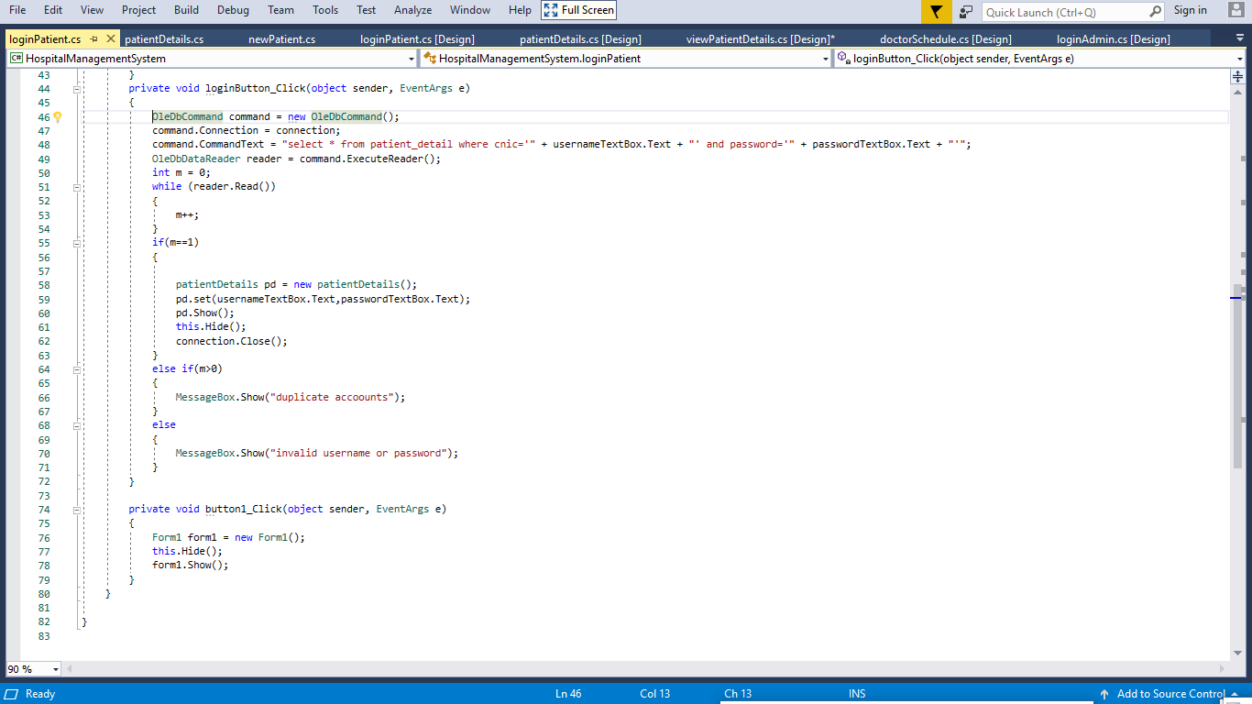

**Name of module 8: Patient details**

**Description:** in this form patient can only view his details. There is a “view doctor schedule” button to view all of the doctors schedule of the institution.

**Interface:**

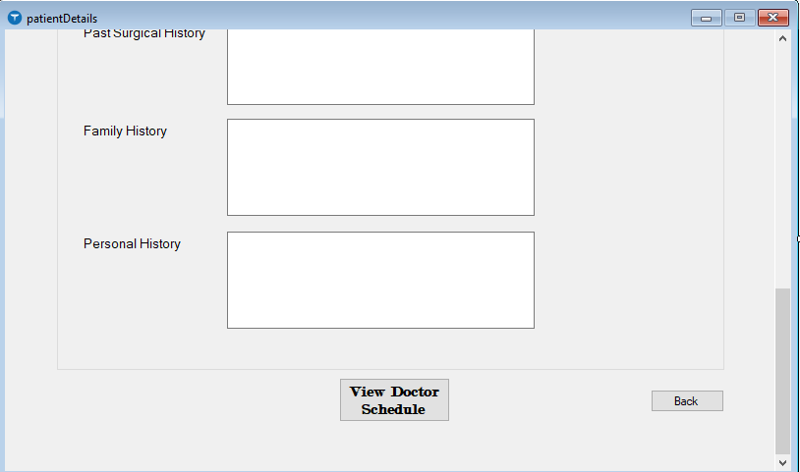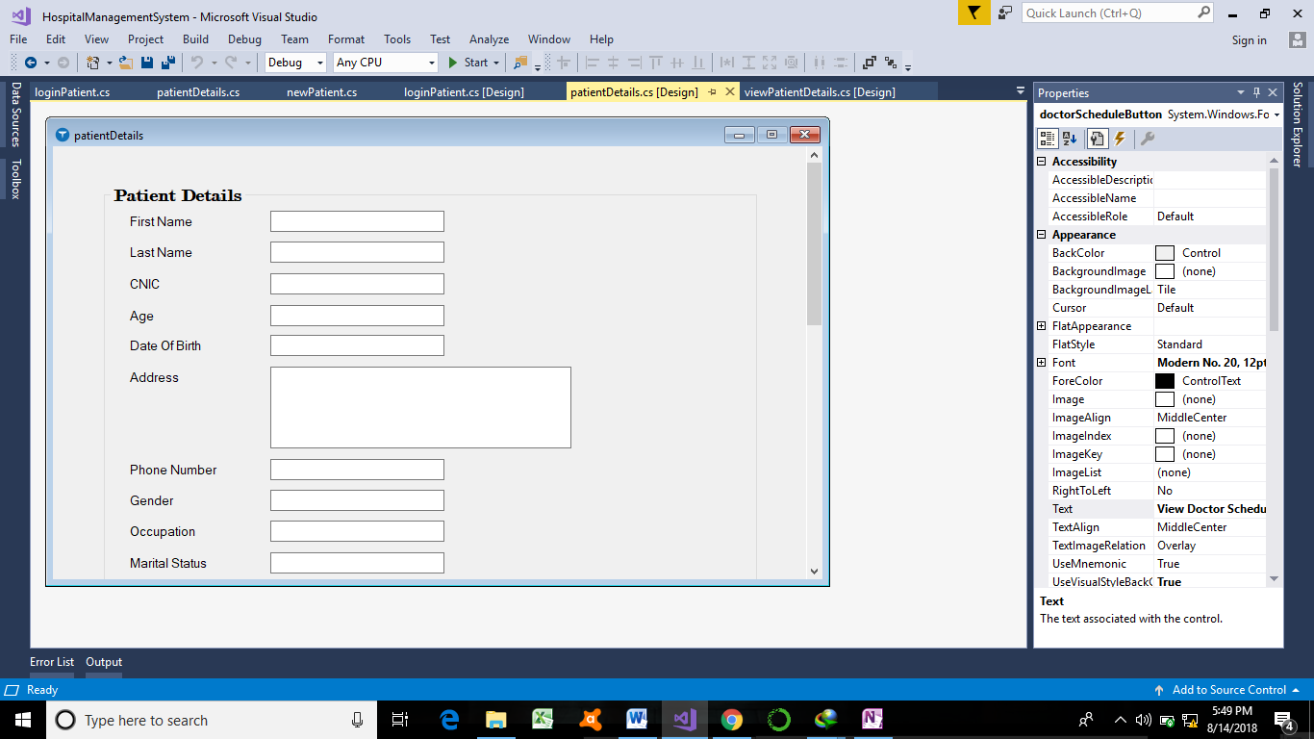

**Coding:**

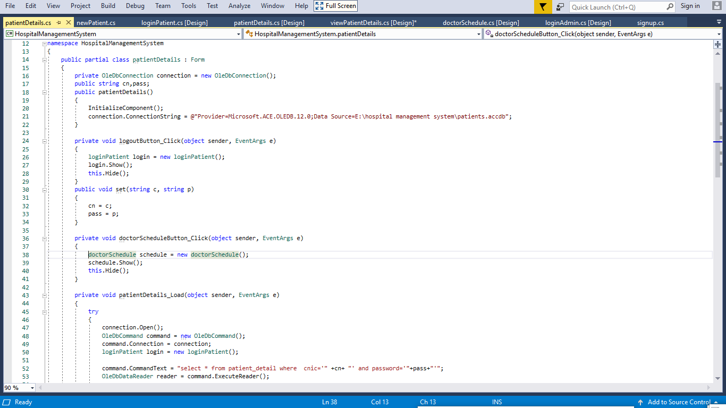

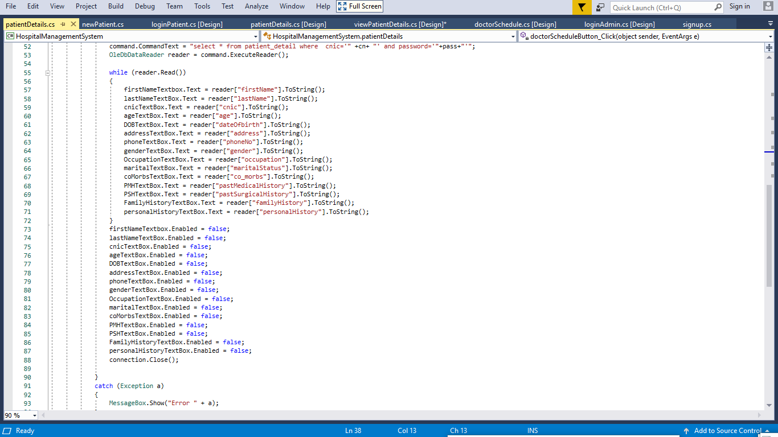

**Name of module 9: View doctors schedule**

**Description:** it displays all of the schedules of doctors currently employed in the institution.

**Interface:**

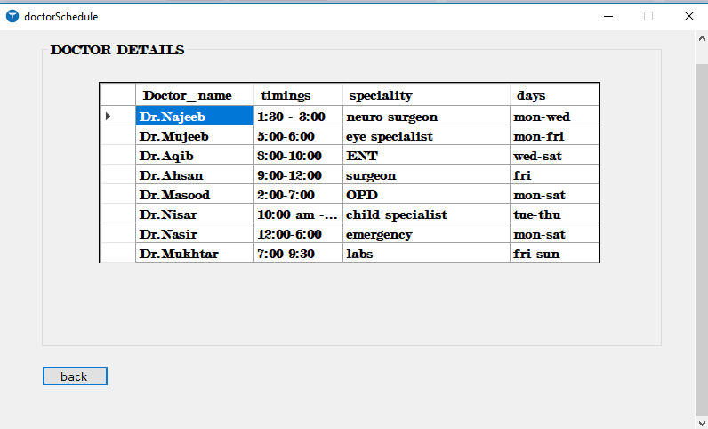

**Conclusion:**

The package was designed in such a way that future modifications can be done easily. The following conclusion can be deduced from the development of the project.

* Automation of the entire system improves the efficiency
* It provides a friendly graphical user interface which proves to be better when compared to the existing system.
* It gives appropriate access to the authorized users depending on their permissions.

It effectively overcomes the delay in communications. Updating of information becomes so easier. System security, data security and reliability are the striking features. The System has adequate scope for modification in future if itis necessary.