MillionSpaces

Valuation Report

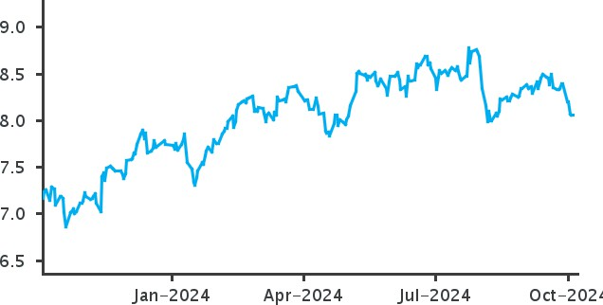
May 2026

MillionSpaces

Terms of Reference: Rosmead Partners have been engaged by Million Spaces to conduct this commercial assignment. Rosmead Partners is a consulting firm that advises private companies and family offices.

The terms of reference would include the following analysis of Rhydycar West:

MillionSpaces Overview and Its Business Model
- Description of Rhydycar West
- Project Goals
- Financial Highlights
Industry Overview
- Market trends and growth drivers
- Competitive landscape
- Regional insights
Financial Analysis and Forecast
- Project Context Financial Analysis
- Forecast assumptions and projections
- Key operating metrics
Valuation Summary – DCF & Public Comparable
- DCF assumptions and valuation output
        - Public comparable companies and multiples
        - Valuation triangulation and conclusion

Executive Summary

About MillionSpaces

Asset-light marketplace for booking flexible workspaces on demand

MillionSpaces is an asset-light marketplace for booking flexible workspaces on demand, hot desks, private offices, meeting rooms, event spaces and virtual offices, earning a 12 to 15% commission on bookings rather than holding leases. Built on a cloud and mobile platform with Stripe payments, AI support and smart dashboards, it is now scaling from a proven base in Sri Lanka and the UK into three target markets: Singapore, Dubai, and Boston.

The thesis rests on a global flexible-workspace market projected to grow from roughly $52B in 2026 to $195B by 2034 at a high-teens CAGR, with demand led increasingly by enterprises rather than freelancers. Traction to date is strongest in Sri Lanka, where bookings grew from 12,428 (2023) to 38,425 (2025, +115%) with 115,000+ projected for 2026, alongside roughly 3x marketing ROI and a 2026 UK healthcare JV.

On the model, Dubai (12%) and Boston (9.5%) are deliberately priced below local competitors to win share, while Singapore now sits at the market median (15%). Dubai is the strongest unit (+$0.30M over its horizon) and Boston the largest by GMV but thinner on margin (+$0.12M). Singapore remains the investment-phase market and the group's main drag (-$1.04M), though a higher take rate and a leaner cost base have roughly halved its loss. At group level the business loses about $0.63M across the horizon, turns annually profitable in Year 2, and reaches a solidly positive upside case (+$0.67M). Led by founder and CEO Prasath Nanayakkara (MIT, INSEAD; prior exit of Cloud Technology Partners to HPE), the company is raising to fund the three-market launch, with the raise amount and terms still to be confirmed.

Exhibit 1: 36-Month Horizon

Market | Total GMV | Net Commission (9.5%, 12%, 12%) | Operating Expenses | Operating Profit
Boston | $15,705,170 | $1,491,991 | $1,370,000 | +$121,991
Dubai | $10,183,699 | $1,160,942 | $864,000 | +$296,942
Singapore | $5,826,553 | $636,260 | $2,362,125 | -$1,725,866
GLOBAL TOTAL | $31,715,422 | $3,289,193 | $4,596,125 | -$1,306,933

Source: Rosmead Partners

Industry Overview

Market Snapshot

Global Flexible Workspace (2026–2034)
Projected to grow from ~$52B in 2026 to ~$195B by 2034, a high-teens CAGR, with demand led increasingly by enterprises rather than freelancers

Hybrid Work Adoption
A majority of companies have adopted or are moving toward hybrid models, making flexible space a core part of corporate real estate strategy

APAC Growth Engine
APAC is the fastest-growing coworking region at ~23% share in 2026, with Singapore a leading hub forecast to reach ~$407.8M by 2030 (24.3% CAGR)

Target Markets
Scaling from a proven base in Sri Lanka and the UK into Singapore, Dubai and Boston, priced below local competitors to win share

Industry Overview: Flexible Workspace
The flexible workspace industry has moved from a startup-and-freelancer niche to a mainstream component of corporate real estate strategy. The shift is driven by the durability of hybrid work: across markets, a majority of companies have adopted or are moving toward hybrid models, and demand is increasingly led by enterprise occupiers rather than individuals.
The flexible workspace industry has moved from a startup-and-freelancer niche to a mainstream component of corporate real estate strategy. The shift is driven by the durability of hybrid work: across markets, a majority of companies have adopted or are moving toward hybrid models, and demand is increasingly led by enterprise occupiers rather than individuals.
Market Size and Growth
A structural shift, not a cycle
Estimates vary by definition (coworking vs. flexible office vs. flexible space), but the direction is consistent: a large market compounding at mid-to-high teens. The global flexible office market is projected to grow from roughly $52.0B in 2026 to $194.8B by 2034, a CAGR of about 18% (Fortune Business Insights, 2026). MillionSpaces' own deck cites a comparable $55.1B (2026) to $196.2B (2034) at 17.2% (Precedence Research, 2024). Narrower "coworking space" definitions place 2026 value lower, in the ~$15 to 21B range, but still growing at 14 to 19% (SNS Insider, 2025; Next Move Strategy Consulting, 2025). The takeaway for an investor: a structurally expanding TAM with consensus growth in the high-teens, though the absolute number depends heavily on how the segment is scoped.

APAC is the growth engine
APAC is expected to be the fastest-growing region in coworking, holding roughly 23% share in 2026, driven by urbanization, flexible-work adoption, and expanding startup ecosystems, with Singapore a leading regional hub (Coherent Market Insights, 2026).

Singapore Overview
The Singapore coworking market was valued at about $88.2M in 2023 and is forecast to reach roughly $407.8M by 2030, a 24.3% CAGR, with the footprint expanding from 1.2M sq ft in 2015 to 3.7M sq ft (Next Move Strategy Consulting, 2025). Raw demand growth has been steadier than headline market-value growth: Singapore recorded a 5% year-over-year increase in flexible workspace demand in 2025, ninth of ten APAC cities, with Manila leading at +51% (The Instant Group, 2026). Pricing firmed meaningfully into 2026: average desk rates reached roughly $761 per desk per month by March 2026, with the CBD (~$737) and Marina Bay (~$779) at a premium and decentralized submarkets such as OneNorth (~$429) and Tanjong Pagar (~$595) cheaper (Worka, 2026). Notably, the CBD still accounts for about half of total flexible workspace demand, but decentralized and suburban hubs are gaining share as companies seek shorter commutes and distributed work (Worka, 2026). That decentralization is the precise gap MillionSpaces is positioning into by aggregating local, suburban inventory.

Dubai Overview
The UAE flexible office market is estimated at about $1.12B in 2025, projected to reach roughly $1.81B by 2030 at a ~10% CAGR, with Dubai holding 65.3% of overall UAE value in 2024 (Mordor Intelligence, 2025). Demand drivers are strong: nearly 60% of large organizations have adopted long-term hybrid arrangements, premium supply is tight with Grade A occupancy above 94% in 2025, and free-zone incentives plus 0% corporate tax eligibility widen the tenant base (Mordor Intelligence, 2025).

Boston Overview
Boston is one of the largest and fastest-growing US flexible-workspace markets. It ended 2025 with just over 6 million square feet across 265 locations, the sixth-largest coworking market in the country despite ranking only tenth by population, having grown 26% year-over-year against a 16% national rate. High office vacancy is a tailwind here: downtown vacancy hit 18.9% in 2025, pushing landlords toward flexible operators, and coworking now sits at about 2.2% of Boston office inventory, above the national share. Demand is anchored by the city's universities, life-sciences corridor, and startup base. It is also one of the priciest US markets, with flexible desks averaging around $740 per month and private offices starting near $1,000, a high baseline that supports strong GMV even under a below-market take rate

Valuation Analysis

Valuation Metrics

Asset-light marketplace earning commission on host GMV, with no property or lease obligations

Valued as a venture-stage platform on expansion economics rather than physical assets

MillionSpaces Fit

Commission model across Singapore, Dubai and Boston; take rate and market mix drive value, with credible asymmetric upside

Transaction Overview

MillionSpaces is a genuine asset-light marketplace, not a leveraged operating asset, and that distinction defines the entire valuation. It earns commission on host GMV, carries no property, and has already proven the model in one market. The question is not whether the business works, but whether the expansion economics justify a venture-stage price. On balance they do, with meaningful optionality to the upside, and the case has strengthened: Singapore, the lead market, still loses money over the horizon, but a move to a 15% take rate (originally 12%) and a leaner cost base have roughly halved that loss to about $1.04M, and the group now turns annually profitable in Year 2. Two features still temper the view rather than making it outright positive: Singapore does not break even on commission alone, and the deliberate The decision to undercut local rates in Dubai and Boston caps the profit those markets can throw off. The result is an asset with credible asymmetric upside that is fairly priced for the risk it carries, with the risk-reward now tilted more constructively than before.

Path to Profitability

Year 1 loss of $1.31M, improving to +$0.09M in Year 2

Reaches +$0.59M by Year 3 as commission compounds on host GMV

Market Contribution

Dubai strongest at +$0.30M; Boston +$0.12M on the largest GMV base

Singapore remains the drag at -$1.04M despite a higher 15% take rate

MillionSpaces’ Positioning

Asset with credible asymmetric upside, fairly priced for the risk; the group turns annually profitable in Year 2, with an upside case of +$0.67M

Path to Profitability
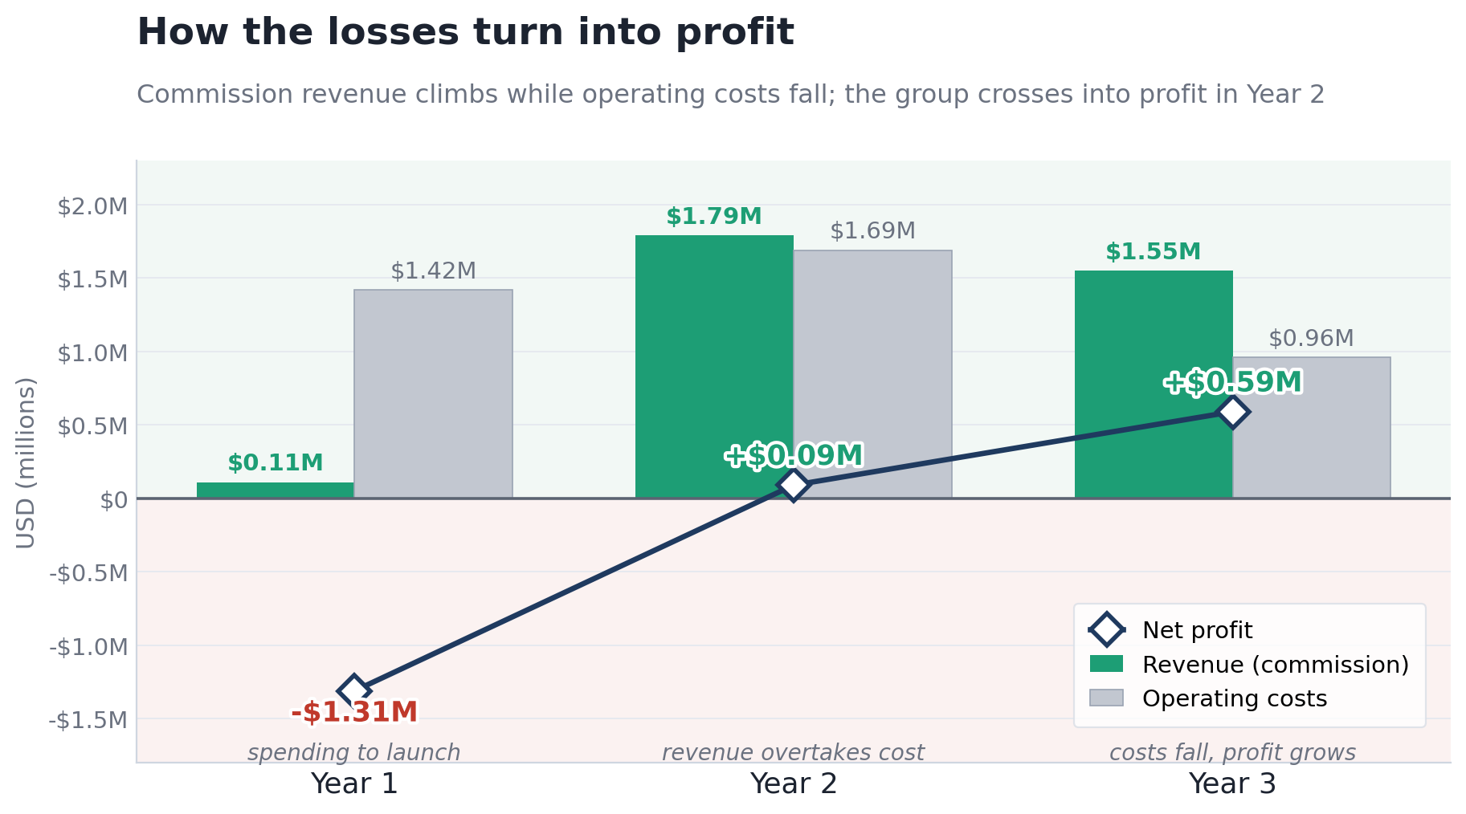By the second year the group turned annually profitable, improving from a Year 1 loss of $1.31M to a $0.09M profit in Year 2 and $0.59M in Year 3. Revenue is entirely commission on host GMV, net of local sales taxes, with no inventory cost line because the platform owns no space. Dubai is the strongest unit at +$0.30M, Boston contributes +$0.12M on the largest GMV base, and Singapore remains the drag at -$1.04M despite a higher 15% take rate and a leaner cost base.

Bull Case
- Proven engine in Sri Lanka (bookings +11.5% in 2025); valuation are actuals layered in
- Dubai already profitable in-model (+$0.30) in a tight, high-occupancy market; Boston is the largest GMV pool
- Asset-light structure scales city-to-city without lease risk; Upside scenario reaches near-breakeven group

Bear Case
- Singapore never breaks even across 36 months, its cost base remains the issue regardless of pricing strategies
- Below-market take rates (9.5-12%) structurally cap commission and thin the margin of safety
- Booking growth is an assumed monthly rate with no unit economics beneath it

Revenue sets the value

Because MillionSpaces is loss-making with no stabilised EBITDA, it cannot be valued on earnings: there is no profit to capitalise and no reliable terminal cash flow to discount. The right anchor for an early-stage, take-rate marketplace is a multiple of forward net commission, cross-checked against GMV to confirm the two agree. Benchmarked to comparable proptech and marketplace businesses (a high-single-digit revenue multiple) and then discounted for MillionSpaces' early stage, thin revenue base, and single proven market, a 3 to 6x forward net commission multiple is appropriate. Applied to the model's forward commission, this supports an illustrative enterprise value of roughly $7M to $14M, with GMV multiples landing in the same range.
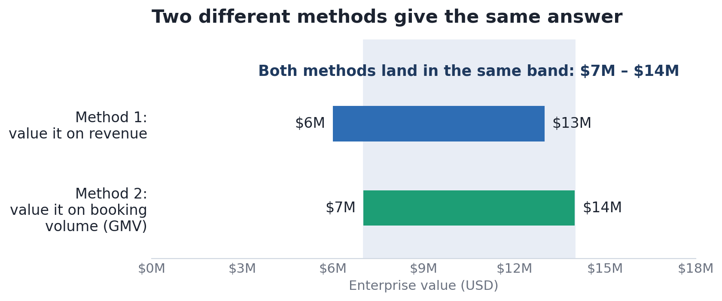
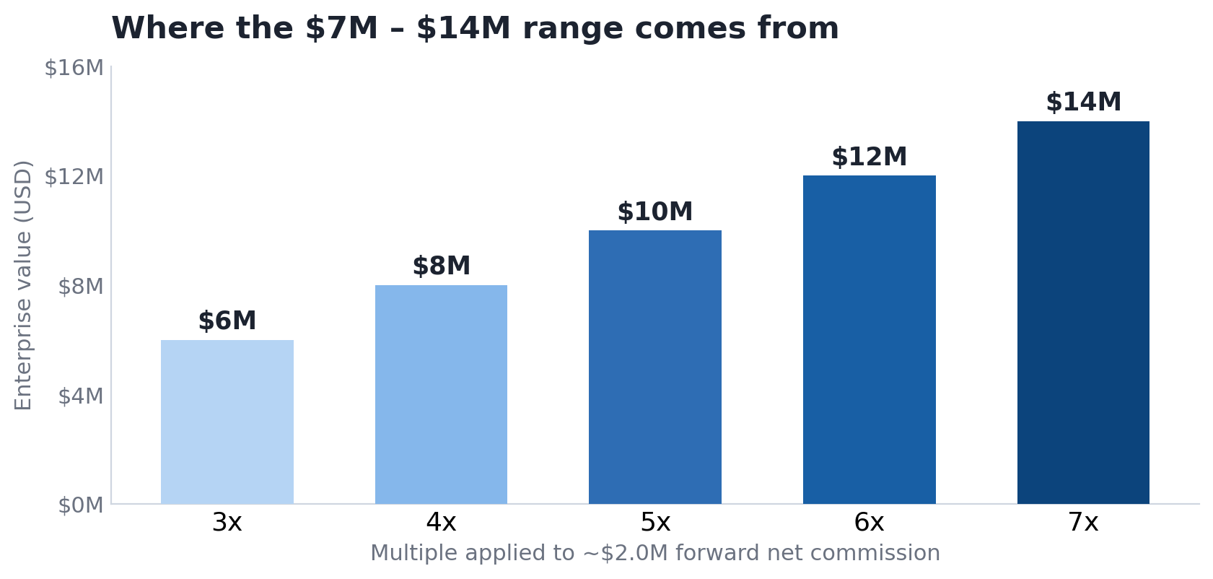

Singapore is the swing factor
Singapore is the lead market and the single largest determinant of group value, and while it remains the weakest element, it no longer fails outright. It still loses money over the 36-month forecast, ending the period in deficit at about $1.04M, but a move to a 15% take rate (now at the market median) and a leaner cost base have roughly halved that loss. Its implied break-even commission rate has fallen to the mid-30s percent, still above anything the market would bear, which means the residual issue is structural cost rather than pricing, with operating expense still running at a multiple of net commission. This matters in two directions. Singapore is the principal drag on the blended number now, and it remains the largest single source of further upside if management can keep tightening the cost base. Until more of that discipline is visible on paper, the prudent stance is to treat Singapore as improving but not yet a value driver.

Key upsides to note
- Dubai and Boston carry genuine optionality:
  - Dubai is already profitable in-model in a high-occupancy marketL Boston is the largest GMV pool in a large, fast-growing US flex market: Both reward executing rather than relying on optimistic assumptions
- Near-breakeven is within reach:
  - The Upside scenario brings the group to roughly breakeven, so a credible path to positive group BITDA, the trigger that would move MillionSpaces from venture pricing toward an earnings multiple, is not far off

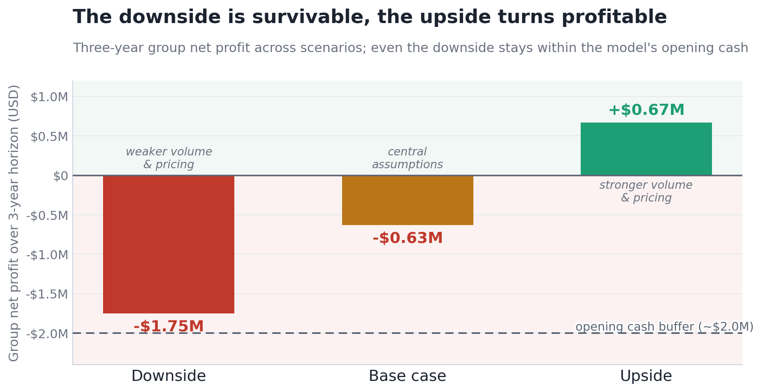

Investment Conclusion
MillionSpaces is a credible early-stage marketplace that we value at an illustrative $7M to $14M, anchored on a discounted multiple of forward commission revenue and confirmed by a GMV cross-check. Our stance is neutral but strengthening. The business is no longer deeply loss-making: the group loses about $0.63M over the three-year horizon, roughly half the prior estimate, and crosses into profit in Year 2, with a credible upside case of +$0.67M and a downside of about -$1.75M that stays within the funding buffer the model assumes. The case rests on execution rather than current earnings, and one risk dominates the rest: Singapore still does not cover its own cost base, so cost discipline is the single biggest swing factor for both the valuation and the path to group profitability. We would move from neutral toward constructive once four things are in hand: Sri Lanka's trading actuals (the proven market the model leaves out), a clear view of how the launch is funded and the runway it buys, a single designated base case, and unit economics, CAC, repeat rate and churn, beneath the assumed booking growth. On the current evidence the asset is fairly priced for its risk, with genuine room to re-rate as those items are delivered.

Key Investment Themes

Multi-Faceted Experience

Industry driven by physical immersion, integrated hospitality, and multi-generational appeal

Advanced all-weather infrastructure (e.g., tropical waterpark, c. 400m snow slope) removes seasonality

Strategic Convening & Elite Sports

Marquee partnerships (GB Snowsport, Snowsport Cymru Wales) drive brand equity and global credibility

Hosting regional, national, and international competitions serves as a core revenue and engagement engine

Defensibility

Operators like SnowWorld lead in combining high-capacity indoor sports with integrated hospitality

High barriers to entry and £255,544,000 project cost ensure growth through monopolistic regional delivery

Global Hub Strategy
The MillionSpaces expansion thesis is anchored by a high performance trajectory in Western and Middle Eastern markets. Boston and Dubai specifically demonstrate highly efficient cash conversion and validate the core platform technology. Boston is projected to achieve profitability early in Year 2, establishing a blueprint for global margin expansion. The strategic opportunity moving forward is to take the operational efficiencies perfected in these lead markets and systematically apply them to the Asian footprint. By optimizing the fixed cost structure in Singapore to mirror Dubai, the company can unlock significant enterprise value and align global profitability.

Commission Strategy for Market Penetration
To rapidly acquire inventory and secure dominant market share in highly competitive regions, MillionSpaces has modelled competitive commission rates. This aggressive go to market strategy is designed to undercut local incumbents and quickly onboard premium workspace operators. As the platform achieves critical mass and becomes a primary lead generation source for these operators, MillionSpaces will possess the pricing power to gradually normalize take rates back to the industry standard of 15 percent. This transition from an acquisition focused rate to a mature margin structure represents a clear, actionable path to multiplying revenue on existing transaction volume.
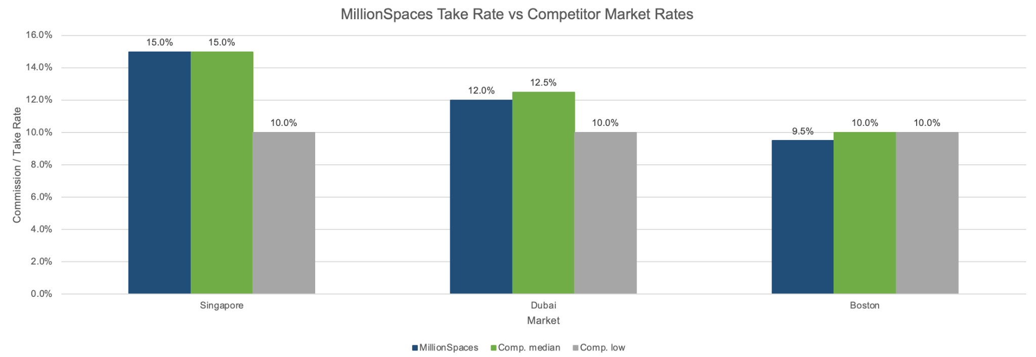

Competitors and Industry Context
Leading global peers in this space include IWG (Regus) and LiquidSpace, two companies that have successfully integrated asset-light marketplace dynamics and recurring enterprise bookings into scalable commercial platforms. Companies like IWG and LiquidSpace are full-spectrum workspace distributors, delivering high-value booking solutions across global markets. These firms blend real-time inventory management and algorithmic pricing to serve enterprise and freelance professionals at scale.
Their performance illustrates the market’s appetite for high-retention, experiential platforms:
- IWG reported record system-wide revenue in recent years by aggressively pivoting to capital-light partnership agreements rather than traditional heavy leases.
- LiquidSpace continues to capture market share by operating strictly as a marketplace, taking a commission without holding any physical real estate risk.
Both firms maintain scalable margin structures, recurring enterprise bookings, and control of proprietary marketplace tech, characteristics also central to MillionSpaces’ value proposition
The Need for Grounded Valuation and Physical Capacity limits
While the platform utilizes highly scalable booking software, the most defensible financial projections account for the physical constraints of partner real estate. The updated diligence framework appropriately models growth along a logistic curve, recognizing that partner facilities will eventually reach natural utilization caps. Moving away from infinite software compounding assumptions presents stakeholders with a mature, realistic forecast. This ensures the enterprise valuation is grounded in commercial real estate realities rather than inflated digital metrics, providing stakeholders with a highly reliable growth thesis.
Dynamic Customer Acquisition Scaling required
The current model demonstrates the platform's ability to efficiently onboard early adopters and independent professionals. To maintain this growth velocity as the business scales, the strategy moving forward incorporates a dynamic performance marketing budget. Anticipating the natural rise in customer acquisition costs allows MillionSpaces to proactively allocate capital and outbid local competitors for premium enterprise leads. Building a robust and scalable marketing engine protects the company's top of funnel dominance and secures its long term market share across all four global expansion hubs.

High-Yield Ecosystem & Cross-Pollination
Rhydycar West is a hospitality ecosystem. By offering a 198-bedroom family resort wing , a 100-bedroom luxury spa wing , a 120-bedroom sport and value wing , and up to 30 free-standing luxury woodland lodges, the site cross-pollinates high-margin room rates with high-margin attractions. The Woodland Lodges alone are projected to operate at a massive 61.2% EBITDA margin by Year 5.
Scarcity and Defensibility
High barriers to entry which are driven by complex planning permissions and massive infrastructure scale that makes assets like Rhydycar West highly defensible. The total estimated project cost is £298,916,000. There is currently no comparable "like-for-like" integrated competition in the UK market.

Company Analysis and Financial Insights
IWG plc | LiquidSpace
IWG plc operates multiple flexible workspace facilities globally, proving the vast demand for agile and hybrid office solutions. The company, listed on the London Stock Exchange, welcomes millions of professionals annually across its expansive global footprint. Their flagship Regus and Spaces brands alone drive significant daily footfall in prime tier one commercial real estate markets.  Historically generating record system wide revenues approaching £3.3 billion, the company has deployed a strategy of retaining capital by shifting aggressively toward capital light partnership agreements. This aligns perfectly with modern real estate trends, proving that operating as a technology and management layer can sustain massive, highly profitable enterprise adoption without holding heavy lease liabilities. | Operating as a pure play digital aggregator, LiquidSpace has proven the intense enterprise willingness to pay premium prices for flexible booking software. By connecting companies directly with empty desks and private offices, LiquidSpace operates a highly lucrative marketplace model. This translates to an incredibly efficient operating margin, as the platform takes a commission without holding any physical real estate risk.  LiquidSpace's emphasis on frictionless, high speed bookings aligns directly with modern agile workforce trends. To capture secondary enterprise spend, the company has aggressively expanded its software footprint, acquiring key partnerships globally. Its success indicates a mature, high spending corporate target market that a fully integrated aggregator could tap into immediately.
Exhibit 2: Comparative Summary

Company | Key Activities | Key Financial Metric | Alignment with Trends
IWG plc | Flexible office  management,  Coworking brands | ~£3.3B Revenue  (2023), Capital-light  expansion | Enterprise hybrid work,  Landlord partnerships
LiquidSpace | Real-time workspace  booking software | Pure marketplace  commission, Zero lease  liability | SaaS infrastructure,  Friction-free enterprise  booking
MllionSpaces (Context) | Coworking aggregator,  Meeting rooms | $7.61M SG GMV (36-  mo), 15% Comm.  Structure | Asset-light scaling, Lean  CapEx market entry
Source: Rosmead Partners

Conclusion:
MillionSpaces presents a highly compelling growth opportunity anchored by a refined, capital efficient global expansion strategy. By securing a standardized 15 percent commission rate across its emerging markets and drastically reducing upfront capital expenditures, the platform has successfully repaired its localized unit economics. This strategic pivot ensures that the aggressive transaction volume already proven in profit engines like Boston and Dubai will translate directly into global margin expansion. The company is now positioned to capture significant transaction value without the burden of unsustainable fixed overhead, establishing a clear and accelerated timeline to global profitability.

Furthermore, the enterprise operates with a highly defensible, asset light marketplace infrastructure that perfectly aligns with modern commercial real estate trends. By avoiding heavy, long term lease liabilities, MillionSpaces can dynamically scale its booking technology across global hubs while maintaining maximum capital flexibility. As the platform matures, deploying targeted performance marketing will allow it to consistently capture premium enterprise demand and outbid regional competitors. Grounded in the physical realities of facility utilization rather than inflated digital metrics, this optimized model offers investors a mature, highly scalable asset with a clear trajectory toward commanding a dominant position in the flexible workspace sector.

Transformation in the Experiential Leisure Sector

Weather-Proof Infrastructure & Innovation

The c. 550-acre resort utilizes climate-controlled environments to provide an experiential destination for enjoyment all year round.

Operations are anchored by a c. 400m indoor snow slope and an indoor tropical waterpark, removing the friction of seasonality.

Integrated Ecosystems & Diversified Revenue

The resort offers multiple types of accommodation to cater to different visitor preferences and budgets, effectively capturing secondary spend.

The hospitality model cross-pollinates attractions with a 198-bed Family Resort Wing, a 100-bed Luxury Spa Wing, a 120-bed Sport Wing, and up to 30 Woodland Lodges.

Frictionless Booking Innovation
The commercial real estate sector is undergoing a massive structural transformation, moving away from rigid, long term leases toward highly engineered, on demand workspace aggregation. By investing heavily in seamless digital booking environments, operators can guarantee high velocity, year round revenue generation. MillionSpaces exemplifies this shift, anchoring its operations not in physical concrete, but in a centralized digital marketplace. Coupled with advanced inventory management, the platform utilizes innovative software infrastructure to remove the friction of traditional commercial leasing and drive consistent, scalable bookings across international hubs.
High Barriers to Entry and Regional Market Dominance
Strategic supplier acquisition and massive network scale are prevalent in the sector as operators seek to establish dominant regional ecosystems. Building a two sided marketplace requires complex funding and localized relationship building. However, once established, these high barriers to entry create a highly defensible market position. By capturing the primary inventory of local coworking operators early, MillionSpaces positions the project to capture unmatched regional and national market share before secondary competitors can establish liquidity.

Macro Economic Resilience and the Hybrid Work Boom
In the face of global economic challenges and inflationary pressures, premium flexible workspace platforms are demonstrating remarkable resilience. The global workforce boasts millions of active hybrid professionals, making the transition to remote enabled infrastructure a permanent macroeconomic shift. Despite this massive demand, many markets lack a centralized, frictionless aggregator capable of hosting enterprise level teams seamlessly. By providing a scalable alternative to expensive, long term corporate leases, MillionSpaces taps directly into this counter cyclical growth trend, ensuring sustained demand regardless of broader commercial real estate downturns.

High Barriers to Entry and Monopolistic Scale
Strategic capital deployment and massive infrastructure scale are prevalent in the sector as operators seek to establish monopolistic regional assets. With a total estimated whole project cost of £298,916,000, assets like Rhydycar West face complex planning and funding requirements. However, once established, these high barriers to entry create a highly defensible market position. There is currently no "like-for-like" integrated competition in the UK market, positioning the project to capture unmatched regional and national market share.
Sustainable Development and Ecosystem Synergies
Strategic capital deployment and massive infrastructure scale are prevalent in the sector as operators seek to establish monopolistic regional assets. With a total estimated whole project cost of £298,916,000, assets like Rhydycar West face complex planning and funding requirements. However, once established, these high barriers to entry create a highly defensible market position. There is currently no "like-for-like" integrated competition in the UK market, positioning the project to capture unmatched regional and national market share.
Sustainability and Social Responsibility
Sustainability and social responsibility are increasingly important in the media sector, with companies adopting eco-friendly practices, promoting diversity and inclusion, and supporting social causes. These initiatives enhance brand image and attract socially conscious consumers. Media companies investing in sustainable practices are better positioned to meet the growing demand for corporate responsibility.
Multi-Generational and Immersive Leisure
The rise of immersive, multi-faceted physical environments is transforming the traditional theme park landscape. Mega-resorts are designing specific, tailored zones to capture every demographic in a single visit. Rhydycar West's inclusion of an indoor and outdoor adventure centre (featuring zip wires and climbing walls), alongside a luxury spa and a tropical waterpark, ensures a dynamic, multi-generational appeal. This comprehensive offering extends dwell times, creates new secondary revenue streams, and positions the resort as a multi-day destination.
Macro-Economic Resilience and the “Staycation” Boom
In the face of economic challenges and inflationary pressures, premium domestic tourism platforms are demonstrating remarkable resilience. The UK boasts over 6 million active skiers, making it the fourth largest country by active skiers in Europe. Despite this massive domestic demand, the UK currently lacks a facility capable of hosting international competitions. By providing a world-class alternative to expensive overseas travel, Rhydycar West is perfectly positioned to capture the booming "staycation" market, ensuring resilience against broader macroeconomic volatility.

Forecasts & Assumptions

EBITDA Margin Outlook

Indoor Snow margin stable at 36.4% (2026) to 36.7% (2030) with minimal expansion across the forecast

Cost lines modelled as fixed % of revenue

Segment Growth Assumptions (2026)

Indoor Snow: Anchor asset at 991 Year 1 visitors, growing just 0.24% p.a. To 2030

Hotels & Lodges: Three hotels plus lodges providing accommodations cross-sell into the snow attraction

Capital Structure & Valuation

93.3% debt- financed / 6.7% equity leads to high financial leverage which amplifies equity risk

WACC: 9.2% (Base), 8.0% - 11% range being sensitivity tested

2026-2028 Revenue Forecasts

FY2026: Site-wide NOCF £16.4m, led by Indoor Snow as the dominant cash contributor

FY2027: NOCF grows to £17.7m (+8%) as hotels and lodges reach stabilised occupancy

FY2028: NOCF reaches £18.8m, with Adventure Centre and Waterpark settling into mature run-rate

Historical Analysis
MillionSpaces enters its three target markets from a genuinely proven base, but one that sits outside the model. In Sri Lanka, bookings grew from 12,428 in 2023 to 38,425 in 2025 (+115%), with 115,000+ projected for 2026, at roughly 3x marketing ROI, and a UK healthcare joint venture was added in 2026. The model deliberately excludes this trading history and forecasts only the three new markets (Singapore, Dubai, Boston) from a standing start in September 2026. That is conservative for the company as a whole, since the one market with demonstrated unit economics contributes nothing to the modelled numbers.

Revenue Forecasts
Revenue is entirely commission earned on host GMV, net of local sales taxes. The three markets generate $31.7M of GMV across the 36-month horizon, converting to $3.45M of net commission. The build by year is heavily back-loaded:
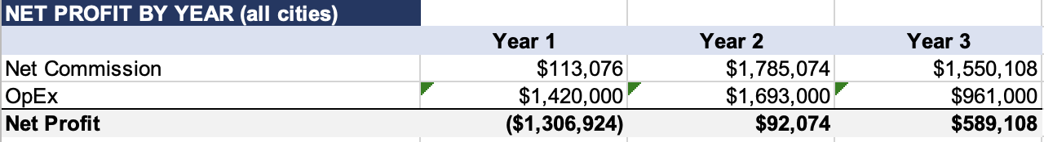

Exhibit 3: Valuation Snapshot
Source: Rosmead Partners

Why does revenue ramp so steeply from year 1 to Year 2
This is the single most aggressive assumption in the model and the one to scrutinise. Year 1 is small for two structural reasons: the September launch means the first quarter (Sep to Nov 2026) earns nothing while the platform is set up, and the first paying month is December, into a slow ramp that compounds off a near-zero base. Year 2 is therefore the first full year of operation across all three cities at scale, which produces the step change from $0.11M to $1.79M of net commission. The forecast assumes that ramp holds without a seasonality haircut, so it is the assumption most worth pressure-testing against real booking data.

Profitability Outlook
Because the business is pre-profit and asset-light, the right lens is not an expanding EBITDA margin but the path from loss to profit. The group loss narrows from $1.31M in Year 1 to a small profit in Year 2, then widens to $0.59M in Year 3 as Singapore's cost base falls and the two profitable markets mature. Over the full horizon the group margin is -18% of net commission, driven there almost entirely by Singapore. (The loss-to-profit bridge is shown in the path-to-profitability chart already prepared.)

Exhibit 4: Segment (Market) Growth Assumptions

Market | Take Rate | Outlook | Justification
Singapore | 15% (net 13.65% after 9% GST) | Investment Phase | Now priced at the market median, not below it. Loss of $1.04M over the horizon; the constraint is its cost base, not pricing, and the loss has roughly halved after the rate increase and cost cut.
Dubai | 12% (net 11.4% after 5% VAT) | Strongest Unit | Priced just below the ~12.5% median in a tight, high-occupancy market; +$0.30M at a 26% margin.
Boston | 9.5% (no sales tax) | Largest GMV, thin margin | Largest GMV pool ($15.7M) but priced at the ~10% floor; +$0.12M at an 8% margin, with most GMV resting on the private-office price assumption.

Source: Rosmead Partners
Key Modelling Assumptions

- No property capex and no leases
  - The platform owns no space, so there’s no capital-asset line and no depreciation
- No debt
  - There is no interest cost and no capital structure to weight, which is why a WACC and a terminal-value DCF are not used. Valuation instead rests on a forward net-commission multiple cross-checked against GMV
- Working capital set to nil
  - The model assumes no timing lag between collecting GMV and paying hosts. In reality a marketplace carrier host-payout and tax-remittance timing, so this is a red flag to raise

Other Assumptions:

Commission net of tax: Local sales taxes (9% GST in Singapore, 5% VAT in Dubai, non in Boston) are deducted to give net commission the only revenue line

Exhibit 5: Segmented revenue forecasts for 2030
Red Flags | Justification
Margin Asymmetry | The current projections apply aggressive month-over-month compounding to booking volumes well into Years 2 and 3. This operates under the assumption of infinite demand and zero market saturation. In reality, physical spaces hit utilization caps. As partner facilities reach 80% to 85% capacity, the exponential growth curve will inevitably flatten, requiring a fundamental adjustment to the terminal valuation.
Customer Acquisition Costs | The projections model a scenario where total transaction volume increases tenfold, yet marketing and operational expenses remain virtually static. Customer Acquisition Cost (CAC) will aggressively degrade as the platform is forced to bid for colder audiences and service an exponentially larger user base.
Source: Rosmead Partners

Scenario and Risk Analysis
s

Range of Scenarios:
To stress test our assumptions, we have considered high and low scenarios varying the discount rate (8.0% to 11.0%) and the terminal multiple (12.0x to 17.0x). The lower bound reflects execution risk and slower hotel uptake, while the upper bound incorporates rapid stabilization and higher margin realization on the Snow and Waterpark assets.

Exhibit 6: Upside Scenario
Upside Driver | Description | Valuation Impact
Public Sector Grants | Securing Government funding for the £94.0M Public Realm Capex | Removes the £45.2M valuation drag = ↑ Base Case EV
Accelerated Hotel Ramp | Reaching 80%+ occupancy in Years 1-2 due to integrated marketing. | Higher early cash flows = ↓ Debt servicing risk
Premium Pricing Power | Increasing ticket yields on Indoor Snow and Waterpark above inflation. | Enhances operating leverage = ↑ Margin = ↑ Terminal Value
Source: Rosmead Partners

Exhibit 7: Downside Scenario
Downside Driver | Description | Valuation Impact
Terminal Multiple Contraction | Exit multiple drops to 12.0x due to shifting macroeconomic leisure trends. | Heavy DCF impact = ↓ EV to £198m–£224m range
Interest Rate / Debt Risk | Inability to secure the 5.0% debt rate on the £278.9M requirement. | ↑ Cost of Capital = ↓ Free Cash Flow = ↓ Equity Value
Construction Overruns | Capex exceeds the £298.9M budget due to supply chain or labor issues. | Requires emergency equity injection = ↑ Dilution
Source: Rosmead Partners

Exhibit 8: Sensitivity Analysis
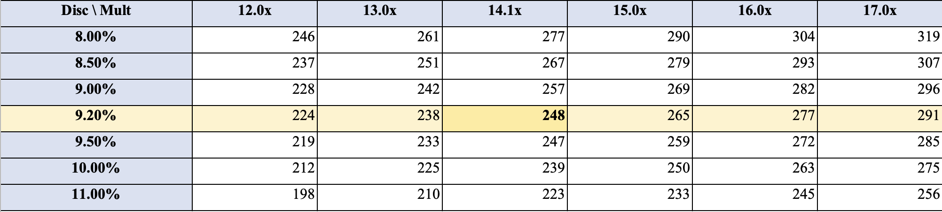
Source: Rosmead Partners

*Important information
This report has been provided by Rosmead Partners Management Consultancies Co. LLC an entity registered in the UAE. We have prepared this report at the request of Rhydycar West based on the information provided to us by this entity, combined with publicly available information. We have used this information in good faith and have not tested its veracity. The report does not represent investment advice and does not constitute an investment recommendation. The report is not for public distribution. We are providing this report to our client, and it is not to be relied upon by (nor do we undertake any legal or professional duty towards) any other entity.

