ARENA
Gaming Communities Platform

Database Design Report
Exploratory Data Analysis | Entity-Relationship Design | Normalization to 3NF | Relational Schema

Prepared by: Faizan Toheed, Muhammad Rohan Jabbar, Muhammad Usman
May 2026
Course: Database Management Systems (DBMS)

1. Project Overview

1.1 Platform Description
ARENA is a unified gaming platform where fragmented gaming communities come together. It provides detailed information about the most successful communities, including player statistics, primary platforms, games they sponsor, and insights into their top games.
The platform aggregates data from 400 gaming communities worldwide and tracks key performance indicators such as membership size, active player ratios, tournament activity, and social media footprint.

1.2 Objective
This report documents the complete database design pipeline for the ARENA platform, covering:
- Exploratory Data Analysis (EDA) of the raw gaming communities dataset
- Identification of entities, attributes, and relationships from the cleaned data
- Entity-Relationship (ER) modelling using Crow's Foot notation
- Normalization of the flat dataset up to Third Normal Form (3NF)
- Derivation of the final relational schema with all keys and constraints defined

1.3 Dataset Summary
The original dataset (gaming_communities.csv) contained 400 rows and 28 columns covering community profiles, player metrics, social media sizes, geographic information, and platform data. After cleaning, 357 valid records remained across 22 attributes.

2. Exploratory Data Analysis (EDA)

2.1 Session 1 — Dataset Loading and Inspection
The raw CSV was loaded into a Pandas DataFrame. Initial inspection revealed the following:
- Shape: 400 rows × 28 columns
- 15 numeric columns (float64 / int64); 13 non-numeric (object) columns
- Several columns had significant missing values (notably twitch_stream_viewers_avg with 302 nulls, monthly_revenue_usd with 302 nulls, win_rate_pct with 288 nulls)
- Anomalies identified: year_founded contained impossible future years (e.g. 3005, 2087)
- community_id was confirmed as the most unique column, with 400 distinct values
- FPS was the most represented genre, followed by Battle Royale and MOBA

2.2 Session 2 — Data Cleaning and Preprocessing
A working copy of the dataset was created and the following transformations applied:
- Rows with null active_players were dropped, reducing the dataset from 400 to 357 rows
- avg_member_age null values were filled with the column median to reduce outlier bias
- secondary_game nulls were replaced with the string 'None' (game is optional)
- Columns exceeding 60% null threshold were dropped: average_prize_pool_usd, twitch_stream_viewers_avg, win_rate_pct, monthly_revenue_usd
- year_founded was forward-filled and cast to Int64; future-year anomalies (> 2026) replaced with NaN
- Zero-variance columns removed: sponsorship, verified_account, recruitment_open
- member_count extreme values clipped at the 99th percentile
- 229 rows with duplicate community names were identified (not dropped, as names can repeat across different communities)
- All remaining nulls filled (region/country → 'Unknown', tournaments_hosted → 0); final null count = 0
- community_id reset to sequential range 1–357 after row drops

2.3 Session 3 — Grouping, Aggregations & Feature Engineering

Part A–C: Single and Multi-Level Groupings
- Fighting genre had the highest average member count (~5,596 members)
- SemiPro tier hosted the most tournaments (525 total)
- Twitter/X had the highest median active players per platform (311.0)
- EU had the widest age spread (min 14.0, max 37.9 average member age)
- English (141 communities), Spanish (62), and Portuguese (32) were the top three languages
- Asia + Twitch pairing had the highest average active players (~3,696)
- 2019 FPS communities had the highest total member count (158,947)

Part D: Ranking and Filtering
- Only 18.8% of communities had a member count above their regional average
- Reaper Crew (FPS) had the highest member count in its genre at 68,819
- Genres with total tournaments <= 50 (MMORPG, Strategy, Fighting) were identified as low-activity

Part E: Feature Engineering
Ten derived columns were engineered from the base attributes:
Feature Column | Formula / Method | Key Insight
engagement_ratio | active_players / member_count | Battle Royale & MMORPG highest (~0.45)
tier_score | Amateur=1, SemiPro=2, Professional=3, Elite=4 | Asia had highest avg tier (1.63)
age_group | pd.cut() on avg_member_age [0,18,25,35,100+] | Segments: Teen / Young Adult / Adult / Senior
community_age | 2025 - year_founded | Measures organisational maturity
has_coaching | True if coaching_staff > 0 | 100% of Elite/Professional have coaching
has_multiple_platforms | discord_server_size > 0 AND reddit > 0 | Only 51.5% maintain both channels
log_member_count | np.log1p(member_count) | Confirms log-normal distribution
tournament_intensity | tournaments_hosted / (member_count / 1000) | Normalised competitive activity rate
top_player_tier | pd.qcut() into 3 quantiles: High/Medium/Low | Lower rank number = better (High tier)
total_social_presence | discord + reddit + (content_creators × 1000) | Pulse Nation highest at 123,596

2.4 Session 4 — Key Visualisation Findings
- M1 Histogram: log_member_count follows a roughly bell-shaped (log-normal) distribution; most communities cluster between log values 6 and 9
- M2 Bar Chart: Battle Royale and MMORPG genres have the highest average engagement ratios
- M3 Scatter: Strong positive linear relationship between member_count and active_players across all tiers; Elite communities deviate above the trendline
- M4 Boxplot: Discord and Reddit platforms show the widest spread in tournament_intensity
- M5 Dual-axis: Older communities generally show higher social presence, though some young communities exhibit rapid early growth
- M6 Violin: Average member ages broadly similar across regions (typically 20–32); EU shows wider spread
- Plotly interactive charts confirmed Discord as the dominant primary platform across all regions

3. Entity Identification and Data Dictionary

3.1 Entity Table
Based on the cleaned dataset and attribute analysis, five logical entities were identified. Derived/computed columns from feature engineering (engagement_ratio, tier_score, etc.) are excluded from the physical schema as they are calculated at query time.

Entity | Description / Purpose | Primary Key | Foreign Key(s) | References
Community | Core profile, sizes, and performance metrics of each gaming organisation | community_id | location_id, platform_id | Location, Platform
Game | Master list of distinct video games played by communities | game_id | None | N/A
Location | Geographic and demographic attributes — avoids redundancy in Community | location_id | None | N/A
Platform | Communication platforms used as operational hubs by communities | platform_id | None | N/A
Community_Game | Junction table resolving the Many-to-Many relationship between Community and Game | (community_id, game_id) Composite | community_id, game_id | Community, Game

3.2 Attribute Data Dictionary

Entity: COMMUNITY
Attribute | Data Type | Key Type | Description
community_id | INTEGER | PK | Unique identifier for each community
community_name | VARCHAR(100) | — | Official name of the gaming group
year_founded | INTEGER | — | Year the community was established
member_count | INTEGER | — | Total registered members in the organisation
active_players | INTEGER | — | Subset of members actively playing games
avg_member_age | DECIMAL(4,1) | — | Average age demographic of members
community_tier | VARCHAR(20) | — | Competitive rank level: Amateur, SemiPro, Professional, Elite
tournaments_hosted | INTEGER | — | Total competitive events hosted
top_player_rank | INTEGER | — | Highest individual player rank within the group
coaching_staff | INTEGER | — | Number of coaches employed or volunteering
content_creators | INTEGER | — | Number of streamers or video creators
discord_server_size | INTEGER | — | Total user count inside their Discord guild
reddit_community_size | INTEGER | — | Total subscriber count on their Subreddit
social_media_platforms | INTEGER | — | Number of distinct social channels used
location_id | INTEGER | FK | Links to geographic details in Location table
platform_id | INTEGER | FK | Links to the primary messaging hub in Platform table

Entity: GAME
Attribute | Data Type | Key Type | Description
game_id | INTEGER | PK | Unique identifier for each video game title
game_name | VARCHAR(100) | — | Title of the game (e.g. Valorant, League of Legends)
genre | VARCHAR(50) | — | Gameplay classification (e.g. FPS, MOBA, Battle Royale)

Entity: LOCATION
Attribute | Data Type | Key Type | Description
location_id | INTEGER | PK | Unique identifier for a geographic/demographic profile
region | VARCHAR(10) | — | Server/continent region (e.g. NA, EU, AS, OC)
country_of_origin | VARCHAR(60) | — | Country where the community is primarily based
language | VARCHAR(40) | — | Primary language spoken by community members

Entity: PLATFORM
Attribute | Data Type | Key Type | Description
platform_id | INTEGER | PK | Unique identifier for an online platform service
primary_platform | VARCHAR(30) | — | Service name (e.g. Discord, Reddit, Twitch, YouTube)

Entity: COMMUNITY_GAME (Junction Table)
Attribute | Data Type | Key Type | Description
community_id | INTEGER | PK, FK | Links to the associated Community record
game_id | INTEGER | PK, FK | Links to the associated Game record
play_designation | VARCHAR(15) | — | States whether the game is 'Primary' or 'Secondary'

3.3 Relationships and Cardinality

Left Entity | Right Entity | Relationship | Cardinality | Business Rule
Location | Community | Hosts | 1:N | One Location hosts many Communities; each Community has exactly one Location
Platform | Community | Houses Hub For | 1:N | One Platform serves as hub for many Communities; each Community picks exactly one primary hub
Community | Community_Game | Has Assignments | 1:N | One Community can have many game rows in the junction table (one per game played)
Game | Community_Game | Is Played By | 1:N | One Game can appear many times in the junction table (across many communities)
Community | Game | Plays (resolved via junction) | M:N | Many Communities play Many Games. Resolved through Community_Game junction table

4. Entity-Relationship Diagram (Crow's Foot Notation)
The diagram below presents the ARENA database using Crow's Foot notation. Each entity is shown as a box with its attributes listed. Relationship lines use the standard Crow's Foot symbols: a double bar (||) at the 'one' end and a crow's foot (diverging lines) with a circle at the 'many/optional' end.

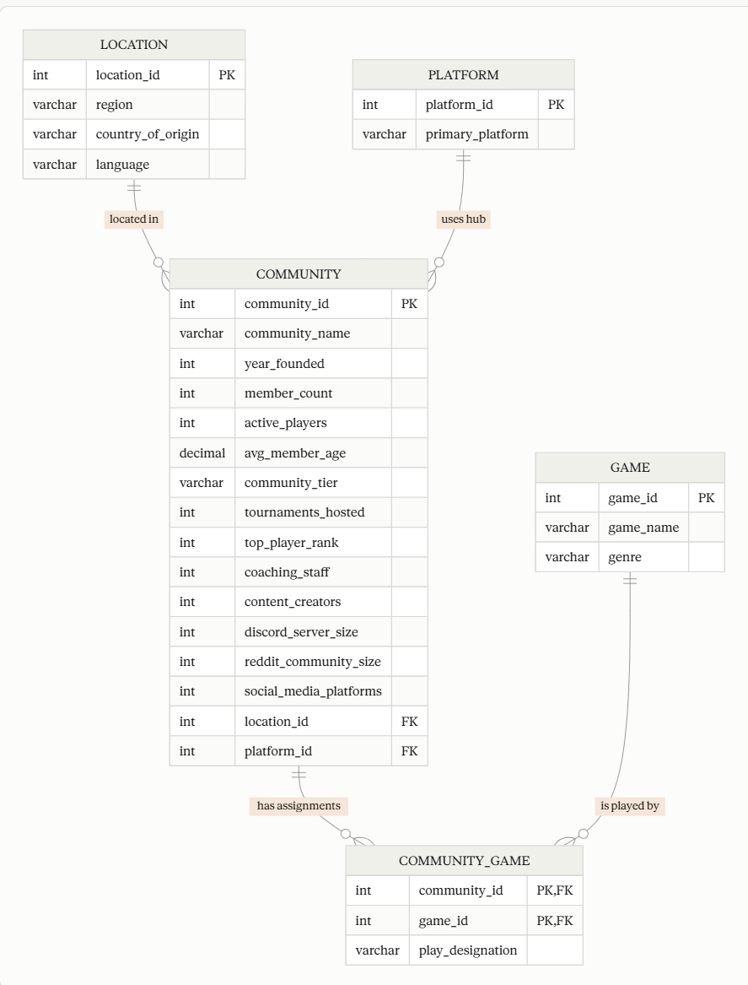

Figure 1 — ARENA Crow's Foot Entity-Relationship Diagram

4.1 Diagram Notes
- Location and Platform are lookup/reference entities with no foreign keys of their own — they serve as the 'parent' end of 1:N relationships
- Community is the central/core entity, linking to both lookup tables and to Game through the junction table
- Community_Game (shown with a dashed border) is a bridge/junction table with a composite primary key (community_id, game_id)
- The M:N relationship between Community and Game is fully decomposed — it cannot be represented by a direct foreign key and requires the junction table
- Derived columns from EDA (engagement_ratio, tier_score, community_age, etc.) are NOT stored in the physical schema; they are computed at query time

