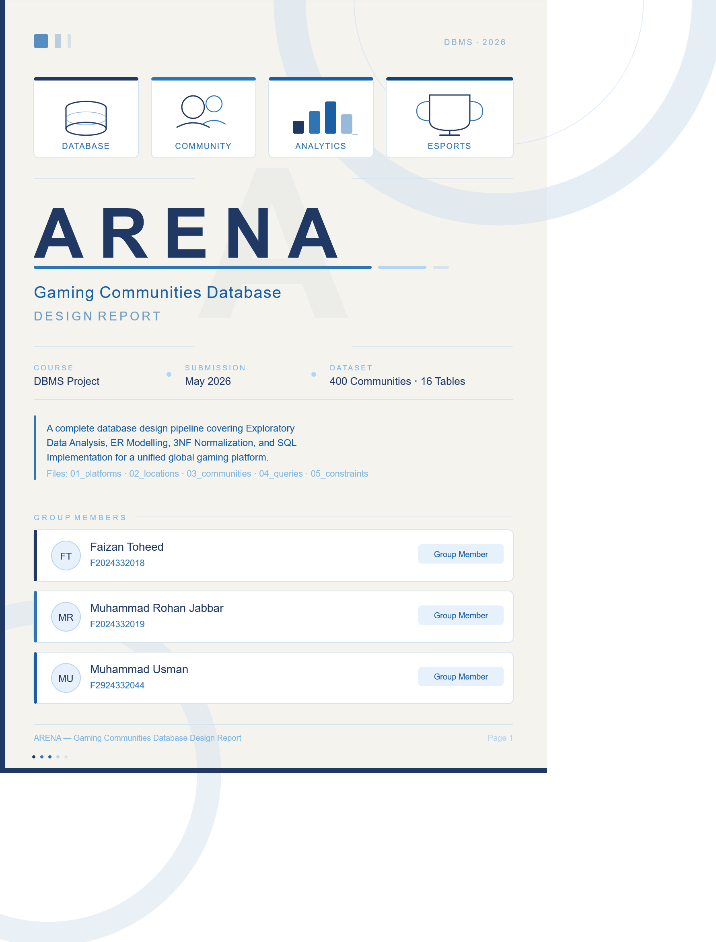

Table of Contents
Table of Contents 2
1. Project Overview 4
1.1 Platform Description 4
1.2 Objective 4
1.3 Dataset Summary 4
2. Exploratory Data Analysis (EDA) 5
2.1 Session 1 — Dataset Loading & Inspection 5
2.2 Session 2 — Data Cleaning & Preprocessing 5
2.3 Session 3 — Grouping, Aggregations & Feature Engineering 5
2.4 Session 4 — Key Visualisation Findings 6
3. Entity Identification & Data Dictionary 7
3.1 Logical Entities 7
3.2 Relationships & Cardinality 7
4. Entity-Relationship Diagram (Crow's Foot Notation) 8
4.1 Diagram Notes 8
5. Physical Schema — Entities & Attributes 9
5.1 Master Entity Overview 9
5.2 Attribute Data Dictionaries 10
COMMUNITY 10
COMMUNITY_MEMBERSHIP / COMPETITION / STAFF 10
COMMUNITY_SOCIAL_MEDIA & COMMUNITY_GAME 10
Geographic & Lookup Tables 11
5.3 Relationships & Cardinality (Physical Schema) 11
6. Database Normalization 13
6.1 Introduction 13
6.2 Original Structure (UNF) 13
6.3 Functional Dependency Analysis 13
6.4 First Normal Form (1NF) 13
6.5 Second Normal Form (2NF) 14
6.6 Third Normal Form (3NF) 14
6.7 Final 3NF Functional Dependencies 14
6.8 Normalization Stages Summary 15
7. SQL Implementation 16
7.1 File Execution Order 16
7.2 File 01 — Platforms & Games 16
7.3 File 02 — Locations & Countries 17
7.4 File 03 — Communities 17
Reporting Views 18
7.5 File 04 — Analytical Queries 19
7.6 File 05 — Constraints & Indexes 20
Phase 1 — CHECK Constraints & DEFAULT Values 20
Phase 2 — NOT NULL & UNIQUE Constraints 20
Phase 3 — Performance Indexes 20
7.7 Schema Summary 21

1. Project Overview

1.1 Platform Description
ARENA is a unified platform aggregating data from 400 gaming communities worldwide. It tracks membership size, active player ratios, tournament activity, social media footprint, and game assignments for the most successful communities globally.

1.2 Objective
This report documents the complete database design pipeline for ARENA, covering:
- Exploratory Data Analysis (EDA) of the raw gaming communities dataset
- Entity identification, ER modelling using Crow's Foot notation
- Normalization from flat CSV to Third Normal Form (3NF)
- SQL implementation across five structured files

1.3 Dataset Summary
Item | Detail
Source File | gaming_communities.csv
Original Shape | 400 rows × 28 columns
After Cleaning | 357 valid rows, 22 attributes
Numeric Columns | 15 (float64 / int64)
Object Columns | 13 (non-numeric / categorical)
Final Tables | 16 physical tables + 3 reporting views

2. Exploratory Data Analysis (EDA)

2.1 Session 1 — Dataset Loading & Inspection
The raw CSV was loaded into a Pandas DataFrame. Key findings:
- Shape: 400 rows × 28 columns; several columns had high null counts (twitch_stream_viewers_avg: 302 nulls, monthly_revenue_usd: 302 nulls, win_rate_pct: 288 nulls).
- community_id was the unique identifier (400 distinct values).
- FPS was the most represented genre, followed by Battle Royale and MOBA.
- Anomaly detected: year_founded contained impossible future values (e.g., 3005, 2087).

2.2 Session 2 — Data Cleaning & Preprocessing
A working copy was created and the following transformations applied:
- Dropped rows with null active_players → reduced to 357 rows.
- avg_member_age nulls filled with column median to reduce outlier bias.
- Dropped columns exceeding 60% null threshold: average_prize_pool_usd, twitch_stream_viewers_avg, win_rate_pct, monthly_revenue_usd.
- year_founded forward-filled; future-year anomalies (> 2026) replaced with NaN; cast to Int64.
- member_count extreme values clipped at the 99th percentile.
- Zero-variance columns removed: sponsorship, verified_account, recruitment_open.
- All remaining nulls filled (region/country → 'Unknown', tournaments_hosted → 0); final null count = 0.
- community_id reset to sequential range 1–357 after row drops.

2.3 Session 3 — Grouping, Aggregations & Feature Engineering
Key aggregation findings:
- Fighting genre had the highest average member count (~5,596 members).
- SemiPro tier hosted the most tournaments (525 total).
- Twitter/X had the highest median active players per platform (311.0).
- English (141), Spanish (62), and Portuguese (32) were the top three community languages.
- Asia + Twitch pairing had the highest average active players (~3,696).
- Only 18.8% of communities exceeded their regional average member count.

Ten derived features were engineered from base attributes:
Feature Column | Formula / Method | Key Insight
engagement_ratio | active_players / member_count | Battle Royale & MMORPG highest (~0.45)
tier_score | Amateur=1 … Elite=4 (ordinal map) | Asia had highest avg tier (1.63)
age_group | pd.cut() on avg_member_age [0,18,25,35,100+] | Teen / Young Adult / Adult / Senior
community_age | 2025 − year_founded | Measures organisational maturity
has_coaching | True if coaching_staff > 0 | 100% of Elite/Professional have coaching
has_multiple_platforms | discord > 0 AND reddit > 0 | Only 51.5% maintain both channels
log_member_count | np.log1p(member_count) | Confirms log-normal distribution
tournament_intensity | tournaments / (member_count / 1000) | Normalised competitive activity rate
top_player_tier | pd.qcut() into 3 quantiles | High / Medium / Low ranking tiers
total_social_presence | discord + reddit + (creators × 1000) | Pulse Nation highest at 123,596

2.4 Session 4 — Key Visualisation Findings
- M1 Histogram: log_member_count follows a roughly bell-shaped (log-normal) distribution; most communities cluster between log values 6–9.
- M2 Bar Chart: Battle Royale and MMORPG genres have the highest average engagement ratios.
- M3 Scatter: Strong positive linear relationship between member_count and active_players; Elite communities deviate above the trendline.
- M4 Boxplot: Discord and Reddit show the widest spread in tournament_intensity.
- M5 Dual-axis: Older communities generally show higher social presence; some young communities exhibit rapid early growth.
- M6 Violin: Average member ages broadly similar across regions (20–32); EU shows wider spread.
- Plotly interactive charts confirmed Discord as the dominant primary platform across all regions.

3. Entity Identification & Data Dictionary

3.1 Logical Entities
Five logical entities were identified from the cleaned dataset. Derived EDA columns (engagement_ratio, tier_score, etc.) are excluded from the physical schema — they are computed at query time.
Entity | Description | Primary Key | Foreign Key(s)
COMMUNITY | Core profile, sizes, and performance metrics | community_id | location_id, platform_id
GAME | Master list of distinct video games | game_id | None
LOCATION | Geographic & demographic attributes | location_id | None
PLATFORM | Communication platforms used as hubs | platform_id | None
COMMUNITY_GAME | Junction table: Community ↔ Game (M:N) | (community_id, game_id) | community_id, game_id

3.2 Relationships & Cardinality
Left Entity | Right Entity | Cardinality | Business Rule
LOCATION | COMMUNITY | 1 : N | One location hosts many communities; each community has exactly one location.
PLATFORM | COMMUNITY | 1 : N | One platform serves many communities; each community picks one primary hub.
COMMUNITY | COMMUNITY_GAME | 1 : N | One community can have many game rows in the junction table.
GAME | COMMUNITY_GAME | 1 : N | One game can appear across many communities in the junction table.
COMMUNITY | GAME (via junction) | M : N | Many communities play many games — resolved through COMMUNITY_GAME.

4. Entity-Relationship Diagram (Crow's Foot Notation)
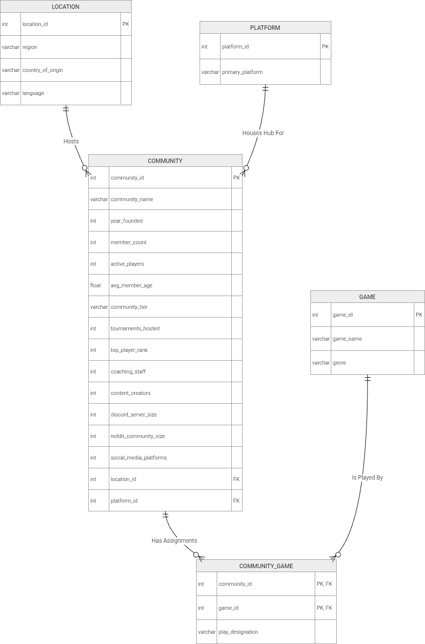

4.1 Diagram Notes
- LOCATION and PLATFORM are reference/lookup entities with no foreign keys — they are the 'parent' end of 1:N relationships.
- COMMUNITY is the central entity, linking to both lookup tables and to GAME via the junction table.
- COMMUNITY_GAME (shown with a dashed border) has a composite primary key (community_id, game_id).
- The M:N relationship between COMMUNITY and GAME cannot be represented by a direct FK — it requires the junction table.
- Derived EDA columns are NOT stored in the physical schema.

5. Physical Schema — Entities & Attributes

5.1 Master Entity Overview
After full 3NF normalization the schema contains 16 physical tables:
Entity | Purpose | PK | FK(s) → References
COMMUNITY | Core community profile | community_id | region_id → COMMUNITY_REGION gaming_platform_id → GAMING_PLATFORM
COMMUNITY_MEMBERSHIP | Member & active player counts | membership_id | community_id → COMMUNITY
COMMUNITY_COMPETITION | Tournaments & top player rank | competition_id | community_id → COMMUNITY
COMMUNITY_STAFF | Coaching & content creator counts | staff_id | community_id → COMMUNITY
COMMUNITY_SOCIAL_MEDIA | Per-platform social media sizes | community_social_id | community_id, social_platform_id
COMMUNITY_GAME | Junction: community ↔ game (M:N) | (community_id, game_id) | community_id, game_id
COMMUNITY_REGION | Region lookup for communities | region_id | —
GAMING_PLATFORM | Gaming hub lookup | gaming_platform_id | —
GAME | Video game master list | game_id | genre_id → GENRE
GENRE | Genre classification lookup | genre_id | —
SOCIAL_PLATFORM | Social channel name lookup | social_platform_id | —
COUNTRY_LOCATION | Country-to-continent mapping | location_id | country_id → COUNTRY
COUNTRY | Country name & language mapping | country_id | language_id → LANGUAGE
LANGUAGE | Language name lookup | language_id | —
PLATFORM | Communication platform lookup | platform_id | platform_type_id → PLATFORM_TYPE
PLATFORM_TYPE | Platform category lookup | platform_type_id | —

5.2 Attribute Data Dictionaries

COMMUNITY
Attribute | Data Type | Key | Description
community_id | INT | PK | Unique identifier for each community
community_name | VARCHAR(255) | — | Official name of the gaming group
year_founded | INT | — | Year the community was established
avg_member_age | DECIMAL(5,2) | — | Average age demographic of members
community_tier | VARCHAR(50) | — | Competitive rank: Amateur / Semi-Pro / Professional / Elite
region_id | INT | FK | Links to COMMUNITY_REGION
gaming_platform_id | INT | FK | Links to GAMING_PLATFORM

COMMUNITY_MEMBERSHIP / COMPETITION / STAFF
Table | Attribute | Data Type | Description
MEMBERSHIP | membership_id | INT PK | Surrogate key
MEMBERSHIP | member_count | INT | Total registered members
MEMBERSHIP | active_players | INT | Subset actively playing games
COMPETITION | competition_id | INT PK | Surrogate key
COMPETITION | tournaments_hosted | INT | Total competitive events hosted
COMPETITION | top_player_rank | INT | Highest individual rank in the group
STAFF | staff_id | INT PK | Surrogate key
STAFF | coaching_staff | INT | Number of coaches employed/volunteering
STAFF | content_creators | INT | Number of streamers / video creators

COMMUNITY_SOCIAL_MEDIA & COMMUNITY_GAME
Attribute | Data Type | Key | Description
community_social_id | INT | PK | Surrogate key for social media row
community_id | INT | FK | Links to COMMUNITY
social_platform_id | INT | FK | Links to SOCIAL_PLATFORM
platform_size | INT | — | Total followers/subscribers on that channel
— (COMMUNITY_GAME) —
community_id | INT | PK, FK | Part of composite key; links to COMMUNITY
game_id | INT | PK, FK | Part of composite key; links to GAME
play_designation | VARCHAR(100) | — | Primary or Secondary designation

Geographic & Lookup Tables
Table | Key Attributes
COUNTRY_LOCATION | location_id (PK), region VARCHAR(100), country_id (FK → COUNTRY)
COUNTRY | country_id (PK), country_name VARCHAR(100), language_id (FK → LANGUAGE)
LANGUAGE | language_id (PK), language_name VARCHAR(100)
PLATFORM | platform_id (PK), primary_platform VARCHAR(100), platform_type_id (FK → PLATFORM_TYPE)
PLATFORM_TYPE | platform_type_id (PK), type_name VARCHAR(100)
GAME | game_id (PK), game_name VARCHAR(255), genre_id (FK → GENRE)
GENRE | genre_id (PK), genre_name VARCHAR(100)

5.3 Relationships & Cardinality (Physical Schema)
Left Entity | Right Entity | Cardinality | Business Rule
COMMUNITY_REGION | COMMUNITY | 1 : N | One region hosts many communities; each community has one region.
GAMING_PLATFORM | COMMUNITY | 1 : N | One gaming platform serves many communities.
COMMUNITY | COMMUNITY_MEMBERSHIP | 1 : 1 | Enforced by UNIQUE constraint on community_id (prevents double-counting).
COMMUNITY | COMMUNITY_COMPETITION | 1 : 1 | Enforced by UNIQUE constraint on community_id.
COMMUNITY | COMMUNITY_STAFF | 1 : 1 | Enforced by UNIQUE constraint on community_id.
COMMUNITY | COMMUNITY_SOCIAL_MEDIA | 1 : N | One community can have multiple social media rows (one per channel).
COMMUNITY | COMMUNITY_GAME | 1 : N | One community can have many game assignments.
GAME | COMMUNITY_GAME | 1 : N | One game can appear across many community assignments.
GENRE | GAME | 1 : N | One genre classifies many games.
LANGUAGE | COUNTRY | 1 : N | One language is spoken in many countries.
COUNTRY | COUNTRY_LOCATION | 1 : N | One country maps to one location/region entry.
PLATFORM_TYPE | PLATFORM | 1 : N | One type categorises many communication platforms.

6. Database Normalization

6.1 Introduction
The original dataset was a flat CSV (400 rows, 28 columns). After cleaning, 357 rows and 22 attributes remained. Normalization progressed from five logical entities to 16 physical tables. Goals: reduce data redundancy, eliminate insertion/update/deletion anomalies, improve integrity and scalability.

6.2 Original Structure (UNF)
The pre-normalization design had five tables: COMMUNITY, GAME, LOCATION, PLATFORM, and COMMUNITY_GAME. The COMMUNITY table was severely overloaded — it held identity, membership, competition, staff, and social media data in a single row. Problems identified:
- Data Redundancy — social and competition metrics stored with every community row.
- Update Anomalies — updating a social stat required rewriting the entire community record.
- Insertion Anomalies — new communities could not record social platform data independently.
- Deletion Anomalies — deleting a community erased all associated statistical data.

6.3 Functional Dependency Analysis
Key dependencies identified before normalization:
- COMMUNITY: community_id → {name, year_founded, member_count, active_players, avg_member_age, community_tier, tournaments_hosted, top_player_rank, coaching_staff, content_creators, discord_server_size, reddit_community_size, location_id, platform_id} — high dependency concentration.
- LOCATION: location_id → region, country_of_origin, language — and country_of_origin → language (transitive dependency triggering 3NF split).
- GAME: game_id → game_name, genre — genre repeats across many games (triggering 3NF split).
- PLATFORM: platform_id → primary_platform, platform_type — type shared across platforms (triggering 3NF split).
- COMMUNITY_GAME: (community_id, game_id) → play_designation — full composite key, no partial dependency.

6.4 First Normal Form (1NF)
Definition: All attributes contain atomic values; no repeating groups; each row uniquely identifiable.
The COMMUNITY table, while technically atomic, grouped multiple unrelated attribute clusters. It was decomposed into five focused tables:
Table Created | Purpose
COMMUNITY | Core profile only: name, year founded, age, tier, region FK, platform FK.
COMMUNITY_MEMBERSHIP | Membership statistics: member_count, active_players.
COMMUNITY_COMPETITION | Competition stats: tournaments_hosted, top_player_rank.
COMMUNITY_STAFF | Staffing data: coaching_staff, content_creators.
COMMUNITY_SOCIAL_MEDIA | Social media metrics: discord size, reddit size.
Tables after 1NF: 9 total.

6.5 Second Normal Form (2NF)
Definition: In 1NF with no partial dependencies — every non-key attribute depends on the full primary key.
The only composite key was in COMMUNITY_GAME: (community_id, game_id). Its sole non-key attribute play_designation depends on the full composite key — no partial dependency exists. All other tables use single-column PKs, making partial dependencies impossible by definition.
Additional refinement: social_media_platforms (a raw count) was replaced with a proper SOCIAL_PLATFORM lookup table and COMMUNITY_SOCIAL_MEDIA junction, enabling per-platform size queries. Tables after 2NF: 10 total.

6.6 Third Normal Form (3NF)
Definition: In 2NF with no transitive dependencies — non-key attributes depend only on the primary key, not on other non-key attributes.
Entity Affected | Transitive Dependency | Resolution
LOCATION | location_id → country → language (country determines language) | Split into COUNTRY_LOCATION + COUNTRY + LANGUAGE
GAME | game_id → genre (genre name repeats across many games) | Split into GAME (genre_id FK) + GENRE
PLATFORM | platform_id → platform_type (type shared across platforms) | Split into PLATFORM (platform_type_id FK) + PLATFORM_TYPE
Tables after 3NF: 14 total. Physical implementation added COMMUNITY_REGION and GAMING_PLATFORM as additional lookup tables → 16 total.

6.7 Final 3NF Functional Dependencies
Each table has clean, non-transitive dependencies. Key examples:
community_id → community_name, year_founded, avg_member_age, community_tier, region_id, gaming_platform_id
membership_id → community_id, member_count, active_players
competition_id → community_id, tournaments_hosted, top_player_rank
staff_id → community_id, coaching_staff, content_creators
(community_id, game_id) → play_designation
game_id → game_name, genre_id
genre_id → genre_name
location_id → region, country_id
country_id → country_name, language_id
platform_id → primary_platform, platform_type_id

6.8 Normalization Stages Summary
Stage | Tables | Key Change
Original (UNF) | 5 | Large COMMUNITY table; all attributes in one place.
After 1NF | 9 | COMMUNITY decomposed into 5 focused satellite tables; atomic values ensured.
After 2NF | 10 | SOCIAL_PLATFORM introduced; social media data queryable per platform.
After 3NF | 14 | GENRE, LANGUAGE, COUNTRY, PLATFORM_TYPE introduced; transitive deps removed.
Physical Implementation | 16 | COMMUNITY_REGION and GAMING_PLATFORM added as lookup tables.

7. SQL Implementation

7.1 File Execution Order
The five SQL files must be executed in the following order due to foreign key dependencies:
File | Filename | Purpose
01 | 01_platforms_and_games.sql | Creates and populates PLATFORM_TYPE, PLATFORM, GENRE, GAME, SOCIAL_PLATFORM lookup tables.
02 | 02_locations_and_countries.sql | Creates and populates LANGUAGE, COUNTRY, COUNTRY_LOCATION geographic hierarchy.
03 | 03_communities.sql | Creates all community tables (16 total), loads 357 community rows, defines 3 reporting views.
04 | 04_queries.sql | 12 analytical SELECT queries: joins, aggregation, subqueries, window functions.
05 | 05_add_constraints_and_indexes.sql | Adds CHECK constraints, NOT NULL / UNIQUE constraints, and performance indexes (3 phases).

7.2 File 01 — Platforms & Games
Establishes all lookup/reference tables for the games and platforms subsystem. Must run first because files 03 and 05 reference GAME and SOCIAL_PLATFORM via foreign keys.
Tables created: PLATFORM_TYPE, PLATFORM, GENRE, GAME, SOCIAL_PLATFORM
Key design decisions:
- PLATFORM_TYPE separates platform categories (Forum, VoIP, Streaming, Social Media) from platform names, eliminating the transitive dependency found in the original PLATFORM table.
- GAME references GENRE via genre_id FK (ON DELETE SET NULL), so a genre deletion does not cascade-delete game records.
- 17 game titles inserted across 6 genres: FPS, MOBA, Battle Royale, Sports, MMORPG, Fighting.
- SOCIAL_PLATFORM stores two entries only — Discord Server Size and Reddit Community Size — matching the two social metrics in the cleaned dataset.
- SET FOREIGN_KEY_CHECKS = 0/1 wraps all DROP TABLE statements to allow safe re-execution in any order.

Representative DDL:
CREATE TABLE `PLATFORM_TYPE` (
`platform_type_id` INT AUTO_INCREMENT PRIMARY KEY,
`type_name` VARCHAR(100) NOT NULL
);

CREATE TABLE `GAME` (
`game_id` INT AUTO_INCREMENT PRIMARY KEY,
`game_name` VARCHAR(255) NOT NULL,
`genre_id` INT,
FOREIGN KEY (`genre_id`) REFERENCES `GENRE`(`genre_id`)
ON DELETE SET NULL ON UPDATE CASCADE
);

7.3 File 02 — Locations & Countries
Builds the full geographic hierarchy: LANGUAGE → COUNTRY → COUNTRY_LOCATION. Implements the 3NF decomposition of the original flat LOCATION entity to eliminate the transitive dependency country → language.
Tables created: LANGUAGE, COUNTRY, COUNTRY_LOCATION
Key design decisions:
- LANGUAGE is the root with no FKs; COUNTRY references LANGUAGE; COUNTRY_LOCATION references COUNTRY — insertion order follows this dependency chain.
- 24 countries across 10 languages (English, Korean, Japanese, French, German, Chinese, Portuguese, Spanish, Arabic, Russian).
- Region codes used: OC (Oceania), AS (Asia), EU (Europe), SA (South America), Unknown (where region was ambiguous).
- Six language corrections applied during data entry: Chile/Argentina (Portuguese → Spanish), France (Spanish → French), Spain (Russian → Spanish), Saudi Arabia (English → Arabic), Japan (Chinese → Japanese).
- Two region corrections: Turkey (AF → EU), Saudi Arabia (AF → AS).
- Table named COUNTRY_LOCATION (not LOCATION) to avoid naming conflict with the community region lookup in file 03.

Representative DDL:
CREATE TABLE `COUNTRY` (
`country_id` INT AUTO_INCREMENT PRIMARY KEY,
`country_name` VARCHAR(100) NOT NULL,
`language_id` INT,
FOREIGN KEY (`language_id`) REFERENCES `LANGUAGE`(`language_id`)
ON DELETE SET NULL ON UPDATE CASCADE
);

7.4 File 03 — Communities
The largest file. Creates all community-related tables, inserts 357 community rows with satellite data, and defines three reporting views. Must run after files 01 and 02.
Tables created: COMMUNITY_REGION, GAMING_PLATFORM, COMMUNITY, COMMUNITY_MEMBERSHIP, COMMUNITY_COMPETITION, COMMUNITY_STAFF, COMMUNITY_SOCIAL_MEDIA, COMMUNITY_GAME
Key design decisions:
- COMMUNITY_REGION stores 100 region entries ranging from broad (North America, Europe) to country-specific (Turkey, Singapore, Brazil).
- GAMING_PLATFORM is renamed from PLATFORM to avoid a naming conflict with the social media PLATFORM table in file 01; stores 5 gaming hub options (PC Steam, Discord Hub, PlayStation Network, Xbox Live, Nintendo Switch Online).
- COMMUNITY_MEMBERSHIP, COMMUNITY_COMPETITION, and COMMUNITY_STAFF each use a surrogate PK with a NOT NULL FK to COMMUNITY — the 1NF decomposition of the overloaded original entity.
- COMMUNITY_GAME uses a true composite PK (community_id, game_id), preventing duplicate community-game pairs.
- Satellite tables (COMMUNITY_STAFF, COMMUNITY_SOCIAL_MEDIA, COMMUNITY_GAME) are populated for community IDs 1–200; IDs 201–357 have core rows only (documented as a known gap).

Representative DDL (satellite table + junction table):
CREATE TABLE `COMMUNITY_MEMBERSHIP` (
`membership_id` INT AUTO_INCREMENT PRIMARY KEY,
`community_id` INT NOT NULL,
`member_count` INT DEFAULT 0,
`active_players` INT DEFAULT 0,
FOREIGN KEY (`community_id`) REFERENCES `COMMUNITY`(`community_id`)
ON DELETE CASCADE ON UPDATE CASCADE
);

CREATE TABLE `COMMUNITY_GAME` (
`community_id` INT NOT NULL,
`game_id` INT NOT NULL,
`play_designation` VARCHAR(100),
PRIMARY KEY (`community_id`, `game_id`),
FOREIGN KEY (`community_id`) REFERENCES `COMMUNITY`(`community_id`)
ON DELETE CASCADE ON UPDATE CASCADE,
FOREIGN KEY (`game_id`) REFERENCES `GAME`(`game_id`)
ON DELETE CASCADE ON UPDATE CASCADE
);

Reporting Views
View Name | Description
vw_complete_community_profiles | Joins COMMUNITY with COMMUNITY_REGION and GAMING_PLATFORM to produce a flat profile row with region and platform names resolved.
vw_community_metrics_dashboard | Extends the profile view with INNER JOINs to MEMBERSHIP, COMPETITION, and STAFF — a full operational dashboard row per community.
vw_community_game_assignments | Joins COMMUNITY_GAME with COMMUNITY to show each game assignment alongside community name and play designation.

Representative view DDL:
CREATE VIEW vw_community_metrics_dashboard AS
SELECT c.community_id, c.community_name, c.community_tier,
cr.region_name, gp.platform_name,
m.member_count, m.active_players,
comp.tournaments_hosted, comp.top_player_rank,
s.coaching_staff, s.content_creators
FROM COMMUNITY c
JOIN COMMUNITY_REGION cr ON c.region_id = cr.region_id
JOIN GAMING_PLATFORM gp ON c.gaming_platform_id = gp.gaming_platform_id
JOIN COMMUNITY_MEMBERSHIP m ON c.community_id = m.community_id
JOIN COMMUNITY_COMPETITION comp ON c.community_id = comp.community_id
JOIN COMMUNITY_STAFF s ON c.community_id = s.community_id;

7.5 File 04 — Analytical Queries
Contains 12 read-only SELECT queries demonstrating a range of SQL techniques. Requires files 01–03 to be executed first.
No. | Query Type | Description
Q1 | Two-table INNER JOIN | Top 10 communities by active players (> 500), sorted descending.
Q2 | LEFT JOIN (missing data) | Identifies communities with no region assigned (NULL check).
Q3 | GROUP BY + AVG/COUNT | Per-tier community count, average members, and average active players.
Q4 | GROUP BY + HAVING | Tiers where total tournaments hosted exceed 100.
Q5 | Uncorrelated Subquery | Communities with avg_member_age above the overall dataset average.
Q6 | Correlated Scalar Subquery | Number of games each community plays (top 10 by game count).
Q7 | ROW_NUMBER() Window | Ranks all communities by member count (largest first).
Q8 | RANK() with PARTITION BY | Ranks communities by active players within each competitive tier.
Q9 | 4-Table JOIN | Each community's primary game and genre.
Q10 | Aggregate + Multi-JOIN | Per-region: community count, total members, avg tournaments.
Q11 | EXISTS Subquery | Communities with at least one tournament AND coaching staff.
Q12 | Self-JOIN via Junction | Pairs of communities sharing the same primary game (no duplicates).

Sample queries (Q8 Window Function, Q12 Self-JOIN):
-- Q8: Rank communities by active players within each tier
SELECT c.community_name, c.community_tier, m.active_players,
RANK() OVER (PARTITION BY c.community_tier
ORDER BY m.active_players DESC) AS rank_in_tier
FROM COMMUNITY c
JOIN COMMUNITY_MEMBERSHIP m ON c.community_id = m.community_id
ORDER BY c.community_tier, rank_in_tier
LIMIT 30;

-- Q12: Community pairs sharing the same primary game
SELECT g.game_name, c1.community_name AS community_1,
c2.community_name AS community_2
FROM COMMUNITY_GAME cg1
JOIN COMMUNITY_GAME cg2 ON cg1.game_id = cg2.game_id
AND cg1.community_id < cg2.community_id
JOIN GAME g ON cg1.game_id = g.game_id
JOIN COMMUNITY c1 ON cg1.community_id = c1.community_id
JOIN COMMUNITY c2 ON cg2.community_id = c2.community_id
WHERE cg1.play_designation = 'Primary'
AND cg2.play_designation = 'Primary'
ORDER BY g.game_name LIMIT 25;

7.6 File 05 — Constraints & Indexes
Runs last and adds three phases of database hardening. SET FOREIGN_KEY_CHECKS = 0/1 wraps execution to allow safe ALTER statements.

Phase 1 — CHECK Constraints & DEFAULT Values
Constraint | Rule Enforced
chk_community_tier | community_tier IN ('Amateur', 'Semi-Pro', 'Professional', 'Elite')
chk_avg_member_age | avg_member_age BETWEEN 0 AND 100
chk_year_founded | year_founded BETWEEN 1900 AND 2100
DEFAULT values | member_count, active_players, tournaments_hosted, coaching_staff, content_creators all default to 0

Phase 2 — NOT NULL & UNIQUE Constraints
NOT NULL is applied to all meaningful columns across all 16 tables. UNIQUE constraints are added to the three satellite tables to enforce the intended 1:1 relationships:
UNIQUE Constraint | Effect
uq_membership_comm (COMMUNITY_MEMBERSHIP) | Prevents more than one membership row per community, avoiding double-counted aggregates.
uq_competition_comm (COMMUNITY_COMPETITION) | Prevents duplicate competition rows, ensuring tournament aggregates are accurate.
uq_staff_comm (COMMUNITY_STAFF) | Prevents duplicate staff rows, ensuring staffing counts are not inflated.

Phase 3 — Performance Indexes
Index Group | Indexes Created
FK Indexes (3.1) | idx_community_region, idx_community_platform, idx_membership_comm, idx_competition_comm, idx_community_staff_comm, idx_community_social_comm, idx_community_game_comm, idx_community_game_game — speed up all JOIN operations.
Filter Columns (3.2) | idx_community_tier, idx_community_year, idx_membership_member_count, idx_membership_active_players, idx_competition_tournaments, idx_competition_top_rank — speed up WHERE and HAVING clauses.
Lookup Names (3.3) | idx_region_name, idx_game_name, idx_genre_name, idx_country_name, idx_language_name — speed up name-based searches.
Composite (3.4) | idx_comm_tier_age on (community_tier, avg_member_age) — optimises the common pattern of filtering by tier and age simultaneously.

Representative constraint & index DDL:
-- CHECK constraints
ALTER TABLE `COMMUNITY`
ADD CONSTRAINT chk_community_tier
CHECK (`community_tier` IN ('Amateur','Semi-Pro','Professional','Elite'));

-- UNIQUE to enforce 1:1 satellite relationships
ALTER TABLE `COMMUNITY_MEMBERSHIP`
ADD CONSTRAINT uq_membership_comm UNIQUE (`community_id`);

-- FK and filter indexes
CREATE INDEX idx_community_region ON `COMMUNITY`(`region_id`);
CREATE INDEX idx_membership_active ON `COMMUNITY_MEMBERSHIP`(`active_players`);
CREATE INDEX idx_comm_tier_age ON `COMMUNITY`(`community_tier`, `avg_member_age`);

7.7 Schema Summary
Object Type | Count / Details
Physical Tables | 16
Reporting Views | 3 (vw_complete_community_profiles, vw_community_metrics_dashboard, vw_community_game_assignments)
Foreign Keys | 17 FK relationships enforcing referential integrity across all tables
CHECK Constraints | 11 (tier, age, year_founded, and non-negative numeric columns)
UNIQUE Constraints | 3 (enforcing 1:1 satellite relationships for membership, competition, and staff)
Indexes | 22 total (9 FK, 6 filter, 5 name-search, 1 composite, plus implicit unique indexes)
Data Rows | 357 community profiles; satellite data populated for IDs 1–200
Analytical Queries | 12 (joins, aggregation, subqueries, window functions, EXISTS, self-joins)

