**Analysis report**

**Total changes in data:**

Initially we took all the data and put it in a single table in our DB. To find total changes, the approach we used contained a query in which we were getting data grouped by issue id and created a dataframe for every id in which we had all the rows for that specific id. Later, we applied the logic of finding changes by comparing 2 consecutive rows and found if any of the columns were changing for a specific id and incremented the count of changes.

Here is a sample output we got for the issue ids:

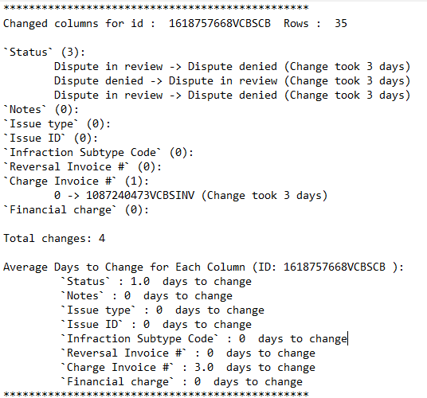

Explanation:

Initially it shows what id is being considered with total no. of rows. Under that we are displaying every column and with total number of changes enclosed in brackets. For every change we are also displaying the previous value and the new changed value as well. Under column names, the total number of changes are printed for that specific issue id which sums changes for every individual column. After that we are showing average days, it took for a column to changes it value. The same output is displayed for all the issue ids in the log file.

**Weekly changes in data:**

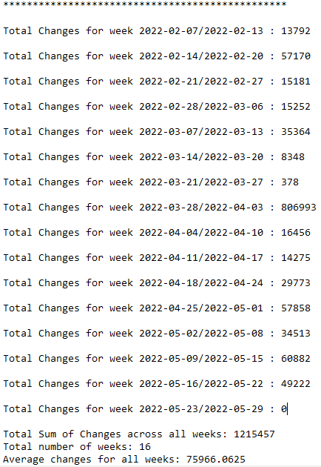

The above screenshot displays the changes that occurred on weekly basis. It shows total count in every week and later on we found the average changes by dividing the total changes by number of weeks in the complete data.

**Monthly changes in data:**

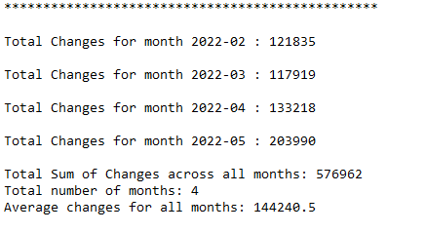

The above screenshot displays the changes that occurred on monthly basis. It shows total count in every month and later, we found the average changes by dividing the total changes by number of months in the complete data.