**Hand Based Cancelable Biometric Authentication Scheme**

By

Faizanur Rahman(Roll No. 2015085)

&

Manish Kumar Vyas(Roll No. 2015144)

Supervisor:

Dr. Preeti Khanna



Computer Science and Engineering

**INDIAN INSTITUTE OF INFORMATION TECHNOLOGY DESIGN & MANUFACTURING, JABALPUR**

May 28, 2018 to June 14, 2018

# CERTIFICATE

This is to certify that the thesis entitled, “Hand Based Cancellable Biometric Authentication System using Maximum curvature” submitted by Mr. Faizanur Rahman (2015085) and Mr. Manish Kumar Vyas (2015144) in partial fulfilment of the requirements for the award of degree of Bachelor of Technology at PDPM Indian Institute of Information Technology, Design and Manufacturing, Jabalpur is a record of genuine work carried by him under my supervision. To the best of my knowledge, the material embodied in this thesis has not been submitted elsewhere to any other university/institute for the award of any degree.

#### Dr. Pritee Khanna

(Associate Professor) Computer Science and Engineering

PDPM Indian Institute of Information Technology, Design and Manufacturing, Jabalpur

482005, India.

Date………….

Place…………

# ACKNOWLEDGEMENT

Mr. Faizanur Rahman

2015085

Mr. Manish Kumar Vyas

2015144

### *TABLE OF CONTENTS*

***Chapter 1***

**INTRODUCTION 1**

* 1. [Biometric Authentication 1](#_heading=h.30j0zll)
  2. [Cancellable Biometrics 2](#_heading=h.2et92p0)
  3. [Scope of work 3](#_heading=h.3znysh7)

### *Chapter 2*

#### LITERATURE REVIEW 4

* 1. Biometric Cryptosystem 4
  2. Cancellable Biometric 4
     1. Biometric Salting Technique 4
     2. Non Invertible Transformation 5
  3. Motivation 7

***Chapter 3***

#### PROPOSED TEMPLATE TRANSFORMATION SCHEME 8

#### 

* 1. Data Acquisition
  2. Pre Processing 8

|  |  |  |
| --- | --- | --- |
| 3.2.1 | Introduction | 9 |
| 3.2.2 | Image Segmentation   1. Image Segmentation based on statical approach 2. Image Segmentation based on edge 3. Image segmetation based on wavelet transform | 9 |
| 3.2.3 | Edge Linking   1. Morphological Operation 2. ExtraPolation | 10 |
| 3.2.4 | Log Transform |  |
| 3.2.5 | Local Contrast Enhancement |  |
| 3.2.6 | Laplacian of gaussian |  |
| 3.2.7 | Convolution with Maxican Hat filter |  |

* 1. Feature Extraction 10
     1. Maximum Curvature Method 12
  2. Non Invertible Transformation 13
     1. XOR Function 13
     2. Median Filtering 14
  3. Matching 15
  4. Evaluation of Performance Parameters 15
     1. Confusion Matrix for Multi Class Classification System 15
  5. K-fold Cross Validation 16
     1. K-fold Cross Validation with different random keys 16

### *Chapter 4*

***Chapter 5***

#### EXPERIMENTAL RESULTS AND ANALYSIS 17

* 1. Evaluation Scenarios 17
  2. Visualizations 17
  3. Performance Analysis 20

#### CONCLUSIONS 21

#### REFERENCES 22

**CHAPTER 1: INTRODUCTION**

Project Origin Details:

Privacy Enhancing Revocable Biometric Identities (PERBI), 2016-19 –Awarded by **Board of Research in Nuclear Sciences(BRNS),** Department of Atomic Energy, Govt of India(Funding Rs. 28.8 lacks). (**Status: On-going**).

I contributed to the above live projects under the supervision of **Dr. Pritee Khanna(Principal Investigator)** at the Indian Institute of Information technology, and built a Multimodal Biometric System with Recocable Capabilities, and Implemented a dorsal hand vein authentication system from scratch.

**My Major Contribution:**

1. During Processing Dorsal Hand Image, developed a heuristic blurring method to remove hair from the image.
2. Extracted clear vein pattern from the dorsal Image by Implementing Maximum Curvature Method.
3. Implemented a Cancellable capability to address the Stolen token(user information) scenario.
4. Reduce the dimension of data up to 75% and achieve 94% multi-class classification accuracy.

In this project, I was to build a biometric authentication system and need to perform authentication based on a person's vein pattern. Since veins are present inside the body, in most cases, not visible to the naked eye so this system was more secure than others.

# CHAPTER 2: LITERATURE REVIEW

This chapter talks about the previous works that have been done and also tells about the motivation behind the proposed technique for achieving the desired purpose*.*

In this chapter, we will introduce the system of biometrics and discuss various security concerns related to biometrics in the current scenario. Also, we will talk about cancellable biometrics and the feature of recurrence.

Biometrics is an excellent system for security used in various platforms such as industry, banking, mobile phones. Presently, many methods are available to verify individual identities, such as fingerprint recognition, voice recognition, retinal scans, facial recognition.

These systems also pose a risk of compromising biometric information in many ways, such as fingerprints can be hacked from glass panels or other locations by mimicking their fingerprints. In the past, fingerprint systems have repeatedly been hacked by the sticky fingerprint method.

To address this problem and to provide better preservation of information, we are attempting to develop a biometric detection system based on the idea of ​​cancelable biometric.

## Biometric Authentication System

Biometric authentication is a process in which a person's identity is verified based on specific biological characteristics.

In biometric authentication, first, a person's biometric information is captured and then matched with the data stored in the database. If both data (captured and stored) match, the authentication is confirmed.

Biometric authentication is the most effective and secure authentication system because a person's biological information is unique. It is possible that a person's password and unique ID can be stolen and misused. Biometric identity is always safe, cannot be leaked, and very difficult to transfer from one person to another.

## Cancellable Biometric Authentication

Since biometric authentication is a widely used authentication system in various departments and is stored digitally in a database, there are chances that someone can steal a piece of biometric information by invading the database and misuse its confidential information.

To avoid such attacks and secure our data, we can use the cancellable biometric authentication system. To protect biometric information in this cancelable biometric system, we intentionally and repeatedly distort the user's biological data.

Templates are responsible for the distortion in the feature by which the original data transformed into some other information. When an attacker tries to steal data, he gets changed information instead of the original information. To secure the user's information and deactivate the stolen data is done by changing the template information, which changes all previous biometric information in the database.

**Motivation**

In the past, much work has already been done to secure biometric information. Many research papers have been published. In all these researches, biometric salting and non-invertible transform techniques were used. The biometric salting technique includes Random Projection, Random Convolution, Random Mapping, and Random Noise transformation. non-invertible transformation includes median filtering technique.

After doing a literature review, I found the following inspiration for this project.

1. I noticed in the literature review that the dorsal veins are novel biometric features. They are more secure than other biometric features such as thumbprints. The dorsal vein also tells us about the livelihood of the individual, as the image of the dorsal vein captured by the device depends on the thermal heat generated during blood circulation. If a person is not alive, the vein patterns will not clear.

2. I noticed in the literature review that After 2010, There are not many contributions in this area yet.

3. I observe in the literature review that there is no contribution to dorsal hand cancellable biometric.

# CHAPTER 3: Building Dorsal Hand Vein Authentication from scratch

* 1. **Data Acquisition**

**About Data:**

I used 850 dorsal hand images of size 400\*400, taken from a special device that uses Infrared light to capture viens data. 850 Biometric Data = 85 people, 10 samples each.

How data capture devices work: Unlikely to oxygenated hemoglobin, deoxidized hemoglobin absorbs light at a wavelength of about 760nm, which is in the range of the near-infrared (NIR) band. Therefore, when the dorsal hand is illuminated with near-infrared light, deoxidized hemoglobin absorbs the light and appears as a black pattern in the dorsal image.

**Statistical Property of image, this is approximated value with 20 sample using ImageJ software:**

These parameters provide information regarding spatial distribution, changes in brightness, and description regarding the structural arrangement of vein patterns.

Channel-1

Histogram- Uni-model

Min value - 31

Max value - 214

Mean -154.702

Variance - 1044.885

Skew- -1.03

Kurt - 1.505

#### Pre-processing

The aim of pre-processing is to improve the existing feature in the data. In the dorsal hand vein image, it suppresses unwillingness to distortions or enhances the visibility of the vein pattern.

**Spatial Smoothness**

**3.2.1 Introduction:**

The goal of image feature extraction is to transform the image into another image from which measurements can be derived.Feature extraction algorithms can be seperated into two classes : one is a **dense descriptor** which extracts local features pixel by pixel over the input image , the other is a **sparse descriptor** which first detects the interest points in a given image and then samples a local patch and describes its invariant features[3].

It provides information regarding spatial distribution, changes in brightness, and description regarding the structural arrangement of surfaces. Therefore, the use of textural features is an important source of information for image description.

Feature descriptors are extracted from the input image and can be based on second-order statistics, parametric models, coeﬃcients obtained from an image transform, or even a combination of these measures.[4]

**B.** **Image Segmentation:**

The goal of image segmentation is to process the data of an acquired image so as to arrive at a meaningful partitioning of the image plane.The assumption behind image segmentation is that homogeneity of a certain local property of the image data[5]

**Goal of image segment:**

1. **Good detection:** Operation should have a low probability of missing an edge, at the same time it should have a low probability of falsely marking non-edges.

Good detection is expressed mathematically in terms of the signal-to-noise ratio SNR. This ratio is defined as the quotient between the response on the step (measured at x = IMG_256) and the standard deviation of the noise.SNR is directly proportional to high rate of detection

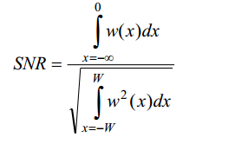 **2.Good localisation:**Good localisation is defined with the standard deviation 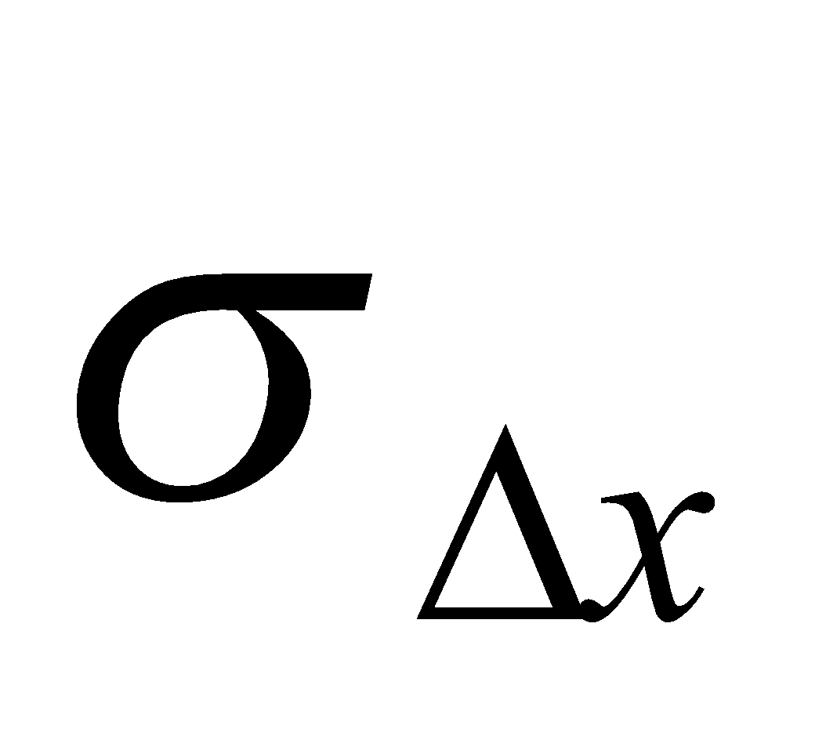of the localisation error IMG_259the operation should locate an edge at the correct position.

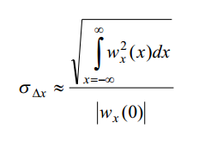

where IMG_261is the first derivative of IMG_262. Localisation is defined as the reciprocal of 

IMG_264

3.**Immunity to interfering objects:** The detection of an edge should not be affected  
 by the presence of edge structures coming from neighbouring objects.

A. **Image segmentation based on statistical approach**-

Methods based on the statistical approach do not explore hierarchical structures presented by the texture, but represent its properties in indirect and probabilistic manner.

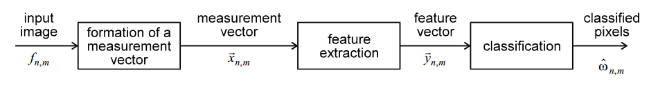Fig Computational structure based on statistical approach

1. **Formation of a measurement vector-**

If 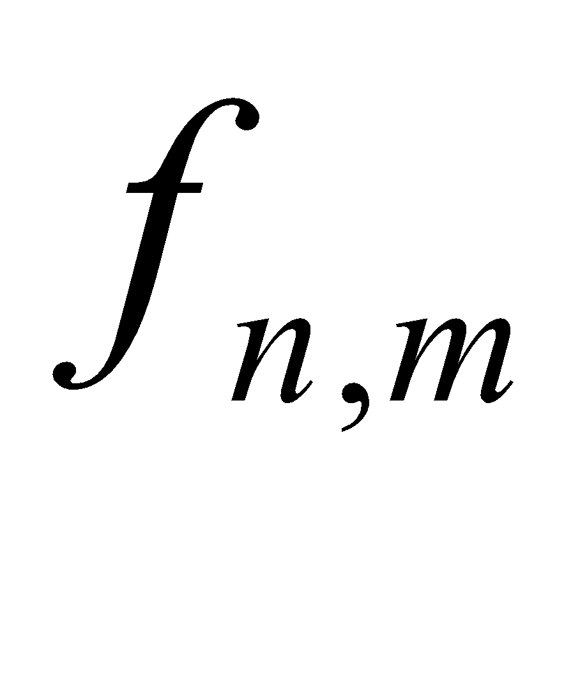is a gray level image, the easiest way to obtain a measurement vector is to use as a 1-dimensional measurement vector 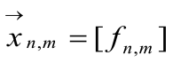

1. **Feature extraction** -

feature extracted from the measurement vector is based on first order statistics like mean, variance, etc.

**First order statistic-**

**A1. Gray level thresholding-**

the image plane is contain three regions: skin, dorsal vein and hair.for detecting these three segment we have to calculate the conditional probability of each region.We have to determine a decision function that maps the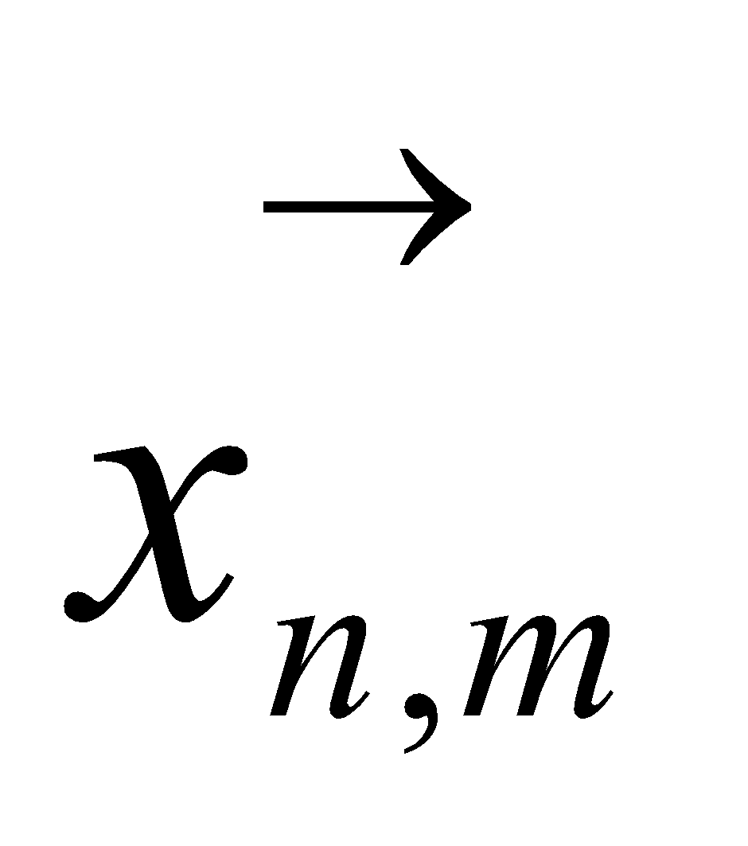onto this set of three region.decision function to is equivalent to the application of a multi-threshold operation to the grey level .The performance of the method is poor. Since our image data-sets have uni-model distribution of gray level.so parzen estimated conditional probability of these three segment is overlap.Due to overlapping zones in the conditional densities the error rate is unacceptable large.



Fig3.2.1(I)   Gray level thresholding

**A2. Adaptive thresholding-**

Instead of thresholding the enhanced image ,one can equally well compare the original image with a space-variant threshold that depends on the average of the neighborhood of image. Such an image operation is called **adaptive thresholding**.The sensitivity to noise can be reduced by increasing the size of the neighborhood of the template

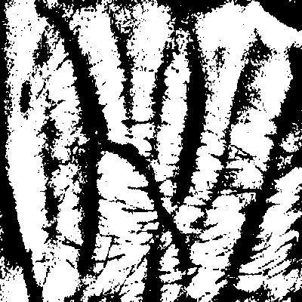

**Fig3.2.1(II)    Adaptive thresholding**

**Second order statistics-**

the gray level distribution could be described by first order statistics, such as mean and variance estimated from a histogram computed from this distribution. However, since the first order statistics consider only pixels individually, this makes such measures more sensitive to changes in the image. Therefore, to avoid this problem, **second order statistics**, which depend on transitions between gray level of pixels, are considered

**A3 Line detection** -

The classical way to detect line elements is to correlate the image with a number of templates. Each template aims at the detection of a line element with a specific orientation. The templates are chosen such that - taken together - all orientations are covered. Usually the orientation is quantised to four directions: horizontal, vertical and diagonal. Known templates for these directions are:

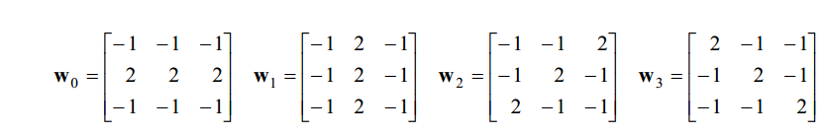

For each image pixel location, the cross correlations between the image data and the four templates are determined. The maximum of the four correlations represents the degree of match at that image pixel location. Comparing this maximum with some well chosen threshold is the most simple method to complete the detection process. Unfortunately, such a process yields configurations of line elements which violates the **constraint of thinness[6].** A more sophisticated method is to add non-local maximum suppression schemes, applied to each of the four correlated images. In order to prevent the connectedness between line elements from being broken the directional suppression method is used, i.e. matched to the orientation of the template.

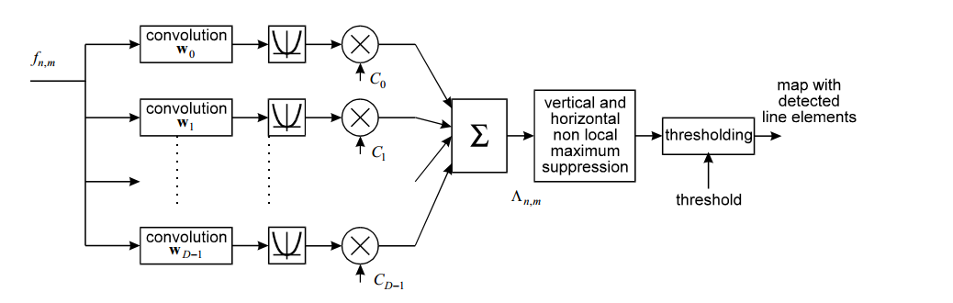

Fig     Computational structure of line detection

The performance of the method is poor. Due to non-local maximum suppression multiple responses which coming from different templates that produce maximums at neighboring positions.

****

**Fig3.2.1(B) line ditection based on all direction**

An improvement of the performance is achieved when the four templates are replaced with one **rotationally invariant template.**

**B.Image segmentation based on edge**Another approach to image segmentation is to locate points in the image plane where the image data is discontinuous. In other word the detection and localisation of discontinuities of these image properties. In a more restrictive sense, it only refers to locations of significant change of irradiance. Points of these locations are called edges or edge elements

The classical approach to find edges is essentially the same as in the line detection[]. line detection in which each operator consists of two or more templates with which the input image is convolved. For each pixel position the resulting outputs can be arranged in feature vectors IMG_277with elements:

IMG_278              where i = 1,2,3,4…..

threshoding IMG_279give the final map of detected edge.

**A1. Canny edge detection-**

In the simplest form of a Canny's edge detector the projection function is a 1 -dimensional Gaussian (with standard deviation 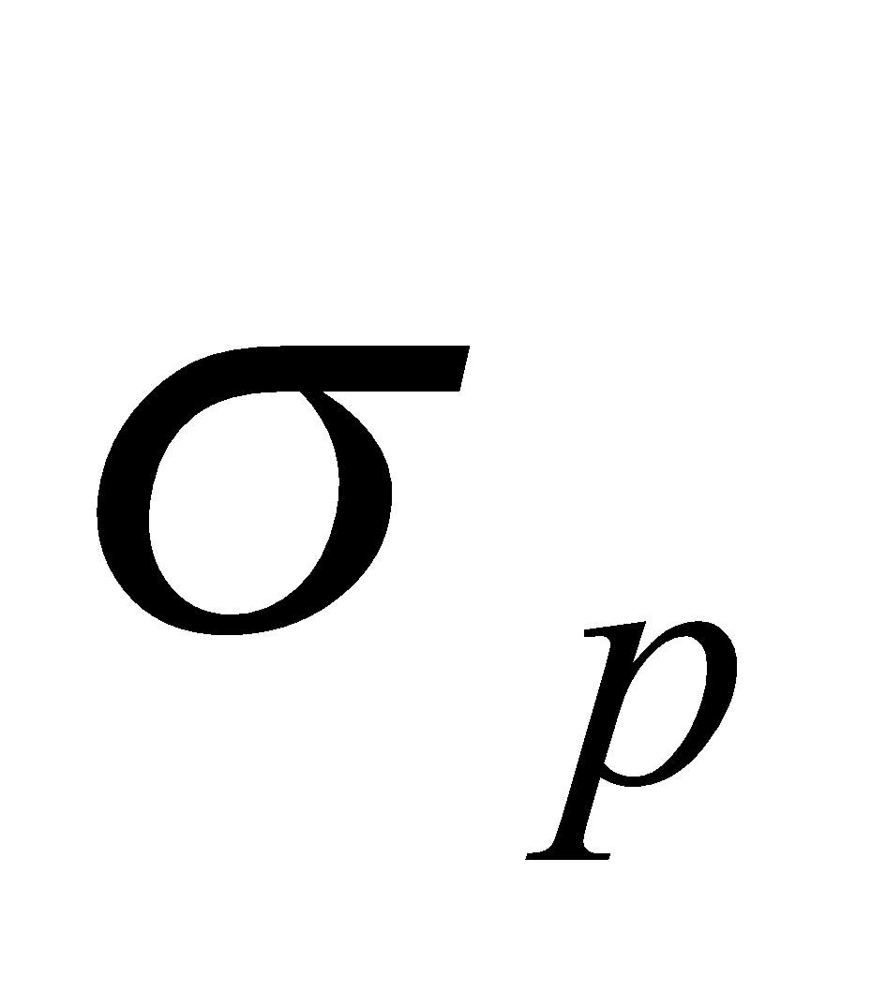) and the detection filter IMG_281is approximated by the first derivative of a 1-dimensional Gaussian (also with standard deviation ).

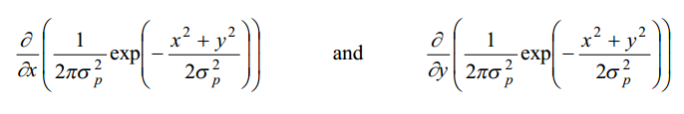

Fig  canny operator in vertical and horizontal direction

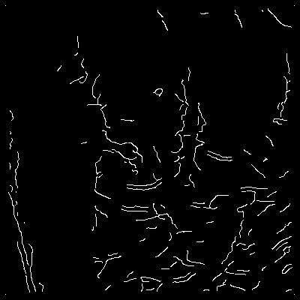

Fig3.2.2(I)   Canny edge with gaussian radius 2 ,low and high threshold is 2 and 3 respectively

**C. Approach Based on Wavelet Transforms -**

Wavelet transforms decompose a signal by means of a series of elementary functions, created from dilations and translations of a basis function IMG_285.The basis functions of a discrete wavelet transform, IMG_286of time independent variable t, can be expressed as

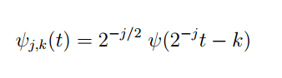

where j and k are integers that guide the dilations and translations of the function to generate a family of wavelets, such as Haar and Daubechies Wavelet transforms provide simultaneous time and frequency localization, whereas the standard Fourier transform is only localized in frequency. Additionally,wavelet transforms are useful for analyzing time-variant, non-stationary signals. Using wavelets as a set of basis functions, an image can be decomposed into a multi-resolution hierarchy of localized information at different frequencies. Wavelet transforms can be implemented by using a pair of low-pass and high-pass filters represented by a sequence of coefficients. In a 2D wavelet decomposition, the filters are applied to an image in both horizontal and vertical directions, typically followed by a down sampling. The output of each level will generate four sub band images, LL, LH, HL and HH. The same process can be repeated on the LL image to generate the next decomposition level. As wavelet coefficients in different frequency bands show variations in horizontal,vertical and diagonal direction , it has been shown that vertical and diagonal directions, it has been shown that texture features can be extracted from these coefficients.13

**3.2.3 Edge linking**

As noted above the process of edge detection often yields fragmented boundaries.  
As such, the edge map does not fully specify the geometry of the regions. Edge  
linking is the process that aims to complete the boundary, and to delete spuriously  
detected edge elements from the edge map.

**a) MORPHOLOGICAL OPERATIONS -**

**EXTRAPOLATION**Gaps with a width of a few pixels may be bridged by extrapolation of edge segments. For that purpose it is needed to estimate the parameters of the tangent of a non-closed segment at one of its end points.

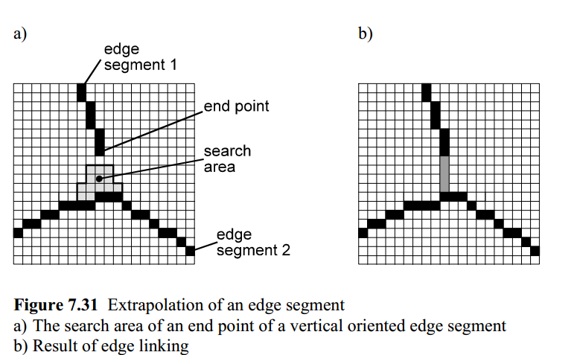

Fig extrapolation of edge link a) search area from end of edge, b) edge linking result

**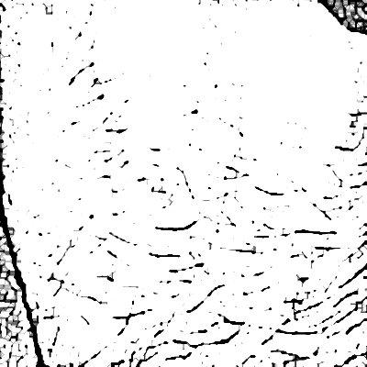**

Fig 4.2.3extrapolation of hair mask image

**3.2.4 Log Transform -**

During log transformation, the dark pixels in an image are expanded as compare to the higher pixel values.so we reduce skin and enhance hair by expanding the dark pixel. The higher pixel values are kind of compressed in log transformation.

**3.2.5 Local Adaptive Histogram Contrast Enhancement:**

Local contrast enhancement (LACHE) is a technique for bringing out detail and texture in an image. It is very similar to sharpening which accentuates only fine and **Stochastic component** detail of dark pixel..

**3.2.6 Laplacian of gaussian(Mexican hat filter):**

Laplacian filters are derivative filters used to discover regions of fast change (hair) in images. Since derivative filters are very sensitive to noise, so we use difference of gaussian at ratio of sigma of gaussian is 8:5(Mexican hat approximation) to reduce sensitive noise.

**3.2.7 Mexican hat filter**

The mexican hat wavelet on the plane is obtained by applying the Laplacian operator to the 2D Gaussian. If we apply the Laplacian to the mexican hat wavelet we obtain a new wavelet and if we iterate the process we get a whole family of wavelets: we call these wavelets the mexican hat wavelet family. We choose the normalization so that the sum of the Fourier transforms of all these wavelets and of the Gaussian filter is one.

The mexican hat function has several advantageous properties then classical filter like it is rotationally symmetric, its Gaussian-like positive kernel has similar shape to a canonical PSF. Its limited extent in both spatial and Fourier domains helps to minimize effects of aliasing.

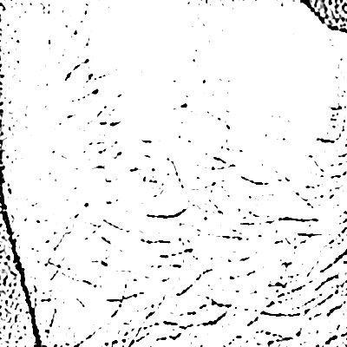

Fig4.2.3(A) mexican hat filter

**3.3 Feature Extraction Process**

To detect feature based on first order statistics or higher order ,the local threshold is decided by local profile of either side of dent profile but due to presence of noise in data , vein feature detection quality decrease.so to solve this problem N. Miura, A. Nagasaka, and T. Miyatake et. al. Proposed a method to extract feature using maximum curvature method.This method is based on cross-correlation between a kernel and a test image.It convolve the kernel with the binary image representing the test image (rotated by 180 degrees), and evaluates how they cross-correlate. If the kernel and test image are very similar, the output of the correlation corresponds to a single scalar and approaches a maximum. In case kernel and probe represent images from the same vein structure, but are misaligned, the output is not guaranteed to be accurate. To mitigate this aspect, Miura et al. proposed to add a small cropping factor to the model image, assuming not much information is available on the borders. This allows the convolution to yield searches for different areas in the probe image. The maximum value is then taken from the resulting operation. The convolution result is normalized by the pixels lit in both the cropped model image and the matching pixels on the probe that yield the maximum on the resulting convolution.

**Algorithm steps in Miura paper:**

[Step 1] Extraction of the center positions of veins.

[Step 2] Connection of the center positions.

[Step 3] Labeling of the image

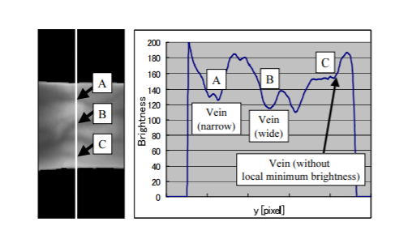  
Fig 10 Cross-sectional profile of vein along vertical line  
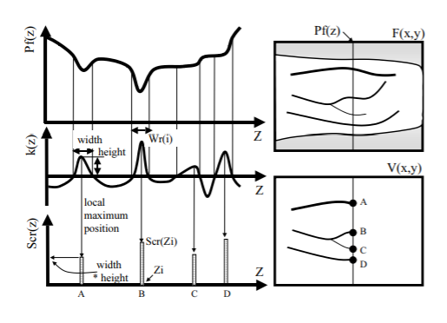

Fig 11 Relationship between among profile, curvature, and probability score of veins.

**3.3.1 Extraction of the center positions of veins-**

Since cross-sectional profile of vein pattern surrounded by skin look like dent because of vein pattern have less intensity then skin.to extract center positions of veins a probabilistic score is assign to each cross-sectional profile to check how much a profile is dent,large value of score show very dent profile.this step is subdivided into three step as mention below

1. **Calculation of the curvatures of profiles**

In this step a mathematical function called kappa, is calculated which check whether a profile is dent or not depending on its value. If kappa value is positive then profile is concave upward otherwise it is concave downward

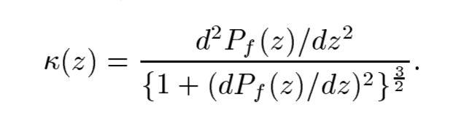

1. **Detection of the centers of veins**

Since profile is classified as concave or convex depending on whether kappa is positive or negative. If kappa is positive, the profile is a dent. In this step, the local maximums of in each concave area are calculated. These points indicate the center positions of the veins.

1. **Assignment of scores to the center positions**

In this step a probabilistic score is define to each profile

1. **Calculation of all the profiles**

To obtain the vein pattern spreading in an entire image, all the profiles in a direction are analyzed. To obtain the vein pattern spreading in all directions, all the profiles in four directions are also analyzed. Thus, all the center positions of the veins are detected by calculating the local maximum curvature.

**3.3.2 Connection of vein center:**

To connect the centers of veins and eliminate noise, the following filtering operation is conducted. First, two neighboring pixels on the right side and two neighboring pixels on the left side of pixel(x,y) are checked. If (x,y) and the pixel both side have large values, then a line is drawn horizontally. When (x,y) have smaller value then it’s two neighbourhood then a line is drawn with gap at (x,y) so to connect line value of (x,y) should be increase. When (x,y) is larger then it’s neighbourhood then dot noise at location (x,y) produced, so should decrease the value of (x,y) to reduce dot noise. Above operation can be calculated as:

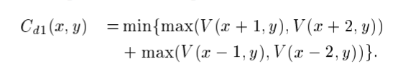

Second, The above value is calculated for horizontal direction so we calculate above value for all direction in same way. Finally, the final image G(x,y) is calculated by selecting the maximum value from all direction of connected center map at each location.

**3.3.3 Labeling the image:**

Finally, the vein image G(x,y) is binarized using threshod, Pixels with values smaller than the threshold are labeled as parts of the background, and those with values greater than or equal to the threshold are labeled as parts of the vein region. the threshold is determine such that the dispersion between the groups of values in G(x,y) is maximum.

* 1. **Non-invertible transformations**

Transformations are performed at two levels on the chain code templates stored in the database.

#### XOR Function

The chain code has been transformed using XOR function. For every image its chain code has been XORed at three levels. At the first level, capital letters have been made use of. Since the length of the chain code is 15, therefore 15 randomly letters have been used to XOR with each character of the chain code. Similarly, for the second level, 10 special characters have been used. Similarly, for the third level, numbers have been used. The range of numbers used is 0-50 .

**Key:** The randomly generated set of alphabets, number and special characters.

The following are the set of alphabets, numbers and special characters used for generating a 15-length key for XOR-based transformation purpose.

[‘A’,’B’,’C’...’X’,’Y’,’Z’] ['!','@','#','$','%','^','&','\*','\_','~'] [0,1,2...,498,499,500]

Transformations are be done in following two ways -

*Worst Case Implementation:* For every person the key used for transformation is the same.

*Best Case Implementation:* For every person the key used for transformation different. The chain codes obtained after XOR at the three levels are then passed through the process of Median Filtering. Median Filtering imparts the functionality of being non revocable.

#### Median Filtering

In the process of median filtering, for each element of the chain code, the median is calculated and then the element in the chain code is replaced with this median. Length of median class used is 5.

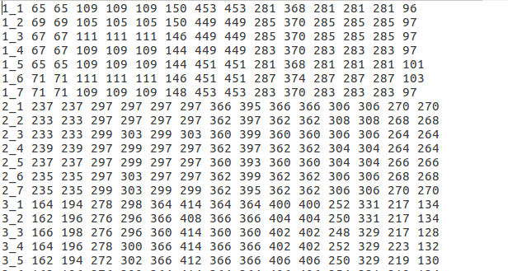

#### Fig. 9. A txt file storing extracted minutiae points in the form of median filtered chain code

* 1. **Matching**

Matching is performed using combination of “Euclidean Distance” and “Hamming Distance” algorithm. Euclidian distance among each of the chain code in 15-length chain code of input template and stored template in the database is calculated and compared with a threshold. If the distance is less then that code in chain code is accepted. Total number of chain code accepted (also called hamming distance) is again compared with one more different threshold. If it exceeds threshold value then input template is successfully matched with the stored template.

## Evaluation of Performance Parameters

Performance parameters have been calculated using various methods like -

#### Confusion Matrix for Multi-Class Classification System

A confusion matrix is a table that is often used to describe the performance of a classification model (or "classifier") on a set of test data for which the true values are known. For multi-class model one of the class is assumed as positive and other as negative and then confusion matrix is calculated. Same exercise is repeated for all the classes. Confusion Matrix consists of following values -

* + - * *True Positives (TP):* These are cases in which we predicted positive, and actual class is positive as well.
      * *True Negatives (TN):* We predicted negative, and actual class is negative as well.
      * *False Positives (FP):* We predicted positive, but actually it is negative (Also known as a "Type I error").
      * *False Negatives (FN):* We predicted negative, but actually it is negative (Also known as a "Type II error") .

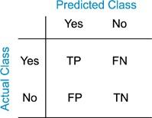

#### Fig. 10. Confusion Matrix

**False Acceptance Rate**

The false acceptance rate, or FAR measures the probability of incorrectly accepting an unauthorized user. FAR can be calculated as follows

FAR = FP / (FP+TN)

#### False Recognition Rate

The false recognition rate, or FRR, measures the probability of incorrectly rejecting an authorized user. FRR can be calculated as follows

FRR = FN / (FN+TP)

#### 3.8 K-fold Cross Validation

In *k*-fold cross-validation, all the samples of a person are randomly partitioned into *k* equal sized subgroups. Of the *k* subgroups, a single subgroup is taken as the validation data group for testing the model and the remaining subgroups are used as training data. This process is then repeated *k* times (the *folds*), with each of the *k* subgroup used exactly once as the validation data. Results obtained over k-iterations are averaged produce a single estimation. One of the advantage of this method is that all observations are used for both training and validation. In our project, we have used k-fold cross validation for k=1.

#### 3.8.1 K-fold Cross Validation with different random keys

K-fold cross validation is performed by changing the randomly generated key (as defined in the section “Non-invertible transformations”) for transformation purpose. Results have been generated for 5 different keys.

DET (Detection Error Tradeoff) curves have also been plotted to visualize the performance of fingerprint after using non-invertible transformations. These curves are plotted between False Positive Rate (FPR) and False Negative Rate (FNR) with FPR on x-axis and FNR on Y-axis.

# CHAPTER 4: EXPERIMENTAL RESULTS AND ANALYSIS

Analysis is performed to study the features of template security such as (i) performance, (ii) non-invertibility, and (iii)changeability of the proposed approach under *stolen token scenario*. It is illustrated that the templates so generated are non-invertible, can be revoked easily and are delivering good performance.

## Evaluation Scenario

Evaluation of performance parameters has been done on (i) original feature vectors stored in the form of chain codes and then on (ii) transformed chain codes using XOR and median filter methid for transformations. FVC2004 DB1A [10] database of 1680 images (140 subjects with 12 samples each) is divided as 7 images for training and 5 images for testing.

## Visualizations

Some of the visualizations are –

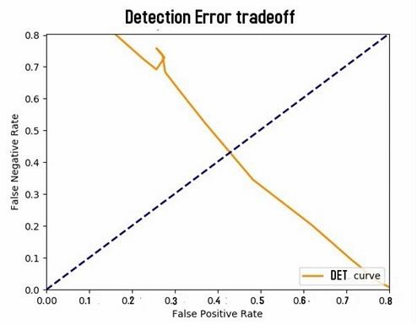

#### Fig. 11(a). Original case implementation with K-fold cross validation.

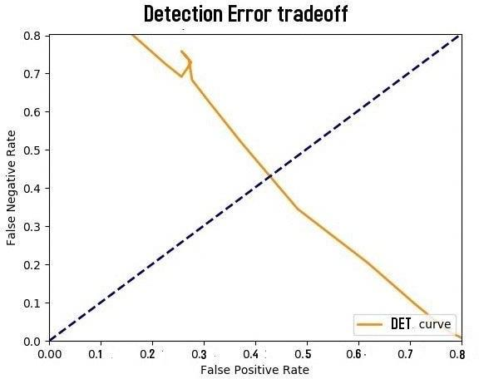

**Fig. 11(b). Worst case implementation with K-fold cross validation.**

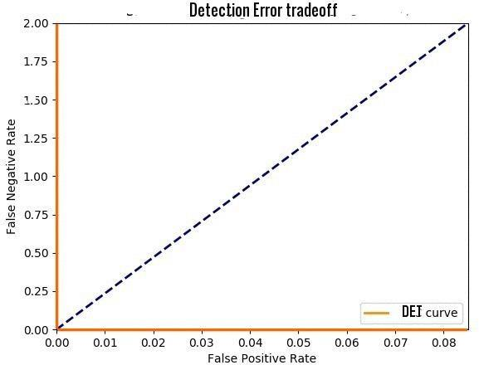

**Fig. 11(c). Best case implementation with K-fold cross validation.**

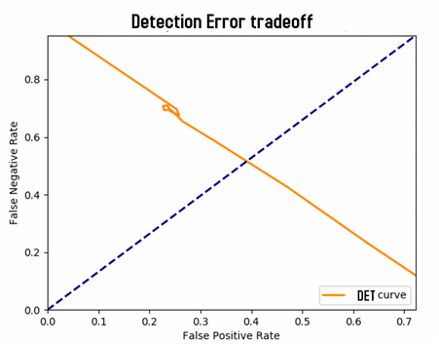

**Fig. 12(a). Worst case implementation with K-fold and 5 different Keys (5 Way K-fold).**

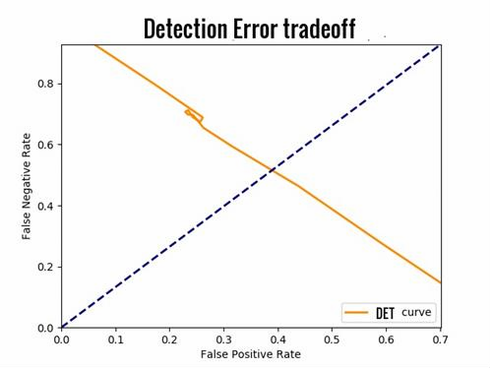

**Fig. 12(b). Worst case implementation with K-fold and 10 different Keys (10 Way K-fold).**

It is observed that matching is being done with a very high accuracy on the databases as described above (in the section of “Acquisition”). Accuracy and other parameters like *False Positive Rate (FPR)*, *False Negative rate (FNR)* and *True Positive Rate (TPR)* have been recorded and visualized on various threshold values.

The efficiency for original feature vector obtained directly from the image in the form of chain codes obtained was 100% .

The efficiency after applying non-invertible transformations to the original feature vector obtained was 100% for both worst and best cases.

|  |  |  |  |
| --- | --- | --- | --- |
| **Method/Case** | **Original Case** | **Worst Case** | **Best Case** |
| **K-fold** | 0.42 | 0.44 | 0.00 |
| **5-way K-fold** | - | 0.45 | 0.00 |
| **10-way K-fold** | - | 0.46 | 0.00 |

#### Table 1. Equal Error Rate using different methods for different cases

* 1. **Performance Analysis**

Worst case performance is comparable to original case which proves that the distortions provided by the transformations to the original templates does not reduces the uniqueness of the fingerprint.

A median filtered chain code was taken and XORed by the same set of keys at three levels to obtain a new chain code. The new chain code so generated did not match the original code that was initially. Therefore, median filter transformation provides the feature of non-invertibility.

Original chain codes were converted to rotation invariant chain code thereby providing the feature of alignment free which ensures that in whatever angle input template is given the output chain code will be same.

# CHAPTER 5: CONCLUSIONS

Performing training and testing on different database along with non-invertible transformation techniques and various visualizations of performance evaluation parameters reveals that the templates so generated are non-invertible, can be revoked easily and are delivering good performance. The proposed approach based on cancellable biometrics has been tested and is successfully working and hence ready to implement.

# REFERENCES

1. S. Chikkerur, N. Ratha, J. Connell, R. Bolle, Generating registration-free cancelable fingerprint templates, in: Proceedings of the 2nd IEEE International Conference on Biometrics: Theory, Applications and Systems, 2016, pp. 1–6.
2. C. Lee, J.-Y. Choi, K.-A. Toh, S. Lee, Alignment-free cancelable fingerprint templates based on local minutiae information, IEEE Trans. Syst., Man, Cybern., Part B 37 (4) (2016) [980–99](http://refhub.elsevier.com/S0031-3203(17)30021-3/sbref3)2
3. S. Tulyakov, F. Farooq, P. Mansukhani, V. Govindaraju, Symmetric hash functions for secure [fi](http://refhub.elsevier.com/S0031-3203(17)30021-3/sbref4)ngerprint biometric systems, Pattern Recognit. Lett. 28 (2007)

2427[–](http://refhub.elsevier.com/S0031-3203(17)30021-3/sbref4)2436[.](http://refhub.elsevier.com/S0031-3203(17)30021-3/sbref4)

1. G. Kumar, S. Tulyakov, V. Gavindaraju, Combination of symmetric hash functions for secure fingerprint matching, in: Proceedings of the 20th International Conference on Pattern Recognition, 2010, pp. 890–893.
2. B. Yang, D. Hartung, K. Simoens, C. Busch, Dynamic Random Projection for Biometric Template Protection, in: Proceedings of the 4th IEEE International Conference on Biometrics: Theory Applications and Systems (BTAS), 2010, pp. 1– 7.
3. [T. Ahmad, J. Hu, S. Wang, Pair-polar coordinate-based cancelable fi](http://refhub.elsevier.com/S0031-3203(17)30021-3/sbref5)ngerprint templates, Pattern Recognit. 44 (10[–](http://refhub.elsevier.com/S0031-3203(17)30021-3/sbref5)11) (2011) 2555[–](http://refhub.elsevier.com/S0031-3203(17)30021-3/sbref5)2564.
4. P. Das, K. Karthik, B.C. Garai, A robust alignment-free fingerprint hashing algorithm based on minimum distance graphs, Pattern Recognit. 45 (9) (2012) 3373–3388.
5. W. Yang, J. Hu, S. Wang, J. Yang, Cancelable Fingerprint Templates with Delaunay Triangle- based Local Structures, Cyberspace Safety and Security, Lecture Notes in Computer Science, 8300, 2013 pp. 81–91.
6. Quan, Feng, et al. "Cracking cancelable fingerprint template of Ratha." Computer Science and Computational Technology, 2008. ISCSCT'08. International Symposium on. Vol. 2. IEEE, 2008.
7. FVC2004, 2004. Available from[: http://bias.csr.unibo.it/fvc2004/databases.asp](http://bias.csr.unibo.it/fvc2004/databases.asp)
8. S. Chikkerur, N. Ratha, J. Connell, R. Bolle, "Generating registration-free cancelable fingerprint templates", *Proc. IEEE Int. Conf. Biometrics: Theory Applications and Systems*, pp. 1-6.
9. N. Ratha, S. Chikkerur, J. Connell, R. Bolle, "Generating cancelable fingerprint templates", *IEEE Trans. Pattern Anal. Mach. Intell.*, vol. 29, no. 4, pp. 561-572, Apr. 2007.
10. N. Ratha, S. Chikkerur, J. Connell, R. Bolle, "Generating cancelable fingerprint templates", *IEEE Trans. Pattern Anal. Mach. Intell.*, vol. 29, no. 4, pp. 561-572, Apr. 2015.