**Contact Scripting Activity**

**Printing Phone List:**

**Adding new contact:**

**Searching for Phone number:**

**Viewing Phone record List:**

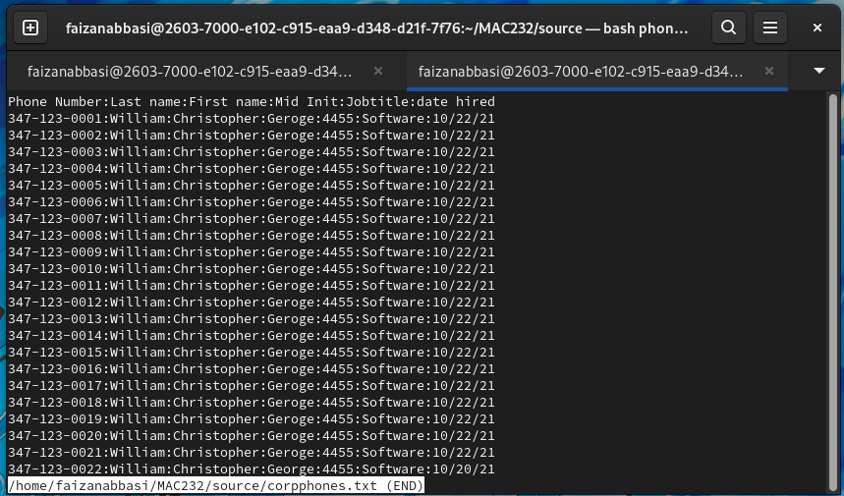

**Deleting Phone number:**

