Web Engineering

Project Final Report

For

StaaCart

**A compact e-commerce platform where you buy your own world**

Version 1.0 approved

Prepared by:   
  
Faizan Zafar - 33125 - 14besefzafar@seecs.edu.pk  
Hamza Javed - 32976 - 14besehjaved@seecs.edu.pk   
Amin-Ur-Rashid - 33451 – 14besearashid@seecs.edu.pk

BESE-5B | SEECS

29th January, 2017

Table of Contents

Table of Contents ii

Revision History ii

1. Introduction 4

**1.1 Brief Description…………………………………………………………………………………..4  
 1.2 Tools & Techniques………………………………………………………………………………4**

2. Navigational Structure 5

3. Description of main elements 6

**3.1 Key Features……………………………………..…………………………………………..15**

4. Work Distribution 15

5. Summary 16

Appendix A: To Be Determined List 16

Revision History

|  |  |  |  |
| --- | --- | --- | --- |
| **Authors** | **Date** | **Reason For Changes** | **Version** |
| **Hamza Javed**  **Amin Ur Rashid**  **Faizan Zafar** | 29/01/2017 | Project Final Report: Final Draft | 1.0 |

# Introduction

## Brief Description

## StaaCart is a dynamic e-commerce platform providing solutions in the form of fashion and furniture products. We have used web technologies to create an online shopping experience for customers like never before. StaaCart is aimed at providing an e-commerce platform for everyone regardless of their exposure to the internet. Its use at a large scale level will diminish the boundaries of markets and inculcate a very welcoming user experience.

StaaCart provides a clean interface to its users which is a challenge in the current competitive e-commerce market. The basic and extended functionalities of this project will serve as a means of efficient UI practices and consequent smooth backend and frontend development.

## Tools & Techniques

The following web based tools have been used for the development of this project:

* HTML
* CSS which extends to Bootstrap
* JavaScript which extends to jQuery
* PHP
* MySQL
* WAMP Server

No additional frameworks are used. We have used agile development approach whereby increments and iterations are executed on the original codebase to produce the final product.

# Navigational Structure

A sitemap is included in the footer section of each web page so the users can understand the flow of the website and perceive the hierarchy of webpages involved.

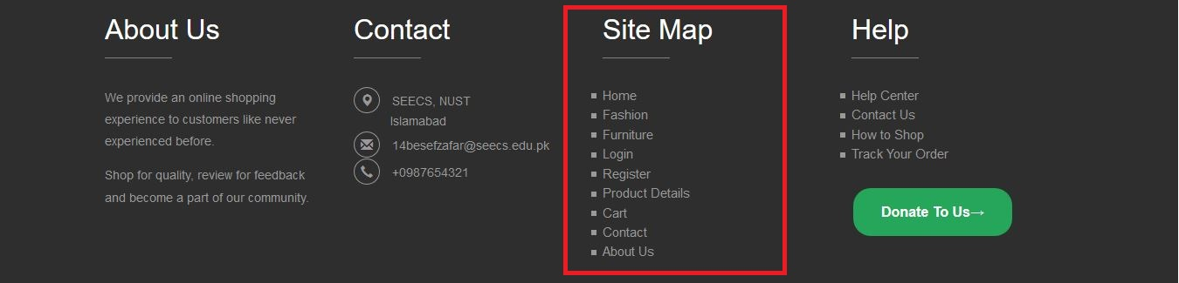

`

C:\Users\User\Downloads\Untitled Diagram.pngNavigational structure (hierarchy) of the website is as follows:

# Description of main elements

The web pages and their respective functionalities are as follows:

* Home Page

The Home page of our website is captivating enough so the user can further dive into the pages. We have ensured that our home page follows all standards and is easy on the users’ eyes. The header consists of a navigation panel where most of the features and pages of the site can be accessed. The state of the user and the state of the cart can also be seen here. A search bar allows search of keywords within the site. The social icons enable interaction with social media. The header is common to every web page. Below the header, the carousel shows a variety of images and captions that the user is bound to explore. Latest Collections of products with their prices and ‘add to cart’ option is displayed below. The home page also shows sales and offers on any products so the user is aware of them. User has the option to subscribe to our newsletter by entering their email. The footer of the home page contains an ‘About Us’ column to give a better understanding of StaaCart’s aims to the customer. Contact details in the form of address, email and telephone. A sitemap is included so developers and users can understand the flow of the website. A help section to aid new customers in how to make a transaction using our site. Copyrights are also included here. The footer is common to every web page.

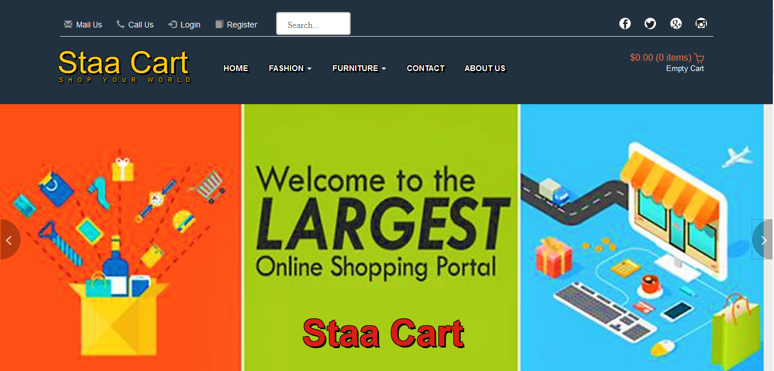

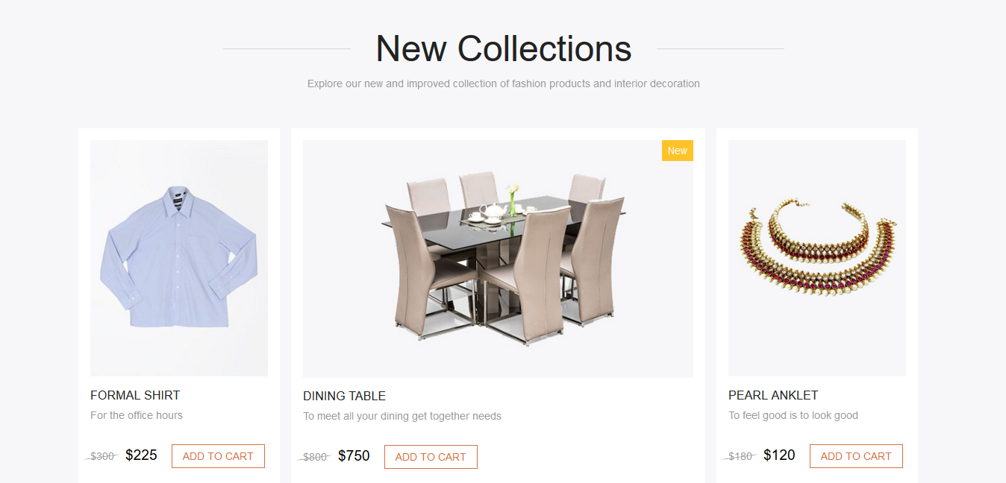



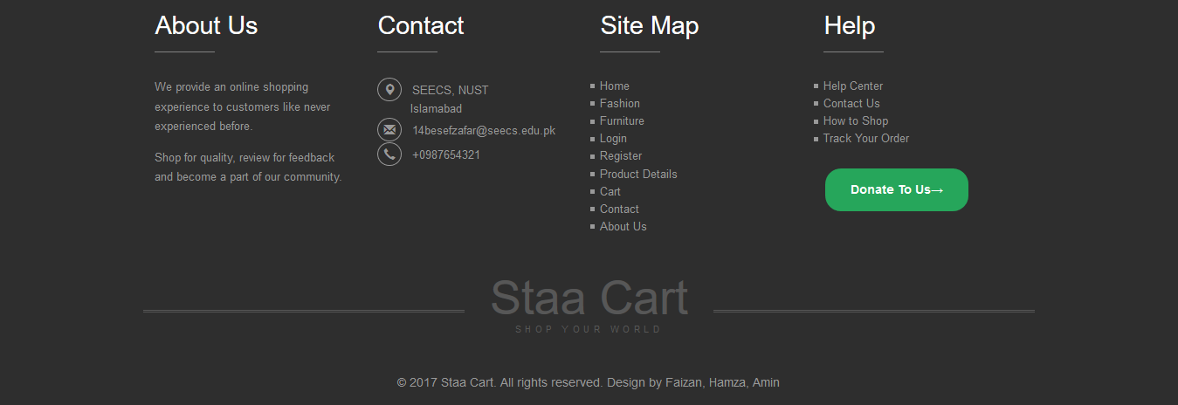

* Sign Up

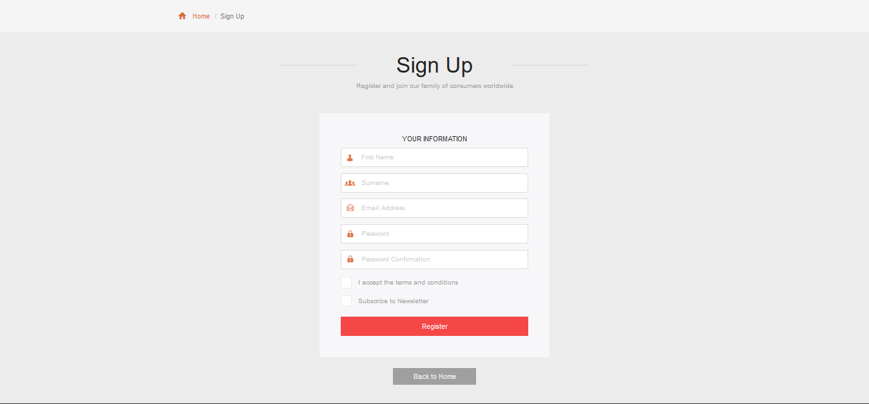The page asks for user’s information and credentials so the user can be registered on the website. The ‘Register’ button stores the information in the backend database. A ‘Back to Home’ navigation allows the user to revisit the homepage is they want to explore further and register later.

* Login

The page asks for user’s credentials so the user can logged in on the website. The ‘Login’ button retrieves the user information from the backend database and gives a personalized view. A ‘Forgot Password’ button aids the user in setting up a new password for their account. Navigation buttons below allows the user to revisit the homepage is they want to explore further or register with a new account.

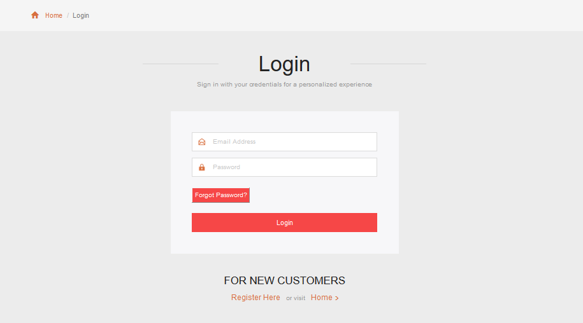

* Contact

This page has a contact form where a user can get in touch with StaaCart’s team and provide their valuable feedback. We have included contact details of our manager so the user can get the feeling of connection with another user rather than a computer. A map below shows the location of the headquarters office.

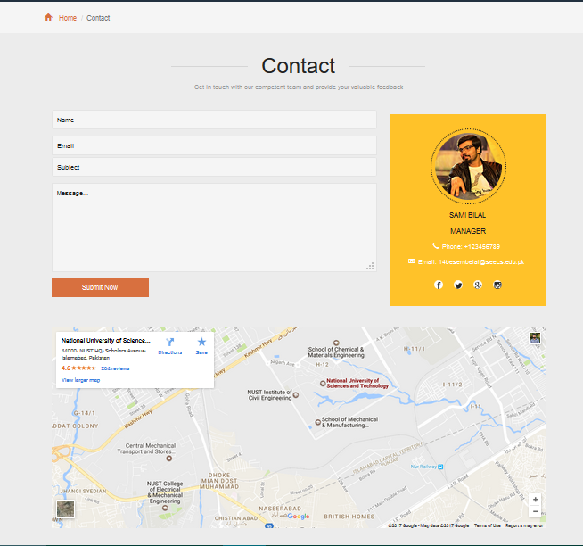

* About Us

The company’s mission statement, vision and privacy policy are included here. This is a standard for all registered firms. The section below displays the team of developers who have worked to produce this website along with social icons to get in touch.

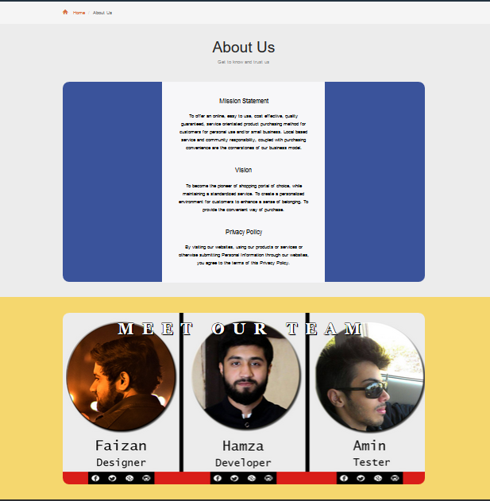

* Products Catalogue (Fashion & Furniture Products)

This page displays the list of items to be purchased by the customers. The items can be filtered by price using a range slider visible on the top right. The web page allows customizability in the form of sorting the products with various filters. A Categories section allows filter of different products based on their type. A separate section displays the latest in line products which are trending in the market.

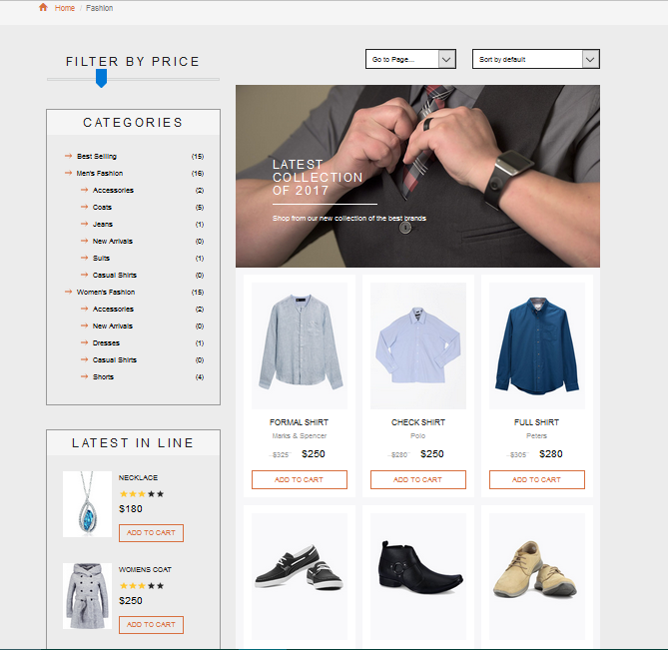

* Product Details

This web page contains much of our stated features. A slider contains images of the specific product from different angles. We have included a zoom in functionality so the user can hover over the image and view an enlarged image of the product. The user has the option to rate the product out of 5 stars. All specific details like quantity, size, information and description can be found here. The product can also be featured on a social site using the icons. Users can enter reviews about the products and read reviews of registered customers. Some details are required so the user can enter their reviews. Related products of the kind are displayed in a section just above the footer.

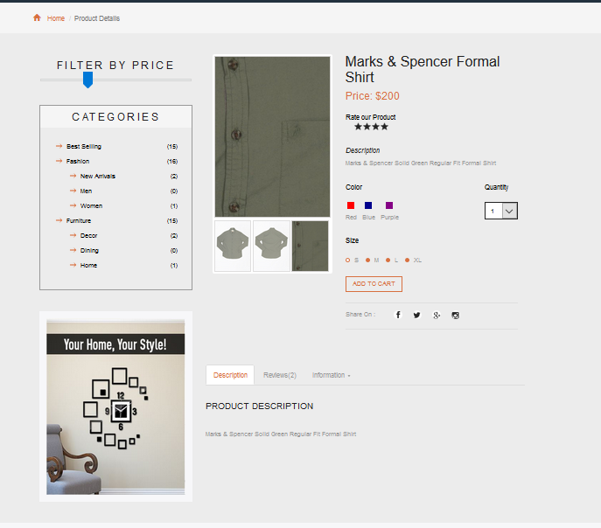

* Shopping Cart

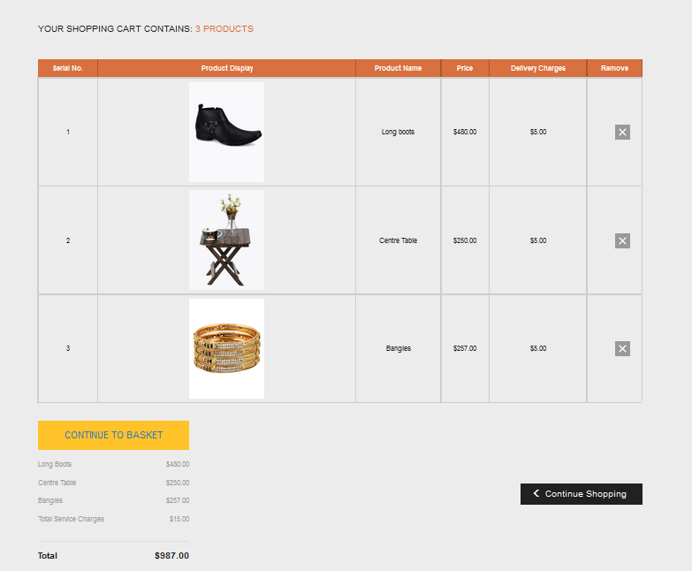This is a key feature of our system. The cart is meant to provide a simulation of a shopping cart whereby items can be added or removed depending upon the user’s requirements. The product’s display and details are presented in a tabular format. This is clear to comprehend by the user. The product can be removed by the user by clicking on the cross sign. A billing view is also displayed here which is another view in terms of prices and product names only. It also displays the total cost that has incurred to the customer. The cart is reset by using the ‘Empty Cart’ link.

## Key Features

**Browsing Through Items**: The customer will access a web page which allows easy browsing. Basically the items in the shop are well organised and well-presented so that a user can find his required item easily.

**Item Selection**: When an item is selected, a new web page is opened which displays details of product including ratings, reviews and specifications.

**Cart**: The customer is allowed to update/change/add products to his shopping cart with due authorisation.

**Reviews:** The customer is allowed to post queries and reviews about products available and discuss products sold online.

# Work Distribution

**Faizan Zafar:**

Worked on the front end development in this project. This includes all web pages, responsive sliders, format of product listing and cart, adding reviews, and graphics designing. Used all technologies.

**Hamza Javed:**

Worked on the back end development in this project. This includes shopping cart functionality, user registration and login, error checks, database handling. Used all technologies.

**Amin ur Rashid:**

Worked on the project final report which includes navigational structure, brief description of the main elements and functionality with screenshots, testing the website with sample data and correcting any errors.

# Summary

The document covers the navigational structure of the system and brief descriptions of the main elements and functionality of the system. The reader can understand the functionalities involved in the system. The final report will be of great value during the evaluation phase.

**Appendix A: To Be Determined List**

Presently there are no remaining TBDs. All TBDs have been tracked to their closure.