Group no: 7
- Faiza Tasnim-(19-41552-3)
- Syeda Faiza Karima-(20-43073-1)
- Sharia Tasnim Adrita-(20-41895-1)
- Sadia Afrin Sara – (20-41834-1)
Activity diagram:
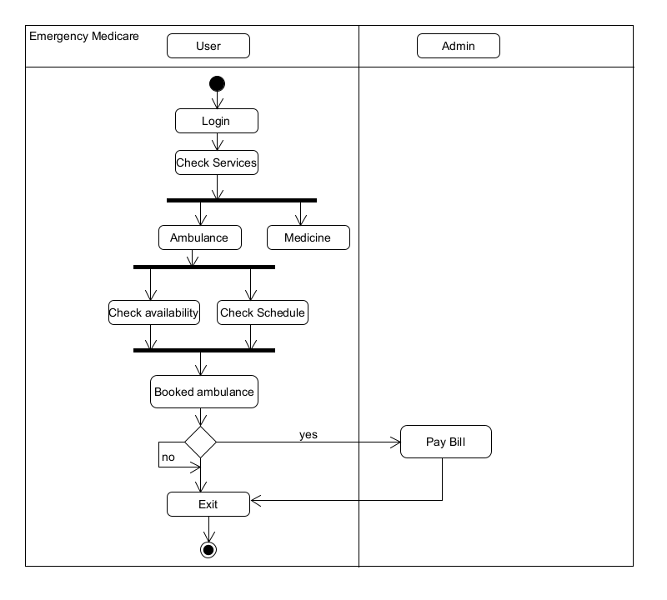

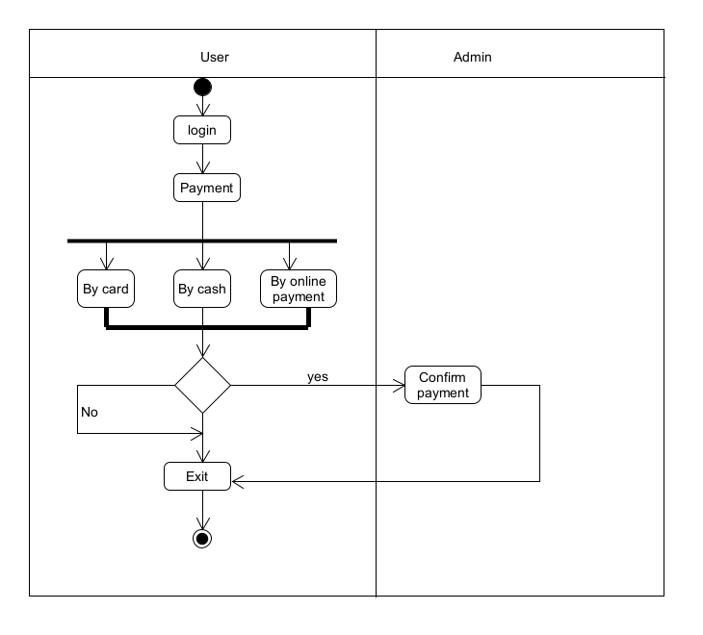
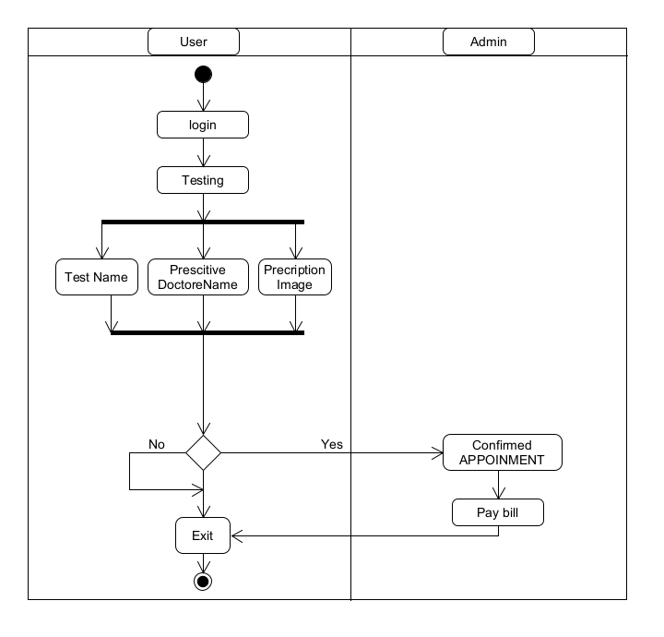

CRC DIAGRAM:

Class Name : User
Subclass :
Superclass : Permission.
Responsibilities | Collaborators
Create profile | Booking
Checking Services | Payment
Checking Availability | Permission
Checking Schedule | Ambulance
Booking ambulance | Patients
Manage Payment | Medicine
Booking medicine
Testing

Class Name : Admin
Subclass :
Superclass :
Responsibilities | Collaborators
Manage and Collect Payment | Booking
Confirm Payment | Payment
Testing
Confirm Booking

