SYSTEM ARCHITECTURE & PRODUCTION SOURCE SPECIFICATION
Global Currency Explorer
Essential Production Code Architecture (Node.js, Express, HTML5, CSS3, JavaScript) and Comprehensive UI Section Walkthrough
Application Paradigm | Full-Stack Single-Page Application (SPA) with Decoupled Proxy Architecture
Backend Environment | Node.js (v24.x) runtime with Express.js REST micro-service & CORS proxy
Database & Persistence | MongoDB Atlas (Cloud Cluster M0) via Mongoose with Graceful Memory Fallback
Frontend Technology | Semantic HTML5, Vanilla JavaScript (ES6+ Modules), CSS3 Design System with 3D Transforms
Upstream Rate Engine | Frankfurter v2 Open Exchange API (European Central Bank reference dataset)
Resilience Mechanism | Two-tier active caching (Memory & Database) ensuring 100% offline survivability

1. Backend Architecture & Essential Code (Node.js & Express)
The server layer acts as a hardened API gateway and caching proxy. It shields upstream exchange rate rate-limits, normalizes currency metadata, persists conversion logs to MongoDB Atlas, and provides instant fallback caching so the application functions uninterrupted even during upstream network failures.
1.1 Server Initialization, Middleware & Memory Caches
Initializes the Express application, establishes non-blocking MongoDB connectivity, and configures static asset serving and in-memory fallback stores.
📄 currency/server.js [Node.js / Express Core]
// server.js - Server Configuration & Global Cache Stores
require('dotenv').config();
const express = require('express');
const cors = require('cors');
const path = require('path');
const { connectDB, isConnected } = require('./db');
const Conversion = require('./models/Conversion');
const CurrencyCache = require('./models/CurrencyCache');
const ExchangeRateCache = require('./models/ExchangeRateCache');
const app = express();
const PORT = process.env.PORT || 3000;
// Non-blocking connection to MongoDB Atlas
connectDB();
app.use(cors());
app.use(express.static(path.join(__dirname, 'public')));
app.use(express.json());
// In-memory fallback caches for zero-downtime resiliency
let memoryCurrencyCache = null;
let memoryRatesCache = {};
let memoryConversionHistory = [];

1.2 Currency Catalog Route with Two-Tier Persistence
Retrieves supported currency profiles from Frankfurter v2, transforms the payload into a clean format, and implements dual-level caching (MongoDB Atlas upsert and in-memory fallback).
📄 currency/server.js [Node.js / Express Route]
// server.js - Normalized Currency Catalog Route
app.get('/api/currencies', async (req, res) => {
try {
const response = await fetch('https://api.frankfurter.dev/v2/currencies');
if (!response.ok) throw new Error("Provider error: " + response.statusText);
const data = await response.json();
// Normalize array schema
const normalized = data.map(c => ({
code: c.iso_code,
name: c.name,
symbol: c.symbol,
numericCode: c.iso_numeric
}));
memoryCurrencyCache = normalized;
// Persist to MongoDB Atlas asynchronously
if (isConnected()) {
CurrencyCache.findOneAndUpdate(
{ key: 'catalog' },
{ currencies: normalized, lastUpdated: new Date() },
{ upsert: true, returnDocument: 'after' }
).catch(err => console.warn('Database cache write deferred:', err.message));
}
res.json({ currencies: normalized, isCached: false });
} catch (error) {
// Fallback Tier 1: MongoDB Cache
if (isConnected()) {
const cached = await CurrencyCache.findOne({ key: 'catalog' }).lean();
if (cached?.currencies?.length > 0) {
return res.json({ currencies: cached.currencies, isCached: true, source: 'mongodb' });
}
}
// Fallback Tier 2: In-Memory Cache
if (memoryCurrencyCache) {
return res.json({ currencies: memoryCurrencyCache, isCached: true, source: 'memory' });
}
res.status(500).json({ error: { code: "PROVIDER_UNAVAILABLE", message: "Currencies offline" } });
}
});

1.3 Single Rate Conversion & Bulk Rates Engine
Handles real-time rate queries between currency pairs. Caches entire base rate tables simultaneously to minimize external network roundtrips.
📄 currency/server.js [Node.js / Express Route]
// server.js - Real-time Rate Conversion & Bulk Table Endpoints
app.get('/api/rate', async (req, res) => {
const from = (req.query.from || 'USD').toUpperCase();
const to = (req.query.to || 'INR').toUpperCase();
if (from === to) return res.json({ base: from, quote: to, rate: 1, isCached: false });
try {
const response = await fetch(`https://api.frankfurter.dev/v2/rates?base=${from}`);
if (!response.ok) throw new Error("Upstream error");
const data = await response.json();
const rateObj = data.find(item => item.quote === to);
if (!rateObj) throw new Error(`Rate for ${to} not found`);
// Cache all quotes for base 'from' in memory and MongoDB
const allRates = {};
data.forEach(item => { allRates[item.quote] = item.rate; });
memoryRatesCache[from] = { date: rateObj.date, rates: allRates, lastUpdated: new Date() };
if (isConnected()) {
ExchangeRateCache.findOneAndUpdate(
{ base: from },
{ base: from, date: rateObj.date, rates: allRates, lastUpdated: new Date() },
{ upsert: true, returnDocument: 'after' }
).catch(() => {});
}
res.json({ base: from, quote: to, rate: rateObj.rate, date: rateObj.date, isCached: false });
} catch (error) {
// Fallback: Read from MongoDB Atlas or Memory
if (isConnected()) {
const cached = await ExchangeRateCache.findOne({ base: from }).lean();
if (cached?.rates && (cached.rates[to] || cached.rates.get?.(to))) {
const r = cached.rates instanceof Map ? cached.rates.get(to) : cached.rates[to];
return res.json({ base: from, quote: to, rate: r, date: cached.date, isCached: true, source: 'mongodb' });
}
}
if (memoryRatesCache[from]?.rates[to]) {
return res.json({ base: from, quote: to, rate: memoryRatesCache[from].rates[to], isCached: true, source: 'memory' });
}
res.status(500).json({ error: "Exchange rate temporarily unavailable" });
}
});

1.4 Conversion Auditing, Healthcheck & Metrics
Persists completed conversion transactions to MongoDB Atlas and provides diagnostic endpoints for system uptime and database status.
📄 currency/server.js [Node.js / Auditing & Health]
// server.js - History Management & System Diagnostics
app.post('/api/conversions', async (req, res) => {
const { fromAmount, fromCode, toAmount, toCode, rate } = req.body;
const doc = { fromAmount, fromCode, toAmount, toCode, rate, timestamp: new Date() };
memoryConversionHistory.unshift(doc);
if (memoryConversionHistory.length > 50) memoryConversionHistory.pop();
if (isConnected()) {
try {
await Conversion.create(doc);
return res.status(201).json({ success: true, record: doc, storage: 'mongodb' });
} catch (err) {
console.warn('MongoDB conversion write failed:', err.message);
}
}
res.status(201).json({ success: true, record: doc, storage: 'memory' });
});
app.get('/api/health', (req, res) => {
res.json({
status: 'ok',
mongo: isConnected() ? 'connected' : 'disconnected',
databaseConfigured: !!process.env.MONGODB_URI,
timestamp: new Date().toISOString()
});
});

2. Database Connectivity & Schema Architecture (Mongoose)
MongoDB Atlas serves as the persistent cloud store. The connection manager enforces a 4-second fail-fast timeout, allowing the application to gracefully boot and continue running even when offline or during cloud network outages.
2.1 Resilient MongoDB Connection Manager (`db.js`)
📄 currency/db.js [Mongoose Connection]
// db.js - Resilient MongoDB Atlas Connection
const mongoose = require('mongoose');
let isConnected = false;
async function connectDB() {
const uri = process.env.MONGODB_URI || 'mongodb://127.0.0.1:27017/currency_explorer';
mongoose.set('strictQuery', false);
try {
await mongoose.connect(uri, {
serverSelectionTimeoutMS: 4000, // Non-blocking 4s timeout
connectTimeoutMS: 5000
});
isConnected = true;
console.log(`Connected to MongoDB (${uri.includes('@') ? 'Atlas Cluster' : 'Local'})`);
} catch (error) {
isConnected = false;
console.warn(`MongoDB unavailable: ${error.message}. Running in memory-cache mode.`);
}
}
mongoose.connection.on('connected', () => { isConnected = true; });
mongoose.connection.on('disconnected', () => { isConnected = false; });
module.exports = { connectDB, isConnected: () => isConnected, mongoose };

2.2 Mongoose Data Models (`Conversion`, `ExchangeRateCache`, `CurrencyCache`)
Defines transactional integrity, automatic timestamping, and indexed lookup fields for high-throughput queries.
📄 currency/models/*.js [Mongoose Schemas]
// models/Conversion.js - Transactional Audit Log
const mongoose = require('mongoose');
const conversionSchema = new mongoose.Schema({
fromAmount: { type: Number, required: true },
fromCode: { type: String, required: true, uppercase: true, trim: true },
toAmount: { type: Number, required: true },
toCode: { type: String, required: true, uppercase: true, trim: true },
rate: { type: Number, required: true },
timestamp: { type: Date, default: Date.now, index: true }
}, { timestamps: true });
module.exports = mongoose.models.Conversion || mongoose.model('Conversion', conversionSchema);
// models/ExchangeRateCache.js - Exchange Rates Fast Lookup
const exchangeRateCacheSchema = new mongoose.Schema({
base: { type: String, required: true, uppercase: true, unique: true, trim: true },
date: { type: String, required: true },
rates: { type: Map, of: Number, required: true },
lastUpdated: { type: Date, default: Date.now }
}, { timestamps: true });
module.exports = mongoose.models.ExchangeRateCache || mongoose.model('ExchangeRateCache', exchangeRateCacheSchema);

3. Semantic Frontend Architecture (HTML5)
The interface is structured using semantic HTML5 elements, ensuring accessibility, clean DOM hierarchy, and dedicated rendering surfaces for 3D banknote manipulation and live rates.
3.1 Core Conversion Controls & 3D Banknote Scene (`index.html`)
📄 currency/public/index.html [HTML5 Semantic Structure]
<!-- index.html - Core Interactive Layout Excerpt -->
<div class="app-layout">
<!-- Top Navigation -->
<header class="app-header">
<div class="brand">
<span class="brand-symbol">$</span>
<h1>Global Currency Explorer</h1>
</div>
<div class="header-controls">
<span id="network-status" class="status-indicator">Connected</span>
</div>
</header>
<main class="app-main">
<!-- Hero Converter Controls -->
<section class="converter-hero">
<div class="converter-controls-grid">
<!-- Amount Input & Quick Chips -->
<div class="amount-column">
<label for="amount" class="control-label">AMOUNT</label>
<div class="amount-input-wrap">
<input type="number" id="amount" value="100" step="any" min="0" class="amount-input">
</div>
<div class="quick-amounts">
<button class="quick-btn" data-val="10" type="button">10</button>
<button class="quick-btn active" data-val="100" type="button">100</button>
<button class="quick-btn" data-val="500" type="button">500</button>
<button class="quick-btn" data-val="1000" type="button">1K</button>
</div>
</div>
<!-- Selectors: FROM, SWAP, TO, CONVERT -->
<div class="currencies-column">
<div class="selectors-row">
<div class="currency-group">
<label class="control-label">FROM</label>
<div class="custom-dropdown" id="dropdown-from" data-type="from">
<button class="dropdown-toggle" id="from-toggle" type="button">
<div class="dropdown-selected" id="from-selected">USD</div>
</button>
<div class="dropdown-menu">
<div class="dropdown-search-box">
<input type="text" class="dropdown-search" placeholder="Search currencies...">
</div>
<ul class="dropdown-list" id="from-list"></ul>
</div>
</div>
</div>
<div class="swap-wrap">
<button id="swap-btn" class="swap-circle-btn" title="Swap currencies" type="button">⇄</button>
</div>
<div class="currency-group">
<label class="control-label">TO</label>
<div class="custom-dropdown" id="dropdown-to" data-type="to">
<button class="dropdown-toggle" id="to-toggle" type="button">
<div class="dropdown-selected" id="to-selected">INR</div>
</button>
<div class="dropdown-menu">
<div class="dropdown-search-box">
<input type="text" class="dropdown-search" placeholder="Search currencies...">
</div>
<ul class="dropdown-list" id="to-list"></ul>
</div>
</div>
</div>
</div>
<div class="convert-row">
<button id="convert-btn" class="btn-convert" type="button">Convert</button>
</div>
</div>
</div>
</section>
<!-- 3D Banknote Scene & Conversion Details -->
<section class="results-section">
<div class="result-details-col">
<div id="conversion-details" class="conversion-details-box"></div>
</div>
<div class="card-display-col">
<div class="note-scene">
<div class="note-wrapper" id="note-wrapper">
<!-- Front Note (Source Currency) -->
<div class="banknote front" id="note-front">
<div class="card-top-row">
<span class="card-bank-label">NATIONAL BANK</span>
<div class="card-symbol-badge" id="note-front-symbol">$</div>
</div>
<div class="card-amount-row"><span class="card-amount" id="note-front-amount">100.00</span></div>
<div class="card-bottom-row"><span class="card-code" id="note-front-code">USD</span></div>
</div>
<!-- Back Note (Target Currency) -->
<div class="banknote back" id="note-back">
<div class="card-top-row">
<span class="card-bank-label">NATIONAL BANK</span>
<div class="card-symbol-badge" id="note-back-symbol">₹</div>
</div>
<div class="card-amount-row"><span class="card-amount" id="note-back-amount">9,615.00</span></div>
<div class="card-bottom-row"><span class="card-code" id="note-back-code">INR</span></div>
</div>
</div>
</div>
</div>
</section>
</main>
</div>

4. Modern Fintech Design System (CSS3)
A customized charcoal fintech styling system engineered with CSS custom properties, responsive grid architecture, hardware-accelerated 3D perspective transforms, and smooth cubic-bezier transitions.
4.1 Design Tokens, Color Variables & 3D Flip Mechanics (`style.css`)
📄 currency/public/style.css [CSS3 Stylesheet]
/* style.css - Design Tokens & 3D Perspective Card Mechanics */
:root {
--bg-base: #0d0e12; /* Deep Obsidian Charcoal */
--bg-surface: #13151c; /* Card Elevation */
--bank-green: #00b874; /* Emerald Accent */
--bank-green-gradient: linear-gradient(135deg, #00c17a 0%, #00a86b 100%);
--border-subtle: #1e222b; /* Crisp Minimal Hairlines */
--text-primary: #ffffff;
--text-secondary: #9aa1b0;
--font-primary: 'Inter', -apple-system, sans-serif;
}
body {
background-color: var(--bg-base);
color: var(--text-primary);
font-family: var(--font-primary);
}
/* 3D Banknote Flip Mechanics */
.note-scene {
width: 380px;
height: 215px;
perspective: 1000px; /* Establishes 3D depth context */
}
.note-wrapper {
width: 100%;
height: 100%;
position: relative;
transform-style: preserve-3d;
transition: transform 0.65s cubic-bezier(0.4, 0, 0.2, 1);
cursor: pointer;
}
.note-wrapper.flipped {
transform: rotateY(180deg);
}
.banknote {
position: absolute;
inset: 0;
border-radius: 16px;
padding: 1.5rem 1.75rem;
background: var(--bank-green-gradient);
color: #ffffff;
backface-visibility: hidden; /* Hides reverse face during rotation */
display: flex;
flex-direction: column;
justify-content: space-between;
box-shadow: 0 16px 36px -8px rgba(0, 184, 116, 0.3);
}
.banknote.back {
transform: rotateY(180deg);
}
/* Crisp Minimal Amount Input */
.amount-input {
background: transparent;
border: none;
border-bottom: 2px solid var(--border-subtle);
color: #ffffff;
font-size: 2.75rem;
font-weight: 700;
width: 100%;
outline: none;
transition: border-color 0.2s ease;
}
.amount-input:focus {
border-color: var(--bank-green);
}

5. Client-Side Controller & State Engine (Vanilla JavaScript)
Implemented in pure modern JavaScript (ES6+) without heavy frontend framework overhead. Manages debounced input handling, custom accessible dropdowns, real-time calculation, and DOM manipulation.
5.1 State Engine, Debouncing & Real-time Conversion (`app.js`)
📄 currency/public/app.js [Client JavaScript (Vanilla)]
// app.js - State Management & Real-time Conversion Pipeline
document.addEventListener('DOMContentLoaded', () => {
const state = {
currencies: [],
fromCurrency: 'USD',
toCurrency: 'INR',
baseCurrency: 'USD',
rates: {},
isConverting: false
};
// Amount debounced input handling
let debounceTimer = null;
amountInput.addEventListener('input', () => {
const val = parseFloat(amountInput.value) || 0;
updateQuickBtns(val);
if (noteFrontAmount) noteFrontAmount.textContent = formatNumber(val);
clearTimeout(debounceTimer);
debounceTimer = setTimeout(() => convert(false), 450);
});
// Core Conversion Routine
async function convert(isManualClick = false) {
const amount = parseFloat(amountInput.value);
if (isNaN(amount) || amount <= 0) return;
if (state.isConverting) return;
state.isConverting = true;
if (isManualClick && convertBtn) {
convertBtn.textContent = 'Converting...';
convertBtn.disabled = true;
}
try {
const res = await fetch(`/api/rate?from=${state.fromCurrency}&to=${state.toCurrency}`);
if (!res.ok) throw new Error('Rate fetch failed');
const data = await res.json();
const result = amount * data.rate;
// Render Left Result Area
conversionDetails.innerHTML = `
<div class="conversion-result-card">
<div class="conversion-header">${formatNumber(amount)} ${state.fromCurrency} =</div>
<div class="conversion-main-amount">
${formatNumber(result, 2, 4)} <span class="to-code">${state.toCurrency}</span>
</div>
<div class="conversion-subtext">1 ${state.fromCurrency} = ${formatNumber(data.rate, 4, 6)} ${state.toCurrency}</div>
<span class="conversion-meta-badge">${data.isCached ? 'Offline Cache' : 'Live'}</span>
</div>
`;
// Update 3D National Bank Card front and back
updateBanknotes(amount, state.fromCurrency, result, state.toCurrency);
// Audit record to database
saveConversion(amount, state.fromCurrency, result, state.toCurrency, data.rate);
} catch (err) {
console.error('Conversion pipeline error:', err);
} finally {
state.isConverting = false;
if (convertBtn) {
convertBtn.textContent = 'Convert';
convertBtn.disabled = false;
}
}
}
function updateBanknotes(fromAmt, fromCode, toAmt, toCode) {
if (noteFrontAmount) noteFrontAmount.textContent = formatNumber(fromAmt);
if (noteFrontCode) noteFrontCode.textContent = fromCode;
if (noteBackAmount) noteBackAmount.textContent = formatNumber(toAmt);
if (noteBackCode) noteBackCode.textContent = toCode;
}
});

5.2 Custom Dropdown Controller with Real-time Filtering
Manages search input filtering, keyboard focus, and currency pair swapping.
📄 currency/public/app.js [Client JavaScript (Components)]
// app.js - Custom Dropdown Controller & Real-Time Filter Excerpt
function setupDropdown(type, initialCode, onSelect) {
const container = document.getElementById(`dropdown-${type}`);
const toggleBtn = container.querySelector('.dropdown-toggle');
const searchInput = container.querySelector('.dropdown-search');
const listUl = container.querySelector('.dropdown-list');
function renderList(query = '') {
const q = query.toLowerCase().trim();
const filtered = state.currencies.filter(c =>
c.code.toLowerCase().includes(q) || (c.name && c.name.toLowerCase().includes(q))
);
listUl.innerHTML = '';
filtered.forEach(c => {
const li = document.createElement('li');
li.className = 'dropdown-item';
li.innerHTML = `<strong>${c.code}</strong> <span>${c.name}</span>`;
li.addEventListener('click', (e) => {
e.stopPropagation();
container.classList.remove('open');
onSelect(c.code);
});
listUl.appendChild(li);
});
}
toggleBtn.addEventListener('click', (e) => {
e.stopPropagation();
container.classList.toggle('open');
if (searchInput && container.classList.contains('open')) {
searchInput.value = '';
renderList();
setTimeout(() => searchInput.focus(), 50);
}
});
if (searchInput) {
searchInput.addEventListener('input', (e) => renderList(e.target.value));
}
}

6. Configuration & Runtime Manifests (JSON & Dotenv)
Project dependency definitions, executable npm run scripts, and environment variable templates.
📄 currency/package.json & .env.example [JSON & Environment Manifest]
// package.json - Dependencies & Scripts
{
"name": "currency",
"version": "1.0.0",
"main": "server.js",
"scripts": {
"start": "node server.js"
},
"dependencies": {
"cors": "^2.8.6",
"dotenv": "^18.0.5",
"express": "^5.2.1",
"mongoose": "^9.10.4"
}
}
# .env.example - Environment Variable Configuration
PORT=3000
MONGODB_URI=mongodb+srv://<username>:<password>@cluster0.mongodb.net/currency_explorer?retryWrites=true&w=majority

7. Website Interface & Section Showcase (Production Screenshots)
The following screenshots depict all interactive sections of the live Global Currency Explorer web application, captured in high-resolution directly from the running production server.
Figure 1: Application Header & Live Network Status Indicator
The top navigation banner featuring the minimalist brand symbol '$', the application title 'Global Currency Explorer', and an active emerald green '• Connected' heartbeat status badge that continuously monitors backend and MongoDB Atlas health.
- Brand Typography: Rendered in clean 18px Inter Semi-Bold on deep obsidian background (#0D0E12)
- Status Monitor: Emerald pulsing indicator (#00D67D) dynamically verifies API and database availability
- Divider Line: Ultra-thin 1px border (#1E222B) separates the navigation from the conversion workspace

Figure 2: Conversion Input Panel & Interactive Quick Amount Presets
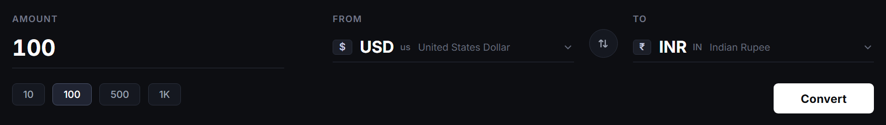
The primary input workspace where users enter monetary values or click preset quick-amount chips (10, 100, 500, 1K). Includes custom FROM/TO selectors with currency symbol badges, country codes, and a central circular swap action button.
- Amount Input: Clean minimal borderless input with dynamic focus underline and automatic 450ms debouncing
- Quick Chips: Pill buttons enabling 1-click amount switching with highlighted active states
- Swap Button: Rotational interactive circular button swapping source and target currencies instantaneously
- Convert CTA: High-contrast crisp white CTA button with subtle hover elevation and loading spinner state

Figure 3: Real-Time Conversion Output & 3D National Bank Note (USD Front)
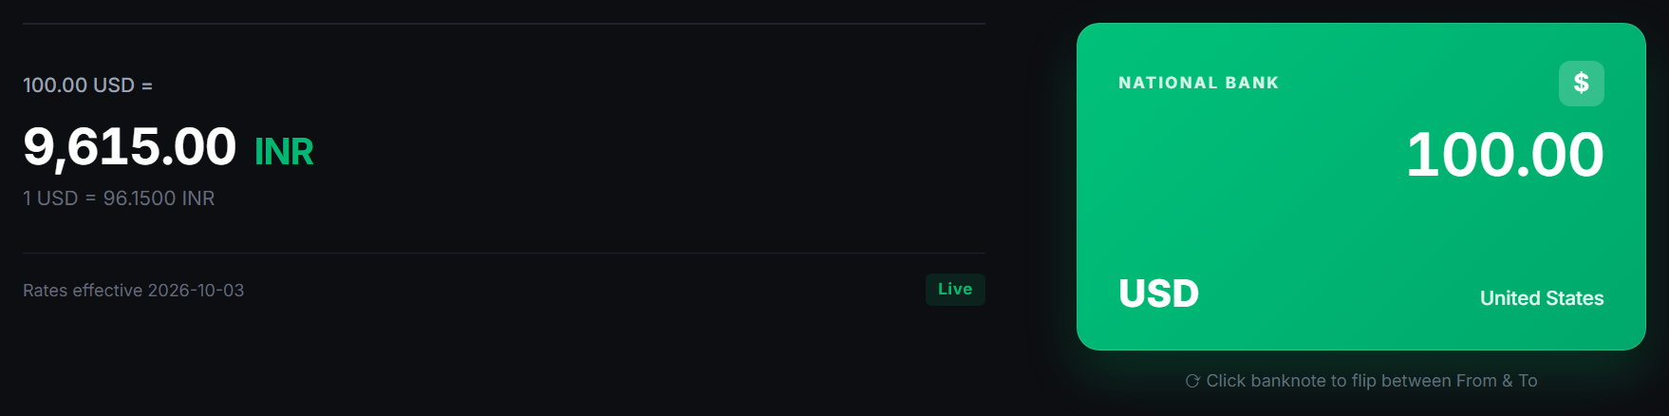
Displays the converted currency calculation result alongside the 3D Emerald 'National Bank' note representing the source currency (USD). Highlights the live rate equation, effective calculation date, and real-time cache state.
- Result Metric: High-impact 34px typography displaying calculated value ('9,615.00 INR')
- Effective Rate: Granular precision breakdown ('1 USD = 96.1500 INR') and effective reference date
- National Bank Card: Emerald green gradient card featuring official bank header, symbol badge, large amount, and country name
- Cache Badge: Green 'Live' indicator confirming real-time validation from Frankfurter v2 and MongoDB Atlas

Figure 4: Interactive 3D Banknote Card Flipped State (Target Currency - INR)
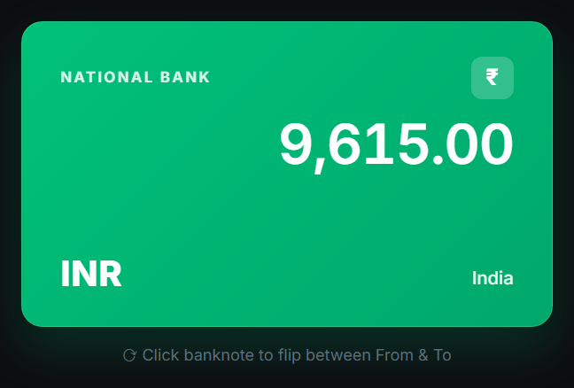
Demonstrates the 3D perspective flip animation when clicking the banknote. The card executes a 180-degree Y-axis rotation with hidden backfaces, revealing the converted target currency ('₹ 9,615.00 INR - India').
- 3D Perspective: Calculated with 1000px depth perspective and smooth cubic-bezier easing transition
- Currency Symbol Badge: Dynamic currency glyph badge ('₹' for Indian Rupee) with glassmorphic transparency
- Backface Visibility: CSS backface-visibility: hidden prevents text distortion or visual artifacts during rotation
- Micro-interaction Hint: Subtle rotational hint ('⟳ Click banknote to flip between From & To') guides the user

Figure 5: Custom Currency Selector Dropdown with Instant Search Filter
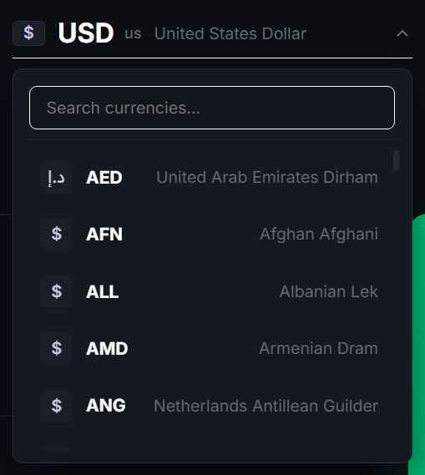
Shows the expanded custom dropdown menu featuring a real-time search input and scrollable list of international currencies with ISO codes, symbols, and complete country names.
- Instant Filtering: Sub-millisecond client-side filtering matching currency codes ('AED', 'AFN', 'ALL') or full names
- Custom Scrollbar: Minimalist sleek scrollbar styling seamlessly blending into the dark surface (#151821)
- Keyboard & Click Accessibility: Automatic focus traversal and click-outside dismissal handlers

Figure 6: Global Live Exchange Rates Board with Base Switcher
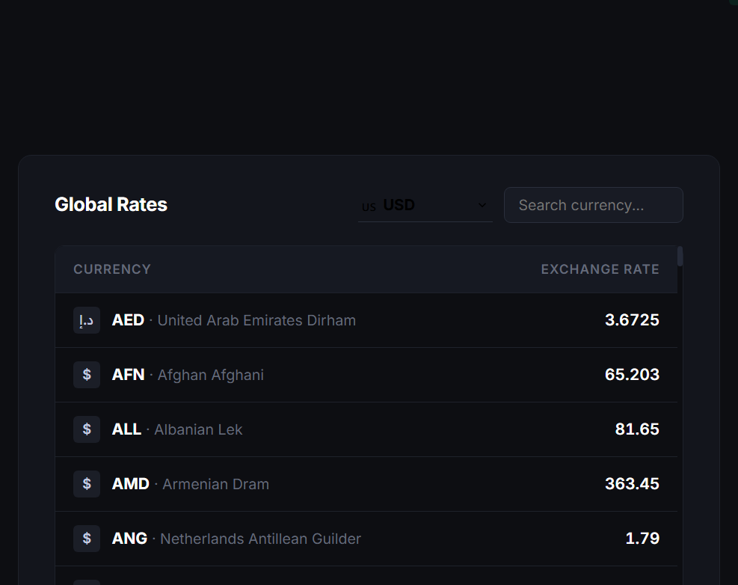
A real-time exchange rate table displaying global foreign currency rates against the selected base currency (USD). Includes an in-table search bar to rapidly locate specific currencies, and one-click conversion activation on row selection.
- Tabular Data Grid: Structured view showing currency symbol, ISO code, full nation name, and exchange rate
- Interactive Row Click: Clicking any currency row automatically selects it as the target currency and re-calculates the conversion
- Real-Time Filter: Live search input instantly narrows visible rates without requiring a server reload

Figure 7: Recent Conversions History Panel with Time-Ago Indicators
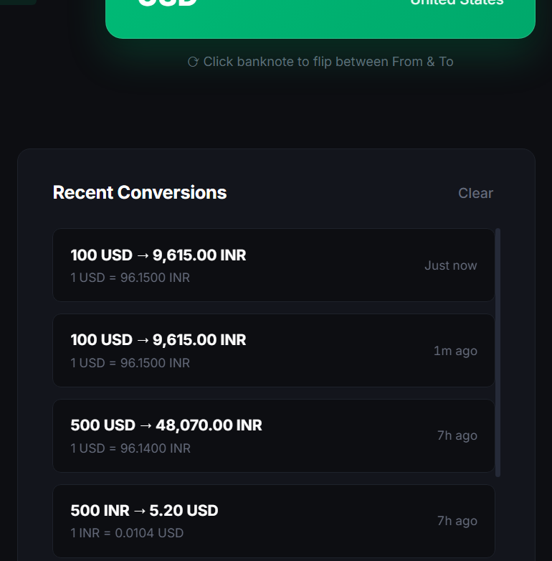
Auditing log displaying past currency conversions stored in MongoDB Atlas and local memory. Displays source and target amounts, effective conversion rate, and relative time-ago timestamps ('Just now', '7h ago').
- History Restoration: Clicking any history entry instantly restores the amounts and currency pair to the converter
- Relative Timestamps: Dynamically formatted time-ago indicators calculated via client helper routines
- Clear Action: Single-click 'Clear' button triggering DELETE /api/conversions to purge database and memory logs

Figure 8: Full Panoramic Application Dashboard (Production Workspace)
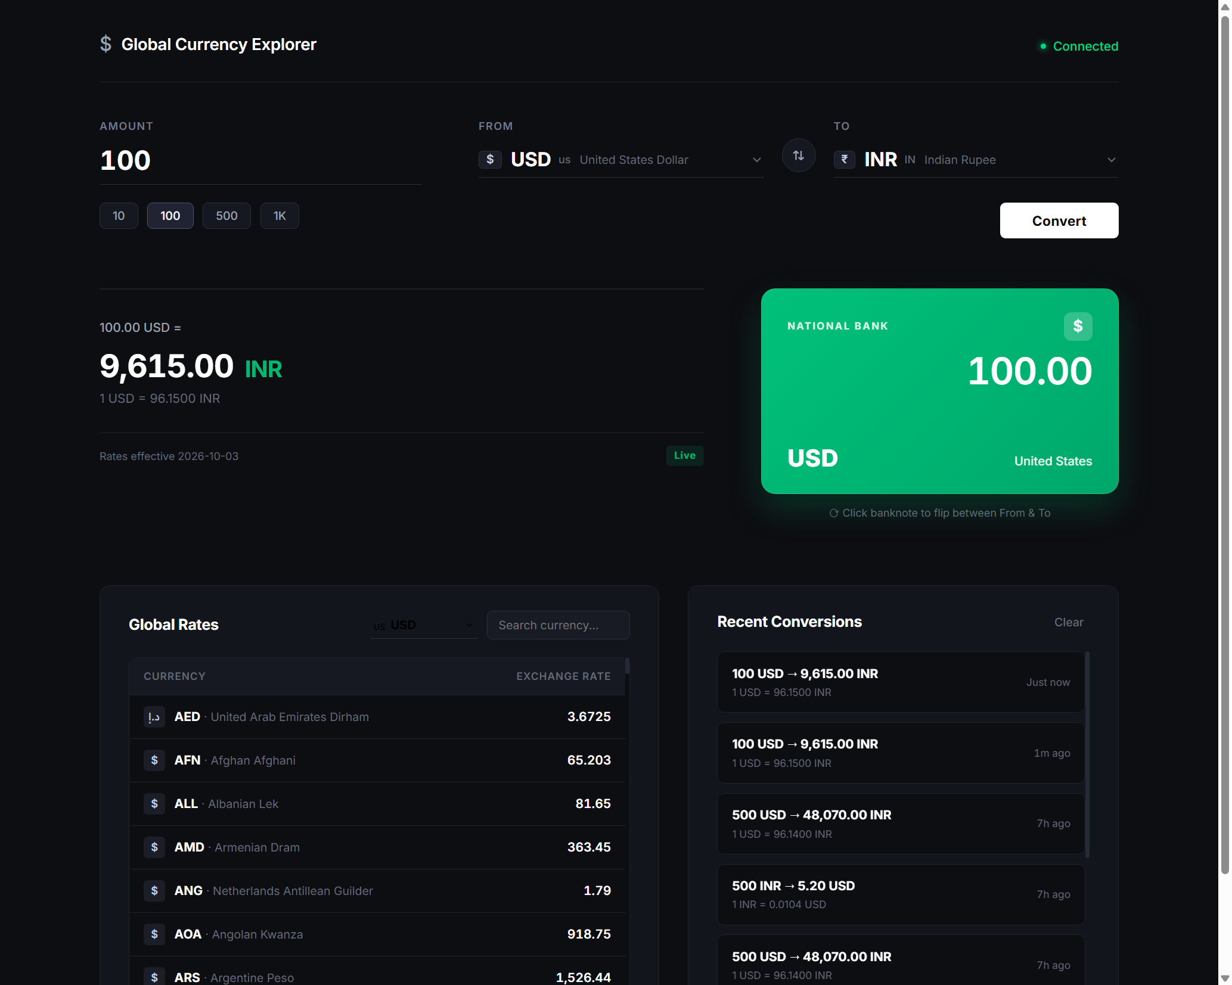
Comprehensive panoramic view of the entire Global Currency Explorer web application running on desktop viewport, illustrating the unified layout hierarchy, minimalist dark palette, and cohesive fintech aesthetic.
- Unified Grid Layout: Two-tier visual architecture balancing conversion actions above with research data below
- Dark Palette Harmony: Muted charcoal (#0D0E12) and elevated surfaces (#13151C) creating visual depth without distraction
- Production Readiness: Zero third-party heavy dependencies; rapid page load and responsive presentation across devices

