

COLLEGE OF COMPUTING AND INFORMATICS
PUTRAJAYA CAMPUS
CSEB5223: Software Construction and Methods

Assignment Part 1 (4%)
SEMESTER 1, ACADEMIC YEAR 2026/2027

SUBJECT CODE : CSEB5223
SUBJECT : Software Construction and Methods
DATE :
GROUP NUMBER : Group 7
SECTION : 1B
LECTURER : TS. DR. LOO YIM LING

NAME OF MEMBERS :

No. | Full Name | Student ID
1 | Muhammad Faiz Fitree Bin Zuffree | BSW01084678

- Use Case Diagram

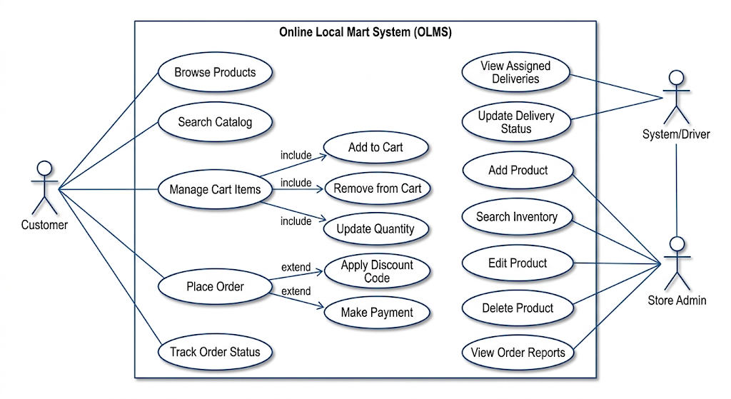

- UML Class Diagram

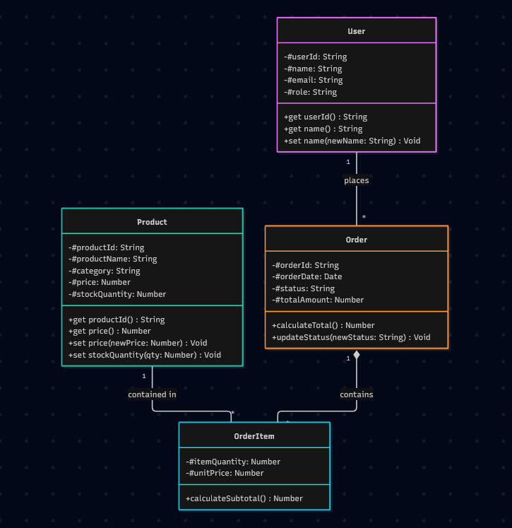

- Naming Conventions

1. General Architectural Casing Conventions

Element Type | Style Standard | Rule Format | Example
Classes / ES6 Modules | PascalCase | Noun | ProductController, OrderItem
Functions / Methods | camelCase | Verb + Noun | findProductById(), calculateTotal()
Variables / Arguments | camelCase | Noun | stockQuantity, customerEmail
Private Class Fields | Encapsulated | # + camelCase | #productId, #unitPrice
Global Constants | UPPER_SNAKE_CASE | Noun | MAX_STOCK_LIMIT, DEFAULT_TAX_RATE
Source File Names | kebab-case | noun.js | product-service.js, order-model.js

2. Domain Entities & Attributes Dictionary

Entity / Class | Field Name | Data Type | Validation / Constraints | Description
User | userId | String | Required, Unique, Non-empty | Unique identifier for each user account.
 | name | String | Required, Max 100 chars | Full name of the customer or admin user.
 | email | String | Required, Unique, Valid email | Primary contact email and login identifier.
 | role | String | Required, Enum: CUSTOMER, ADMIN, DRIVER | Role determining system access permissions.
Product | productId | String | Required, Unique, Non-empty | Unique identifier for each product item.
 | productName | String | Required, Max 150 chars | Descriptive name of the grocery/retail product.
 | category | String | Required, Non-empty | Product classification (e.g., Produce, Dairy, Bakery).
 | price | Number | Required, Positive float (>= 0.00) | Retail price per unit in local currency.
 | stockQuantity | Number | Required, Integer (>= 0) | Current inventory count available for purchase.
Order | orderId | String | Required, Unique, Non-empty | Unique identifier for each customer transaction.
 | orderDate | Date | Required, ISO 8601 Timestamp | Timestamp when the order was successfully placed.
 | status | String | Required, Enum: PENDING, PROCESSING, SHIPPED, DELIVERED, CANCELLED | Current fulfillment status of the order.
 | totalAmount | Number | Required, Positive float (>= 0.00) | Sum of all order item subtotals.
OrderItem | itemQuantity | Number | Required, Integer (>= 1) | Units of a specific product purchased.
 | unitPrice | Number | Required, Positive float (>= 0.00) | Locked unit price at the time of purchase.

3. Method & Function Dictionary

Module / Class | Function / Method | Parameters | Return Type | Description
Product | createProduct() | (productData: Object) | Object | Validates input attributes and instantiates a new Product entity.
 | searchProducts() | (criteria: String) | Array<Object> | Searches and returns matching products, or displays "Not found".
 | editProduct() | (productId: String, updates: Object) | Boolean | Searches product by ID, validates updates, and modifies attributes.
 | deleteProduct() | (productId: String) | Boolean | Prompts confirmation, displays target details, and removes entity.
 | displayProducts() | (productList: Array) | Void | Formats and prints product list clearly in organized tabular view.
 | get productId() | None | String | Returns encapsulated private #productId.
 | get price() | None | Number | Returns encapsulated private #price.
 | set price() | (newPrice: Number) | Void | Validates price (>= 0.00) and updates #price.
 | set stockQuantity() | (qty: Number) | Void | Validates integer quantity (>= 0) and updates #stockQuantity.
Order | calculateTotal() | None | Number | Iterates over items to calculate and return the total order amount.
 | updateStatus() | (newStatus: String) | Void | Validates allowed status state and updates order fulfillment state.
OrderItem | calculateSubtotal() | None | Number | Multiplies itemQuantity by unitPrice to return item subtotal.

4. Prohibited Terminology & Synonyms Rule

Primary Standard Term | Prohibited Synonyms / Aliases | Approved Usage Context
productId | item_id, p_id, sku_code, product_code | Primary key identifier for product entities.
productName | title, item_name, label, p_name | Public-facing display name of a product.
price | cost, unit_cost, amount, rate | Retail selling price of an item in local currency.
stockQuantity | qty, stock, count, available_items | Total available inventory count.
userId | account_id, member_id, u_id | Unique account identifier for users.
orderId | transaction_id, receipt_no, checkout_id | Identifier for customer purchases and orders.
itemQuantity | number_of_items, item_count, basket_qty | Quantity of a specific item selected in a cart or order.

- Define Functions and Modularity
To ensure code maintainability, testability, and clarity, all software modules must abide by the following constraints:
- Single Responsibility Principle (SRP):
  - Each module or function must perform one specific operation (e.g., search logic, input validation, data formatting).
- Function Length Limit:
  - Functions must stay concise and not exceed 30 lines of code. Large functions must be split into modular helper utilities.
- Encapsulation via Accessors:
  - Direct property modification is restricted. Mutations must go through getter and setter methods containing explicit validation checks.

- Define Communication and Continuous Integration Rules

Task Name | Standard / Requirement | Implementation Detail
Data Display Execution | Fetch & Render Data | Automatically query and render the full, updated record set immediately following any Search, Edit, or Delete operation.
Layout & Organization | Structured Display | Format output into an organized view (e.g., Markdown table or UI grid) with aligned column headers.
Attribute Completeness | Explicit Attributes | Ensure all primary entity fields (productId, productName, category, price, stockQuantity) are clearly presented.
State Feedback | Empty State / Graceful Handling | Render an explicit "No records found" message when query results return empty rather than breaking or showing blank space.

