COLLEGE OF COMPUTING AND INFORMATICS
PUTRAJAYA CAMPUS

CSEB5223: Software Construction and Methods
Assignment Part 2
Construction of Inputs and Outputs
SEMESTER 1, ACADEMIC YEAR 2026/2027

SUBJECT CODE : CSEB5223
SUBJECT : Software Construction and Methods
GROUP NUMBER : Group 7
SECTION : 1B
LECTURER : TS. DR. LOO YIM LING

NAME OF MEMBERS :
No. | Full Name | Student ID
1 | Muhammad Faiz Fitree Bin Zuffree | BSW01084678

1. Objective
This report documents the construction of the classes and the CRUD (Create, Search, Edit, Delete) and Data Display functions for the Supply Chain Management (SCM) grocery system planned in Assignment Part 1. The code follows the naming conventions, data dictionary, method dictionary, modularity rules and display rules defined in that plan.
The implementation is written in modern JavaScript (ES6 modules, Node.js) and is run from the terminal with node main.js. Every screenshot in this report is the real output of that code.

2. Project Structure
Each source file has one responsibility and is named in kebab-case, as required by the naming convention.
File | Responsibility
product-model.js | Product entity with private fields (#productId, #productName, #category, #price, #stockQuantity) and validated getters/setters.
user-model.js | User entity (userId, name, email, role) with validated accessors.
order-model.js | OrderItem (calculateSubtotal) and Order (calculateTotal, updateStatus) entities.
validators.js | Reusable validation helpers shared by all models (non-empty string, non-negative number, integer, enum).
product-service.js | Product management module: createProduct, searchProducts, editProduct, deleteProduct, displayProducts.
main.js | Entry point that demonstrates every function, including failure cases.
package.json | Enables ES modules ("type": "module") and the npm start script.

3. Class Construction

3.1 Product class: attributes, data types and accessors
The Product class follows the attribute dictionary from Part 1. All fields are private (# prefix). They can only be read through getters and changed through setters that validate the new value before storing it.
Attribute | Data type | Validation (in code) | Accessors
productId | String | Required, non-empty | Getter only (read-only after creation)
productName | String | Required, non-empty, max 150 chars | Getter and setter
category | String | Required, non-empty | Getter and setter
price | Number | Number, >= 0 | Getter and setter
stockQuantity | Number | Integer, >= 0 | Getter and setter

Extract from product-model.js:

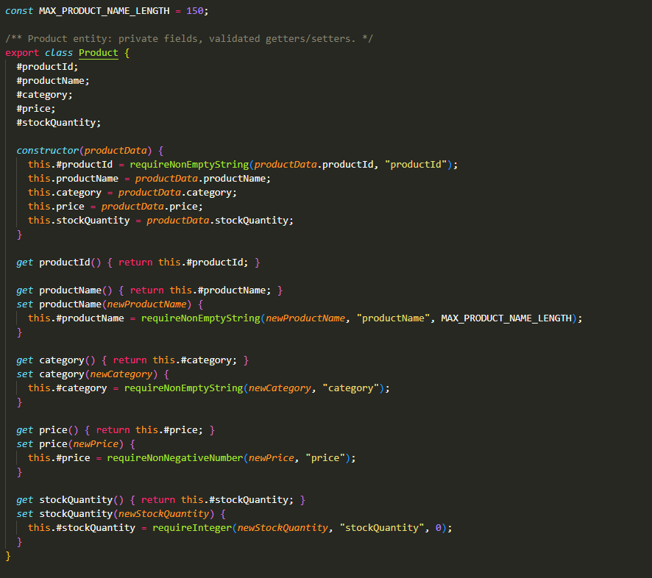
Because the constructor assigns through the setters, a Product object can never be created in an invalid state. The same validation is reused when a product is edited.

3.2 Supporting classes
- User: userId, name (max 100 chars), email (valid format) and role (CUSTOMER, ADMIN or DRIVER).
- OrderItem: itemQuantity (integer >= 1) and a unitPrice locked at purchase time; calculateSubtotal() returns itemQuantity x unitPrice.
- Order: orderId, orderDate (ISO 8601), status (PENDING, PROCESSING, SHIPPED, DELIVERED or CANCELLED) and its items; calculateTotal() sums the item subtotals and updateStatus() validates the new status.

4. CRUD and Data Display Functions
All five functions are methods of ProductService in product-service.js. The module keeps its list of products in a private field (#products), so other code cannot change it directly.

4.1 Create Function: createProduct(productData)
Input: an object holding productId, productName, category, price and stockQuantity. The function first checks that the productId is unique, then builds a Product (which validates every field). It returns the new Product, or null with a [CREATE FAILED] message that states the reason.
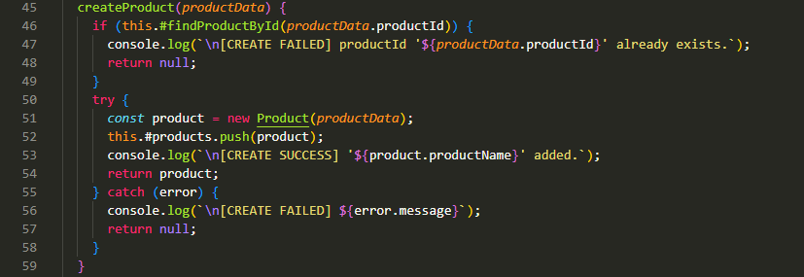

Figure 1 shows three successful creations, followed by three rejected ones: a duplicate productId, a negative price and a non-integer stock quantity. The table at the end is produced by displayProducts().

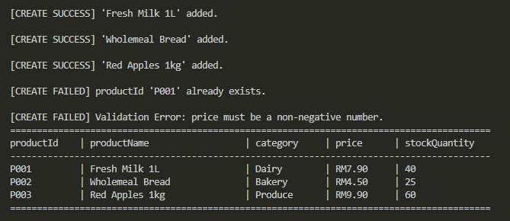

Figure 1: Create function: successful and rejected inputs

4.2 Search Function: searchProducts(criteria)
Input: a search keyword. It matches an exact productId, or part of the productName or category (case-insensitive). Matching products are shown in a table. If nothing matches, the message "Not found." is shown. An empty keyword is rejected. After every search the full record set is displayed again.
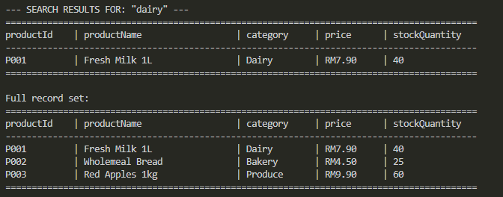
Figure 2: Search by category ("dairy") followed by the full record set
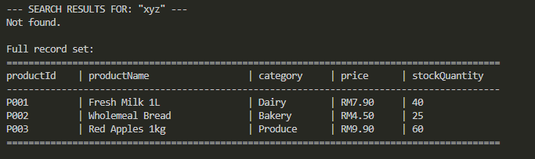
Figure 3: Search with no match and with an empty keyword

4.3 Edit Function: editProduct(productId, updates)
Input: the productId of the target and an object with the fields to change (for example { price: 5.2, stockQuantity: 18 }). The function searches for the product, applies each change through its setter (so every change is validated) and reports [EDIT SUCCESS] or [EDIT FAILED]. The full updated record set is displayed in both cases.

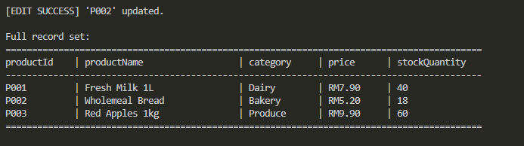
Figure 4: Successful edit of P002 (price and stockQuantity)
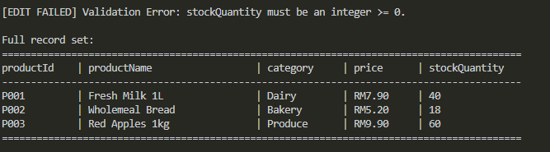
Figure 5: Unsuccessful edits: invalid stockQuantity and unknown productId

4.4 Delete Function: deleteProduct(productId, confirmed)
Input: the productId of the target. The function searches for the product and, unless confirmation was given, shows all its attributes with a [CONFIRMATION REQUIRED] prompt and does not delete anything. When called again with confirmed = true it removes the product and shows the updated record set. Deleting an unknown productId (for example one that was already deleted) is reported as [DELETE FAILED].
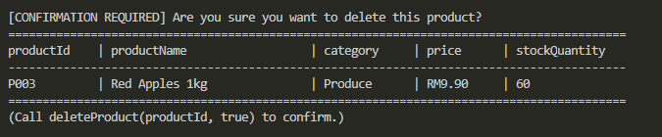
Figure 6: Delete confirmation prompt showing the full attributes of P003
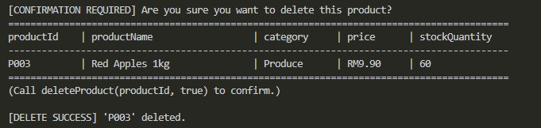
Figure 7: Confirmed deletion, updated record set, and repeated deletion rejected

4.5 Data Display Function: displayProducts(productList)
This function prints any list of products (all of them by default) as an aligned table with all five attributes: productId, productName, category, price and stockQuantity. When the list is empty it prints "No records found." instead of a blank space. It is called automatically after every search, edit and delete, as required by the display rules in Part 1.

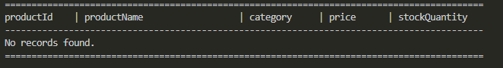
Figure 8: Empty state of the data display function

4.6 Order and User classes in use
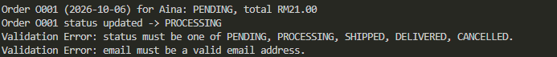
Figure 9: Order total calculation and status validation

5. Software Construction Best Practice Analysis

5.1 Practices applied
Best practice | How it is applied in the code | Evidence
Meaningful naming | Names follow the Part 1 conventions: PascalCase classes, camelCase methods and variables, # private fields, UPPER_SNAKE_CASE constants, kebab-case files. Names state intent (findProductById, requireNonNegativeNumber). | All files; MAX_PRODUCT_NAME_LENGTH, ORDER_STATUSES
Prohibited synonyms avoided | Only the standard terms productId, productName, price, stockQuantity, itemQuantity are used. Aliases such as qty, stock or cost are not used. | Whole code base
Single Responsibility | Models hold data and rules, validators.js only validates, product-service.js manages products, and the print helpers only format output. | File structure in Section 2
Short functions | Every function is under 30 lines. The longest one (searchProducts / editProduct / deleteProduct) is 17 lines including braces. | product-service.js
Encapsulation | All fields are private. Changes go through setters that validate the new value, and the product list cannot be touched from outside the service. | #fields, set price(), #products
DRY (no duplication) | Validation rules are written once in validators.js and reused by Product, User, Order and OrderItem. The table printer is reused by search, delete and display. | validators.js, printTable()
Defensive programming | Duplicate IDs, unknown IDs, empty search keywords, negative numbers and invalid enum values are all rejected before any data is changed. | Figures 1, 3, 5, 7, 9
Graceful error handling | Validation errors are thrown by the models and caught in the service with try/catch, so the program prints a clear message and continues instead of crashing. | createProduct, editProduct
Self-explaining code and documentation | Small functions with descriptive names, JSDoc comments on each public method (purpose, parameters, return value), and comments that explain why rather than what. | product-service.js
Consistent user feedback | Every action reports [SUCCESS] or [FAILED] with a reason, and the data display is refreshed automatically after search, edit and delete. | Figures 1 to 7

5.2 Limitations and possible improvements
- Persistence: Products are kept in memory, so data is lost when the program ends. A later part could add file or database storage.
- Interactivity: The delete confirmation is a parameter (confirmed = true) rather than a typed yes/no answer. A command-line menu using the readline module would make it fully interactive.
- Separation of concerns: The print helpers live in product-service.js. Moving them to a separate display module would separate presentation from business logic even more clearly.
- Testing: The demo in main.js was checked by running it. Automated unit tests (for example with Node's built-in test runner) would protect the validation rules against future changes.

6. Version Control (GitHub)
The codebase is stored in a GitHub repository with the structure shown in Section 2, plus a README.md that explains how to run the project. Each function was committed as a separate, small change with a descriptive message.
Repository URL: [insert GitHub repository link here]

7. Conclusion
The Product, User, Order and OrderItem classes and the five Product functions (Create, Search, Edit, Delete and Data Display) have been built as planned in Part 1. They use private fields with validated accessors, short single-purpose functions, shared validation, and clear success, failure and empty-state messages. The screenshots show that each function behaves as specified for both valid and invalid input.

