**FAIZ MUHAMMAD**

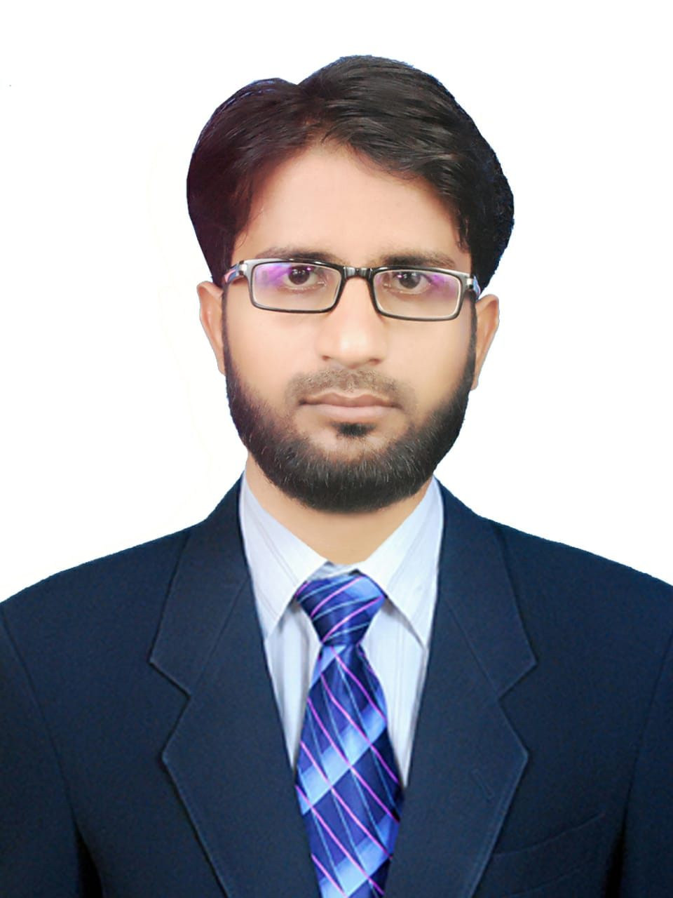

+92 (301) 2452567

[faizhafeez3131@gmail.com](mailto:faizhafeez3131@gmail.com)

**Objective**

Seeking a suitable position to utilize my ability, education and earned experience in the field of Physics. I’m available at immediate request and willing to start anywhere in Karachi.

**Education**

***Intermediate (Pre-Engineering)*** 2013

Govt. College Formen Nazimabad

***Bachelor of Science in Physics*** Jan, 2015 – Dec, 2018

Karachi University

Experience

***Matric*** – (Math, Physics): 7 Years of Teaching Experience

***Intermediate*** – (Physics): 3 Years of Teaching Experience

ARPA school & College (A project of Virtual University)

Adamjee Coaching Centre (Campus 31)

Key Skills

Quiz Competition:

I am winner of all Karachi quiz competitions and also have arranged competitions at various schools in Karachi.

Communication:

Strong team working, leadership and communication skills.

Computer Skills:

CIT and Graphic designer

**Interest and Other Activities**

I want to get an opportunity to educate students of Pakistan.