**CSV file and Process to Read CSV file**

**Sources used to run this Script**

1. Programming language :: Python
2. Text Editor :: Visual Studio

**Basic Concepts**

**What is CSV file?**

Common separated files(CSV) is simple file like any other file. It contains data which could be in the form of tables or list of data. Programs like Microsoft could be used to export and import CSV files. A simple CSV data file is shown in the figure.

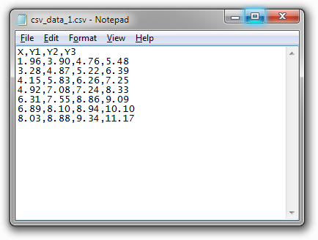

**How to Read CSV file ?**

There are multiple ways of accessing a CSV files. One such method is follow in my task. Below figure shows the command used for this purpose. Delimiter is used to specify the start and end of a plain text or other data stream.



**How to order the list from A to Z ?**

A list could contain any data from alphabet; number etc. Sorted function is used for the purpose of alphabetically ordering of the lines. It is shown in the figure below.

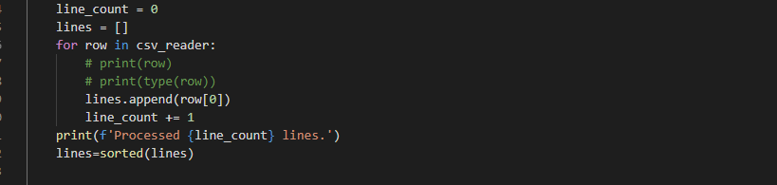

**How to calculate number of words?**

After reading the lines or row from the csv file, next step would be to extract the words from these lines. When these words are extracted from the lines, it is easier to count the number of words. Line_count is an integer which contains the number of words. “*Split”* *function* is used for the purpose of extracting the word and *“len “* function is used to calculate the length.

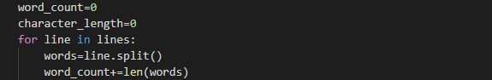

**What is evaluation of Average word length of list?**

In order to calculate the average word length of list, the formula would be :

**Average word length = Total character / Total words**

To calculate the total number of character the code shown in the figure could be used. After the total number of characters and total number of words are counted, simply use the formula shown above to get the average word length of list.

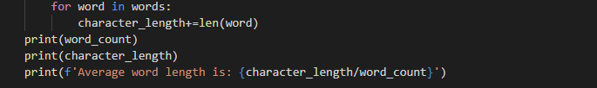

**Completed Task**

Given this word list (<https://docs.google.com/spreadsheets/d/1Clf6VpAwHRvTxeFft2TRCbSxLvMHO14zJiyA7fH1l5Y/edit#gid=0>), write a script to:

- order the list from A to Z and generate a new ordered CSV file;

- count the number of words;

- evaluate the average word length for the list.

**Helpful links**

<https://www.python.org/>

<https://www.learnpython.org/>

<https://docs.microsoft.com/en-us/powershell/module/microsoft.powershell.utility/import-csv?view=powershell-6>

<https://tutorials.visualstudio.com/vs-get-started/intro>

<https://www.geeksforgeeks.org/python-programming-language/>

<https://stackoverflow.com/>