Name: Faiz Rasool Roll no: 195075

LAB MID

Q#4: Using turorial UWPEmployeelist, Develop an application to fetch the Employee list using Generic collections and Hashset(last 05 Roll nos from count of 35 students)

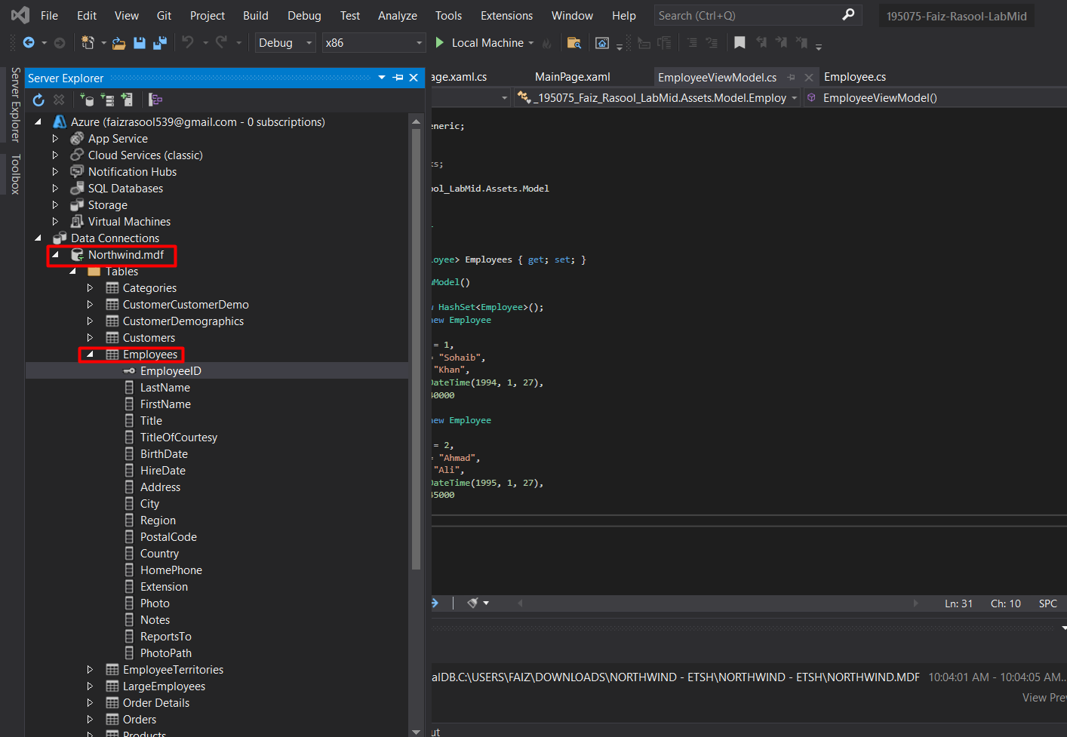

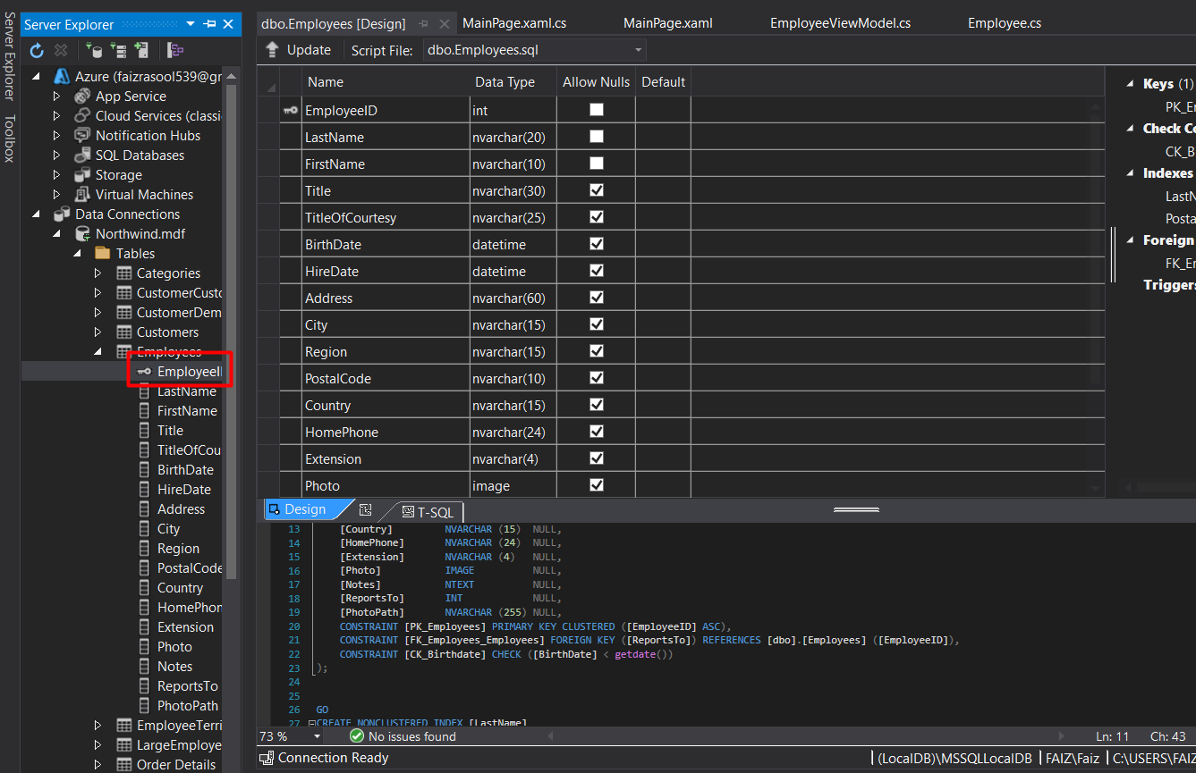

Adding northwind.sql database and fetching Employee tables

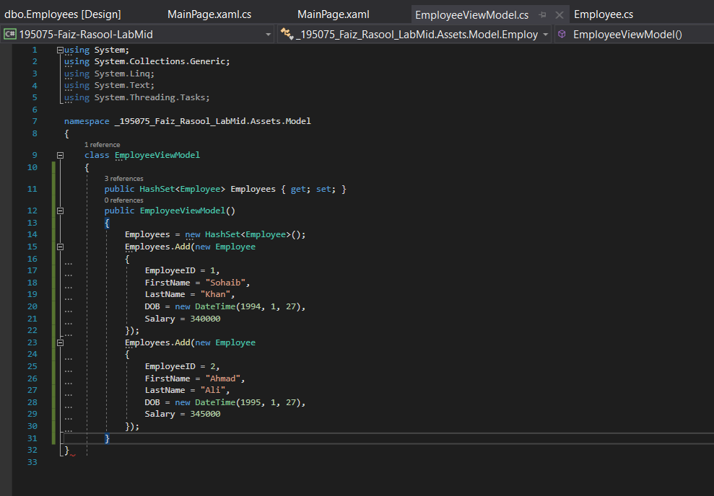

Fetching the Employee list using Generic collections and Hashset

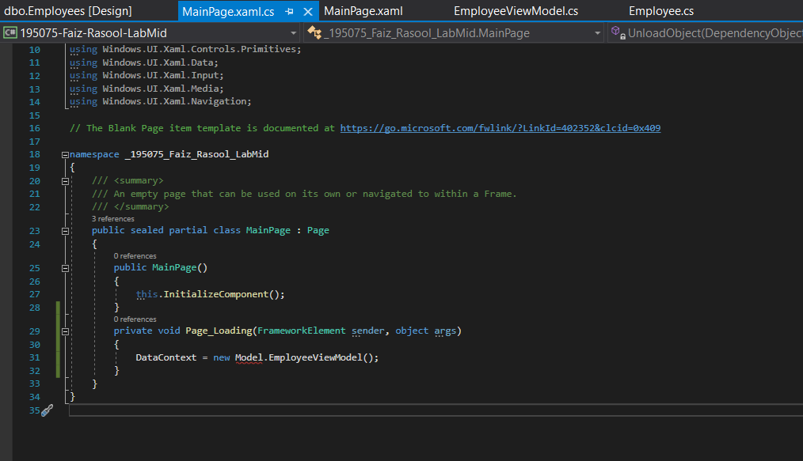

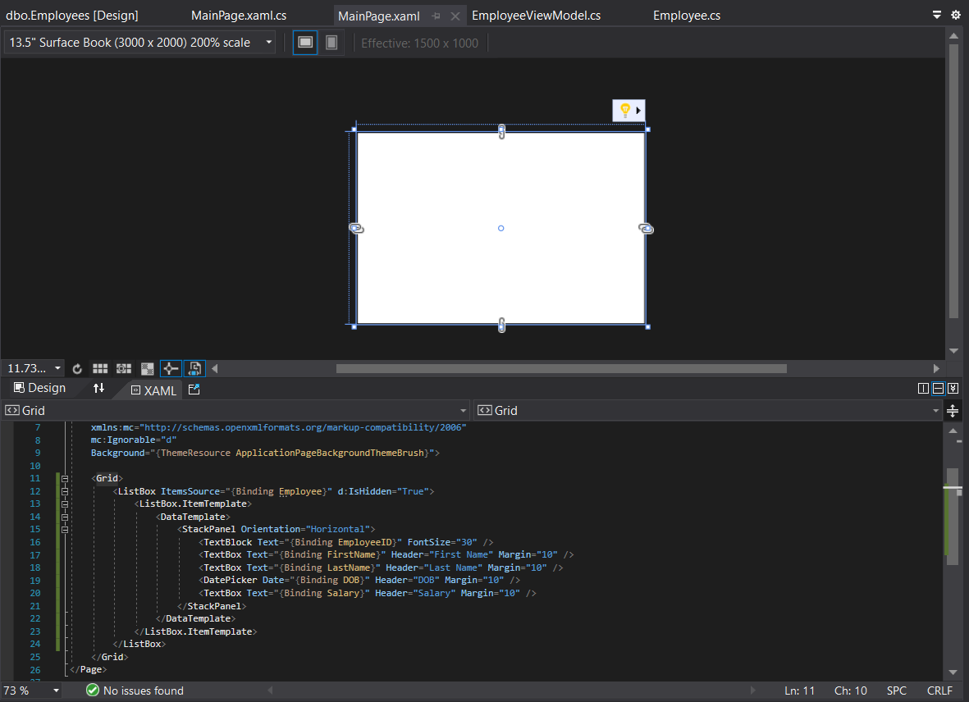

Creating mainpage.xaml view

