PYTHON SKILLS

1) expert pyhton programming. ( Done ) ---(Do free code camp intermediate course)

2) Expertise in web framework. (Django Done)

4) Knowlegde of ORM libraries (shell cammands). (DONE )

10) web scrapping. (Done)

Django: (Done) [dec]
login ,logout , authentication. (done)
User role based permissions. (done)
Creating charts. (after learning javascript)
Adding search form. (Done)
Confirmation email. (done)
Payment/paypal integration. (project)
User profile. (project) (done)
User Image upload. (project) (done)
Deploying app to heroku (done)
connecting postgres database with heroku (done)
password reset email. (done)
Signals in django (done)
connecting postgres and pg-admin (done).

projects:

todo app. (done)
criaglists clone. (done)
ecommerce website. (done)
my personal app. (At the end with javascript).
ecommerce-freecodecamp(IN FEB)

JAVASCRIPT SKILLS:

10) JAVASCRIPT vanilla (DONE)

9) experience of full stack. (javascript, Html, Css,bootstrap) (Done) [january]

11) javascript es6 ( Done )

13) TYPESCRIPT (IN MARCH)

14) express (agr time hu)

15) nodejs (extra video agr time hu)

RUST

→ Turtorial bootcamp (IN Feb)

→ webassembly in rust (IN MARCH)

→ RUST CHAT APP. (IN MARCH)

→ rust rest Api (IN FEB) (DONE HOME AUTOMATION SRVER )

→ EMBEDED RUST (DONE)

→ deploy rust app to heroku (Remaining)

→ BACKEND WITH ROCKET,HYPER
DATABASES

→ MONGODB (DONE)

→ mysql (IN MARCH)

DEVOPS

8) strong devops. (Done in Piaic) ---(Take a look for python again)

3) Agile metholgies. (Done in Piaic)
→ linux (DONE)
→ docker (IN MARCH)
→ kubernetes (IN APRIL)

CHATBOTS AND VOICEBOTS

→ dialogflow (DONE with Integrations)

→ ALEXA BOT (Bootcamp 2021)

THE END

AI skills:

1) web scrapping (Done)

2) face Detection app.

3) smile Detection app.

4) self driving car app.

5) image classifier app.

6) NUMPY

7) PANDAS

8) scipy

9) Matplotib

10) seaborn

11) data vizualization

12) opencv

13) motion detection

14) data wrangling

OPTIONAL (AT THE END)

STM32f1:

esp32 with stm32f1

mqtt protocol :

python

Chat app with django(sockets): (At the End)

https://www.youtube.com/watch?
v=Wv5jlmJs2sU&list=PLLRM7ROnmA9EnQmnfTgUzCfzbbnc-oEbZ

remaining:
django rest , chat app , project freecodecamp

RUST

→ RUST CHAT APP. (IN MARCH)
→ deploy rust app to heroku (Remaining)

Data science Roadmap:
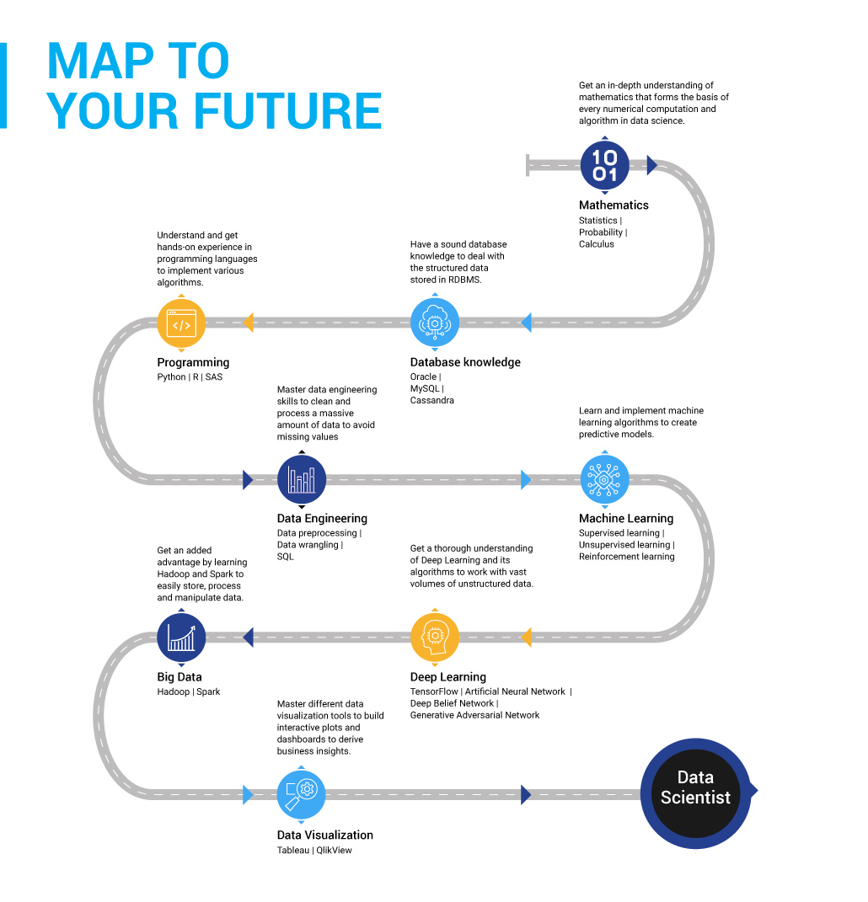

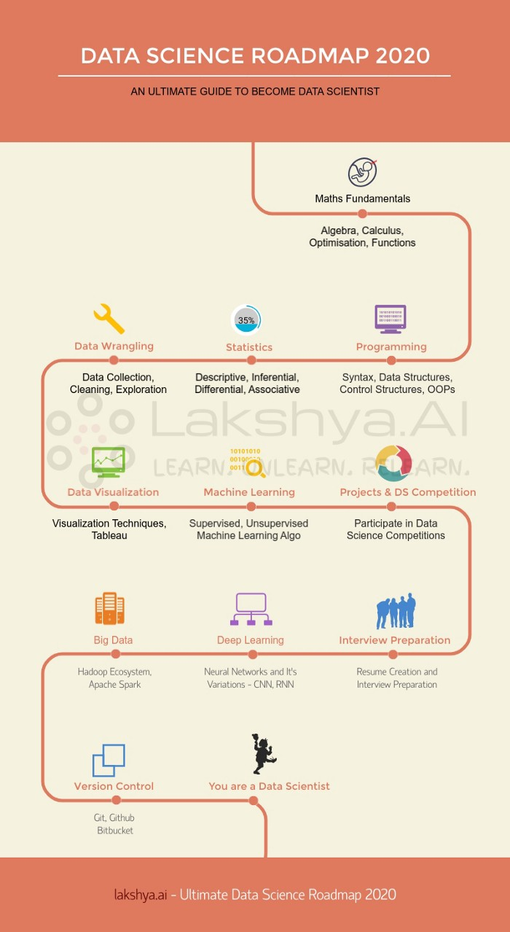

best website for projects:
https://www.education-ecosystem.com/projects/artificial-intelligence

