SYSTEM REQUIREMENT DOCUMENT (SRD)

Requirement | ⚪[Secarang][Insurance] To onboard Zurich Takaful under Pemaju Eksklusif Sdn. Bhd. to the Secarang portal.
Targeted Platform(s) | Secarang
Version | Version 0.1
Latest Revision Date | 28.07.2025 (Mon)

CONTENTS
1. DOCUMENT INFORMATION 3
1.1 Purpose 3
1.2 Intended Audience 3
1.3 Revision History 3
1.4. Glossary Of Terms 4
1.5 Associated Document(s) – if any 5
2.0 REQUIREMENT 6
2.1 High Level Requirement 6
2.2. Specific Requirement 7
2.2.2.1: Specific Requirement > Secarang 8
2.2.2.1.1 Insurance Quotation Page 9

DOCUMENT INFORMATION
This section provides essential details about the System Requirements Document, including its purpose, scope, intended audience, and version history. It serves as a foundational reference for all stakeholders involved in the project, ensuring a shared understanding of the document's objectives and structure.

  - Purpose
The System Requirements Document outlines the agreed system specifications. Once approved, it becomes the baseline to ensure the system meets business goals. Sign-off is required for development to start, and any changes must follow the System Enhancement Management process.

1.2 Intended Audience
The intended audience for this document includes project stakeholders and any team members involved in defining, implementing, or validating the system requirements.

1.3 Revision History
The section records all modifications to the document until it reaches Version 1.0, at which point it is finalized and established as the baseline for future reference.
Once the document is baselined at Version 1.0, any new changes will be assessed based on their severity. If the changes are significant, an addendum may be created to address them. For less critical updates, a formal change request may be submitted, ensuring that all modifications are properly reviewed, approved, and documented while maintaining alignment with the original requirements and project objectives.
Version No | Date | Revised By | Reason for Revision
0.1 | 28.07.2025 (Mon) | Aishah Dhabitah Nor Azman | Initial Draft
Note: Update made to the document is highlighted in blue

1.4. Glossary Of Terms
This section defines key terminology and acronyms used throughout the document, providing clarity and ensuring a common understanding among all audiences of the document.
# | Abbreviation/ Terminology/Terms | Interpretation/Description
1 | BO user | Back Office user
2 | UCD | Used Car Dealer
3 | PO | Product Owner

1.5 Associated Document(s) – if any
This section records essential information and recommends reviewing the following documents, as they provide valuable support and context for the contents of this document.

# | Item | Location / URL | Rationale for Relevance

2.0 REQUIREMENT
This section outlines the key specifications needed for the successful development of the system. It includes two main parts: High-Level Requirements, which summarize the project’s goals and essential functions, and Specific Requirements, which detail the exact criteria and tasks the system must meet. Together, these components meant to provide a clear understanding of what is needed to guide the development process and align stakeholder expectations.

2.1 High Level Requirement
The section reflects the general requests of stakeholders while providing a broad overview and context for the project’s goals without delving into detailed specifications.
High Level Requirement 2.1.1 [Secarang][Insurance] To onboard Zurich Takaful under Pemaju Eksklusif Sdn. Bhd. to the Secarang portal.
# | Item | Description
a | Problem Statement | a. Present handling  Currently, Syarikat Takaful Malaysia is the sole Takaful provider for motor insurance on the Secarang portal. The available coverage types include Comprehensive and Third Party, Fire and Theft (TPFT).  b. Reason for raising this request  To enable Zurich Takaful as the insurance provider for motorcycle, private, and company vehicles on both the eAuto and Secarang platforms, replacing Syarikat Takaful Malaysia.  c. Enhancement Required  To enhance provider options, this enhancement proposes the onboarding of Zurich Takaful as the new Takaful provider for motorcycle, private, and company vehicles on both platforms, replacing Syarikat Takaful Malaysia.  d. Benefit of implementing this enhancement  Implementing this allows users greater insurer choice and access to Zurich Takaful’s coverage, enhancing user experience, pricing competitiveness, and platform appeal while ensuring continuous Takaful availability.
b | Targeted Portal(s) | - Secarang
c | Impacted Key Stakeholder(s) & Impact Description | - Secarang user  Primary reason: The enhancement will be implemented on Secarang.
d | Additional Note(s) - if any | Requirements for eAuto web portal and mobile app will be on another SRD.

2.2. Specific Requirement
The section offers a detailed breakdown of the high-level requirements, specifying the exact criteria and functionalities that the system must achieve to fulfil the enhancement’s overall objective(s).

2.2.2.1: Specific Requirement > Secarang
# | Affected Page | Specification Requirement (SR) Reference
# | Affected Page | Figure | Table
2.2.2.1.1 | Insurance Quotation Page | Figure 2.2.2.1.1.1: Insurance Quotation Page | Table 2.2.2.1.1.1: SR – Insurance Quotation Page

2.2.2.1.1 Insurance Quotation Page
Figure 2.2.2.1.1.1: Insurance Quotation Page
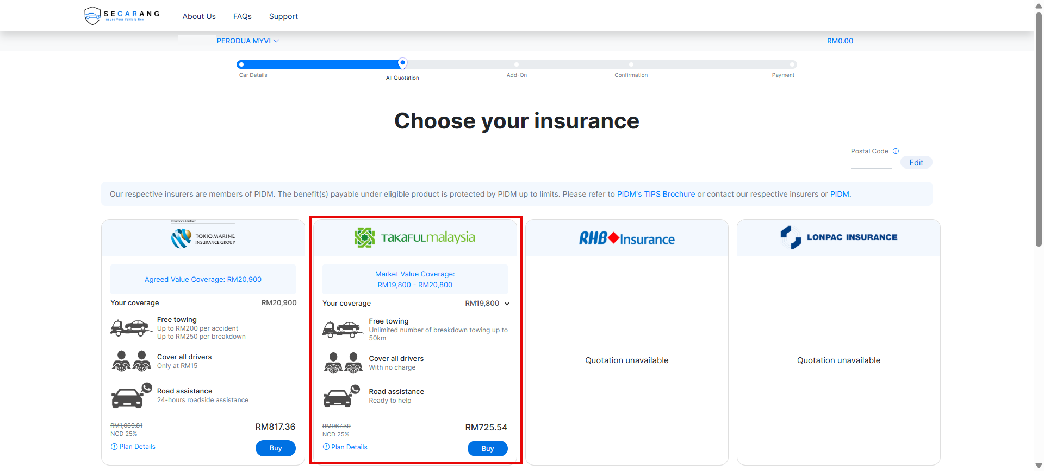

Table 2.2.2.1.1.1: SR – Table 2.2.2.1.1.1: SR – Insurance Quotation Page
# | Callout | Field | Existing / New field | Field format | Mandatory (M) / Optional (O) | Update description
1 | - | Insurance Quotation | New | Handling | - | Current Handling:  At present, Syarikat Takaful Malaysia is the only Takaful provider available for motor insurance on both the eAuto and Secarang platforms.  The coverage options offered are Comprehensive and Third Party, Fire and Theft (TPFT).  New Handling:  To onboard Zurich Takaful as the new Takaful provider for motorcycle, private, and company vehicles, replacing Syarikat Takaful Malaysia, while adhering to the existing insurer prioritisation sequence.

