NETWORK NAMESPACE INSPECTING

Linux Network Stack
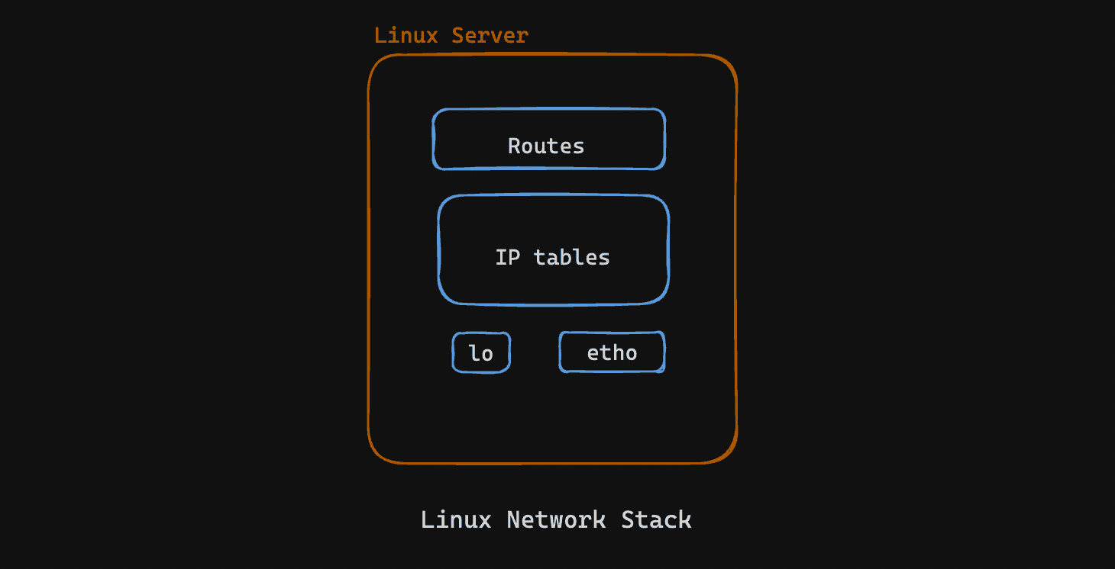
In Linux networking, within the Linux network stack, routes define traffic paths, iptables configures packet filtering, lo is a local loopback interface for testing, and eth0 is the primary Ethernet interface for external connections. Let's inspect the network stack, in short.
Network interfaces allow us to establish communication between a network and a device.
ip link list
lo is the loopback interface, allowing local network communication within a device without external network involvement. Verify the loopback interface is up
ifconfig lo
A route in networking specifies the path for network traffic from source to destination. View the routing table:
ip route show
iptables is a user-space utility for configuring packet filter rules in the Linux kernel's Netfilter framework. View iptables rules:
iptables -L

Create Custom Network Namespace
Let's create a custom namespace using ip netns add utiliy.
sudo ip netns add ntech
sudo ip netns list
Now, entering a network namespace in Linux:
ip netns exec
It is part of the iproute2 package and is often used for managing network namespaces.
sudo ip netns exec ntech bash
nsenter
The nsenter utility is commonly used to enter into namespaces in Linux, including network namespaces.
sudo nsenter --net=/var/run/netns/ntech bash
Now, check the network interfaces inside the new ns.
ip link show
Let's check for iptable rules for custom ns.
ifconfig lo

CONNECT NETWORK NS TO HOST

Connecting a container to host using virtual Ethernet cable
In root ns, it looks like
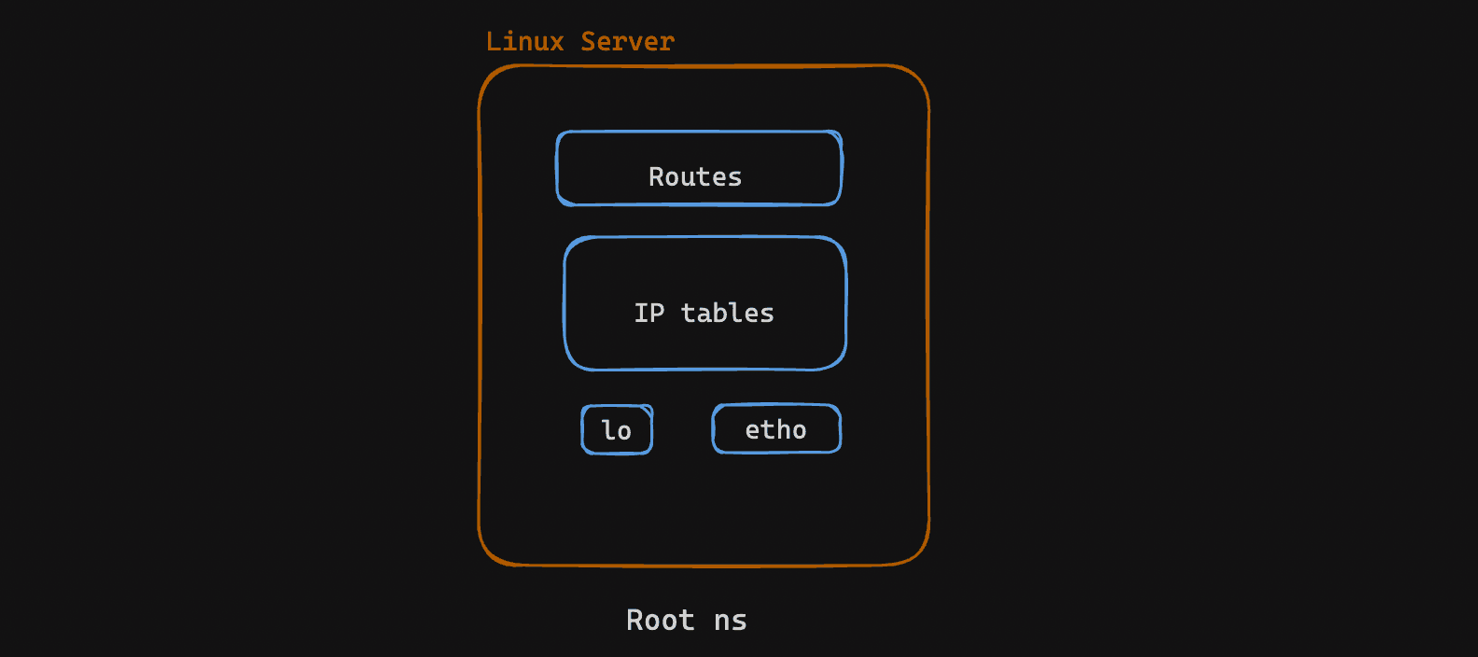
Let's create a custom namespace using ip netns add utiliy.
sudo ip netns add red
sudo ip netns list
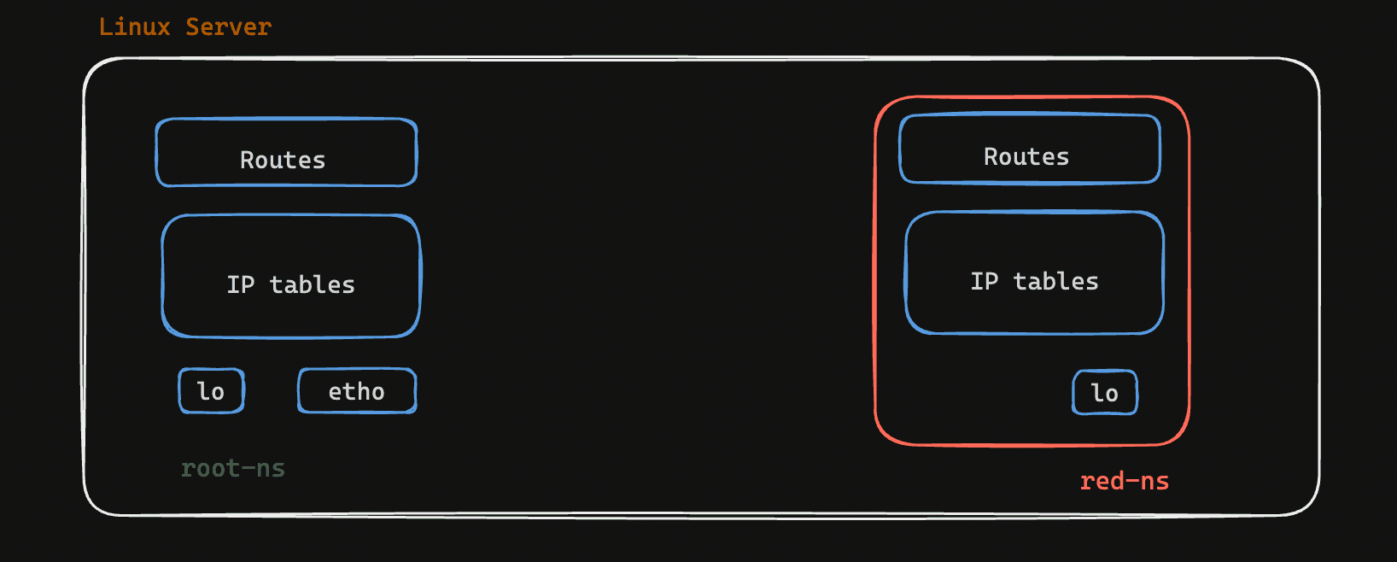
From the root network namespace, let's create a veth cable:
sudo ip link add veth-red type veth peer name veth-host
We just created a pair of interconnected virtual Ethernet devices or interfaces, whatever we say. Both veth-red and veth-host lies inside the root ns.
ip link list
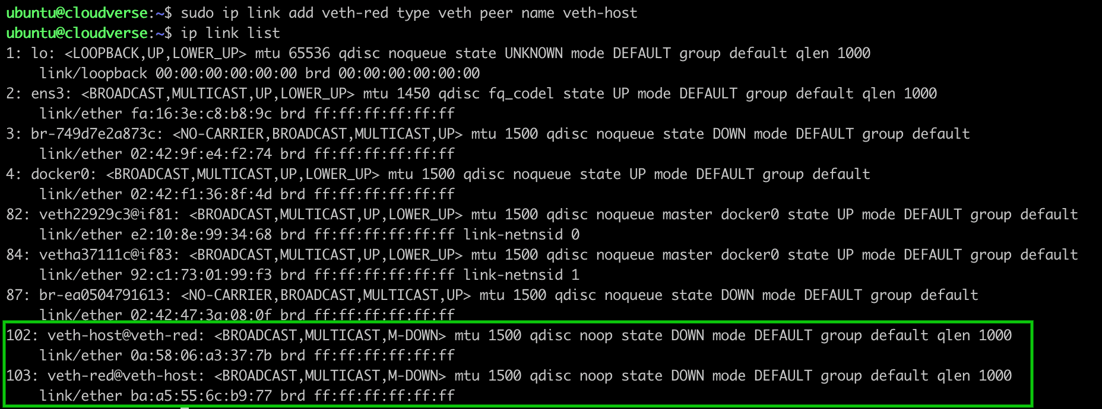
To connect the root namespace with the red namespace, we need to keep one end of the cable in the root namespace and move another one end into the red ns.
sudo ip link set veth-red netns red
This moves one end of the veth pair (veth-red) into the "red" namespace. The other end (veth-host) remains in the default network namespace.
Now, let's configure IP Addresses to both end of this veth cable and once we turn up the interfaces, the peer device will instantly display any packet that appears on one of the devices.
In the "red" namespace:
sudo ip netns exec red ip addr add 192.168.1.1/24 dev veth-red
sudo ip netns exec red ip link set veth-red up
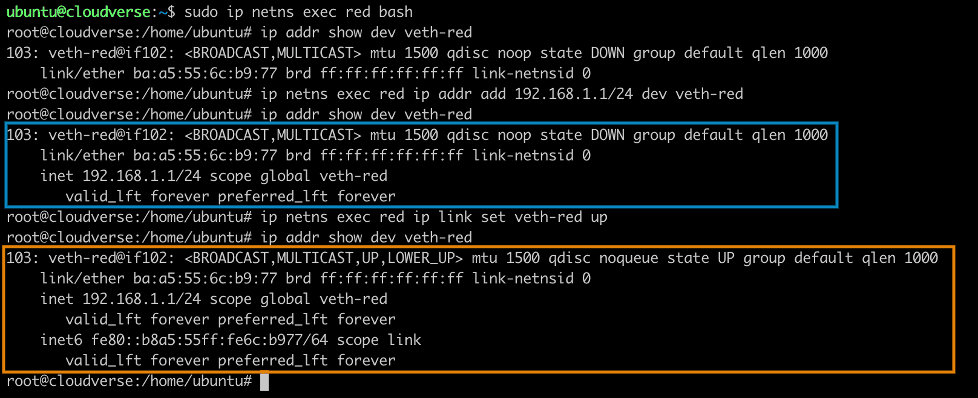
On the host side:
sudo ip addr add 192.168.1.2/24 dev veth-host
sudo ip link set veth-host up
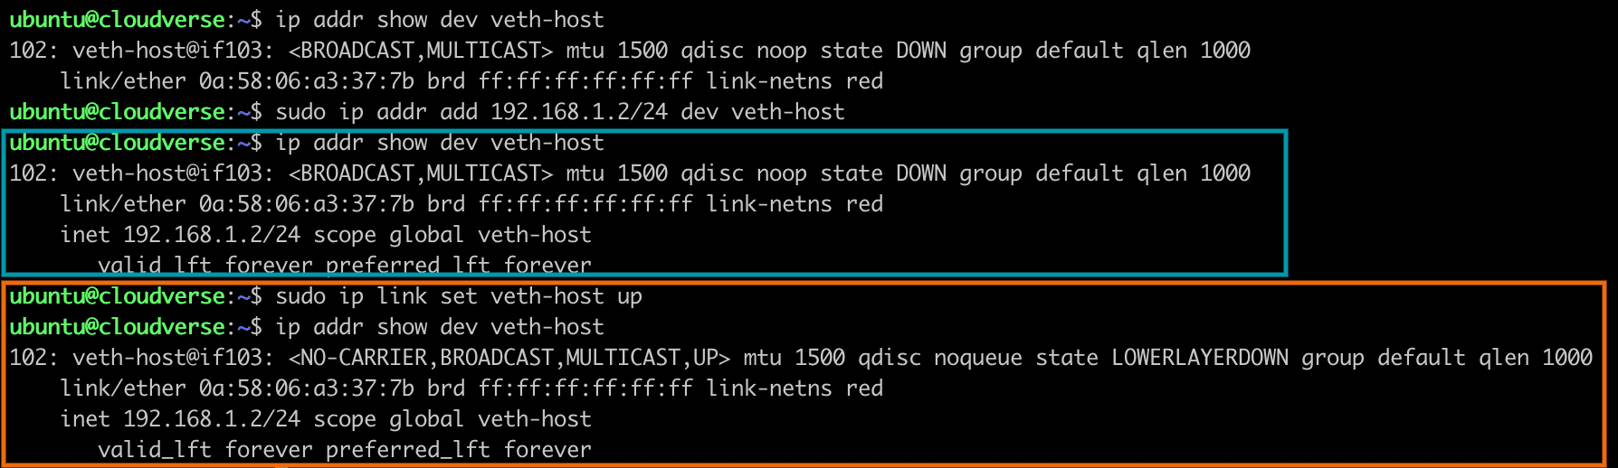
The virtual ethernet pair is now ready.
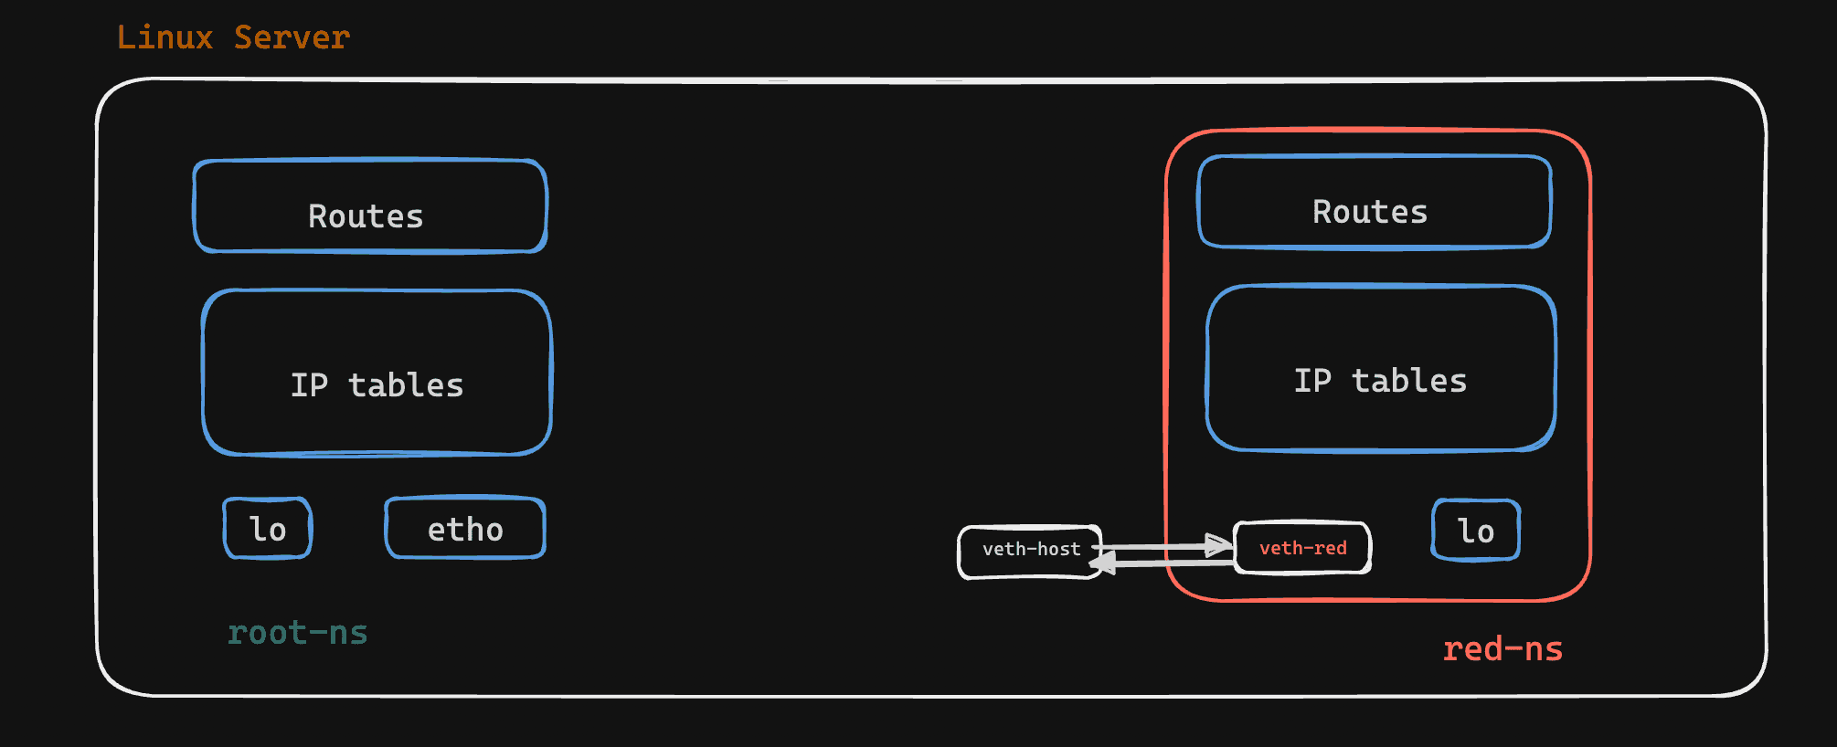
A route is needed to add on the host to direct traffic destined for 192.168.1.1 through the veth-host interface.
sudo ip route add 192.168.1.1 dev veth-host

Why Add a Route?
Without adding the route, the system doesn't know how to reach 192.168.1.1. When we ping 192.168.1.1, the system checks its routing table to determine where to send the ping packets. If there's no specific route for 192.168.1.1, it won't know which interface to use.
By adding the route, we are explicitly telling the system that to reach 192.168.1.1, it should send the traffic through the veth-host interface, which is part of the veth pair connected to the "red" namespace.

Test connectivity
Let's try to ping the red ns from the veth-host interface:
ping 192.168.1.1 -c 3
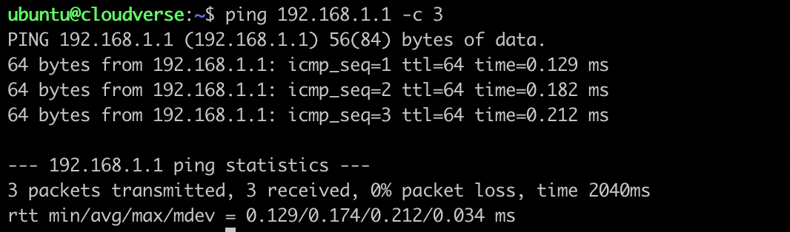
Again, let's try to ping the veth-host interface from the red namespace:
sudo ip netns exec red bash
ping 192.168.1.2 -c 3
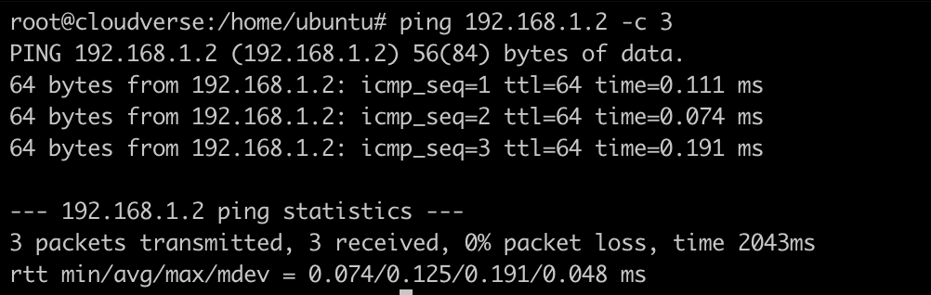

CONNECT NETWORK NS TO ROOT

CONNECT NETWORK NS TO ROOT
Expand

Connecting a container network namespace to root network namespace
Let's create a custom network namespace ns0 and a bridge br0. In Linux networking, a bridge is a virtual network device that connects multiple network interfaces, allowing them to function as a single logical network.
sudo ip netns add ns0
sudo ip link add br0 type bridge
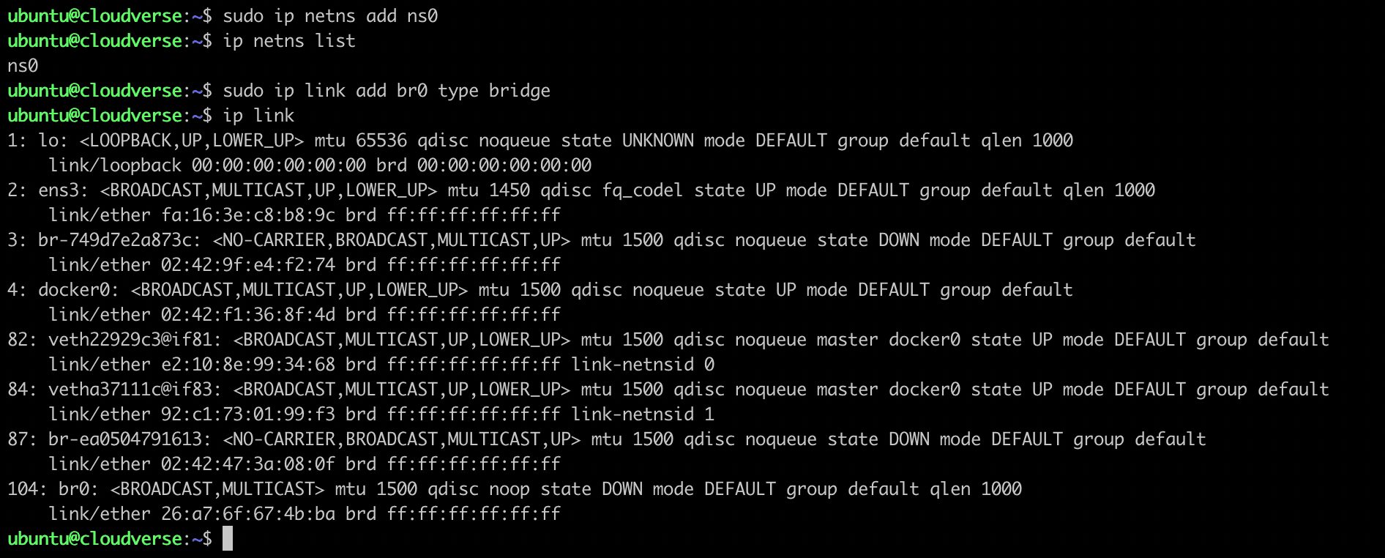

Configure a bridge interface
A new device, the br0 bridge interface, has been created, but it's now in a DOWN state. Let's assign ip address and turn it into UP state.
sudo ip link set br0 up
sudo ip addr add 192.168.0.1/16 dev br0
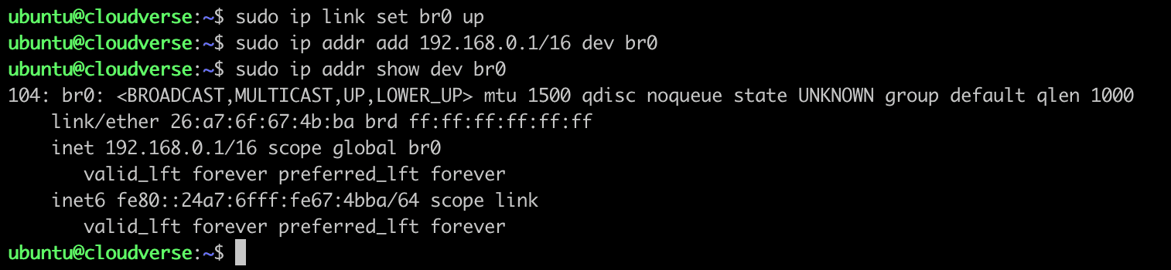
Now let's verify whether br0 is able to receive the packet or not.
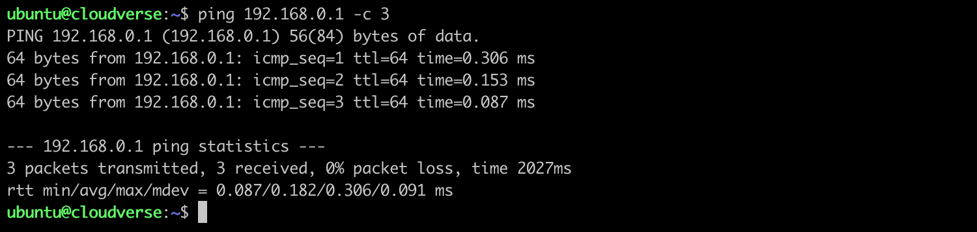

Configure virtual ethernet cable
It's time to set up a virtual Ethernet cable. One cable hand will be configured as a nic card in the ns0 namespace, while the other hand will be configured in the br0 interface.
sudo ip link add veth0 type veth peer name ceth0
sudo ip link set ceth0 netns ns0
sudo ip link set veth0 master br0
Both end of this cable is now in DOWN state. Let's turn into UP state
sudo ip netns exec ns0 ip link set ceth0 up
sudo ip link set veth0 up

Configure ns0 namespace
We need to assign an ip address to ceth0 and turn loopback interface into UP state.
sudo ip link set lo up
sudo ip addr add 192.168.0.2/16 dev ceth0

Namespace ns0 to root ns Communication
Let's check the Ip address assigned to primary ethernet interface of host machine.
ip addr show
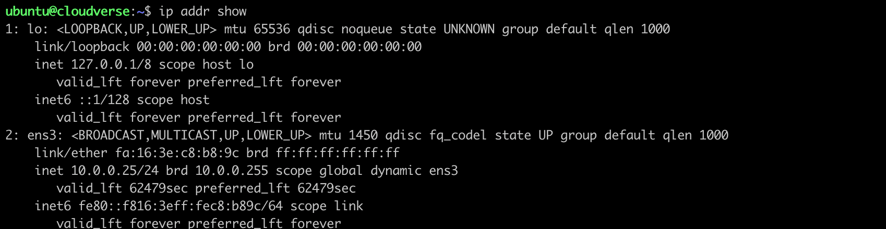
Now, ping to this ip address
sudo ip netns exec ns0 bash
ping 10.0.0.25
It says network in unreachable. So, something is not okay. Let's check the route table.
route
The output may look like.
Kernel IP routing table
Destination Gateway Genmask Flags Metric Ref Use Iface
192.168.0.0 0.0.0.0 255.255.0.0 U 0 0 0 ceth0
This routing table entry indicates that any destination IP address within the 192.168.0.0/16 network should be reached directly through the ceth0 interface, without the need for a specific gateway.
So we need to add a Default Gateway in the route table.
ip netns exec ns0 bash
ip route add default via 192.168.0.1
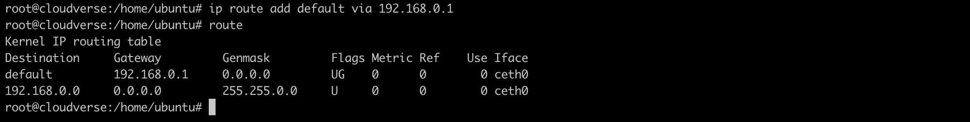
Now we are good to go! Let's ping again.
sudo ip netns exec ns0 bash
ping 10.0.0.25 -c 5
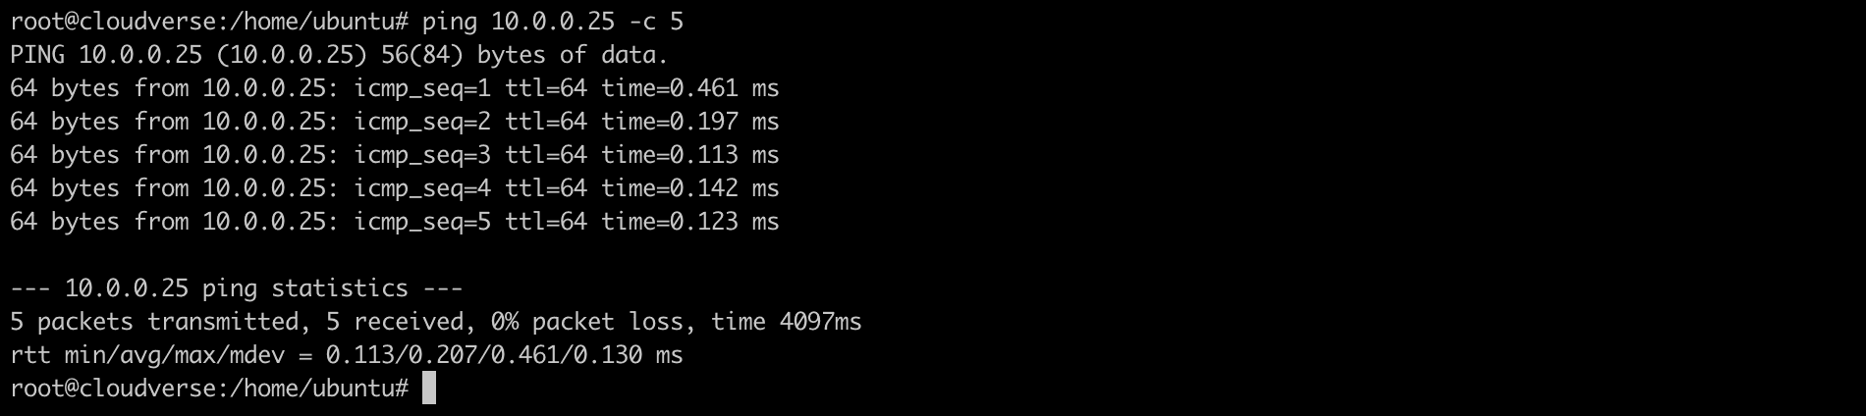

EGRESS TRAFFIC

EGRESS TRAFFIC
Expand

Connecting a container network namespace to root network namespace
Let's create a custom network namespace ns0 and a bridge br0. In Linux networking, a bridge is a virtual network device that connects multiple network interfaces, allowing them to function as a single logical network.
sudo ip netns add ns0
sudo ip link add br0 type bridge


Configure a bridge interface
A new device, the br0 bridge interface, has been created, but it's now in a DOWN state. Let's assign ip address and turn it into UP state.
sudo ip link set br0 up
sudo ip addr add 192.168.0.1/16 dev br0

Now let's verify whether br0 is able to receive the packet or not.


Configure virtual ethernet cable
It's time to set up a virtual Ethernet cable. One cable hand will be configured as a nic card in the ns0 namespace, while the other hand will be configured in the br0 interface.
sudo ip link add veth0 type veth peer name ceth0
sudo ip link set ceth0 netns ns0
sudo ip link set veth0 master br0
Both end of this cable is now in DOWN state. Let's turn into UP state
sudo ip netns exec ns0 ip link set ceth0 up
sudo ip link set veth0 up

Configure ns0 namespace
We need to assign an ip address to ceth0 and turn loopback interface into UP state.
sudo ip link set lo up
sudo ip addr add 192.168.0.2/16 dev ceth0

Namespace ns0 to root ns Communication
Let's check the Ip address assigned to primary ethernet interface of host machine.
ip addr show

Now, ping to this ip address
sudo ip netns exec ns0 bash
ping 10.0.0.25
It says network in unreachable. So, something is not okay. Let's check the route table.
route
The output may look like.
Kernel IP routing table
Destination Gateway Genmask Flags Metric Ref Use Iface
192.168.0.0 0.0.0.0 255.255.0.0 U 0 0 0 ceth0
This routing table entry indicates that any destination IP address within the 192.168.0.0/16 network should be reached directly through the ceth0 interface, without the need for a specific gateway.
So we need to add a Default Gateway in the route table.
ip netns exec ns0 bash
ip route add default via 192.168.0.1

Now we are good to go! Let's ping again.
sudo ip netns exec ns0 bash
ping 10.0.0.25 -c 5


Ping 8.8.8.8 from ns0 [ egress traffic ]
We have come so far. Now we can ping our root ns or primary ethernet interface from custom namesapce. But can we ping outside the world? Let's ping to 8.8.8.8.
sudo ip netns exec ns0 bash
ping 8.8.8.8 -c 5
Okay, it does not seem that the network is unreachable. It's something else. Maybe somewhere, packets have stuck. Let's dig it out. We can do it using the Linux utility tcpdump. We will check two interfaces. One is br0, and the other is ens3 (in the case of my device).
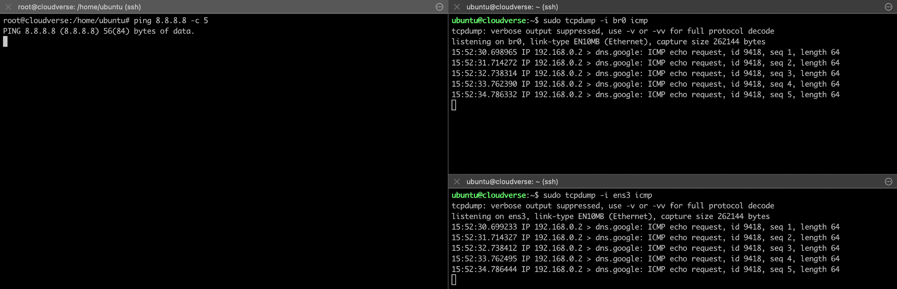
Here we can see that packets are coming to those interfaces but are still stuck in ns0. But why?

Root Cause
See! The source IP address, 192.168.0.2, is attempting to connect to Google DNS 8.8.8.8 using its private IP address. So it's very basic that the outside world can't reach that private IP because they have no idea about that particular private IP address. That's why packets are able to reach Google DNS, but we are not getting any replies from 8.8.8.8.

Solution
We must somehow change the private IP address to a public address in order to sort out this issue with the help of NAT (Network Translation Address). So, a SNAT (source NAT) rule must be added to the IP table in order to modify the POSTROUTING chain.
sudo iptables -t nat -A POSTROUTING -s 192.168.0.0/16 -j MASQUERADE

Role of POSTROUTING
The POSTROUTING chain in iptables is part of the NAT (Network Address Translation) table, and it is applied to packets after the routing decision has been made but before the packets are sent out of the system. The primary purpose of the POSTROUTING chain is to perform Source Network Address Translation (SNAT) or MASQUERADE on outgoing packets.

MASQUERADE Action
The MASQUERADE target in iptables is used for Network Address Translation (NAT) in order to hide the true source address of outgoing packets. Here, when the packet matches the conditions specified in an iptables rule with the MASQUERADE target, the source IP address of the packet is dynamically replaced with the IP address of the outgoing interface. The NAT engine on the router or gateway replaces the private source IP address with its own public IP address before forwarding the packet to the external network. When the external network sends a reply back to the public IP address, the NAT engine tracks the translation and forwards the reply back to the original private IP address within the internal network.

Firewall rules
sudo iptables -t nat -L -n -v
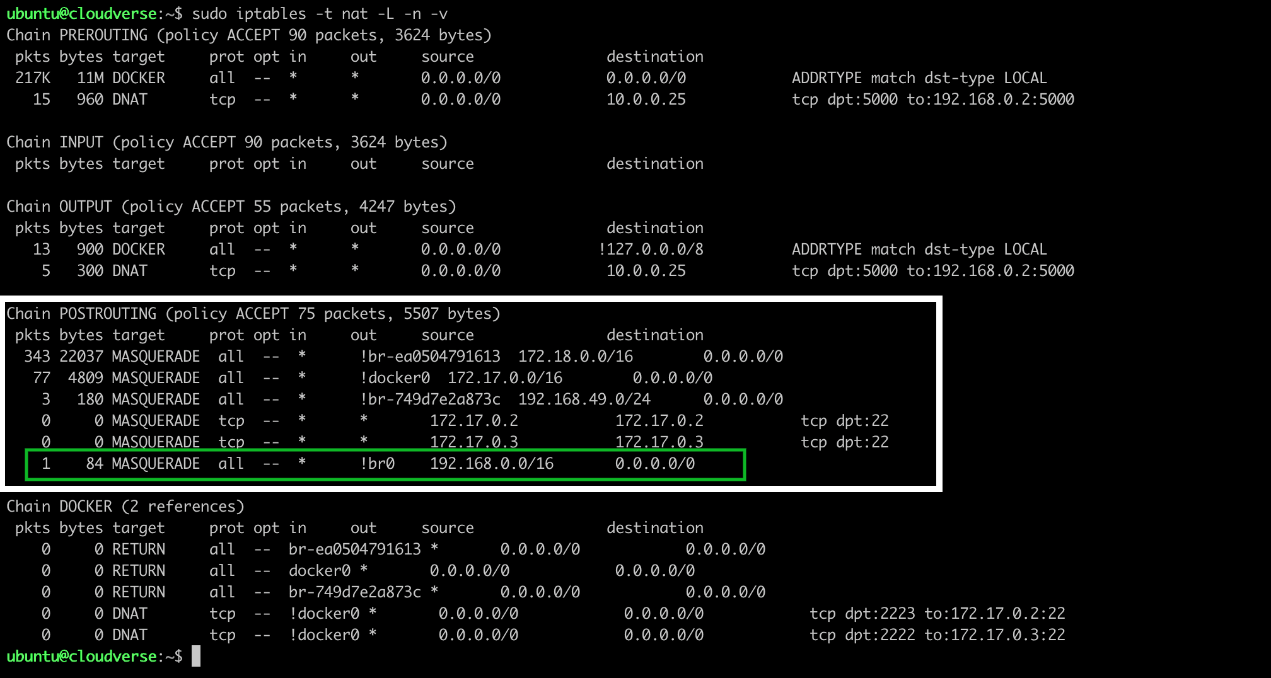
In case if still it not works then we may need to add some additional firewall rules.
sudo iptables --append FORWARD --in-interface br0 --jump ACCEPT
sudo iptables --append FORWARD --out-interface br0 --jump ACCEPT
These rules enabled traffic to travel across the br0 virtual bridge.These are useful to allow all traffic to pass through the br0 interface without any restrictions. However, keep in mind that using such rules without any filtering can expose your system to potential security risks. But for now we re good to ping!

Test Connectivity
ping 8.8.8.8 -c 5
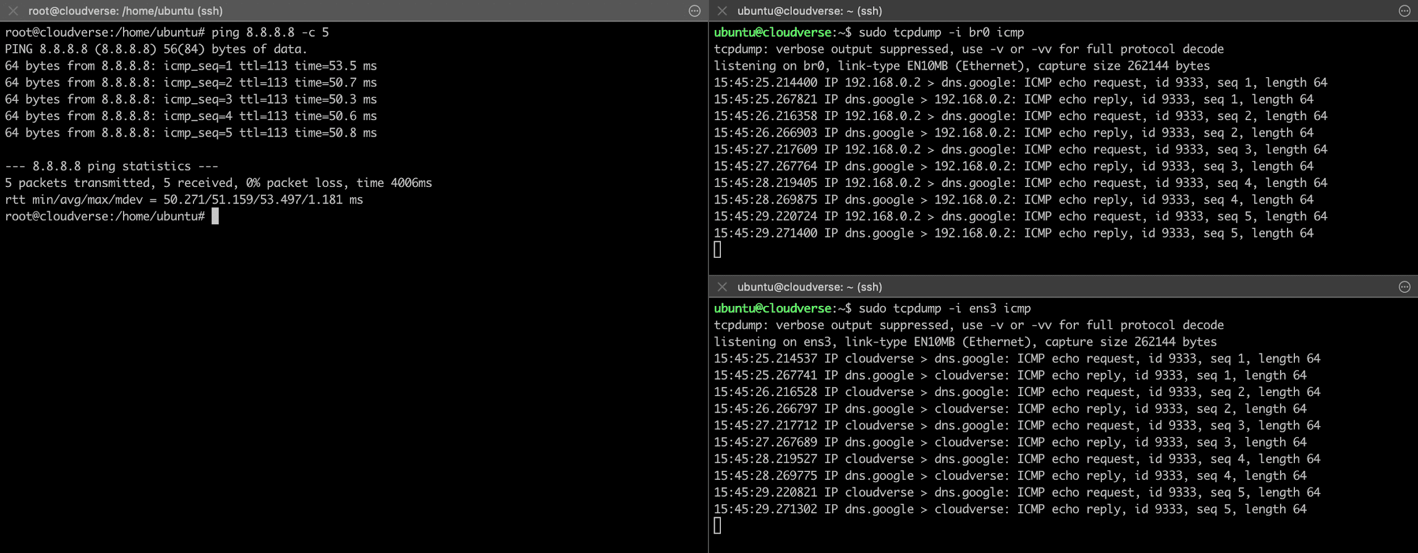
Bingo!

6. CONNECT TWO CUSTOM NETWORK NS
Expand

CONNECT TWO CUSTOM NETWORK NS
Expand

Setting up Virtual Network between Namespaces
This guide outlines the steps to create two namespaces named blue-namespace and lemon-namespace, and establish a virtual Ethernet network between them using veth interfaces. The goal is to enable communication between the namespaces and allow them to ping each other.

Prerequisites
- Linux operating system
- Root or sudo access
- Packages
sudo apt update
sudo apt upgrade -y
sudo apt install iproute2
- sudo apt install net-tools

Steps

1. Enable IP forwarding in the Linux kernel:
sudo sysctl -w net.ipv4.ip_forward=1
This step enables IP forwarding in the Linux kernel, allowing the namespaces to communicate with each other.

2. Create namespaces:
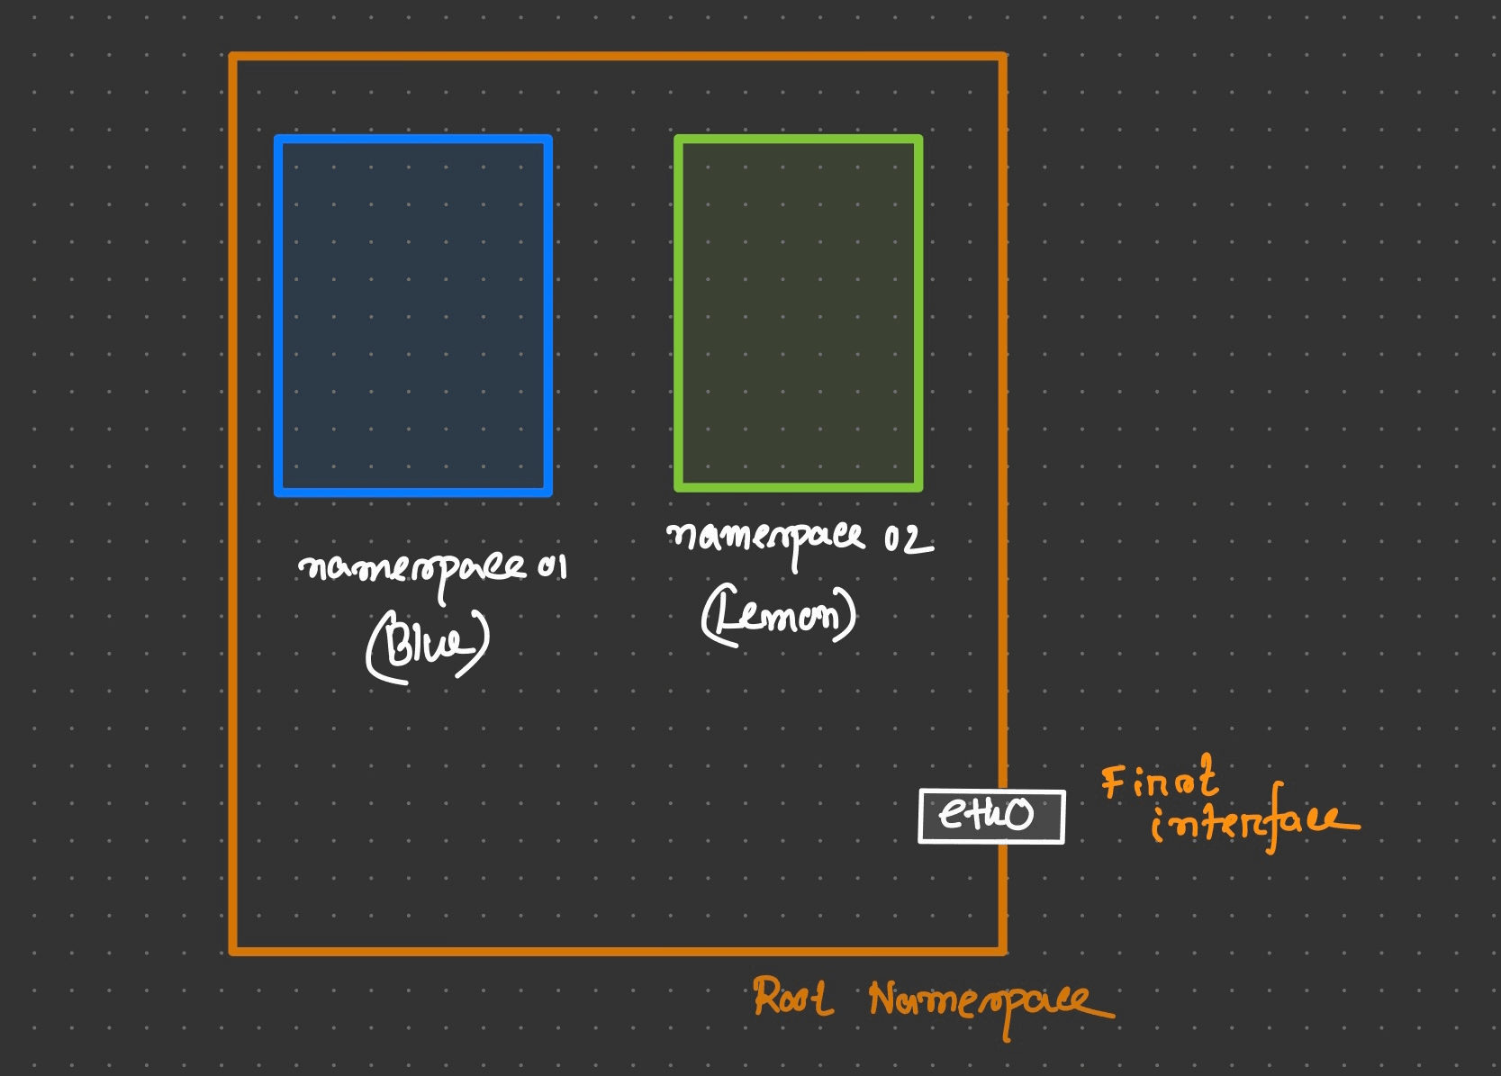
sudo ip netns add blue-namespace
sudo ip netns add lemon-namespace
This step creates two namespaces named blue-namespace and lemon-namespace.

3. Create the virtual Ethernet link pair:
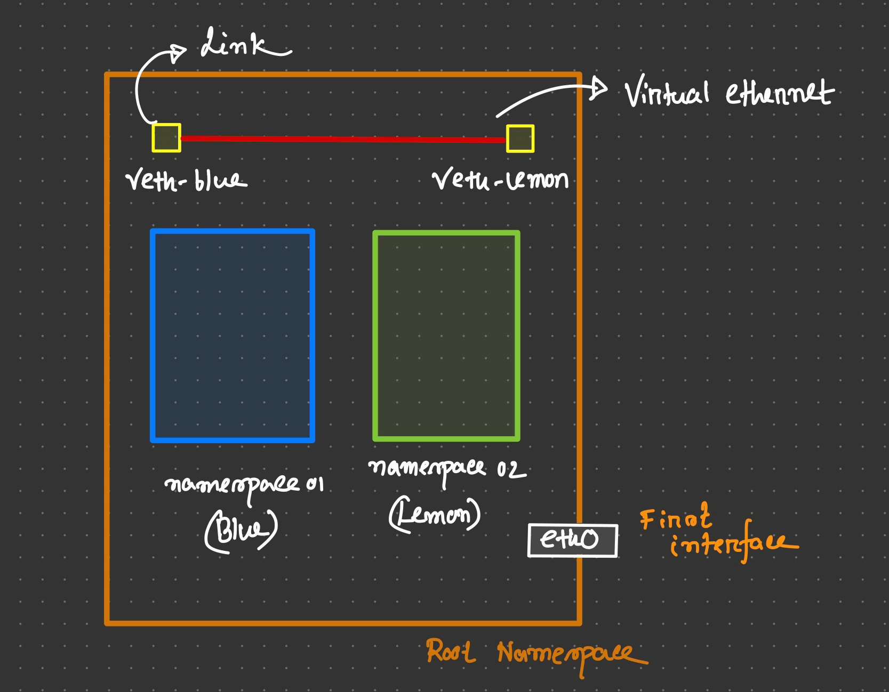
sudo ip link add veth-blue type veth peer name veth-lemon
This command creates a virtual Ethernet link pair consisting of veth-blue and veth-lemon at root namespace.
In order to verify, run sudo ip link list
Expected Output:
6: veth-lemon@veth-blue: <BROADCAST,MULTICAST,M-DOWN> mtu 1500 qdisc noop state DOWN mode DEFAULT group default qlen 1000
link/ether 22:21:fc:9e:d0:2b brd ff:ff:ff:ff:ff:ff
7: veth-blue@veth-lemon: <BROADCAST,MULTICAST,M-DOWN> mtu 1500 qdisc noop state DOWN mode DEFAULT group default qlen 1000
link/ether 2e:34:8e:0c:1c:6e brd ff:ff:ff:ff:ff:ff

4. Set the cable as NIC
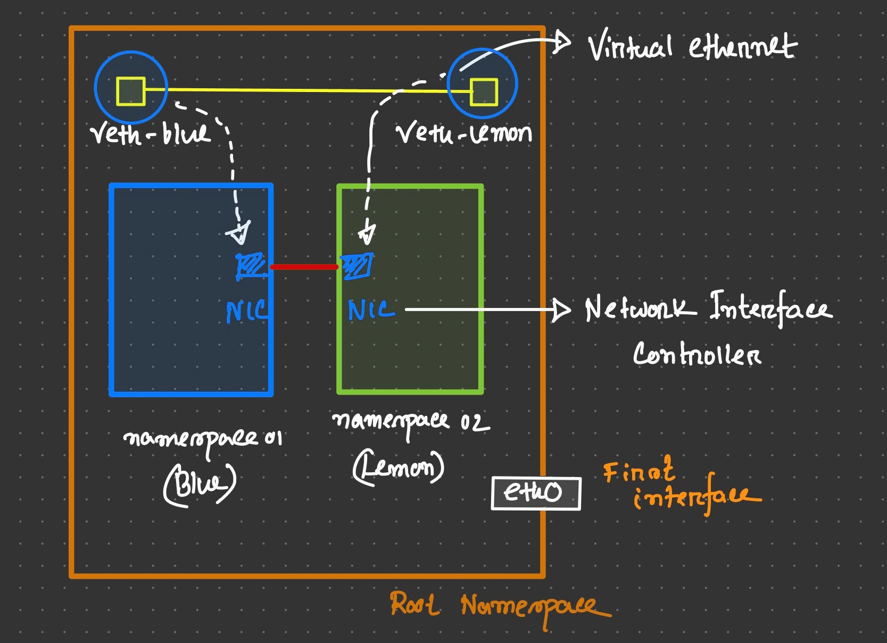
sudo ip link set veth-blue netns blue-namespace
sudo ip link set veth-lemon netns lemon-namespace
This command acts as NIC link pair consisting of veth-blue and veth-lemon.
To verify run sudo ip netns exec blue-namespace ip link and sudo ip netns exec lemon-namespace ip link
Expected Output
1: lo: <LOOPBACK> mtu 65536 qdisc noop state DOWN mode DEFAULT group default qlen 1000
link/loopback 00:00:00:00:00:00 brd 00:00:00:00:00:00
7: veth-blue@if6: <BROADCAST,MULTICAST> mtu 1500 qdisc noop state DOWN mode DEFAULT group default qlen 1000
link/ether 2e:34:8e:0c:1c:6e brd ff:ff:ff:ff:ff:ff link-netns lemon-namespace
and
1: lo: <LOOPBACK> mtu 65536 qdisc noop state DOWN mode DEFAULT group default qlen 1000
link/loopback 00:00:00:00:00:00 brd 00:00:00:00:00:00
6: veth-lemon@if7: <BROADCAST,MULTICAST> mtu 1500 qdisc noop state DOWN mode DEFAULT group default qlen 1000
link/ether 22:21:fc:9e:d0:2b brd ff:ff:ff:ff:ff:ff link-netns blue-namespace
But as we see, interface has been created but it's DOWN and has no ip. Now assign a ip address and turn it UP.

5. Assign IP Addresses to the Interfaces
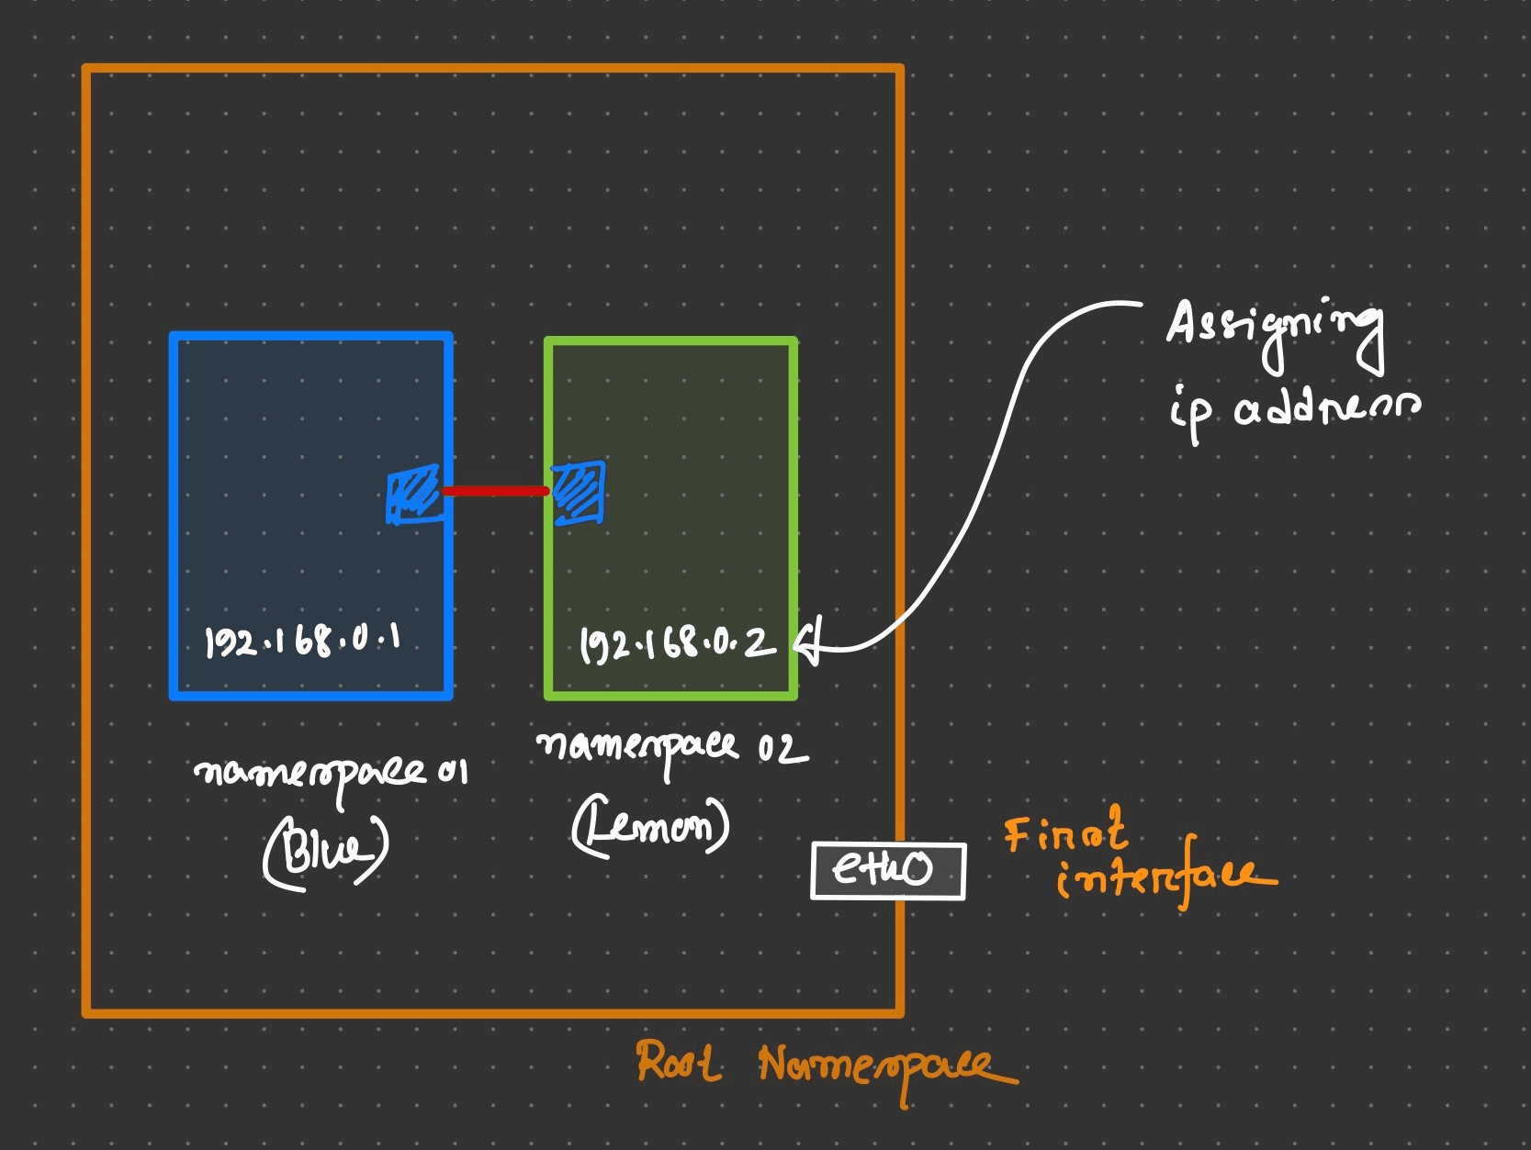
sudo ip netns exec blue-namespace ip addr add 192.168.0.1/24 dev veth-blue
sudo ip netns exec lemon-namespace ip addr add 192.168.0.2/24 dev veth-lemon
In this step, IP addresses are assigned to the veth-blue interface in the blue-namespace and to the veth-lemon interface in the lemon-namespace.
To verify run sudo ip netns exec blue-namespace ip addr and sudo ip netns exec lemon-namespace ip addr
Expected Output:
7: veth-blue@if6: <BROADCAST,MULTICAST> mtu 1500 qdisc noop state DOWN group default qlen 1000
link/ether 2e:34:8e:0c:1c:6e brd ff:ff:ff:ff:ff:ff link-netns lemon-namespace
inet 192.168.0.1/24 scope global veth-blue
valid_lft forever preferred_lft forever
and
6: veth-lemon@if7: <BROADCAST,MULTICAST> mtu 1500 qdisc noop state DOWN group default qlen 1000
link/ether 22:21:fc:9e:d0:2b brd ff:ff:ff:ff:ff:ff link-netns blue-namespace
inet 192.168.0.2/24 scope global veth-lemon
valid_lft forever preferred_lft forever

6. Set the Interfaces Up
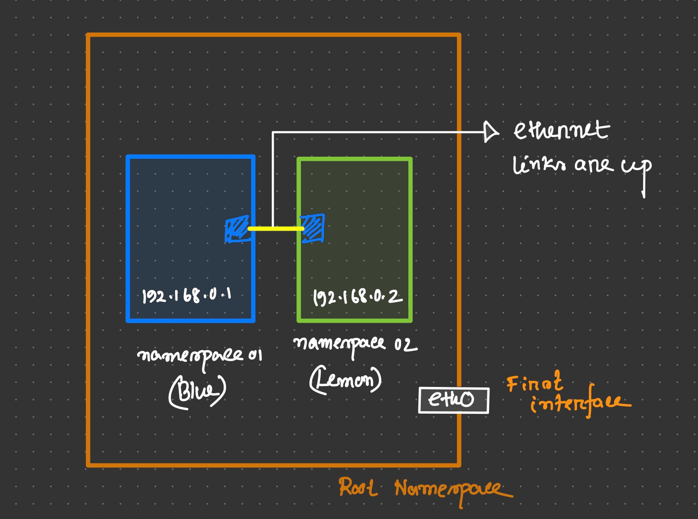
sudo ip netns exec blue-namespace ip link set veth-blue up
sudo ip netns exec lemon-namespace ip link set veth-lemon up
These commands set the veth-blue and veth-lemon interfaces up, enabling them to transmit and receive data.
Now run again sudo ip netns exec blue-namespace ip link and sudo ip netns exec lemon-namespace ip link to verify
Expected Output:
7: veth-blue@if6: <BROADCAST,MULTICAST,UP,LOWER_UP> mtu 1500 qdisc noqueue state UP mode DEFAULT group default qlen 1000
link/ether 2e:34:8e:0c:1c:6e brd ff:ff:ff:ff:ff:ff link-netns lemon-namespace
and
6: veth-lemon@if7: <BROADCAST,MULTICAST,UP,LOWER_UP> mtu 1500 qdisc noqueue state UP mode DEFAULT group default qlen 1000
link/ether 22:21:fc:9e:d0:2b brd ff:ff:ff:ff:ff:ff link-netns blue-namespace

7. Set Default Routes
sudo ip netns exec blue-namespace ip route add default via 192.168.0.1 dev veth-blue
sudo ip netns exec lemon-namespace ip route add default via 192.168.0.2 dev veth-lemon
These commands set the default routes within each namespace, allowing them to route network traffic.
In order to verify run sudo ip netns exec blue-namespace ip route and sudo ip netns exec lemon-namespace ip route
Expected Output:
default via 192.168.0.1 dev veth-blue
192.168.0.0/24 dev veth-blue proto kernel scope link src 192.168.0.1
and
default via 192.168.0.2 dev veth-lemon
192.168.0.0/24 dev veth-lemon proto kernel scope link src 192.168.0.2

In addition, the route command in the context of the ip netns exec allows you to view the routing table of a specific network namespace. The routing table contains information about how network traffic should be forwarded or delivered.
To view the routing table of the lemon-namespace, you can execute the following command:
sudo ip netns exec lemon-namespace route
Output
Kernel IP routing table
Destination Gateway Genmask Flags Metric Ref Use Iface
default 192.168.0.2 0.0.0.0 UG 0 0 0 veth-lemon
192.168.0.0 0.0.0.0 255.255.255.0 U 0 0 0 veth-lemon
To view the routing table of the blue-namespace, you can execute the following command:
sudo ip netns exec blue-namespace route
Output
Kernel IP routing table
Destination Gateway Genmask Flags Metric Ref Use Iface
default 192.168.0.1 0.0.0.0 UG 0 0 0 veth-blue
192.168.0.0 0.0.0.0 255.255.255.0 U 0 0 0 veth-blue

8. Test Connectivity
sudo ip netns exec blue-namespace ping 192.168.0.2
sudo ip netns exec lemon-namespace ping 192.168.0.1
Use these commands to test the connectivity between the namespaces by pinging each other's IP address.
Expected Output:
PING 192.168.0.2 (192.168.0.2) 56(84) bytes of data.
64 bytes from 192.168.0.2: icmp_seq=1 ttl=64 time=0.024 ms
64 bytes from 192.168.0.2: icmp_seq=2 ttl=64 time=0.069 ms
64 bytes from 192.168.0.2: icmp_seq=3 ttl=64 time=0.063 ms
64 bytes from 192.168.0.2: icmp_seq=4 ttl=64 time=0.064 ms
64 bytes from 192.168.0.2: icmp_seq=5 ttl=64 time=0.063 ms
^C
--- 192.168.0.2 ping statistics ---
5 packets transmitted, 5 received, 0% packet loss, time 4099ms
rtt min/avg/max/mdev = 0.024/0.056/0.069/0.016 ms
and
PING 192.168.0.1 (192.168.0.1) 56(84) bytes of data.
64 bytes from 192.168.0.1: icmp_seq=1 ttl=64 time=0.033 ms
64 bytes from 192.168.0.1: icmp_seq=2 ttl=64 time=0.072 ms
64 bytes from 192.168.0.1: icmp_seq=3 ttl=64 time=0.071 ms
64 bytes from 192.168.0.1: icmp_seq=4 ttl=64 time=0.074 ms
64 bytes from 192.168.0.1: icmp_seq=5 ttl=64 time=0.070 ms
^C
--- 192.168.0.1 ping statistics ---
5 packets transmitted, 5 received, 0% packet loss, time 4099ms
rtt min/avg/max/mdev = 0.033/0.064/0.074/0.015 ms

Furthermore, the arp command in the context of the ip netns exec allows you to view the ARP cache of a specific network namespace. The ARP cache contains mappings of IP addresses to MAC addresses.
To view the ARP cache of the blue-namespace, you can execute the following command:
sudo ip netns exec blue-namespace arp
Output
Address HWtype HWaddress Flags Mask Iface
127.0.0.53 (incomplete) veth-blue
192.168.0.2 ether 22:21:fc:9e:d0:2b C veth-blue
To view the ARP cache of the lemon-namespace, you can execute the following command:
sudo ip netns exec lemon-namespace arp
Output
Address HWtype HWaddress Flags Mask Iface
192.168.0.1 ether 2e:34:8e:0c:1c:6e C veth-lemon
127.0.0.53 (incomplete) veth-lemon

9. Clean Up (optional)
sudo ip netns del blue-namespace
sudo ip netns del lemon-namespace
If you want to remove the namespaces run these commands to clean up the setup.

6. BRIDGE NETWORKING AMONG NAMESPACES

BRIDGE NETWORKING AMONG NAMESPACES
Expand

Setting up Linux Bridge Network among Namespaces
This guide outlines the steps to create three namespaces named blue-ns, gray-ns and lime-ns. Then establish a linux bridge network among them using veth interfaces. The goal is to enable communication among the namespaces and allow them to ping each other.

Prerequisites
- Linux operating system
- Root or sudo access
- Packages
sudo apt update
sudo apt upgrade -y
sudo apt install iproute2
- sudo apt install net-tools

Step 1: Create a Linux bridge:
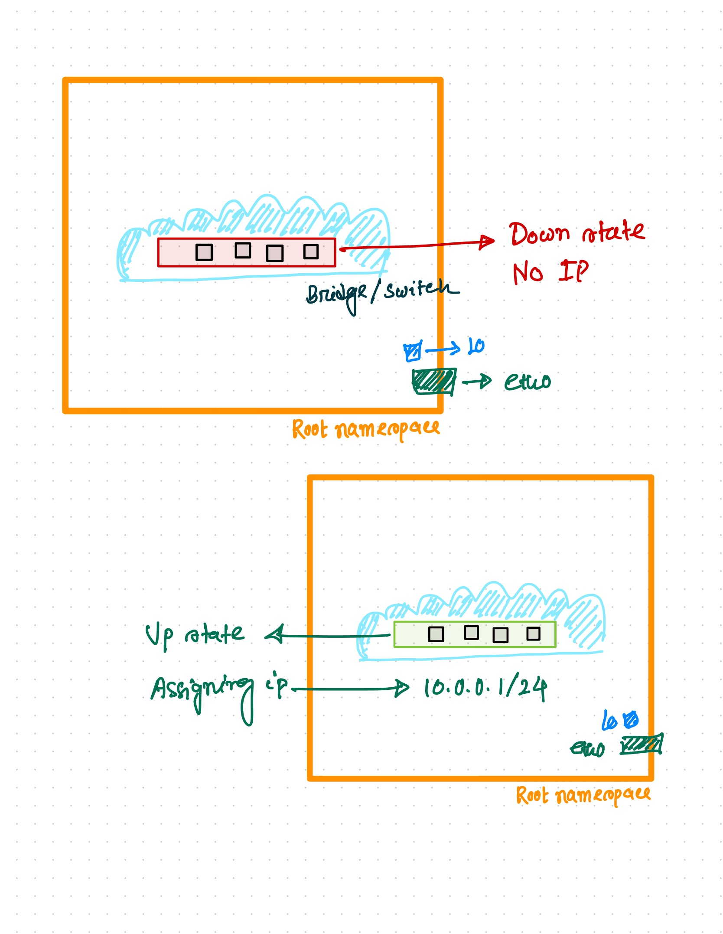
sudo ip link add dev v-net type bridge
Lets run sudo ip links show to check and the expected output might look like
12: v-net: <BROADCAST,MULTICAST> mtu 1500 qdisc noop state DOWN mode DEFAULT group default qlen 1000
link/ether d2:22:49:28:a4:c8 brd ff:ff:ff:ff:ff:ff
But here v-net is now in down state. So lets turn into up.
sudo ip link set dev v-net up
and now expected output might look like
12: v-net: <NO-CARRIER,BROADCAST,MULTICAST,UP> mtu 1500 qdisc noqueue state DOWN mode DEFAULT group default qlen 1000
link/ether d2:22:49:28:a4:c8 brd ff:ff:ff:ff:ff:ff
Here, the "UP" flag indicates that the interface is enabled and operational, while the "DOWN" state indicates that the interface is currently inactive or not functioning as there is no any physical connectivity of the interface right now.

Step 2: Assign an IP address to the bridge interface 'v-net':
sudo ip address add 10.0.0.1/24 dev v-net
Run sudo ip addr show dev v-net
12: v-net: <NO-CARRIER,BROADCAST,MULTICAST,UP> mtu 1500 qdisc noqueue state DOWN group default qlen 1000
link/ether d2:22:49:28:a4:c8 brd ff:ff:ff:ff:ff:ff
inet 10.0.0.1/24 scope global v-net
valid_lft forever preferred_lft forever

Step 3: Create three network namespaces:
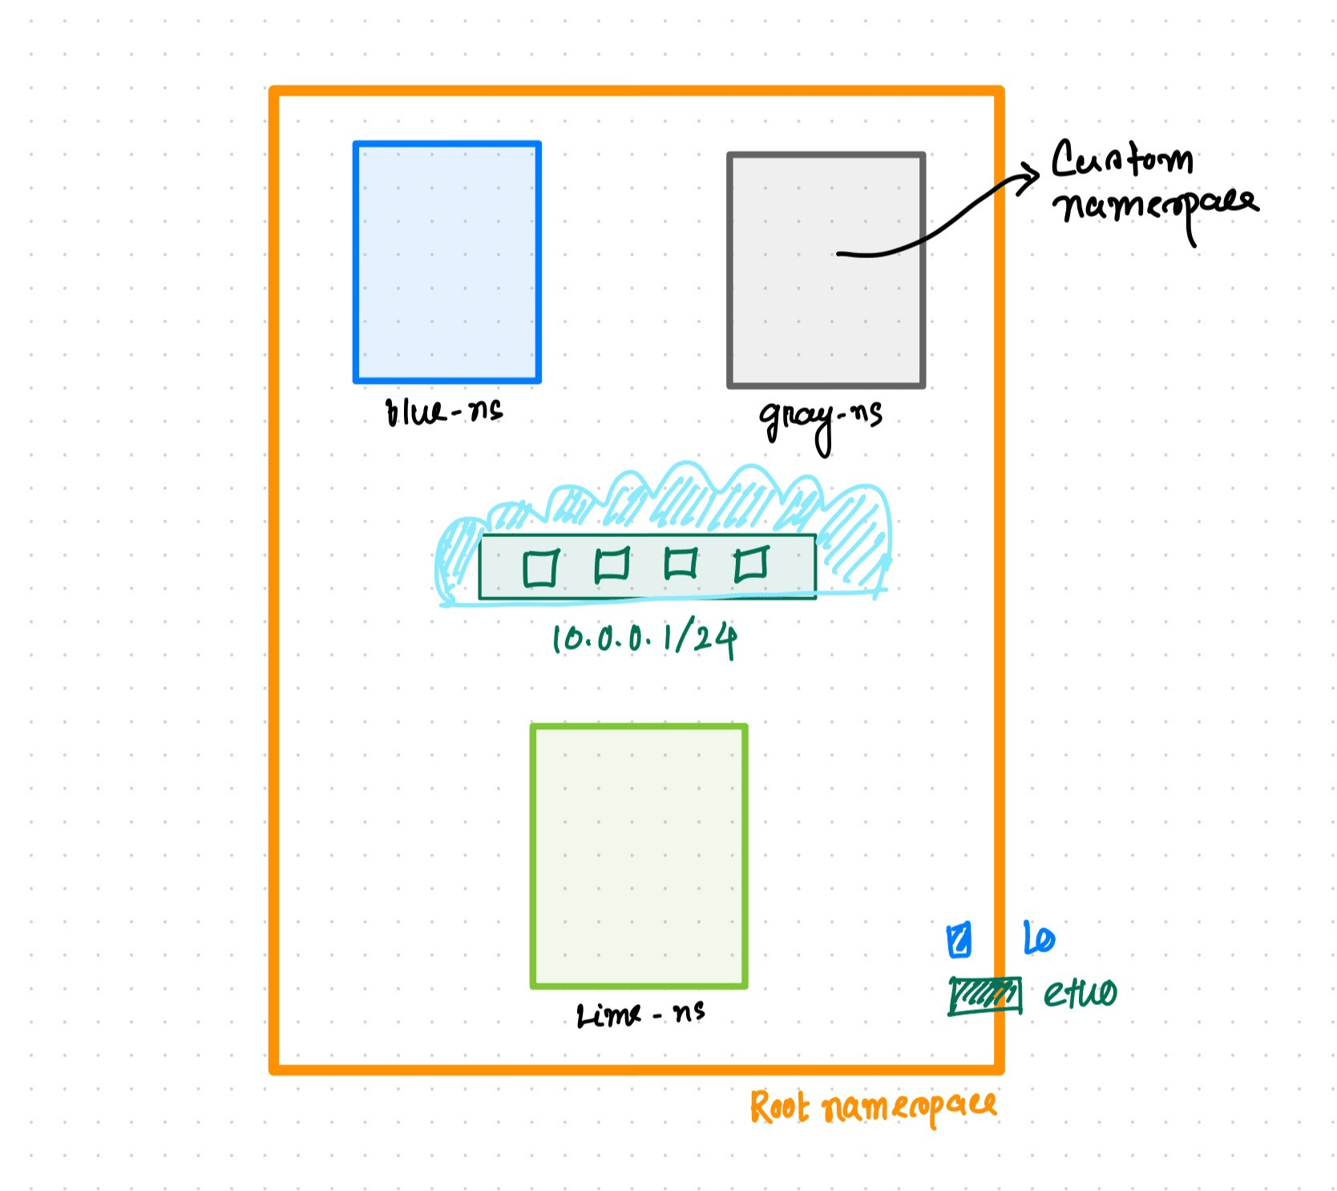
sudo ip netns add blue-ns
sudo ip netns add gray-ns
sudo ip netns add lime-ns
Run sudo ip netns list to check the list of namespaces.

Step 4: Create virtual Ethernet pairs:
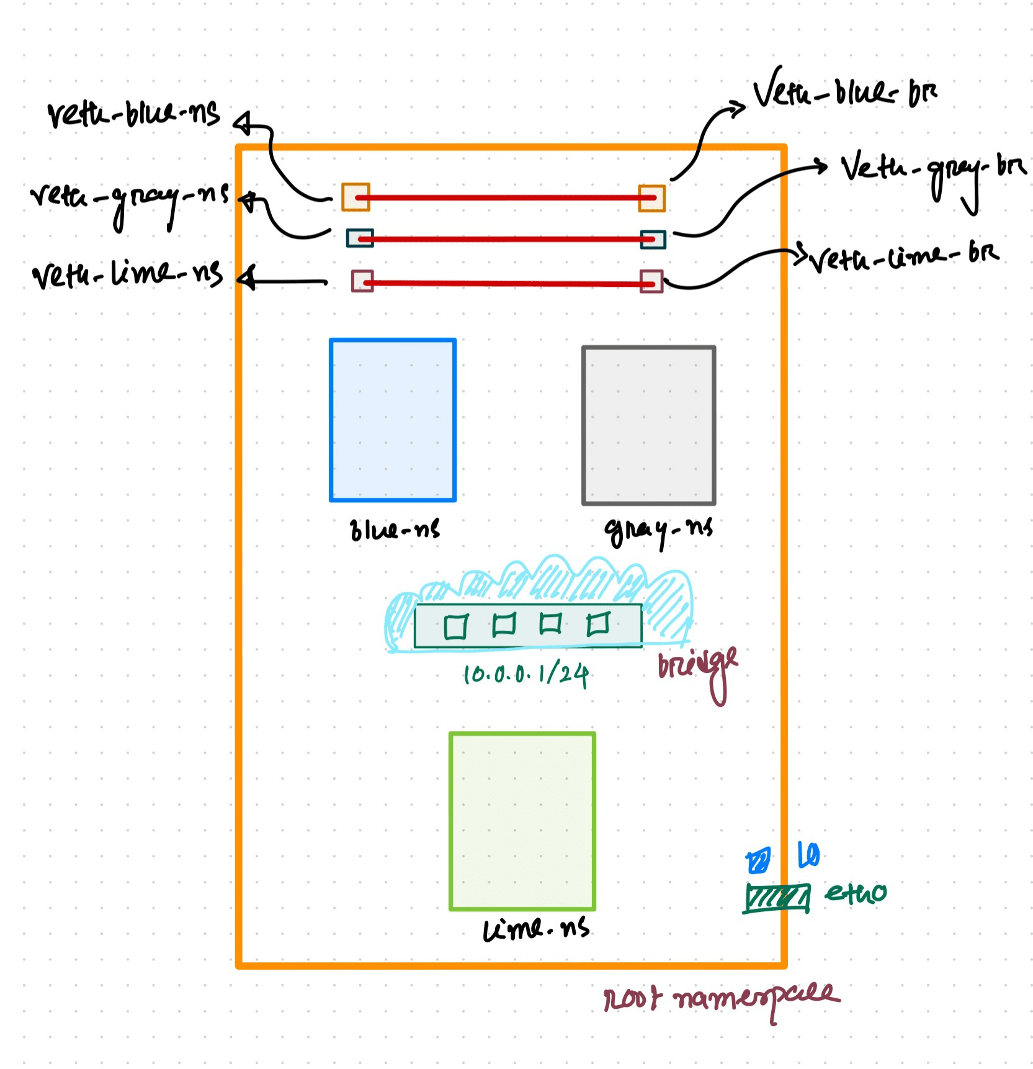
sudo ip link add veth-blue-ns type veth peer name veth-blue-br
sudo ip link add veth-gray-ns type veth peer name veth-gray-br
sudo ip link add veth-lime-ns type veth peer name veth-lime-br
Each cable now has two ends. Before connecting them to the appropriate bridge and namespaces, run sudo ip link show command to verify if the cables have been successfully created. Expected Output
13: veth-blue-br@veth-blue-ns: <BROADCAST,MULTICAST,M-DOWN> mtu 1500 qdisc noop state DOWN mode DEFAULT group default qlen 1000
link/ether fa:b8:a7:3c:41:0a brd ff:ff:ff:ff:ff:ff
14: veth-blue-ns@veth-blue-br: <BROADCAST,MULTICAST,M-DOWN> mtu 1500 qdisc noop state DOWN mode DEFAULT group default qlen 1000
link/ether ea:ff:ec:28:f3:aa brd ff:ff:ff:ff:ff:ff
15: veth-gray-br@veth-gray-ns: <BROADCAST,MULTICAST,M-DOWN> mtu 1500 qdisc noop state DOWN mode DEFAULT group default qlen 1000
link/ether be:2a:cb:68:4d:18 brd ff:ff:ff:ff:ff:ff
16: veth-gray-ns@veth-gray-br: <BROADCAST,MULTICAST,M-DOWN> mtu 1500 qdisc noop state DOWN mode DEFAULT group default qlen 1000
link/ether 1a:08:51:d7:ab:95 brd ff:ff:ff:ff:ff:ff
17: veth-lime-br@veth-lime-ns: <BROADCAST,MULTICAST,M-DOWN> mtu 1500 qdisc noop state DOWN mode DEFAULT group default qlen 1000
link/ether 02:9a:fd:3e:85:8a brd ff:ff:ff:ff:ff:ff
18: veth-lime-ns@veth-lime-br: <BROADCAST,MULTICAST,M-DOWN> mtu 1500 qdisc noop state DOWN mode DEFAULT group default qlen 1000
link/ether fe:c0:37:07:25:e4 brd ff:ff:ff:ff:ff:ff

Step 5: Move each end of veth cable to a different namespace:
sudo ip link set dev veth-blue-ns netns blue-ns
sudo ip link set dev veth-gray-ns netns gray-ns
sudo ip link set dev veth-lime-ns netns lime-ns
Run sudo ip netns exec <namespace-name> ip link show to verify

Step 6: Add the other end of the virtual interfaces to the bridge:
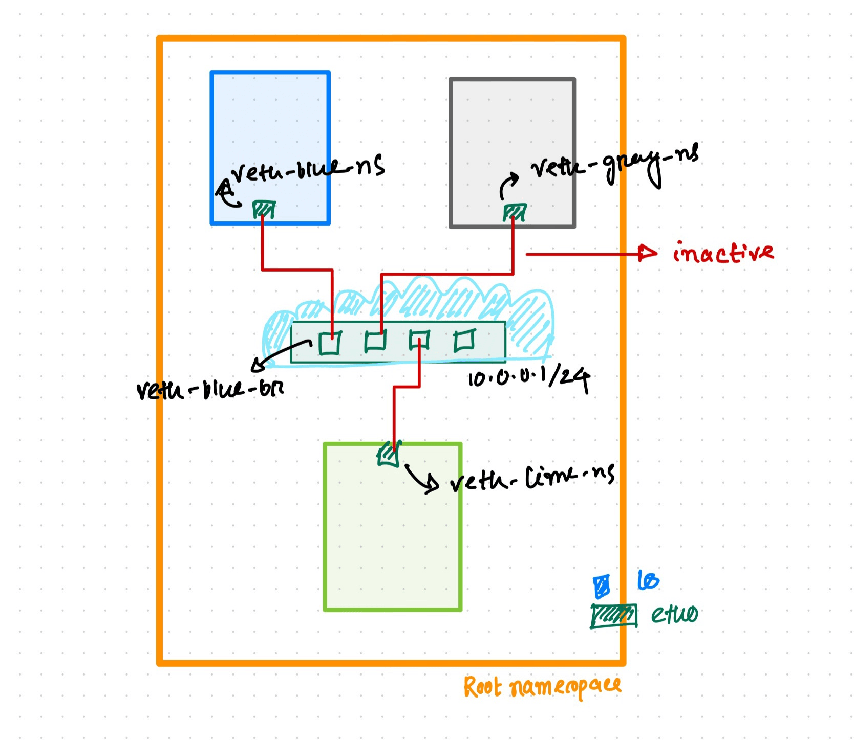
sudo ip link set dev veth-blue-br master v-net
sudo ip link set dev veth-gray-br master v-net
sudo ip link set dev veth-lime-br master v-net
Again run sudo ip link show command to verify.

Step 7: Set the bridge interfaces up:
sudo ip link set dev veth-blue-br up
sudo ip link set dev veth-gray-br up
sudo ip link set dev veth-lime-br up
Run sudo ip link show and expected output might look like
13: veth-blue-br@if14: <NO-CARRIER,BROADCAST,MULTICAST,UP> mtu 1500 qdisc noqueue master v-net state LOWERLAYERDOWN mode DEFAULT group default qlen 1000
link/ether fa:b8:a7:3c:41:0a brd ff:ff:ff:ff:ff:ff link-netns blue-ns
15: veth-gray-br@if16: <NO-CARRIER,BROADCAST,MULTICAST,UP> mtu 1500 qdisc noqueue master v-net state LOWERLAYERDOWN mode DEFAULT group default qlen 1000
link/ether be:2a:cb:68:4d:18 brd ff:ff:ff:ff:ff:ff link-netns gray-ns
17: veth-lime-br@if18: <NO-CARRIER,BROADCAST,MULTICAST,UP> mtu 1500 qdisc noqueue master v-net state LOWERLAYERDOWN mode DEFAULT group default qlen 1000
link/ether 02:9a:fd:3e:85:8a brd ff:ff:ff:ff:ff:ff link-netns lime-ns
The "LOWERLAYERDOWN" state typically applies to virtual interfaces that are dependent on another interface or component. If one end is not currently in the 'up' state, it suggests that there may be an issue with the namespaces at that end (in our case).

Step 8: Set the namespace interfaces up:
sudo ip netns exec blue-ns ip link set dev veth-blue-ns up
sudo ip netns exec gray-ns ip link set dev veth-gray-ns up
sudo ip netns exec lime-ns ip link set dev veth-lime-ns up
Now, run sudo ip link show command again and it should show all interfaces are currently in UP state.

Step 9: Assign IP addresses to the virtual interfaces within each namespace and set the default routes:
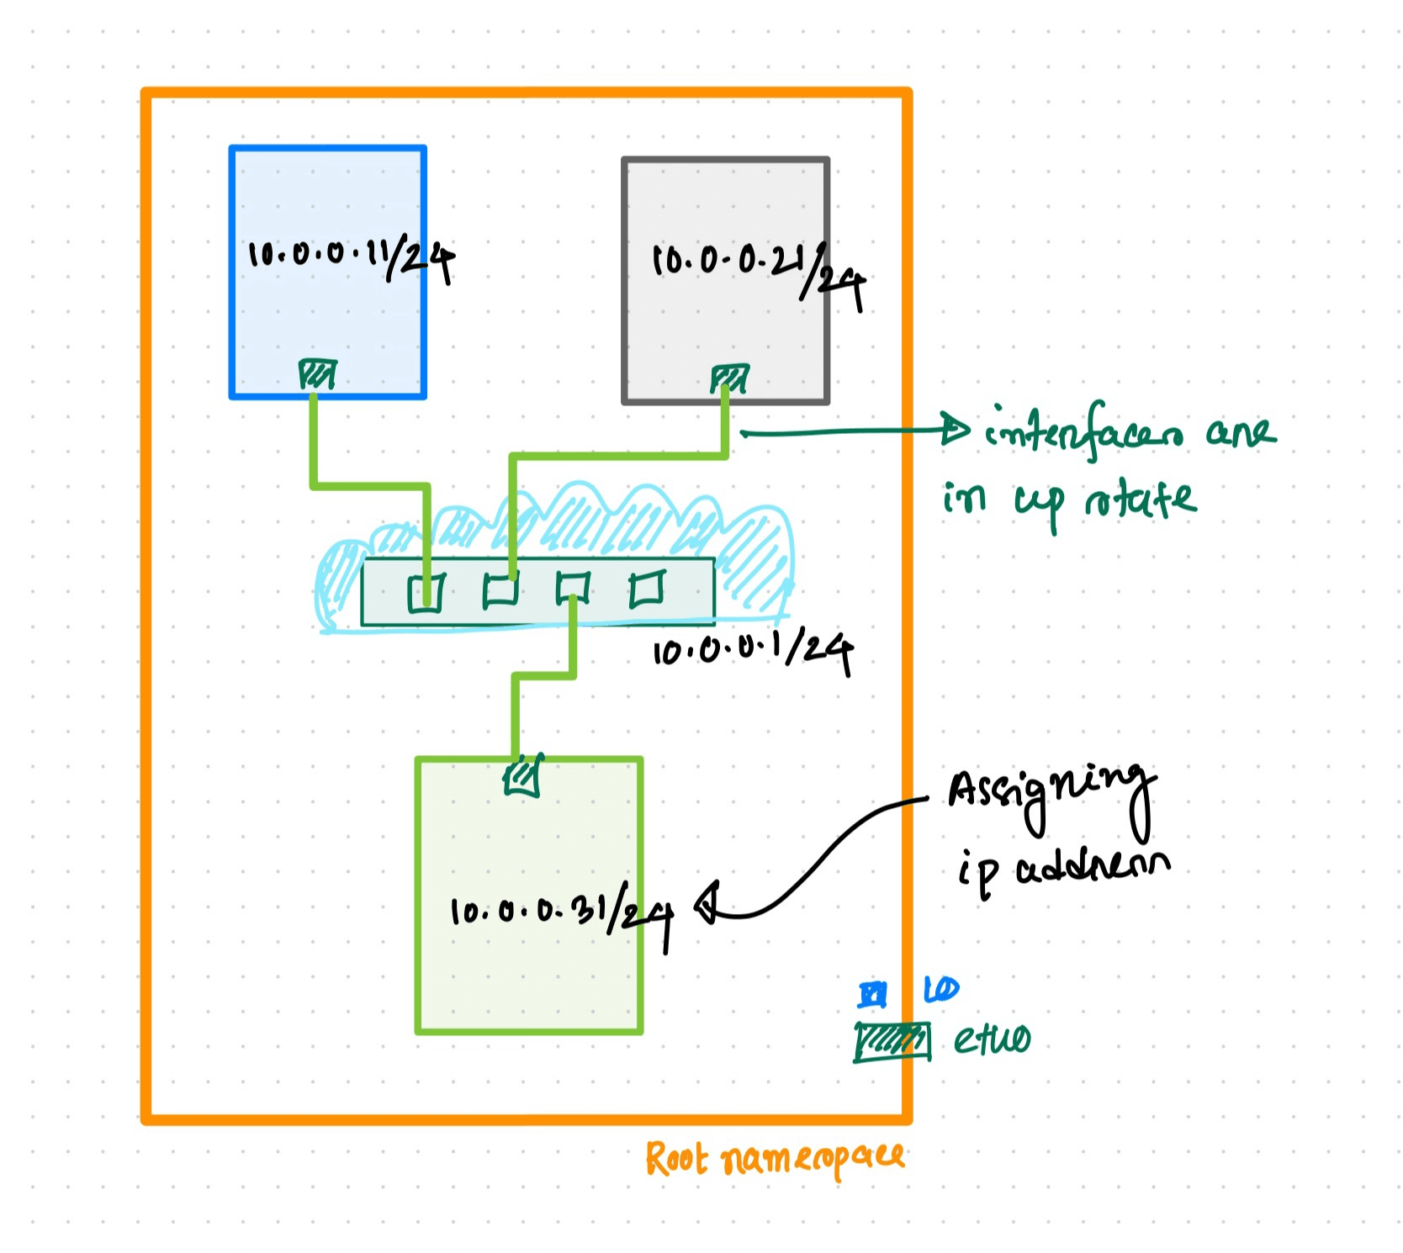
- In the blue-ns namespace:
sudo ip netns exec blue-ns ip address add 10.0.0.11/24 dev veth-blue-ns
- sudo ip netns exec blue-ns ip route add default via 10.0.0.1
- In the gray-ns namespace:
sudo ip netns exec gray-ns ip address add 10.0.0.21/24 dev veth-gray-ns
- sudo ip netns exec gray-ns ip route add default via 10.0.0.1
- In the lime-ns namespace:
sudo ip netns exec lime-ns ip address add 10.0.0.31/24 dev veth-lime-ns
- sudo ip netns exec lime-ns ip route add default via 10.0.0.1

Step 10: Firewall rules:
sudo iptables --append FORWARD --in-interface v-net --jump ACCEPT
sudo iptables --append FORWARD --out-interface v-net --jump ACCEPT
These rules enabled traffic to travel across the v-net virtual bridge.These are useful to allow all traffic to pass through the v-net interface without any restrictions.However, keep in mind that using such rules without any filtering can expose your system to potential security risks. But for now we re good to ping!

Test Connectivity
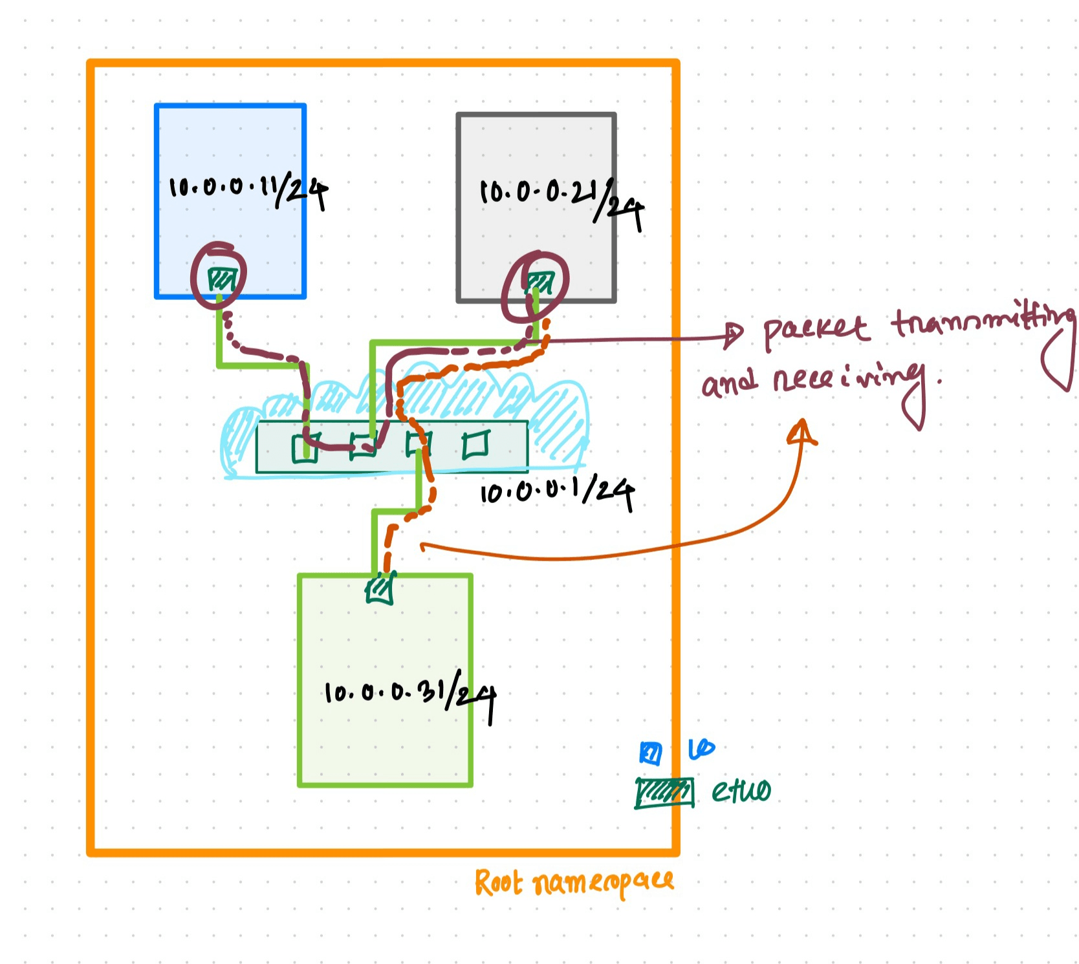
sudo ip netns exec lime-ns ping -c 2 10.0.0.11
Expected Output
PING 10.0.0.11 (10.0.0.11) 56(84) bytes of data.
64 bytes from 10.0.0.11: icmp_seq=1 ttl=64 time=0.064 ms
64 bytes from 10.0.0.11: icmp_seq=2 ttl=64 time=0.169 ms

--- 10.0.0.11 ping statistics ---
2 packets transmitted, 2 received, 0% packet loss, time 1006ms
rtt min/avg/max/mdev = 0.064/0.116/0.169/0.052 ms
Another one:
sudo ip netns exec gray-ns ping -c 2 10.0.0.11
Expected Output
PING 10.0.0.11 (10.0.0.11) 56(84) bytes of data.
64 bytes from 10.0.0.11: icmp_seq=1 ttl=64 time=0.051 ms
64 bytes from 10.0.0.11: icmp_seq=2 ttl=64 time=0.112 ms

--- 10.0.0.11 ping statistics ---
2 packets transmitted, 2 received, 0% packet loss, time 1024ms
rtt min/avg/max/mdev = 0.051/0.081/0.112/0.030 ms
Another one:
sudo ip netns exec blue-ns ping -c 2 10.0.0.21
Expected Output
PING 10.0.0.21 (10.0.0.21) 56(84) bytes of data.
64 bytes from 10.0.0.21: icmp_seq=1 ttl=64 time=0.056 ms
64 bytes from 10.0.0.21: icmp_seq=2 ttl=64 time=0.109 ms

--- 10.0.0.21 ping statistics ---
2 packets transmitted, 2 received, 0% packet loss, time 1018ms
rtt min/avg/max/mdev = 0.056/0.082/0.109/0.026 ms
Another one:
sudo ip netns exec blue-ns ping -c 2 10.0.0.31
Expected Output
PING 10.0.0.31 (10.0.0.31) 56(84) bytes of data.
64 bytes from 10.0.0.31: icmp_seq=1 ttl=64 time=0.073 ms
64 bytes from 10.0.0.31: icmp_seq=2 ttl=64 time=0.127 ms

--- 10.0.0.31 ping statistics ---
2 packets transmitted, 2 received, 0% packet loss, time 1031ms
rtt min/avg/max/mdev = 0.073/0.100/0.127/0.027 ms

In addition, the route command in the context of the ip netns exec allows you to view the routing table of a specific network namespace. The routing table contains information about how network traffic should be forwarded or delivered.
To view the routing table of the blue-ns namespace, execute the following command:
sudo ip netns exec blue-ns route
Output:
Kernel IP routing table
Destination Gateway Genmask Flags Metric Ref Use Iface
default 10.0.0.1 0.0.0.0 UG 0 0 0 veth-blue-ns
10.0.0.0 0.0.0.0 255.255.255.0 U 0 0 0 veth-blue-ns
To view the routing table of the gray-ns namespace, execute the following command:
sudo ip netns exec gray-ns route
Output:
Kernel IP routing table
Destination Gateway Genmask Flags Metric Ref Use Iface
default 10.0.0.1 0.0.0.0 UG 0 0 0 veth-gray-ns
10.0.0.0 0.0.0.0 255.255.255.0 U 0 0 0 veth-gray-ns
To view the routing table of the lime-ns namespace, execute the following command:
sudo ip netns exec lime-ns route
Output:
Kernel IP routing table
Destination Gateway Genmask Flags Metric Ref Use Iface
default 10.0.0.1 0.0.0.0 UG 0 0 0 veth-lime-ns
10.0.0.0 0.0.0.0 255.255.255.0 U 0 0 0 veth-lime-ns

Furthermore, the arp command in the context of the ip netns exec allows you to view the ARP cache of a specific network namespace. The ARP cache contains mappings of IP addresses to MAC addresses.
To view the ARP cache of the blue-ns namespace, execute the following command:
sudo ip netns exec blue-ns arp
Output
Address HWtype HWaddress Flags Mask Iface
10.0.0.1 ether d2:22:49:28:a4:c8 C veth-blue-ns
10.0.0.31 ether fe:c0:37:07:25:e4 C veth-blue-ns
10.0.0.21 ether 1a:08:51:d7:ab:95 C veth-blue-ns
To view the ARP cache of the gray-ns namespace, execute the following command:
sudo ip netns exec gray-ns arp
Output
Address HWtype HWaddress Flags Mask Iface
10.0.0.1 ether d2:22:49:28:a4:c8 C veth-gray-ns
10.0.0.11 ether ea:ff:ec:28:f3:aa C veth-gray-ns
To view the ARP cache of the lime-ns namespace, execute the following command:
sudo ip netns exec lime-ns arp
Output
Address HWtype HWaddress Flags Mask Iface
10.0.0.1 ether d2:22:49:28:a4:c8 C veth-lime-ns
10.0.0.11 ether ea:ff:ec:28:f3:aa C veth-lime-ns

Clean Up (optional)
sudo ip netns del <namespace>
sudo ip link delete <bridge network name> type bridge
If you want to remove the namespaces and bridge network device run these commands to clean up the setup.

