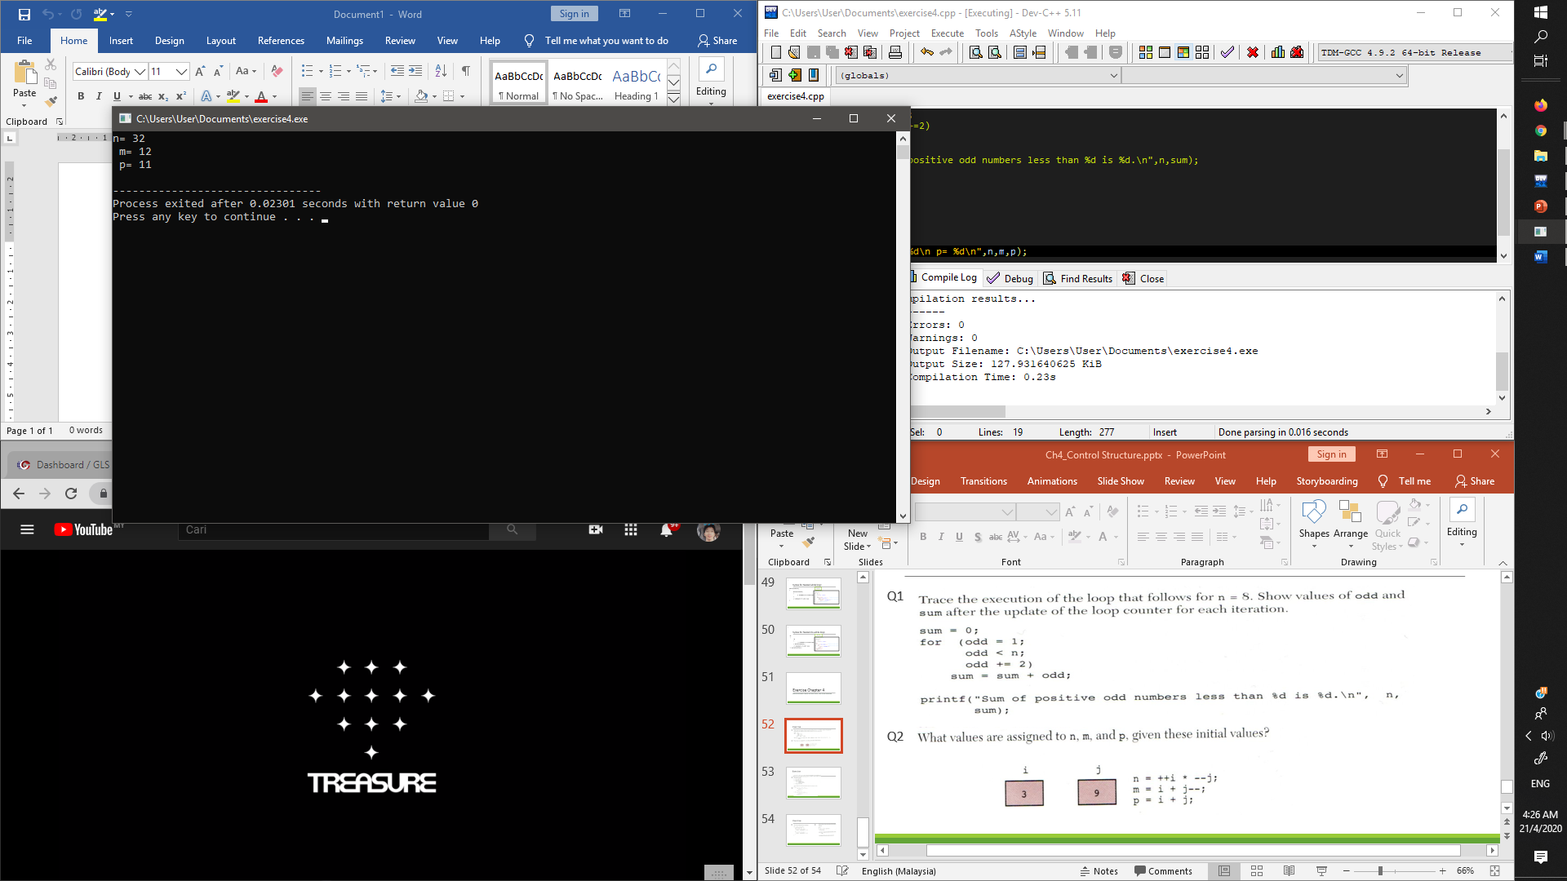

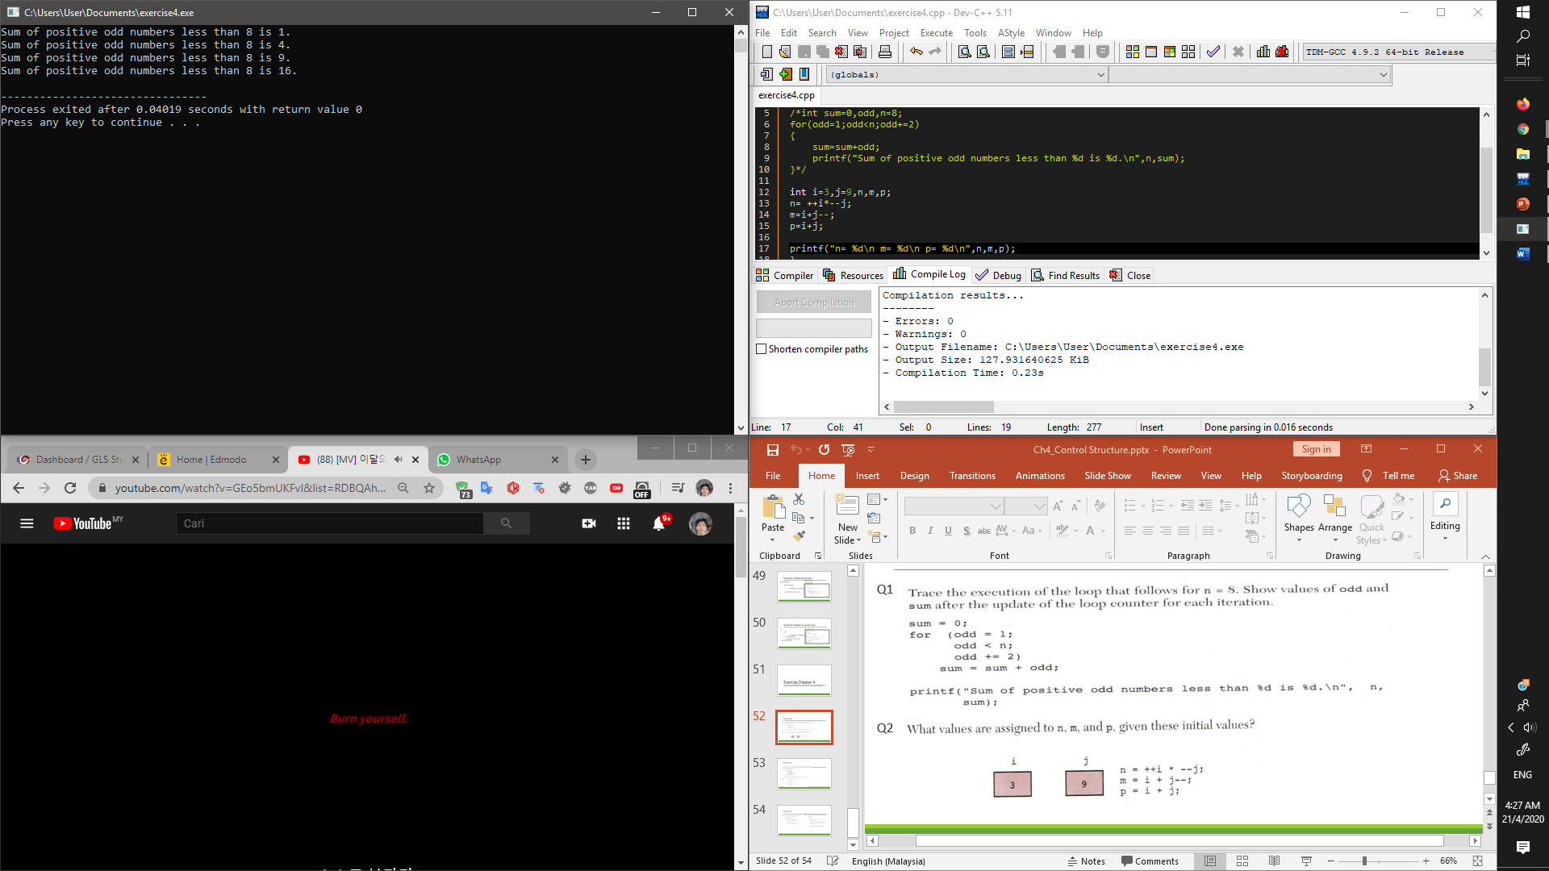

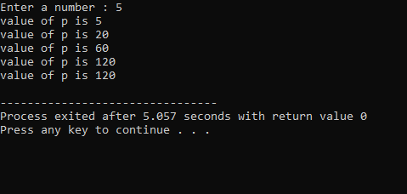

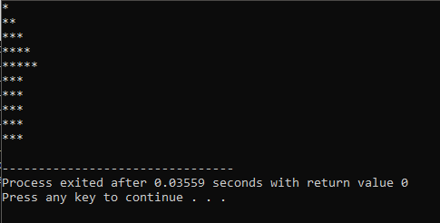

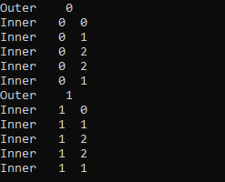

odd sum n odd<n condition

1 0 8 1<8 true

3 1 8 3<8 true

5 4 8 5<8 true

7 9 8 7<8 true

9 16 8 9<8 false

#include<stdio.h>

int main ()

{int n,p=1;

printf("Enter a number : ");

scanf("%d",&n);

while(n>0)

{

p=p\*n;

--n;

printf("value of p is %d\n",p);

}

printf("value of p is %d",p);

}

Outer 0

Inner 0 0

Inner 0 1

Inner 0 2

Inner 0 2

Inner 0 1

Outer 1

Inner 1 0

Inner 1 1

Inner 1 2

Inner 1 2

Inner 1 1

#include<stdio.h>

int main()

{

int sum=0,odd=1,n=8;

do

{

sum=sum+odd;

printf("Sum of positive odd numbers less than %d is %d.\n",n,sum);

odd+=2;

}while (odd<n);

}