**Case 1: ELTE GPS - They offer waste bin fill-level sensors for smart collection**

* **Solution**: ET Bins system. This solution is exactly like our idea. Instead of the waste bins, we plan to use them in the pits dug in the roads. This sensor does the work we want it to.
* **Point of contact**: [info@eltegps.com](mailto:info@eltegps.com)
* **Reference**: <https://www.eltegps.com/our-offer/waste-bin-fill-level-monitoring-system.html>

**Case 2: WISWM - BIN FILL LEVEL MONITORING SYSTEM (LORA, NB-IOT AND 3G)**

* **Solution**: Fill X1 sensors. There are two types of this sensor
  + 3g version – far flung locations (Buildings, hospitals)
  + LORA / NB-IoT version - shopping malls, service stations, restaurants, etc
* **Point of contact**: <https://www.wiswm.ie/about/contact-wiswm/>
* **Reference**: <https://www.wiswm.ie/bin-fill-level-monitoring/>

**Case 3: Draffin Street furniture – Farsite communications netBin system**

* **Solution**: FarSite’s netBin fill level monitoring suite offers optimised bin monitoring and collection system for smarter cities. This end-to-end suite includes HUB, COLLECT, nPod and ANALYSER.
  + At the core of the netBin system is the HUB, a comprehensive web-based management platform that becomes the centre for your decision making, route creation and analysis.
  + COLLECT smartphone app is used by drivers to receive jobs assigned from the netBin HUB. Information on suggested routes, estimated job duration and so on can be passed directly onto the driver. The app also can upload photographs and notes on any problems, allowing the network manager to determine action required.
  + The nPod sensor continuously feeds real time data – such as fill levels, temperature and position, back to the HUB. The clever nPod can also detect if your bins are alight, been moved, or knocked over.
  + ANALYSER is an exel based analytics tool that allows you to take an in-depth look at your historical raw data. Produce spreadsheets that show performance statistics over the requested period in just a few clicks.
* **Point of contact**: <https://draffin.com.au/contact/>
* **Reference**: <https://draffin.com.au/choosing-fill-level-smart-bin-sensor/>

**Case 4: SigFox partner network – Metro Fill-level sensors**

* **Reference**: https://partners.sigfox.com/products/metro-fill-level-sensor

**Case 5: SigFox partner network – Level sensors**

* **Solution**: This product allows garbage collection companies to monitor in real time the location and the level of its recycling bins.

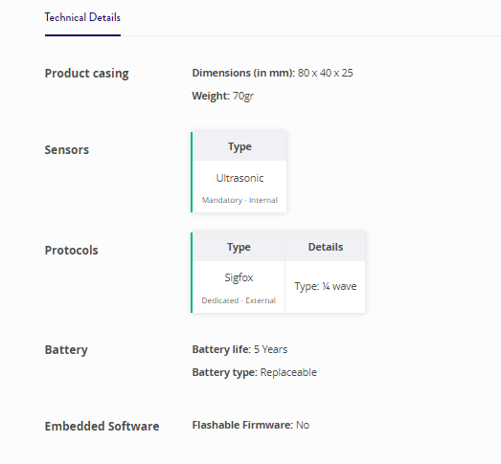

* **Reference:** <https://partners.sigfox.com/products/sonde-de-niveau>
* **Note**: Sign in to find out about the ratings, price, etc

**Case 6: Sensoneo**

* **Solution**: Sensoneo Smart sensors measure fill-levels in bins via ultrasonic beams. Our sensors can monitor any type of waste (mixed waste, paper, plastics, glass, clothing, bio-waste, liquids, electronics, metal….) in bins and containers of various types and sizes.



**Case 7: Smart waste containers**

* **Reference**: <https://www.smartupcities.com/smart-waste-containers/>