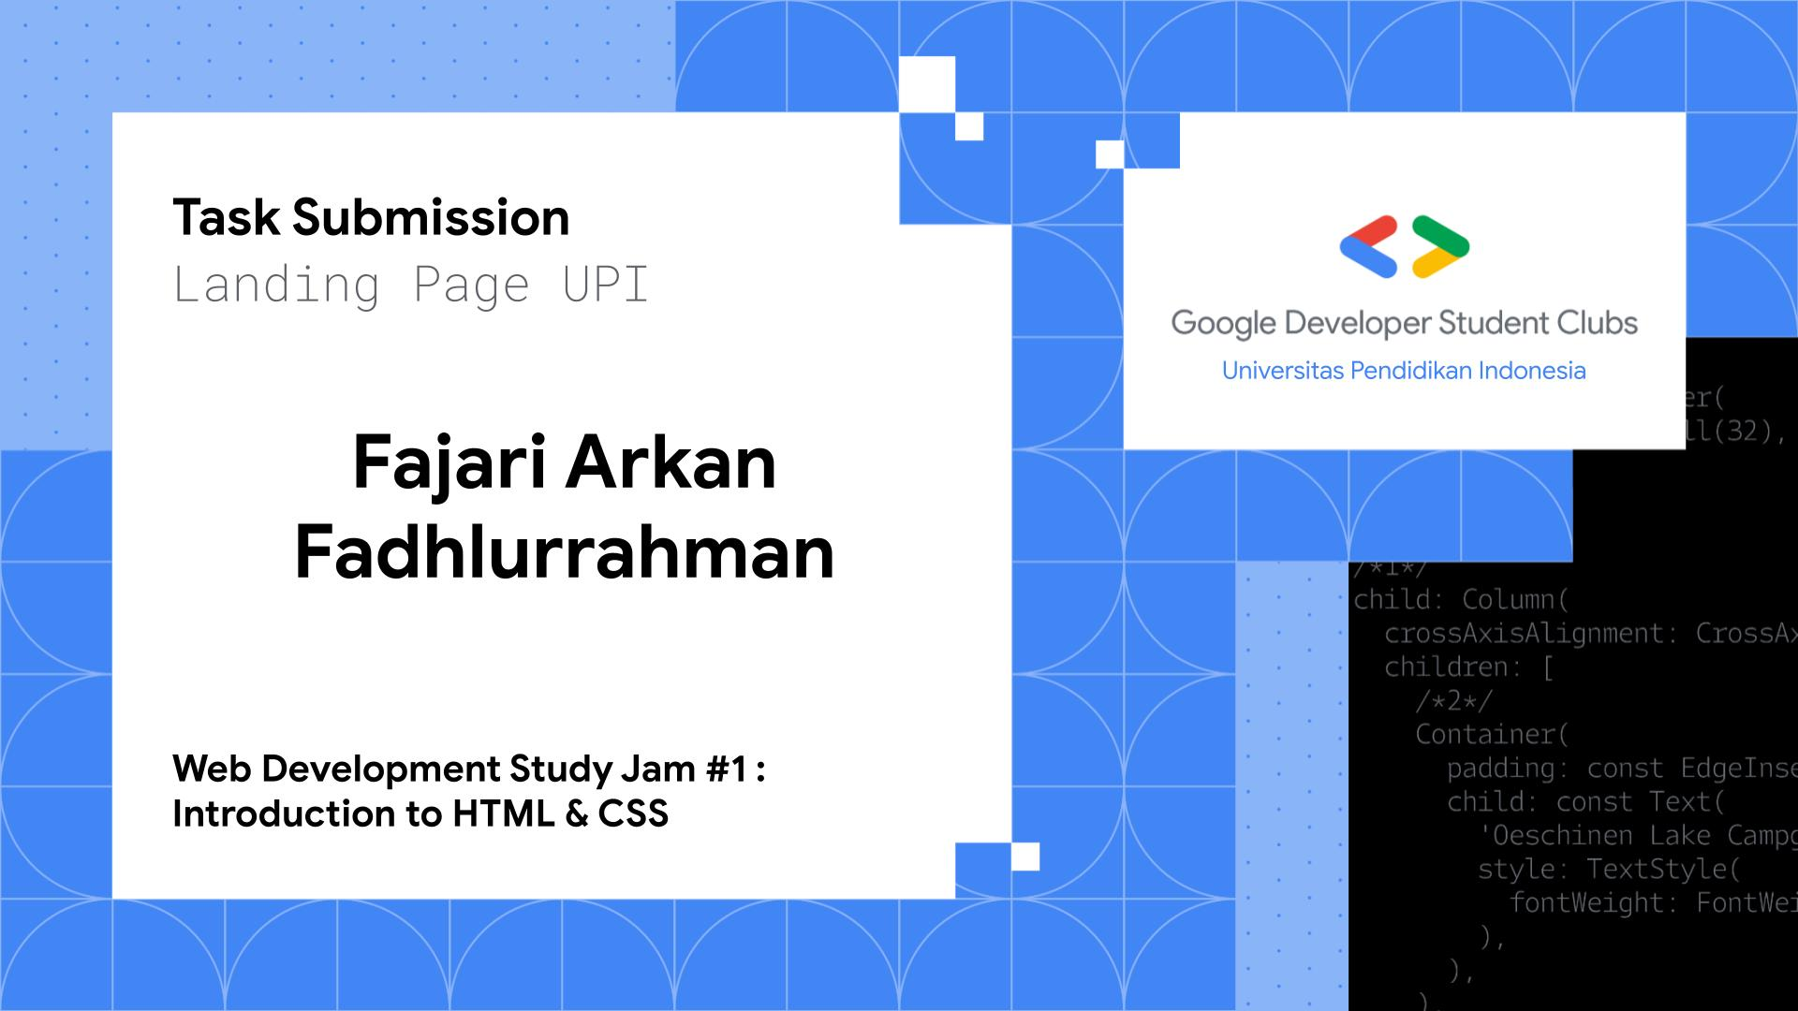

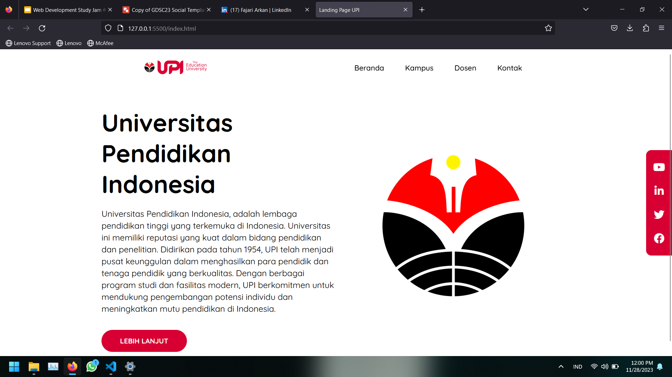

**INDEKS.HTML**

<!DOCTYPE *html*>

<html *lang*="en">

  <head>

    <meta *charset*="UTF-8" />

    <meta *name*="viewport" *content*="width=device-width, initial-scale=1.0">

    <title>Landing Page UPI</title>

    <!-- *CSS Utama* -->

    <link *rel*="stylesheet" *href*="css/app.css" />

    <!-- *Font Awesome 5.15.4* -->

    <link

*rel*="stylesheet"

*href*="https://cdnjs.cloudflare.com/ajax/libs/font-awesome/5.15.4/css/all.min.css"

*integrity*="sha512-1ycn6IcaQQ40/MKBW2W4Rhis/DbILU74C1vSrLJxCq57o941Ym01SwNsOMqvEBFlcgUa6xLiPY/NS5R+E6ztJQ=="

*crossorigin*="anonymous"

*referrerpolicy*="no-referrer"

    />

  </head>

  <body>

    <header *class*="navbar-container">

      <div *class*="logo">

        <img *src*="img/UPI-Logo-white.png" *alt*="Universitas Pendidikan Indonesia" />

      </div>

      <nav *class*="nav-list">

        <ul>

          <li><a *href*="#">Beranda</a></li>

          <li><a *href*="#">Kampus</a></li>

          <li><a *href*="#">Dosen</a></li>

          <li><a *href*="#">Kontak</a></li>

        </ul>

      </nav>

    </header>

    <main>

      <div *class*="content">

        <div *class*="content-description">

          <h1 *class*="title">Universitas Pendidikan Indonesia</h1>

          <p>

            Universitas Pendidikan Indonesia, adalah lembaga pendidikan tinggi yang terkemuka di Indonesia. Universitas ini memiliki reputasi yang kuat dalam bidang pendidikan dan penelitian. Didirikan pada tahun 1954, UPI telah menjadi pusat keunggulan dalam menghasilkan para pendidik dan tenaga pendidik yang berkualitas. Dengan berbagai program studi dan fasilitas modern, UPI berkomitmen untuk mendukung pengembangan potensi individu dan meningkatkan mutu pendidikan di Indonesia.

          </p>

          <button *onclick*="*goToAnotherPage*()">Lebih lanjut</button>

        </div>

        <div *class*="content-image">

          <img *src*="img/1200px-Logo_Almamater_UPI.svg.png" *alt*="Universitas Pendidikan Indonesia" />

        </div>

      </div>

      <aside>

        <div *class*="social-media">

          <ul>

            <li>

              <a *href*="#"><i *class*="fab fa-youtube"></i></a>

            </li>

            <li>

              <a *href*="#"><i *class*="fab fa-linkedin-in"></i></a>

            </li>

            <li>

              <a *href*="#"><i *class*="fab fa-twitter"></i></a>

            </li>

            <li>

              <a *href*="#"><i *class*="fab fa-facebook"></i></a>

            </li>

          </ul>

        </div>

      </aside>

    </main>

    <script *src*="script.js"></script>

  </body>

</html>

APP.CSS

@*import* url('https://fonts.googleapis.com/css2?family=Quicksand:wght@400;500;700&display=swap');

*,

*::*before*,

*::*after* {

  box-sizing: border-box;

}

body {

  height: 100vh;

  font-family: 'Quicksand', sans-serif;

  margin: 0;

  display: flex;

  flex-direction: column;

}

header.*navbar-container* {

  max-width: 1200px;

  width: 100%;

  margin-inline: auto;

  display: flex;

  justify-content: space-around;

  align-items: center;

  padding-block: 1rem;

  z-index: 999;

}

header.*navbar-container* .*logo* img {

  width: 150px;

}

header.*navbar-container* .*nav-list* ul {

  padding-left: 0;

  display: flex;

  justify-content: center;

  gap: 2rem 1rem;

}

header.*navbar-container* .*nav-list* li {

  list-style-type: none;

}

header.*navbar-container* .*nav-list* lia {

  text-decoration: none;

  font-size: 1.05rem;

  font-weight: 500;

  color: black;

  padding: 0.5rem 1rem;

  border-radius: 500px;

  transition: all 0.2s ease-in-out;

}

header.*navbar-container* .*nav-list* li:*hover* a {

  background-color: #F78CA2;

  color: white;

}

main {

  max-width: 1200px;

  width: 100%;

  margin-inline: auto;

  padding: 2rem 4rem;

  flex: 1;

  display: flex;

  align-items: center;

}

main.*content* {

  flex: 1; /* *Flex-grow, Flex-shrink, Flex-basis* */

  display: flex;

  align-items: center;

}

main.*content* .*content-description* {

  flex: 1 1;

}

main.*content* .*content-description* .*title* {

  font-size: 3.5rem;

  margin-block: 1rem;

}

main.*content* .*content-description* p {

  line-height: 1.7rem;

  font-size: 1.2rem;

}

main.*content* .*content-description* button {

  padding: 0.8rem 2.5rem;

  margin-block-start: 1rem;

  text-transform: uppercase;

  font-weight: 700;

  font-size: 1rem;

  font-family: 'Quicksand', sans-serif;

  color: white;

  border: 3px solid transparent;

  border-radius: 999px;

  background-color: #D80032;

  cursor: pointer;

  transition: all 0.15s ease-in;

}

main.*content* .*content-description* button:*hover* {

  border: 3px solid #F78CA2;

  color: #F78CA2;

  background-color: transparent;

}

main.*content* .*content-image* {

  flex: 1;

  display: flex;

}

main.*content* .*content-image* img {

  margin: auto;

  min-width: 250px;

  width: 350px;

}

mainaside {

  position: fixed;

  inset-block: 0;

  inset-inline-end: 0;

}

mainaside.*social-media* {

  height: 100%;

  display: flex;

}

mainaside.*social-media* ul {

  padding: 1.5rem 1rem;

  margin: auto;

  border-top-left-radius: 12px;

  border-bottom-left-radius: 12px;

  background-color: #D80032;

  display: flex;

  flex-flow: column nowrap;

  align-items: center;

  justify-content: center;

  gap: 1.5rem;

}

mainaside.*social-media* li {

  list-style-type: none;

}

mainaside.*social-media* lia {

  text-decoration: none;

  font-size: 1.5rem;

  color: white;

  transition: all 0.1s ease-in-out;

}

mainaside.*social-media* lia:*hover* {

  color: #89b0d9;

}

/* *Medium devices (landscape tablets, 768px and down)* */

@*media* screen and (max-width: 768px) {

  header.*navbar-container* {

    flex-direction: column;

  }

  header.*navbar-container* .*nav-list* ul {

    flex-wrap: wrap;

    column-gap: 0.5rem;

  }

  main {

    padding: 1rem 3rem;

  }

  main.*content* {

    flex-direction: column;

    gap: 2rem;

  }

  main.*content* .*content-description* .*title* {

    font-size: 3rem;

  }

  main.*content* .*content-description* p {

    font-size: 1rem;

  }

  main.*content* .*content-image* {

    order: -1;

  }

}

@*media* screen and (max-width: 400px) {

  header.*navbar-container* {

    flex-direction: column;

    align-items: center;

    margin-left: 50px;

  }

  mainaside {

    visibility: hidden;

  }

}