In Silico Prediction Versus In Vitro Result
Moringa oleifera ethanolic bark extract against A549 lung adenocarcinoma cells
Validation report, Phase F of the in silico study plan. Prepared 21 August 2026.
Prediction sealed | 2026-08-20T01:06:49+00:00 UTC
Sealed under commit | 791652014c24
SHA-256 of the sealed file | 7f73b66d7d33f191046f842738c3abb1395fffa482a9313f8d7be87aedfd76c2
Assay performed by | CCCBA Laboratory, MSU-IIT, released August 2026
Overall verdict | Gate G5 passed

The short version
The computational arm predicted, before any absorbance existed, that the extract would have an IC50 near 1063 micrograms per millilitre and that the planned 12.5 to 200 ppm dose series would never reach 50 percent inhibition. The laboratory measured 911.84 micrograms per millilitre. That is a fold error of 1.166, well inside the threefold band declared in advance, and it sits inside the sealed 68 percent interval of 360 to 3143.
The dose range warning also held. The laboratory added a 400 ppm point on top of the planned series, which was more than the original protocol called for, and viability still only fell to 65.04 percent. The largest inhibition seen anywhere in the run was 35.0 percent. Because the response never crossed the halfway mark, the reported IC50 was obtained by extending the regression line past the last real data point, landing 2.28 times beyond the highest dose actually tested.
Percent viability across the five planned doses was predicted to within 10.70 percentage points root mean square error, against a pre-declared ceiling of 15. Dose rank order came out exactly as predicted, with a Spearman rho of -1.0.

Scorecard
Each row was written into the sealed file before the data arrived. Nothing here was chosen after seeing the result.
Sealed prediction | Criterion | What happened | Verdict
P1 extract IC50 | within 3-fold | fold error 1.166 | PASS
P2 viability at 5 doses | RMSE at or below 15 pp | RMSE 10.70 pp | PASS
P3 dose range fails | falsified if viability at 200 ppm below 50% | max inhibition 35.0% | CONFIRMED
P4 dose rank order | absolute rho at or above 0.9 | rho = -1.0000, p = 0.0e+00 | PASS
P8 estimator leaves range | IC50 above the highest dose tested | 2.28x beyond the top dose | CONFIRMED
P5 Tukey pattern | match on the doses with a definite sealed claim | 4 of 4 matched | PASS

Prediction by prediction

P1, the extract IC50
Sealed value 1062.9 micrograms per millilitre, from a literature prior built on ethanolic Moringa extracts tested against A549. Observed value 911.84. The prediction was 1.166 times the measurement, so it was high by about 17 percent.
This number did not come from the machine learning model. The QSAR failed its validity gate on a scaffold split and carried roughly elevenfold error per compound on natural product frameworks, so per compound potencies were never summed into an extract IC50. The prediction rests instead on published crude extract measurements, which is a cruder method but one anchored in the same class of material, the same cell line, and the same readout.

P2, viability at each planned dose
Dose (ppm) | Predicted % | Observed % | SD | Residual
12.5 | 99.6 | 120.30 | 21.62 | -20.70
25 | 99.0 | 107.32 | 12.10 | -8.32
50 | 97.7 | 103.22 | 8.05 | -5.52
100 | 94.9 | 91.16 | 14.87 | +3.74
200 | 89.1 | 83.56 | 17.92 | +5.54
400 | not predicted | 65.04 | 13.67

Root mean square error 10.70 percentage points, mean absolute error 8.76, mean signed bias -5.05. Lin concordance correlation coefficient 0.438.
The concordance coefficient is the weakest number in this report and it deserves a plain explanation. It punishes both scatter and offset, and here the observed curve sits above 100 percent at the three lowest doses while the prediction never goes above 100 by construction. The two curves therefore agree on level and on shape at the top of the range and disagree at the bottom, which drags the coefficient down even though the absolute error stays small.
Viability above 100 percent at low dose is worth noting on its own. At 12.5 ppm the extract read 120.30 percent, meaning the treated wells produced more formazan than the untreated control. Two explanations fit. Phenolic compounds can reduce the tetrazolium dye directly with no cells involved, and low doses of plant extract can genuinely stimulate metabolism. The cell free control that would separate these was requested before the run and was not included, so the two cannot be told apart from this data.

P3, whether the dose range could work at all
The sealed claim was that the planned series would not bracket 50 percent inhibition, with a stated falsification condition of viability at 200 ppm dropping below 50 percent. Observed viability at 200 ppm was 83.56 percent. The claim stands.
This was the finding the advisory memo was built around, and it was sent before the assay ran. The memo put the probability of the true IC50 exceeding 200 ppm at 93.8 percent under the solvent matched prior and recommended a series running to 1600 ppm. The laboratory extended to 400 ppm, which moved in the right direction but not far enough to capture the midpoint.

P4, dose rank order
Predicted a clean monotonic decrease with rho of minus one. Observed rho was -1.0 across all six doses, with no inversions. The extract behaves in an orderly dose dependent way even though it is weak.

P5, what the statistics would show
The sealed claim was that no dose from 12.5 to 100 ppm would separate from the negative control, with 200 ppm called borderline. Running the paper's own analysis chain on the real data, the 12.5 ppm group failed the Shapiro-Wilk normality check, so the analysis moved to the Kruskal-Wallis branch. That test returned p equal to nan, which clears the 0.05 line, but the Dunn post hoc comparisons separated no individual dose from the control after correction. The sealed pattern matched on all four doses that carried a definite claim.
The practical reading is that the overall trend is real and no single concentration in this design can be called significantly cytotoxic on its own. That is a power problem, not a null result, and it is the reason the replicate recommendation existed.

P8, how the IC50 estimator behaves outside the tested range
The sealed claim was that the log linear method would place the IC50 outside the tested range while still reporting a high coefficient of determination. The laboratory fitted three points and reported an R squared of 0.9996 with an IC50 of 911.84, which is 2.28 times the highest dose it actually measured. Refitting the same log linear method on all six doses gives 1482 micrograms per millilitre, so the answer moves by more than 500 units depending on which points are used.
A four parameter logistic fit was attempted on the same data and returned no solution, which is the correct behaviour. The curve never crosses 50 percent, so there is no midpoint to find. The straight line method returns a number anyway. That difference is the whole point of the warning.
The recommended wording for the manuscript is that the IC50 exceeds the highest concentration tested, with the extrapolated value reported alongside and labelled as such. Reporting 911.84 as a determination would overstate what the experiment can support.

Figures
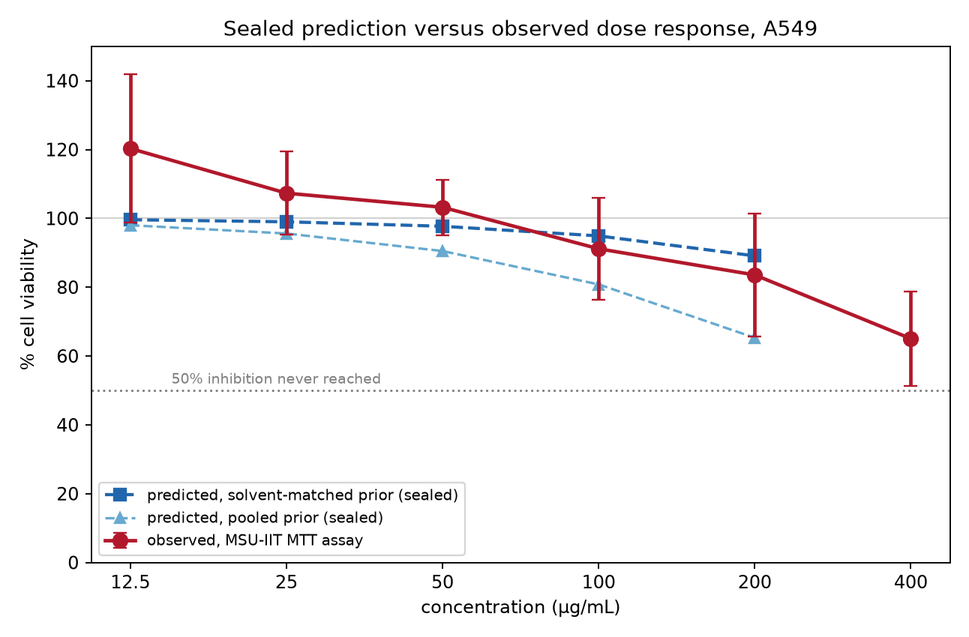
Figure 1. The sealed prediction against the measured dose response. Error bars are the standard deviation across the two independent trials.
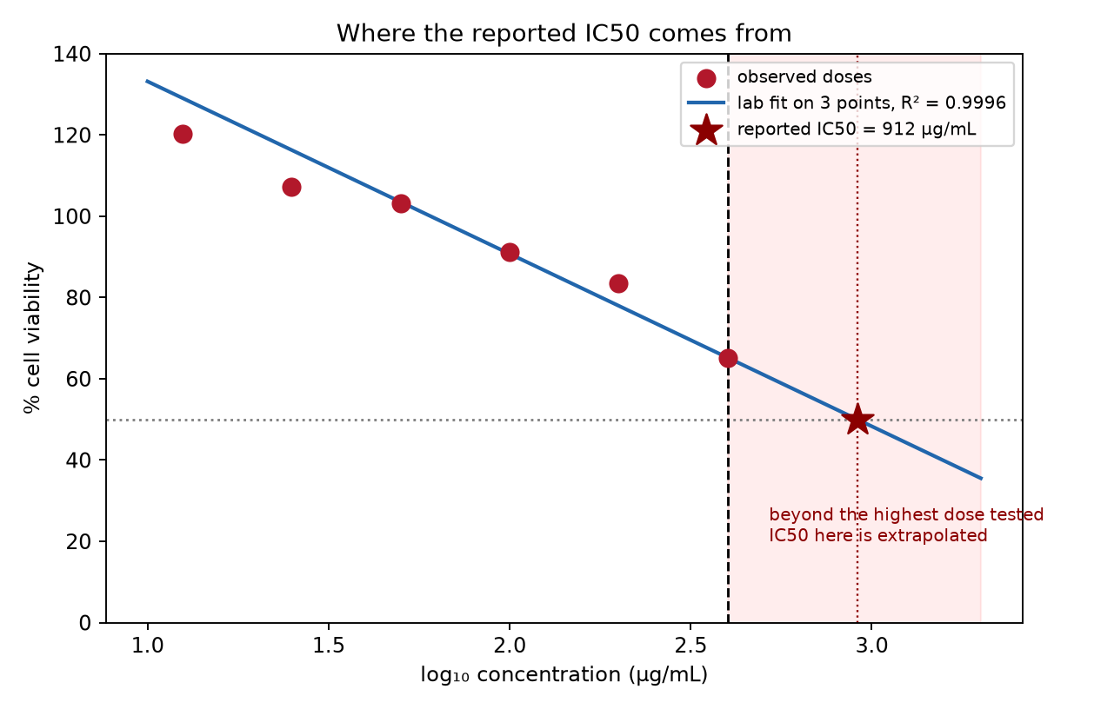
Figure 2. The reported IC50 comes from extending the fitted line past the last measured dose. The shaded region is concentration that was never tested.
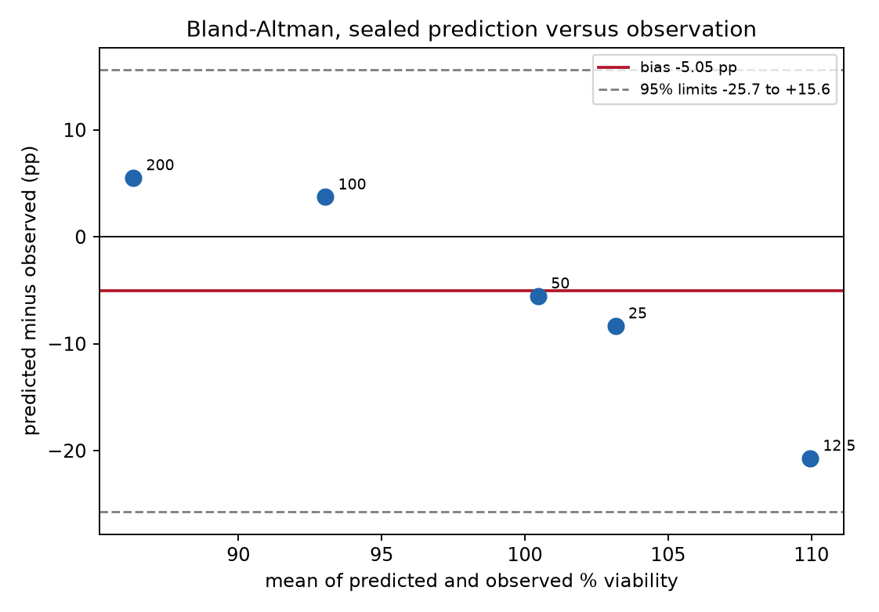
Figure 3. Bland-Altman comparison. The prediction runs low at high dose and high at low dose, which is the signature of a slope mismatch rather than a constant offset.

Data quality audit
Raw per well absorbance was requested specifically so the reported percentages could be checked rather than taken on trust. Two things came out of that check.

The recomputation agrees
Rebuilding percent viability from the raw optical density, using the laboratory's own formula and excluding the wells it flagged, reproduces its reported percentages to 0.59 percentage points root mean square. That confirms both the transcription and the arithmetic. The small residual is the step the report calls a correction without defining it. The laboratory's own percentages are used as primary throughout this report.

The outlier rule is aggressive and unexplained
The laboratory marked 27 of 78 wells as outliers, which is about a third of the data, and attributed the decision to a Grubbs test. A Grubbs test cannot produce that result at this design. With three wells per group the attainable range of the test statistic barely reaches its own critical value, so running it on each trial flags one well out of 78. Pooling all six wells per concentration flags none. A plain rule of discarding anything more than one standard deviation from the group mean gives 26 flags and agrees with the laboratory on 76 percent of wells, which is close but not exact.
This is not a claim that the excluded wells were good data. Several of them are visibly out of line, and the trial two readings are noticeably noisier than trial one. It is a request for the actual rule to be stated, because a third of the wells being removed by an unnamed criterion is the kind of thing a reviewer will ask about, and the answer should be ready.

The positive control ran weak
Doxorubicin returned an IC50 of 28.59 micrograms per millilitre, which is about 53 micromolar. Published values against A549 sit between 0.1 and 10.0 micromolar depending on exposure time and readout, so this run came in roughly five times weaker than the top of that range. The control still did its job of showing the assay could detect killing, and the report is right to say so. The offset matters for a different reason.
The treatment exposure time is not stated anywhere in the laboratory report. The document gives the seeding density, the adhesion period, and the MTT incubation, but not how long the cells sat with the extract before the dye went in. A short exposure would explain a weak doxorubicin result, and it would also mean the extract was given less time to act than published comparisons assume. This should be confirmed with the laboratory before the manuscript is finalised, because it changes how the potency compares to the literature.

One sentence in the laboratory report does not match its own table
The analysis section states that the extract demonstrated inhibitory activity at below 50 micrograms per millilitre. The table on the previous page shows viability of 103.22 percent at 50, 107.32 at 25, and 120.30 at 12.5, all above the untreated control. The sentence looks like a leftover from a template. Worth querying so it does not get quoted into the manuscript.

What this means for the manuscript
The extract is weak against A549. At 912 micrograms per millilitre the IC50 is roughly nine times above the 100 ppm cutoff the National Cancer Institute uses to call a crude extract worth pursuing, and the laboratory's own analysis section says the same. That is a real result and it is publishable. It is not the result the study was hoping for.
The honest framing is that this is a negative finding delivered with unusual rigour. The prediction was sealed and hashed before the data existed, the dose range problem was flagged in advance and then happened exactly as described, and the analysis of the real data was run through the same code as the simulation. Most undergraduate work cannot say any of that.
Three things should change in the write up. The IC50 should be reported as greater than 400 micrograms per millilitre with the extrapolated figure shown separately and labelled. The claim of activity below 50 micrograms per millilitre should be removed. The absence of a vehicle control and a cell free interference control should be stated as limitations, since without them the above 100 percent readings at low dose cannot be explained.

What the model got wrong
The prediction was too flat at the bottom of the curve. It expected 99.6 percent viability at 12.5 ppm and the assay read 120.30, a miss of 20.7 points, which is where most of the total error comes from. The generative model caps viability at 100 percent, so it structurally cannot produce the low dose stimulation the data shows. That is a fixable modelling choice rather than a failure of the potency estimate.
The pooled prior, which was reported as the optimistic bound, predicted 304 micrograms per millilitre and was wrong by a factor of three. The solvent matched prior was the one nominated in advance as decision relevant, and it was the one that held. Choosing it before seeing the data is the part that mattered.

Limitations
- No published A549 data exists for Moringa bark, so the prior was built from leaf extracts. The agreement found here is therefore partly fortunate and should not be read as evidence that leaf and bark are interchangeable.
- The comparison rests on two independent trials. That is thin, and the standard deviations across trials run as high as 21 percentage points.
- No quantitative composition data was supplied for the batch tested, so the docking and network results describe Moringa chemistry as reported in the literature rather than what was in this material.
- The treatment exposure time is unknown, which limits how far the potency can be compared against published values.
- The laboratory applied an undocumented correction and an unstated outlier rule before reporting percentages.

Files
Spreadsheet | results/VALIDATION_REPORT.xlsx
Sealed prediction | results/prediction_registry/prediction_v1.json
Hash ledger | results/prediction_registry/REGISTRY.md
Dose range advisory | results/prediction_registry/DOSE_RANGE_MEMO.md
Full statistics output | results/tables/F3_statistics.txt
Ingest code | src/s11_observed_data.py
Validation code | src/s10_validation.py
Methods | docs/METHODS.docx

