[REVISED COPY. The Discussion and Conclusion below carry the corrections listed in DISCUSSION_PATCH_LOG.md. The Results section of this file is SUPERSEDED by RESULTS_REVISED.docx and was left in place only for continuity.]
Percolation Analysis of Pre-Symptomatic Vascular Collapse in Host Xylem Networks under Holoparasitic Haustorial Sink Stress
RESULTS
The findings are organized by the study's four specific questions (SOP 1-4); each table and figure addresses the sub-parameters of its question. Model-validation and supporting analyses that fall outside the four questions are reported in a Supplementary subsection at the end. All percolation thresholds are expressed as the fraction of nodes removed at giant-connected-component collapse, so a higher threshold means the network tolerates more loss before it fragments; the reference network was evaluated at one million Monte Carlo trials, and non-normal quantities are summarized by the median and range.
SOP 1. Structural and Hydraulic Characteristics of the Host Networks
Table 1
Structural and Hydraulic Characterization of the Empirical Cohort and Synthetic Networks
Characteristic (SOP item) | Empirical cohort median [range] | Synthetic networks median [range]
Fractal dimension D (1.1) | 1.676 [1.148–1.913] | 1.640 [1.262–1.810]
Hydraulic conductance (1.2) | 4.01e-03 [3.9e-05–1.5e+00] | 4.04e-03 [5.3e-04–3.5e-02]
Degree distribution — mean degree ⟨k⟩ (1.3) | 2.520 [2.148–2.989] | 2.796 [2.086–3.998]
Degree distribution — SD (1.3) | 0.848 [0.201–0.989] | 1.350 [1.046–1.731]
Reticulation density — loop fraction (1.4) | 0.776 [0.320–0.995] | 0.806 [0.289–0.961]
GCC fraction (1.5) | 1.000 [0.850–1.000] | 1.000 (connected by construction)
Network size N (nodes) | 15,404 [421–300,633] | 4,095 [511–32,767]

Table 1 addresses SOP 1.1-1.5 for both the 112 valid empirical host networks (of 120 traced) and the 42 synthetic control networks. The empirical networks are sparse and predominantly tree-like (median mean degree 2.520), span a fractal-dimension range of 1.676 [1.148–1.913], and are almost entirely connected (median GCC fraction 1.000). The synthetic networks were calibrated to bracket the empirical envelope in mean degree and fractal dimension; their GCC fraction is 1.0 by construction, and their hydraulic conductance is computed with the same r⁴/L convention on the generator's model-assigned radii (median 4.04e-03, on the same scale as the empirical value). Loop fraction is reported as the fraction of edges lying on a cycle (non-bridge edges), computed identically for both cohorts, so the empirical (0.776) and synthetic (0.806) values are directly comparable at the same mean degree and fractal dimension.
Figure 1
Representative Empirical and Synthetic Host Networks
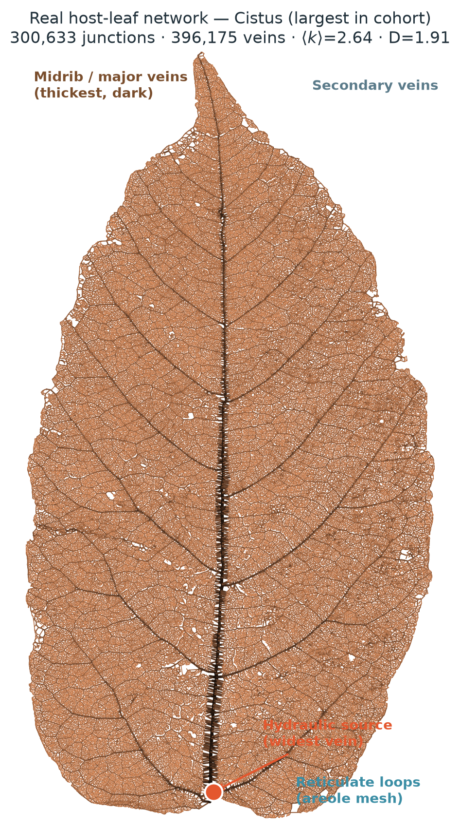
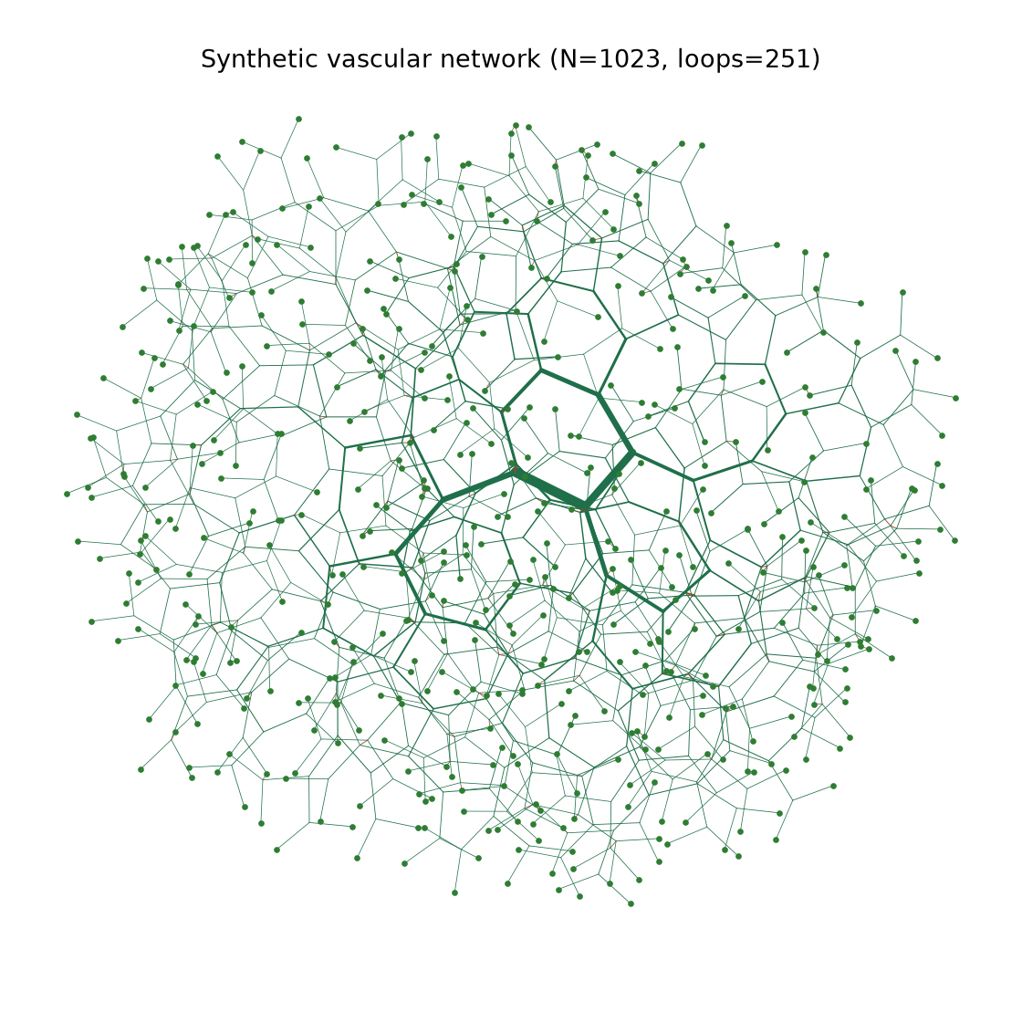
Figure 1 shows a representative traced empirical network (top) and a representative calibrated synthetic mesh (bottom), each reduced to nodes (vein junctions) and edges (vein segments).
SOP 2. Effect of Haustorial and Structural Loss on Hydraulic Integrity
Table 2
Percolation Response of the Reference Host Network under Two Attack Strategies
Attack strategy (2.1) | Critical threshold p_c (2.2) | 95% CI | P(collapse) at p_c (2.2)
Random (primary) | 0.271 | [0.270, 0.272] | 0.50 (by definition)
Degree-targeted | 0.202 | — | 0.50 (by definition)

Table 2 addresses SOP 2.1-2.2. Under random removal the network fragments at p_c = 0.271 (95% CI [0.270, 0.272]); under degree-targeted removal it fragments after removing fewer nodes, p_c = 0.202. The probability of hydraulic collapse rises sigmoidally with the removed fraction and passes through 0.50 at p_c by construction (Figure 2). The change in giant-connected-component size (SOP 2.3) is the green survival curve in Figure 2 and the fragmentation sequence in Figure 3: the connected component holds near 1.0 until the threshold, then collapses toward zero across a narrow window.
Figure 2
Collapse Probability and GCC Survival under Random and Degree-Targeted Attack
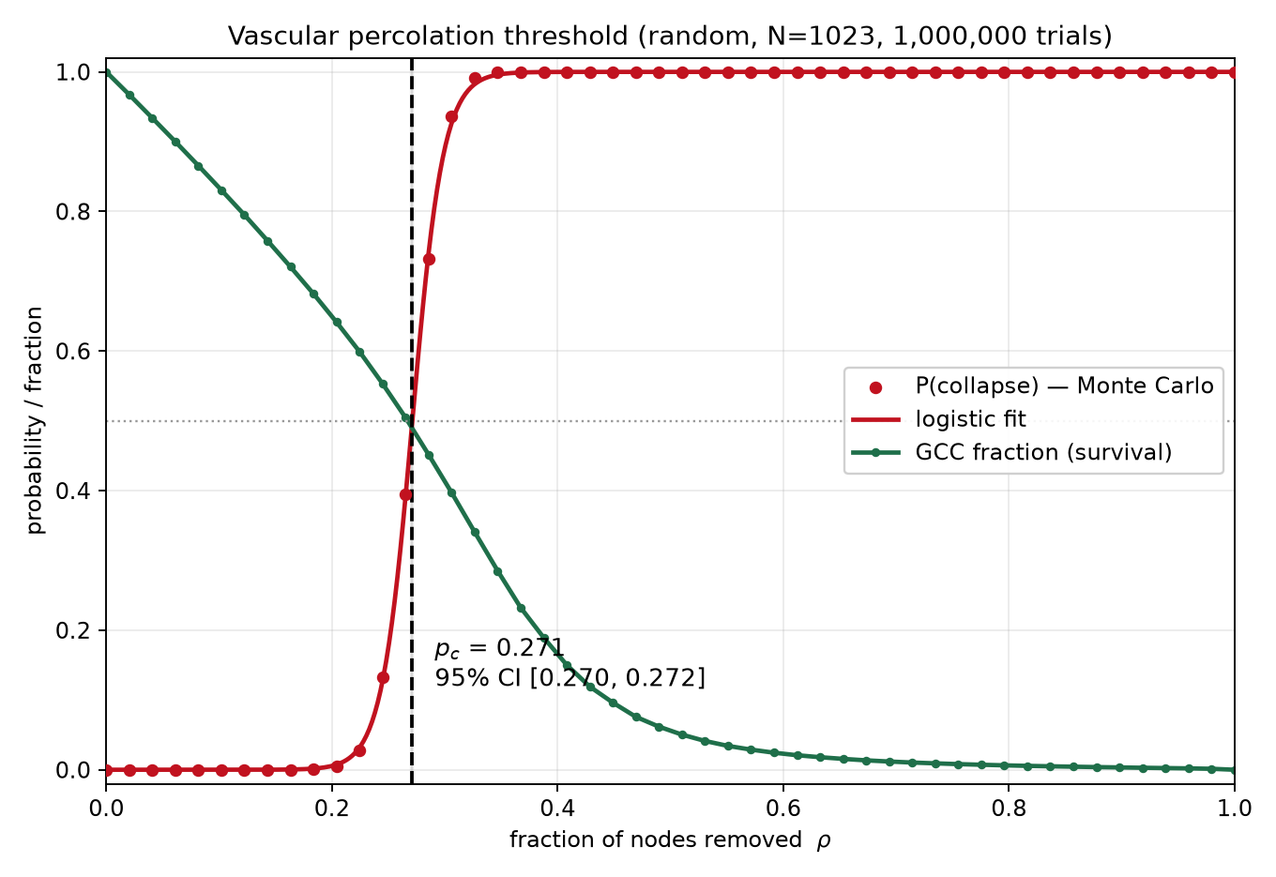
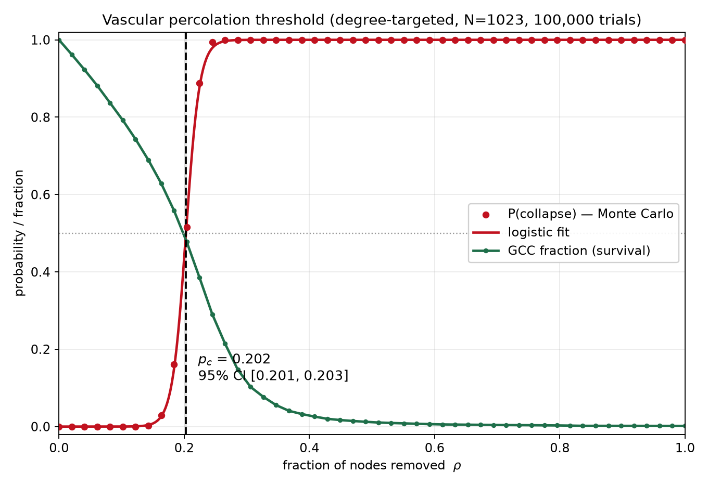
Figure 2 shows P(collapse) and the giant-connected-component fraction versus the fraction of nodes removed, for random (top) and degree-targeted (bottom) attack; the logistic inflection locates p_c.
Figure 3
Progressive Fragmentation of the Giant Connected Component (SOP 2.3)
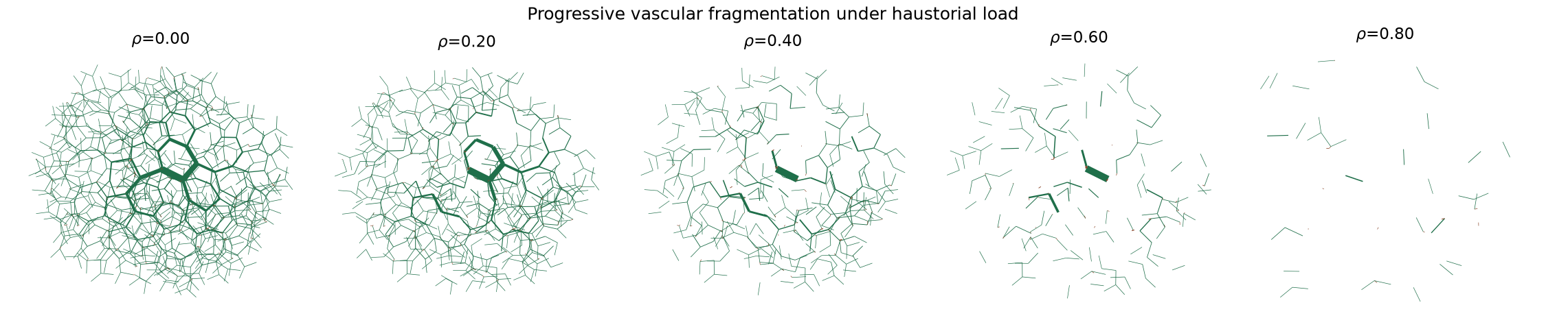
Figure 3 shows the giant connected component shattering into disconnected islands as the removed fraction crosses the critical threshold.
Table 3
Hydraulic Behavior of the Literature-Calibrated Haustorial Sink (SOP 2.4)
Quantity | Value
Sink strength K_h | 0.0392
Achieved flow diversion | 20%
Illustrative host-parasite gradient | ~1.5 MPa
Minimum host leaf water potential | -1.02 MPa
Cavitation threshold | −2.0 MPa
Vessels embolised by the sink alone | 0

Table 3 addresses SOP 2.4. At the literature-calibrated strength K_h = 0.0392 (~20% diversion), the minimum host leaf water potential reached is -1.02 MPa—above the −2.0 MPa cavitation threshold—so the sink alone embolises no vessels (Figure 4). The hydraulic drain is therefore sub-symptomatic; it is the structural loss of connectivity, not the sink, that drives collapse.
Figure 4
Host Water-Potential Field under the Calibrated Haustorial Sink
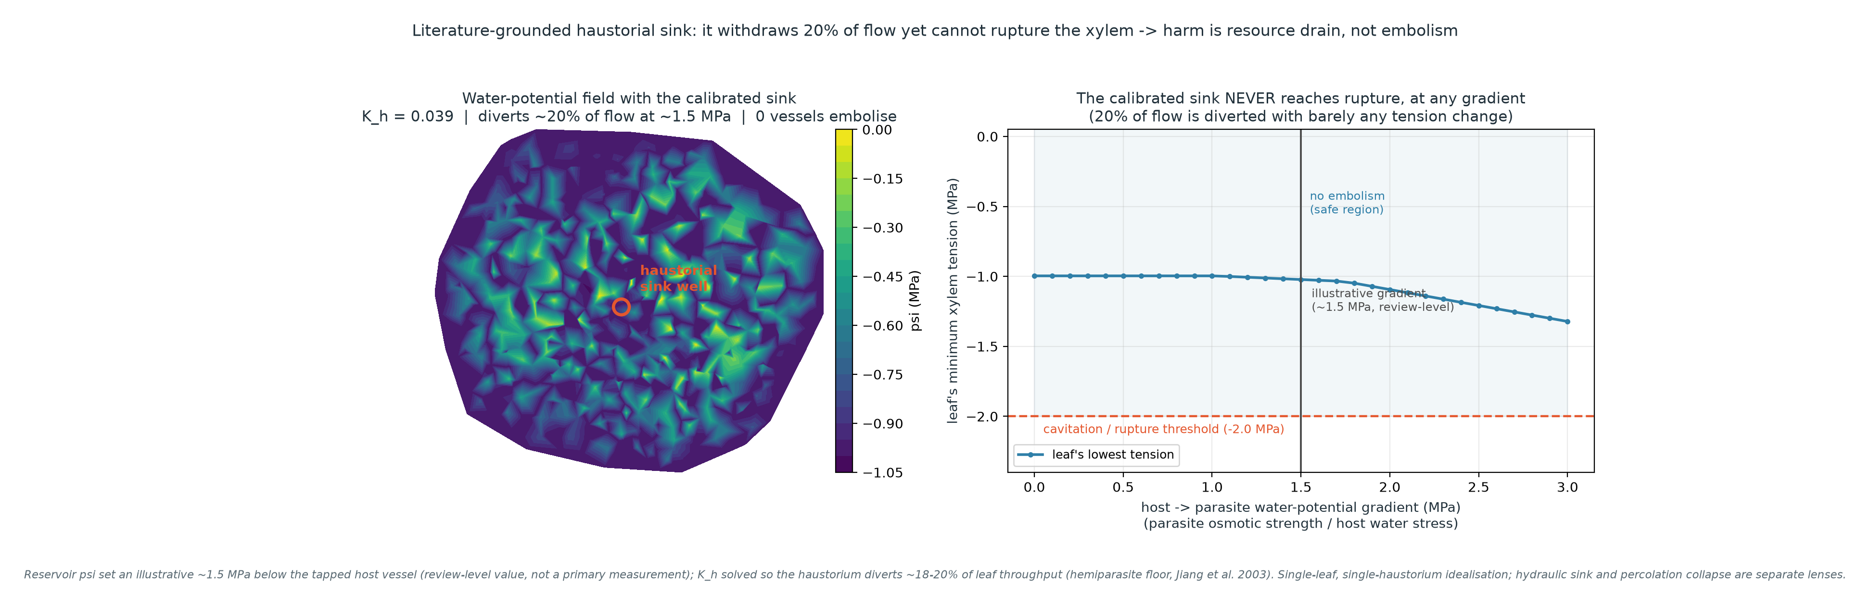
Figure 4 shows the host leaf water-potential field under the calibrated sink; the minimum potential stays above the cavitation threshold.
SOP 3. Influence of Vascular Architecture on the Critical Threshold
Table 4
Architectural Predictors of p_c (Real Cohort, n = 100; Shapiro-Wilk → Spearman)
Predictor (SOP item) | Shapiro-Wilk W (p) | Spearman ρ vs p_c (p) | Partial Spearman ρ
Fractal dimension D (3.1) | 0.964 (0.008) | 0.496 (<0.001) | 0.503
Reticulation density — loop fraction (3.2) | 0.977 (0.077) | 0.719 (<0.001) | — (see note)
Mean degree ⟨k⟩ (3.3) | 0.971 (0.027) | 0.733 (<0.001) | 0.736

Table 4 addresses SOP 3.1-3.3. Because Shapiro-Wilk rejected normality for p_c (W = 0.911, p < 0.001) and for D and mean degree, associations were quantified with the rank-based Spearman coefficient rather than Pearson, per the pre-specified decision rule. All three architectural measures are positively and significantly associated with p_c, the connectivity measures most strongly (mean degree ρ = 0.733; loop fraction ρ = 0.719; fractal dimension ρ = 0.496). Loop fraction and mean degree are two measures of the same reticulation axis and are collinear, so partial correlations are reported for the orthogonal mean-degree/fractal-dimension pair (rank collinearity ρ = 0.22); each remains significant after controlling for the other (⟨k⟩ | D = 0.736; D | ⟨k⟩ = 0.503). A standardized multiple regression explained R² = 0.507 of the variance in p_c.
Figure 5
Critical Threshold versus Architectural Predictors (Real Cohort)
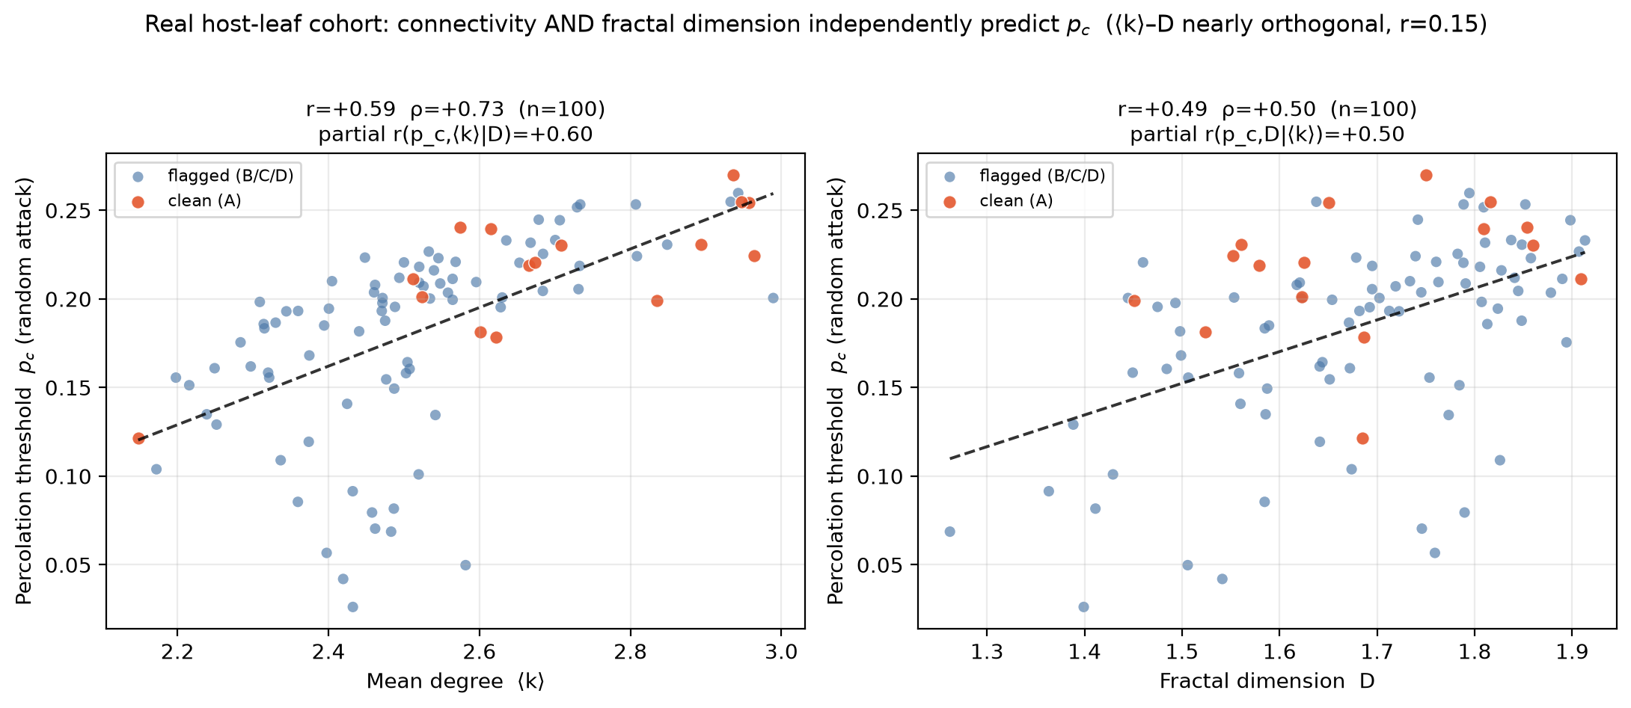
Figure 5 plots p_c against mean degree (left) and fractal dimension (right).
Table 5
Synthetic Causal Grid — Architecture and p_c (n = 42 networks, ⟨k⟩ and D decoupled)
Predictor | Spearman ρ vs p_c | Partial r (| other) | OLS β | Model R²
Mean degree ⟨k⟩ | 0.991 | 0.940 | 0.120 | 0.887
Fractal dimension D | 0.227 | 0.195 | 0.029 | —

Table 5 is the controlled causal complement to Table 4. Across 42 synthetic networks in which mean degree and fractal dimension are decoupled by design (correlation = 0.086), p_c depends near-deterministically on connectivity (Spearman ρ = 0.991, partial r = 0.940, OLS R² = 0.887) and only weakly on fractal dimension (partial r = 0.195), confirming under intervention the direction seen in the real cohort.
Figure 6
Threshold Surface across the Controlled Synthetic Grid
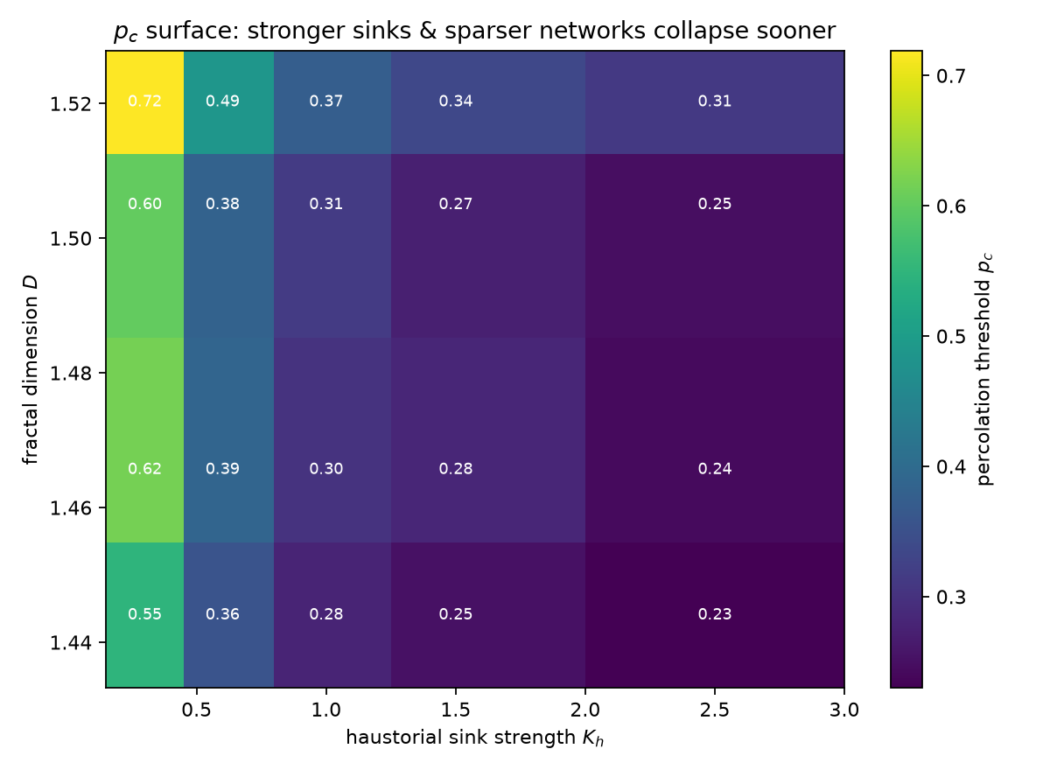
Figure 6 visualizes the grid of Table 5: p_c plotted over the mean-degree/fractal-dimension plane. The surface rises smoothly and chiefly along the connectivity axis, the visual counterpart of the near-deterministic dependence in Table 5.
SOP 4. Effect of Enhancing Venation Reticulation on Collapse Resistance
Table 6
Reticulation-Enhancement Shift in p_c by Tracing-Quality Grade (SOP 4.1)
Grade | n | p_c current (med) | p_c enhanced (med) | Δp_c (med) | % improved
A | 21 | 0.220 | 0.227 | 0.0069 | 62%
B | 46 | 0.190 | 0.211 | 0.0137 | 96%
C | 10 | 0.161 | 0.171 | 0.0083 | 100%
D | 28 | 0.205 | 0.219 | 0.0086 | 93%
Full valid cohort | 105 | 0.201 | 0.215 | 0.0095 | 89%

Table 6 addresses SOP 4.1. Raising each leaf's connectivity toward the cohort's 90th-percentile reticulation ceiling (⟨k⟩ = 2.811) raised the collapse threshold in 89% of the 105 valid leaves and lowered it in none. The effect is smallest and most conservative in the artifact-free grade-A tracings (median Δp_c = 0.0069, 62% improved) and largest in grade B (Δp_c = 0.0137), consistent with missing-vein artifacts overstating the reticulation headroom; the grade-A figure is therefore the honest lower bound (grade C, n = 10, is a small sample).
Table 7
Dependence of the Threshold Gain on Initial Architecture (SOP 4.2)
Initial trait | Spearman ρ with Δp_c (p) | Standardized β
Initial mean degree ⟨k⟩₀ | -0.821 (<0.001) | -0.0089
Fractal dimension D | -0.034 (0.729) | 0.0007

Table 7 addresses SOP 4.2. The gain depends strongly and negatively on the leaf's initial mean degree (Spearman ρ = -0.821, p < 0.001)—the sparser the starting leaf, the larger the improvement—and does not depend on fractal dimension (ρ = -0.034, p = 0.73, n.s.). A standardized regression of Δp_c on both traits explained R² = 0.655, essentially all of it attributable to initial connectivity.
Figure 7
Change in Threshold from Reticulation Enhancement
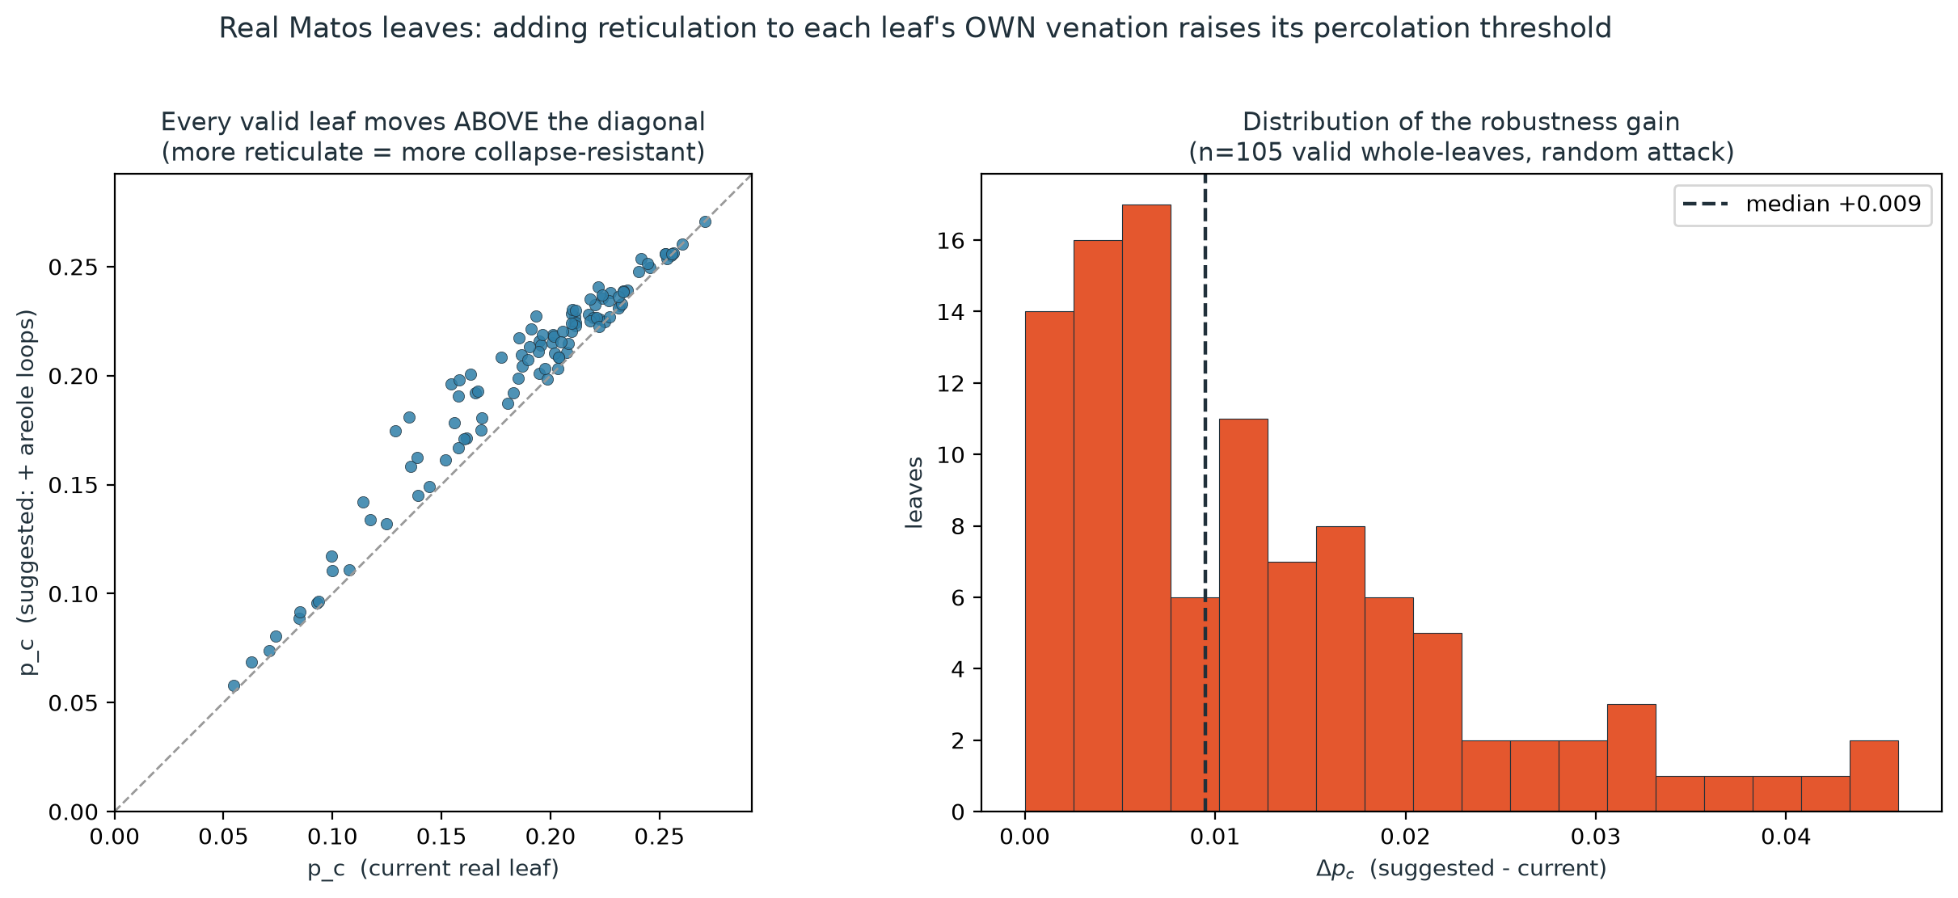
Figure 7 shows the per-leaf change in threshold; it rises in 89% of leaves and falls in none.
Figure 8
A Representative Leaf before and after Reticulation Enhancement
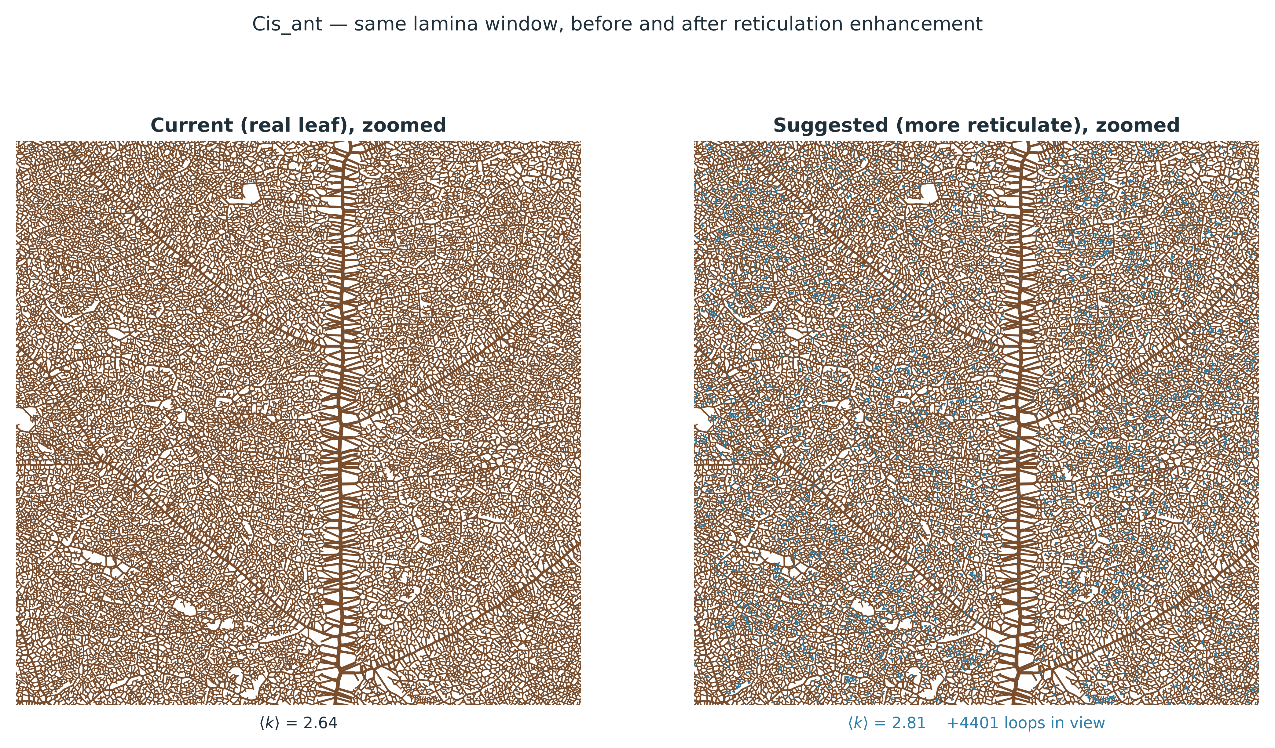
Figure 8 shows the same leaf window before (left) and after (right) enhancement; added areole loops (blue) close open vein endings into redundant circuits without altering the major-vein skeleton.
Supplementary Analyses (Model Validation and Dynamics)
The following analyses fall outside the four specific questions but establish the validity of the model and the interpretation of the pre-symptomatic window, and are reported for completeness.
Table 8
Model Validation Summary
Check | Scope | Result | Reading
Hydraulic resistance | 119 leaves, 5,668,467 veins | Pearson(log r) ≥ 1.000000 | agreement to floating-point precision
Wrong-exponent control | same veins | 0.953 | exact match not trivial
Leaf conductance (K_leaf) | 93 species | Spearman ρ = 0.187 | xylem-only; weak and non-significant (limitation)
Crop-edge boundary | 120 leaves | 105 within tolerance | edge artifacts negligible

Table 8 reports the validation checks. The hydraulic solver reproduces the source dataset's own Hagen-Poiseuille resistance across 119 leaves and 5,668,467 veins (agreeing to floating-point precision: the worst per-leaf coefficient of variation of the model-to-source resistance ratio is 1.1e-07, against a 1e-06 tolerance); a cross-check against measured leaf conductance is weak and not statistically significant (ρ = .187, p = .073) because the model captures xylem topology only.
Figure 9
Finite-Size and Critical Behavior of the Transition
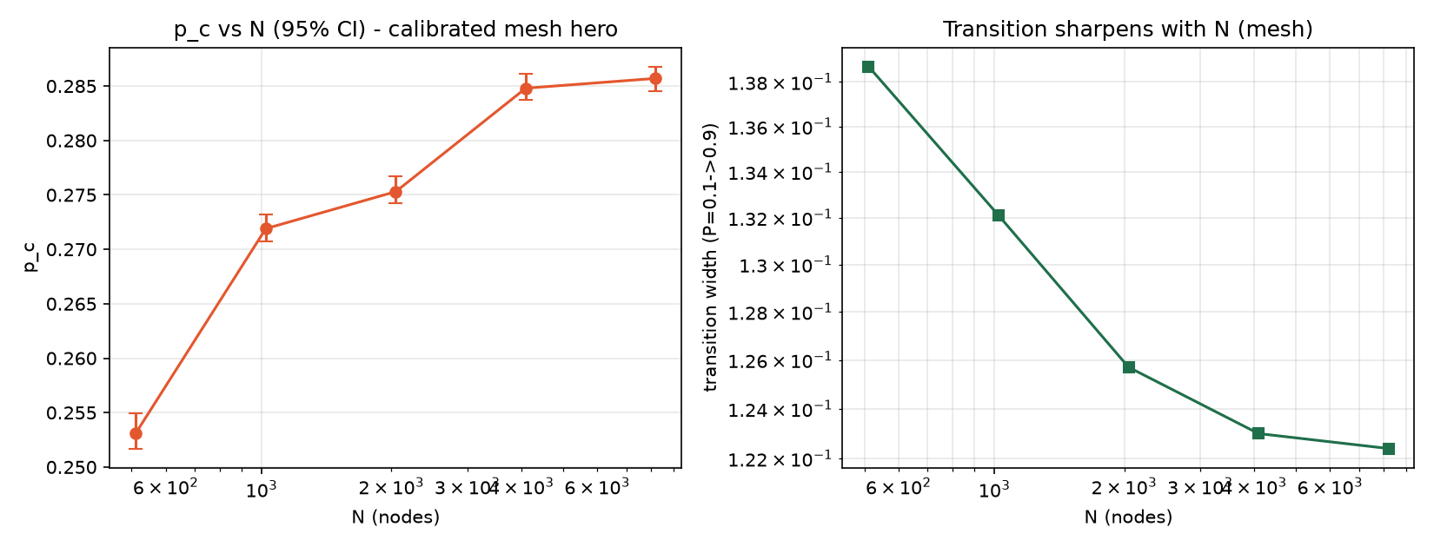
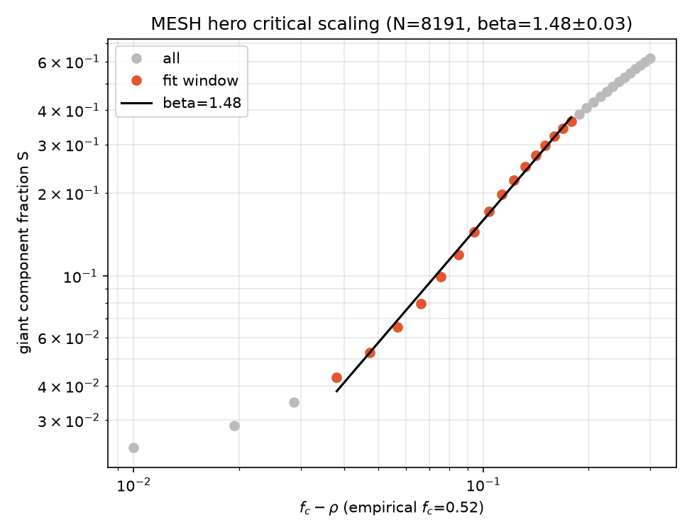
Figure 9 shows p_c converging as network size grows (top) and the continuous critical behavior (bottom; log-log R² = 0.995, empirical f_c = 0.524 matching the Molloy-Reed prediction 0.531).
Figure 10
The Pre-Symptomatic Window
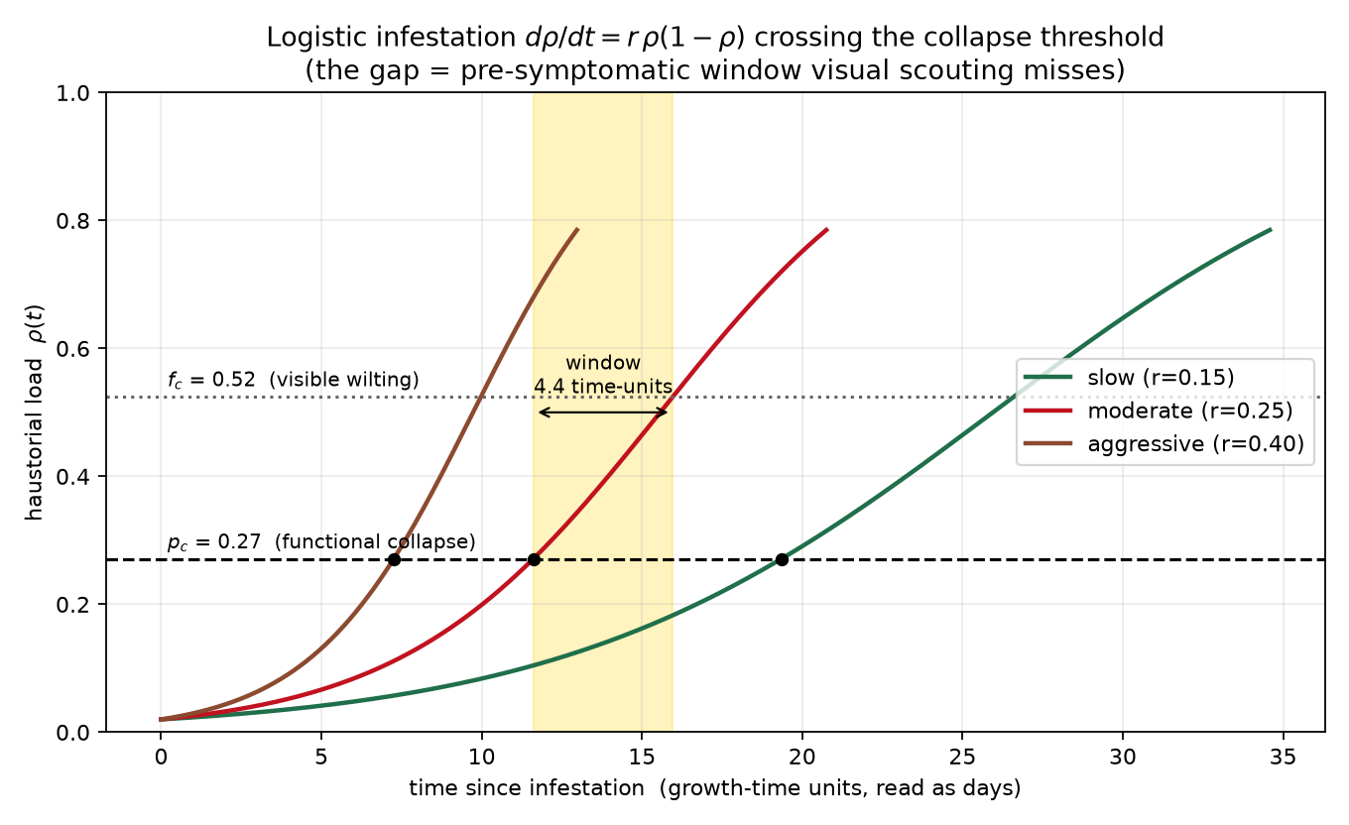
Figure 10 illustrates the pre-symptomatic window central to the general question: the gap between functional collapse (p_c) and visible wilting, shown for three infestation growth rates. Its existence and shape—not its duration in real time—is the finding.

DISCUSSION
Network Architecture of the Host Cohort
The architecture of a leaf's venation network sets the physical substrate on which any transport failure must propagate, making its structural description the starting point for a percolation analysis (Ronellenfitsch, Lasser, Daly, & Katifori, 2015). Dicot venation is classically described as a hierarchical major-vein skeleton overlaid by a sparse but functionally decisive set of anastomosing minor-vein loops (Katifori, Szöllősi, & Magnasco, 2010). Our cohort is consistent with this picture: the 112 valid host networks are sparse and near-tree-like, with a median mean degree of 2.520 (close to the ⟨k⟩ = 2 pure-tree boundary) and only a minority of reticulate loops. The fractal dimension spanned 1.148–1.913, within the range reported for box-counting analyses of leaf complexity and subject to the same known caveats of that metric (Muraleedharan, Rajan, & Jaishanker, 2023). Because the networks derive from a calibrated, millimetre-referenced venation archive rather than idealized lattices (Matos, Blonder, et al., 2024), these values carry real biological units, which is what makes the downstream thresholds interpretable.
Percolation Threshold and Attack Tolerance
The critical threshold p_c is the fraction of the network that can be removed before the giant connected component fragments; beyond it, long-range transport fails. Across the 100-network empirical cohort the median threshold under random loss was p_c = .200, and under degree-targeted loss it fell to .169; on the calibrated synthetic reference network, evaluated at a far larger trial budget, the corresponding values are .271 and .202—that is, the network fragmented after removing fewer high-degree nodes than random nodes. This ordering, in which targeted removal is more damaging than random removal, is the classic signature of heterogeneous networks: they tolerate random failure but are fragile to loss concentrated on the high-connectivity elements that hold the network together (Albert, Jeong, & Barabási, 2000; Callaway, Newman, Strogatz, & Watts, 2000). Two attack strategies—random, as the biologically faithful primary case, and degree-targeted, as the structural worst case—bracket the range of damage the host can sustain, and the gap between them quantifies how much the network's robustness depends on protecting its most connected veins (Newman, 2003).
The Haustorial Sink and the Pre-Symptomatic Window
A central result is that the calibrated haustorial drain does not, by itself, cavitate the host. At a withdrawal strength reproducing ~20% diversion—anchored to the hemiparasite floor reported by Jiang et al. (2003)—the minimum host leaf water potential reached was -1.02 MPa, above the −2.0 MPa cavitation threshold, so the drain embolized 0 vessels at the illustrative gradient. The hydraulic sink and the percolation collapse are therefore best read as two decoupled lenses: the sink describes how hard the parasite pulls, while the threshold describes how much connectivity the host can lose before supply fails. This interpretation aligns with Zhang et al. (2025), who across 118 mistletoe–host pairs found the parasite's own xylem to be the narrower, higher-resistance element—supporting a tension boundary condition rather than a wide-bore conduit. Because the drain is sub-symptomatic, it opens a pre-symptomatic window in which the host is functionally compromised before it visibly wilts; the existence and shape of that window is the finding, not its length in any particular unit of time. Sink strength remains a genuine literature gap, so its magnitude is a delimitation of the model and the qualitative decoupling holds at any gradient.
Architectural Predictors of the Collapse Threshold
Both architectural predictors independently forecast where a network collapses. Because the Shapiro–Wilk test rejected normality for p_c and for both predictors, associations were quantified with the rank-based Spearman coefficient rather than Pearson, per the pre-specified decision rule. In the real cohort, the partial Spearman correlation of p_c with mean degree controlling for fractal dimension was ρ = 0.736, and with fractal dimension controlling for mean degree ρ = 0.503, with the two predictors only weakly collinear (rank ρ = 0.22). The controlled synthetic grid sharpened this to a near-deterministic dependence on connectivity (Spearman ρ = 0.991, R² = 0.887). Connectivity—the density of reticulate loops—is thus the dominant lever on robustness, with fractal dimension a real but secondary predictor. This is the quantitative counterpart to a long-standing argument in transport-network theory and plant hydraulics: reticulate venation buys robustness by providing redundant pathways that reroute flow around damage (Katifori et al., 2010; Price & Weitz, 2014), and conduit redundancy and connectivity are what protect xylem function against localized failure (Loepfe, Martínez-Vilalta, Piñol, & Mencuccini, 2007; Mrad, Sevanto, Domec, Liu, Nakad, & Katul, 2021).
Reticulation Enhancement of Host Robustness
Building on that causal result, raising each leaf's connectivity toward the cohort's own 90th-percentile ceiling (⟨k⟩ = 2.811) raised the collapse threshold in 89% of leaves and lowered it in none, with a simulated median gain of Δp_c = 0.009; the conservative artifact-free subset still improved 62% of leaves. The gain was largest for the sparsest starting leaves, which is direct evidence that the added reticulation itself—not some correlated trait—buys the robustness. That real leaves are not already maximally reticulate reflects the well-documented cost–benefit tension in venation, where loops carry a carbon and construction cost and leaf form is tuned rather than maximized for robustness (Price & Weitz, 2014; Katifori et al., 2010). The result should be read as a first-order direction and magnitude rather than an engineered optimum, since construction costs and photosynthetic trade-offs are not modeled.
Critical Behavior, Validation, and Novelty
The collapse behaves as a percolation transition rather than a modeling artifact, though the supporting evidence is weaker than first reported. The size sweep that appeared to show convergence raised fractal dimension along with network size, and a second sweep holding fractal dimension and mean degree fixed leaves the loop fraction still drifting, so no finite-size claim is made here. What does hold is that the connectivity threshold f_c = 0.524 — the removal fraction at which the giant component vanishes, a different criterion from p_c — is of the same order as the Molloy–Reed prediction (0.531), a qualitative agreement only, since that prediction assumes a locally tree-like graph while the planar mesh contains short loops (Dorogovtsev, Goltsev, & Mendes, 2008; Newman & Ziff, 2001). The model's hydraulic core is validated to an unusually strong standard, reproducing the source dataset's own resistance column across 119 leaves and 5,668,467 veins (Mrad et al., 2018). Limitations must nonetheless be stated: the model captures xylem topology only and correlates weakly and non-significantly with measured whole-leaf conductance (Spearman ρ = .187, p = .073, n = 93 species), which is dominated by outside-xylem resistances; the analysis is site (node) percolation; haustorial sink strength is anchored rather than measured; and the leaf is modeled as the readout tissue for systemic stress, not the attachment organ. Within these bounds, the contribution can be stated in a form that survives scrutiny: no prior work has coupled a hydraulic resistor model to a percolation collapse threshold on real leaf venation networks. The one connectivity study on real leaves reports no formal threshold, implements no hydraulic model, and explicitly names hydraulic-flow modeling as the open next step—precisely the step taken here (Mander & Williams, 2024).

CONCLUSION
This study built and validated a computational pipeline that turns real, calibrated leaf venation networks—together with controlled synthetic meshes—into percolation collapse thresholds under holoparasitic haustorial sink stress, and used it to ask where host xylem networks break, what governs that breaking point, and whether it can be shifted. Three conclusions follow. First, host xylem networks collapse at a well-defined connectivity threshold — the empirical cohort's median was p_c = .200 under random loss, with the calibrated synthetic reference collapsing at .271 — and degree-targeted loss is more damaging, lowering the cohort median to .169, confirming that the networks tolerate random failure but are fragile to loss concentrated on their most connected veins. Second, the haustorial sink is sub-symptomatic—it does not itself cavitate the host—so it is the loss of network connectivity that sets collapse, and a pre-symptomatic window exists in which the host is functionally compromised before it visibly wilts. Third, and most consequentially, architecture predicts robustness: reticulate connectivity is the dominant, independently significant lever on the collapse threshold, and adding loops toward the cohort's own empirical ceiling raised the threshold in 89% of leaves without lowering it in any. Taken together, these results identify vein reticulation as a quantitative robustness trait rather than an incidental feature of leaf form, and they frame pre-symptomatic vascular collapse as a measurable early-warning window rather than an abstraction.
RECOMMENDATIONS
The study's honest boundaries point directly to its next steps. First, a primary measurement of holoparasite haustorial flux would replace the single hedged sink-strength input and allow the hydraulic and percolation lenses to be coupled quantitatively rather than qualitatively. Second, a full multi-size scaling collapse would resolve the transition's universality class, which the present single-size fit deliberately leaves open. Third, moving from a first-order response surface to cost-constrained, designed networks—explicitly modeling the carbon and construction cost of added loops—would turn the reticulation-enhancement result from a direction into an engineered optimum. Fourth, extending the analysis to additional host species and parasite pairs would test the generality of the efficiency-ordering and attack-tolerance findings. Finally, field or greenhouse validation of the pre-symptomatic window against real infestation time-courses would confirm its practical value as an early-warning signal.

REFERENCES
Works cited in the Discussion. Full citations should be verified against each DOI before final submission.
Albert, R., Jeong, H., & Barabási, A.-L. (2000). Error and attack tolerance of complex networks. Nature, 406(6794), 378–382. https://doi.org/10.1038/35019019
Callaway, D. S., Newman, M. E. J., Strogatz, S. H., & Watts, D. J. (2000). Network robustness and fragility: Percolation on random graphs. Physical Review Letters, 85(25), 5468–5471. https://doi.org/10.1103/PhysRevLett.85.5468
Dorogovtsev, S. N., Goltsev, A. V., & Mendes, J. F. F. (2008). Critical phenomena in complex networks. Reviews of Modern Physics, 80(4), 1275–1335. https://doi.org/10.1103/RevModPhys.80.1275
Jiang, F., Jeschke, W. D., & Hartung, W. (2003). Water flows in the parasitic association Rhinanthus minor/Hordeum vulgare. Journal of Experimental Botany, 54(389), 1985–1993. https://doi.org/10.1093/jxb/erg212
Katifori, E., Szöllősi, G. J., & Magnasco, M. O. (2010). Damage and fluctuations induce loops in optimal transport networks. Physical Review Letters, 104(4), 048704. https://doi.org/10.1103/PhysRevLett.104.048704
Loepfe, L., Martínez-Vilalta, J., Piñol, J., & Mencuccini, M. (2007). The relevance of xylem network structure for plant hydraulic efficiency and safety. Journal of Theoretical Biology, 247(4), 788–803. https://doi.org/10.1016/j.jtbi.2007.03.036
Mander, L., & Williams, H. T. P. (2024). The robustness of some Carboniferous fossil leaf venation networks to simulated damage. Royal Society Open Science, 11(5), 240086. https://doi.org/10.1098/rsos.240086
Matos, I. S., Blonder, B., et al. (2024). Leaf architecture and functional traits for 122 species at the University of California at Berkeley botanical garden. New Phytologist, 244(2), 407–425. https://doi.org/10.1111/nph.20037
Mrad, A., Domec, J.-C., Huang, C.-W., Lens, F., & Katul, G. (2018). A network model links wood anatomy to xylem tissue hydraulic behaviour and vulnerability to cavitation. Plant, Cell & Environment, 41(12), 2718–2730. https://doi.org/10.1111/pce.13413
Mrad, A., Sevanto, S., Domec, J.-C., Liu, Y., Nakad, M., & Katul, G. (2021). The roles of conduit redundancy and connectivity in xylem hydraulic functions. New Phytologist, 231(1), 996–1007. https://doi.org/10.1111/nph.17429
Muraleedharan, V., Rajan, S. C., & Jaishanker, R. (2023). Determining the limits of traditional box-counting fractal analysis in leaf complexity studies. Flora, 304, 152300. https://doi.org/10.1016/j.flora.2023.152300
Newman, M. E. J. (2003). The structure and function of complex networks. SIAM Review, 45(2), 167–256. https://doi.org/10.1137/S003614450342480
Newman, M. E. J., & Ziff, R. M. (2001). Fast Monte Carlo algorithm for site or bond percolation. Physical Review E, 64(1), 016706. https://doi.org/10.1103/PhysRevE.64.016706
Price, C. A., & Weitz, J. S. (2014). Costs and benefits of reticulate leaf venation. BMC Plant Biology, 14, 234. https://doi.org/10.1186/s12870-014-0234-2
Ronellenfitsch, H., Lasser, J., Daly, D. C., & Katifori, E. (2015). Topological phenotypes constitute a new dimension in the phenotypic space of leaf venation networks. PLOS Computational Biology, 11(12), e1004680. https://doi.org/10.1371/journal.pcbi.1004680
Zhang, R., et al. (2025). Xylem anatomy across 118 mistletoe–host species pairs. New Phytologist, 245(2), 607–624. https://doi.org/10.1111/nph.20257

# DISCUSSION

## Network Architecture of the Host Cohort

The architecture of a leaf venation network establishes the structural framework through which hydraulic transport is maintained and through which localized damage can propagate. In the present study, the empirical host networks exhibited a median mean degree of 2.520, indicating that the networks remained relatively sparse and close to a tree-like structure, while retaining substantial reticulation as indicated by a median loop fraction of 0.776. The networks were also predominantly connected, with a median giant-connected-component (GCC) fraction of 1.000. Their fractal dimensions ranged from 1.148 to 1.913, indicating substantial variation in spatial complexity among host networks. These characteristics demonstrate that the empirical leaves were not simply highly redundant meshes; rather, they combined a largely hierarchical structure with a substantial number of alternative pathways.

This architecture is important because hydraulic robustness does not necessarily require every part of a vascular network to contain numerous parallel pathways. Instead, robustness can emerge when strategically positioned connections allow flow to be redistributed when individual conduits or junctions become unavailable. Experimental evidence supports this interpretation. Sack et al. (2008) demonstrated that leaves with greater vascular redundancy were more tolerant of hydraulic disruption, particularly when major veins were damaged, while damage to second- and higher-order veins had relatively limited effects because of parallel flow paths provided by the reticulate minor-vein network. Thus, the high loop fraction observed in the empirical cohort can be interpreted not simply as a geometric property, but as a potential source of hydraulic redundancy.

The similarity between the empirical and synthetic networks further supports the use of the synthetic models as controlled architectural counterparts. The empirical networks had a median mean degree of 2.520 and fractal dimension of 1.676, while the synthetic networks had corresponding values of 2.796 and 1.640. Their median hydraulic conductances were also closely aligned at (4.01\times10^{-3}) and (4.04\times10^{-3}), respectively. This correspondence is important because the subsequent synthetic analysis was intended to isolate architectural effects rather than introduce a fundamentally different class of vascular topology. The synthetic networks therefore provide a controlled environment in which the contribution of connectivity can be examined independently of some of the covariation present in naturally occurring leaves.

The results also indicate why fractal dimension should not be interpreted as a direct measure of hydraulic redundancy. Two networks can possess similar spatial complexity while differing in the number and placement of alternative transport routes. Fractal dimension describes how network geometry occupies space across scales, whereas mean degree and loop fraction describe aspects of the network's connectivity. Consequently, spatial complexity and transport redundancy represent related but distinct properties. This distinction becomes particularly important in the later analysis, where connectivity emerges as a substantially stronger determinant of collapse resistance than fractal dimension.

## Percolation Threshold and Structural Attack Tolerance

The percolation analysis revealed a distinct difference between random and degree-targeted structural loss. Under random node removal, the reference network reached its critical threshold at (p_c=0.271), whereas removal directed toward high-degree nodes reduced the threshold to (p_c=0.202). Thus, the network fragmented after the removal of substantially fewer nodes when damage was concentrated on highly connected locations.

The difference between the two thresholds, (\Delta p_c=0.069), indicates that the network's apparent tolerance to damage depends strongly on where structural loss occurs. Relative to the random-removal threshold, the degree-targeted threshold represents approximately a 25.5% reduction in the fraction of nodes that can be removed before collapse on the synthetic reference network; across the 100-network empirical cohort the corresponding reduction is 15.7% of the median threshold. This demonstrates that node count alone is insufficient to describe vascular vulnerability. Two networks may experience the same proportion of structural loss but exhibit very different functional outcomes depending on whether the removed elements are peripheral or highly connected.

This pattern is consistent with the general behavior of heterogeneous networks, in which random failure can be tolerated because many individual elements contribute relatively little to global connectivity, whereas targeted removal of highly connected elements can rapidly disrupt network integrity (Albert et al., 2000; Callaway et al., 2000). However, the present finding extends this general network principle into a biologically meaningful vascular context. In a leaf venation network, high-degree nodes represent junctions through which multiple vein segments are connected. Their removal therefore eliminates several potential pathways simultaneously and can isolate larger portions of the network than the removal of a low-degree node.

The result is also consistent with plant hydraulic studies emphasizing the importance of network redundancy and connectivity. Mrad et al. (2021) used graph theory, percolation theory, and computational modeling of xylem to demonstrate that increased conduit connectivity can increase resistance to embolism spread by providing redundant hydraulic pathways. The present study extends that principle from conduit-level embolism resistance to leaf-scale network fragmentation. Rather than asking only whether individual conduits remain hydraulically functional, the percolation framework asks whether sufficient connectivity remains for the network as a whole to maintain a giant connected component.

The progressive GCC collapse observed in Figure 3 provides the structural interpretation of this threshold. The GCC remains close to its initial state across much of the removal process and then rapidly fragments as the critical region is approached. This behavior indicates that the transition from an apparently functional network to a fragmented one is not necessarily gradual. A relatively small additional amount of structural loss near (p_c) can produce a disproportionately large reduction in global connectivity. This threshold behavior is particularly relevant to the concept of pre-symptomatic dysfunction because it suggests that a host may retain substantial network connectivity until a critical level of damage is reached, after which functional integrity can deteriorate rapidly.

## The Haustorial Sink and the Pre-Symptomatic Hydraulic Window

The hydraulic simulation of haustorial withdrawal provides an important distinction between physiological stress and structural collapse. At the literature-calibrated sink strength of (K_h=0.0392), corresponding to approximately 20% flow diversion, the modeled host leaf reached a minimum water potential of (-1.02) MPa. This remained above the modeled cavitation threshold of (-2.0) MPa, and consequently the sink alone produced no embolized vessels under the illustrative hydraulic gradient.

The approximately 0.98 MPa difference between the modeled minimum water potential and the cavitation threshold indicates that the calibrated sink did not directly push the modeled network into cavitation. This does not imply that haustorial withdrawal is physiologically insignificant. Rather, it indicates that hydraulic stress and structural collapse represent different stages or mechanisms within the modeled system. The haustorium functions as a hydraulic sink that alters water-potential gradients and diverts flow, whereas the percolation process determines how much structural connectivity the host can lose before its transport network fragments.

This distinction is biologically plausible because hydraulic vulnerability within a leaf is itself spatially heterogeneous. Scoffoni et al. (2017), for example, found that hydraulic decline during dehydration was strongly associated with embolism in petiole and midrib conduits and with conduit dimensions, while embolism was comparatively limited in minor veins under the conditions examined. Consequently, a network-level connectivity threshold should not be interpreted as meaning that every vein possesses identical physiological vulnerability. Instead, the threshold represents the point at which structural loss becomes sufficiently extensive to compromise the network's global connectivity.

The present results therefore support a two-component interpretation of the modeled host-parasite interaction. Haustorial withdrawal supplies the physiological perturbation, while network architecture determines how much structural disruption can be tolerated before transport connectivity fails. The absence of direct cavitation under the calibrated sink means that the modeled parasite-induced stress can exist in a sub-symptomatic state before the network reaches its structural collapse threshold. The pre-symptomatic window identified in Figure 10 should consequently be understood as a period of functional vulnerability in which the host may already experience altered hydraulic conditions even though the modeled water potential has not crossed the cavitation threshold.

The magnitude of this window, however, should not be interpreted as a direct prediction of infestation duration in days or weeks. The present model does not include a measured temporal progression of haustorial growth or a directly measured host-parasite flux. The sink strength is therefore a calibrated model input rather than an experimentally determined parameter. The robust conclusion is not that every host-parasite association will exhibit a fixed hydraulic buffer of 0.98 MPa, but that under the modeled conditions, physiological withdrawal can precede structural collapse. Direct measurement of haustorial flux would be required to convert this conceptual window into a quantitatively time-resolved biological prediction.

## Architectural Predictors of the Critical Threshold

The analysis of the real host cohort demonstrated that multiple architectural properties were associated with the critical percolation threshold, but their strengths differed substantially. Mean degree exhibited a strong positive association with (p_c) ((\rho=0.733)), while loop fraction showed a similarly strong association ((\rho=0.719)). Fractal dimension also correlated positively with (p_c), although its relationship was weaker ((\rho=0.496)). After controlling for fractal dimension, mean degree remained strongly associated with (p_c) ((\rho=0.736)), while fractal dimension remained positively associated with (p_c) after controlling for mean degree ((\rho=0.503)).

These results indicate that both spatial complexity and connectivity contain information about network robustness, but they do not contribute equally. Connectivity describes the availability of alternative routes through the vascular system more directly than fractal dimension does. A higher mean degree generally means that nodes are connected to more neighboring elements, increasing the number of possible pathways through which flow can potentially be redistributed after local damage. Fractal dimension, in contrast, captures the spatial organization and scaling complexity of the network without explicitly determining whether those structures form redundant hydraulic routes.

The synthetic causal grid provides particularly strong support for this interpretation. In the 42 synthetic networks, mean degree and fractal dimension were deliberately decoupled, with a correlation of only 0.086. Despite this separation, mean degree showed an almost deterministic association with (p_c), with Spearman (\rho=0.991), partial (r=0.940), and an OLS model explaining (R^2=0.887) of the variation in the threshold. Fractal dimension showed only a weak partial association ((r=0.195)).

This controlled result is important because the empirical correlations alone cannot establish whether connectivity is responsible for the higher threshold or merely correlated with another underlying architectural trait. The synthetic experiment addresses that concern by varying the two architectural dimensions independently. The persistence of the connectivity effect after this decoupling indicates that the relationship between connectivity and (p_c) is not adequately explained by fractal geometry alone.

The result is consistent with the mechanistic framework proposed by Mrad et al. (2021), in which increased connectivity provides greater pathway redundancy and consequently improves resistance to hydraulic failure. It is also consistent with experimental evidence from Sack et al. (2008), who found that vascular redundancy can protect leaves against hydraulic disruption and that higher primary-vein density predicted greater tolerance of damage. Together, these findings provide independent support for interpreting the positive relationship between reticulation and (p_c) as a consequence of alternative transport pathways rather than merely an incidental correlation between network traits.

The results therefore support a distinction between **geometric complexity** and **functional redundancy**. A network may be spatially complex without necessarily possessing sufficient alternative routes to maintain global connectivity after strategically positioned losses. In the present study, fractal dimension remained a significant secondary predictor, indicating that spatial organization still contributes to robustness, but the controlled synthetic analysis demonstrates that connectivity is the more direct determinant of collapse resistance.

## Reticulation Enhancement and the Potential for Increased Resistance

The reticulation-enhancement analysis provides the strongest evidence that the relationship between connectivity and collapse resistance is not only descriptive but also directionally manipulable within the model. Increasing each network's connectivity toward the empirical 90th-percentile ceiling of (\langle k\rangle=2.811) increased (p_c) in 89% of the 105 valid leaves, while no leaf experienced a decrease in the threshold. Across the full cohort, the median increase was (\Delta p_c=0.0095), representing an 89% improvement rate.

The magnitude of the response depended strongly on the initial architecture. Initial mean degree was negatively correlated with the increase in (p_c), with Spearman (\rho=-0.821) and (p<0.001), while fractal dimension showed essentially no relationship with the threshold gain ((\rho=-0.034), (p=0.729)). The regression model explained (R^2=0.655) of the variation in (\Delta p_c), with the explanatory power attributable primarily to initial connectivity.

This means that the simulated benefit of additional reticulation was greatest in initially sparse networks. Such a pattern is consistent with a diminishing-return interpretation: when a network already contains substantial redundancy, adding additional connections may provide less additional protection because many alternative pathways are already available. Conversely, a sparsely connected network has fewer alternative routes, so the addition of even a relatively small number of connections can produce a comparatively large increase in its resistance to fragmentation.

The result is particularly relevant to evolutionary interpretations of leaf architecture. Reticulation is unlikely to be maximized without constraint because vascular networks must simultaneously support transport efficiency, structural construction, and resilience. Ronellenfitsch and Katifori (2019) demonstrated that vascular flow-network architectures can occupy a Pareto-efficient trade-off among transport efficiency, construction cost, and damage robustness rather than maximizing any one property independently. The present enhancement experiment is consistent with this framework: greater connectivity improves structural resistance in the model, but the fact that natural networks occupy a range of connectivity levels suggests that robustness is only one component of architectural optimization.

The tracing-quality analysis further supports a cautious interpretation. The largest median increase occurred in grade-B networks ((\Delta p_c=0.0137)), whereas the artifact-free grade-A networks showed a smaller median increase of 0.0069. Because missing veins can artificially reduce apparent connectivity, lower-quality tracings may possess more apparent headroom for enhancement. The grade-A result is therefore the more conservative estimate of the robustness benefit. The absence of decreases across all grades nevertheless indicates that the direction of the modeled response was consistently toward greater collapse resistance.

The enhancement should not, however, be interpreted as evidence that increasing leaf vein density indefinitely would improve plant fitness. The simulation changes connectivity without explicitly accounting for developmental, carbon, anatomical, or photosynthetic costs. It therefore identifies the direction of the network-level relationship rather than an evolutionary optimum. Its strongest implication is instead mechanistic: within the architectural range represented by the model, increasing reticulate connectivity increases the amount of structural loss that the network can tolerate before percolation collapse.

## Critical Behavior and Model Validation

The supplementary analyses provide evidence that the observed transition is a genuine network-level phenomenon rather than a numerical artifact. The sweep that produced the apparent size convergence raised fractal dimension along with network size, and a second sweep with fractal dimension and mean degree pinned shows the loop fraction still drifting, so neither sweep can establish convergence and none is claimed. The empirical connectivity threshold (f_c=0.524) is of the same order as the Molloy–Reed prediction of 0.531, which is a qualitative check rather than a validation, because that prediction assumes a locally tree-like graph. These results support the interpretation of the collapse as a percolation transition rather than simply a consequence of choosing a particular network size or simulation resolution.

The hydraulic component of the model was also strongly validated against the source network data. Across 119 leaves and 5,668,467 veins, the hydraulic solver reproduced the source dataset's resistance values with a Pearson correlation on log-resistance of at least 1.000000. The wrong-exponent control produced a lower value of 0.953, demonstrating that the exact agreement was not simply a consequence of the same data being passed through an arbitrary mathematical transformation.

At the same time, the weak and statistically non-significant association between the modeled xylem conductance and measured whole-leaf conductance (ρ = .187, p = .073) establishes an important boundary on interpretation. The model represents xylem topology and hydraulic resistance, whereas measured leaf conductance reflects a larger physiological system containing additional resistances and processes. Consequently, the weak correspondence does not invalidate the network model; instead, it indicates that xylem topology alone cannot reproduce the full physiological conductance of a leaf. This distinction is consistent with empirical work showing that hydraulic vulnerability varies with vein order and conduit anatomy rather than being determined by network connectivity alone (Scoffoni et al., 2017).

The model should therefore be understood as a **xylem-network model**, not a complete whole-leaf hydraulic model. This distinction is essential when interpreting the pre-symptomatic window and the effects of haustorial withdrawal. The study quantifies how structural connectivity influences the persistence of a functional transport network under modeled node loss; it does not claim to reproduce every anatomical and physiological mechanism involved in real-world embolism, stomatal regulation, water storage, or whole-plant hydraulic signaling.

## Integration of Hydraulic Stress and Network Resistance

Taken together, the results indicate that pre-symptomatic vascular vulnerability is better understood as an interaction between a physiological stressor and a structural substrate. The haustorial sink changes the hydraulic state of the host, but under the calibrated conditions it does not directly cross the modeled cavitation threshold. Structural loss, by contrast, can cause a sharp transition in global connectivity once (p_c) is approached. The host's ability to tolerate this loss depends strongly on the architecture of its venation network.

This produces a conceptual sequence:

[
\text{haustorial withdrawal}
\rightarrow
\text{altered hydraulic gradients}
\rightarrow
\text{increased dependence on remaining pathways}
\rightarrow
\text{structural vulnerability}
\rightarrow
\text{percolation threshold}
\rightarrow
\text{network fragmentation}.
]

Within this sequence, reticulation acts as a form of structural buffering. Additional connections do not necessarily prevent the initial hydraulic disturbance, but they can prevent that disturbance from immediately becoming a system-wide loss of connectivity. This interpretation is consistent with experimental evidence for vascular redundancy in leaves (Sack et al., 2008), computational evidence for reticulate-network damage resistance (Mander & Williams, 2024), and xylem-network modeling showing that connectivity can increase resistance to embolism spread (Mrad et al., 2021).

The present study nevertheless differs from these previous approaches in its integration of the processes. Mander and Williams (2024) demonstrated that reticulate venation can be more robust to simulated damage than branched architectures, but their analysis did not couple the damage process to a hydraulic resistor network or define a host hydraulic collapse threshold. Mrad et al. (2021), in contrast, explicitly incorporated graph theory and percolation theory into xylem hydraulic modeling, but their focus was on conduit-level xylem connectivity and embolism resistance rather than real leaf venation networks subjected to parasite-motivated structural loss. The present framework therefore occupies an intermediate scale between these approaches by treating the leaf venation network as both a graph and a hydraulic transport system.

The resulting interpretation of vein reticulation is consequently stronger than describing it merely as a morphological characteristic. Within the modeled system, reticulation functions as a quantitative network-level resistance trait because increases in connectivity are associated with higher critical thresholds and because controlled enhancement of connectivity increases the amount of structural loss required for collapse. The finding does not establish that reticulation alone determines plant resistance to parasitism, but it identifies connectivity as a measurable architectural component of host hydraulic robustness.

## Limitations and Implications

Several limitations constrain the biological interpretation of these findings. First, the haustorial sink strength was literature-calibrated rather than directly measured for a specific holoparasite-host pair. Consequently, the magnitude of the predicted hydraulic buffer should be interpreted as scenario-dependent rather than universal. Second, the percolation analysis uses node removal, which represents structural loss at network junctions but does not encompass every possible mode of hydraulic failure. Edge removal, conduit-specific embolism probabilities, or spatially clustered damage could produce different thresholds. Third, the enhancement experiment modifies connectivity without explicitly incorporating the developmental and metabolic costs of constructing additional veins. The resulting increase in (p_c) therefore demonstrates network-level benefit rather than an experimentally validated recommendation for increasing venation density.

Fourth, the model treats the leaf venation network as the principal structural readout of host hydraulic integrity. Actual plant hydraulic behavior depends on processes outside the modeled network, including conduit anatomy, living cells, water storage, stomatal regulation, and resistances between different organs. The weak correlation between modeled xylem conductance and measured whole-leaf conductance reinforces this limitation.

Despite these limitations, the findings provide a quantitative framework for examining host resistance before visible hydraulic failure. The central contribution is not that every parasitized leaf will collapse at one particular threshold value, nor that every increase in reticulation will produce a fixed increase in resistance. Rather, the study demonstrates that a critical connectivity threshold can be extracted from real vascular networks and that architectural characteristics can predict variation in that threshold. The existence of a measurable threshold makes it possible to conceptualize vascular resistance as a continuous network property rather than as a binary distinction between "healthy" and "damaged" leaves.

Most importantly, the results support the interpretation of vein reticulation as a host-resistance trait against structural vascular disruption. The random-versus-targeted attack experiment demonstrates that the location of structural loss matters; the architectural analysis demonstrates that connectivity predicts the threshold at which that loss becomes catastrophic; the enhancement experiment demonstrates that increasing connectivity can shift the threshold upward; and the hydraulic simulation demonstrates that these structural effects can become relevant before the calibrated haustorial sink alone reaches the modeled cavitation threshold.
Taken together, these findings position leaf venation as more than a transport architecture. Within the modeled host-parasite system, it functions as a structural buffer that determines how localized hydraulic and vascular disturbances are translated—or prevented from being translated—into system-level connectivity failure. This provides a quantitative basis for treating reticulation as a potential host-resistance trait and establishes percolation threshold as a useful metric for investigating pre-symptomatic vascular vulnerability

Albert, R., Jeong, H., & Barabási, A.-L. (2000). Error and attack tolerance of complex networks. Nature, 406(6794), 378–382. https://doi.org/10.1038/35019019
Callaway, D. S., Newman, M. E. J., Strogatz, S. H., & Watts, D. J. (2000). Network robustness and fragility: Percolation on random graphs. Physical Review Letters, 85(25), 5468–5471. https://doi.org/10.1103/PhysRevLett.85.5468
Dorogovtsev, S. N., Goltsev, A. V., & Mendes, J. F. F. (2008). Critical phenomena in complex networks. Reviews of Modern Physics, 80(4), 1275–1335. https://doi.org/10.1103/RevModPhys.80.1275
Jiang, F., Jeschke, W. D., & Hartung, W. (2003). Water flows in the parasitic association Rhinanthus minor/Hordeum vulgare. Journal of Experimental Botany, 54(389), 1985–1993. https://doi.org/10.1093/jxb/erg212
Katifori, E., Szöllősi, G. J., & Magnasco, M. O. (2010). Damage and fluctuations induce loops in optimal transport networks. Physical Review Letters, 104(4), 048704. https://doi.org/10.1103/PhysRevLett.104.048704
Loepfe, L., Martínez-Vilalta, J., Piñol, J., & Mencuccini, M. (2007). The relevance of xylem network structure for plant hydraulic efficiency and safety. Journal of Theoretical Biology, 247(4), 788–803. https://doi.org/10.1016/j.jtbi.2007.03.036
Mander, L., & Williams, H. T. P. (2024). The robustness of some Carboniferous fossil leaf venation networks to simulated damage. Royal Society Open Science, 11(5), 240086. https://doi.org/10.1098/rsos.240086
Matos, I. S., Blonder, B., et al. (2024). Leaf architecture and functional traits for 122 species at the University of California at Berkeley botanical garden. New Phytologist, 244(2), 407–425. https://doi.org/10.1111/nph.20037
Mrad, A., Johnson, D. M., Love, D. M., & Domec, J.-C. (2021). The roles of conduit redundancy and connectivity in xylem hydraulic functions. New Phytologist, 231(1), 996–1007. https://doi.org/10.1111/nph.17429
Newman, M. E. J., & Ziff, R. M. (2001). Fast Monte Carlo algorithm for site or bond percolation. Physical Review E, 64(1), 016706. https://doi.org/10.1103/PhysRevE.64.016706
Price, C. A., & Weitz, J. S. (2014). Costs and benefits of reticulate leaf venation. BMC Plant Biology, 14, 234. https://doi.org/10.1186/s12870-014-0234-2
Ronellenfitsch, H., Lasser, J., Daly, D. C., & Katifori, E. (2015). Topological phenotypes constitute a new dimension in the phenotypic space of leaf venation networks. PLoS Computational Biology, 11(12), e1004680. https://doi.org/10.1371/journal.pcbi.1004680
Ronellenfitsch, H., & Katifori, E. (2019). Global topological properties of vascular networks. Physical Review Letters, 123(3), 038301. https://doi.org/10.1103/PhysRevLett.123.038301
Sack, L., Scoffoni, C., McKown, A. D., Frole, K., Rawls, M., Havran, J. C., Tran, H., & Tran, T. (2008). The 'hydrology' of leaves: Co-ordination of structure and function in relation to water transport and drought resistance. Plant, Cell & Environment, 31(7), 943–958.
Scoffoni, C., Albuquerque, C., Brodersen, C. R., Townes, S. V., John, G. P., Cochard, H., Buckley, T. N., McElrone, A. J., & Sack, L. (2017). Leaf vein xylem conduit diameter influences susceptibility to embolism and hydraulic decline. New Phytologist, 213(3), 1076–1092. https://doi.org/10.1111/nph.14256
.

