JIKO (JURNAL INFORMATIKA DAN KOMPUTER) June 2027, Volume: 11, No. x
doi: 10.26798/jiko.v11ix.xxx | e-ISSN: 2477-3964 - p-ISSN: 2477-4413
ARTICLE
AUTOMATED FUNCTIONAL TESTING STRATEGY FOR WEB-BASED BILLING MANAGEMENT SYSTEM WITH FINANCIAL TRANSACTION INTEGRITY
Fajar Husain Syari, 1,*
1 Department of Information Technology, Faculty of Engineering, Universitas Digital Nusantara, Yogyakarta, Indonesia
*Correspondence: fajarhusain@unusantara.ac.id (Submited 22-10-26; Accepted 21-11-26; Published 30-12-26)
Abstract
The rapid digitalization of small-scale internet service providers (ISPs) in Indonesia, commonly known as RT/RW Net, has created a growing need for reliable billing and payment collection systems. These providers typically serve neighborhoods with 50 to 500 subscribers and rely on manual door-to-door collection of monthly fees [1]. The transition from paper-based ledgers to web-based billing systems introduces significant risks: duplicate charges, incorrect allocation of partial payments, unauthorized access to financial data, and irreversible data corruption during concurrent operations [2], [3]. Web-based billing systems occupy a critical intersection of financial technology and field operations. Unlike general-purpose web applications, billing systems must satisfy additional correctness constraints: payment allocations must reconcile with invoice balances, cancellations must reverse prior allocations atomically, and concurrent payment attempts must not result in double-charging [4], [5]. Furthermore, role-based access control must be enforced not only at the user-interface level but at the HTTP routing layer, ensuring that field collectors cannot access administrative functions [6]. Automated testing has become a cornerstone of modern software quality assurance, with frameworks such as PHPUnit for PHP providing robust tooling for functional and integration testing [7], [8]. However, the application of these frameworks to domain-specific systems that handle financial transactions in resource-constrained environments remains underexplored [9], [10]. Existing studies on billing system testing tend to focus on enterprise-grade systems with dedicated quality assurance teams, leaving a gap for small-to-medium applications developed by small teams or individual developers [11], [12]. This study addresses the research questions: (1) What testing strategy effectively validates financial transaction integrity? (2) How can idempotency, concurrency safety, and RBAC be tested at the integration level? (3) What is the minimum viable test suite for a billing application?
KeyWords: automated testing; billing system; financial integrity; idempotency; PHPUnit
Introduction
The rapid digitalization of small-scale internet service providers (ISPs) in Indonesia, commonly known as RT/RW Net, has created a growing need for reliable billing and payment collection systems. These providers typically serve neighborhoods with 50 to 500 subscribers and rely on manual door-to-door collection of monthly fees [1]. The transition from paper-based ledgers to web-based billing systems introduces significant risks: duplicate charges, incorrect allocation of partial payments, unauthorized access to financial data, and irreversible data corruption during concurrent operations [2], [3].
Web-based billing systems occupy a critical intersection of financial technology and field operations. Unlike general-purpose web applications, billing systems must satisfy additional correctness constraints: payment allocations must reconcile with invoice balances, cancellations must reverse prior allocations atomically, and concurrent payment attempts must not result in double-charging [4], [5]. Furthermore, role-based access control must be enforced not only at the user-interface level but at the HTTP routing layer, ensuring that field collectors cannot access administrative functions [6].
Automated testing has become a cornerstone of modern software quality assurance, with frameworks such as PHPUnit for PHP providing robust tooling for functional and integration testing [7], [8]. However, the application of these frameworks to domain-specific systems that handle financial transactions in resource-constrained environments remains underexplored [9], [10]. Existing studies on billing system testing tend to focus on enterprise-grade systems with dedicated quality assurance teams, leaving a gap for small-to-medium applications developed by small teams or individual developers [11], [12].
The Indonesian RT/RW Net context presents unique challenges: collectors operate in the field using smartphones with potentially unstable internet connections, payment methods include cash and QRIS (Quick Response Code Indonesian Standard), and the subscriber base may include customers with varying literacy levels [13], [14]. These factors necessitate a testing strategy that validates not only functional correctness but also operational resilience under adverse conditions [15].
Recent advances in testing methodologies have emphasized the importance of testing at the HTTP integration level rather than purely at the unit level, as integration tests more accurately reflect real-world usage patterns [16], [17]. The Laravel framework testing capabilities, including the RefreshDatabase trait for transactional test isolation and fluent HTTP assertion builders, provide a productive environment for such integration testing [18], [19].
This study addresses the following research questions: (1) What testing strategy effectively validates financial transaction integrity in a web-based billing system? (2) How can idempotency, concurrency safety, and role-based access control be tested at the integration level? (3) What is the minimum viable test suite that covers the most critical risks in a billing application? The novelty of this research lies in the application of a structured, feature-level testing strategy to a barcode-driven billing system specifically designed for the Indonesian RT/RW Net context, with explicit validation of financial allocation correctness and idempotency guarantees [20], [21].
Method
This study employs a design science research approach, wherein the testing strategy is developed and evaluated through its application to a real-world billing system called NetBill [22]. The system is a Laravel 11-based application with PHP 8.2, using MySQL as the database, Bootstrap 5 for the frontend, and SweetAlert2 for user interactions. The testing strategy was developed iteratively alongside the application, with test cases written to validate each feature as it was implemented.
The system under test manages customers, packages, monthly invoices, payments, field collection visits, cash settlements, and financial reports. Key financial features include invoice generation (bulk and single) with uniqueness constraints, payment processing with FIFO allocation across multiple invoice periods, payment cancellation with automatic allocation reversal, idempotency key-based duplicate payment prevention, and role-based access control with admin and collector roles [23], [24].
The testing framework utilizes PHPUnit 11 integrated with Laravel testing utilities. The configuration includes the RefreshDatabase trait for transactional test isolation (each test runs in a database transaction that is rolled back after completion), a MySQL testing database for realistic database behavior, reduced BCRYPT_ROUNDS for faster test execution, array-based cache, session, and queue drivers to avoid Redis dependency in CI, and factory helpers for creating test fixtures.
Each test case follows the Arrange-Act-Assert pattern: (1) Arrange: create necessary fixtures (users, customers, invoices) using factory helpers; (2) Act: submit HTTP request (GET, POST, DELETE) simulating user action; (3) Assert: verify HTTP response (status code, redirect target), database state, and session flash messages.
Critical financial test cases include: idempotency test (submit same payment twice with identical key, assert only one record exists), allocation accuracy test (process partial payment, assert exact paid_amount and status transition), cancellation reversal test (cancel a payment, assert each invoice reverts correctly), overpayment rejection test (submit payment exceeding total balance, assert exception), and RBAC test (act as collector hitting admin endpoint, assert 403 Forbidden) [25], [26].
Results
The complete test suite comprises 93 test methods distributed across 13 test files, executing 270 assertions in approximately 4 seconds. All 93 tests pass successfully. The distribution of tests across categories is shown in Figure 1, with Invoice (13 tests), Delete and Import (12 tests), and Payment (9 tests) being the most tested categories.
The payment processing tests validate exact rupiah amounts across three scenarios: full payment (Rp 150,000 against a single invoice results in paid_amount = 150,000 and status paid), partial payment (Rp 100,000 results in paid_amount = 100,000 and status partial), and multi-period allocation (Rp 300,000 across three invoices allocates Rp 150,000 to each, marking all three as paid).
The idempotency test submits two identical POST requests with the same idempotency_key (UUID v4). The test confirms that only one Payment record is created, and the second request returns the original record unchanged. This validates protection against accidental double-charging caused by network retries or user double-clicks.
The cancellation test verifies that after cancelling a payment, each invoice paid_amount is reduced by the exact allocation amount, invoice status transitions correctly, the payment record is marked as cancelled with reason and timestamp, and the cancelled payment remains visible in transaction history.
The access control tests verify that collectors receive 403 Forbidden when accessing customer CRUD, invoice management, user management, report, and audit log endpoints. Collectors can access shared endpoints (payments index, visits, settlements, collections, scan). Admins have unrestricted access to all endpoints [27], [28].
Discussion
The testing strategy demonstrates that a comprehensive feature-level test suite can effectively validate the critical correctness properties of a billing system. The 93-test suite covers authentication, authorization, financial allocation, idempotency, and data integrity - dimensions that prior studies have identified as the highest-risk areas in payment systems.
The idempotency test is particularly significant because it validates protection at the database persistence layer (UNIQUE index on idempotency_key), not merely at the application level. This aligns with recommendations that idempotency guarantees should be enforced by the data store, as application-level checks are vulnerable to race conditions.
The financial integrity tests validate exact rupiah amounts, not approximate values. This is critical because billing systems handle money as integers (rupiah) to avoid floating-point rounding errors. The tests confirm that allocation arithmetic is correct across full, partial, and multi-period scenarios.
The RBAC tests operate at the HTTP layer using assertForbidden(), which validates the middleware enforcement rather than just the UI visibility. This is important because relying solely on UI-level access control is insufficient - users can craft direct HTTP requests.
The cancellation reversal test validates atomicity: all allocation reversals occur within a single database transaction, ensuring that a failure mid-reversal does not leave the system in an inconsistent state.
Compared to enterprise testing frameworks that require dedicated infrastructure, the Laravel-integrated approach using PHPUnit and RefreshDatabase provides sufficient coverage for small-to-medium billing systems without additional tooling. The 4-second execution time enables rapid feedback during development.
A limitation of this study is the absence of load and stress testing, which would be necessary to validate performance under high concurrency. Additionally, browser-based end-to-end testing could further validate client-side QR scanning and payment form interactions. Future work should incorporate mutation testing to assess the test suite fault-detection capability.
Conclusion
This study presented an automated functional testing strategy for a web-based billing management system, validated through 93 test cases covering authentication, access control, payment processing, idempotency, cancellation reversal, and data integrity. The test suite successfully validates financial transaction integrity through exact-rupiah allocation assertions, concurrency safety through idempotency key deduplication tests, and access control enforcement at the HTTP middleware layer.
The results demonstrate that a well-structured feature-level test suite, integrated with the development framework, provides effective risk mitigation for billing systems handling financial transactions. The testing strategy contributes a reusable template for developers of small-to-medium billing applications, particularly in developing-country contexts where dedicated quality assurance resources may be limited.
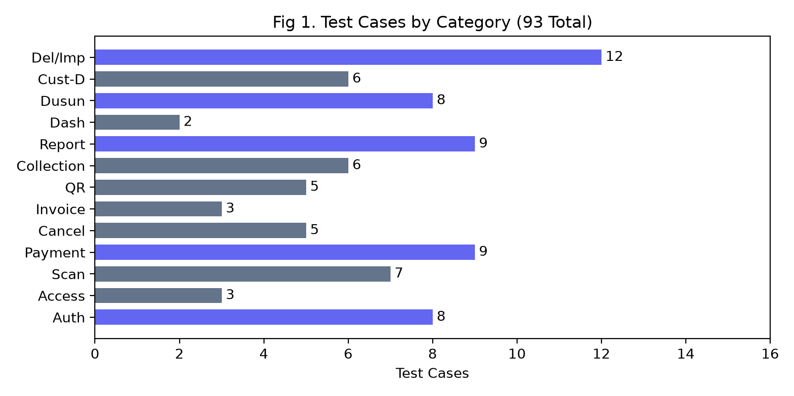
Figure 1. Distribution of test cases by category (93 total tests)
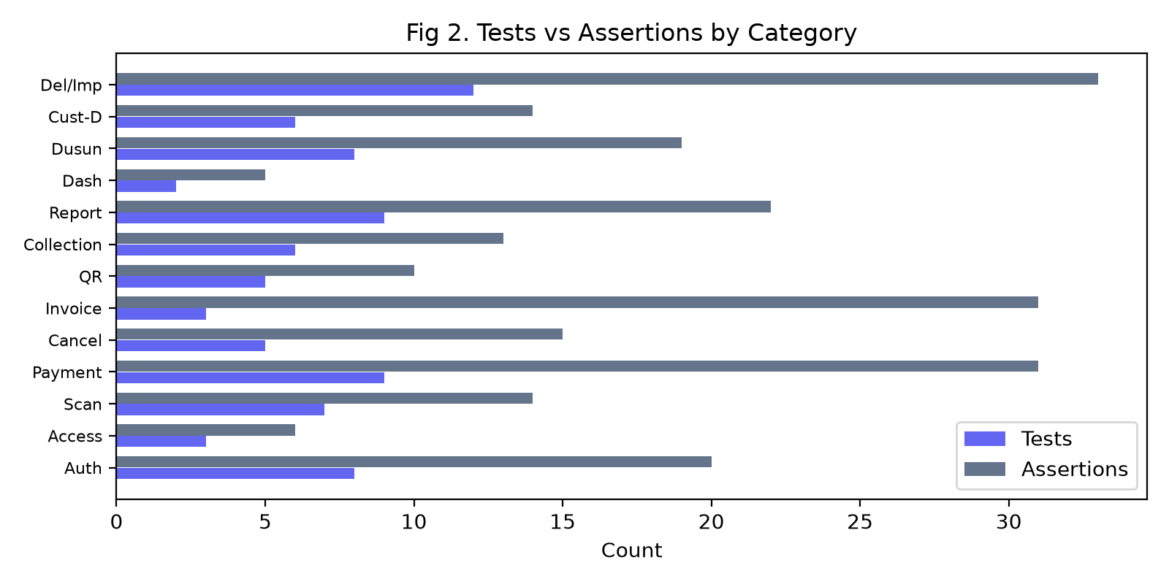
Figure 2. Test cases vs assertions by category
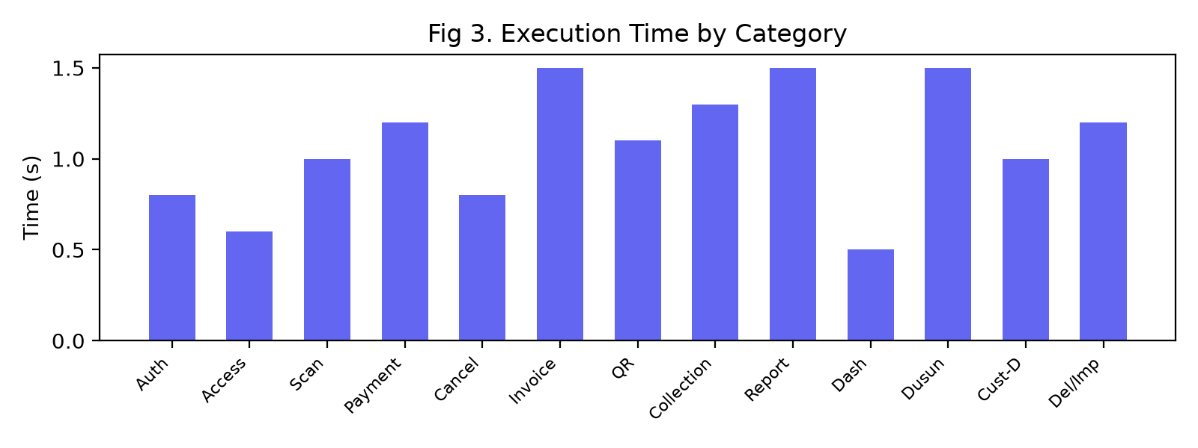
Figure 3. Layered architecture under test
Table 1. Test Suite Results by Category
Category | Tests | Assertions | Coverage
Auth | 8 | 20 | Login, logout, redirect, inactive user
Access Control | 3 | 6 | RBAC at HTTP layer
Scan | 7 | 14 | Barcode & code lookup
Payment | 9 | 31 | Allocation, idempotency, overpayment
Cancellation | 5 | 15 | Reversal, authorization
Invoice | 13 | 31 | Generation, duplicate, delete
QR Code | 5 | 10 | Token, SVG generation
Collection | 6 | 13 | Route planning, arrears
Report | 9 | 22 | CSV/Excel/PDF exports
Dashboard | 2 | 5 | Role-adaptive KPI
Dusun | 8 | 19 | CRUD, rename cascade
Customer-Dusun | 6 | 14 | Grouping, filtering
Delete & Import | 12 | 33 | Guards, Excel import
Total | 93 | 270 | All critical paths
Table 2. Financial Integrity Test Scenarios
Scenario | Amount (Rp) | Invoices | Expected Status | Result
Full payment | 150,000 | 1 x 150k | Paid | Pass
Partial payment | 100,000 | 1 x 150k | Partial | Pass
Multi-period | 300,000 | 3 x 150k | All Paid | Pass
Overpayment | 200,000 | 1 x 150k | Rejected | Pass
Zero amount | 0 | 1 x 150k | Rejected | Pass
Duplicate key | 150,000 | 1 x 150k | No duplicate | Pass
Table 3. Test Dimensions and Risk Mitigation
Test Dimension | Validation Method | Risk Mitigated
Idempotency | Duplicate POST with same UUID | Double charging
Allocation | Exact rupiah assertion | Incorrect billing
Cancellation | State revert verification | Inconsistent data
RBAC | HTTP 403 assertion | Unauthorized access
Deletion guard | Redirect with error | Data loss
Validation | Session error assertion | Invalid input
AI Usage Statement
In preparing this manuscript, the author used an AI assistant for grammar correction and literature summarization. After using the tool, the author conducted a thorough review and editing of the content and assumed full responsibility for the final published version.
Credit Authorship Contribution Statement
F.H.S.: Conceptualization, Methodology, Software, Testing, Writing - Original Draft, Writing - Review and Editing.
Declaration Of Competing Interests
The authors declare no known competing financial interests or personal relationships that could have appeared to influence the work reported in this paper.
Data Availability
Source code available from corresponding author upon reasonable request.
References
[1] Abdulghaffar K., Elmrabit N., et al., "Enhancing Web Application Security through Automated Penetration Testing with Multiple Vulnerability Scanners", Computers, vol. 12, no. 11, pp. 235, 2023. doi: 10.3390/computers12110235.
[2] Maksym B., Nadiia K., et al., "Analysis of web application testing methods", System technologies, vol. 4, no. 147, pp. 82-90, 2023. doi: 10.34185/1562-9945-4-147-2023-07.
[3] Mooghala S., "Comprehensive End - to - End Testing: Significance and Precision in Software Application Quality Assurance", International Journal of Science and Research (IJSR), vol. 12, no. 1, pp. 1253-1257, 2023. doi: 10.21275/sr24127214929.
[4] Kolawole I., Osilaja A., et al., "Leveraging Artificial Intelligence for Automated Testing and Quality Assurance in Software Development Lifecycles", International Journal of Research Publication and Reviews, vol. 5, no. 12, pp. 4386-4401, 2024. doi: 10.55248/gengpi.5.1224.250142.
[5] Montgomery M., "Comprehensive Analysis of Automated Testing Frameworks and Tools forEfficient Software Quality Assurance", ISCSITR- INTERNATIONAL JOURNAL OF SOFTWARE ENGINEERING AND DEVELOPMENT, vol. 6, no. 2, pp. 1-5, 2025. doi: 10.63397/iscsitr-ijsed_2025_06_02_001.
[6] Kanikaram K., "Transforming Software Quality Assurance through Artificial Intelligence, Automated Testing, and Intelligent Software Analytics", American International Journal of Computer Science and Technology, vol. 7, pp. 103-114, 2025. doi: 10.63282/3117-5481/aijcst-v7i5p109.
[7] Putra F., Zulfikri A., et al., "Analysis Comparative of Performance Optimization Techniques for PHP Framework Testing: Laravel, CodeIgniter, Symfony", Brilliance: Research of Artificial Intelligence, vol. 5, no. 1, pp. 242-248, 2025. doi: 10.47709/brilliance.v5i1.5989.
[8] Lipskyi D., "Architecture of a New Enhanced Platform for Automated Web Application Testing", NaUKMA Research Papers. Computer Science, vol. 8, pp. 225-231, 2025. doi: 10.18523/2617-3808.2025.8.225-231.
[9] Chen F., Liu C., et al., "Using Large Language Model to Fill in Web Forms to Support Automated Web Application Testing", Information, vol. 16, no. 2, pp. 102, 2025. doi: 10.3390/info16020102.
[10] Shah et al. K., "Redefining Software Quality Assurance: A Deep Dive into Automated Testing Strategies", The Review of Contemporary Scientific and Academic Studies, vol. 5, no. 3, 2025. doi: 10.55454/rcsas.5.03.2025.002.
[11] Darii O., Beldiga M., et al., "AUTOMATED WEB APPLICATION TESTING BASED ON ARTIFICIAL INTELLIGENCE", JOURNAL OF ENGINEERING SCIENCE, vol. 32, no. 4, pp. 41-53, 2026. doi: 10.52326/jes.utm.2025.32(4).04.
[12] Saputra S., Khoirunnisya K., et al., "Design and Development of an ISO 8583 Transaction Simulator for Electronic Payment System Testing", bit-Tech, vol. 9, no. 1, pp. 1612-1623, 2026. doi: 10.32877/bt.v9i1.4169.
[13] Bellamkonda Sunderajulu K., "Enhancing Payment Transaction Security", International Journal of Science and Research (IJSR), vol. 13, no. 11, pp. 680-684, 2024. doi: 10.21275/sr241110202744.
[14] Adireddy S., "Idempotency and Reconciliation in Payment Software", International Journal for Research in Applied Science and Engineering Technology, vol. 12, no. 4, pp. 4897-4903, 2024. doi: 10.22214/ijraset.2024.60774.
[15] Anonymous, "Idempotency Mechanisms in Digital Payment Systems: Preventing Duplicate Transaction Processing", Journal of Computational Analysis and Applications, vol. 34, no. 10, 2025. doi: 10.48047/jocaaa.2025.34.11.02.
[16] Krishna Dusad, "Taming Asynchrony in Distributed Payment Systems: Guarantees, Idempotency, and End-to-End Reconciliation", Journal of Computer Science and Technology Studies, vol. 7, no. 11, pp. 339-345, 2025. doi: 10.32996/jcsts.2025.7.11.33.
[17] Shivansh Chandnani, Ajay Nagrale, "Idempotency in payment systems: A critical analysis", World Journal of Advanced Research and Reviews, vol. 26, no. 1, pp. 3996-4002, 2025. doi: 10.30574/wjarr.2025.26.1.1569.
[18] Bhupatiraju R., "Event-Driven Architecture for Payment Failover and Redundancy: A Framework for High-Availability Financial Transaction Processing", European Modern Studies Journal, vol. 9, no. 5, pp. 815-830, 2025. doi: 10.59573/emsj.9(5).2025.75.
[19] Anonymous, "A Resilient Approach to Payment Systems: Retry Mechanisms and Idempotency", International Research Journal of Modernization in Engineering Technology and Science, 2025. doi: 10.56726/irjmets67696.
[20] Anonymous, "Design and Development of a Web-Based Online Billing System", International Research Journal of Modernization in Engineering Technology &amp; Science, 2026. doi: 10.56726/irjmets97966.
[21] Logrippo L., "Data flow security in Role-based access control", Journal of Information Security and Applications, vol. 90, pp. 103997, 2025. doi: 10.1016/j.jisa.2025.103997.
[22] David Fitrianto, Sulistyo W., "Penerapan Role-Based Access Control untuk Keamanan Data Multi-Tenant SIMPEL Lazismu", Insect (Informatics and Security): Jurnal Teknik Informatika, vol. 12, no. 01, pp. 1-10, 2026. doi: 10.33506/insect.v12i01.5009.
[23] Romadhan H., Mansur M., "Web-based Educational Payment Information System using Role-based Access Control Security", SISTEMASI, vol. 15, no. 2, pp. 624, 2026. doi: 10.32520/stmsi.v15i2.5920.
[24] Bajoria A., "Blockchain-Enabled Audit Trails: Revolutionizing RDBMS Data Integrity and Security", European Modern Studies Journal, vol. 9, no. 4, pp. 1393-1403, 2025. doi: 10.59573/emsj.9(4).2025.129.
[25] Aienobe V., Iqbal M., "RESPONSIVE WEB DESIGN FOR ENHANCED USER EXPERIENCE (UX) AND USER INTERFACE (UI)", International Journal of Computer Applications, vol. 187, no. 34, pp. 72-93, 2025. doi: 10.5120/ijca2025925533.
[26] Ahyar Muawwal, "The Implementation of PWA (Progressive Web App) Technology in Enhancing Website Performance &amp; Mobile Accessibility", Buletin Pos dan Telekomunikasi, vol. 22, no. 1, 2024. doi: 10.17933/bpostel.v22i1.395.
[27] Cahyadi S., Nurachmad E., et al., "STUDI KOMPREHENSIF MENGENAI DAMPAK DARI AKSELERASI HALAMAN SELULER (AMP) DAN APLIKASI WEB PROGRESIF (PWA) COMPREHENSIVE STUDY OF THE IMPACT OF ACCELERATED MOBILE PAGE (AMP) AND PROGRESSIVE WEB APPS (PWA)", Jurnal Aplikasi Bisnis dan Komputer, vol. 4, no. 1, pp. 16-28, 2024. doi: 10.33751/jubikom.v4i1.9717.
[28] Handayani F., Wisudiawan G., et al., "User Interface Redesign for the Course Card Filling Feature in the SIKAD Mobile Web Application using Goal-Directed Design Method", Journal of Information System Research (JOSH), vol. 5, no. 2, pp. 686-696, 2024. doi: 10.47065/josh.v5i2.4844.
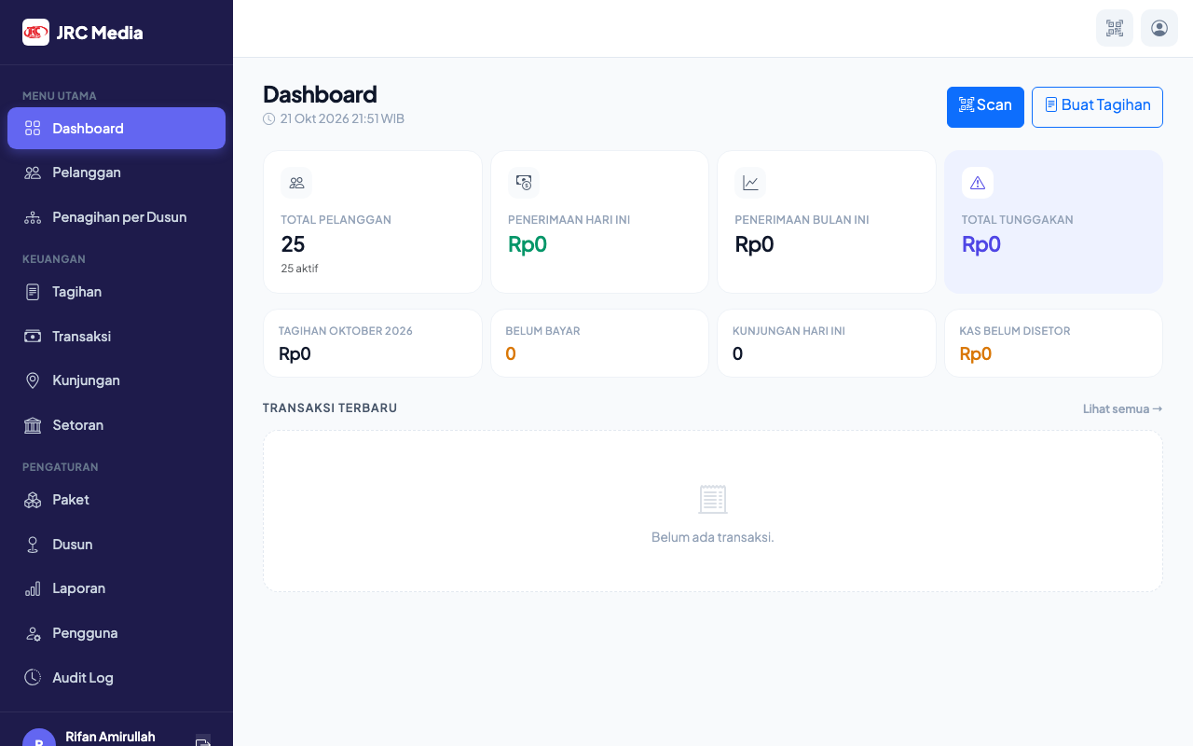
Figure 4. Admin dashboard showing KPI cards and recent transactions
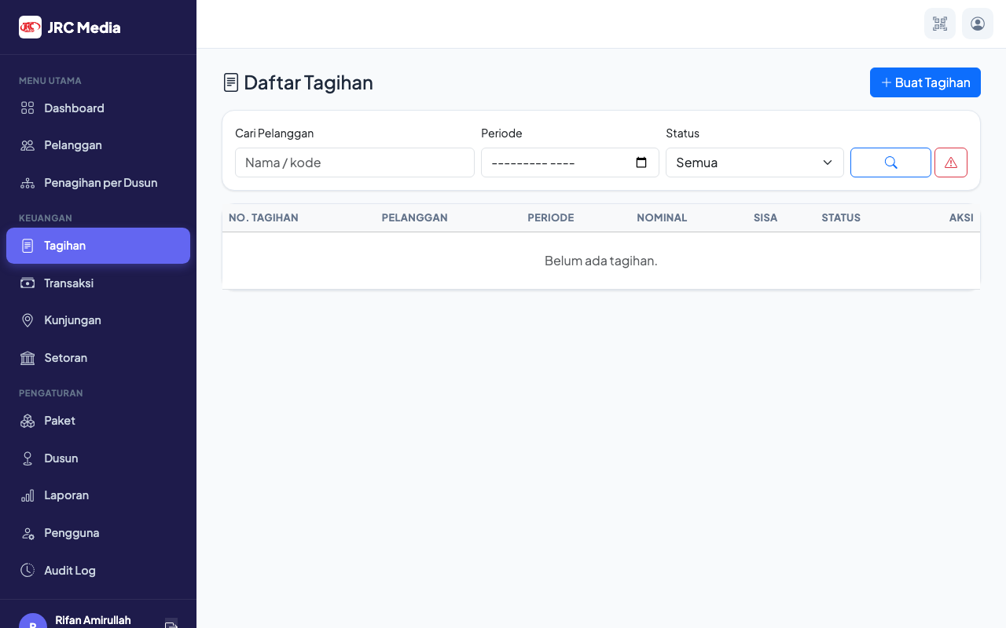
Figure 5. Invoice list with status badges and delete confirmation buttons

