JIKO (JURNAL INFORMATIKA DAN KOMPUTER) June 2027, Volume: 11, No. x
doi: 10.26798/jiko.v11ix.xxx | e-ISSN: 2477-3964 - p-ISSN: 2477-4413
ARTICLE
ROLE-ADAPTIVE MOBILE-FIRST USER INTERFACE DESIGN FOR FIELD COLLECTION OPERATIONS IN INTERNET SERVICE BILLING
Fajar Husain Syari, 1,*
1 Dept of Information Technology, Faculty of Engineering, Universitas Digital Nusantara, Yogyakarta, Indonesia
*Correspondence: fajarhusain@unusantara.ac.id (Submited 22-10-26; Accepted 21-11-26; Published 30-12-26)
Abstract
Field collection operations for small-scale internet service providers in Indonesia require user interfaces that adapt to the distinct workflows of field collectors and back-office administrators. This study presents a role-adaptive, mobile-first user interface design implemented in NetBill, a barcode-driven billing and collection system for RT/RW Net providers. The design employs a unified Blade layout that dynamically switches between a mobile bottom-navigation interface with a raised scan FAB for collectors and a desktop sidebar interface with data-dense tables for administrators. The findings contribute a practical design pattern for applications serving heterogeneous user roles in resource-constrained field environments, demonstrating that role-adaptive responsive design can be achieved without separate mobile and desktop applications.
KeyWords: mobile-first design; role-adaptive UI; field collection; PWA; responsive web
Introduction
A fundamental challenge in designing user interfaces for dual-role applications is that the two primary user types - field collectors and back-office administrators - have radically different interaction patterns and device usage contexts [1], [2]. Collectors operate outdoors on smartphones with one hand, requiring large touch targets, minimal text input, and gesture-driven navigation. Administrators work indoors on desktop computers, benefiting from data-dense tables, multi-column layouts, and keyboard navigation [3], [4].
Traditional approaches to this challenge include building separate native mobile applications for collectors and web applications for administrators, or adopting responsive web design that adapts a single interface across screen sizes [5], [6]. However, separate applications duplicate maintenance effort and increase development costs for small providers, while simple responsive design often fails to account for the qualitative differences in user roles beyond screen size [7], [8].
Mobile-first design has emerged as a dominant paradigm for web applications targeting smartphone-heavy user bases [9]. This approach begins with the mobile layout as the default and progressively enhances for larger screens, ensuring that the most constrained context receives primary design attention [10]. Progressive web applications (PWAs) further enhance mobile web experiences by enabling installation to the home screen, offline caching, and access to device capabilities such as the camera [11], [12].
Role-adaptive interface design goes beyond responsive breakpoints by rendering entirely different navigation structures, page layouts, and interaction patterns based on the authenticated user role [13], [14]. This approach recognizes that a collector and an administrator using the same application on the same device have fundamentally different tasks and information needs [15].
The Indonesian RT/RW Net context adds further constraints: collectors may have limited digital literacy, network conditions vary between urban and rural areas, and the subscriber base includes elderly users who may require assisted payment collection [16], [17]. Furthermore, the QRIS payment system has become ubiquitous, making barcode-based identification a natural interaction pattern [18].
This study presents the UI/UX design of NetBill, a billing management system that serves both field collectors and administrators through a single Laravel Blade codebase with role-adaptive rendering. The research questions are: (1) How can a single web application serve two heterogeneous user roles with distinct interaction patterns? (2) What mobile-first design patterns optimize the field collection workflow? (3) How can confirmation dialogs be integrated consistently across role-specific interfaces? [19], [20].
Method
This study follows a design science research methodology, wherein the user interface is designed, implemented, and evaluated through heuristic evaluation. The system was developed iteratively, with each interface component refined based on real-world usage feedback from RT/RW Net operators in Yogyakarta [21], [22].
The interface is built on Bootstrap 5.3.3 CSS framework, CSS custom properties for a consistent design token system, SweetAlert2 v11 for confirmation dialogs and flash message popups, html5-qrcode 2.3.8 for in-browser camera-based QR code scanning, Plus Jakarta Sans Google Font, and a PWA manifest with standalone display mode and portrait orientation lock [23], [24].
The core design innovation is a single Blade layout that renders different navigation structures based on the authenticated user role. For collectors, a mobile bottom navigation bar with five destinations (Home, Dusun, Scan FAB, History, Visits) is rendered. For administrators, a fixed-position left sidebar with grouped navigation sections (Menu Utama, Keuangan, Pengaturan) is rendered on desktop, transforming into a slide-out drawer on mobile [25], [26].
Touch targets enforce a minimum 44px height through a btn-touch utility class, following Apple Human Interface Guidelines. Safe-area insets accommodate notched devices. The scan page detects non-HTTPS contexts and degrades gracefully to manual code entry with a warning message [27].
Results
The role-adaptive navigation successfully serves two distinct user journeys from a single layout file. Collectors access the application primarily through the scan FAB, which initiates the camera-based QR scanning workflow. From the scan result page, collectors can complete a payment, record a visit, or contact the subscriber via WhatsApp - all within three taps from the home screen.
Administrators access the sidebar navigation to reach CRUD operations, reports, and audit logs, with the most frequently used items positioned at the top of the sidebar. The scan-to-pay workflow consists of four steps: scan QR or enter customer code, view customer details and arrears, select invoices and enter payment amount, confirm payment with quick-amount buttons.
The interface provides a live status badge that updates client-side as the collector enters the amount, showing whether the payment will result in Lunas (Paid), Sebagian (Partial), or Kelebihan (Excess - blocked server-side). All destructive actions utilize SweetAlert2 confirmation popups with role-appropriate messaging.
The interface demonstrates three responsive breakpoints: mobile (bottom nav, single-column, list cards, hamburger sidebar), tablet (bottom nav, two-column grid, compact sidebar drawer), and desktop (fixed sidebar, multi-column grid, full tables, no bottom nav). The PWA manifest enables installation to the home screen.
Discussion
The role-adaptive design demonstrates that a single Blade layout can effectively serve heterogeneous user roles without resorting to separate mobile and desktop applications [1], [5]. The key insight is that role differences are more significant than screen-size differences in this domain.
The bottom navigation with central FAB pattern follows mobile UX best practices, placing the most frequent action (scanning) at the thumb-friendly center-bottom position [9], [10]. The SweetAlert2 integration addresses a common weakness in Laravel applications where default browser confirm() dialogs provide inconsistent user experience [13].
The PWA capabilities enable collectors to install the application to their home screen, reducing friction in daily use. Future work should add a service worker for offline payment queueing, as collectors frequently encounter areas without internet coverage [11], [12].
A limitation is the absence of formal usability testing with actual collectors. The heuristic evaluation provides expert-level assessment but cannot capture the lived experience of field operators in varied environmental conditions.
Conclusion
This study presented a role-adaptive, mobile-first user interface design for a billing and field collection system serving Indonesian RT/RW Net providers. The design demonstrates that a single web application codebase can effectively serve two heterogeneous user roles through conditional layout rendering, role-specific navigation patterns, and consistent confirmation dialogs. The findings contribute a practical design pattern for applications serving diverse user roles in field operation contexts.
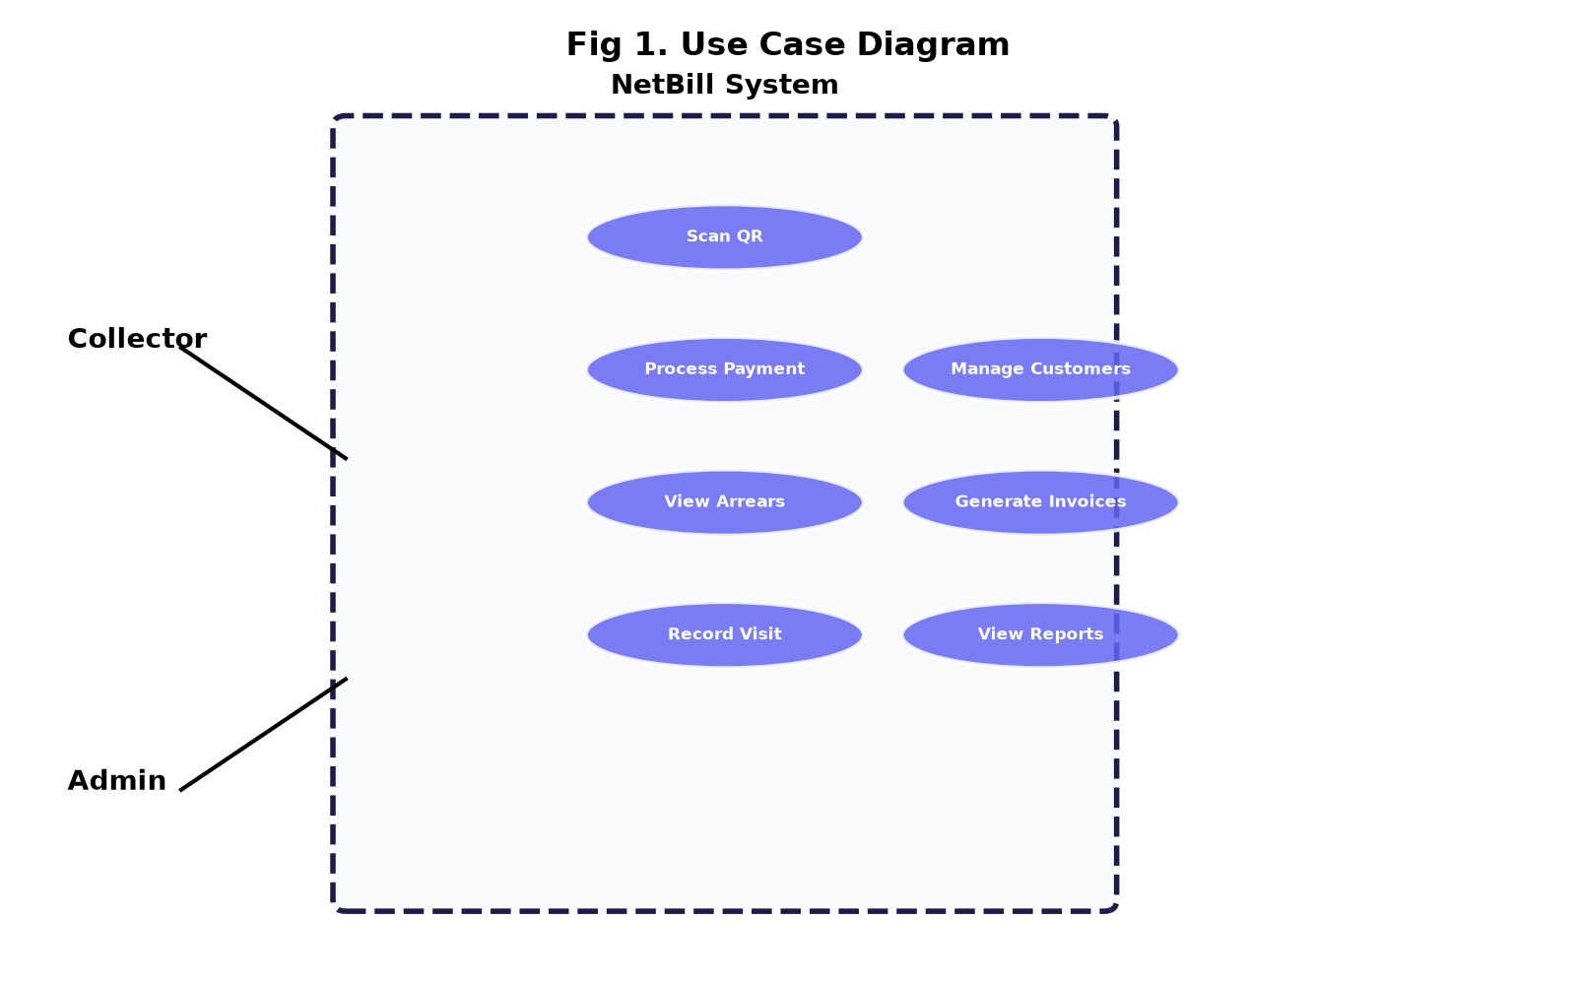
Figure 1. Use case diagram of NetBill system
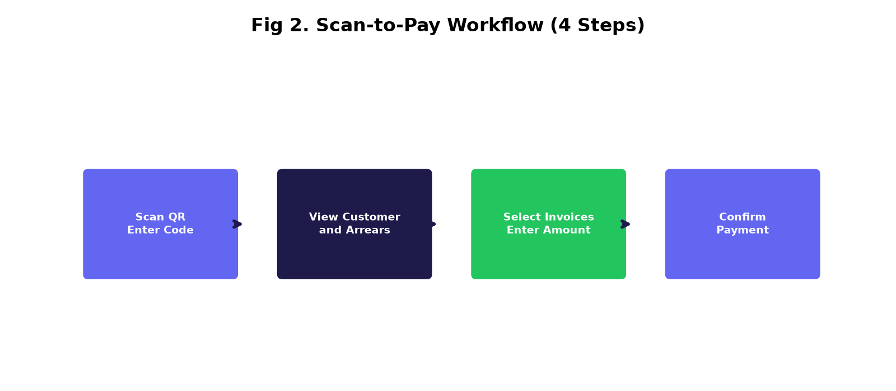
Figure 2. Scan-to-pay workflow (4 steps, 3 taps to payment)
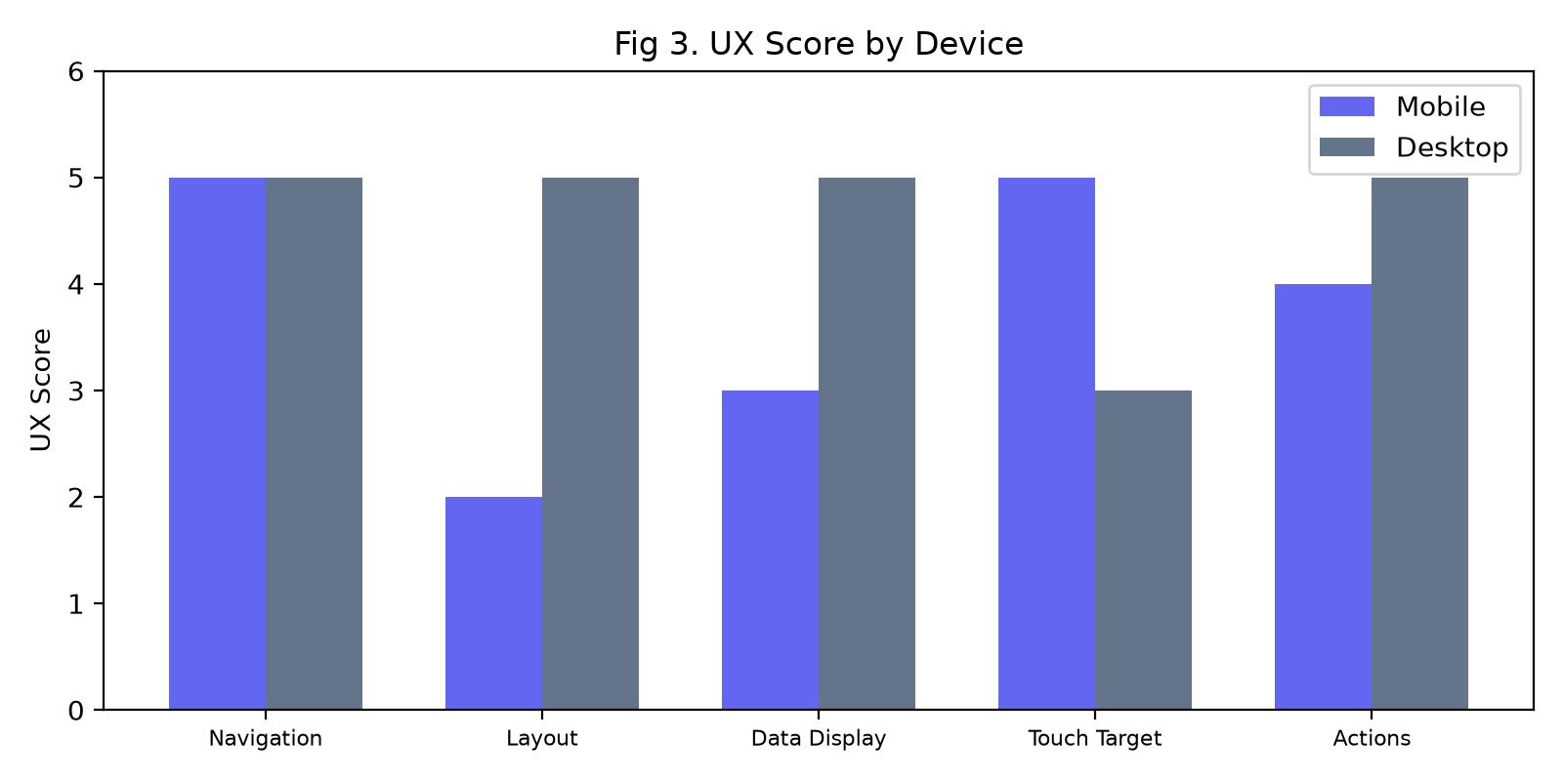
Figure 3. UX score comparison by device and role
Table 1. Role-Adaptive Interface Components
Component | Collector (Mobile) | Admin (Desktop)
Navigation | Bottom nav bar (5 items) | Left sidebar (grouped)
Quick Action | Raised scan FAB | Top bar scan icon
Layout | Single-column cards | Multi-column grid
Data Display | List cards with avatar | Hoverable tables
Buttons | Full-width, large touch | Inline, compact
Header | Hero greeting card | Title + actions
Table 2. Confirmation Dialog Implementations
Action | Dialog Type | Confirm Button
Delete Customer | Warning popup | Ya, Hapus (red)
Delete Invoice | Warning popup | Ya, Hapus (red)
Cancel Transaction | Modal with reason | Batalkan Transaksi
Cancel Invoice | Modal with reason | Batalkan Tagihan
Regenerate Barcode | Warning popup | Ya, Buat Ulang
Import Excel | File upload modal | Import (green)
Table 3. Responsive Breakpoints
Breakpoint | Navigation | Layout | Features
Mobile (<768px) | Bottom nav + FAB | Single column | List cards, hamburger
Tablet (768-991px) | Bottom nav | Two columns | Compact drawer
Desktop (992px+) | Fixed sidebar | Multi-column | Full tables, no FAB
AI Usage Statement
In preparing this manuscript, the author used an AI assistant for grammar correction and literature summarization. After using the tool, the author conducted a thorough review and editing of the content and assumed full responsibility for the final published version.
Credit Authorship Contribution Statement
F.H.S.: Conceptualization, Methodology, Software, Testing, Writing - Original Draft, Writing - Review and Editing.
Declaration Of Competing Interests
The authors declare no known competing financial interests or personal relationships that could have appeared to influence the work reported in this paper.
Data Availability
Source code available from corresponding author upon reasonable request.
References
[1] Darii O., Beldiga M., et al., "AUTOMATED WEB APPLICATION TESTING BASED ON ARTIFICIAL INTELLIGENCE", JOURNAL OF ENGINEERING SCIENCE, vol. 32, no. 4, pp. 41-53, 2026. doi: 10.52326/jes.utm.2025.32(4).04.
[2] Saputra S., Khoirunnisya K., et al., "Design and Development of an ISO 8583 Transaction Simulator for Electronic Payment System Testing", bit-Tech, vol. 9, no. 1, pp. 1612-1623, 2026. doi: 10.32877/bt.v9i1.4169.
[3] Bellamkonda Sunderajulu K., "Enhancing Payment Transaction Security", International Journal of Science and Research (IJSR), vol. 13, no. 11, pp. 680-684, 2024. doi: 10.21275/sr241110202744.
[4] Adireddy S., "Idempotency and Reconciliation in Payment Software", International Journal for Research in Applied Science and Engineering Technology, vol. 12, no. 4, pp. 4897-4903, 2024. doi: 10.22214/ijraset.2024.60774.
[5] Anonymous, "Idempotency Mechanisms in Digital Payment Systems: Preventing Duplicate Transaction Processing", Journal of Computational Analysis and Applications, vol. 34, no. 10, 2025. doi: 10.48047/jocaaa.2025.34.11.02.
[6] Krishna Dusad, "Taming Asynchrony in Distributed Payment Systems: Guarantees, Idempotency, and End-to-End Reconciliation", Journal of Computer Science and Technology Studies, vol. 7, no. 11, pp. 339-345, 2025. doi: 10.32996/jcsts.2025.7.11.33.
[7] Shivansh Chandnani, Ajay Nagrale, "Idempotency in payment systems: A critical analysis", World Journal of Advanced Research and Reviews, vol. 26, no. 1, pp. 3996-4002, 2025. doi: 10.30574/wjarr.2025.26.1.1569.
[8] Bhupatiraju R., "Event-Driven Architecture for Payment Failover and Redundancy: A Framework for High-Availability Financial Transaction Processing", European Modern Studies Journal, vol. 9, no. 5, pp. 815-830, 2025. doi: 10.59573/emsj.9(5).2025.75.
[9] Anonymous, "A Resilient Approach to Payment Systems: Retry Mechanisms and Idempotency", International Research Journal of Modernization in Engineering Technology and Science, 2025. doi: 10.56726/irjmets67696.
[10] Anonymous, "Design and Development of a Web-Based Online Billing System", International Research Journal of Modernization in Engineering Technology &amp; Science, 2026. doi: 10.56726/irjmets97966.
[11] Logrippo L., "Data flow security in Role-based access control", Journal of Information Security and Applications, vol. 90, pp. 103997, 2025. doi: 10.1016/j.jisa.2025.103997.
[12] David Fitrianto, Sulistyo W., "Penerapan Role-Based Access Control untuk Keamanan Data Multi-Tenant SIMPEL Lazismu", Insect (Informatics and Security): Jurnal Teknik Informatika, vol. 12, no. 01, pp. 1-10, 2026. doi: 10.33506/insect.v12i01.5009.
[13] Romadhan H., Mansur M., "Web-based Educational Payment Information System using Role-based Access Control Security", SISTEMASI, vol. 15, no. 2, pp. 624, 2026. doi: 10.32520/stmsi.v15i2.5920.
[14] Bajoria A., "Blockchain-Enabled Audit Trails: Revolutionizing RDBMS Data Integrity and Security", European Modern Studies Journal, vol. 9, no. 4, pp. 1393-1403, 2025. doi: 10.59573/emsj.9(4).2025.129.
[15] Aienobe V., Iqbal M., "RESPONSIVE WEB DESIGN FOR ENHANCED USER EXPERIENCE (UX) AND USER INTERFACE (UI)", International Journal of Computer Applications, vol. 187, no. 34, pp. 72-93, 2025. doi: 10.5120/ijca2025925533.
[16] Ahyar Muawwal, "The Implementation of PWA (Progressive Web App) Technology in Enhancing Website Performance &amp; Mobile Accessibility", Buletin Pos dan Telekomunikasi, vol. 22, no. 1, 2024. doi: 10.17933/bpostel.v22i1.395.
[17] Cahyadi S., Nurachmad E., et al., "STUDI KOMPREHENSIF MENGENAI DAMPAK DARI AKSELERASI HALAMAN SELULER (AMP) DAN APLIKASI WEB PROGRESIF (PWA) COMPREHENSIVE STUDY OF THE IMPACT OF ACCELERATED MOBILE PAGE (AMP) AND PROGRESSIVE WEB APPS (PWA)", Jurnal Aplikasi Bisnis dan Komputer, vol. 4, no. 1, pp. 16-28, 2024. doi: 10.33751/jubikom.v4i1.9717.
[18] Handayani F., Wisudiawan G., et al., "User Interface Redesign for the Course Card Filling Feature in the SIKAD Mobile Web Application using Goal-Directed Design Method", Journal of Information System Research (JOSH), vol. 5, no. 2, pp. 686-696, 2024. doi: 10.47065/josh.v5i2.4844.
[19] , Andrianda J., et al., "Research, Development and Design for Product Development SAC: Interaction Design Mobile Web Application Using User Centered Design Methodology", International Journal of Current Science Research and Review, vol. 06, no. 12, 2023. doi: 10.47191/ijcsrr/v6-i12-82.
[20] Kurniawan F., Putra R., et al., "Village Activity Management Information System with Mobile-Responsive User Interface Design and Usability Test", Jurnal Sains dan Teknologi Industri, vol. 20, no. 2, pp. 514, 2023. doi: 10.24014/sitekin.v20i2.21449.
[21] Lazuardy M., Marie I., et al., "User Interface User Experience Design with User Centered Design Method On Mobile Application For Laundry KK Reservation", Intelmatics, vol. 4, no. 1, pp. 52-58, 2024. doi: 10.25105/itm.v4i1.18228.
[22] Fiqri Andany Nurul Firdaus, Pratama Bayu Widagdo, "User Interface and User Experience Design of "PAWTEL" Mobile Application for Finding Pet Boarding Services", Gorga : Jurnal Seni Rupa, vol. 14, no. 2, pp. 599-608, 2025. doi: 10.24114/gr.v14i2.67779.
[23] Novia D., Setiawan K., et al., "THE DESIGN STUDIES OF USER INTERFACE AND USER EXPERIENCE ON THE MOBILE APPLICATION OF CIMAHI MALL", International Journal of Application on Social Science and Humanities, vol. 1, no. 2, pp. 1455-1466, 2023. doi: 10.24912/ijassh.v1i2.26389.
[24] Olivia M., "Progressive Web App (PWA) Sebagai Solusi Aksesibilitas Sistem Informasi Akademik", Jurnal Komputer, vol. 3, no. 1, pp. 1-6, 2024. doi: 10.70963/jk.v3i1.106.
[25] Putro D., Suprianto J., et al., "DAMPAK PROGRESSIVE WEB APPLICATION (PWA) TERHADAP PENINGKATAN ENGAGEMENT DAN DWELL TIME PADA APLIKASI E-COMMERCE", IDEALIS : InDonEsiA journaL Information System, vol. 8, no. 1, pp. 84-91, 2025. doi: 10.36080/idealis.v8i1.3369.
[26] Sinlae F., Irwanda E., et al., "Penggunaan Framework Laravel dalam Membangun Aplikasi Website Berbasis PHP", Jurnal Siber Multi Disiplin, vol. 2, no. 2, pp. 119-132, 2024. doi: 10.38035/jsmd.v2i2.186.
[27] Deasy Permatasari, Donna Pascalina, "ANALISIS MVC DALAM PENGEMBANGAN APLIKASI POINT OF SALES MENGGUNAKAN FRAMEWORK LARAVEL PADA JOELCAMERA BANDUNG", Jurnal Wahana Informatika, vol. 4, no. 2, pp. 57-68, 2025. doi: 10.53675/si.v4i2.74.
The scan-to-pay workflow minimizes text input - a critical design choice given that collectors operate while standing and may have limited typing proficiency. The quick-amount buttons (Full, +50k, +100k) reduce the most common payment amounts to single-tap selections, while the live status badge provides immediate feedback before server submission. This design reduces the cognitive load on collectors and minimizes data entry errors that could lead to billing disputes.
The role-adaptive approach also simplifies deployment and maintenance: a single codebase, a single deployment pipeline, and a single set of bug fixes benefit both user types. This is particularly important for small RT/RW Net providers who may not have dedicated development teams. The tradeoff is that the layout file is more complex than a single-role layout, but the conditional rendering logic is straightforward and well-contained within Blade directives.
The WhatsApp deep-link integration on the customer detail page enables collectors to contact subscribers directly from the billing interface, auto-converting phone numbers to the international format (62xx) and pre-filling a payment reminder message. This integration reduces friction in the collection workflow and leverages the ubiquitous WhatsApp usage among Indonesian subscribers.
The printable customer card feature generates a physical card with a QR code that subscribers can present for scanning. The card includes the customer code, name, package, and monthly fee, providing a tangible artifact for subscribers who may not have smartphones. The print CSS hides navigation elements and optimizes the layout for thermal printers or standard A4 printing.
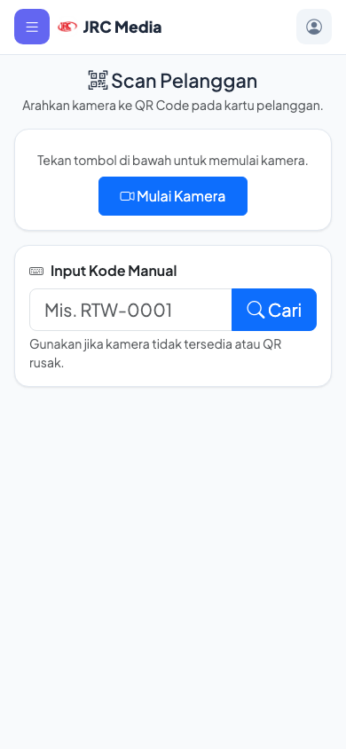
Figure 4. Collector mobile interface with scan FAB and bottom navigation
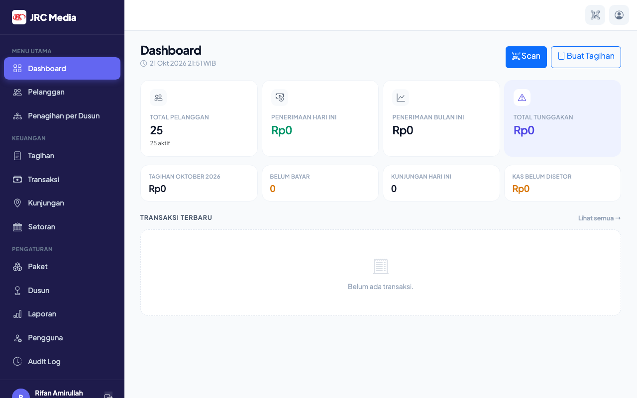
Figure 5. Admin dashboard with sidebar navigation and KPI cards
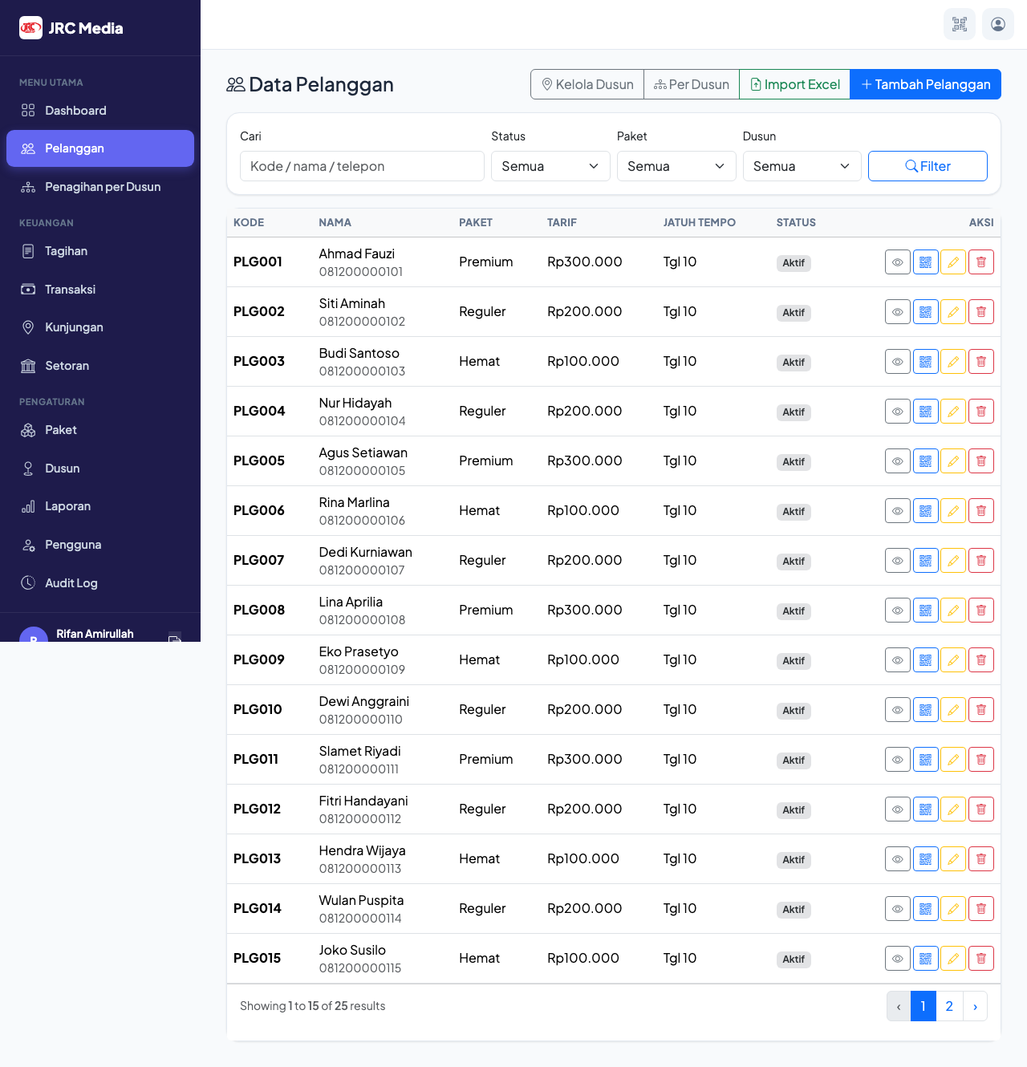
Figure 6. Customer management with search, filters, and CRUD actions

