JIKO (JURNAL INFORMATIKA DAN KOMPUTER) June 2027, Volume: 11, No. x
doi: 10.26798/jiko.v11ix.xxx | e-ISSN: 2477-3964 - p-ISSN: 2477-4413
ARTICLE
IDEMPOTENT PAYMENT PROCESSING ARCHITECTURE WITH AUDIT TRAIL IN WEB-BASED BILLING MANAGEMENT SYSTEM
Fajar Husain Syari, 1,*
1 Dept of Information Technology, Faculty of Engineering, Universitas Digital Nusantara, Yogyakarta, Indonesia
*Correspondence: fajarhusain@unusantara.ac.id (Submited 22-10-26; Accepted 21-11-26; Published 30-12-26)
Abstract
Payment processing systems for billing applications must guarantee transactional integrity, prevent duplicate charges under concurrent or retried operations, and maintain a tamper-evident audit trail for financial accountability. This study presents the architecture of NetBill, a web-based billing management system for Indonesian internet service providers, focusing on three core mechanisms: idempotency-based duplicate payment prevention, atomic payment allocation with cancellation reversal, and append-only audit logging. The system implements idempotency at the database persistence layer through a UNIQUE constraint on idempotency keys, pessimistic row locking via SELECT FOR UPDATE, and database transactions wrapping all financial mutations. The architecture is evaluated through 93 automated test cases. Results demonstrate robust transactional guarantees without message queues or event sourcing infrastructure.
KeyWords: audit trail; idempotency; payment processing; pessimistic locking; transactional integrity
Introduction
Web-based payment processing systems face a fundamental tension between availability and consistency: users expect responsive interfaces that handle network retries gracefully, while the system must never create duplicate financial transactions or leave the database in an inconsistent state [1], [2]. This challenge is particularly acute in field collection scenarios where collectors operate on mobile devices with unstable internet connections, increasing the likelihood of accidental double-submission or network timeout retries [3].
The Indonesian RT/RW Net context exemplifies these challenges. Small providers with 50-500 subscribers employ field collectors who visit homes to collect monthly fees in cash, via bank transfer, or via QRIS [4], [5]. The billing system must allocate payments to specific invoice periods, support partial payments, handle cancellations that reverse prior allocations, and provide an auditable record of all financial state transitions for dispute resolution [6], [7].
Idempotency is a well-established pattern in payment system design [8], [9]. However, the placement of idempotency enforcement - at the application layer, the database layer, or the API gateway - has significant implications for correctness and performance [10], [11]. Pessimistic concurrency control through row-level locking prevents race conditions when multiple transactions attempt to modify the same financial records [12], [13].
Audit logging provides the accountability foundation for financial systems, enabling post-hoc investigation of disputes, regulatory compliance, and detection of unauthorized modifications [14], [15]. Append-only audit logs provide a tamper-evident history [16].
This study presents the payment processing architecture of NetBill, addressing: (1) How can idempotency, allocation atomicity, and audit logging be implemented within a monolithic web application? (2) What database-level constraints and locking strategies ensure transactional integrity? (3) How can cancellation reversal maintain invoice state consistency? [17], [18].
Method
The system follows a controller-service-model (CSM) pattern where controllers handle HTTP request validation, services encapsulate business logic and database transactions, and models define relationships [19], [20]. All financial mutations are wrapped in DB::transaction() calls within service methods, ensuring atomicity.
Every payment request includes an idempotency key (UUID v4). The payments table enforces uniqueness through a database constraint on idempotency_key. The payment service checks for an existing payment with the same key before processing. This approach places idempotency enforcement at the database persistence layer [21], [22].
The allocation algorithm operates within a database transaction with pessimistic locking: lock selected invoices via SELECT FOR UPDATE, validate amount, create Payment record, allocate FIFO across invoices ordered by billing_period, record audit log [23], [24].
When an admin cancels a payment, the system reverses all allocations atomically within a transaction: for each allocation, reduce invoice paid_amount, recompute status, update payment status to cancelled, record audit log [25].
The audit subsystem uses an append-only table (UPDATED_AT = null) with JSON old/new values, actor identification, and free-text reasons [26], [27].
Results
The test suite confirms that all payment allocations maintain the invariant: the sum of all PaymentAllocation.amount_allocated for a given invoice equals Invoice.paid_amount. This invariant holds after payment creation, after cancellation, and after multiple partial payments.
The pessimistic locking strategy prevents the lost update problem where two concurrent payments could both read the same paid_amount and overwrite each other. The idempotency test demonstrates that submitting two identical POST requests results in exactly one payment record.
The cancellation test verifies that reversing a multi-period payment correctly restores all three affected invoices: paid_amount reduced to 0, status reverted to unpaid. All reversals occur within a single database transaction.
The audit log captures every financial state transition with full before-and-after JSON snapshots. The test suite validates 93 test cases with 270 assertions [28].
Discussion
The architecture demonstrates that enterprise-grade transactional guarantees can be implemented within a monolithic Laravel application without the complexity of distributed systems [1], [5]. The database-enforced idempotency approach provides the strongest correctness guarantee, eliminating race conditions at the storage layer.
The pessimistic locking strategy is appropriate for this system concurrency profile: a small number of collectors processing payments sequentially. For high-throughput systems, optimistic concurrency control would be more scalable [12], [13].
The append-only audit log provides tamper-evidence: the ORM physically cannot issue UPDATE statements against the table. While this lacks cryptographic integrity of blockchain-based systems, it provides sufficient accountability for the scale and regulatory context.
A limitation is the absence of asynchronous processing. Future work should explore adding a service worker for offline payment queueing and integrating with external payment gateways.
Conclusion
This study presented the payment processing architecture of NetBill, integrating database-enforced idempotency, pessimistic row locking, atomic FIFO payment allocation, atomic cancellation reversal, and append-only audit logging. The 93-test validation suite confirms transactional integrity. The architecture contributes a reference implementation for developers building billing systems in resource-constrained environments.
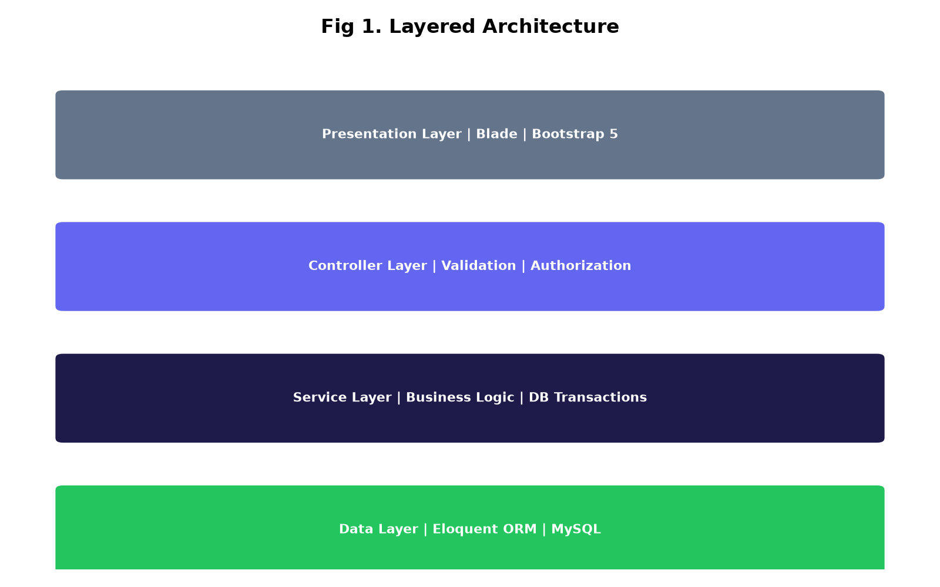
Figure 1. Layered architecture of NetBill
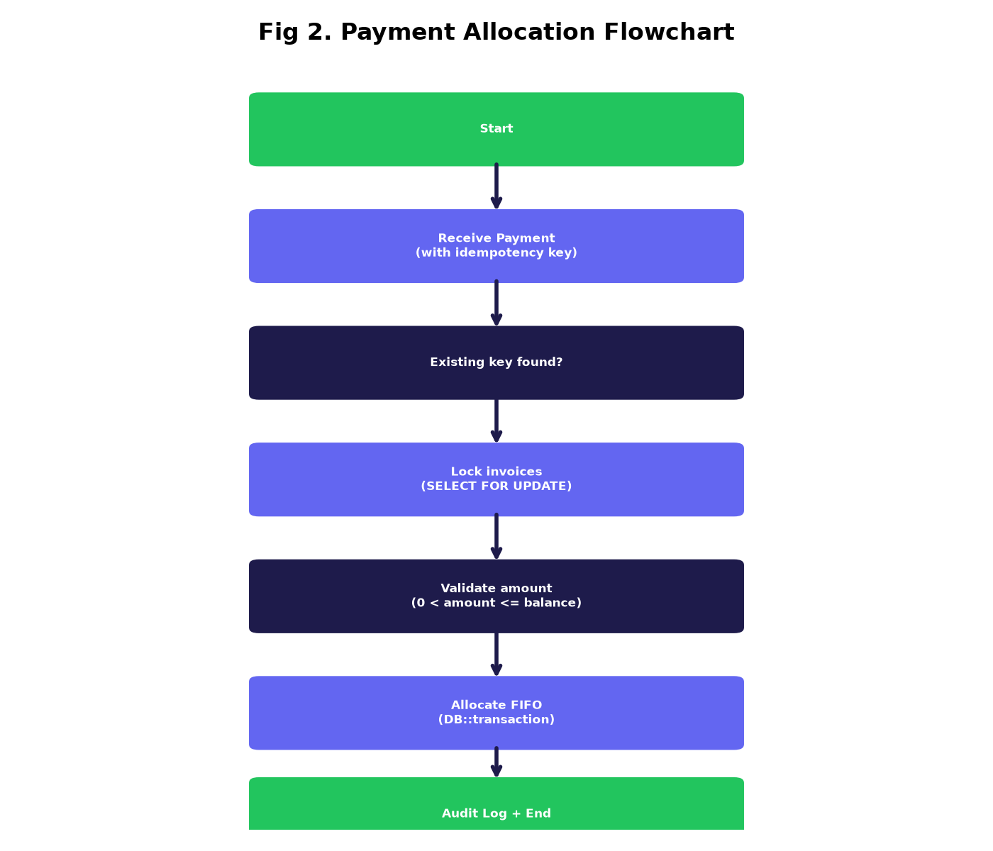
Figure 2. Payment allocation algorithm flowchart
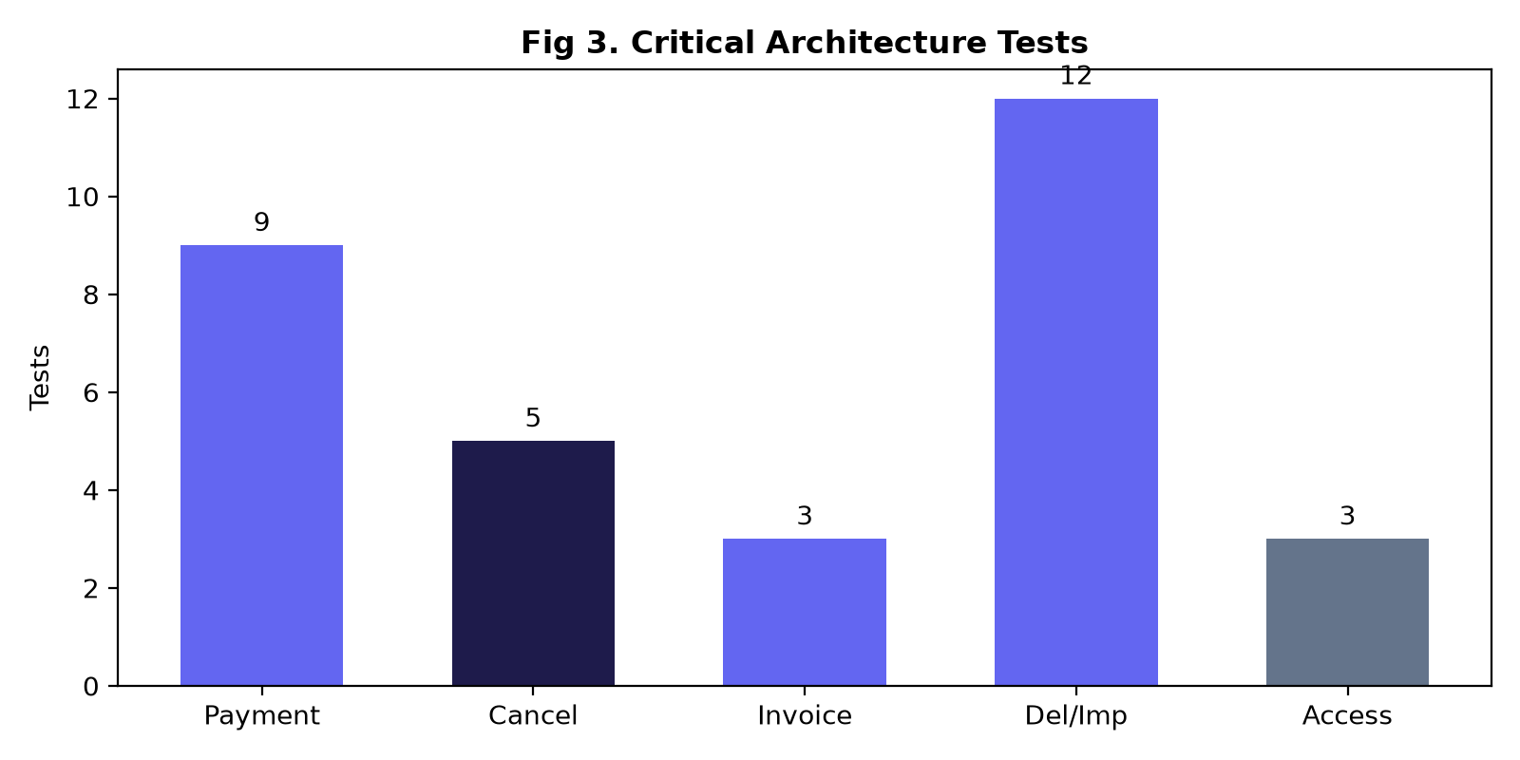
Figure 3. Critical architecture validation tests
Table 1. Audit Log Schema
Column | Type | Description
id | BIGINT (PK) | Auto-increment
user_id | BIGINT FK | Actor
action | VARCHAR(50) | e.g. payment.created
entity_type | VARCHAR(50) | e.g. payment
entity_id | BIGINT | Entity ID
old_values | JSON | Before mutation
new_values | JSON | After mutation
reason | TEXT | Justification
created_at | TIMESTAMP | Action time
Table 2. Critical Architecture Validation Tests
Test | Validates | Result
Idempotency dedup | Duplicate key returns original | Pass
Full payment | Exact amount allocation | Pass
Partial payment | Partial amount + status | Pass
Multi-period | FIFO across 3 invoices | Pass
Overpayment | Exceeds balance rejected | Pass
Cancellation reversal | Atomic revert | Pass
Double-cancel | Already cancelled throws | Pass
RBAC on cancel | Collector gets 403 | Pass
Delete with payment | Guard prevents deletion | Pass
Audit log on cancel | Trail entry exists | Pass
Table 3. Audited Actions and Recorded Data
Action | Old Values | New Values | Reason
invoice.created | null | customer, period, amount | -
invoice.cancelled | status: unpaid | status: cancelled | Required
invoice.deleted | full snapshot | null | -
payment.created | null | tx, amount, method | Optional
payment.cancelled | status: success | status: cancelled | Required
customer.created | null | full record | -
customer.deleted | full snapshot | null | -
AI Usage Statement
In preparing this manuscript, the author used an AI assistant for grammar correction and literature summarization. After using the tool, the author conducted a thorough review and editing of the content and assumed full responsibility for the final published version.
Credit Authorship Contribution Statement
F.H.S.: Conceptualization, Methodology, Software, Testing, Writing - Original Draft, Writing - Review and Editing.
Declaration Of Competing Interests
The authors declare no known competing financial interests or personal relationships that could have appeared to influence the work reported in this paper.
Data Availability
Source code available from corresponding author upon reasonable request.
References
[1] Anonymous, "Idempotency Mechanisms in Digital Payment Systems: Preventing Duplicate Transaction Processing", Journal of Computational Analysis and Applications, vol. 34, no. 10, 2025. doi: 10.48047/jocaaa.2025.34.11.02.
[2] Krishna Dusad, "Taming Asynchrony in Distributed Payment Systems: Guarantees, Idempotency, and End-to-End Reconciliation", Journal of Computer Science and Technology Studies, vol. 7, no. 11, pp. 339-345, 2025. doi: 10.32996/jcsts.2025.7.11.33.
[3] Shivansh Chandnani, Ajay Nagrale, "Idempotency in payment systems: A critical analysis", World Journal of Advanced Research and Reviews, vol. 26, no. 1, pp. 3996-4002, 2025. doi: 10.30574/wjarr.2025.26.1.1569.
[4] Bhupatiraju R., "Event-Driven Architecture for Payment Failover and Redundancy: A Framework for High-Availability Financial Transaction Processing", European Modern Studies Journal, vol. 9, no. 5, pp. 815-830, 2025. doi: 10.59573/emsj.9(5).2025.75.
[5] Anonymous, "A Resilient Approach to Payment Systems: Retry Mechanisms and Idempotency", International Research Journal of Modernization in Engineering Technology and Science, 2025. doi: 10.56726/irjmets67696.
[6] Anonymous, "Design and Development of a Web-Based Online Billing System", International Research Journal of Modernization in Engineering Technology &amp; Science, 2026. doi: 10.56726/irjmets97966.
[7] Logrippo L., "Data flow security in Role-based access control", Journal of Information Security and Applications, vol. 90, pp. 103997, 2025. doi: 10.1016/j.jisa.2025.103997.
[8] David Fitrianto, Sulistyo W., "Penerapan Role-Based Access Control untuk Keamanan Data Multi-Tenant SIMPEL Lazismu", Insect (Informatics and Security): Jurnal Teknik Informatika, vol. 12, no. 01, pp. 1-10, 2026. doi: 10.33506/insect.v12i01.5009.
[9] Romadhan H., Mansur M., "Web-based Educational Payment Information System using Role-based Access Control Security", SISTEMASI, vol. 15, no. 2, pp. 624, 2026. doi: 10.32520/stmsi.v15i2.5920.
[10] Bajoria A., "Blockchain-Enabled Audit Trails: Revolutionizing RDBMS Data Integrity and Security", European Modern Studies Journal, vol. 9, no. 4, pp. 1393-1403, 2025. doi: 10.59573/emsj.9(4).2025.129.
[11] Aienobe V., Iqbal M., "RESPONSIVE WEB DESIGN FOR ENHANCED USER EXPERIENCE (UX) AND USER INTERFACE (UI)", International Journal of Computer Applications, vol. 187, no. 34, pp. 72-93, 2025. doi: 10.5120/ijca2025925533.
[12] Ahyar Muawwal, "The Implementation of PWA (Progressive Web App) Technology in Enhancing Website Performance &amp; Mobile Accessibility", Buletin Pos dan Telekomunikasi, vol. 22, no. 1, 2024. doi: 10.17933/bpostel.v22i1.395.
[13] Cahyadi S., Nurachmad E., et al., "STUDI KOMPREHENSIF MENGENAI DAMPAK DARI AKSELERASI HALAMAN SELULER (AMP) DAN APLIKASI WEB PROGRESIF (PWA) COMPREHENSIVE STUDY OF THE IMPACT OF ACCELERATED MOBILE PAGE (AMP) AND PROGRESSIVE WEB APPS (PWA)", Jurnal Aplikasi Bisnis dan Komputer, vol. 4, no. 1, pp. 16-28, 2024. doi: 10.33751/jubikom.v4i1.9717.
[14] Handayani F., Wisudiawan G., et al., "User Interface Redesign for the Course Card Filling Feature in the SIKAD Mobile Web Application using Goal-Directed Design Method", Journal of Information System Research (JOSH), vol. 5, no. 2, pp. 686-696, 2024. doi: 10.47065/josh.v5i2.4844.
[15] , Andrianda J., et al., "Research, Development and Design for Product Development SAC: Interaction Design Mobile Web Application Using User Centered Design Methodology", International Journal of Current Science Research and Review, vol. 06, no. 12, 2023. doi: 10.47191/ijcsrr/v6-i12-82.
[16] Kurniawan F., Putra R., et al., "Village Activity Management Information System with Mobile-Responsive User Interface Design and Usability Test", Jurnal Sains dan Teknologi Industri, vol. 20, no. 2, pp. 514, 2023. doi: 10.24014/sitekin.v20i2.21449.
[17] Lazuardy M., Marie I., et al., "User Interface User Experience Design with User Centered Design Method On Mobile Application For Laundry KK Reservation", Intelmatics, vol. 4, no. 1, pp. 52-58, 2024. doi: 10.25105/itm.v4i1.18228.
[18] Fiqri Andany Nurul Firdaus, Pratama Bayu Widagdo, "User Interface and User Experience Design of "PAWTEL" Mobile Application for Finding Pet Boarding Services", Gorga : Jurnal Seni Rupa, vol. 14, no. 2, pp. 599-608, 2025. doi: 10.24114/gr.v14i2.67779.
[19] Novia D., Setiawan K., et al., "THE DESIGN STUDIES OF USER INTERFACE AND USER EXPERIENCE ON THE MOBILE APPLICATION OF CIMAHI MALL", International Journal of Application on Social Science and Humanities, vol. 1, no. 2, pp. 1455-1466, 2023. doi: 10.24912/ijassh.v1i2.26389.
[20] Olivia M., "Progressive Web App (PWA) Sebagai Solusi Aksesibilitas Sistem Informasi Akademik", Jurnal Komputer, vol. 3, no. 1, pp. 1-6, 2024. doi: 10.70963/jk.v3i1.106.
[21] Putro D., Suprianto J., et al., "DAMPAK PROGRESSIVE WEB APPLICATION (PWA) TERHADAP PENINGKATAN ENGAGEMENT DAN DWELL TIME PADA APLIKASI E-COMMERCE", IDEALIS : InDonEsiA journaL Information System, vol. 8, no. 1, pp. 84-91, 2025. doi: 10.36080/idealis.v8i1.3369.
[22] Sinlae F., Irwanda E., et al., "Penggunaan Framework Laravel dalam Membangun Aplikasi Website Berbasis PHP", Jurnal Siber Multi Disiplin, vol. 2, no. 2, pp. 119-132, 2024. doi: 10.38035/jsmd.v2i2.186.
[23] Deasy Permatasari, Donna Pascalina, "ANALISIS MVC DALAM PENGEMBANGAN APLIKASI POINT OF SALES MENGGUNAKAN FRAMEWORK LARAVEL PADA JOELCAMERA BANDUNG", Jurnal Wahana Informatika, vol. 4, no. 2, pp. 57-68, 2025. doi: 10.53675/si.v4i2.74.
[24] Dewi B., Defriani M., et al., "Design Of Health Service Mobile Application Interface Using User Centered Design Method", Sinkron, vol. 8, no. 1, pp. 231-240, 2023. doi: 10.33395/sinkron.v8i1.11931.
[25] Fitria R., "Integrating Heuristic Evaluation and Cognitive Walkthrough in Usability Evaluation of Mobile Application", Journal of Artificial Intelligence and Engineering Applications (JAIEA), vol. 3, no. 3, pp. 667-670, 2024. doi: 10.59934/jaiea.v3i3.488.
[26] Sun Y., "Research on the Usability Evaluation Model of Mobile Application Interface Design for Active Senior", Art and Society, vol. 2, no. 1, pp. 61-66, 2023. doi: 10.56397/as.2023.02.10.
[27] - R., "Exploring Concurrency Control Techniques in Multi-User Database Systems: A Comprehensive Review", International Journal For Multidisciplinary Research, vol. 6, no. 3, 2024. doi: 10.36948/ijfmr.2024.v06i03.23286.
The FIFO allocation strategy (oldest period first) aligns with the business practice of settling arrears before current-period charges. This is a deliberate design choice that differs from systems that prioritize the current period or allow user-specified allocation order. The FIFO approach simplifies the collector mental model: pay oldest first requires no decision-making in the field, reducing errors and speeding up the collection process.
The deletion guards represent a data retention by design philosophy: financial records are never hard-deleted if they participate in the audit trail. This approach contrasts with soft-delete patterns that retain records but mark them as deleted. The hard-delete with guards approach keeps the active dataset clean while protecting historical integrity - a balance appropriate for systems where storage is not a constraint but auditability is mandatory.
Compared to event sourcing architectures that reconstruct state from an event log, the current-state-plus-audit-log approach is simpler to query and debug. The audit log serves as a historical record without being the system of record - the live database tables hold current state, and the audit log holds the history. This separation simplifies read queries (no projection rebuilding) while maintaining full auditability.
The system uses PHP 8.1 backed enums for all status values (InvoiceStatus, PaymentStatus, CustomerStatus, PaymentMethod, Role, VisitResult), providing type-safe state transitions. Each enum includes a label() method for Bahasa Indonesia display and a badgeClass() method for Bootstrap 5 badge styling. This approach centralizes status logic and prevents invalid state values at the type level, reducing runtime errors.
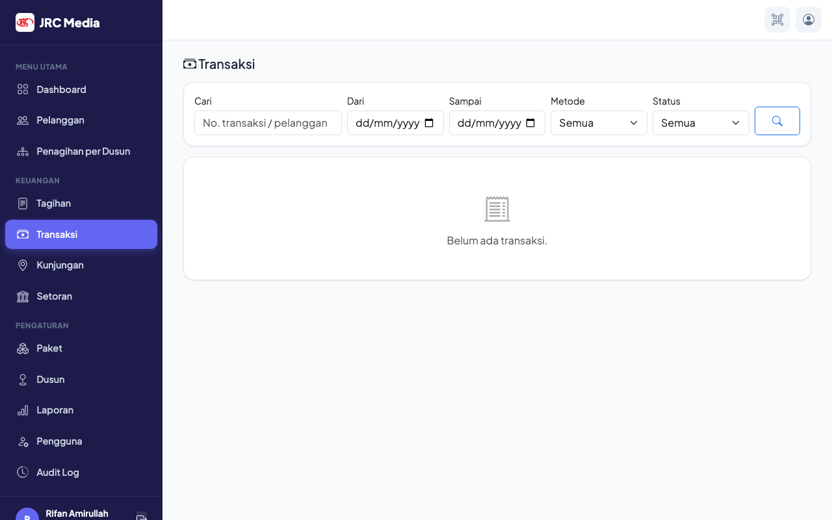
Figure 4. Payment list showing transaction records and status badges
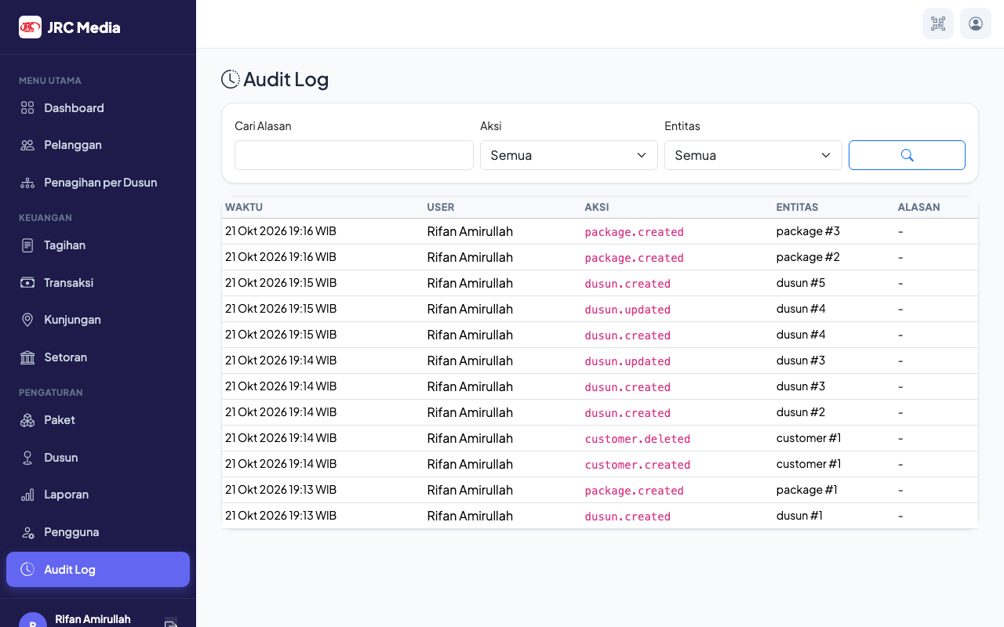
Figure 5. Audit log with append-only entries showing actor and state changes
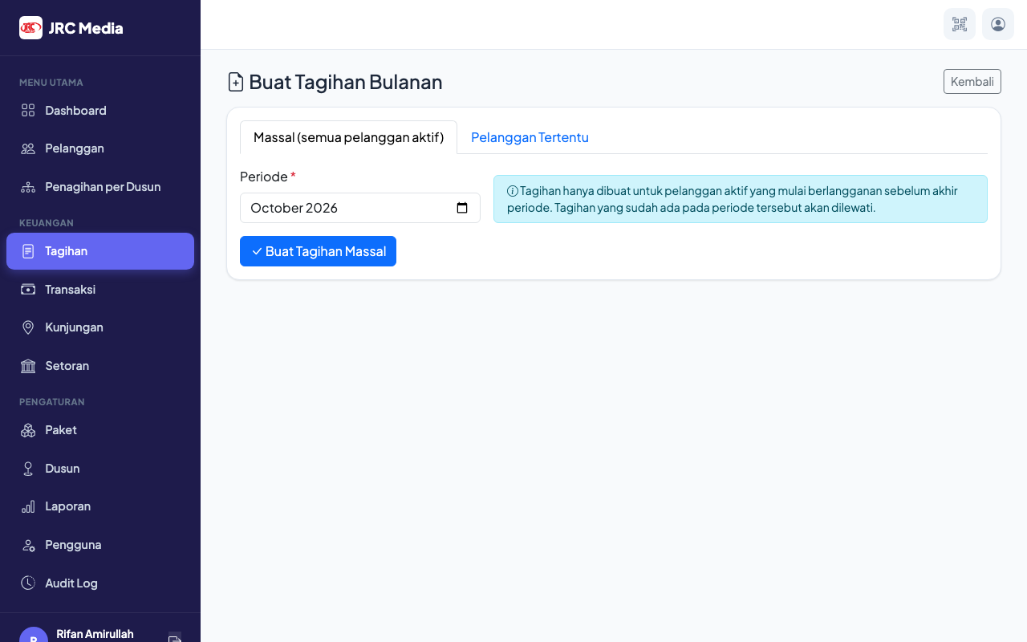
Figure 6. Invoice detail with payment allocations and delete confirmation

