- What is Kubernetes …………………………………………………
- BORG
- Monolithic Architeture
- Microservices Architecture
- How Kubernetes fits with microservices
- Kubernetes Architecture and its component
- What is Kubernetes?
- Kubernetes (often called K8s) is an open-source container orchestration platform that helps you deploy, manage, scale, and maintain containerized applications automatically.
- Kubernetes is a system that runs and manages containers reliably at scale.
- Docker → Creates containers
- Kubernetes → Manages containers in production
- What is meant by a Container Orchestration Platform?
  - Orchestration refers to the automated management of containerized applications throughout their entire lifecycle.
  - A container orchestration platform is a system that automatically manages the lifecycle of containers across multiple machines.
  - It decides where containers run, keeps them running, scales them, connects them, and fixes them when they fail — without manual intervention.
- Running hundreds of containers across multiple servers is hard:
  - What if a container crashes?
  - Which machine should run it?
  - How do containers talk to each other?
  - How do we scale when traffic increases?
  - How do we update without downtime?
- Container orchestration platforms solve these problems automatically.
- Kubernetes acts as a container orchestrator. Instead of you manually:
  - Starting containers
  - Placing them on servers
  - Restarting them when they fail
  - Scaling them up/down
  - Wiring networking and storage
- Kubernetes does all of this for you, based on the desired state you declare.
- K (UBERNETE)8 S
- K8s is CNCF Graduated
  - The Cloud Native Computing Foundation (CNCF) has three maturity levels for projects:
    - Sandbox – early stage
    - Incubating – growing, production ready in parts
    - Graduated – stable, widely adopted, production proven
  - Kubernetes reached Graduated status in March 2018, making it the first CNCF project to graduate.

- BORG
- Borg is to Google what Kubernetes is to the rest of the world.
- Borg is a cluster management system developed by Google to:
  - Run hundreds of thousands of jobs
  - Across tens of thousands of machines
  - With high availability, scalability, and efficiency
- Google has been using Borg since the early 2000s to run services like:
  - Google Search
  - Gmail
  - YouTube
  - Google Maps
- Why Borg was created
  - Google faced problems very early that most companies face only now:
    - Massive scale
    - Frequent failures
    - Dynamic workloads
    - Need for efficient resource utilization
    - Manual management was impossible.

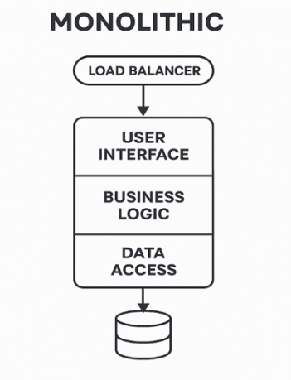
- Monolithic Architecture
  - Monolithic Architecture is a traditional software design approach where the entire application is built as a single, unified codebase and deployed as one unit.
  - All components—UI, business logic, data access, authentication, integrations—are tightly coupled and run as one application process.
  - If the application needs an update in any part, the entire application must be rebuilt and redeployed.
  - Become complex and difficult to maintain as the size and complexity of the application grow.
  - Tight Coupling
    - Components depend heavily on each other
    - Changes in one module may impact others
    - All modules access the same database
    - No data ownership boundaries

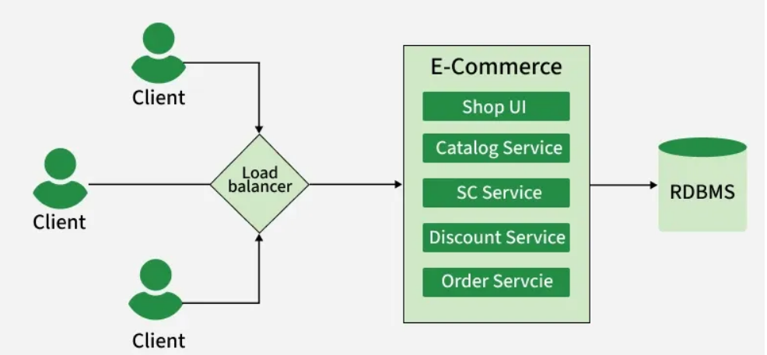
- Microservices Architecture
- Microservices architecture is an architectural style where an application is built as a collection of small, independent services, each responsible for a single business capability and communicating with other services via lightweight APIs (HTTP/REST, gRPC, messaging).
- Each microservice is independently developed, deployed, scaled, and maintained.
- Loose Coupling
  - Services interact via APIs or events
  - No shared codebases or databases
  - Example:
    - User Service → User DB
    - Order Service → Order DB
    - Payment Service → Payment DB

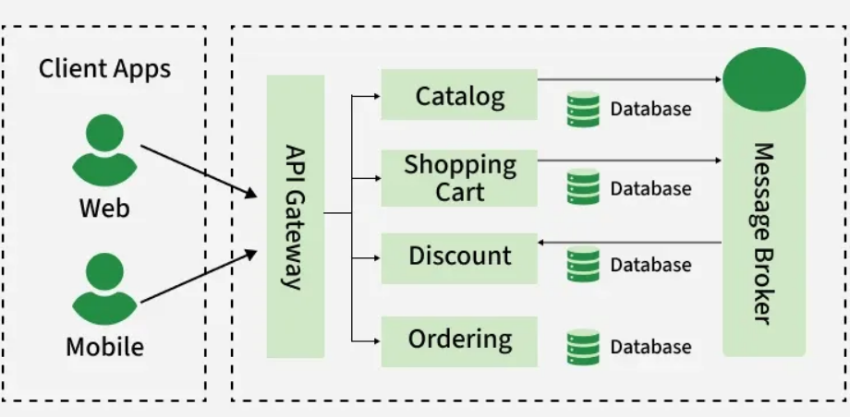

- How Kubernetes Fits with Microservices ?
- Microservices define what you build. Kubernetes defines how you run them at scale.
- Microservices create many small, independent services.
- Kubernetes provides the runtime platform that makes operating those services reliable, scalable, and automated.

- Kubernetes Architecture and its components
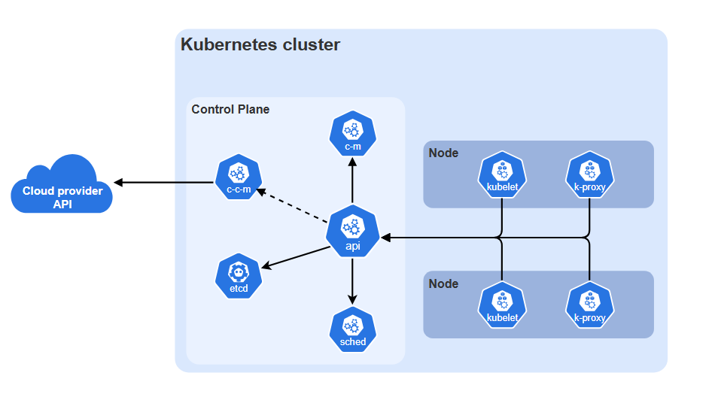
- Here,
  - c-m: controller manager
  - c-c-m: cloud controller manager
  - etcd: persistence store
  - sched: scheduler
  - k-proxy: kube-proxy

- Cluster in Kubernetes
  - A Kubernetes cluster is a set of machines (nodes) that work together to run, manage, scale, and maintain containerized applications under the control of Kubernetes.
  - A cluster is the execution environment where Kubernetes operates.
  - Kubernetes Cluster is divided into two major parts:
    - Control Plane (management layer) → Decides what should happen
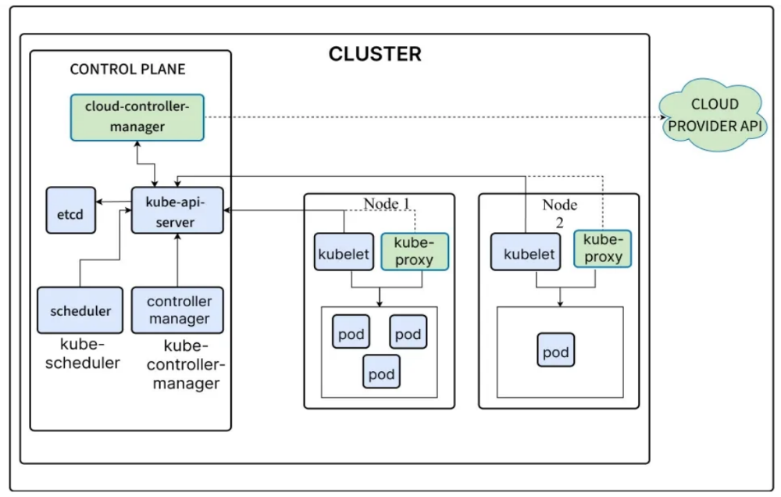
    - Worker Nodes (execution layer) → Actually run the workloads

- kubectl / kube-control
  - kubectl is the command-line interface (CLI) tool used to interact with a Kubernetes cluster.
  - A way to talk to the Kubernetes API

- Cloud Provider API
  - What it represents
    - This shows Kubernetes running on cloud infrastructure (AWS, Azure, GCP, etc.).
  - Why Kubernetes talks to the Cloud Provider
    - Kubernetes does not create infrastructure itself. Instead, it asks the cloud provider to:
      - Create / delete VMs
      - Attach storage volumes
      - Create load balancers
      - Assign IP addresses
  - Who talks to the cloud?
    - Cloud Controller Manager (c-c-m)

- Control Plane
  - The Control Plane is the decision‑making brain of Kubernetes.
  - It does not run application containers.
  - Control Plane Components:
    - kube api server
    - etcd
    - kube scheduler
    - kube controller manager
    - cloud controller manager (cloud only)

- API Server / kube-api-server
  - What it is
    - Central entry point to the cluster
    - All communication goes through it
  - Who talks to the API server?
    - kubectl
    - UI dashboards
    - Controllers
    - Scheduler
    - Kubelets on nodes
  - Responsibilities
    - Validates requests
    - Authenticates users
    - Updates cluster state in etcd
  - ALL components communicate only through the API Server
  - Nothing happens in Kubernetes without the API server

- Cluster State Store or Database / etcd
  - What it is
    - Distributed key-value store/database
    - Stores entire cluster state
  - What is stored in etcd?
    - Pods
    - Deployments
    - Services
    - ConfigMaps
    - Secrets
    - Node status
  - etcd is the single source of truth
  - If etcd is lost → cluster state is lost.
  - That’s why:
    - etcd is replicated
    - Backups are mandatory in production

- Scheduler / kube-scheduler
  - What it is:
    - Decision maker for Pod placement
  - What it does:
    - The scheduler answers one question:
      - On which node should this Pod run?
    - Watches API Server for unscheduled Pods
    - Finds suitable nodes
    - Picks the best node for each Pod
    - Scheduler only assigns Pods, it does not run them

- Controller Manager (c-m) / kube-controller-manager
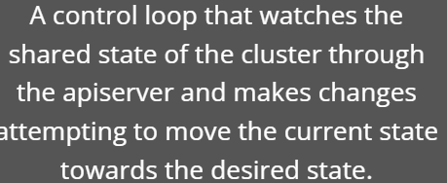
  - What it is:
    - A collection of controllers
    - Implements Kubernetes’ reconciliation loop
  - What it does
    - Ensures desired state = actual state
    - Examples:
- ReplicaSet Controller → ensures correct Pod count
- Node Controller → detects node failure
- Endpoint Controller → updates Services
- This is how Kubernetes becomes self-healing

- Cloud Controller Manager (c-c-m)
  - What it is:
    - Integration layer between Kubernetes and the cloud provider
    - cloud-controller-manager only runs controllers that are specific to your cloud provider.
  - Responsibilities:
    - Manage cloud Load Balancers
    - Provision cloud volumes
    - Handle node lifecycle (VMs)
  - Makes Kubernetes cloud-agnostic

  - Worker Nodes
    - Worker nodes are where application workloads / microservices actually run.
    - Each worker node contains:
      - kubelet
      - container runtime (containerd, CRI O)
      - kube proxy
      - Pods
    - Each node is a VM (virtual machine) or physical machine.
    - Each Node can have multiple pods and pods have containers running inside them.
    - There are 3 processes in every Node that are used to Schedule and manage those pods.
      - Kubelet
      - Kube-proxy
      - Container runtime

- kubelet (Inside every node)
  - What it is
      - Agent running on each node (Node level Agent).
      - Communicates with kube-api-server.
  - Responsibilities:
      - Pull container images
      - Start / stop containers
      - Run health checks
      - Report status back to API Server
  - kubelet enforces what Control Plane decided, at node level

- kube-proxy (Inside every node)
  - What it is: Networking Component
    - Runs on each node and manages network communication for pods.
    - It implements Kubernetes Services by maintaining network rules that allow pods to communicate with each other and with external clients.
    - Kube-proxy can handle traffic via iptables or IPVS, enabling service discovery and load balancing across pods.

- Container Runtime
    - A container runtime is the software responsible for running containers on a node.
    - Kubernetes does NOT run containers itself. It asks a container runtime to do it.
    - It executes the application containers that are part of pods and manages their lifecycle.
    - Popular container runtimes include Docker, containerd, and CRI-O.

- Pods
    - Pod is the smallest deployable unit in Kubernetes.
    - A Pod is NOT a container. A Pod is a wrapper around one or more containers.
    - Pods are ephemeral i.e, Pods are temporary execution units that can be created, destroyed, and replaced at any time by Kubernetes.
    - Kubernetes never deploys containers directly, only via Pods.
  - Why Pods exist:
      - Kubernetes does not manage containers directly.
      - Instead, it manages:
      - Pod → contains container(s)
    - This allows:
      - Shared networking
      - Shared storage
      - Tight coupling when needed
  - Key Points:
      - Pods do not have a guaranteed lifetime
      - Pods can disappear and reappear
      - When a Pod dies, it is NOT repaired. Instead, a new Pod is created

- Ways to create Kubernetes cluster
  - Kubeadm (High-Cost)
  - KIND (Kubernetes in Docker)
  - Minikube (Local/EC2)
  - EKS / AKS / GKE

- To run Kubernetes locally (especially using KIND), three tools — Docker, kubectl, and KIND — are required

  - Why Docker is necessary
    - Docker provides:
      - Containers
      - Container images
      - Container networking
      - Isolated runtime environments
  - Why Kubernetes needs Docker (in KIND’s case)
    - Kubernetes does not run directly on your laptop OS. It needs machines (nodes) to run on.
  - KIND creates Kubernetes nodes as Docker containers.
    - So:
      - Each Kubernetes node = one Docker container
      - Control plane node = Docker container
      - Worker node(s) = Docker container(s)
  - Without Docker
    - KIND has nowhere to create nodes
    - Kubernetes has no runtime
    - No pods, no services, nothing
  - Docker is the foundation (infrastructure layer)

  - Why KIND (Kubernetes in Docker) is necessary
    - It is a tool that:
      - Creates Kubernetes clusters
      - Runs them locally
      - Uses Docker containers as nodes
    - What problem KIND solves
      - Running Kubernetes “normally” requires:
        - Multiple VMs or physical machines
        - Complex networking
        - Cloud setup

    - KIND removes all that by:
      - Creating a real Kubernetes cluster
      - Inside Docker
      - On a single machine

  - Why kubectl is necessary
    - kubectl is:
      - The official Kubernetes CLI
      - A client, not a server
    - It talks to:
      - Kubernetes API Server (running inside the cluster)
    - What kubectl allows you to do
    - Using kubectl you can:
      - Deploy applications
      - Create pods, services, deployments
      - Scale workloads
      - View logs
      - Debug issues
    - Without kubectl
      - Cluster exists, but you cannot control it
      - No way to deploy apps
      - No way to inspect resources

- Setting KIND, Kubectl and Docker (Local Environment)
- Installing Homebrew on MacOs
  - Run the below command
  - Once installed, homebrew will ask to run some commands in the terminal so that homebrew can be added to path
  - Once homebrew has been installed do as below to install kind and kubectl
    - brew install kind kubectl
    - verify installation
      - kind --version
      - kubectl version or kubectl version --client
  - To install docker
    - Download the ‘Docker desktop’ for mac
    - Open the downloaded .dmg
    - Drag docker applications
    - Open docker from applications
    - Allow permissions when asked
      - Verify in terminal
        - docker --version
        - docker ps (empty list)

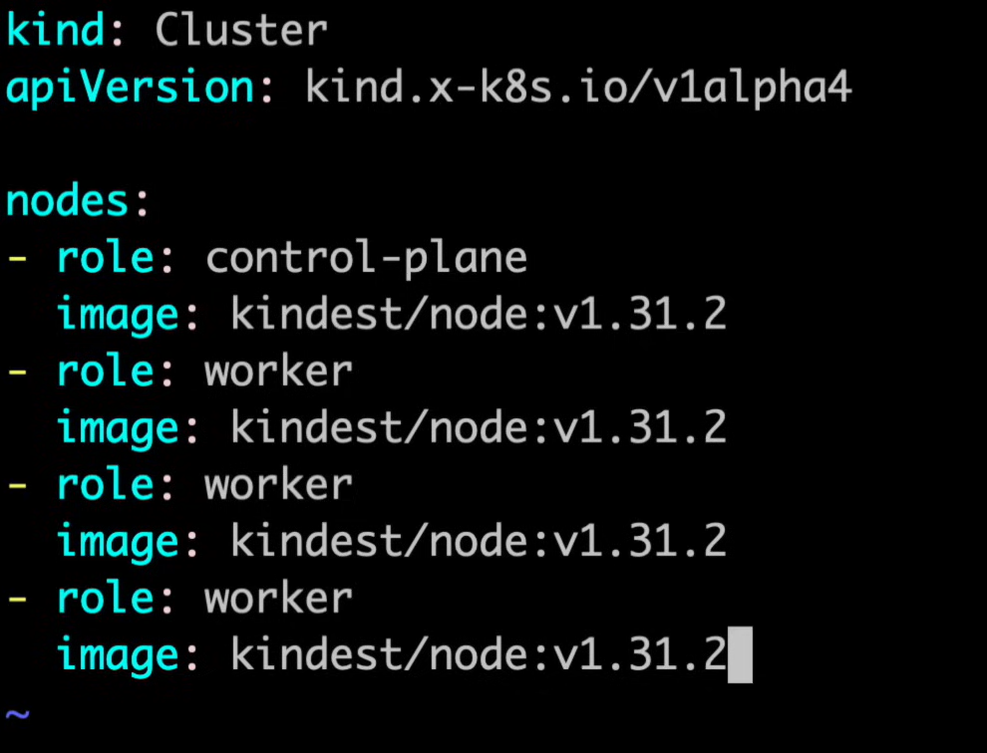
- KIND Cluster Creation (Time Stamp 53:00)
- .yaml file and its config
- Minikube cluster creation
- Kubeadm cluster creation and containerD intro (important)
- Kubernetes Namespace
  - Docker container
  - Pod
  - Deployment
  - Service
  - User

- Creating an EC2 instance via Amazon AWS
- Assign ‘Name’
- Application and OS Images (Amazon Machine Image)
  - This is the type of server
  - Select ‘Ubuntu’
- Architecture
  - Select ‘ 64-bit (x86)
- Instance Type
  - T2.micro: free tier eligible
  - Recommended: T2.medium
- Key-pair
  - Key-pair name
  - Key-pair type: RSA
  - Private key file format: .pem
  - Select ‘create key pair’
- Network Settings
  - Allow SSH traffic from
  - Allow HTTPS traffic from the internet
  - Allow HTTP traffic from the internet
- Configure Storage
  - 1x 30 GiB gp3 root volume
- Select ‘launch Instance’

- Once Instance is created
  - Select and open the instance
  - ‘Connect to instance’
  - ‘SSH Client’
  - Timestamp 34:00

- Creating K8s via CLI thereafter via YML/YAML configurations

