- Install Git as per OS compatibility
https://git-scm.com/install/

- Configure Git (One-Time Setup, recommended to use Git Bash terminal)
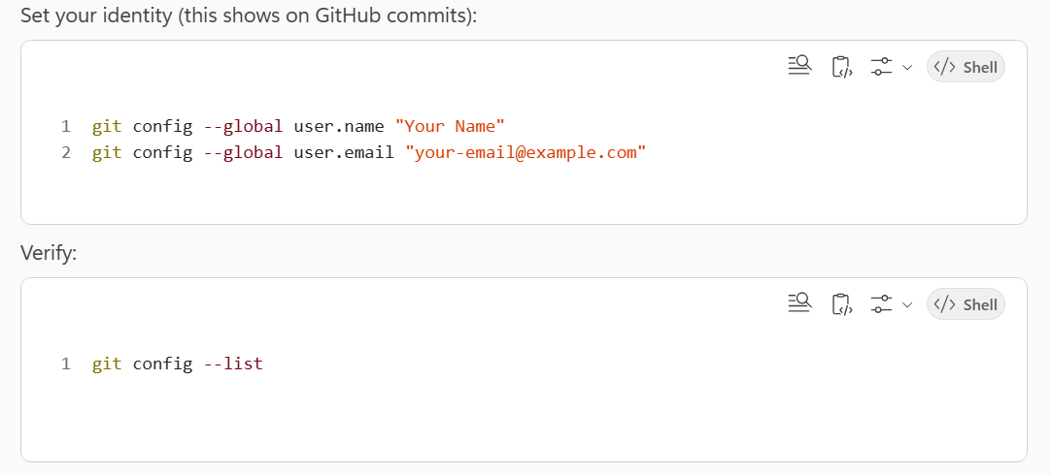

- Create a GitHub Repository
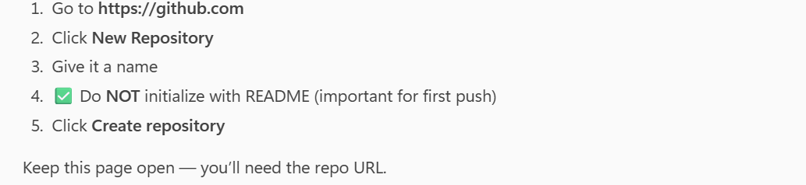

- Choose Authentication Method (IMPORTANT)
GitHub no longer allows password-based pushes. Use SSH (recommended) or HTTPS with token.
  - Generate SSH key
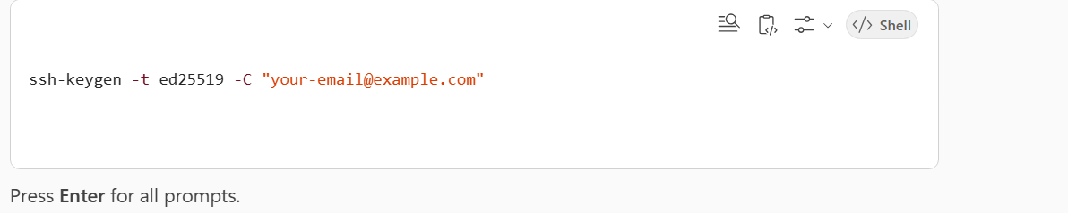

  - Press Enter for all further prompts
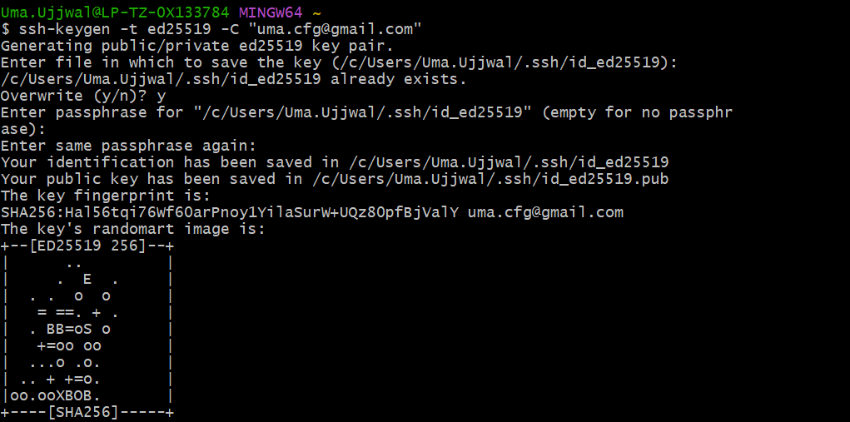

  - Start SSH Agent
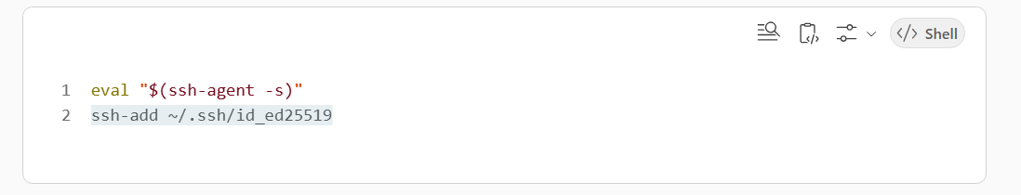
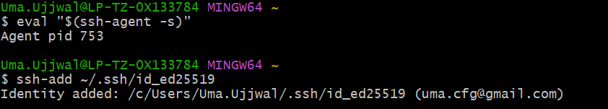

  - Add SSH key to GitHub
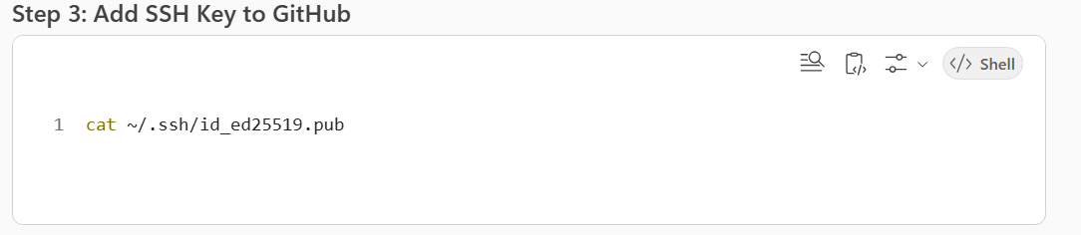

  - Copy Output
  - GitHub → Settings → SSH and GPG Keys → New SSH Key → Paste → Save
    - Add Title
    - Add key (Entire Output of 4.4.)
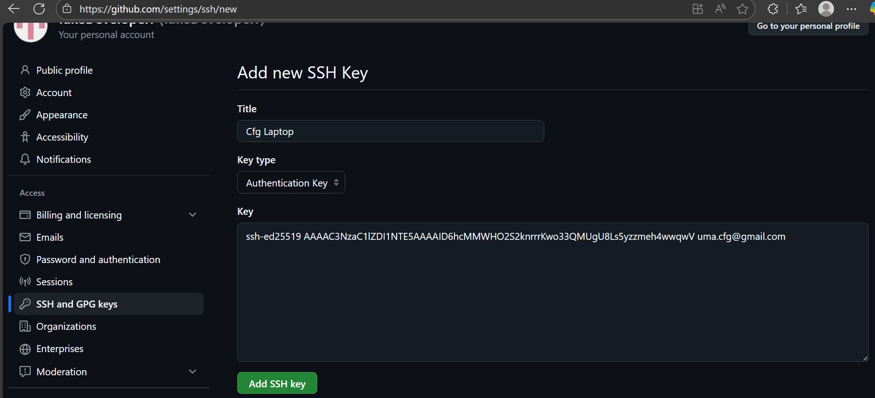

- Test Connection
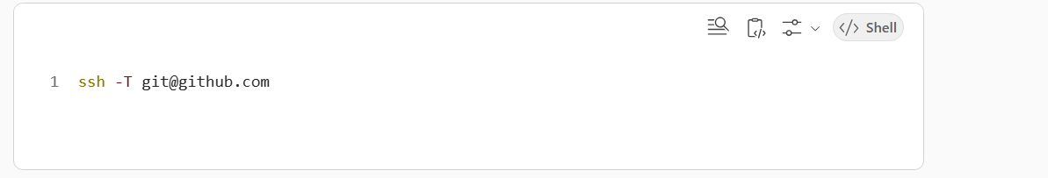
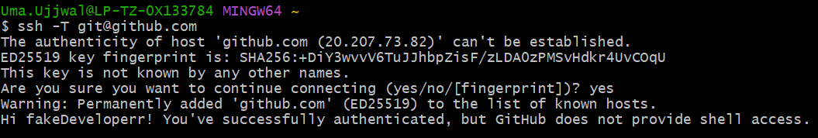

- Uploading Files/Folder
  - Navigate to the current directory in terminal

  - Initialize Git (Only Once)
Command: git init

  - Stage Changes
Command: git add .

  - Commit files
Command: git commit -m "Initial Commit"

  - Connect to your GitHub Repo
Syntax: git remote add origin <repo_url>
Command: git remote add origin https://github.com/fakeDeveloperr/Doc-Upload-Download.git

    - Copy Repo URL
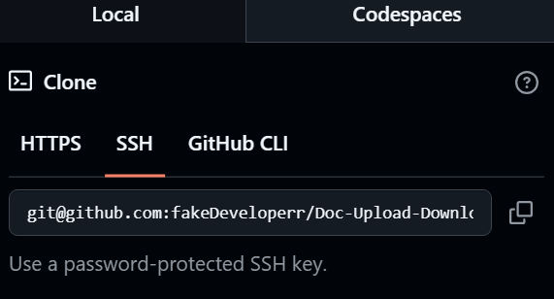

  - Push to GitHub
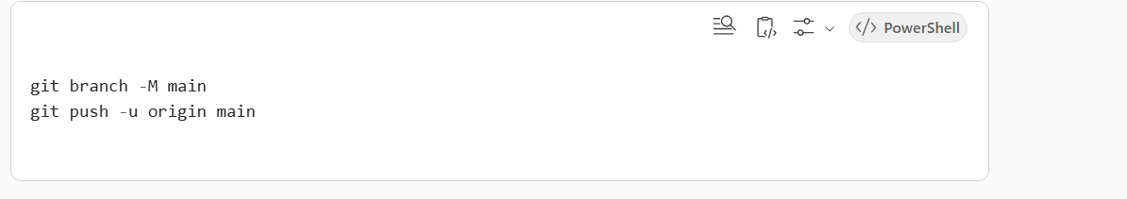

- Open folder ‘Say My Folder’ in terminal
- git init
- git remote add origin <repo_url>
- git clone <repo_url>
- the downloaded repo will be present in ‘My Folder’

To add connection
Syntax: git remote add origin <repo_url>

To change the connection origin
Syntax: git remote set-url origin <repo_url>
e.g: git remote set-url origin git@github.com:fakeDeveloperr/Doc-Upload-Download.git

To remove the established connection
Syntax: git remote remove origin

To list/verify the established connection
Syntax: git remote -v

