- Virtual Machine and Virtualisation………………………………………...
  - What is a virtual machine?
  - What does software based emulation mean?
  - What is Virtualization?
  - VMs Components/Architecture
  - Scenario based Qs
  - When Virtualization exists, why containerisation?
    - Virtualization vs Containerization
- Introduction to Docker……………………………………………………..
  - What is docker?
  - Why is docker needed?
  - How docker packages everything the application needs?
  - Docker Architecture
    - Docker Client
    - Docker Host
    - Docker Daemon (dockerd)
    - Docker Engine
    - Docker Objects
      - Docker Images
      - Docker Containers
      - Docker Storage Mounts
      - Docker Volumes
      - Docker Network
    - Docker Registry
    - Scenario based Qs
  - Docker engine architecture/ How docker runs containers internally…..
    - containerd
      - Why containerd exist?
      - What containerd actually does?
    - shim / containerd-shim
      - Why containerd-shims are needed?
    - runc
      - Why runc exits?
      - What is the issue if runc stays alive?
  - Docker File
    - What are Layers?
    - Which dockerfile instructions create layers?
    - How Layers are Shared?
  - Docker hub and docker images
  - Running docker images
    - Detached mode

- Writing / Creating a dockerfile
  - Dockerfile for Java Application
  - Dockerfile for Python Flask Application
    - Port Mapping
  - Dockerfile for Node Application

- Docker Networking
  - Docker Network Drivers
  - Types of Docker Network Drivers
    - Bridge Network Drivers
    - Host Network Drivers
    - None Network Drivers
    - User Defined Network Drivers
    - MACVLAN Network Drivers
    - IPVLAN Network Drivers
    - Overlay Network Drivers

- What is a Virtual Machine? (Virtualisation)
  - A Virtual Machine is a software-based emulation of a physical computer.
  - It behaves like a full computer system with its own:
    - Operating System (OS)
    - CPU (virtualized)
    - RAM (virtualized)
    - Storage (virtual disks)
    - Network interfaces
  - A VM runs on top of a physical machine using a software layer called a hypervisor.

  - What does Software based emulation mean?
    - Emulation means fully mimicking hardware behavior in software — even if the hardware does not exist or is different.
    - In virtualisation:
      - The hypervisor is the software that performs this emulation.

  - What is Virtualisation?
    - Virtualization allows you to create multiple simulated (virtual) computing environments on top of a single physical hardware system.
    - Dividing one physical machine into many independent virtual machines using software.
    - The software that enables this is the hypervisor.

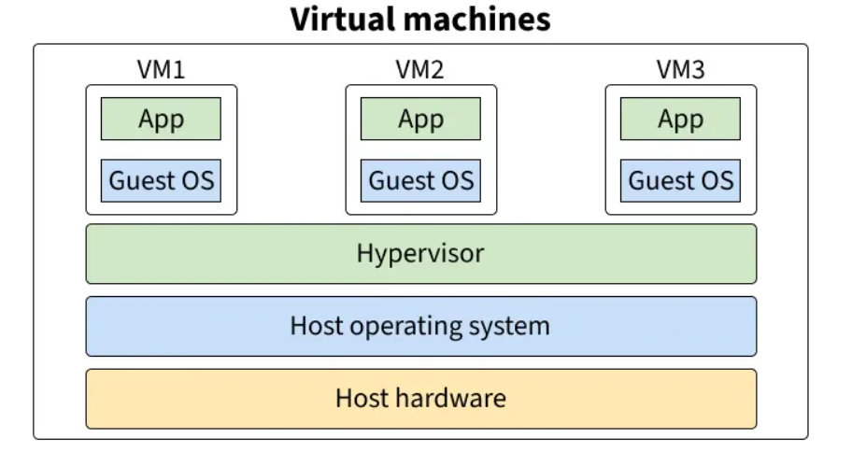
  - VMs Components:

    - Host Hardware (Physical Machine)
      - This is your actual physical server/laptop.
      - It includes:
        - CPU
        - RAM
        - Storage
        - Network card
      - Every VM eventually uses these physical resources, but indirectly through the hypervisor.

    - Host Operating System
      - This is the OS installed directly on the physical machine.
      - Examples:
        - Windows 11 / Windows Server
        - Linux (Ubuntu, RHEL, CentOS)
      - This OS is responsible for:
        - Managing hardware
        - Providing drivers
        - Running the hypervisor (if it’s Type 2)
      - Note: This layer exists only for Type‑2 hypervisors. For Type‑1 (bare‑metal), the hypervisor sits directly on hardware.

    - Hypervisor (Virtualization Layer)
      - A Hypervisor is a specialized software layer responsible for creating, running, and managing Virtual Machines (VMs).
      - It sits between the physical hardware and the Virtual Machines and performs hardware virtualization.
      - It performs two key jobs:
- Hardware Virtualization/Emulation
        - The hypervisor creates virtual hardware:
          - Virtual CPU (vCPU)
          - Virtual RAM
          - Virtual Disk
          - Virtual Network card (vNIC)
          - Virtual BIOS
        - The Guest OS believes it is running on actual hardware.
        - Example:
          - VM thinks it has:
            - vCPU = 4 cores
            - vRAM = 8GB
            - vDisk = 40GB
          - But hypervisor is mapping all of this to real physical hardware.
- Isolation
        - Each VM:
          - Runs its own OS (Guest OS)
          - Has its own memory
          - Cannot access other VMs
          - Cannot corrupt the host
      - Resource Management, Hypervisor decides:
        - How much CPU each VM gets
        - How much RAM is mapped
        - How disk I/O is allocated
        - Scheduling for VM execution
      - Two types:
      - Type 1 – Bare-metal Hypervisor
        - Runs directly on hardware, no host OS beneath.
        - Examples: VMware ESXi, Microsoft Hyper-V, Xen
        - Fastest, most secure and used in datacenters & cloud providers.
      - Type 2 – Hosted Hypervisor
        - Runs on top of a host OS(Windows/Linux/macOS)
        - Examples: VMware Workstation, VirtualBox
        - Used for local development or personal use.

    - Guest OS (Operating System inside VM)
      - This is the OS running inside the VM, independent from the host OS.
      - Examples:
        - Windows
        - Ubuntu
      - Each VM can run a different OS, because the hypervisor emulates hardware for them.

    - Applications
      - Applications run on top of the Guest OS exactly as if they were running on a real physical machine.
      - Examples:
        - Database servers (MySQL, PostgreSQL)
        - Web servers (Nginx, Apache)
        - Enterprise apps
        - Developer tools
      - Each VM is isolated, so you can run:
        - VM1 → Windows + Active Directory
        - VM2 → Linux + Database
        - VM3 → Ubuntu + Web server
      - All on the same hardware.

Q. How can Linux run on a Windows machine when Windows is the host OS?
Say, Host OS = Windows
Guest OS inside VM = Linux
Answer:
- Hypervisor Virtualizes Hardware, Not OS
  - A VM never depends on the Host OS.
  - Instead, the VM depends on virtual hardware created by the hypervisor.
- The hypervisor sits between the guest OS and the host OS/hardware.
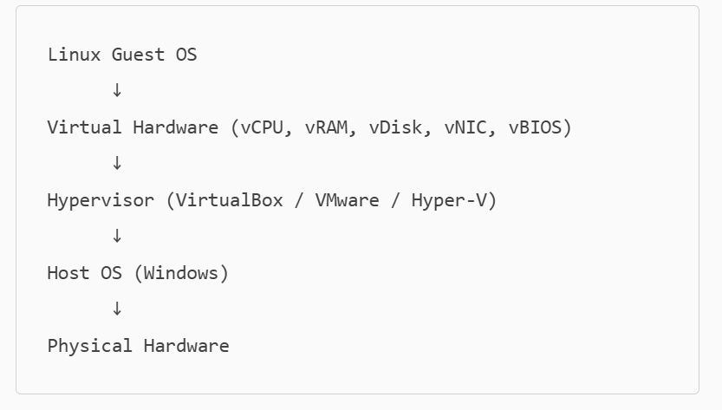

- Linux is not running on Windows. Linux is running on virtual hardware created by the hypervisor.
- The hypervisor only uses Windows as a base layer (Type‑2 hypervisor).
- But Linux never interacts with Windows directly.

- When VMs and the concept of virtualization exists, why docker and containerisation is needed? (Virtualization vs Containerization)
  - VM:
    - “Run a machine on any hardware.”
  - Docker:
    - “Run an application on any operating system.”
  - VMs solved infrastructure problems:
    - Run Windows + Linux on same machine
    - Server consolidation
    - Full OS isolation
    - Strong security boundaries
  - BUT VMs were never designed for running thousands of tiny, fast-deploying applications, especially microservices.
  - Containers solve application-level problems, not OS problems.

- What is Docker ?
  - Docker is a containerization platform that allows you to package an application + all its dependencies into a lightweight, portable container that runs consistently across environments.
  - Think of it as “run anywhere without configuration issues” for applications.
  - Docker is written in the Go programming language and takes advantage of several features of the Linux kernel to deliver its functionality.
  - Docker uses a technology called namespaces to provide the isolated workspace called the container.
  - When you run a container, Docker creates a set of namespaces for that container.

- Why is Docker Needed?
  - Different developers have different environments:
    - Different OS versions
    - Different libraries
    - Different dependencies
    - Different configurations
  - Result → The application works on one system but breaks on another.
  - Docker solves this by:
    - Packaging everything the app needs inside a container:
      - OS-level dependencies
      - Libraries
      - Runtime (Node.js, Java JDK/JRE, Python interpreter, etc.)
      - Configurations files (yaml, env, etc.)
  - So the app runs the same on:
    - Your local laptop
    - Dev environment
    - Test
    - Production
    - Cloud

- How does Docker packages everything the application needs?
  - Docker packages your application into an image.
  - A Docker image is built using a Dockerfile — a set of instructions.
  - When you run the image, it becomes a container.

- Docker Architecture
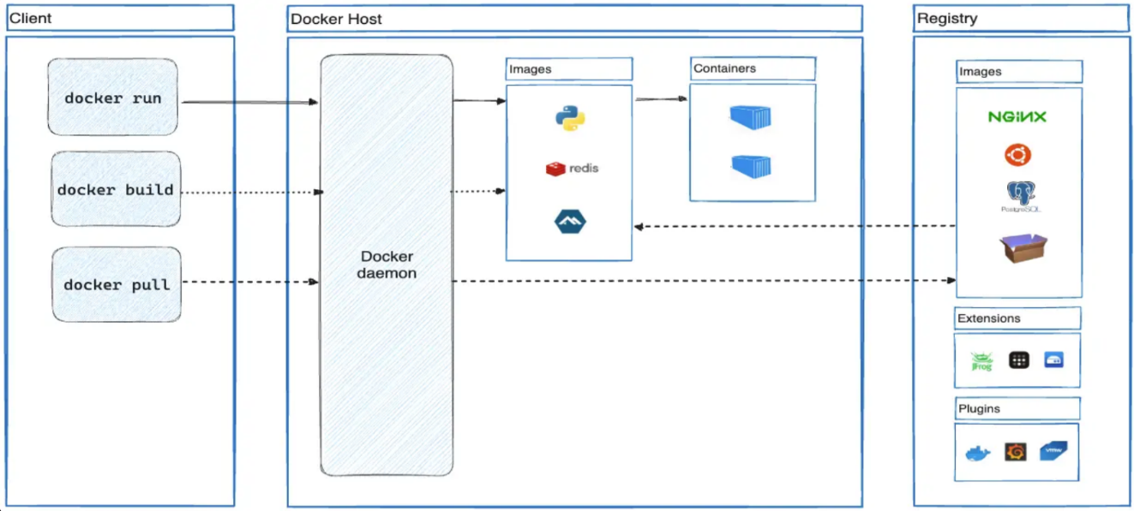

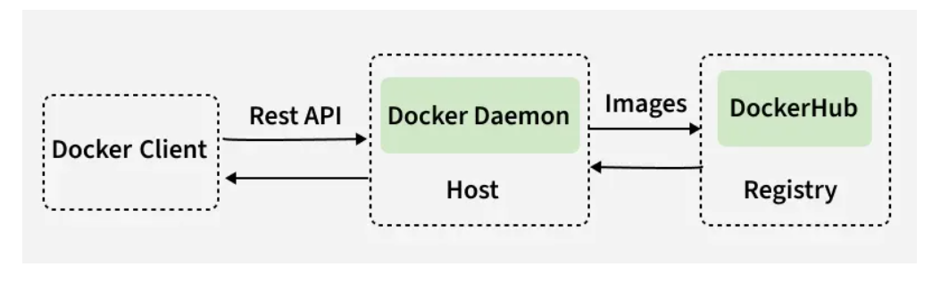
  - Docker follows a client–server architecture with three major components:
    - Docker Client
    - Docker Host
    - Docker Registry

  - Docker Client
    - This is the interface through which you interact with Docker.
    - Acts as the front-end/ user-facing CLI.
    - The Docker Client can communicate with Docker Daemon on:
      - the same machine, or
      - a remote machine (remote Docker host)
    - Whenever you type commands such as:
      - docker run
      - docker build
      - docker pull
    - the client does NOT perform these actions itself. You are using the client to request Docker actions.
    - It simply sends the instructions to the Docker daemon using REST API calls.
    - The client does NOT run containers, pull images, or manage networks.

  - Docker Host
    - This is the machine where Docker is installed.
    - It contains:
      - Docker Daemon
      - Images
      - Containers

  - Docker Daemon (dockerd)
    - The daemon is the core engine/brain of Docker.
    - dockerd manages Docker by distributing work to dedicated lower-level components
    - Responsibilities of Docker Daemon:
      - Builds images: dockerd utilises BuildKit to build images
      - Runs containers: It orchestrates container creation through containerd.
      - Manages volumes
      - Manages networks: implemented by libnetwork inside dockerd.
      - Talks to container runtime (containerd / runc)
      - Pulls/pushes images from registries
    - dockerd (Docker Daemon) acts as high-level brain of the docker and utilizes lower-level components like containerd, containerd‑shim, and runc to actually manage and run containers.
    - The full execution flow is:
      - Docker CLI → dockerd → containerd → containerd-shim → runc → Linux Kernel (via namespaces, cgroups, and other primitives)

  - Docker Engine
    - Docker Host = The machine
    - Docker Engine = The Docker application installed on that machine
    - Once Docker Engine is installed, that machine becomes a Docker Host.
    - Docker Engine is native to Linux.
    - Docker Engine is also available for Windows, macOS, and Linux, through Docker Desktop.
    - Docker Engine uses the CLI only, Docker Desktop includes a GUI for easier container management.

  - Docker Objects
    - When you use Docker, you are creating and using images, containers, networks, volumes, plugins, and other objects.

    - Docker Images
      - An image is a read-only template with instructions for creating a Docker container.
      - Image = Blueprint (read-only, not running)
      - Built using Dockerfile.
      - Includes everything needed to run an application: the code, a runtime, system tools, libraries, and settings.
      - Images are immutable. Once an image is created, it can't be modified. You can only make a new image or add changes on top of it.
      - Any “change” produces a NEW image, doesn’t modify the old one.

    - Docker Containers
      - A container is a runnable instance of an image.
      - Container = Running instance of the image (read-write)
      - You can create, start, stop, move, or delete a container using the Docker API or CLI.
      - You can connect a container to one or more networks, attach storage to it, or even create a new image based on its current state.
      - By default, a container is relatively well isolated from other containers and its host machine.

    - Docker Storage mount options
    - Docker supports 4 storage mechanisms:
      - Volumes
      - Bind mounts
      - tmpfs mounts
      - Named pipes

    - Docker Volumes
      - A Docker Volume is a persistent storage mechanism used to store data outside the container filesystem, so that data is not lost when:
        - The container stops
        - The container is deleted
        - The image is rebuilt
      - Containers are ephemeral, but volumes are persistent.
      - Persistent = data remains even if containers are removed or restarted.
    - Docker Network
      - Container networking refers to the ability for containers to connect to and communicate with each other, and with non-Docker network services.
      - A Docker Network allows containers to communicate:
        - With each other
        - With the host
        - With the internet
      - Networking is essential for microservices.

  - Docker Registry
    - A registry stores images, similar to App Store or Play Store.
    - Examples:
      - Docker Hub (public)
      - GitHub Container Registry
      - AWS ECR
      - GCR / GAR (Google Cloud)
      - ACR (Azure)
    - Images are pushed to and pulled from the registry.
      - docker pull → pulls image from registry
      - docker push → pushes image to registry

Q. Say Docker is installed on my laptop, so is my laptop/me Docker Client or Docker Host?
- When you open your terminal and type commands like:
  - docker run nginx
  - docker pull redis
  - docker build .
- You are acting as the Docker Client, because:
  - You are sending commands to the Docker daemon (dockerd)
  - The CLI communicates with the daemon using the Docker Engine API
  - Your terminal = Docker Client

- Because Docker is installed locally, your machine contains:
  - The Docker Daemon (dockerd)
  - Local image storage
  - Containers that run on your machine
  - Networking and storage drivers
- All of these are components of a Docker Host.
- Your laptop = Docker Host
- Docker Engine Architecture / How Docker Runs Containers Internally
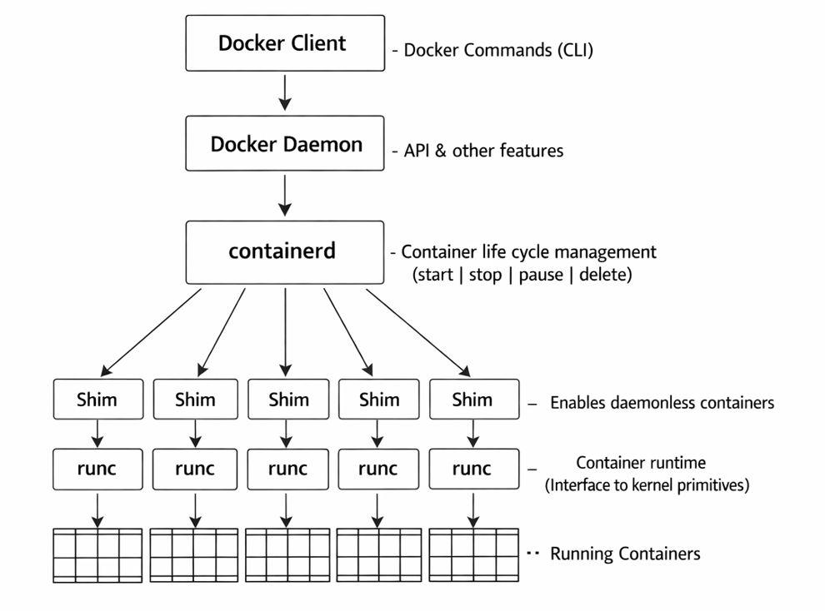

  - Containerd
    - containerd is an industry-standard container runtime used to run containers, manage container lifecycle, and provide low-level container operations.
    - It is a CNCF graduated project, originally developed by Docker, now used by:
      - Kubernetes (default runtime since v1.24)
      - Docker Engine (Docker uses containerd internally)
      - Amazon ECS / EKS
      - Cloud providers & Linux distros
    - Think of it as the core engine responsible for running containers, while tools like Docker CLI or Kubernetes use it in the background.

    - Why does containerd exist?
      - Because Docker Engine was too big and included a lot of extra components (build system, networking stack, logging, CLI).
      - Kubernetes needed a clean, lightweight, stable, industry-standard container runtime, so Docker split out the core runtime → containerd.
      - Now Kubernetes directly talks to containerd, not Docker.

    - What Containerd actually does?
      - Container life cycle management
      - Image Management
      - Snapshotting (to maintain file system layers)
      - Stores container metadata in
        - BoltDB (key-value database)
        - Local filesystem (layers, snapshots)
      - Handles container logs

  - Containerd-shim
    - containerd-shim is a small lightweight process that sits between containerd and runc.
    - responsible for managing the container's lifetime after runc starts it.
    - Each container has its own shim:
      - shim A → container A
      - shim B → container B
      - shim C → container C

    - Why shims are needed?
      - Allows container to run without containerd
        - Once the shim starts a container, the container doesn't depend on dockerd or containerd. The container continues running even if containerd dies or restarts.
      - Keeps runc short-lived (as intended by OCI spec)
        - Open Container Initiative(OCI) says:
          - runc should only create/start the container
          - It should exit immediately
        - But containers run for hours/days.
        - shim takes over the process supervision and runc is not kept running for the entire life of the container.
      - Handles container I/O (stdin, stdout, stderr)
    - Without shim, if containerd crashed:
      - All running containers would die
      - Parent-child process hierarchy would break
      - Zombie processes would accumulate
      - runc would have to stay alive as long as containers run (not intended)
    - So shim isolates container runtime from containerd.

  - runc
    - runc is the low‑level OCI-compliant container runtime used by Docker, containerd, Kubernetes (via containerd/CRI‑O), and most modern container ecosystems.
    - It is responsible for the actual creation of a container using Linux kernel features.
    - runc does NOT stay running, It runs the container process and immediately exits. So,runc just does one job:
      - "Create and start the container, then exit."

    - Why runc exits?
      - It is not supposed to manage the container lifecycle
      - It only creates & starts the container
      - Then the container is kept alive by containerd-shim, NOT runc.
    - Higher level services (Docker Daemon, containerd, shim) do not create containers.
      - Only runc actually does this:
        - creates namespaces
        - assigns cgroups
        - sets root filesystem
        - performs pivot_root() / chroot
        - sets capabilities
        - applies seccomp / AppArmor profiles
        - starts the container process
      - This is why runc is considered the “kernel interface layer”.

    - What is the issue if runc stays alive?
      - If runc stayed alive, killing the container would also kill runc.
      - If runc remained the parent process of the container, then:
        - stopping runc → container dies
        - docker daemon restart → container dies
        - losing runtime process = losing container
      - This contradicts a core principle of Docker:
      - Containers must stay running independently, even if Docker Engine crashes.
      - So runc must exit.

- Dockerfile
  - A Dockerfile is a declarative build script that defines how to build a container image.
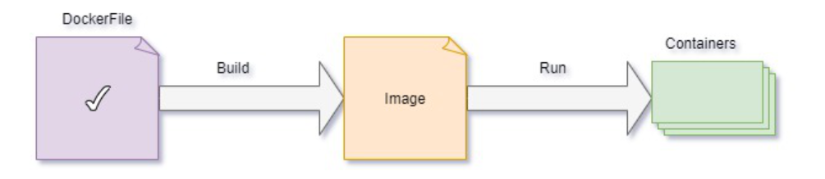
  - To build your own image, you create a Dockerfile with a simple syntax for defining the steps needed to create the image and run it.
  - Each instruction (e.g., FROM, RUN, COPY) creates a layer in the image (except a few metadata-only instructions).
  - Docker builds images by executing the Dockerfile top-to-bottom, caching layers where possible for fast incremental builds.

  - What are Layers?
    - A Docker image is made of multiple read-only layers, and each Dockerfile instruction creates a new layer.
    - Each layer:
      - Stores file changes made by that instruction
      - Is read-only
      - Is cached (if unchanged)
      - Is shared across images (saves disk space)

  - Which dockerfile instructions create layers?
Instruction | Creates Layer? | Notes
FROM | Yes | Starts a new stage
RUN | Yes | Every RUN = a new layer
COPY | Yes | Files copied → new layer
ADD | Yes | Same as COPY, plus extraction
CMD, ENTRYPOINT, ENV, WORKDIR, USER, EXPOSE | No | Only metadata

  - How layers are shared?
    - Docker uses content-addressable storage. Docker stores each layer in the filesystem using the layer’s content hash.
    - Every layer has a unique sha256 hash based on its contents.
    - Layers are stored in /var/lib/docker by digest
      - Digest is a cryptographic hash (SHA‑256) that uniquely identifies the exact content of a Docker layer or image.
    - If two images contain a layer with the same hash → Docker stores it once and reuses it.
    - Image A Dockerfile
      - FROM ubuntu:20.04
      - RUN apt-get install -y python3
      - COPY appA /app
    - Image B Dockerfile
      - FROM ubuntu:20.04
      - RUN apt-get install -y python3
      - COPY appB /app
    - Shared layers:
      - ubuntu:20.04 → same digest
      - RUN apt-get install python3 → same command → same final filesystem → same digest
    - Not shared:
      - COPY appA layer
      - COPY appB layer
    - Thus:
      - 2 layers are shared
      - 1 layer is unique per image
      - Disk usage saved = huge.

  - When you change the Dockerfile and rebuild the image, only those layers which have changed are rebuilt. This is part of what makes images so lightweight, small, and fast, when compared to other virtualization technologies.

- Docker hub and docker images
  - Docker Hub is the world’s largest container registry, serving as a cloud-based platform for storing, managing, and sharing Docker container images.
  - It enables developers to push (upload) and pull (download) images for applications, with support for both public and private repositories.
  - Commands
    - docker images
    - docker login ( using personal access token/PAT )
      - To push and pull images from docker hub
      - Using PAT is recommended rather than username and password
    - Login to docker hub
      - User Profile > Account Settings
      - Personal access tokens
        - Generate new token
        - Create Access Token
          - Access token description (Token Name)
          - Access permissions (Read, Write, Delete)
          - Click ‘Generate’ and Copy the PAT
      - docker login
        - username: (docker hub username)
        - password: paste the PAT

- Running Docker Images
  - docker pull <image-name>
    - e.g: docker pull hello-world
  - docker images (to list all the images stored on the local machine)
  - docker run <image-name>
    - e.g: docker run hello-world
  - While a container is running, it block your terminal/screen. Thus, it is recommended to use container in detached mode.
    - To run a Docker container in detached mode, use the -d or --detach flag with the docker run command. This starts the container in the background, freeing your terminal for other tasks.
      - docker run -d <image-name>
      - Example: docker run -d nginx starts an Nginx server in the background.
    - Verify the container is running:
      - docker ps
      - This lists all running containers, including those in detached mode.
  - To stop docker container
    - docker stop <container-id>

- Writing / Creating a dockerfile
  - Dockerfile for Java Application
  - Creating an Image that can run Java Application in a container
  - To create/build docker image from dockerfile located in the current directory:
    - docker build -t <assign-image-name> .
      - e.g: docker build -t java-app .
    - docker build
      - Tells Docker to build an image using a Dockerfile.
    - -t image-name
      - The -t flag means tag the image.
      - image-name is the name of the image you want to give.
      - You can optionally add a version:
        - -t image-name:1.0
      - If no version is given, Docker uses latest by default.
    - . (dot)
      - This is the build context.
      - . means: use the current directory as the context.
      - Everything in this directory is sent to the Docker Engine, including:
        - Dockerfile
        - source code
        - configs
        - dependencies
      - Docker then reads the Dockerfile from this context and builds the image.

- Docker Networking
  - Containers run in isolated environments. By default, a container cannot talk to other containers, the host, or the outside world unless Docker provides a networking layer.
  - Docker networking allows containers to communicate:
    - With each other
    - With the host machine
    - With the outside world
    - In controlled isolated networks, similar to VMs but lighter
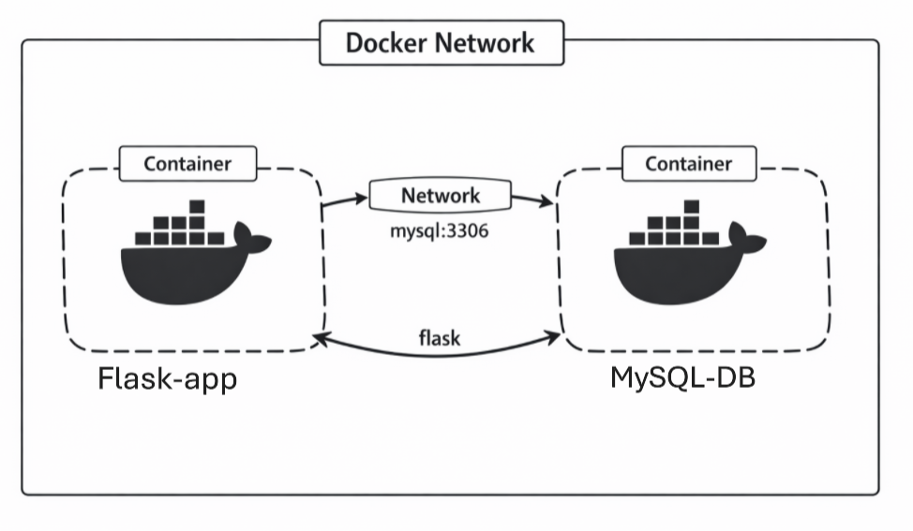
  - Docker uses a network namespace per container + virtual Ethernet interfaces + Linux bridge + iptables for routing/NAT.

  - When Docker Engine on Linux starts for the first time, it has a single built-in network called the "default bridge" network. When you run a container without the --network option, it is connected to the default bridge.
  - Containers attached to the default bridge have access to network services outside the Docker host. They use "masquerading" which means, if the Docker host has Internet access, no additional configuration is needed for the container to have Internet access.

  - Docker Network Drivers
    - Drivers = Plugins that tell Docker how to do something.
    - For example:
      - A network driver plugin tells Docker how to route packets.
      - A volume driver plugin tells Docker how to store data.
      - A logging driver plugin tells Docker where and how logs go.

  - Types of Network Drivers
  - There are 7 types of Docker Networking Drivers

    - Bridge Network Driver (Default)
      - The default network driver. If you don't specify a driver, this is the type of network you are creating.
      - Bridge networks are commonly used when your application runs in a container that needs to communicate with other containers on the same host.
      - Purpose: Private internal network on single host
      - Common Use: Multi-container apps on one machine

    - Host Network Driver
      - Remove network isolation between the container and the Docker host, and use the host's networking directly.
      - The container shares the host's networking namespace
      - E.g: if you run a container which binds to port 80 and you use host networking, the container's application is available on port 80 on the host's IP address.

    - None Network Driver
      - Completely isolate a container from the host and other containers.
      - Container has no network.
      - none is not available for Swarm services.

    - User Defined Networks (Custom)
      - You manually create a network:
        - docker network create -d bridge my-net
        - Here,
        - docker network create: This tells Docker to create a new user‑defined virtual network.
        - -d bridge: -d specifies the network driver. Here, bridge driver.
        - my-net: This is the name of the network.
      - Run containers in it:
        - docker run -d --name app --network=mynet app-image
        - docker run -d --name db --network=mynet db-image
      - Benefits:
        - Native container name resolution (DNS)
        - Better isolation
        - Better control of subnets, IP ranges

    - MACVLAN Network Driver (docker swarm)
      - Some applications, especially legacy applications or applications which monitor network traffic, expect to be directly connected to the physical network.
      - In this type of situation, you can use the macvlan network driver to assign a MAC address to each container's virtual network interface, making it appear to be a physical network interface directly connected to the physical network.
      - Macvlan networks allow you to assign a MAC address to a container, making it appear as a physical device on your network.
      - The Docker daemon routes traffic to containers by their MAC addresses.

    - IPVLAN Network Driver
      - IPVLAN is a high‑performance L3/L2 network driver where containers share the host’s MAC but get unique IPs, optimized for clouds, VMs, and environments where MACVLAN cannot operate.
      - Where MACVLAN focuses on Layer‑2 separation (each container gets its own MAC),
      - IPVLAN provides Layer‑3 separation (containers share the host MAC but get unique IPs).
      - IPvlan networks give users total control over both IPv4 and IPv6 addressing.

    - Overlay Network Driver
      - Used in Docker Swarm / Kubernetes.
      - Purpose:
        - Connect containers across multiple hosts
        - Encrypted traffic (VXLAN)
      - Overlay networks connect multiple Docker daemons together and enable Swarm services and containers to communicate across nodes. This strategy removes the need to do OS-level routing.

- Docker Network connection of a 2-tier application (Time Stamp: 1:28:00)
  - Flask application
  - MySQL application
  - Implementation of docker network between them
- Learn
  - docker network ls
    - list all Docker networks available on your Docker host.
  - Creating custom Docker network
    - docker network create <custom-network-name> -d <network-driver-name>
      - e.g: docker network create mynetwork -d bridge

  - Running MySql
    - docker ps -a : lists all the containers (running+stopped)
    - If any container related to MySQL is running, stop it first and then remove or delete all the associated containers.
      - docker stop <container-id>
      - docker rm <container-id>
    - docker image ls : lists all the images

    - Pull MySQL image
      - docker pull mysql
        - this will pull latest version image of mysql
    - docker image ls
    - verify the image has been pulled successfully
    - Setting Environment Variable inside container
      - docker run -d -e MYSQL_ROOT_PASSWORD=root --name MySQL-container mysql:latest
      - -d: runs container in background
      - -e MYSQL_ROOT_PASSWORD: sets root password
      - -- name MySQL-container: container name
      - mysql:latest : pulls and runs latest MySql image
    - Connect to MySQL
      - docker exec -it MySQL-container mysql -u root -p
      - docker exec: runs a command inside an already running container
      - -it: these are two flags
        - -i: interactive input
        - -t: allocate a terminal
        - Together they let you interact like a real terminal
      - MySQL-container: this is the container name where the command will run
      - mysql: this is the MySql client program inside the container
      - -u: username
      - -u root: login as root user
      - -p: ask for password interactively
    - Enter Password: root
    - You are now connected to MySQL Server
      - Now you can run queries. E.g: show databases;

- Docker Network connection of a two tier application
  - docker run -e
    - used to set environment variables inside a container at runtime.
  - cat <filename> Vs Vim <filename>
  - docker build -t two-tier-backend .
    - builds a Docker image using the current directory as the build context.
    - Syntax:
      - docker build -t <image-name/tag> <build-context>
    - docker build: Builds a Docker image from a Dockerfile.
    - -t: Tag flag assigns a name (and optionally a version) to the image.
    - two-tier-backend: The tag/name given to the resulting image (equivalent to two-tier-backend:latest).
    - . : Build context — the current directory whose files are sent to Docker daemon for use in the build.
  - docker run -d -p 5001:5000 -e MYSQL_HOST=MySQL-container -e MYSQL_USER=root -e MYSQL_PASSWORD=root -e MYSQL_DB=DevOps two-tier-backend:latest
    - when you run this command for ‘two-tier-backend:latest’ image, and execute ‘docker ps’
    - you will notice the container for the image ‘two-tier-backend:latest’ is not present.
    - Now, run ‘docker ps -a’
    - Here, you will see the ‘two-tier-backend:latest’ has exited. Why???????
      - Because this is a two-tier app and Backend cannot connect to MySQL is why your container exits.
      - This happens because your containers are not on the same Docker network.
    - Stop and remove/delete the prior running containers of MySQL
    - Create a network
      - docker network create two-tier-network -d bridge
      - use the mysql image to create a container inside ‘two-tier-network’ network
      - use the two-tier-backend image to create a container inside 'two-tier-network’ network
      - README.MD github
- Next Start from 1:48:00
- When a container say MySql is deleted all of its data is lost
- Thus, we bind the containers data with host via Docker volume
- Time stamp 1:53:00
- 1:58:00 using local folder as volumes
- docker create volume

- Next is:
  - dockerfile for java application, python application, node application etc.
  - creating images and containers for java, python and node application
  - how to keep containers running (docker -itd <image-name>)
  - detached mode
  - using mysql via docker
  - Port Mapping between Docker and Local machine
  - Docker Networking
    - Port Publishing and Mapping
    - DNS Services
    - Subnet Allocation
    - Connecting to multiple networks
    - Attaching Containers to Networks / User Defined Network drivers
  - How Containers communicate
    - Container to Container (Same Network)
    - Container to host (and vice-versa)
    - Container to internet (and vice-versa)
  - Docker Swarm
    - MACVLAN
    - IPVLAN
    - Overlay
    - These 3 are outdated and no longer used even in docker swarm. This claim of the Video is INCORRRREECCTTTT.
- One-line summary for each component
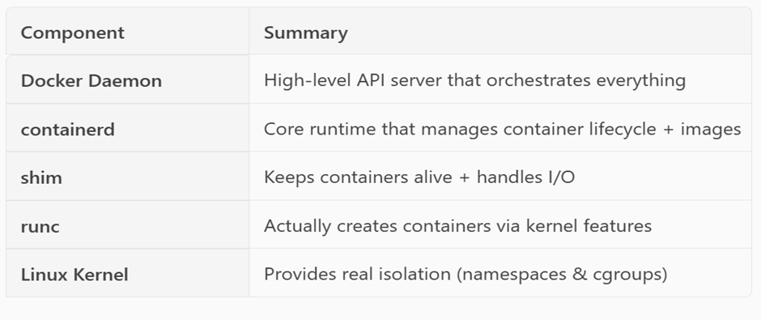
- Points to Ponder:
  - What happens when you run a container
  - 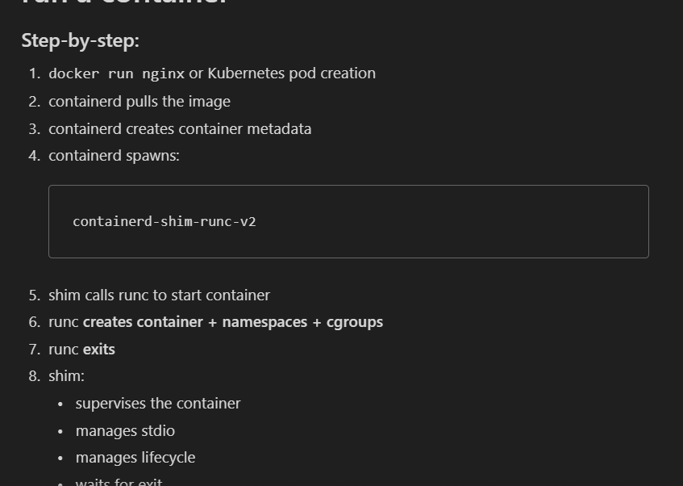
  - What happens when docker daemon crashes
  - What happens when containerd crashes
  - What happens when shim crashes
  - What happens when runc crashes
  - Flow of execution
  - Full diagram of containerd → shim → runc recovery flow

