page

priest

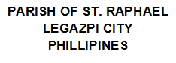

purpose

date

no

page

day

sponsor2

sponsor1

by

month

year

day

name

Saint Raphael

day

year

month

born

mother

father