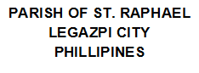

date

book

no

page

priest

by

year

month

day

name