Quit1:

求0.2A+(-5)B-2C的D11和D24

求D=A+B-C, *D*23 *D*31​

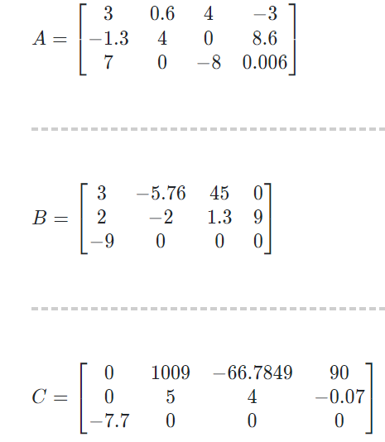

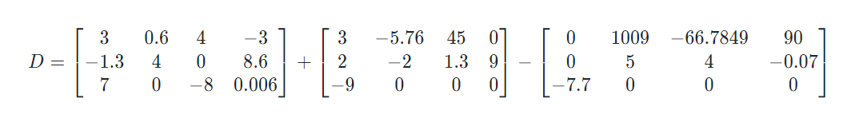

Solution:

D23=-2.7

D31=5.7

D11=-14.4

D24=-43.14

Quiz2:

求A\*B和B\*A

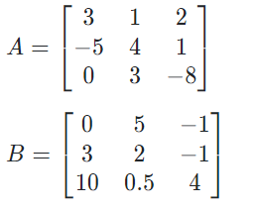

Solution:

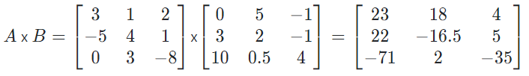

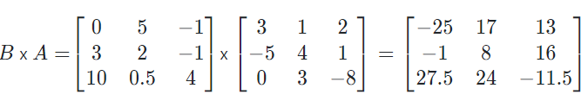

Quiz3:

求A\*B

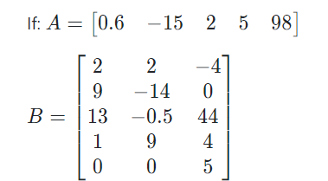

Solution:

