UNDERVERSE • USER DOCUMENTATION

USER GUIDE
UEDITOR
  - Detailed Guide for End Users

Text Editing • Formatting • Images • Links • Content Blocks • Advanced Tables • Formulas • Shortcuts • Troubleshooting
INFORMATION — Document Language
This edition is written in English, and all screenshots use the English interface. Section 19 provides an English–Vietnamese terminology reference.

Document Version | 2.0
Last Updated | July 24, 2026
Audience | Customers / End Users
Scope | UEditor in the Underverse project

USER GUIDE • VERSION 2.0

Document Information and Scope
This document provides instructions on how to use UEditor from an end user perspective. Content is mapped directly to the UEditor implementation in the project, including toolbars, classic menus, quick commands, tables, formulas, images, attachments, and keyboard shortcuts.
NOTE — The Interface May Vary
UEditor allows each application screen to enable or disable toolbars, classic menus, bubble menus, counters, and selected integrated features. Therefore, a screen may not display every button described in this guide.

How Feature Names Are Presented
- Feature names are shown in English to match the screenshots. Vietnamese equivalents are listed in Section 19.
- Ctrl/Cmd means using Ctrl on Windows/Linux and using ⌘ Command on macOS.
- “Select content” means highlighting text, selecting an image, or selecting one or more table cells before using a command.
- A gray or unclickable button usually means that the current cursor position does not match the command.

Shortcut Reliability Levels
Type | Meaning
UEditor shortcut | Is handled directly by UEditor/Tiptap and can be used when the cursor is in the editing area.
Browser shortcut | Cut, copy, paste… are handled by the browser/operating system; may depend on clipboard permissions.
Shortcut label in menu | Menu can display suggestions such as Ctrl+S, Ctrl+K, Ctrl+Shift+F; Operability also depends on the integrated screen.

Table of Contents
The table of contents will update when the document is opened in Microsoft Word.
INFO — Updated table of contents
If the page numbers do not appear immediately, open the document in Microsoft Word, right-click the table of contents, and select Update Field → Update entire table.

1. Quick Start: 3 Minutes

1.1 Creating and Saving Content
1. Click on the white area of the UEditor to place the cursor.
2. Enter text as in a regular editor. Press Enter to create a new paragraph.
3. Highlight the part that needs formatting, then use the toolbar or floating menu.
4. Type “/” in a paragraph to quickly insert titles, lists, tables, information boxes, files…
5. Check the word/character counter in the editor footer if the screen has limits enabled.
6. Click the Save button of the application screen or File → Save if this function has been integrated by the system.
7. Wait for the successful save notification, especially if the content has images or files to upload.
TIP — The fastest way to operate
With normal content, just remember 4 operations: highlight to format, type “/” to insert block, type “:” to find emoji and use Ctrl/Cmd+Z to undo.

1.2 Quick Reference
Task | Quick way
Create title | Type /heading then select level 1–3; or Ctrl/Cmd+Alt+1, 2, 3.
Bold / italic / underline | Highlight the text and press Ctrl/Cmd+B, I or U.
Insert link | Highlight the text → Link button → enter a valid URL → confirm.
Insert image | Image button → URL/Upload. You can also paste or drag and drop images into the editor.
Insert table | Table button → drag to select cell number; or type /table to create a 3×3 table.
Calculate the total in the table | Select the result cell → enter =SUM(A1:A3) → Enter.
Insert info box | Type /callout → Enter → select emoji and background color.
Insert file | Type /file → Enter → select the file on the device.
Preview | View → Preview or eye button.
Return to the previous operation | Ctrl/Cmd+Z.

2. Getting Familiar with the Interface

2.1 Main Interface Areas
Region | Purpose | When does it appear?
Classic menu (Menu bar) | File, Edit, View, Insert, Format, Tools, Table. | Appears only when the screen is in classic menu mode.
Toolbar | Format text, color, alignment, list, image, table, undo… | Usually located in the editing area; Horizontal scrolling is possible on narrow screens.
Editing area | Type, select, paste, and organize content. | Always when the editor is in edit or view mode.
Bubble menu | Tools follow the currently selected object: text, image, link or table cell. | Appears after highlighting/selecting an object and the editor has focus.
Formula bar | Shows cell addresses, formulas, and apply/convert to value/delete buttons. | Appears when selecting a table cell containing a formula.
Table controls | Row/column handle, three-dot button, add row/column bar, resize handle. | Shows when pointing or placing the cursor in a table.
Editor pin | Displays word count, character count, and limit if applicable. | When the screen turns on the footer and counter.

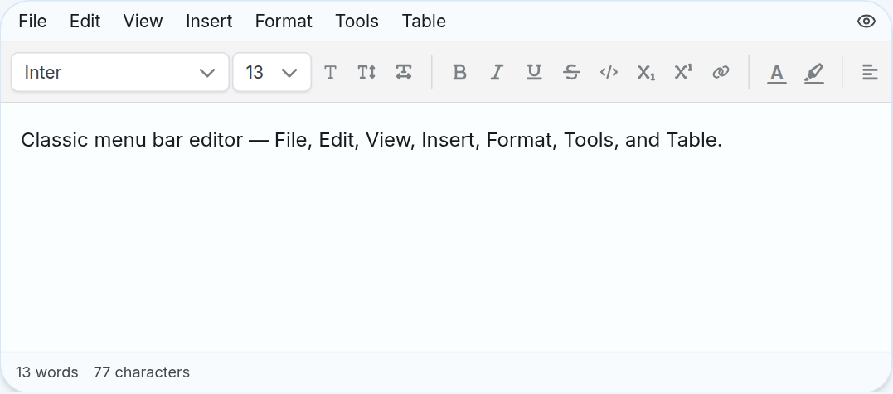
Figure 1. Classic menu, toolbar, input area and counter (English interface).
Figure 2. Full toolbar: font, font size, font style, links, color and alignment (English interface).

2.2 Button States
- Button is being filled with fill: formatting is currently applied to the cursor position or selection.
- Dim/lock button: invalid operation in current context; For example, Merge Cells is only used when multiple adjacent cells are selected.
- Button with arrow or click opens menu: contains multiple options in the same group.
- Icon may vary by object; For example, the Merge Cells button changes to Split Cell when in the merged cell.

2.3 Read-Only Mode
When UEditor is in read-only mode, toolbars, editing borders, and resizing handles are often hidden. Users can still read content, open links, or download files if the screen allows, but cannot edit.

3. Basic Editing

3.1 Creating, Selecting, and Deleting Content
Action | How to do it
Set cursor | Click on the location you want to enter.
Create new segment | Press Enter.
Choose a word | Double-click the word.
Select a text area | Hold down the left mouse button and drag over the content; or hold Shift and arrow keys.
Select all content | Ctrl/Cmd+A when the cursor is in the editor.
Delete selection | Press Backspace or Delete.
Undo | Ctrl/Cmd+Z or Undo button.
Do it again | Ctrl/Cmd+Y; On macOS you can use Shift+Cmd+Z.

3.2 Cut, Copy, and Paste
- Cut: Ctrl/Cmd+X.
- Copy: Ctrl/Cmd+C.
- Paste: Ctrl/Cmd+V.
- Paste as plain text: Edit → Paste as Text. The browser may ask for permission to read the clipboard.
- Paste table from Excel/Google Sheets or tab-separated data: UEditor tries to convert to table and keep compatible data/formats.
- Paste image from clipboard: image is inserted at the cursor position if the format and size are accepted by the system.
NOTE — Browser clipboard permissions
Some browsers block the Paste button in the menu. Then use Ctrl/Cmd+V. If pasting a table from an external source, always recheck borders, cell merges, and formulas after pasting.

3.3 Indenting with Tab
- When the cursor is in the middle of a paragraph: Tab inserts a tab space at the cursor position; Shift+Tab deletes the tab immediately before the cursor.
- When the cursor is at the beginning of a paragraph or multiple paragraphs are selected: Tab increases the indentation of the entire block; Shift+Tab reduces indentation.
- In list: Tab makes item a child; Shift+Tab moves the item up one level.
- In table: Tab moves to next cell; Shift+Tab goes back to the previous cell.
- Backspace at the beginning of an indented paragraph will decrease by one level before merging the paragraph.

4. Text and Paragraph Formatting

4.1 Paragraph Styles
Type | Purpose | How to use
Normal text | Body content. | Place cursor in paragraph → Text Style → Normal text.
Heading 1 (Heading 1) | The largest title of the content. | Text Style → Heading 1 or Ctrl/Cmd+Alt+1.
Heading 2 (Heading 2) | Level 2 content group. | Text Style → Heading 2 or Ctrl/Cmd+Alt+2.
Heading 3 (Heading 3) | Level 3 content group. | Text Style → Heading 3 or Ctrl/Cmd+Alt+3.
Quote (Quote/Blockquote) | Highlight a citation or citation note. | Quote button, /quote or Ctrl/Cmd+Shift+B.
Code Block | Show code snippet with syntax highlighting. | Code Block button, /code or Ctrl/Cmd+Alt+C.

TIP — Use headings at the right level
Do not select Heading just to make the text larger. Use Heading 1 → Heading 2 → Heading 3 according to the document structure to make the content easier to read and support better accessibility.

4.2 Font, Font Size, Line Height, and Letter Spacing
- Font Family: select the font for the highlighted text area or the next text to enter. The font list can be configured for each screen.
- Font Size: default sizes from 8 to 28, additional 36, 48, 72 and 96 px. The floating menu allows direct input of 8–96 px values.
- Line Height: default line spacing or levels 1.2, 1.5, 1.75 and 2.
- Letter Spacing: letter spacing from -0.02em to 0.08em; Use negative values to make the text closer and positive to make the text more airy.
- To return to default, select Default in the corresponding menu.

4.3 Character Formatting
Features | English label | UEditor shortcut | How to use
Bold | Bold | Ctrl/Cmd+B | Highlight the text and press B.
Italics | Italic | Ctrl/Cmd+I | Highlight the text and press I.
Underline | Underline | Ctrl/Cmd+U | Highlight the text and press U.
Strash | Strikethrough | Ctrl/Cmd+Shift+S | Used for canceled/no longer applicable content.
Inline code | Inline Code | Ctrl/Cmd+E | Used for command names, variables, or short code snippets.
Subscript | Subscript | Ctrl/Cmd+, | Example H₂O.
Upper index | Superscript | Ctrl/Cmd+. | Example x².

4.4 Text and Highlight Colors
1. Highlight the content that needs to be colored.
2. Click Text Color to select text color or Highlight to select text background color.
3. Select an available color; Use More Colors if you need custom colors.
4. Select Automatic/Default to return the default color.
NOTE — Contrast
Don't use too light colors for text and don't just use colors to convey status. When sending content to clients, it's a good idea to test both light and dark mode if the system supports it.

4.5 Alignment, text direction and line breaks
- Align Left / Center / Right / Justify: align left, center, right or both sides for paragraph/heading.
- Decrease/Increase Indent: reduces or increases the paragraph indent.
- When the cursor is in a table cell, the Alignment menu adds Top/Middle/Bottom vertical alignment.
- Text Direction in table cell: horizontal or vertical text.
- Wrap Text: enable/disable automatic line wrapping in table cells.

4.6 Clear Formatting
In the classic menu, select Format → Clear Formatting to remove the currently applied formatting and return the block to its basic form. If you only want to turn off one attribute, highlight the text and then press the active button again.

5. Lists, Tasks, and Form Fields

5.1 Bulleted and Numbered Lists
- Bullet List: used for ideas without order; shortcut Ctrl/Cmd+Shift+8.
- Numbered List: used for process or priority order; shortcut Ctrl/Cmd+Shift+7.
- Press Enter to create the next entry.
- Press Enter at an empty entry to exit the list.
- Create child level tab; Shift+Tab brings the item to the parent level.

5.2 Task Lists
1. Select the list button → Task List, type /todo or press Ctrl/Cmd+Shift+9.
2. Enter job content.
3. Click on the bullet box to mark completed/incomplete.
4. Use Tab/Shift+Tab to create a child job or send it to a superior.

5.3 Checkbox Form Fields
Form Checkbox is an interactive field located right in the text line, different from Task List. There are two types: square and round. Choose from the toolbar, Insert → Form Fields or the /checkbox and /round checkbox commands.
- Click on the checkbox to enable/disable.
- When the checkbox has keyboard focus, press Space or Enter to toggle it on/off.
- Form checkbox works independently; Multiple checkboxes can be selected at the same time.

5.4 Radio Button Form Fields
1. Type /radio or select Insert → Form Fields → Form Radio Button.
2. Press the radio to select; Radios with the same Group Name only allow one value to be selected.
3. Select the radio in the editor to display the gear icon.
4. Press the gear and edit Group Name if you want multiple radios to belong to the same group.
TIP — Same group name
To create a single-choice question, set the same Group Name for all radios of that question. Two different questions must use two different Group Names.

6. Links

6.1 Inserting Links into Text
1. Highlighting text will become a link.
2. Click the Link button on the toolbar/bubble menu or select Insert → Link.
3. Paste or type the address, for example https://example.com.
4. Confirm to apply. After insertion, further typing will continue beyond the link.

6.2 Opening, Editing, and Removing Links
- Click on the text with the link to open the preview menu.
- Open Link opens the link in a new tab.
- Edit Link allows editing the address.
- Remove Link/Unlink removes the link but keeps the text intact.

6.3 Valid URLs
UEditor checks for safety before inserting or opening links. Full HTTPS is recommended. The system can accept local addresses, relative paths, email (mailto:) or phone numbers (tel:) if formatted correctly; Dangerous addresses such as javascript: rejected.
NOTE — Ctrl/Cmd+K
The menu can display Ctrl+K next to Link, but the current UEditor code does not register this key as a required shortcut. For stable operation, use the Link button or menu Insert → Link.

7. Images

7.1 Inserting Images
How | Action | Note
From URL | Image → Add from URL → enter image URL and description. | URL must be valid and accessible.
From device | Image → Upload → select one or more images. | Only images with the correct format/configuration capacity will be inserted.
Paste | Copy the image then Ctrl/Cmd+V in the editor. | The image is placed at the cursor position.
Drag and drop | Drag the image file into the editing area. | The image is placed near the drop location.

Supported default formats include PNG, JPEG, WebP, GIF, and SVG. The default limit is 10 MB per image. Application screens can set smaller limits or remove formatting.

7.2 Image Descriptions (Alt Text)
When inserting an image from a URL, you should fill in a brief Alt text describing the content or purpose of the image. For decorative images that do not carry information, they can be left blank. Alt text helps screen reader users and displays when images are corrupted.

7.3 Image Layout and Size
1. Click on the image to select. The selected image has a colored border and a floating menu appears.
2. Select Block so the image is on a separate line.
3. Select Left or Right so that the image floats left/right and the text flows around it.
4. Select S, M or L to apply the preset size.
5. Use Reset to return to natural size or Delete to delete the image.
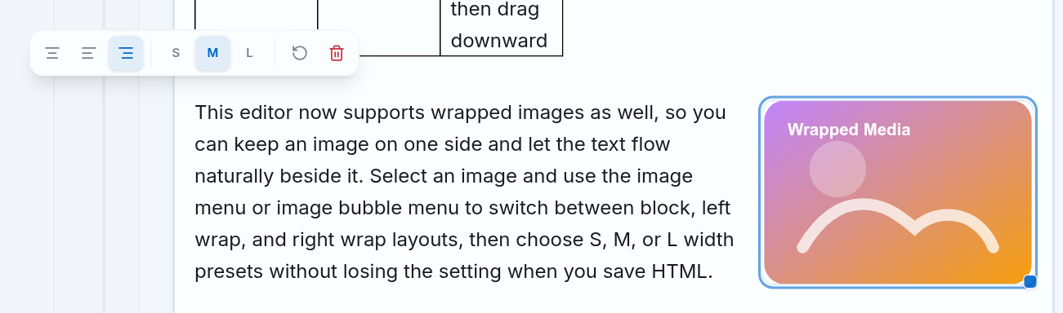
Figure 3. Selected image, layout menu Block/Left/Right, size S/M/L, Reset and Delete (English interface).

7.4 Resizing Images by Dragging
1. Click or hover over the image to display a small handle in the lower right corner.
2. Hold the left mouse button on the handle and drag.
3. Release the mouse button when it reaches the desired size. UEditor keeps image proportions and prevents images from exceeding editor width.

7.5 How Images Are Handled When Saving
Depending on configuration, images can be uploaded immediately upon insertion or temporarily kept in the content and then uploaded upon Save. If the screen uses an upload-on-save mechanism, do not close the page until a success message appears.
WARNING — Do not close the page while an image is loading
If there is a network outage or the page closes while the image/file is loading, the saved content may be missing media. Try again, check the image displayed and only leave the page after the system confirms successful saving.

8. Slash Commands

8.1 Opening and Navigating the Command Menu
1. Place the cursor at a paragraph and type /.
2. Enter keywords to filter, for example /table, /quote, /file.
3. Use Arrow Up/Arrow Down to move between results.
4. Press Enter to insert the currently selected item. Press Esc to close the list.
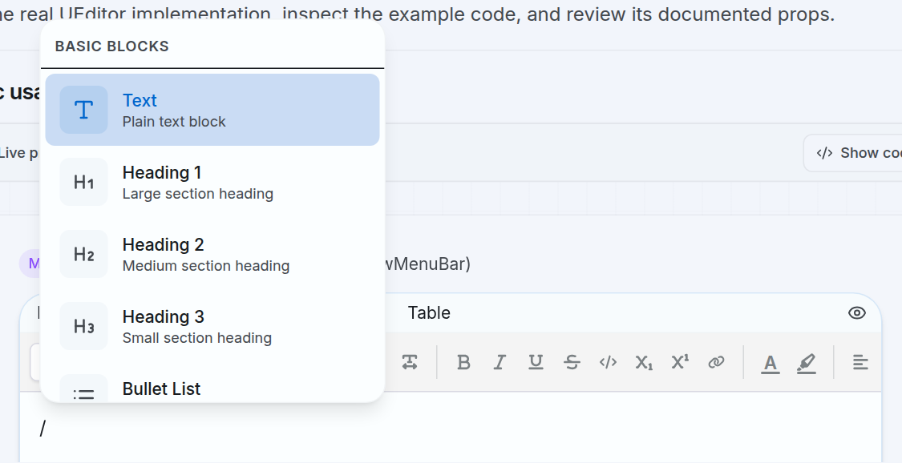
Figure 4. Basic Blocks list after typing / (English interface).

8.2 Command Reference
Command/block | Result | Main usage
Text | Normal paragraph. | Convert the current paragraph to text.
Heading 1/2/3 | Header level 1–3. | Organize content structure.
Bullet List | Bulleted list. | Listing is not ordered.
Numbered List | Numbered list. | Process or order.
To-do List | Job List. | Track completion status.
Quote | Block quote. | Highlight the quote.
Code Block | Code block with color. | Select language and copy code.
Divider | Horizontal lines. | Separate parts.
Table | 3×3 table has header rows. | Quickly insert default table.
Callout | Information box with emoji. | Highlight important notes.
Bookmark Card | Link preview tag. | Enter URL in the ask box.
File Attachment | Attachment tag. | Select files on the device.
Form Checkbox | Square Checkbox. | Independent field selection.
Round Checkbox | Circular Checkbox. | Round independent selection field.
Form Radio Button | Select one button. | Use Group Name to group.

9. Emoji and Advanced Content Blocks

9.1 Inserting Emoji with :
1. Type : and enter the emoji name in English, for example :heart.
2. Use the arrow keys to move through the list.
3. Press Enter to insert emoji. Press Esc to close.
4. If no results, try another English keyword or just type : to see popular emojis.

9.2 Callouts
1. Type /callout and press Enter.
2. Click the emoji icon at the top of the box to open the picker.
3. Choose the right emoji.
4. Select background color Gray, Blue, Green, Yellow or Red.
5. Click on the text of the box and enter the content as a normal paragraph.

9.3 Bookmark Cards
Type /bookmark, enter the URL in the question box and confirm. UEditor displays the title, description, domain name, and preview image if the system has a metadata retrieval service. Click the tag or press Enter when the tag is in focus to open the link. If loading preview fails, use Retry Preview.

9.4 File Attachments
1. Type /file and press Enter.
2. Select files on the device.
3. Check the Uploading status if the system uploads the file immediately.
4. If there is an Upload failure, click Retry Upload.
5. Click the file tab or Download button to download.

9.5 Code Blocks
- Select language: Plain Text, JavaScript, TypeScript, HTML, CSS, Python, Go, Rust, C++, Java, SQL, JSON, YAML or Shell.
- Syntax color updated by language.
- Hover over the code block to display the language selection button and Copy.
- Click Copy to copy the entire code; Check mark icon indicates successful operation.
- Press Enter three times in succession at the end of the block to exit the code block; or use the down arrow key when at the end of the block.

9.6 Horizontal Rule
Use /divider or Insert → Horizontal Rule to insert horizontal lines. Separators are appropriate between large sections, but should not be used in place of titles.

10. Classic Menus
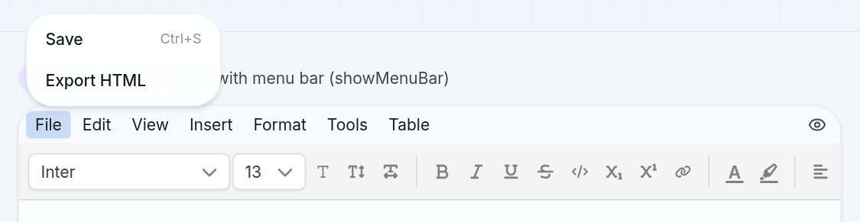
Figure 5. File menu with Save and Export HTML (English interface).

10.1 File
Item | Effect | Conditions/notes
Save | Call the save action of the integrated screen. | Only available when the system has a save function connected. The menu may be locked.
Export HTML | Export content to document.html file. | If the system does not provide native processing, the browser loads the HTML file itself.

10.2 Edit
- Undo / Redo: undo and redo.
- Cut / Copy / Paste: clipboard operation.
- Paste as Text: pasting content does not preserve formatting.
- Select All: select the entire document.

10.3 View
- Source Code: open HTML edit box directly; Click Apply to change the editor content.
- Preview: view content in reading mode before saving.
- Fullscreen: put the editor frame in full screen if the browser allows; exit with Esc.
- The eye button to the right of the menu bar also opens Preview.
WARNING — Edit source code
Source Code for people who understand HTML. Incorrect HTML can ruin the layout or lose properties of tables, pictures, formulas, and interactive fields. You should copy backup content before editing.

10.4 Insert
- Image / Image Upload: insert image from URL or device.
- Link: attach link to selected text.
- Table: select the number of rows/columns using a maximum grid of 8×8.
- Form Fields: Form Checkbox, Round Checkbox and Form Radio Button.
- Horizontal Rule: insert separator line.

10.5 Format
- Bold, Italic, Underline, Strikethrough, Superscript, Subscript, Inline Code.
- Wrap: Paragraph, Heading 1–3, Blockquote, Code Block, Task List.
- Align: Left, Center, Right, Justify.
- Clear Formatting: clear formatting.

10.6 Tools and Table
- Tools → Source Code: opens the HTML editor.
- Table → Insert Table: insert table using grid.
- Table → Delete Table: deletes the entire currently selected table.
- Table → Row/Column: delete row or column.
- Table → Cell: Merge Cells or Split Cell.
- Table Properties is currently an inactive item; Use the three-dot menu and cell menu to adjust the actual properties.

11. Tables: Complete User Guide
This chapter describes all available Table operations in UEditor: creating and pasting tables, selecting cells, managing rows/columns, resizing, formatting cells, borders and formulas. To control coverage, at the end of the chapter there is a matrix of 131 operations and options, coded from T001 to T131.
INFORMATION — How to Interpret the 131-item Count
This is the number of action items and user-observable options, including sub-selections such as 9 border positions, 4 border styles, 5 result formats, and 5 formula error types. These are not 131 independent modules.

11.1 Table Controls
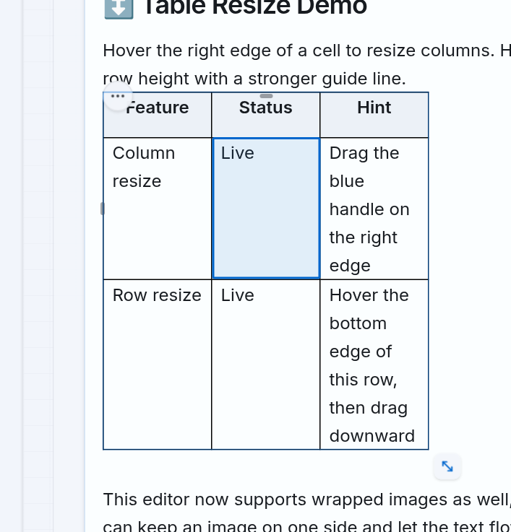
Figure 6. Selected cell, row/column handle, three-dot menu and table resizing button (English interface).
Control area | Location | What is it used for?
Toolbar | Above the editing area | Insert table; When the cursor is in the table, there will be additional columns/rows and cell merging/splitting.
Three-dot menu | Top left corner of the table | Align tables, add/remove structures, enable row/column headers, and open cell formatting.
Cargo handle | Outside the left edge of each row | Drag to change order or open row's own menu.
Column handle | Above each column | Drag to change the order or open the column's individual menu.
+ bar | Right edge and bottom edge of the table | Quickly add one or more columns/rows.
Diagonal drag button | Bottom right corner | Resize entire table.
Cell formatting toolbar | Floats above the currently selected cell | Background color, border, formula, merge/split, wrap, vertical alignment and text direction.
Formula bar | Above the editor content | Edit a formula, convert it to a value, or delete the formula cell.

11.2 Inserting a New Table
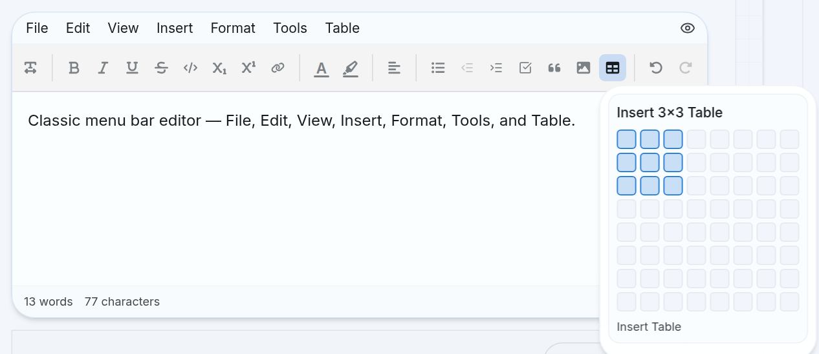
Figure 7. Select table size on the Insert Table grid (English interface).
How to insert | Steps | Result
Toolbar | Click Insert Table → drag to the desired number of rows/columns → click. | Create a table from 1×1 to 8×8, with the first row being the header.
Insert Menu | Select Insert → Table → select dimensions on the grid. | Same as the toolbar operation.
Menu Table | Select Table → Insert Table → select size. | Used when the interface has classic menu enabled.
Quick command | Type /table → press Enter. | Quickly create a 3×3 table with header rows.

TIP — Tables larger than 8×8
Create the closest size on the grid, then use Add Row, Add Column or drag the + bar to expand. The insert grid only limits the initial selection, not the final size of the table.

11.3 Pasting a Table from Excel, Google Sheets, or a Website
1. At the source, select the data area to copy and press Ctrl/Cmd+C.
2. Place the cursor on a blank line in UEditor.
3. Press Ctrl/Cmd+V. If the clipboard has an HTML table, UEditor creates the table according to that structure. If the data is text with Tab-delimited columns, UEditor creates a table from the TSV data.
4. Check the number of rows/columns, merged cells, background color, borders, width, height and text format.
5. Check the formula again. Excel/Google Sheets formulas are not interpreted as UEditor formulas unless the data already has compatible formula properties.
Data may be held | Conditions
Rows, columns, header cells, colspan and rowspan | The replication source must provide a valid HTML table structure.
Column width and row height | The source has a readable size property or CSS.
Background color, text color, border and content alignment | Source puts formatting into clipboard HTML/CSS.
Bold, italic, underline, strikethrough, and multi-line content | Source of corresponding tags/typefaces.
UEditor number formulas and formats | Held only when HTML has compatible data-formula and data-number-format attributes.

11.4 Selecting Cells and Navigating with the Keyboard
Action | Result | When should you use it?
Click a cell | Set the cursor to enter or edit text. | Compose regular content.
Double-click the text with the left mouse button | Select the text within the cell. | Format text without formatting the entire cell.
Triple-click the text with the left mouse button | Select the entire cell. | Format cells, open formulas, or perform cell operations.
Double-click a blank area in the cell with the left mouse button | Select the entire cell. | Use when the cell has empty space and you don't want to highlight the text.
Drag across multiple cells | Select a rectangular area. | Merge cells or apply formatting at the same time.
Tab | Go to the next cell. | Input data continuously from left to right.
Shift+Tab | Go to previous cell. | Quickly edit the data you just entered.
Tab in the last cell | Create an additional row and move the cursor to the new row. | Expand the table while entering data.
Backspace/Delete in the currently selected formula cell | Delete formulas and cell contents. | Quickly delete calculation cells.

INFORMATION — Selecting Text vs. Selecting a Cell
Double-click directly on the text with the left mouse button to select text within the cell. To select the entire cell, triple-click the text or double-click a blank area inside the cell.

11.5 Three-Dot Menu: Whole-Table Commands
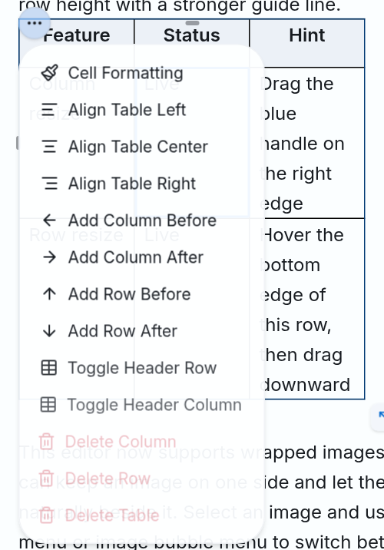
Figure 8. Whole-table control menu (English interface).
Command | Effect | Conditions/notes
Cell Formatting | Select the current cell to open the cell formatting toolbar. | Need to enable floating menu on built-in display.
Align Table Left | Place the entire table to the left. | Do not change text alignment in cell.
Align Table Center | Place the entire table in the middle. | Do not change text alignment in cell.
Align Table Right | Place the entire table to the right. | Do not change text alignment in cell.
Add Column Before/After | Add column before/after current column. | Old data is kept.
Add Row Before/After | Add row above/below current row. | Old data is kept.
Toggle Header Row | Move leading row between title cell and regular cell. | Used for row titles.
Toggle Header Column | Move first column between title cell and regular cell. | Used for column headings.
Delete Column | Delete current column. | Unable to revert after saving. You can use Undo before saving.
Delete Row | Delete current row. | The reference formula can be changed or reported an error.
Delete Table | Delete entire table. | You should check the correct table before clicking.

11.6 Row Menu
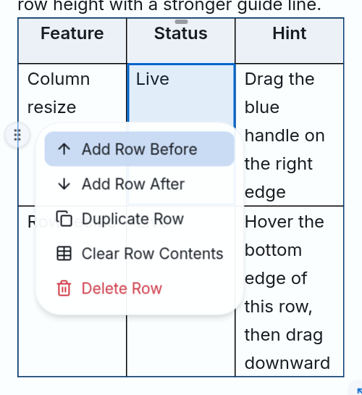
Figure 9. Menu of a row (English interface).
Command | How to do it | Result
Add Row Before | Drag the left edge of the row → open the handle → select command. | Add row above.
Add Row After | Drag the left edge of the row → open the handle → select command. | Add row below.
Duplicate Row | Open the row handle menu and select Duplicate Row. | Copy content and formatting to the new row below.
Clear Row Contents | Open the row handle menu and select Clear Row Contents. | Empty the content but keep the row structure.
Delete Row | Open the row handle menu and select Delete Row. | Delete the entire row.
Move Row | Hold and drag the row handle to a new position. | Change row order.

NOTE — Item has formula
Duplicate Row copies the cell's properties; Clear Row Contents preserves cell structure and formatting. After these two operations, check the formula cells. To completely delete a formula, use Clear Cell or Backspace/Delete in the formula cell.

11.7 Column Menu
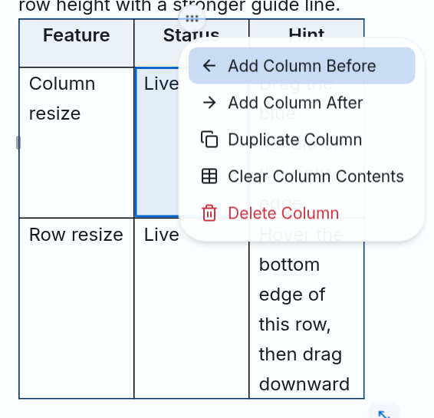
Figure 10. Menu of a column (English interface).
Command | How to do it | Result
Add ColumnBefore | Drag above the column → open the handle → select command. | Add left column.
Add Column After | Drag above the column → open the handle → select command. | Add right column.
Duplicate Column | Open the column handle menu and select Duplicate Column. | Copy content, format and width to new column.
Clear Column Contents | Open the column handle menu and select Clear Column Contents. | Empty the content but keep the column structure.
Delete Column | Open the column handle menu and select Delete Column. | Delete the entire column.
Move Column | Hold and drag the column handle to the new position. | Change column order.

11.8 Adding Multiple Rows or Columns Quickly
1. Click a cell to show the table controls.
2. Move the mouse close to the right edge to display a vertical bar with a + sign. Click to add a column; Hold and drag right to add more columns.
3. Move the mouse close to the bottom edge to display a horizontal bar with a + sign. Click to add a row; Hold and drag down to add more rows.
4. Observe the preview area and then release the mouse to confirm the number of rows/columns to add.

11.9 Resizing Columns, Rows, and the Entire Table
Audience | How to drag | Limits and support keys
Column | Drag the right edge of the box until the blue handle appears, hold and drag horizontally. | UEditor keeps the minimum width for the column to be usable.
Goods | Drag the bottom edge of the row until the guide line appears, hold and drag vertically. | Minimum height is applied automatically.
Entire table | Drag the diagonal resize handle in the lower right corner. | Drag freely to change both width and height.
Single axis lock | Hold Ctrl when dragging the entire table. | UEditor selects the primary change axis and keeps the other axis.
Keep scaling | Hold Ctrl+Shift when dragging the entire table. | The original width/height ratio is kept.

TIP — Wide panel
If the table is wider than the editing area, use the horizontal scroll bar below the table. Do not make the column too narrow because the content will wrap too much and make the table difficult to read.

11.10 Header Rows, Header Columns, and Table Alignment
Target | Command | Suggestions for use
Top is the title | Toggle Header Row | Used when each column has a data name.
The first column is the title | Toggle Header Column | Used when each row has its own label.
The table is on the left | Align Table Left | Fit narrow tables in long content.
The table is in the middle | Align Table Center | Suitable for illustration or summary tables.
The table is on the right | Align Table Right | Use only when the layout really needs it.

11.11 Merging and Splitting Cells
1. Drag to select at least two adjacent cells to form a rectangular area.
2. Click Merge Cells on the toolbar or cell formatting bar.
3. To split, select the merged cell and then click Split Cell.
4. Recheck the column widths, row/column headers and formulas after completion.
NOTE — Cell coordinates may change
Combining, splitting, adding, deleting or moving rows/columns can cause addresses A1, B2... to change. Always double-check formula cells and reference areas before saving.

11.12 Opening the Cell Formatting Toolbar
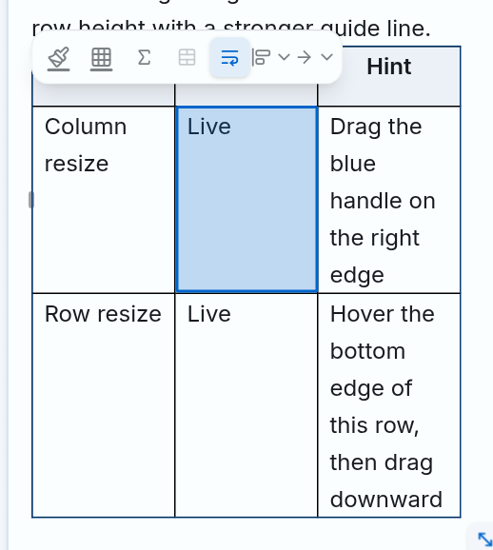
Figure 11. The format bar appears when selecting cells (English interface).
1. Click a cell in the table.
2. Open the three-dot menu and select Cell Formatting; or double-click in an empty area of the cell.
3. A floating format bar appears above the cell. From left to right include: Cell Background, Cell Border, Formula, Merge/Split, Wrap Text, Vertical Alignment and Text Direction.
4. If the toolbar does not appear, use the main toolbar above the editor. Some application screens may disable the bubble menu.

11.13 Cell Background and Horizontal Alignment
Features | How to use | Note
Cell Background | Select cell/cell range → click background color icon → select Automatic, available colors or More Colors. | Select Automatic to remove custom colors.
Align Left | Select text or cell → open Alignment → Align Left. | Only aligns the content, does not move the entire table.
Align Center | Select text or cell → open Alignment → Align Center. | Matching short data or status.
Align Right | Select text or cell → open Alignment → Align Right. | Usually used for numbers.
Justify | Select content → open Alignment → Justify. | Less suitable for narrow cells.

11.14 Vertical Alignment, Text Direction, and Wrapping
Group | Options | Effective
Vertical Alignment | Top Align | Put content close to the top of the cell.
Vertical Alignment | Middle Align | Place content centered in height.
Vertical Alignment | Bottom Align | Place content close to the bottom of the cell.
Text Direction | Horizontal Text | Display text horizontally normally.
Text Direction | Vertical Text | Rotate text display orientation to vertical.
Text Wrap | Wrap Text | Allow content to wrap automatically within column width.
Text Wrap | Don't Wrap Text | Keep content on one line; tables/columns may need horizontal scrolling.

11.15 Cell Border Formatting
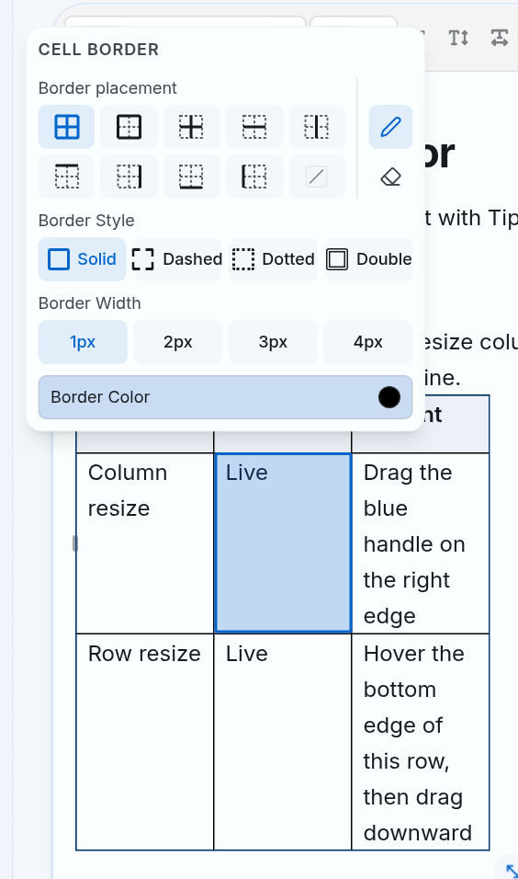
Figure 12. Cell border setting table (English interface).
1. Select a cell or multi-cell range.
2. Open Cell Formatting and click Cell Border.
3. Select Draw Borders mode to draw or Hide Borders mode to hide.
4. Select border position, stroke style, thickness and color.
5. Close the setup panel and then check for common edges between adjacent cells.
Group | Options | Meaning
Location | All, Outer, Inner | All; just the outer shell; or just lines inside the selection.
Internal location | Horizontal, Vertical | Horizontal line only or inside vertical line only.
Each edge | Top, Right, Bottom, Left | Apply only the corresponding edge of the selection.
Delete border | Clear Border | Remove all borders in the applied position.
Mode | Draw Borders, Hide Borders | Draw according to the selected style or set the border to hidden.
Stroke style | Solid, Dashed, Dotted, Double | Continuous, broken, dotted or two lines.
Thickness | 1px, 2px, 3px, 4px | Border thickness.
Color | Color palette, More Colors | Available color or system option color.

11.16 Cell Formulas and Number Formats
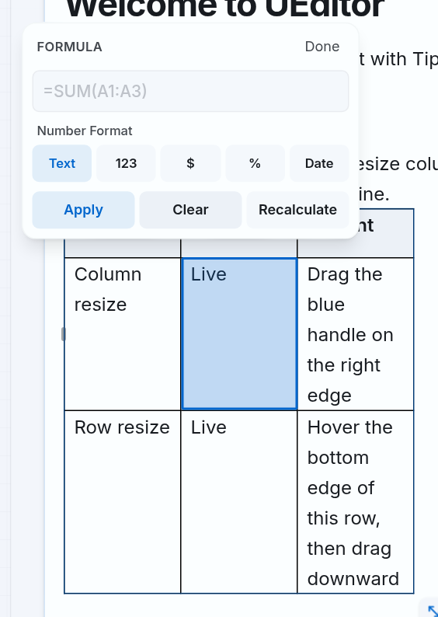
Figure 13. Table for entering formulas and selecting result format (English interface).
Ingredients | How to use
Formula | Enter an expression, for example =SUM(A2:A5). If you remove the = sign, UEditor automatically adds it when applied from this table.
Text | Display raw value.
123 | Number format has thousands separator.
$ | Currency format in USD.
% | Percent format.
Date | Format date from serial number.
Apply | Save the formula and calculate the result.
Clear | Delete formula from cell.
Recalculate | Recalculate the formula in the currently selected table.

Chapter 12 explains in detail the syntax, functions, cell/range references, formula bar, result formatting, and error handling.

11.17 Clear vs. Delete vs. Convert to Value
Command | What was changed | What is kept | Use when
Clear Row/Column Contents | Content displayed in row/column. | Cell structure and format. | Want to empty data but keep layout.
Clear Cell | Cell formulas and contents. | Cells and positions in the table. | I want to completely delete a formula cell.
Delete Row/Column | Data and row/column structure. | The rest of the table. | That row/column is no longer needed.
Delete Table | Entire table. | Content outside the table. | Table no longer needed.
Convert to Value | Formula properties. | Results present as persistent data. | Want to lock the results and not recalculate them yourself.

11.18 Safe Table Editing Workflow
1. Finish row/column structure before entering multiple formulas.
2. Enable header rows/columns and name them clearly.
3. Enter or paste data; check the merged cells and formatting.
4. Adjust column width, row height and overall table position.
5. Apply background color, border, text alignment and wrap.
6. Create final formula; Check results and errors.
7. Use Preview to test the table at the screen size used by the customer.
8. Save and reopen the content to confirm the formula, size, and format are intact.

11.19 Features Not Available in the Current Version
Function | Status | Alternative treatment
Table Properties in the classic menu | Labeled but locked. | Use the three-dot menu, cell formatting toolbar, and resize handle.
Sort and filter data | There is no Sort/Filter command yet. | Sort data in source before pasting.
Freeze rows/columns | No Freeze Row/Column yet. | Keep tables short or split into multiple tables.
Conditional formatting | Not available yet. | Manually color cells.
Chart from table data | Not available yet. | Create a chart outside UEditor and insert it as an image.
Cell annotations and data validation | Not available yet. | Use instruction text or Callout next to the table.
Formula between multiple tables/sheets | Not supported yet. | All references can only be used within the same table.
Entire Excel functions | Only SUM, AVG, MIN, MAX and COUNT. | Calculate externally then paste the results if another function is needed.

11.20 Reference Matrix of 131 Table Operations and Options
The matrix below is used to look up and check coverage. Each code corresponds to an operation or selection that the user can perform in the Table group.
Code | Group | Actions/options | Brief usage
T001 | Insert and import | Insert grid on toolbar | Click Insert Table, drag from 1×1 to 8×8 and then click.
T002 | Insert and import | Insert from the Insert menu | Choose Insert → Table, then select the number of rows and columns in the grid.
T003 | Insert and import | Insert from the Table menu | Select Table → Insert Table and then select the size on the grid.
T004 | Insert and import | Quick insert using /table | Type /table and press Enter to create a 3×3 table with header rows.
T005 | Insert and import | Paste HTML table | Copy table from source with HTML and paste using Ctrl/Cmd+V.
T006 | Insert and import | Paste data in TSV format | Copy a range of cells with Tab-separated columns and paste to create a table.
T007 | Insert and import | Preserve Structure When Pasting | UEditor preserves merged cells, width, height, colors, borders, and text formatting when supplied by the source.
T008 | Select and navigate | Click to enter in the cell | Click a cell and then enter or edit content as regular text.
T009 | Select and navigate | Double-click the text with the left mouse button | Select the text within the cell for text-level formatting.
T010 | Select and navigate | Triple-click the text with the left mouse button | Select the entire cell rather than only the text.
T011 | Select and navigate | Double-click a blank area in the cell with the left mouse button | Select the entire cell and open the cell formatting toolbar when the bubble menu is enabled.
T012 | Select and navigate | Select multi-cell range | Drag over adjacent cells to create a rectangular selection.
T013 | Select and navigate | Go to the next cell | Press Tab.
T014 | Select and navigate | Go to previous cell | Press Shift+Tab.
T015 | Select and navigate | Create row in last cell | Press Tab in the last cell of the table.
T016 | Select and navigate | Scroll a Wide Table Horizontally | Use the horizontal scroll bar below the table when the table is wider than the editing area.
T017 | Rows and columns | Add left column | Use Add Column Before on the toolbar, table menu, or column handle menu.
T018 | Rows and columns | Add right column | Use Add Column After on the toolbar, table menu, or column handle menu.
T019 | Rows and columns | Add row above | Use Add Row Before on a toolbar, table menu, or row handle menu.
T020 | Rows and columns | Add row below | Use Add Row After on a toolbar, table menu, or row handle menu.
T021 | Rows and columns | Duplicate column | Open the column handle menu and select Duplicate Column.
T022 | Rows and columns | Duplicate rows | Open the row handle menu and select Duplicate Row.
T023 | Rows and columns | Delete column data | Select Clear Column Contents. The columnar structure is still kept.
T024 | Rows and columns | Delete row data | Select Clear Row Contents. The row structure is still kept.
T025 | Rows and columns | Delete column | Select Delete Column; both the data and the column structure are deleted.
T026 | Rows and columns | Delete row | Select Delete Row; both the data and the row structure are deleted.
T027 | Rows and columns | Delete entire table | Open the three-dot menu or Table menu and select Delete Table.
T028 | Rows and columns | Change column position | Pull the handle above the column to a new position.
T029 | Rows and columns | Change row position | Drag the handle on the left side of the row to a new position.
T030 | Rows and columns | Quickly add a column | Drag the right edge of the table and click the + bar.
T031 | Rows and columns | Add multiple columns quickly | Drag the + bar on the right edge to the right.
T032 | Rows and columns | Quickly add a row | Drag the bottom edge of the table and click the + bar.
T033 | Rows and columns | Add multiple rows quickly | Drag the + bar at the bottom edge downward.
T034 | Title and location | Enable/disable header row | Open the three-dot menu and select Toggle Header Row.
T035 | Title and location | Enable/disable header column | Open the three-dot menu and select Toggle Header Column.
T036 | Title and location | Left panel alignment | Select Align Table Left.
T037 | Title and location | Align the table in the middle | Select Align Table Center.
T038 | Title and location | Align table to the right | Select Align Table Right.
T039 | Size | Change column width | Drag the right edge of the cell until the drag handle appears, then drag it horizontally.
T040 | Size | Change row height | Drag the bottom edge of the row until the guide line appears, then drag it vertically.
T041 | Size | Resize entire table | Drag the diagonal resize handle in the lower right corner of the table.
T042 | Size | Resize key on one axis | Hold Ctrl while dragging the full table resize button.
T043 | Size | Keep table scale | Hold Ctrl+Shift while dragging the full table resize button.
T044 | Size | See size when dragging | Watch for the width × height label that appears while resizing the entire table.
T045 | Cell and content | Merging cells | Select a rectangular area of adjacent cells and then click Merge Cells.
T046 | Cell and content | Split cells | Select the merged cell and click Split Cell.
T047 | Cell and content | Cell background color | Select one or more cells, click Cell Background and choose a color.
T048 | Cell and content | Align text left | Select the cell/text and use Align Left on the format bar.
T049 | Cell and content | Center text alignment | Select the box/text and use Align Center.
T050 | Cell and content | Align text right | Select the box/text and use Align Right.
T051 | Cell and content | Justify both margins | Select the cell/text and use Justify.
T052 | Cell and content | Align vertically above | Open Vertical Alignment and select Top Align.
T053 | Cell and content | Align vertically to the center | Open Vertical Alignment and select Middle Align.
T054 | Cell and content | Align vertically to the bottom | Open Vertical Alignment and select Bottom Align.
T055 | Cell and content | Horizontal text | Open Text Direction and select Horizontal Text.
T056 | Cell and content | Vertical text | Open Text Direction and select Vertical Text.
T057 | Cell and content | Allow newline | Enable Wrap Text.
T058 | Cell and content | No line break | Select Don't Wrap Text; Columns may be wider than the displayed content.
T059 | Cell border | All borders | In Cell Borders, select All Borders.
T060 | Cell border | Outline of selection | Select Outer Borders.
T061 | Cell border | Entire inner border | Select Inner Borders.
T062 | Cell border | Inner horizontal border | Select Inner Horizontal Borders.
T063 | Cell border | Inner vertical border | Select Inner Vertical Borders.
T064 | Cell border | Top border | Select Top Border.
T065 | Cell border | Right border | Select Right Border.
T066 | Cell border | Bottom border | Select Bottom Border.
T067 | Cell border | Left border | Select Left Border.
T068 | Cell border | Delete border | Select Clear Border.
T069 | Cell border | Border drawing mode | Select Draw Borders and then select the border position to apply.
T070 | Cell border | Border hidden mode | Select Hide Borders and then select the location to remove.
T071 | Cell border | Constant style | Select Solid.
T072 | Cell border | Dash type | Select Dashed.
T073 | Cell border | Dot style | Select Dotted.
T074 | Cell border | Two-way type | Select Double.
T075 | Cell border | Thickness 1 px | Select 1px.
T076 | Cell border | Thickness 2 px | Select 2px.
T077 | Cell border | Thickness 3 px | Select 3px.
T078 | Cell border | Thickness 4 px | Select 4px.
T079 | Cell border | Color in palette | Click Border Color and select an available color swatch.
T080 | Cell border | Optional color | In the color palette, select More Colors and choose a system color.
T081 | Formula | Starts with an = sign | In a table cell, type = to open a function suggestion or enter an expression.
T082 | Formula | Open the cell's formula table | Select the cell and then click Formula on the cell formatting toolbar.
T083 | Formula | Show formula bar | Select a cell that already has a formula.
T084 | Formula | Edit in formula table | Enter the formula in the Formula box and click Apply.
T085 | Formula | Edit in formula bar | Edit expression in Edit Formula field.
T086 | Formula | Automatically add the = sign | When entering a formula in the Formula table without =, UEditor automatically adds it.
T087 | Formula | Apply using the Apply button | Click Apply in the formula table.
T088 | Formula | Apply using Enter in cell | Press Enter when you have finished entering the direct expression.
T089 | Formula | Apply using Enter on the bar | Press Enter in the Edit Formula field.
T090 | Formula | Cancel direct import | Press Escape while typing a formula in a cell.
T091 | Formula | Cancel editing on the bar | Press Escape in the Edit Formula field to discard the draft.
T092 | Formula | Delete formulas with Clear | Click Clear in the formula table.
T093 | Formula | Delete cells using the trash button | Click Clear Cell on the formula bar.
T094 | Formula | Delete with keyboard | Select the formula cell and press Backspace or Delete.
T095 | Formula | Convert to value | Click Convert to Value (#). The results become fixed data.
T096 | Formula | Recalculate manually | Click Recalculate in the formula panel.
T097 | Formula | See cell address | An address such as B2 appears at the top of the formula bar.
T098 | Formula | Single cell reference | Enter address as A2.
T099 | Formula | Referencing a region | Enter the region as A2:C5.
T100 | Formula | Select cell reference with mouse | While typing the formula, click another cell in the same table.
T101 | Formula | Select region with mouse | While typing a formula, drag across cells to insert range addresses.
T102 | Formula | Separate multiple references automatically | When needed, UEditor inserts commas between references in functions.
T103 | Formula | Block references that cause loops | The region causing the loop is marked with a warning and should not be inserted.
T104 | Formula | Addition | Use the + operator.
T105 | Formula | Subtraction | Use the - operator.
T106 | Formula | Multiplication | Use the * operator.
T107 | Formula | Division | Use the / operator.
T108 | Formula | Order in parentheses | Use parentheses ().
T109 | Formula | Negative numbers and decimal numbers | Enter for example -1.5 or .25.
T110 | Formula | SUM function | Sum one or more values/ranges.
T111 | Formula | AVG function | Average numeric values.
T112 | Formula | MIN function | Get the minimum value.
T113 | Formula | MAX function | Get the maximum value.
T114 | Formula | COUNT function | Count cells readable as numbers.
T115 | Formula | Open function list | Type = in the table cell.
T116 | Formula | Filter function list | Continue to type the first letter of the function name.
T117 | Formula | Move in the function list | Press Arrow Up or Arrow Down.
T118 | Formula | Insert function from suggestion | Press Tab or press the function name.
T119 | Formula | Recalculate automatically when data changes | UEditor recalculates dependent formula after source cell changes.
T120 | Formula | Recalculate when opening content | Tables are recalculated when saved content is loaded into the editor.
T121 | Formula | Error #EMPTY | The formula report is empty.
T122 | Formula | Error #INVALID-REFERENCE | Invalid or unreadable reference as number.
T123 | Formula | Error #INVALID-FORMULA | Incorrect syntax or use of an unsupported function.
T124 | Formula | Error #DIVISION-BY-ZERO | Reports division by zero or AVG has no numbers.
T125 | Formula | Error #CIRCULAR-REFERENCE | Indicates direct or indirect reference loop.
T126 | Formula | Text format | Display raw value.
T127 | Formula | Number format | Display number with thousands separator.
T128 | Formula | Currency format | Display USD currency.
T129 | Formula | Percent format | Display value in percentage.
T130 | Formula | Date format | Display date from serial number.
T131 | Formula | Error indicator on bar | The formula bar shows Formula Error when the cell has an error.

12. Table Formulas

12.1 Understanding Cell Addresses
UEditor addresses like a spreadsheet: columns use the letters A, B, C... and rows use numbers 1, 2, 3... For example, B2 is the cell in column B, row 2. Area A2:A5 includes cells A2 to A5 in the same table.
INFO — Formula range
References only work within the same table. UEditor does not yet support sheet names, references to other tables, or Sheet1!A1 style syntax.

12.2 Entering a Formula Directly
1. Select the cell that will display the results.
2. Type the = sign. A list of functions will appear.
3. Enter function name; Use Arrow Up/Arrow Down to select and Tab to insert function templates.
4. Enter cell/range address, for example =SUM(A2:A5). You can click or drag across cells in the same table to insert references.
5. Press Enter to apply and calculate the result.
6. Press Escape while entering to cancel the formula being edited.
=SUM(A2:A5)
=(B2+C2)*10
=MAX(A2:A10, C2)

12.3 Supported Functions
Function | Example syntax | Meaning
SUM | =SUM(A1:A5) | Add numeric values; Ignore blank cells or text in the range.
AVG | =AVG(A1:A5) | Average numeric values; Report an error if there is no number.
MIN | =MIN(A1:A5) | Minimum value.
MAX | =MAX(A1:A5) | Maximum value.
COUNT | =COUNT(A1:A5) | Counts the number of cells that can be read as numbers.

12.4 Operators and Syntax
- Supports addition (+), subtraction (-), multiplication (*) and division (/).
- Support round brackets to specify calculation order.
- Supports negative, positive and decimal numbers, for example -1.5 or .25.
- Multiple arguments in the function are separated by commas, for example =MAX(A1:A3,B2).
- Values with a thousands comma, a leading $ sign, or a trailing % sign can be read as numbers in calculations.
- A direct reference to a cell containing text will error; In the aggregate function, crosswords/blanks are ignored.

12.5 Selecting a Cell Range with the Mouse
While entering a formula in one cell, click another cell to insert its address. Hold down the mouse and drag across multiple cells to create a range, for example A2:C5. UEditor highlights the selected area. If the reference creates a loop, the area is marked with a warning color and is not inserted.

12.6 Formula Bar
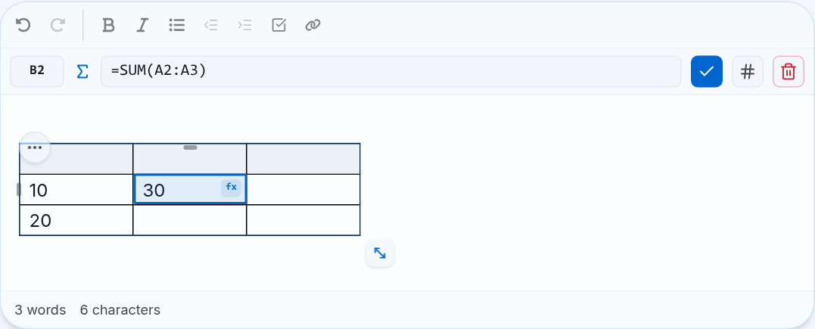
Figure 14. Cell B2 has formula =SUM(A2:A3), result 30 and formula bar (English interface).
Ingredients | Meaning
B2 | The address of the currently selected cell.
Formula cell | Show/edit original formula.
Check mark | Apply the content being edited.
Button # | Convert formula to fixed value; then the cell does not recalculate itself.
Trash | Delete formulas and cell contents.

12.7 Result Formats
Format | Display | Note
Text | Raw value. | Default.
Number | Number with thousands separator, maximum 6 decimal places. | en-US format.
Currency | Currency USD, maximum 2 decimal places. | Show the $ symbol.
Percent | Multiply the displayed value as a percentage. | Example 0.25 → 25%.
Date | Date according to Excel serial number. | Date December 30, 1899; displayed as en-US in the current version.

12.8 Automatic and Manual Recalculation
- When the source value changes, UEditor automatically recalculates the affected formula cells.
- When opening saved content, formulas in tables are recalculated.
- In the cell formula menu, click Recalculate to request a recalculation of the entire selected table.
- If you are in the middle of typing a formula, UEditor waits until it leaves the cell or completes before calculating.

12.9 Formula Errors
Notice | Common causes | How to handle
#EMPTY | Formula is empty. | Enter an expression or delete a formula.
#INVALID-REFERENCE | Cell reference does not exist or cannot be read as a number. | Check source address and data.
#INVALID-FORMULA | Incorrect syntax, function does not support or is missing parentheses. | Check = signs, function names, commas and brackets.
#DIVISION-BY-ZERO | Divide by zero or AVG has no numeric value. | Check denominator/data area.
#CIRCULAR-REFERENCE | Formula refers directly/indirectly to itself. | Remove reference ring.

13. Keyboard Shortcuts

13.1 Shortcuts Handled by UEditor
Keys | Effect | Context
Ctrl/Cmd+B | Enable/disable bold. | Selected text or next input text.
Ctrl/Cmd+I | Turn italics on/off. | Selected text or next input text.
Ctrl/Cmd+U | Enable/disable underlining. | Selected text or next input text.
Ctrl/Cmd+Shift+S | Enable/disable strikethrough. | Selected text or next input text.
Ctrl/Cmd+E | Enable/disable inline code. | Selected text or next input text.
Ctrl/Cmd+, | Enable/disable subscript. | Selected text or next input text.
Ctrl/Cmd+. | Turn on/off the above index. | Selected text or next input text.
Ctrl/Cmd+Alt+1/2/3 | Switch Heading 1/2/3. | Current segment.
Ctrl/Cmd+Shift+8 | Bulleted list. | Current paragraph/list.
Ctrl/Cmd+Shift+7 | Numbered list. | Current paragraph/list.
Ctrl/Cmd+Shift+9 | Job List. | Current paragraph/list.
Ctrl/Cmd+Shift+B | Enable/disable citation. | Current block.
Ctrl/Cmd+Alt+C | Enable/disable code block. | Current block.

13.2 History, Selection, and Clipboard
Keys | Effect | Notes
Ctrl/Cmd+Z | Undo. | UEditor saves a maximum of about 100 historical milestones according to the current configuration.
Ctrl/Cmd+Y | Do it again. | Common on Windows/Linux.
Shift+Cmd+Z | Do it again. | Common on macOS.
Ctrl/Cmd+A | Select all editor content. | The cursor must be in the editor.
Ctrl/Cmd+X | Cut. | Handle by browser/operating system.
Ctrl/Cmd+C | Copy. | Handle by browser/operating system.
Ctrl/Cmd+V | Paste. | May depend on clipboard permissions.

13.3 Context-Sensitive Keys
Context | Keys | Effect
Command / | Arrow Up/Down | Move results.
Command / | Enter / Esc | Select order / close.
Emoji : | Arrow keys | Move in the emoji grid.
Emoji : | Enter / Esc | Insert emoji / close.
Function suggestion | Arrow Up/Down | Move between SUM, AVG, MIN, MAX, COUNT.
Function suggestion | Tab | Insert the currently selected function and enclose the cursor in brackets.
Entering formula | Enter / Escape | Apply/recalculate/cancel import.
Formula bar | Enter / Escape | Apply draft / unchange draft.
Table | Tab / Shift+Tab | Next cell / previous cell; Tab in the last cell adds rows.
List | Tab / Shift+Tab | Increase/degrade list.
Paragraph | Tab / Shift+Tab | Insert tab or increase/decrease margin depending on cursor position.
Checkbox/Radio | Space or Enter | Enable/disable checkbox or select radio.
Bookmark | Enter | Open the link.
Floating menu | Escape | Close menu.
Fullscreen | Escape | Exit full screen by browser.

13.4 How to Interpret Shortcut Labels
NOTE — Save, Link and Fullscreen
Menu shows Ctrl+S for Save, Ctrl+K for Link and Ctrl+Shift+F for Fullscreen. In the current UEditor, this is the instruction label on the menu, not all three being registered directly by the editor. Ability to operate depending on the integrated screen. You can always use the corresponding menu/button.

14. Syntax-Based Typing Shortcuts
In addition to keyboard shortcuts, UEditor recognizes a number of Markdown-style typing templates. Enter the complete pattern and then type a space or ending character as described.
Typing pattern | Result | Example
# + Space | Heading 1 | # Title
## + Space | Heading 2 | ## Title
### + Space | Heading 3 | ### Title
- + Space / * + Space / + + Space | Bullet List | - Section
1. + Space | Numbered List | 1. Step
[ ] + Space or - [ ] + Space | Task List | - [ ] Work
> + Space | Blockquote | > Quote
``` + Space/Enter | Code Block | ```javascript
--- | Horizontal Rule | Type three dashes.
**text** or __text__ | Bold | **important**
*text* or _text_ | Italic | *emphasis*
~~text~~ | Strikethrough | ~~canceled~~
`text` | Inline Code | `npm run build`

TIP — Undo automatic conversion
If UEditor automatically converts the typing pattern but you want to keep the characters intact, press Ctrl/Cmd+Z immediately after converting.

15. Saving, Previewing, and Exporting Content

15.1 Saving Content
UEditor provides content for application screens. The actual Save button may be outside the editor. In classic menu mode, File → Save only works when the app has connected a save action.
1. Check content, links, pictures, files, tables, and formula results.
2. Press the screen's Save button or File → Save.
3. Wait for the system to upload embedded images/files to the server if available.
4. Message confirmation successful.
5. Reopen the content or use Preview to check.

15.2 Previewing Content
Choose View → Preview or click the eye icon. The preview box uses the editor's HTML content in reading mode. If the content is empty, the system displays a message with no content.

15.3 Exporting HTML
File → Export HTML loads the document.html file when the screen is not replaced by native processing. File contains HTML content. The final display may still depend on the CSS of where the file is opened.

15.4 Editing HTML Source
1. Select View/Tools → Source Code.
2. Copy existing HTML for backup.
3. Correct the necessary part.
4. Click Apply to update the editor; Click Close to cancel.
5. Check Preview and save.

16. Content Authoring Best Practices

16.1 Structure and Readability
- Each document should have a clear title and a consistent Heading 1–3 system.
- Each paragraph should focus on one idea; Prioritize lists for multiple items in parallel.
- Do not use all capital letters for long paragraphs.
- Use Callout for important information, not for every paragraph.
- Use tables for data with row/column relationships, do not use tables just to align the layout.

16.2 Accessibility
- Write meaningful Alt text for images.
- Use link text to describe the goal, avoid just writing “click here”.
- Enable header row/column for data table.
- Make sure the text color and background color are contrasting enough.
- Don't just use colors, emojis or images to convey required information.
- Checking content with keyboard when form has checkbox/radio.

16.3 Performance and Stability
- Optimize image size before uploading.
- Avoid pasting too large documents at once; Divide into parts and check.
- Do not insert very large base64 images if the network is weak.
- With large tables, avoid complex cell merges and overly broad reference formulas.
- Phase saving for long content.

17. Troubleshooting
Phenomenon | Possible cause | How to handle
Can't see toolbar/menu | The screen uses minimal variant, read-only mode or has the function disabled. | Check edit permissions; horizontal scroll toolbar; Contact admin if needed.
The button is greyed out | The correct object was not selected or the command is invalid. | Place cursor/select appropriate text, image or cell.
Unable to paste | Browser blocks clipboard. | Use Ctrl/Cmd+V and grant clipboard permissions if asked.
Link refused | URL is missing/malformed or blocked for safety. | Use full HTTPS URL and check characters.
Picture cannot be inserted | Wrong format, over capacity or upload error. | Reduce size, change to PNG/JPEG/WebP, check network and try again.
Image/file says Upload failed | Network or upload service error. | Click Retry; If the error persists, reload the page after backing up the content.
Can't see the floating menu | Editor lost focus, object was not selected or menu was disabled. | Click the editor again, highlight/select the object; Use the toolbar instead.
The panel handle is not visible | The mouse is not at the edge or the table is in read-only mode. | Click in the table and drag to the top, left, right, or bottom corner.
Unable to merge cells | Selection is not contiguous/rectangular. | Select adjacent cells again.
Formula does not count | The formula is being imported, has incorrect syntax, or has an error reference. | Press Enter, check the error message and use Recalculate.
Table changed after pasting | The source has a format that is not fully compatible. | Recheck headers, cell merges, borders, formulas and widths.
Save cannot be clicked | The screen does not integrate the Save action in the menu. | Use the Save button of the application screen.
Fullscreen/clipboard not working | The browser denied permission or the shortcut was not captured by the screen. | Use button/menu and check browser permissions.

17.1 Safe Recovery Workflow
1. Stop the operation that caused the error; try Ctrl/Cmd+Z.
2. Copy important content to a temporary location.
3. Check network if there are pictures/files.
4. Save if the system still allows it.
5. Reload the page and check the saved content.
6. If the error recurs, record the operation step, browser, image, and time to send to support.

18. Complete Feature Inventory
The document inventories 231 user operations and options items: 100 non-table UEditor items (U001–U100) and 131 Table items (T001–T131). This counting method is used to control coverage; Sub-selections are counted separately for easy reference.

18.1 Feature Groups
Group | UEditor feature
Edit | HTML rich text input, select, delete, cut/copy/paste, paste text, undo/redo, word and character counter, character limit.
Text style | Font family, size 8–96 px, line spacing, text spacing, Normal, Heading 1–3.
Inline format | Bold, Italic, Underline, Strikethrough, Inline Code, Subscript, Superscript.
Color and paragraph | Text color, highlight, align left/center/right/even, increase/decrease margins.
List | Bullet, numbered, task list, nested list.
Link | Insert, preview, open, edit, remove, and check URLs safely.
Media | Image URL/upload/paste/drop, alt text, resize, block/left/right, S/M/L, reset, delete; attachments and downloads.
Content block | Quote, code block, divider, callout, bookmark, square/round checkbox, radio.
Emoji | Suggestions with :, search, keytable controls, emoji in callout.
Quick command | 15 blocks via /, filtering and keytable controls.
Structure table | Insert via grid or /table; paste HTML/TSV; add, delete, duplicate, move, and empty rows/columns; enable header row/column.
Size table | Resize columns, rows and entire table; quickly add multiple rows/columns; Ctrl locks axis; Ctrl+Shift keeps proportion; Wide horizontal table scrolling.
Cell table | Select single/multiple cells, merge/split, background color, 9 border positions, 4 stroke styles, 4 thicknesses, custom color, horizontal/vertical alignment, horizontal/vertical text and wrap.
Formula | Cell/range reference, mouse range selection, + − × ÷, SUM/AVG/MIN/MAX/COUNT, auto recalculation, 5 errors and 5 result formats.
Matrix Table | 131 operations and options with codes T001–T131 for coverage checking and quick lookup.
Classic menu | File, Edit, View, Insert, Format, Tools, Table; Preview, Source Code, Fullscreen, Export HTML.
Display mode | Default, minimal, medium, medium-full, full, notion; read-only mode.

18.2 Reference Matrix of 100 Non-Table Operations and Options
Table entries are not repeated in the table below; See matrix T001–T131 in section 11.20.
Code | Group | Actions/options | Brief usage
U001 | Edit | Enter rich text | Click the content area and enter text.
U002 | Edit | Select content | Drag the mouse or use the keyboard to highlight.
U003 | Edit | Delete content | Use Backspace or Delete.
U004 | Edit | Cut | Ctrl/Cmd+X or Edit → Cut.
U005 | Edit | Copy | Ctrl/Cmd+C or Edit → Copy.
U006 | Edit | Formatted paste | Ctrl/Cmd+V. The result depends on clipboard data.
U007 | Edit | Paste as text | Edit → Paste as Text.
U008 | Edit | Select all | Ctrl/Cmd+A or Edit → Select All.
U009 | Edit | Undo | Ctrl/Cmd+Z or Undo.
U010 | Edit | Do it again | Ctrl/Cmd+Y or Shift+Cmd+Z.
U011 | Edit | Word count | View the counter below the editor when enabled.
U012 | Edit | Character count | View the counter below the editor when enabled.
U013 | Edit | Character Limit | Monitor the counter or limit configured for the editor.
U014 | Edit | Read-only mode | Content is displayed but cannot be edited.
U015 | Edit | Placeholder | Suggestion message appears when the editor is empty.
U016 | Text style | Select font | Open Font Family and select the configured font.
U017 | Text style | Returns the default font | Select Default in Font Family.
U018 | Text style | Select available font size | Open Font Size and select the value.
U019 | Text style | Enter font size 8–96 px | Open Text Style, enter the number and confirm.
U020 | Text style | Normal | Converts current block to normal paragraph.
U021 | Text style | Heading 1 | Select Heading 1 or use Alt+1.
U022 | Text style | Heading 2 | Select Heading 2 or use Alt+2.
U023 | Text style | Heading 3 | Select Heading 3 or use Alt+3.
U024 | Text style | Default Line Height | Open Line Height and select Default.
U025 | Text style | Select line spacing | Open Line Height and select the configured level.
U026 | Text style | Letter Spacing default | Open Letter Spacing and select Default.
U027 | Text style | Select text spacing | Open Letter Spacing and select the configured level.
U028 | Text format | Bold | Ctrl/Cmd+B or Bold.
U029 | Text format | Italics | Ctrl/Cmd+I or Italic.
U030 | Text format | Underline | Ctrl/Cmd+U or Underline.
U031 | Text format | Strash | Ctrl/Cmd+Shift+S or Strikethrough.
U032 | Text format | Inline code | Ctrl/Cmd+E or Inline Code.
U033 | Text format | Subscript | Ctrl/Cmd+, or Subscript.
U034 | Text format | Upper index | Ctrl/Cmd+. or Superscript.
U035 | Color | Text color available | Open Text Color and select a color swatch.
U036 | Color | Optional font color | Select More Colors in the text color palette.
U037 | Color | Available marker color | Open Highlight and select a color swatch.
U038 | Color | Optional highlight color | Select More Colors in the Highlight panel.
U039 | Text format | Delete formatting | Format → Clear Formatting.
U040 | Paragraph | Align left | Open Alignment and select Align Left.
U041 | Paragraph | Align center | Open Alignment and select Align Center.
U042 | Paragraph | Align right | Open Alignment and select Align Right.
U043 | Paragraph | Justify | Open Alignment and select Justify.
U044 | Paragraph | Increase margin | Click Increase Indent or Tab in the appropriate context.
U045 | Paragraph | Reduce margin | Press Decrease Indent or Shift+Tab.
U046 | List | Bullet list | Click Bullet List or Ctrl/Cmd+Shift+8.
U047 | List | Numbered list | Select Numbered List or Ctrl/Cmd+Shift+7.
U048 | List | Job List | Select Task List or Ctrl/Cmd+Shift+9.
U049 | List | Level up list | Press Tab at a list item.
U050 | List | Downgrade the list | Press Shift+Tab at a list item.
U051 | Content block | Citation | Select Quote or Ctrl/Cmd+Shift+B.
U052 | Content block | Code block | Select Code Block or Ctrl/Cmd+Alt+C.
U053 | Content block | Select code language | Open the language list on Code Block.
U054 | Content block | Copy code block | Drag up Code Block and click Copy.
U055 | Content block | Dividing line | Select Divider, Horizontal Rule or type ---.
U056 | Link | Create link | Highlight the text, click Link and enter the URL.
U057 | Link | Link preview | Click or place the cursor on a link in edit mode.
U058 | Link | Open the link | Select Open Link in the floating menu.
U059 | Link | Fix link | Select Edit Link and enter the new URL.
U060 | Link | Unlink | Select Remove Link.
U061 | Link | Check URL is safe | UEditor rejected invalid URL/protocol.
U062 | Link | Bookmark Card | Type /bookmark, enter the URL and confirm.
U063 | Image | Insert image from URL | Open Insert Image → URL, enter address and Alt text.
U064 | Image | Download images from device | Open Insert Image → Upload and select the file.
U065 | Image | Paste the image | Copy the image and press Ctrl/Cmd+V.
U066 | Image | Drop image | Drag the image file to the location to insert.
U067 | Image | Alt text | Enter a description in the insert picture box.
U068 | Image | Drag to resize | Select the image and drag the handle.
U069 | Image | Block Layout | Select image → Image Layout Block.
U070 | Image | Wrap the text on the left | Select Image Layout Left.
U071 | Image | Wrap the text on the right | Select Image Layout Right.
U072 | Image | Size S | Select Image Width Small.
U073 | Image | Size M | Select Image Width Medium.
U074 | Image | Size L | Select Image Width Large.
U075 | Image | Restore size | Select Reset Image Size.
U076 | Image | Delete image | Select Delete Image.
U077 | File | Attach file | Type /file and select the file.
U078 | File | Reload or download | Use Retry Upload when there is an error; Click the file tag to download.
U079 | Quick command | Open menu / | Type / at the beginning of a blank line.
U080 | Quick command | Filter commands | Continue to type the name of the block to insert.
U081 | Quick command | Keytable controls | Arrow Up/Down to select, Enter to insert, Esc to close.
U082 | Quick command | Floating Add Block | Click Add block on the blank line when this button appears.
U083 | Callout | Insert Callout | Type /callout or select the corresponding command.
U084 | Callout | Change emoji | Click emoji at the top of Callout and select the icon.
U085 | Callout | Change background color | Open Callout Background Color.
U086 | Form | Checkbox square | Select Form Checkbox or /checkbox.
U087 | Form | Checkbox round | Select Round Checkbox or /round checkbox.
U088 | Form | Radio and Group Name | Insert Form Radio, set the same Group Name for selections in the same group.
U089 | Emoji | Open hint with : | Type: include keywords in the content.
U090 | Emoji | Find emoji | Enter keywords in the emoji table.
U091 | Emoji | Move in the grid | Use the arrow keys.
U092 | Emoji | Insert emoji | Press Enter or press emoji.
U093 | Emoji | Close the emoji panel | Press Escape.
U094 | Menu and output | Classic menu | Use File, Edit, View, Insert, Format, Tools and Table when enabled.
U095 | Menu and output | Preview | Choose View → Preview or click the eye icon.
U096 | Menu and output | Source Code | Select View/Tools → Source Code.
U097 | Menu and output | Apply HTML | In Source Code, click Apply after editing.
U098 | Menu and output | Fullscreen | Select View → Fullscreen. Press Esc to exit.
U099 | Menu and output | Export HTML | Select File → Export HTML.
U100 | Menu and output | Save | Select File → Save when the save action is integrated on the screen.

19. English–Vietnamese Terminology Reference
English label | Meaning used in the document | English label | Meaning used in the document
File | File | Edit | Edit
View | See | Insert | Insert/Add
Format | Format | Tools | Tools
Table | Table | Save | Save
Export HTML | Export HTML | Source Code | Source code
Preview | Preview | Fullscreen | Full screen
Bold | Bold | Italic | Italics
Underline | Underline | Strikethrough | Strash
Inline Code | Inline code | Code Block | Code block
Subscript | Subscript | Superscript | Upper index
Text Color | Text color | Highlight | Marker color
Bullet List | Bulleted list | Numbered List | Numbered list
Task List | Job List | Blockquote | Citation
Callout | Information box | Bookmark Card | Link tag
File Attachment | Attachment | Form Fields | Form field
Merge Cells | Merging cells | Split Cell | Split cells
Wrap Text | Auto line break | Text Direction | Text direction
Recalculate | Recalculate | Convert to Value | Convert to value

